UNITED STATES

SECURITIES AND EXCHANGE COMMISSION

Washington, DC 20549

SCHEDULE 14A INFORMATION

PROXY STATEMENT PURSUANT TO SECTION 14(A)
OF THE SECURITIES EXCHANGE ACT OF 1934
(Amendment No. ___)

 | Filed by the Registrant |  | Filed by a Party other than the Registrant

Check the appropriate box:
Preliminary Proxy Statement
Confidential, for Use of the Commission Only (as permitted by Rule 14A-6(e)(2))
Definitive Proxy Statement
Definitive Additional Materials
Soliciting Material under §240.14a-12



SCHLUMBERGER N.V. (SCHLUMBERGER LIMITED)

(Name of Registrant as Specified in Its Charter)

(Name of Person(s) Filing Proxy Statement if other than the Registrant)

Payment of Filing Fee (Check all boxes that apply):
No fee required
Fee paid previously with preliminary materials
Fee computed on table in exhibit required by Item 25(b) per Exchange Act Rules 14a-6(i)(1) and 0-11
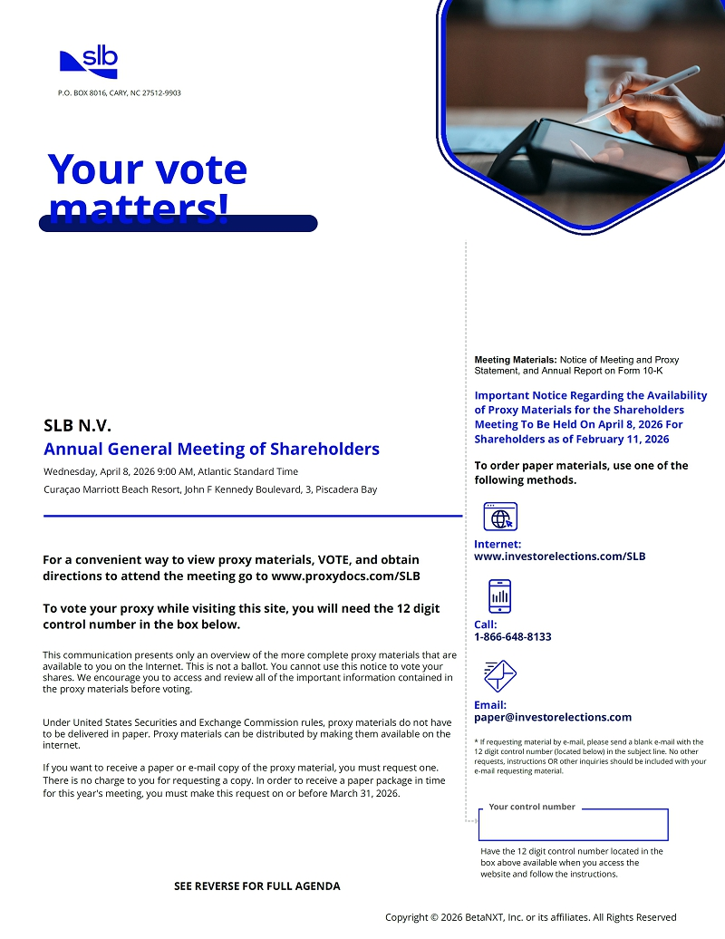
P.O. BOX 8016, CARY, NC 27512-9903 Your vote matters! SLB N.V. Annual General Meeting of Shareholders Wednesday, April 8, 2026 9:00 AM, Atlantic Standard Time Curaçao Marriott Beach Resort, John F Kennedy Boulevard, 3, Piscadera Bay For a convenient way to view proxy materials, VOTE, and obtain directions to attend the meeting go to www.proxydocs.com/SLB To vote your proxy while visiting this site, you will need the 12 digit control number in the box below. This communication presents only an overview of the more complete proxy materials that are available to you on the Internet. This is not a ballot. You cannot use this notice to vote your shares. We encourage you to access and review all of the important information contained in the proxy materials before voting. Under United States Securities and Exchange Commission rules, proxy materials do not have to be delivered in paper. Proxy materials can be distributed by making them available on the internet. If you want to receive a paper or e-mail copy of the proxy material, you must request one. There is no charge to you for requesting a copy. In order to receive a paper package in time for this year's meeting, you must make this request on or before March 31, 2026. Meeting Materials: Notice of Meeting and Proxy Statement, and Annual Report on Form 10-K Important Notice Regarding the Availability of Proxy Materials for the Shareholders Meeting To Be Held On April 8, 2026 For Shareholders as of February 11, 2026 To order paper materials, use one of the following methods. Internet: www.investorelections.com/SLB Call: 1-866-648-8133 Email: paper@investorelections.com * If requesting material by e-mail, please send a blank e-mail with the 12 digit control number (located below) in the subject line. No other requests, instructions OR other inquiries should be included with your e-mail requesting material. Your control number Have the 12 digit control number located in the box above available when you access the website and follow the instructions. SEE REVERSE FOR FULL AGENDA Copyright © 2026 BetaNXT, Inc. or its affiliates. All Rights Reserved
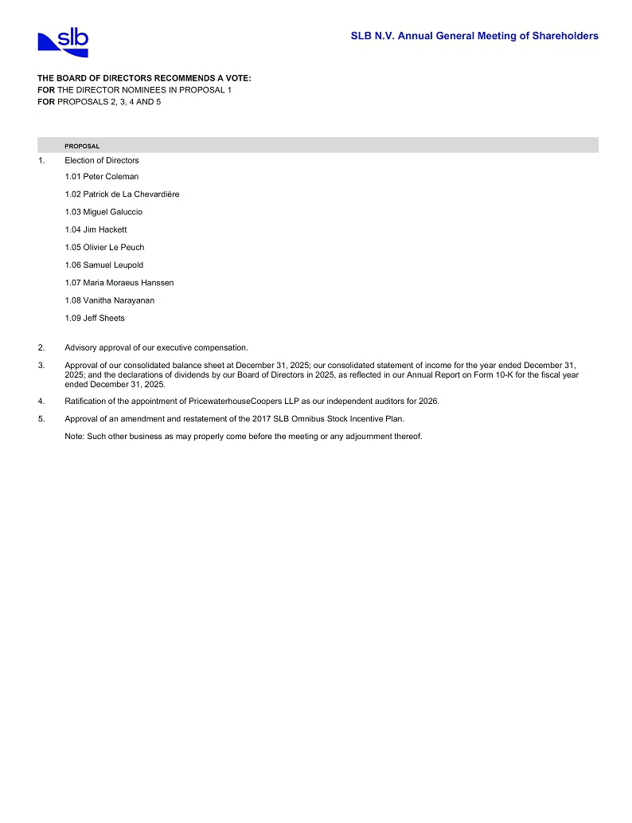
SLB N.V. Annual General Meeting of Shareholders THE BOARD OF DIRECTORS RECOMMENDS A VOTE: FOR THE DIRECTOR NOMINEES IN PROPOSAL 1 FOR PROPOSALS 2, 3, 4 AND 5 PROPOSAL 1. Election of Directors 1.01 Peter Coleman 1.02 Patrick de La Chevardière 1.03 Miguel Galuccio 1.04 Jim Hackett 1.05 Olivier Le Peuch 1.06 Samuel Leupold 1.07 Maria Moraeus Hanssen 1.08 Vanitha Narayanan 1.09 Jeff Sheets 2. Advisory approval of our executive compensation. 3. Approval of our consolidated balance sheet at December 31, 2025; our consolidated statement of income for the year ended December 31, 2025; and the declarations of dividends by our Board of Directors in 2025, as reflected in our Annual Report on Form 10-K for the fiscal year ended December 31, 2025. 4. Ratification of the appointment of PricewaterhouseCoopers LLP as our independent auditors for 2026. 5. Approval of an amendment and restatement of the 2017 SLB Omnibus Stock Incentive Plan. Note: Such other business as may properly come before the meeting or any adjournment thereof.

