
FiledbySchlumbergerN.V.(SchlumbergerLimited)

PursuanttoRule425of theSecuritiesActof1933,asamended,and

deemedfiledpursuanttoRule14a-12oftheSecuritiesExchangeActof1934,asamended

SchlumbergerN.V.(SchlumbergerLimited)(FileNo.:1-4601)

SubjectCompany:SmithInternational,Inc.(FileNo:1-8514)

Schlumberger and Smith International, Inc. to Merge

March, 2010

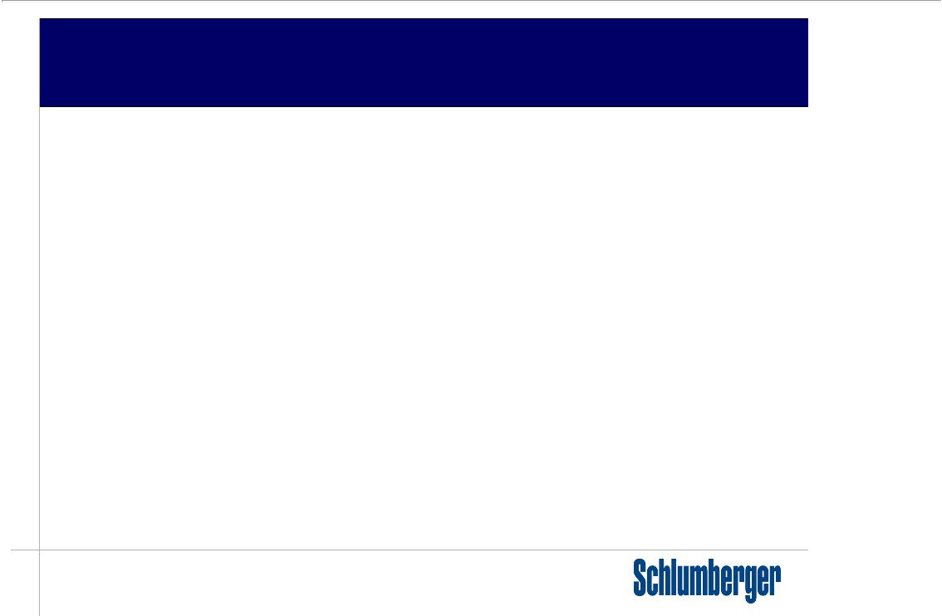
Forward-Looking Statements

This presentation includes “forward-looking statements” within the meaning of Section 27A of the Securities Act of 1933, as amended, and Section 21E of the Securities Exchange Act of 1934, as amended. The opinions, forecasts, projections, or other statements other than statements of historical fact, are forward-looking statements. The Company can give no assurance that such expectations will prove to have been correct. These statements are subject to, among other things, satisfaction of the closing conditions to the merger, the risk that the contemplated merger does not occur, negative effects from the pendency of the merger, the ability to successfully integrate the merged businesses and to realize expected synergies and other risk factors that are discussed in Schlumberger’s and Smith’s most recent 10-Ks as well as each company’s other filings with the SEC available at the SEC’s Internet site (http://www.sec.gov). Actual results may differ materially from those expected, estimated or projected.

Forward-looking statements speak only as of the date they are made, and we undertake no obligation to publicly update or revise any of them in light of new information, future events or otherwise.

Additional Information

STOCKHOLDERS ARE URGED TO READ THE PROXY STATEMENT/PROSPECTUS AND REGISTRATION STATEMENT REGARDING THE PROPOSED TRANSACTION WHEN IT BECOMES AVAILABLE BECAUSE IT WILL CONTAIN IMPORTANT INFORMATION ABOUT THE PROPOSED TRANSACTION. These documents will contain important information about the proposed transaction that should be read carefully before any decision is made with respect to the proposed transaction. These materials will be made available to the shareholders of Smith at no expense to them. Investors and security holders will be able to obtain the documents (when available) free of charge at the SEC’s web site, www.sec.gov. In addition, such materials (and all other documents filed with the SEC) will be available free of charge at www.smith.com or www.slb.com. Such documents are not currently available. You may also read and copy any reports, statements and other information filed by Smith or Schlumberger with the SEC at the SEC public reference room at 100 F Street N.E., Room 1580, Washington, D.C. 20549. Please call the SEC at (800) 732-0330 or visit the SEC’s website for further information on its public reference room.

Each company’s directors and executive officers and other persons may be deemed, under SEC rules, to be participants in the solicitation of proxies in connection with the proposed transaction. Information regarding Schlumberger’s directors and officers can be found in its proxy statement filed with the SEC on March 4, 2010 and information regarding Smith’s directors and officers can be found in its proxy statement filed with the SEC on April 13, 2009. Additional information regarding the participants in the proxy solicitation and a description of their direct and indirect interests in the transaction, by security holdings or otherwise, will be contained in the proxy statement/prospectus and othe relevant materials to be filed with the SEC when they become available.

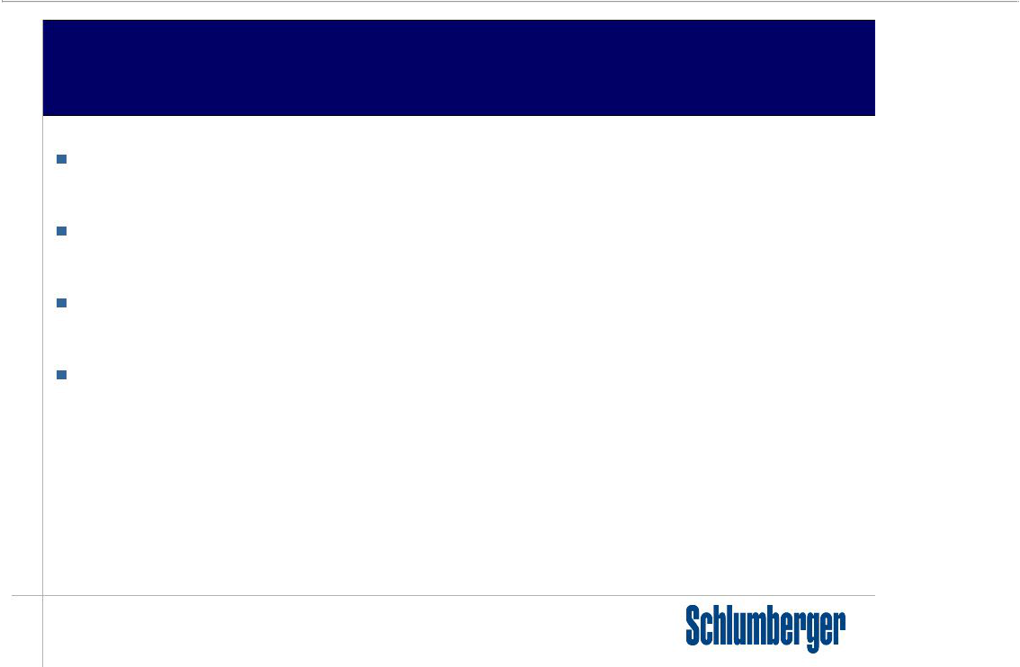
Industry Trends—Drilling

Higher levels of drilling will be necessary to sustain and increase world oil and gas production

Drillingintensityandwellcomplexitywillcontinuetoincreaseduetoareassuch as deepwater sub-salt and shale gas

Geosteeredwells with complex geometries are key to increased recovery and maximizing initial production

Combining our LWD, MWD & DD capabilities with the design and optimization of the entire BHA (including bits, drilling tools and drilling fluids) will improve drilling performance and reduce drilling risk

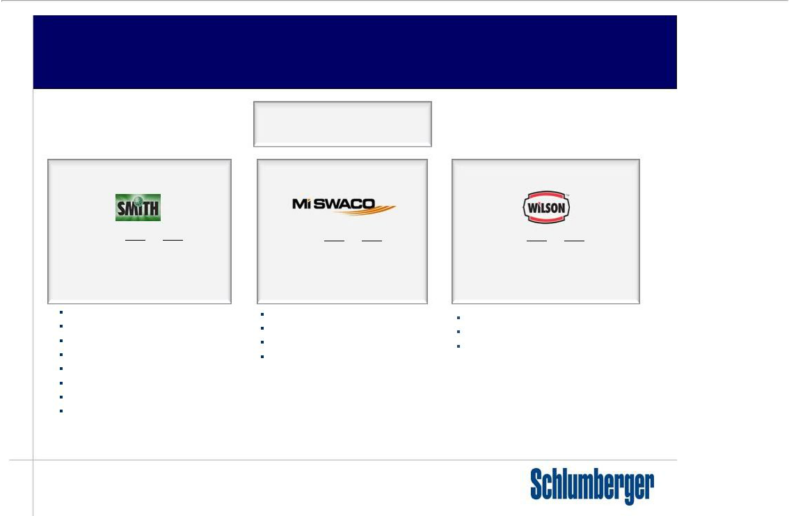
Smith International Organization

 |  |  | Smith International, Inc.
Smith Oilfield |  |  | Smith Fluids |  |  | Smith Distribution
 | 2008A | 2009A |  | 2008A | 2009A |  | 2008A | 2009A
Revenue: | $2,849 | $2,225 | Revenue: | $5,183 | $4,224 | Revenue: | $2,739 | $1,769
Oper. Income: 747 |  | 254 | Oper. Income: 840 |  | 541 | Oper. Income: 180 |  | (32)
Oper. Margin | 26% | 10% | Oper. Margin | 16% | 12% | Oper. Margin | 7% | NM

Drill Bits

Motors and Drilling Tools

Reamers and Hole Openers

Fishing and Casing Existing

Tubular Drill String Components

Completion and Artificial Lift Products

LWD, MWD, DD

Coiled Tubing, CH WL and Perforating

Drilling Fluid Systems and Services | Pipe, Valves and Fittings
Environmental and Process Solutions | Pipe, Valves and Fittings
Environmental and Process Solutions | Mill, Safety and Maintenance Products
Completion Fluids | Mill, Safety and Maintenance Products
Completion Fluids | Supply Chain Services
Production Chemicals | Supply Chain Services

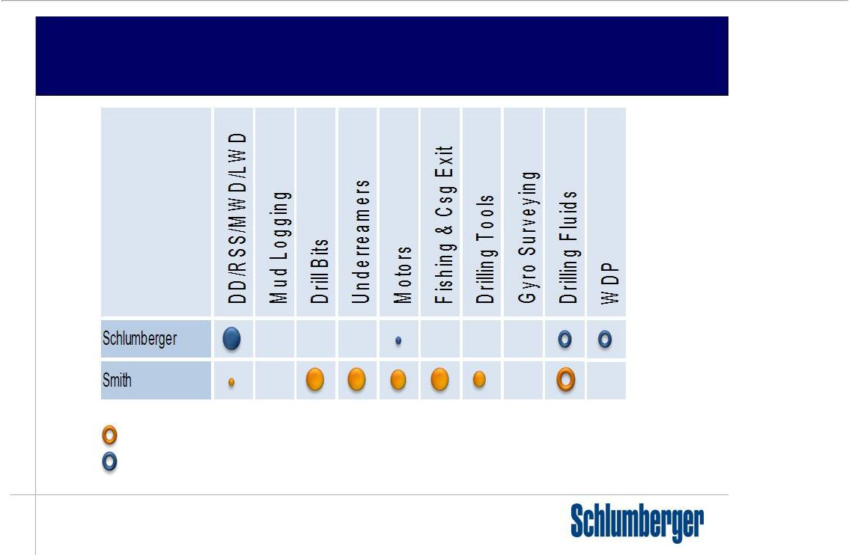
Drilling Services Gap Analysis

Majority JV with SLB

Minority SLB JV interest

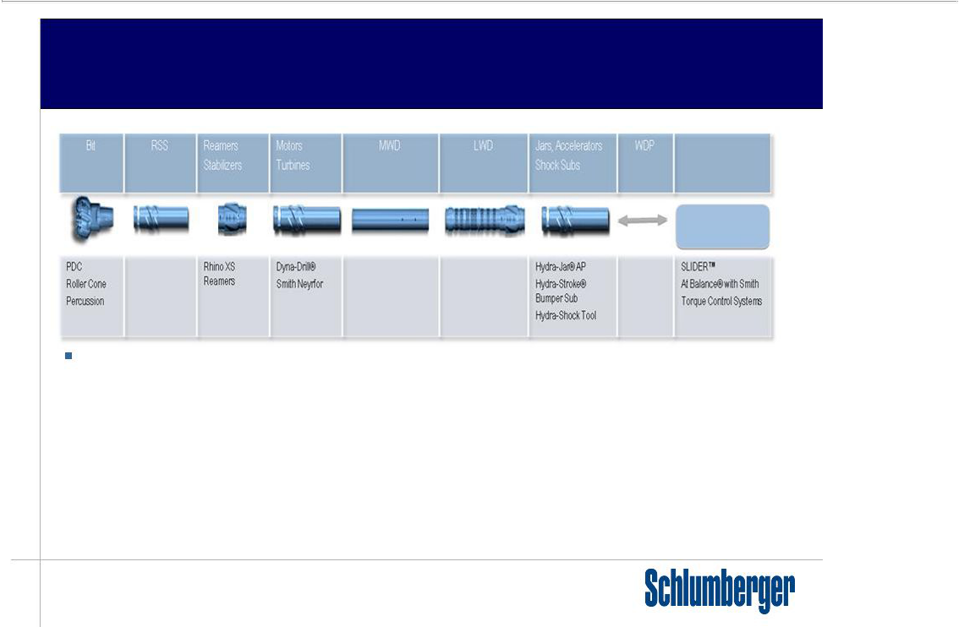
Drilling Services Offering

Surface

Control Systems

Complementary Services

– Integrated fluid engineering and environmental solutions

– IDEAS/i-Drill BHA modeling software

– Fishing services

– Window cutting and exiting services (Trackmaster)

– Inspection and machine shop services

– Rotating drilling heads—pressure containment

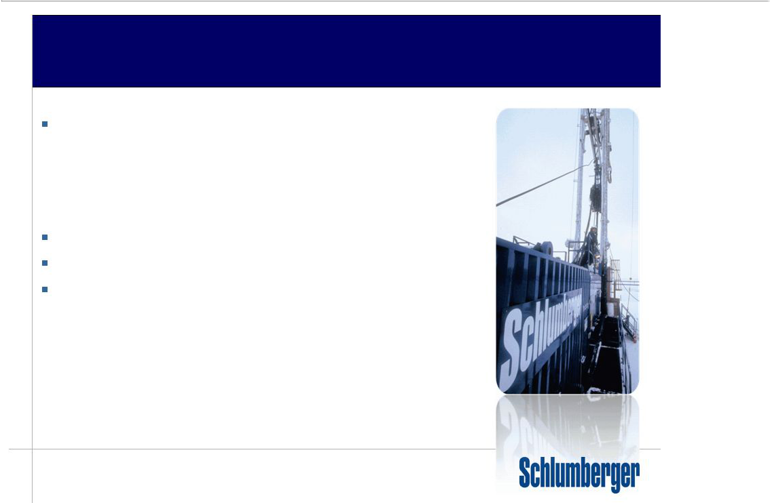
Merger Rationale

Enable SLB to provide a fully optimized drilling services offering:

– Next generation of BHA offering

– Industry leading bit/drillstringsoftware modeling

– In-house drilling bit/motor/turbine engineering and manufacturing

– surface control mechanisms for automation

– Higher temperature MWD/LWD capabilities (175 degC)

BroadenSLBportfolio—re-entry drilling process

Enable SLB to add to completions offerings

Smith manufacturing and distribution channels

– Vehicle for high volume business

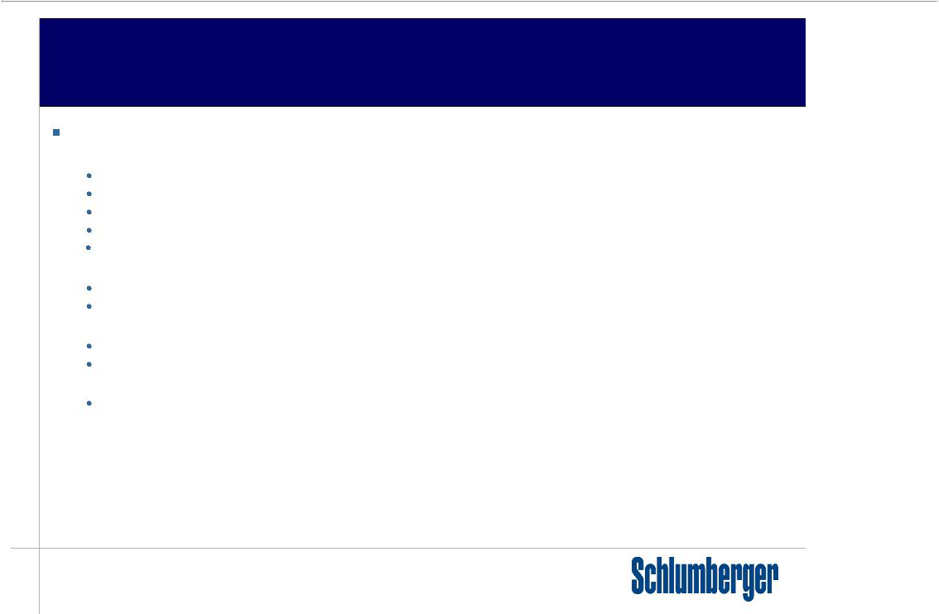
MergerRationale(Continued)

Optimize interaction between MI-Swaco and SLB segments

– Drilling Solutions—D&M, IPM

Integrated fluid engineering and RT hydraulics control (particularly for DW and HT)

Managed pressuredrilling

Wellbore stability and well strengthening solutions

Loss circulation management while drilling solutions

Downhole system reliability—reduced blockage, abrasivity and chemical damage

– Zonal Isolation—Well Services

More efficient cement operations

Improved logistics/supply chain for chemicals and bulk products

– Production Technologies—Well Services and Completions

Uniquecompletion and stimulation solutions

Shale gas environmental solutions—water management

– Water Services

Environmentalsolutions

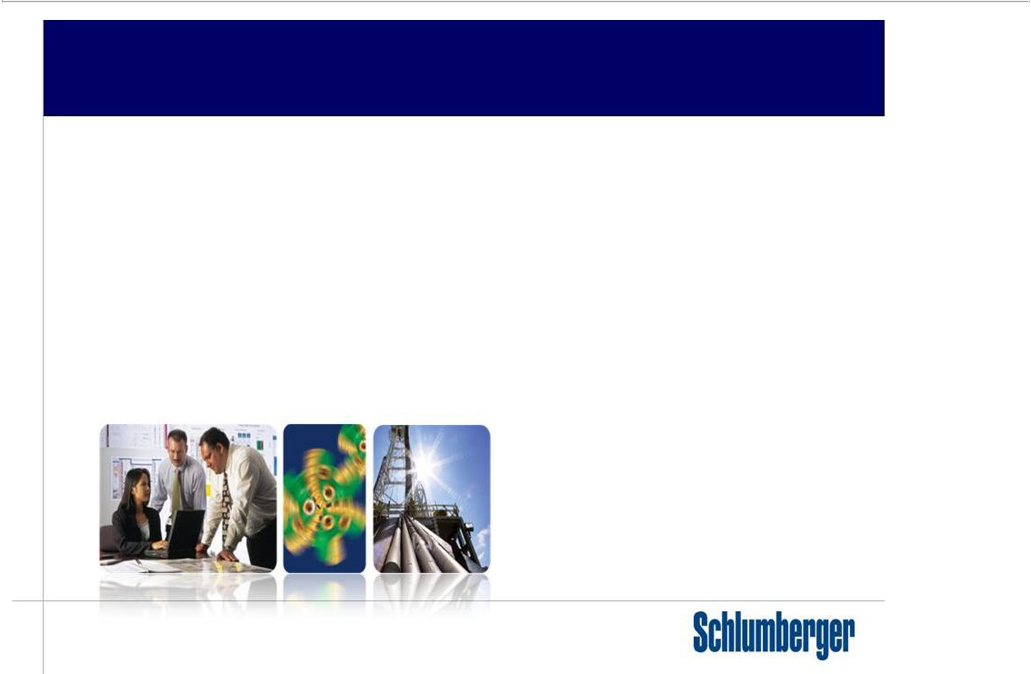
Synergy Realization

- Create a drilling group to integrate our drilling services offering

– Improved drilling performance—integrated BHA design and fluid engineering

– Increased operational efficiency—new motor (Dyna-Drill) and turbine designs (Neyrfor)

– Rotary Steerable Services integration with the bit, plus instrumented bits development

– Bits, reamers and drilling tools on D&M and IPM projects, plus new business

– Increase SLB exposure to vertical drilling—combined bit, PowerV* vertical drilling system and motors

– Comprehensivebrownfieldreentrydrillingpackage—fishing,exitingservices

– PathFinderHT and mid tier LWD/MWD—expand footprint, access to new customers

– Smith manufacturing and distribution channels—vehicle for high volume business

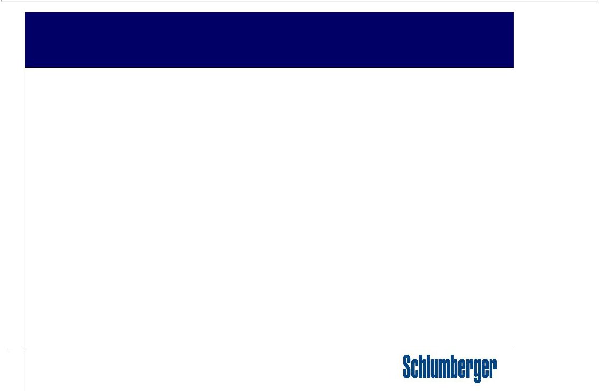
SynergyRealization(Continued)

- OptimizeinteractionbetweenMI-SwacoandSLBsegments

– Drilling Solutions—D&M, IPM

– Integrated fluid engineering and RT hydraulics control
– MPD and Wellbore stability solutions

– Well Productivity—Well Services
– Production Technologies—Reservoir Production new business opportunity
– Environmental Solutions—Water Services

- Smith products and services complement SLB segment portfolios

– Liner hangers—SLB Completions segment
– Production packers—SLB Completions segment
– SmithLift—SLB Artificial Lift segment

– Coiled Tubing Services—SLB Well Services segment
– Casedholewireline—SLBWirelinesegment

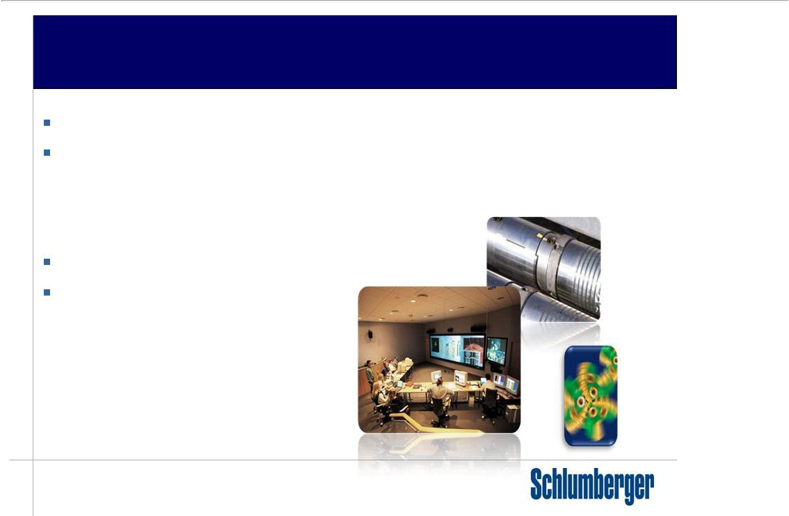
Summary

Combines services and products into one focused drilling organization Purpose of deal is to improve drilling performance for our customers

– Optimized drilling system designs—range of drilling environments

– New product development—evolving drilling challenges

– Improved total system reliability

Add to SLB completions offerings

Strengthens Smith brands

– Increase access to new business opportunities

– Access to SLB R&D

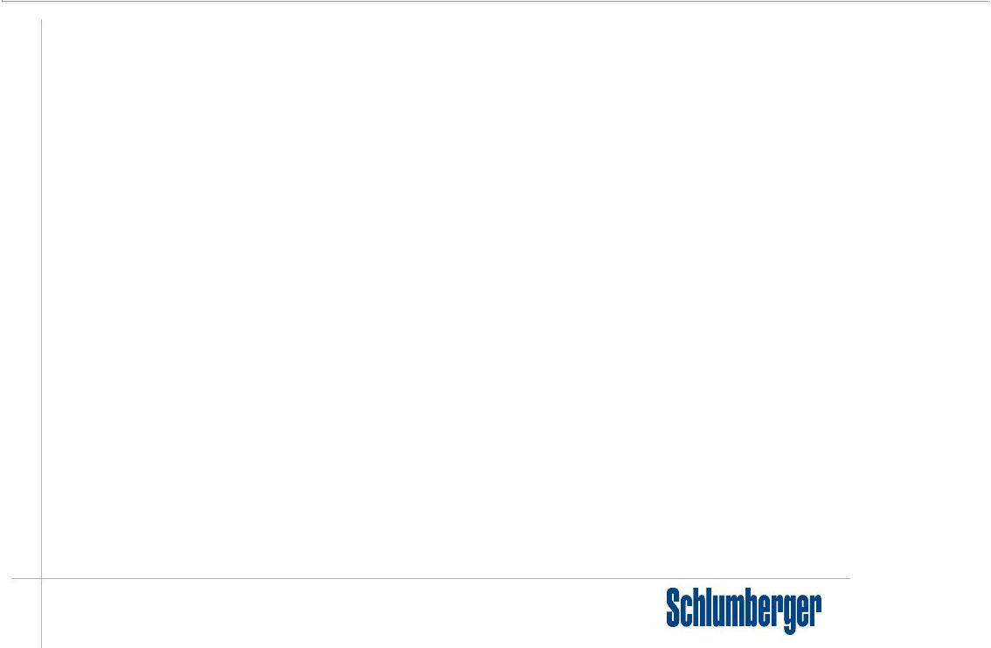

©2010 Schlumberger. All rights reserved.

An asterisk is used throughout this presentation to denote a mark of Schlumberger.

Other company, product, and service names are the properties of their respective owners.

