Filing pursuant to Rule 425 under the

Securities Act of 1933, as amended

Deemed filed under Rule 14a-12 under the

Securities Exchange Act of 1934, as amended

Filer: Schlumberger N.V. (Schlumberger Limited)

Subject Company: Cameron International Corporation

Commission File No.: 1-13884



Cameron Integration


Schlumberger & CameronAUnique– Combination

August 26 Schlumberger– and Cameron jointly announce a definitive merger agreement in which the companies would combine in a stock and cash transaction, with closing expected in Q1 2016

Cameron shareholders to receive 0.716 Schlumberger shares and $14.44 in cash for each share of Cameron

The transaction combines two complementary technology portfolios into a “pore-to-pipeline” products and services offering with customers to benefit through technology system innovation and improved operational performance

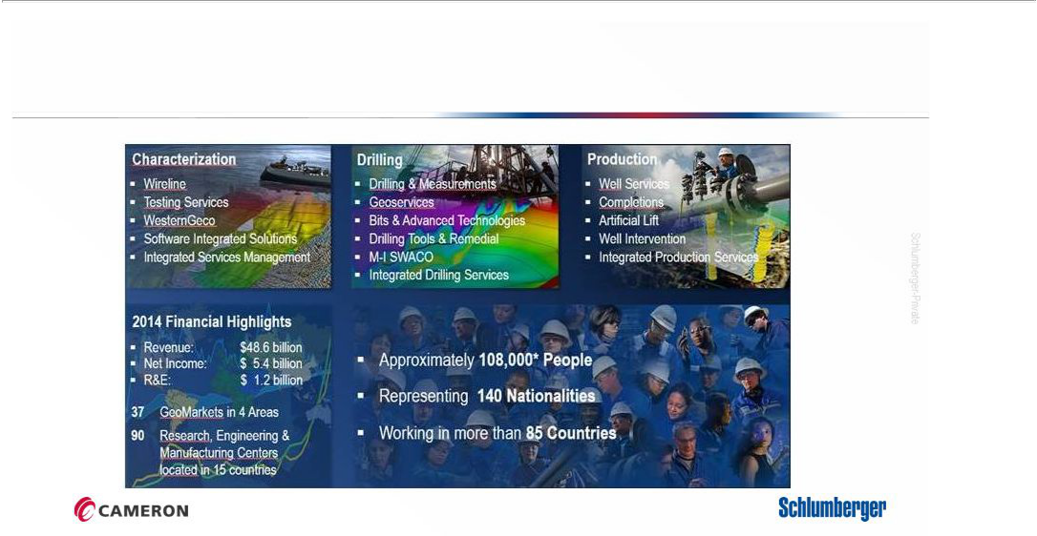
Schlumberger at a Glance

* Note: Effective July, 2015

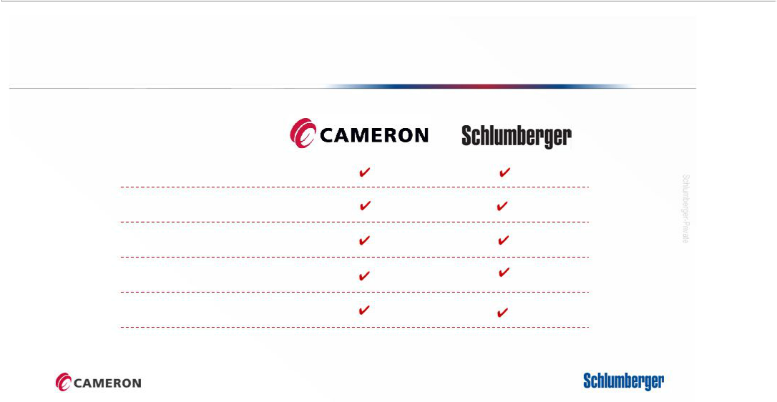
Schlumberger and CameronIdeal– Partners

Strong Core Values

Rich History

Commitment to Safety & Customers

Operational Excellence

Technology Leadership

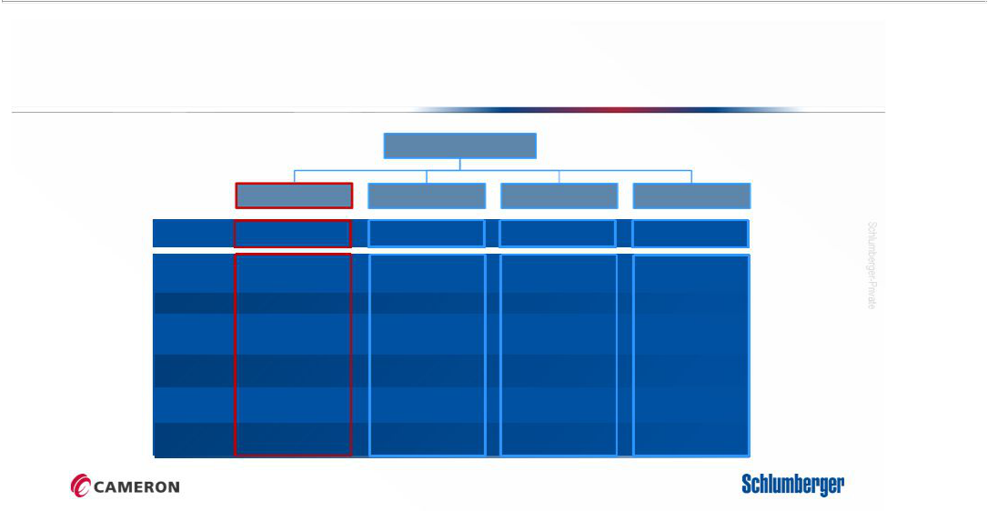
Proposed Schlumberger Group Structure

Schlumberger

 | Cameron |  | Characterization |  | Drilling |  | Production
Revenue | $10.3 billion |  | $12.2 billion |  | $18.5 billion |  | $18.1 billion
Business
Rank
 | OneSubsea | 2 | Wireline | 1 | Drilling & Measurements1 |  | Well Services | 2
 | Drilling Systems | 2 | Testing Services | 1 | Geoservices | 1 | Completions | 3
 | Valves & Measurements1 |  | WesternGeco | 2 | Bits | 1 | Artificial Lift | 2
 | Surface Systems | 1 | SIS* | 1 | M-I SWACO | 1 | Well Intervention | 1
 | Processing Systems1 |  |  |  | Drilling Tools | 4

Notes: (1) Revenue year end 2014, (2) CAM and SLB SEC filings, IHS, Infield, Capital IQ, Spears, SLB and CAM, public sources,

(3) Business Rank source: Spears Oilfield Market Report May 2015, * No ranking published by Spears; source: Schlumberger

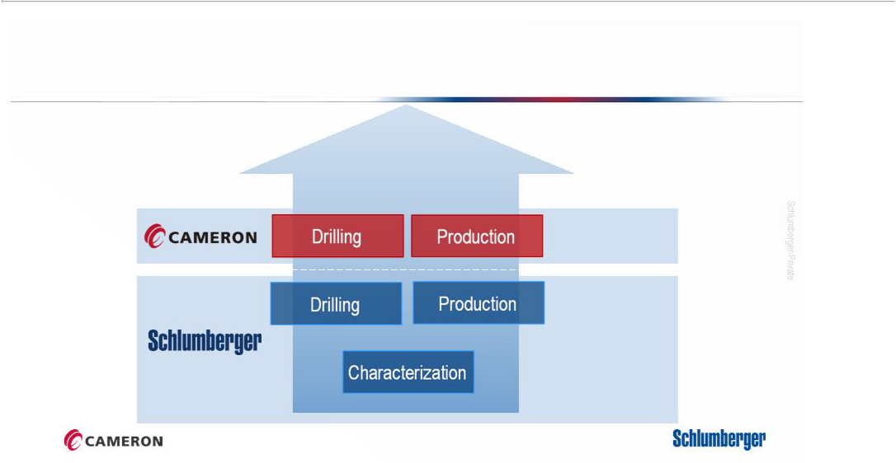
Expanding from Subsurface to Surface

Integrated Drilling Systems

Integrated Production Systems

Wellhead+

Well

Reservoir

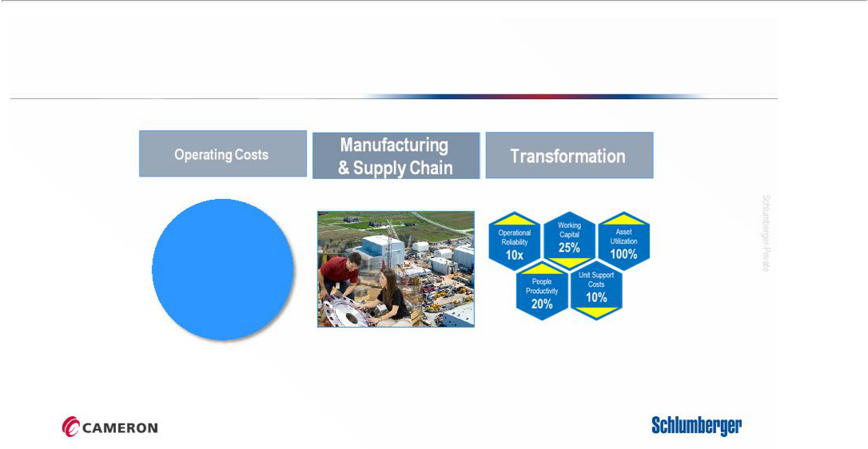
Cost Synergies

Segment &

Geographical G&A

Operational Corporate

Costs G&A

Back-office

Support

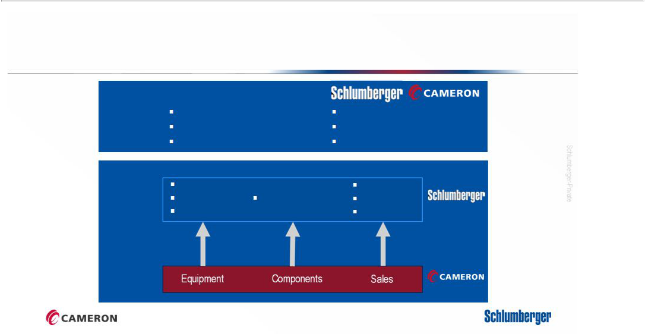
Revenue Benefits

Value

Customers

Increase recovery rates

Expand our customer base

Reduce costs per barrel

Leverage our global footprint

Closer commercial alignment

Broaden our technology portfolio

Automation Performance

Integration Software System Integration Services

Instrumentation Rentals

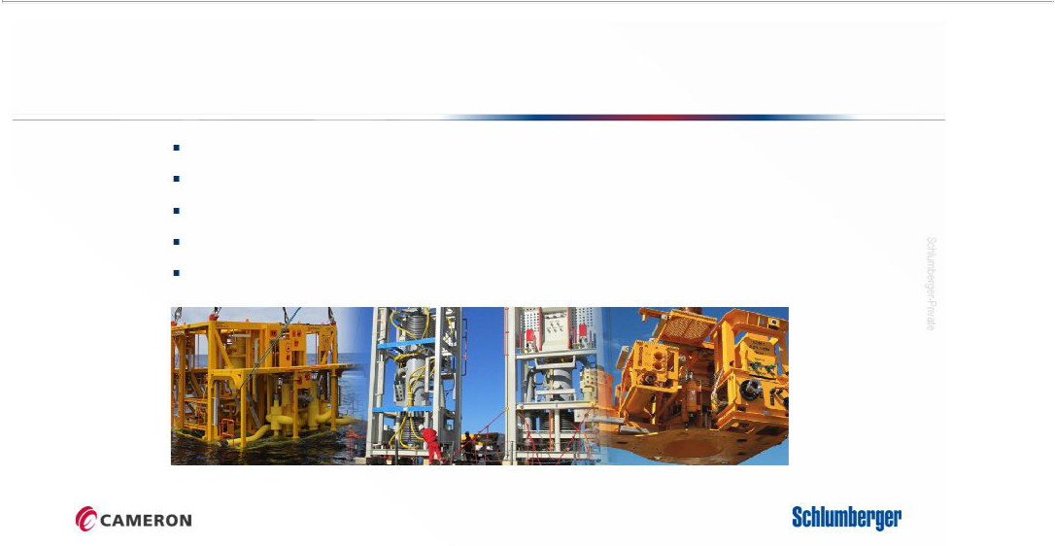
OneSubseaAccelerating– the Implementation

Expand customer base and geographical coverage

Introduce performance based boosting contracts

Accelerate joint R&E with Completion and Artificial Lift product lines

Leverage reservoir knowledge in early design phase discussions

Increase focus on design simplification and cost efficiency

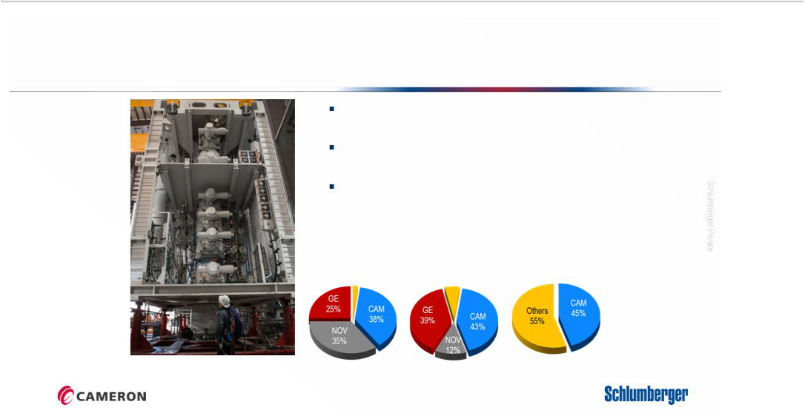
BOP Non-Productive TimeAddressing– the Industry Issue

Largest installed base of BOPs

Introduce service based business models

Launch R&E program for future BOPs

Floaters Jackups Onshore

284 Rigs 492 Rigs 1,789 Rigs

Source: IHS-Petrodata, Internal data. *Active fleet only (newbuilds not included)

10

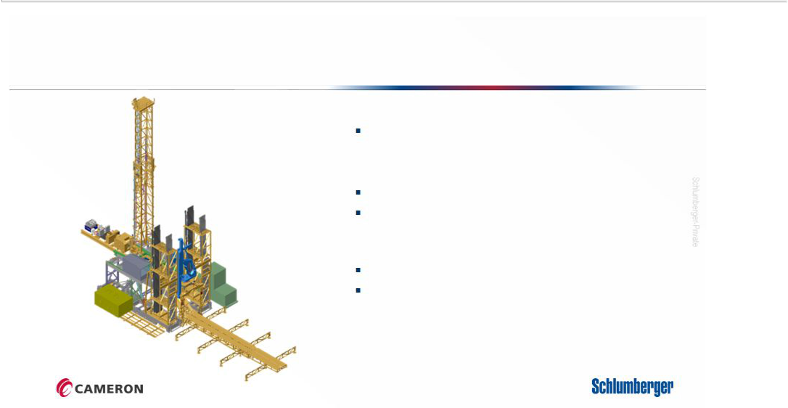
Rig of the FutureThe– New Land Drilling System

Design

Proprietary features based on years of R&E

Rig Equipment

Surface components provided by Cameron

Closely integrated with Drilling Group BHA

Software

Developed on the Petrel platform

Optimization of planning and wellsite execution

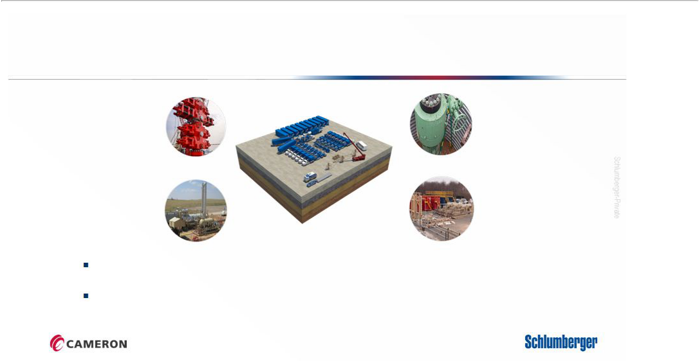
CAMSHALE

Drilling | Wellhead
Pressure | Wellhead
Control | s
Production | Flowback
Systems | and Testing

World’s largest rental fleet of pressure control equipment

Integrate with frac fleet to optimize and automate surface set-up and operations

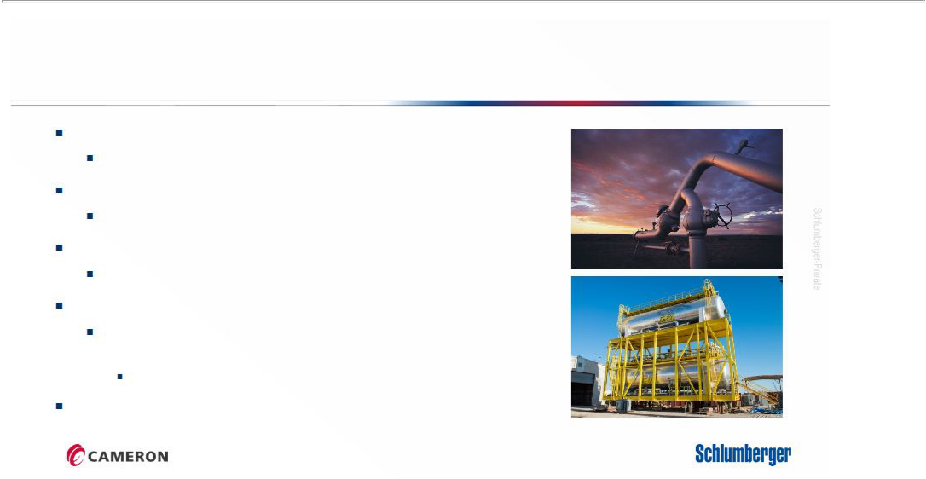
Schlumberger and Cameron: The Next Industry Breakthrough

Greater opportunities for employees

Personal development and career advancement

Technology leadership

Increased focus on R&D

Expansion of customer base

Leveraging Schlumberger’s geographic footprint

Vertical integration

Insource products leveraging Cameron’s manufacturing expertise

eg. Valves and Process Equipment

Supply chain leverage

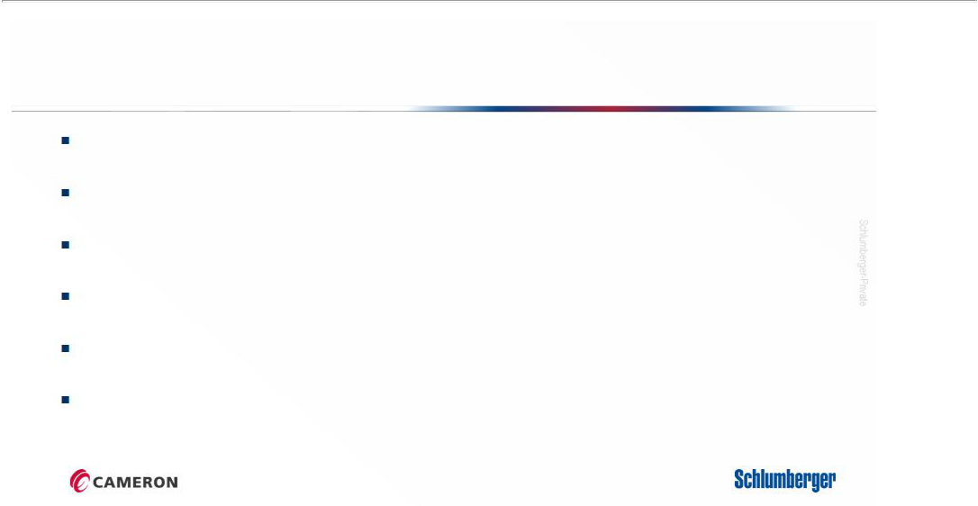
Integration Principles

Preserve highest standards in Ethics and Compliance

Creating value from unique combination of Schlumberger and Cameron Converge around common values while respect cultural differences Ensure seamless transition for customers and suppliers

Establish transparent and ambitious integration plans and execute diligently Select the best from each part of the new organization

Integration Teams |  |  | Executive Steering
 |  |  | Committee ( ESC)
Scott Rowe (CAM) JF Poupeau (SLB) |  |  | Executive Steering Committee
Ashok Belani (SLB) Gerard Martellozo (SLB)
Simon Ayat (SLB) Justin Rounce (CAM) |  |  | Integration Management Office (IMO)
 |  |  |  |  |  | Culture
Functional Integration Teams
Communications | Marketing/ | Sales/ | Finance | Information | Supply | Infrastructure | Human | HSE & | Legal
 | Branding | Accounts |  | Technology | Chain |  | Resources | Security
Business Integration Teams
 | Services | NPD |  |  |  |  | Process
Geography | (After | NPD | Manufacturing | Drilling | Surface | One Subsea | Process | V&M | Transformation
Geography | (After | /Engineering |  |  |  |  | Systems | V&M | Transformation
 | Market) | /Engineering |  |  |  |  | Systems
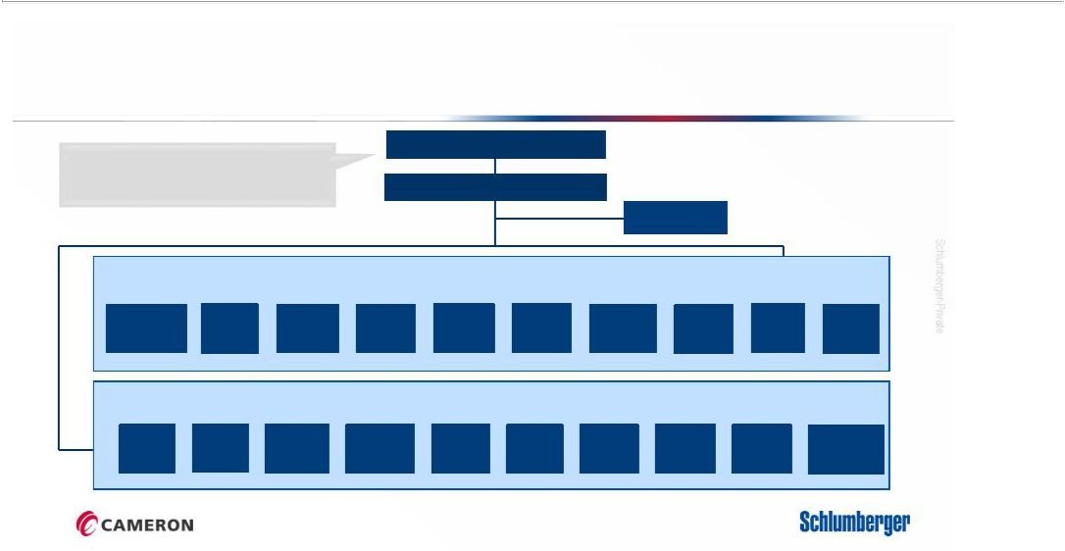
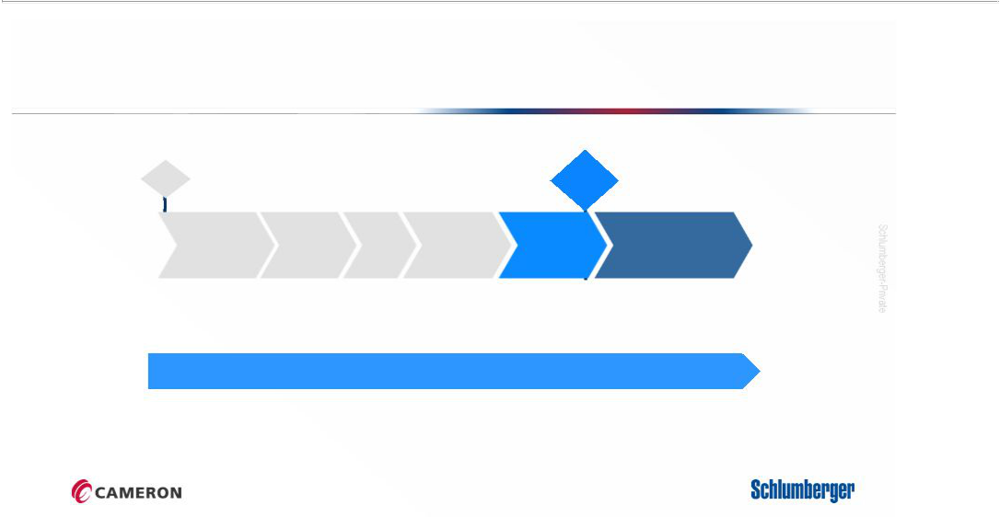
Integration Timeline

Kick-off Meeting | Close
Oct 1 | Q1 2016

Phase I, | Phase II, |  | Phase III, | Contingency
Information | Phase II, | ESC | Phase III, | Contingency
Information | Strategic | ESC | Detailed | Contingency
Gathering & | Strategic | Approvals | Detailed | Period
Analysis | Recom. |  | Planning

Integration

Execution

Ongoing Communications and Change Management

Additional Information

This communication does not constitute an offer to buy or sell or the solicitation of an offer to buy or sell any securities or a solicitation of any vote or approval. The attached presentation relates in part to a proposed business combination between Schlumberger and Cameron International Corporation (“Cameron”). Schlumberger has filed with the Securities and Exchange Commission (the “SEC”) a registration statement on Form S-4 containing a preliminary proxy statement/prospectus of Schlumberger and Cameron and other documents related to the proposed transaction. This communication is not a substitute for any proxy statement, registration statement, proxy statement/prospectus or other document Schlumberger or Cameron may file with the SEC in connection with the proposed transaction.

STOCKHOLDERS ARE URGED TO READ THE PROXY STATEMENT/PROSPECTUS, THE REGISTRATION STATEMENT AND OTHER DOCUMENTS THAT MAY BE FILED WITH THE SEC REGARDING THE PROPOSED TRANSACTION CAREFULLY AND IN THEIR ENTIRETY IF AND WHEN THEY BECOME AVAILABLE BECAUSE THEY WILL CONTAIN IMPORTANT INFORMATION ABOUT THE PROPOSED TRANSACTION THAT SHOULD BE READ CAREFULLY BEFORE ANY DECISION IS MADE WITH RESPECT TO THE PROPOSED TRANSACTION. These materials will be made available to stockholders of Cameron at no expense to them. Investors will be able to obtain free copies of these documents (if and when available) and other documents filed with the SEC by Schlumberger and/or Cameron through the website maintained by the SEC at http://www.sec.gov. Copies of the documents filed with the SEC by Schlumberger will be available free of charge on Schlumberger’s internet website at http://www.slb.com. Copies of the documents filed with the SEC by Cameron will be available free of charge on Cameron’s internet website at http://www.c-a-m.com. You may also read and copy any reports, statements and other information filed by Cameron or Schlumberger with the SEC at the SEC public reference room at 100 F Street N.E., Room 1580, Washington, D.C. 20549. Please call the SEC at (800) 732-0330 or visit the SEC’s website for further information on its public reference room.

Participants in Solicitation

Cameron, Schlumberger, their respective directors and certain of their respective executive officers may be considered, under SEC rules, participants in the solicitation of proxies in connection with the proposed transaction. Information about the directors and executive officers of Schlumberger is set forth in its Annual Report on Form 10-K for the year ended December 31, 2014, which was filed with the SEC on January 29, 2015, and its proxy statement for its 2015 annual meeting of stockholders, which was filed with the SEC on February 19, 2015. Information about the directors and executive officers of Cameron is set forth in its Annual Report on Form 10-K for the year ended December 31, 2014, which was filed with the SEC on February 20, 2015, and its proxy statement for its 2015 annual meeting of stockholders, which was filed with the SEC on March 27, 2015. These documents can be obtained free of charge from the sources indicated above. Additional information regarding the participants in the proxy solicitation and a description of their direct and indirect interests in the transaction, by security holdings or otherwise, will be contained in the proxy statement/prospectus and other relevant materials to be filed with the SEC when they become available.

Forward-Looking Statements

This presentation includes “forward-looking statements” within the meaning of Section 27A of the Securities Act of 1933, as amended, and Section 21E of the Securities Exchange Act of 1934, as amended. The opinions, forecasts, projections, expected timetable for completing the proposed transaction, benefits and synergies of the proposed transaction, future opportunities for the combined company and products, future financial performance and any other statements regarding Schlumberger’s and Cameron’s future expectations, beliefs, plans, objectives, financial conditions, assumptions or future events or performance that are not statements of historical fact, are forward-looking statements. Schlumberger can give no assurance that such expectations will prove to have been correct. These statements are subject to, among other things, satisfaction of the closing conditions to the merger, the risk that the contemplated merger does not occur, negative effects from the pendency of the merger, the ability to successfully integrate the merged businesses and to realize expected synergies, failure to obtain the required vote of Cameron’s stockholders, the timing to consummate the proposed transaction, the ability to successfully integrate the merged businesses and other risk factors that are discussed in Schlumberger’s and Cameron’s most recent Annual Reports on Form 10-K as well as each company’s other filings with the SEC available at the SEC’s Internet site (http://www.sec.gov). Actual results may differ materially from those expected, estimated or projected. Forward-looking statements speak only as of the date they are made, and Schlumberger undertakes no obligation to publicly update or revise any of them in light of new information, future events or otherwise.

