Filed by Schlumberger N.V.

pursuant to Rule 425 under the Securities Act of 1933

and deemed filed pursuant to Rule 14a-12
under the Securities Exchange Act of 1934
Subject Company: ChampionX Corporation
Filer’s SEC File No.: 001-38441
Date: June 17, 2024

Olivier Le Peuch

J.P. Morgan Energy Conference
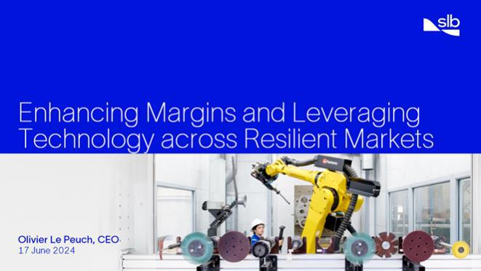

June 17, 2024

Good afternoon, ladies, and gentlemen, it is a pleasure to be here today. I want to thank Arun Jayaram and J.P Morgan for the opportunity to return to the J.P. Morgan Energy, Power, and Renewables Conference.

Throughout this cycle, SLB has consistently demonstrated its ability to deliver industry-leading financial results. This has been driven by our differentiated operating footprint, leading technical and digital offerings, and sustained commitment to operating efficiency and value creation.

SLB is optimally positioned for continued outperformance. Today, I will discuss how we will leverage our exposure in key markets, our technology, and our leading digital capabilities to continue our margin expansion journey, generate cash, and increase returns to shareholders.

Olivier Le Peuch J.P. Morgan Energy Conference June 17, 2024
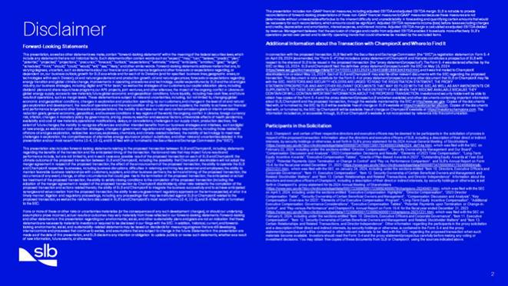

Before we start, let me remind you that some of the statements I will be making are forward-looking and are subject to risks and uncertainties that could cause our results to materially differ from those projected in these statements. I therefore refer you to our latest 10-K and other SEC filings.

In addition, we and ChampionX have filed materials with the SEC related to our proposed transaction, including a registration statement containing a proxy statement and prospectus of the parties. Investors and security holders are urged to read those materials, which can be obtained from the SEC’s website and from ours and ChampionX’s websites. SLB, ChampionX, their directors, executive officers and certain members of management and their employees may be considered participants in the solicitation of proxies from their shareholders in connection with the proposed transaction, as further described in the proxy statement.

Let’s begin.

Olivier Le Peuch J.P. Morgan Energy Conference June 17, 2024
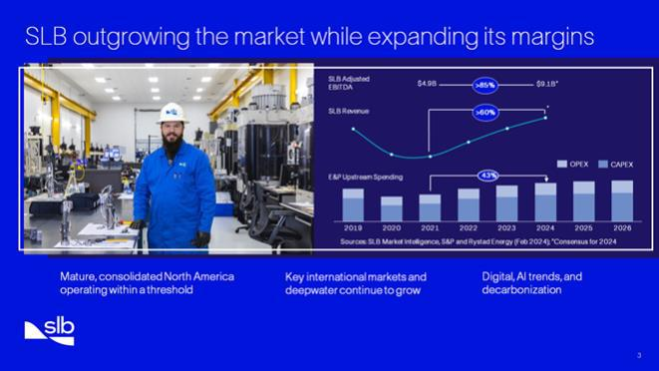

SLB continues to outperform in this cycle, delivering impressive revenue and adjusted EBITDA growth with significant margin expansion. We anticipate market growth to continue for the foreseeable future at a moderate pace. This growth is built around the combination of continued momentum on long-cycle gas and deepwater projects, the emergence of short-cycle production and recovery activity to address production decline, the increasing intensity of technology adoption in North America, and the secular trends of digital and decarbonization serving as upside to the ongoing cycle. We are favorably positioned in the highest-quality areas of the market, supported by the following factors:

First, North America production is operating within a threshold that stems from higher costs of capital, finite tier-one acreage, and factory drilling and completions nearing peak efficiency levels. Together, these factors are contributing to an environment in North America involving more mature assets and a more consolidated customer base exercising capital discipline, which is heightening the need for technology innovation, particularly in production and recovery. At SLB, our capital-light, technology-levered strategy aligns closely with the priorities of operators in the region, and our announced pending acquisition of ChampionX will bolster this strategy by adding a leading production chemicals business, a well-established artificial lift portfolio, and the opportunity to accelerate our technology deployment throughout the region.

Second, key international and deepwater markets continue to grow. This is being driven by various regions, such as gas markets in the Middle East & Asia, the resilience of offshore FIDs below $50, and the necessity to offset decline rates. We fully participate in this market, building on an unmatched international footprint, leveraging our unique integration capabilities and fit-for-basin technologies.

And third, Digital, AI, and decarbonization. Our industry is still in the early stages of digital adoption, presenting significant opportunities for high-margin growth. As a longtime leader in the space, we will continue to deploy digital capabilities to drive performance and efficiency while supporting our customers on their decarbonization journey, particularly through our carbon capture and storage (CCS) offering. CCS is one of the fastest-growing and most-immediate opportunities to reduce carbon emissions, and we are leveraging our domain expertise and deep knowledge of the subsurface to respond to an increase demand in our storage solutions. And at the same time, we expanded our carbon capture offering with the recent addition of Aker Carbon Capture in our portfolio, combining our subsurface expertise with surface process engineering capabilities.

Olivier Le Peuch J.P. Morgan Energy Conference June 17, 2024

As you can see, the market is presenting multiple opportunities for quality growth through technology deployment and enhanced performance. And we will continue to harness these growth factors on the path to achieving our 2025 financial commitments.

Olivier Le Peuch J.P. Morgan Energy Conference June 17, 2024
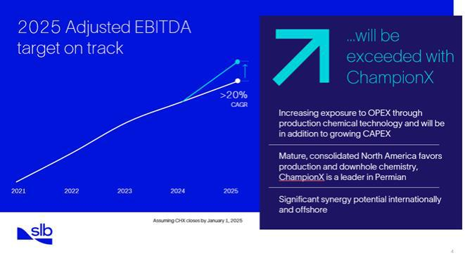

We remain on track to grow adjusted EBITDA at a CAGR of more than 20% between 2021 and 2025. And we will exceed that target with the expected contribution of the announced ChampionX acquisition. With the magnitude of the synergies we have announced, consisting primarily of reduced operating costs, supply chain optimization, and G&A savings, as well as revenue synergies relating to expanding ChampionX’s business internationally, we anticipate this transaction to be neutral to adjusted EBITDA margins in year 1, and accretive from year 2.

The addition of ChampionX will augment our exposure to the production and recovery market, which is becoming an increasing priority for our customers. We believe that there are opportunities for further innovation and integration in this space, and through technology and digital, we can help our customers to unlock efficiency gains throughout the lifecycle of producing assets. Production chemicals presents an exciting opportunity as an asset-light business that will remain resilient to industry cycles, with nearly every liquid produced globally requiring an element of production chemicals that increases with the age of the asset. The demand for production chemicals is prevalent in North America shale and becomes even more compelling in the Middle East as production increases and decline rates accelerate. And in Deepwater markets, the need is even stronger where production chemicals are an integral component of offshore developments, particularly for flow assurance along pipelines or into FPSOs.

As you can see, the potential to achieve further growth as a result of the ChampionX transaction is significant, but this is only part of our strategy. Next, let me explain how we are expanding margins through our offshore offering.

Olivier Le Peuch J.P. Morgan Energy Conference June 17, 2024
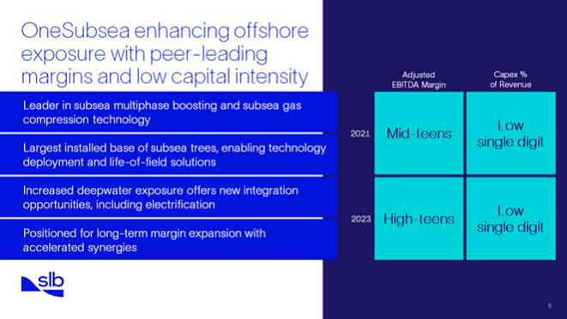

Deepwater continues to grow for years to come, driven by long-cycle developments, production capacity expansions, exploration in new frontier basins, and an increased focus on gas. Many of the FIDs from the past few years have commenced and are progressing, leading to broad-based activity across Asia, Africa, Latin America, and Europe. SLB has a strong foothold in each of these offshore regions and is well positioned to benefit from this strong activity outlook.

SLB has the most profitable subsea portfolio in the industry, and we have deepened our exposure to this resilient market with the formation of our OneSubsea joint venture with Aker and Subsea7.

Through OneSubsea, we are helping our customers unlock reserves and reduce cycle times through an extensive subsea production and processing technology portfolio, including our industry leading subsea multiphase boosting and gas compression, electrification solutions, and unique pore-to-process integration capabilities throughout the subsea production lifecycle.

And recently, we are increasingly getting the opportunity to partner with our customers in early engineering phases to unlock the economics and recovery of their assets, such as the alliance we have formed with BP and the recent collaboration announced with Equinor.

We also have the largest installed base of subsea trees, enabling scaled technology deployment and life-of-field solutions, representing a resilient baseload of activity through the rest of the decade. As a result, we are reaffirming our ambition to deliver more than $4 billion in additional subsea bookings in 2024, representing an increase of more than 20% year-on-year as the market continues to expand.

We are in the early stages of the joint venture, and we are well-positioned for long-term margin expansion in this space as we accelerate the realization of the announced synergies.

Let me now comment on what remains one of our key engines of growth that continues to represent a large opportunity for SLB.

Olivier Le Peuch J.P. Morgan Energy Conference June 17, 2024
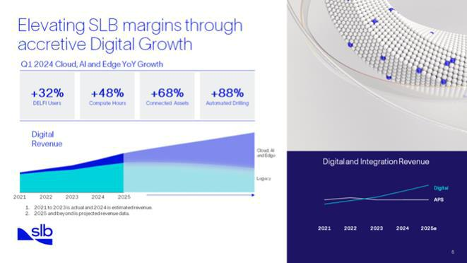

In our industry, the increased adoption and integration of digital technologies remains one of the most significant opportunities for growth. Over the past few years, our customers have made investments to modernize their digital infrastructures, recognizing the pivotal role that digital plays in increasing efficiency, enhancing production, and elevating performance. This is leading to visibly accretive revenue growth throughout our Digital business, and we remain on track to reach approximately $3 billion in Digital revenue annually by 2025.

In Digital, increased adoption of our offerings is supporting visible revenue expansion. This is being led by our new technology platforms, comprising Cloud, AI, and Edge, which have grown at a CAGR of nearly 60% since 2021.

Today, many of our digital offerings are delivered through Delfi, our cloud-native software-as-a-service solution that generates revenue based on the number of user licenses and connected assets as well as the intensity of compute usage. At the end of the first quarter of 2024, we had 6,500 users on the Delfi platform, an increase of 32% year on year. Additionally, the number of connected assets increased by 68%, compute hours increased by 48%, and automated drilling footage amounted to 2.4 million feet, or an increase of 88% compared to the same period last year. These numbers will continue to increase as customers realize the benefits of real-time, data-driven operations. We remain committed to innovation, and we see potential to expand digitally enhanced production solutions, fueled by the announced acquisition of ChampionX, as we expect to add 200,000 connected assets following the close of the transaction.

Building on this momentum, we expect the Cloud, AI, and Edge platform to continue growing at a high CAGR, outpacing the market and therefore anticipate our Digital business to remain an accretive growth engine to SLB throughout the rest of the decade. Because Digital’s operating margin is highly accretive to SLB’s overall margin, its increasing weight in SLB’s portfolio allows SLB to further expand its margin.

Now let me describe how these elements are coming together in support of our long-term strategy.

Olivier Le Peuch J.P. Morgan Energy Conference June 17, 2024
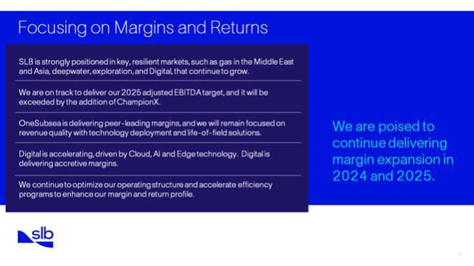

Throughout the cycle, SLB has outpaced the market in revenue growth, with significant adjusted EBITDA growth, and margin expansion.

And we are better positioned for this next phase of quality growth.

We continue to lead in innovation. We also have unmatched exposure to the resilient international and offshore markets, and our Cloud, AI, and Edge offerings continue to elevate SLB’s overall margin profile. In addition, OneSubsea and the expected contribution of ChampionX will drive synergies and deliver growth with low capital intensity. And this will be enhanced by our focus on revenue quality and operating leverage.

We remain on track to achieve the 2025 ambitions we shared at our Investor Day in 2022, and as a result of the synergies and strategic fit we anticipate through the acquisition of ChampionX, we will exceed them.

Finally, we are optimizing our operating structure and accelerating our efficiency programs to enhance our margin and return profile.

We are poised to continue delivering innovation and margin expansion in 2024 and 2025, which we expect to lead to higher cash generation and increased returns to shareholders moving forward. We have already committed to return $7 billion to shareholders through dividends and share repurchases over this period.

To conclude, this is an exceptional opportunity for our business, and our portfolio and offerings are well-aligned to continue delivering on our returns-focused strategy and commitment to shareholder returns.

Thank you.

Disclaimer

Forward-Looking Statements

This presentation, as well as other statements we make, contain “forward-looking statements” within the meaning of the federal securities laws, which include any statements that are not historical facts. Such statements often contain words such as “expect,” “may,” “can,” “believe,” “predict,” “plan,” “potential,” “projected,” “projections,” “precursor,” “forecast,” “outlook,” “expectations,” “estimate,” “intend,” “anticipate,” “ambition,” “goal,” “target,” “scheduled,” “think,” “should,” “could,” “would,” “will,” “see,” “likely,” and other similar words. Forward-looking statements address matters that are, to varying degrees, uncertain, such as statements about our financial and performance targets and other forecasts or expectations regarding, or dependent on, our business outlook; growth for SLB as a whole and for each of its Divisions (and for specified business lines, geographic areas, or technologies within each Division); oil and natural gas demand and production growth; oil and natural gas prices; forecasts or expectations regarding energy transition and global climate change; improvements in operating procedures and technology; capital expenditures by SLB and the oil and gas industry; our business strategies, including digital and “fit for basin,” as well as the strategies of our customers; our capital allocation plans, including dividend plans and share repurchase programs; our APS projects, joint ventures, and other alliances; the impact of the ongoing conflict in Ukraine on global energy supply; access to raw materials; future global economic and geopolitical conditions; future liquidity, including free cash flow; and future results of operations, such as margin levels. These statements are subject to risks and uncertainties, including, but not limited to, changing global economic and geopolitical conditions; changes in exploration and production spending by our customers, and changes in the level of oil and natural gas exploration and development; the results of operations and financial condition of our customers and suppliers; the inability to achieve our financial and performance targets and other forecasts and expectations; the inability to achieve our net-zero carbon emissions goals or interim emissions reduction goals; general economic, geopolitical, and business conditions in key regions of the world; the ongoing conflict in Ukraine; foreign currency risk; inflation; changes in monetary policy by governments; pricing pressure; weather and seasonal factors; unfavorable effects of health pandemics; availability and cost of raw materials; operational modifications, delays, or cancellations; challenges in our

supply chain; production declines; the extent of future charges; the inability to recognize efficiencies and other intended benefits from our business strategies and initiatives, such as digital or new energy, as well as our cost reduction strategies; changes in government regulations and regulatory requirements, including those related to offshore oil and gas exploration, radioactive sources, explosives, chemicals, and climate-related initiatives; the inability of technology to meet new challenges in exploration; the competitiveness of alternative energy sources or product substitutes; and other risks and uncertainties detailed in this presentation and our most recent Forms 10-K, 10-Q, and 8-K filed with or furnished to the Securities and Exchange Commission (the “SEC”).

This presentation also includes forward-looking statements relating to the proposed transaction between SLB and ChampionX, including statements regarding the benefits of the transaction and the anticipated timing of the transaction. Factors and risks that may impact future results and performance include, but are not limited to, and in each case as a possible result of the proposed transaction on each of SLB and ChampionX: the ultimate outcome of the proposed transaction between SLB and ChampionX, including the possibility that ChampionX stockholders will not adopt the merger agreement in respect of the proposed transaction; the effect of the announcement of the proposed transaction; the ability to operate the SLB and ChampionX respective businesses, including business disruptions; difficulties in retaining and hiring key personnel and employees; the ability to maintain favorable business relationships with customers, suppliers, and other business partners; the terms and timing of the proposed transaction; the occurrence of any event, change, or other circumstance that could give rise to the termination of the proposed transaction; the anticipated or actual tax treatment of the proposed transaction; the ability to satisfy closing conditions to the completion of the proposed transaction (including the adoption of the merger agreement in respect of the proposed transaction by ChampionX stockholders); other risks related to the completion of the proposed transaction and actions related thereto; the ability of SLB and ChampionX to integrate the business successfully and to achieve anticipated synergies and value creation from the proposed transaction; the ability to secure government regulatory approvals on the terms expected, at all or in a timely manner; litigation and regulatory proceedings, including any proceedings that may be instituted against SLB or ChampionX related to the proposed transaction, as well as the risk factors discussed in SLB’s and ChampionX’s most recent Forms 10-K, 10-Q, and 8-K filed with or furnished to the SEC.

If one or more of these or other risks or uncertainties materialize (or the consequences of any such development changes), or should our underlying assumptions prove incorrect, actual results or outcomes may vary materially from those reflected in our forward-looking statements. Forward-looking and other statements in this presentation regarding our environmental, social, and other sustainability plans and goals are not an indication that these statements are necessarily material to investors or required to be disclosed in our filings with the SEC. In addition, historical, current, and forward-looking environmental, social, and sustainability-related statements may be based on standards for measuring progress that are still developing, internal controls and processes that continue to evolve, and assumptions that are subject to change in the future. Statements in this presentation are made as of the date of this presentation, and SLB disclaims any intention or obligation to update publicly or revise such statements, whether as a result of new information, future events, or otherwise.

This presentation includes non-GAAP financial measures, including adjusted EBITDA and adjusted EBITDA margin. SLB is not able to provide reconciliations of forward-looking presentations of these non-GAAP financial measures to GAAP measures because these measures are not determinable without unreasonable efforts due to the inherent difficulty and unpredictability in forecasting and quantifying certain amounts that would be necessary for such reconciliations, which amounts could be significant. Adjusted EBITDA represents income (loss) before taxes excluding charges and credits, depreciation and amortization, interest expense, and interest income. Adjusted EBITDA margin is calculated as adjusted EBITDA divided by revenue. Management believes that the exclusion of charges and credits from adjusted EBITDA enables it to evaluate more effectively SLB’s operations period over period and to identify operating trends that could otherwise be masked by the excluded items.

Additional Information about the Transaction with ChampionX and Where to Find It

In connection with the proposed transaction, SLB filed with the Securities and Exchange Commission (the “SEC”) a registration statement on Form S-4 on April 29, 2024 (as amended, the “Form S-4”) that includes a proxy statement of ChampionX and that also constitutes a prospectus of SLB with respect to the shares of SLB to be issued in the proposed transaction (the “proxy statement/prospectus”). The Form S-4 was declared

effective by the SEC on May 15, 2024. SLB and ChampionX filed the definitive proxy statement/prospectus with the SEC on May 15, 2024 (https://www.sec.gov/Archives/edgar/data/87347/000119312524139403/d818663d424b3.htm), and it was first mailed to ChampionX stockholders on or about May 15, 2024. Each of SLB and ChampionX may also file other relevant documents with the SEC regarding the proposed transaction. This document is not a substitute for the Form S-4 or proxy statement/prospectus or any other document that SLB or ChampionX may file with the SEC. INVESTORS AND SECURITY HOLDERS ARE URGED TO READ THE REGISTRATION STATEMENT, THE PROXY STATEMENT/PROSPECTUS AND ANY OTHER RELEVANT DOCUMENTS THAT MAY BE FILED WITH THE SEC, AS WELL AS ANY AMENDMENTS OR SUPPLEMENTS TO THESE DOCUMENTS, CAREFULLY AND IN THEIR ENTIRETY IF AND WHEN THEY BECOME AVAILABLE BECAUSE THEY CONTAIN OR WILL CONTAIN IMPORTANT INFORMATION ABOUT THE PROPOSED TRANSACTION. Investors and security holders will be able to obtain free copies of the Form S-4 and the proxy statement/prospectus (if and when available) and other documents containing important information about SLB, ChampionX and the proposed transaction, through the website maintained by the SEC at http://www.sec.gov. Copies of the documents filed with, or furnished to, the SEC by SLB will be available free of charge on SLB’s website at https://investorcenter.slb.com. Copies of the documents filed with, or furnished to, the SEC by ChampionX will be available free of charge on ChampionX’s website at https://investors.championx.com. The information included on, or accessible through, SLB’s or ChampionX’s website is not incorporated by reference into this communication.

Participants in the Solicitation

SLB, ChampionX and certain of their respective directors and executive officers may be deemed to be participants in the solicitation of proxies in respect of the proposed transaction. Information about the directors and executive officers of SLB, including a description of their direct or indirect interests, by security holdings or otherwise, is set forth in SLB’s proxy statement for its 2024 Annual General Meeting of Stockholders (https://www.sec.gov/ix?doc=/Archives/edgar/data/0000087347/000130817924000033/lslb2024_def14a.htm), which was filed with the SEC on February 22, 2024, including under the sections entitled “Director Compensation”, “Security Ownership by Management and Our Board”, “Compensation Discussion and Analysis”, “2023

Compensation Decisions and Results”, “Elements of 2023 Total Compensation”, “Long-Term Equity Incentive Awards”, “Executive

Compensation Tables”, “Grants of Plan-Based Awards in 2023”, “Outstanding Equity Awards at Year-End 2023”, “Potential Payments
Upon Termination or Change in Control” and “Pay vs. Performance Comparison”, and SLB’s Annual Report on Form 10-K for the fiscal
year ended December 31, 2023
(https://www.sec.gov/ix?doc=/Archives/edgar/data/0000087347/000095017024006884/slb-20231231.htm), which was filed with the SEC
on January 24, 2024, including under the sections entitled “Item 10. Directors, Executive Officers and Corporate Governance”, “Item 11.
Executive Compensation”, “Item 12. Security Ownership of Certain Beneficial Owners and Management and Related Stockholder
Matters”, and “Item 13. Certain Relationships and Related Transactions, and Director Independence”. Information about the directors and
executive officers of ChampionX, including a description of their direct or indirect interests, by security holdings or otherwise, is set forth in
ChampionX’s proxy statement for its 2024 Annual Meeting of Shareholders (https://www.sec.gov/ix?
doc=/Archives/edgar/data/0001723089/000172308924000079/championx-20240401.htm), which was filed with the SEC on April 3, 2024,
including under the sections entitled “Executive Compensation Highlights”, “Director Compensation”, “2023 Director Compensation Table”,

“Security Ownership of Certain Beneficial Owners and Management”, “Compensation Discussion and Analysis”, “Key Compensation
Overview for 2023”, “Elements of Our Executive Compensation Program”, “Long-Term Equity Incentive Compensation”, “Additional
Executive Compensation Governance Considerations”, “Executive Compensation Tables”, “Potential Payments upon Termination or
Change-in-Control”, and “Pay-versus-Performance” and ChampionX’s Annual Report on Form 10-K for the fiscal year ended
December 31, 2023 (https://www.sec.gov/ix?doc=/Archives/edgar/data/1723089/000172308924000011/championx-20231231.htm), which

was filed with the SEC on February 6, 2024, including under the sections entitled “Item 10. Directors, Executive Officers and Corporate
Governance”, “Item 11. Executive Compensation”, “Item 12. Security Ownership of Certain Beneficial Owners and Management and
Related Stockholder Matters” and “Item 13. Certain Relationships and Related Transactions, and Director Independence”. Other
information regarding the participants in the proxy solicitation and a description of their direct and indirect interests, by security holdings or
otherwise, is contained in the Form S-4 and the proxy statement/prospectus and will be contained in other relevant materials to be filed
with the SEC regarding the proposed transaction when such materials become available. Investors should read the Form S-4 and the
proxy statement/prospectus carefully before making any voting or investment decisions. You may obtain free copies of these documents

from SLB or ChampionX using the sources indicated above.

