SECURITIES AND EXCHANGE COMMISSION

Washington, D.C. 20549

FORM 8-K

CURRENT REPORT

Pursuant to Section 13 or 15(d) of the Securities Exchange Act of 1934

Date of Report (date of earliest event reported): April 4, 2005

SCHLUMBERGER N.V. (SCHLUMBERGER LIMITED)

(Exact name of registrant as specified in its charter)

Netherlands Antilles

1-4601

52-0684746

(State or other jurisdiction

of incorporation)

(Commission File Number)

(IRS Employer
Identification No.)

153 East 53rd Street, 57th Floor New York, New York 10022-4624

42, rue Saint-Dominique, Paris, France 75007

Parkstraat 83, The Hague, The Netherlands 2514 JG

(Addresses of principal executive offices and zip or postal codes)

Registrant’s telephone number in the United States, including area code: (212) 350-9400

Check the appropriate box below if the Form 8-K filing is intended to simultaneously satisfy the filing obligation of the registrant under any of the following provisions:

- Written communications pursuant to Rule 425 under the Securities Act (17 CFR 230.425)

- Soliciting material pursuant to Rule 14a-12 under the Exchange Act (17 CFR 240.14a-12)

- Pre-commencement communications pursuant to Rule 14d-2(b) under the Exchange Act (17 CFR 240.14d-2(b))

- Pre-commencement communications pursuant to Rule 13e-4(c) under the Exchange Act (17 CFR 240.13e-4(c))

Item 7.01 Regulation FD Disclosure.

Andrew Gould, Chairman and CEO of Schlumberger Limited (“Schlumberger”), is making a presentation on April 4, 2005 at the Howard Weil Energy Conference. A copy of the presentation and slides is attached as Exhibit 99.1. Schlumberger has also posted this information on its website at www.slb.com/ir.

In addition to financial results determined in accordance with generally accepted accounting principles (GAAP), the attached presentation also includes the following non-GAAP financial measures (as defined under the SEC’s Regulation G):

- Net debt: Net debt is gross debt less cash, short-term investments and fixed income investments held to maturity. Management believes that net debt provides useful information regarding the level of Schlumberger’s indebtedness by reflecting cash and investments that could be used to repay debt, and that the level of net debt provides useful information as to the results of Schlumberger’s deleveraging efforts.

- Return on Capital Employed: Return on capital employed (ROCE) is computed as (1) net income from continuing operations excluding charges plus minority interest plus interest expense minus interest income minus tax benefit on interest expense, divided by (2) the average of shareholders’ equity plus average net debt plus average minority interest. Management believes that ROCE provides useful information regarding the value Schlumberger creates for the providers of capital, namely stockholders and bondholders, by reflecting the level of net income generated by continuing operations using a given level of capital.

The following tables show the calculation of net debt and the components of net debt for the periods and as of the dates indicated:

 |  | 4Q 2004 |  | 2004 |  |  | 2003 |  |  | 2002
 |  |  |  |  | Stated in millions
Net Debt, beginning of period | $(1,658) |  |  | $(4,176) |  |  | $(5,021) |  |  | $(5,037)
Income from continuing operations | 351 |  |  | 1,014 |  |  | 398 |  |  | 489
Gain on sale of drilling rigs |  | — |  |  | — |  |  | — |  | (87)
Excess of equity income over dividends received | (2) |  |  | (66) |  |  | (75) |  |  | (38)
Net charges |  | — |  | 199 |  |  | 440 |  |  | 295
Depreciation and amortization | 338 |  |  | 1,308 |  |  | 1,341 |  |  | 1,309
Changes in working capital requirements | 96 |  |  | (492) |  |  | (186) |  |  | (118)
Capital expenditures | (437) |  |  | (1,279) |  |  | (1,021) |  |  | (1,515)
Dividends paid | (110) |  |  | (441) |  |  | (437) |  |  | (433)
Proceeds from employee stock plans | 65 |  |  | 278 |  |  | 172 |  |  | 175
Proceeds from business divestitures |  | — |  | 1,729 |  |  | 299 |  |  | 259
Proceeds from the sale of the Axalto shares |  | — |  | 99 |  |  |  | — |  | —
Proceeds from the sale of Atos Origin shares |  | — |  | 1,165 |  |  |  | — |  | —
Sale of Grant Prideco stock |  | — |  |  | — |  | 106 |  |  | —
Proceeds from sale of drilling rigs |  | — |  |  | — |  | 58 |  |  | 119
Stock repurchase program | (84) |  |  | (320) |  |  |  | — |  | —
US pension plan contributions |  | — |  | (254) |  |  | (119) |  |  | —
Debt extinguishment costs |  | — |  | (111) |  |  | (168) |  |  | —
Settlement of US interest rate swap |  | — |  | (70) |  |  |  | — |  | —
Investment in PetroAlliance |  | — |  | (12) |  |  |  | — |  | —
Acquisition of Sema plc |  | — |  |  | — |  |  | — |  | (132)
Other business acquisitions |  | — |  | (31) |  |  |  | — |  | (44)
Acquisition related payments |  | — |  |  | — |  |  | — |  | (70)
Sale of Hanover Compressor note |  | — |  |  | — |  | 177 |  |  | —
Discontinued operations |  | — |  | 41 |  |  | 19 |  |  | 133
Other | 64 |  |  | 35 |  |  | 302 |  |  | 181
Translation effect on net debt | (82) |  |  | (75) |  |  | (461) |  |  | (507)
Net Debt, end of period | $(1,459) |  |  | $(1,459) |  |  | $(4,176) |  |  | $(5,021)

 |  | December 31, |  |  |  | December 31, |  |  |  | December 31,
Components of Net Debt |  |  | 2004 |  |  |  | 2003 |  |  |  | 2002
 |  |  |  |  | Stated in millions
Cash and short-term investments |  | $ | 2,997 |  | $ |  | 3,109 |  | $ |  | 1,736
Fixed income investments, held to maturity |  |  | 204 |  |  |  | 223 |  |  |  | 408
Bank loans and current portion of long-term debt |  |  | (716) |  |  |  | (1,411) |  |  |  | (1,136)
Long-term debt |  |  | (3,944) |  |  |  | (6,097) |  |  |  | (6,029)
Net debt |  | $ | (1,459) |  | $ |  | (4,176) |  | $ |  | (5,021)

The following tables show the calculation of return on capital employed (including and excluding charges) for the periods indicated:

ROCE (INCLUDING CHARGES)

 |  | Fourth Quarter |  |  |  | December 31, |  |  |  | December 31, |  |  | December 31,
 |  |  | of 2004 |  |  |  | 2004 |  |  |  | 2003 |  |  | 2002
 |  |  |  |  | Stated in millions, except for percentages
Numerator:
Net income from continuing operations | $ |  | 351 |  | $ |  | 1,014 |  | $ |  | 398 |  | $ | 489
Plus minority interest |  |  | 17 |  |  |  | 36 |  |  |  | (151) |  |  | (85)
Plus interest expense |  |  | 45 |  |  |  | 272 |  |  |  | 334 |  |  | 368
Less interest income |  |  | (15) |  |  |  | (56) |  |  |  | (52) |  |  | (69)
Less tax benefit on interest expense |  |  | (6) |  |  |  | (31) |  |  |  | (62) |  |  | (89)
Total: | $ |  | 392 |  | $ |  | 1,235 |  | $ |  | 467 |  | $ | 614
Denominator:
Average of shareholders’ equity | $ |  | 6,021 |  | $ |  | 5,878 |  | $ |  | 5,684 |  | $ | 8,165
Plus average net debt |  |  | 1,558 |  |  |  | 2,300 |  |  |  | 4,986 |  |  | 5,441
Plus average minority interest |  |  | 409 |  |  |  | 403 |  |  |  | 492 |  |  | 635
Total: | $ |  | 7,988 |  | $ |  | 8,581 |  | $ |  | 11,162 |  | $ | 14,241
Annualized ROCE (including charges): |  |  | 19% |  |  |  | 14% |  |  |  | 4% |  |  | 4%
 | ROCE (EXCLUDING CHARGES)
 |  | Fourth Quarter |  |  |  | December 31, |  |  |  | December 31, |  |  | December 31,
 |  |  | of 2004 |  |  |  | 2004 |  |  |  | 2003 |  |  | 2002
 |  |  |  |  | Stated in millions, except for percentages
Numerator:
Net income from continuing operations | $ |  | 351 |  | $ |  | 1,014 |  | $ |  | 398 |  | $ | 489
Add back charges |  |  | — |  |  |  | 199 |  |  |  | 440 |  |  | 208
Plus minority interest-excluding charges |  |  | 17 |  |  |  | 36 |  |  |  | (15) |  |  | (3)
Plus interest expense-excluding charges |  |  | 45 |  |  |  | 209 |  |  |  | 334 |  |  | 368
Less interest income |  |  | (15) |  |  |  | (56) |  |  |  | (52) |  |  | (69)
Less tax benefit on interest expense |  |  | (6) |  |  |  | (31) |  |  |  | (62) |  |  | (89)
Total: | $ |  | 392 |  | $ |  | 1,371 |  | $ |  | 1,043 |  | $ | 904
Denominator:
Average of shareholders’ equity | $ |  | 6,021 |  | $ |  | 5,878 |  | $ |  | 5,684 |  | $ | 8,165
Plus average net debt |  |  | 1,558 |  |  |  | 2,300 |  |  |  | 4,986 |  |  | 5,441
Plus average minority interest |  |  | 409 |  |  |  | 403 |  |  |  | 492 |  |  | 635
Total: | $ |  | 7,988 |  | $ |  | 8,581 |  | $ |  | 11,162 |  | $ | 14,241
Annualized ROCE (excluding charges): |  |  | 19% |  |  |  | 16% |  |  |  | 9% |  |  | 6%

The attached presentation contains forward looking statements, which include any statements that are not historical facts, such as Schlumberger’s expectations regarding business outlook; the supply of and demand for oil and natural gas; oil and natural gas production growth; opportunities in Russia and with integrated project management; the delivery of new technologies; expected financial results for Schlumberger as a whole and for each of Oilfield Services and WesternGeco; operating and capital expenditures by Schlumberger and the oil and gas industry; and the business strategies of Schlumberger and its customers. These statements involve risks and uncertainties, including, but not limited to, the global economy; changes in exploration and production spending by Schlumberger’s customers and changes in the level of oil and natural gas exploration and development; general economic and business conditions in key regions of the world; political and economic uncertainty and socio-political unrest; and other factors detailed in Schlumberger’s most recent Form 10-K, Form 10-Q and other filings with the Securities and Exchange Commission. If one or more of these risks or uncertainties materialize (or the consequences of such a development changes), or should underlying assumptions prove incorrect, actual outcomes may vary materially from those forecasted or expected. Schlumberger disclaims any intention or obligation to update publicly or revise such statements, whether as a result of new information, future events or otherwise.

Item 9.01 Financial Statements and Exhibits.

(c) Exhibits

The following exhibit is furnished in response to Item 7.01:

99.1 Presentation at Howard Weil Energy Conference

SIGNATURE

Pursuant to the requirements of the Securities Exchange Act of 1934, the registrant has duly caused this report to be signed on its behalf by the undersigned hereunto duly authorized.

SCHLUMBERGER N.V.

(SCHLUMBERGER LIMITED)

By: /s/ Frank A. Sorgie

Frank A. Sorgie

Chief Accounting Officer

Date: April 4, 2005

HOWARD WEIL ENERGY CONFERENCE APRIL 4, 2005 PRESENTATION BY ANDREW GOULD
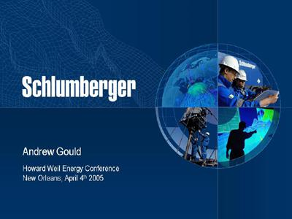

Good morning ladies and gentlemen. It’s always a pleasure to come to New Orleans and I’d like to thank Jeff Parker and Bill Sanchez of Howard Weil for the opportunity to be here today.

When Schlumberger held an investors’ day in Ridgefield Connecticut last June, there was a great deal of agonizing over a phrase from the summary of my remarks when I said “This is perhaps the most favorable business climate we have seen in the upstream industry since the early 1970s”.
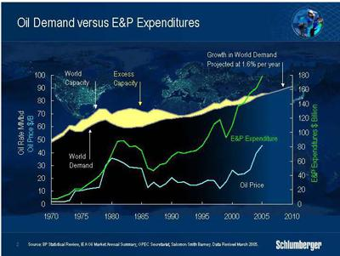

This comment was prompted by the extraordinary narrowing of the gap between supply and demand that took place in the latter half of 2003, and the first part of 2004, but what I did not anticipate at the time however was the continued strength of that demand.

1

HOWARD WEIL ENERGY CONFERENCE APRIL 4, 2005 PRESENTATION BY ANDREW GOULD

2004 turned out to be the fastest year of growth in 28 years, and as the year progressed it became more and more obvious that high prices were not going to significantly affect underlying rates of economic growth.

Throughout 2004 records were consistently broken; an oil price high of $55.67 in October; ten successive months in which the oil price averaged more than $40; and a forward curve at the year-end that saw WTI for 2011 delivery in the low 40s. In the US oil demand passed the 20 million barrel a day mark, and in China it probably increased by more than 12%. Records were set for land rig activity in the US and Canada, surpassing the highs of 2001 and reflecting the increasing difficulty of maintaining levels of gas production.

These figures reflect strong demand, but it is the supply response that this demand has and will engender that has created the highly favorable business climate that I outlined last summer. What is significant however, is the breadth of activity that constitutes the response, and I feel that it is now time to give some of our thoughts on the nature of this part of the cycle.

But first two words of caution. There is always the danger that economic recession could cause a sudden steep drop in demand and this, as well as other factors, would immediately restore excess capacity and cause prices to fall. However, the current world excess capacity is so small, and the production base of such an age, that any reduction in upstream activity would quickly lead to a further decline in supply. The other danger that we cannot ignore in today’s tight market is the possibility of a price shock large enough to curb demand.

So just how visible is the supply response, and how will it affect the extreme sensitivity of prices to the supply shortages that we see in the news everyday? I am afraid the answer is that there is no quick fix. The under-investment in all parts of the industry, from upstream to refining, means that tight supply and volatile prices are likely to remain with us for a number of years. As the IEA reported just last month, the reality is that oil consumption has caught up with the installed crude and refining capacity.

The supply shocks of 1973 and 1979 were induced by political events and not by any real supply shortages. Yet part of the response to this was a diversification of the sources of supply. While the initial North Slope and North Sea discoveries took place in the second half of the 1960s, their production did not reach the market in any volume until the mid-seventies. Mexican production grew from half-a-million to two-and-a-half million barrels a day between the mid-seventies and the mid-eighties.

There is no direct parallel with today’s situation, further large increases in supply from developments in Central Asia and in deepwater are not going to occur quickly enough to correct the situation in the next year or so. The restoration of a comfortable margin of supply in both oil and gas will, absent the risks I outlined above, take a number of years.

Let me explain some of the reasons.

2

HOWARD WEIL ENERGY CONFERENCE APRIL 4, 2005 PRESENTATION BY ANDREW GOULD
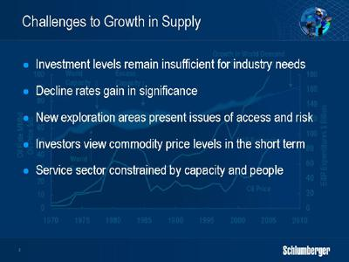

Firstly, while investment levels have increased, they have not yet reached a point where they are sufficient for the industry’s needs. Between 2000 and 2004 published figures show that overall investment in exploration and production increased by about 60% from $109.9 billion to $161.9 billion. Announced figures for 2005 would lead us to believe that spending will increase by a further 10% though personally I feel the figure will be higher. Nobody is happy that these numbers reflect a truly accurate picture but they do show a trend that is unlikely to change.

Secondly, the industry is dealing with a phenomenon that is exaggerated by the lack of investment over the past 18 years. This phenomenon is the decline rate for the older reservoirs that form the backbone of the world’s oil production, both in and out of OPEC. An accurate average decline rate is hard to estimate, but an overall figure of 8% is not an unreasonable assumption. The maintenance required to slow the rate of decline, and increase the overall recovery, is a key element of the supply picture going forward.

Thirdly, politics is playing a big role in current investment patterns. Some of the most prospective areas for new exploration and development are not accessible, or are too risky, for traditional market sources of capital. This places an undue burden on countries and governments to provide the capital and the resources, both human and technical to ensure the rapid development of new sources of production.

Fourthly, investor psychology has been slow to shift with the increase in prices being seen as a short-term phenomenon. Both increases in demand, as well as shortages of supply have been, until recently, treated as short-term imbalances and the need to re-invest in large new supply capacity has only recently been taken seriously. To me, one of the most significant shifts in investor sentiment is represented by the latest rise in the forward price for WTI, at 7 years delivery, to a figure of about $50 per barrel. Just a year ago this figure was in the low thirties. Clearly the market does not see this as a short-term phenomenon.

3

HOWARD WEIL ENERGY CONFERENCE APRIL 4, 2005 PRESENTATION BY ANDREW GOULD

Finally, the oil service industry is not in particularly good shape to meet the needs of a rapid worldwide ramp up in activity. A lot of the rig fleet, and much of the equipment are old. Very little spare capacity exists. This combination will compromise the service response, but the most disturbing shortage by far is the lack of specialized E&P professionals. A lot of skilled people have either been laid off, or have retired from the industry in the last 18 years. This shortage is as acute on the service side as it is on that of the operators. Training their replacements takes time, and there is already a great deal of evidence to suggest that the industry is fighting over the core of professionals that remain.

However, not everything is negative, and a number of positive factors do exist that will help the industry through the cycle.
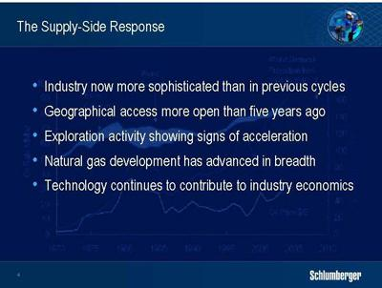

Firstly, I think that the industry is a lot more sophisticated and efficient than in the late seventies and early eighties. We react faster and market mechanisms, particularly for price, are much better defined. As a result, investment decisions are made with a lot more care and attention than was the case in the past. Hedging and derivatives play a much greater role in offsetting risk. The customer base has broadened and operators specialize in different aspects of the E&P chain. This will attenuate some of the “boom and bust” accidents of previous cycles.

Secondly, while there is much talk of limited access to reserves, there have been many positive developments, not the least of which has been the opening up of Russia with its vast potential both in current and future production. Libya is another country where new horizons beckon and large potential exists. This comes after the considerable openings that took place in a number of countries in Latin America and North Africa in the 1990s.

Thirdly, and while this may sound negative, it is in fact positive. Much is being made of any failure to replace reserves, and, if we ignore the accounting arguments, the fact remains that the 1990s and early 2000s corresponded to an era of very low exploration spend. While I am not suggesting that more exploration will solve the reserves replacement issue, I am suggesting that it will attenuate it.

4

HOWARD WEIL ENERGY CONFERENCE APRIL 4, 2005 PRESENTATION BY ANDREW GOULD

Fourthly, extraordinary progress is being made in the development of stranded gas resources with huge investments in LNG and NGL facilities. I do not think that we have seen the end of this and while the level of infrastructure investment may not be sustained at the current pace, technology will continue to reduce the cost of bringing stranded gas to market and new developments will continue. The same is true of unconventional hydrocarbons, be they heavy oil, shale gas or coal bed methane. The level of activity in exploiting these resources has increased dramatically and will continue to do so.

Finally, the contribution of technology will continue to accelerate and make dramatic changes in the economics of hydrocarbon production. The frequently cited effects of 3D seismic and horizontal drilling on finding and development costs mask other remarkable technology achievements that include; oil and gas production in ever-deeper water; continued increases in reservoir recovery factors; economic production of smaller and smaller accumulations of oil and gas; cost-effective recovery of heavier crude; and growing production of non-conventional gas.

What I have tried to show here is the multifaceted nature of the supply-side response. This has only just begun, and it will take several years to adjust the energy mix and create a new supply cushion. Two elements of this response are however certain. One is its global nature, albeit with an eastwards shift in the dynamics of both supply and demand. China and India are becoming increasingly motivated by concerns over security of supply, and Russia, Central Asia and the Middle East will play an increasingly important role in supply. The other is the expanding role that technology will play in meeting the different supply demands. In addition we can fully expect that new business models will emerge that engage the industry players.

The need for a global response in supply, combined with an increasing role for technology, and an opportunity to develop new ways of working, create the most favorable business climate that one could imagine for Schlumberger.

I would like to spend the remainder of my time this morning illustrating these three points. As an example of Schlumberger’s global reach I will take Russia; for our capacity to develop new technology I will show you something very new in Drilling and Measurements; and for our ability to create new business models I will add further color to our activity in Integrated Project Management.

5

HOWARD WEIL ENERGY CONFERENCE APRIL 4, 2005 PRESENTATION BY ANDREW GOULD
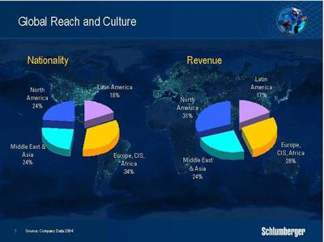

Schlumberger’s decision to globalize its workforce was made 30 years ago. It was based on a desire to offer equal opportunity through merit, irrespective of nationality or gender. The result is a unique global population that reflects both our customer base and the countries in which we work. Our engineers are required to spend part of their careers outside their home country to ensure that we maintain homogeneity of operating and management standards around the world. Our revenues are closely matched to our global presence. And after 30 years our cultural diversity is reflected at even the highest levels with 10 nationalities represented in the 18 top managers and staff.

But nowhere in the last few years have we applied this formula more successfully than in Russia.
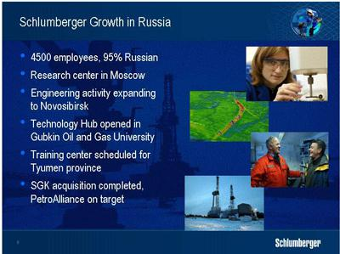

6

HOWARD WEIL ENERGY CONFERENCE APRIL 4, 2005 PRESENTATION BY ANDREW GOULD

Today, we have more than 4,500 employees in Russia, of whom more than 95% are Russian. 70 different nationalities make up the remaining 5% - another very real indication of the diversity of Schlumberger. We have ourselves recruited almost 500 Russian graduate engineers, two thirds of whom are currently, or have been, on international assignments. We have more than a dozen operating locations from Western Siberia to Sakhalin.

Our presence goes beyond operations. For example we opened a research center on the campus of Moscow State University in 1998. Today, this center is staffed by a growing team of scientists, the majority of whom are Russian and of these a number have worked in other Schlumberger technology facilities worldwide. The programs they work on are key for Schlumberger worldwide but are also focused on activities specific to the Russian market. We have also opened an engineering center charged with taking new projects to commercialization and part of this will be located in Novosibirsk, the gateway to Siberia, which is home to highly qualified people and offers a considerable base for industry and manufacturing.

Other projects include a technology hub on the campus of the Gubkin Oil and Gas University in Moscow. Understanding the impact of new technology is a complex business and this facility is designed to provide the working environment where our clients’ experts can work hand-in-hand with Schlumberger geoscientists and engineers on specific challenges that can be addressed by new technology.

With a wide network of geoscientists engaged in similar activities across Russia, the pace of technology introduction is accelerating, particularly in areas of reservoir characterization, fracture stimulation and artificial lift. An approach like this is essential, and would be impossible had we not made early moves to build a population of Russian scientists and geoscientists. Russia is no different to the development of Schlumberger in any other country. The strength lies in the proximity of the technical resources to the producing areas and the development of a Schlumberger workforce from the nationals of that country.

Finally, let me assure you that last year’s events in Russia have in no way changed our view of the market. In spite of the problems that beset Yuganskneftegas in the last quarter of the year, with the consequent effect on our own activity, we fully expect significant further progress in 2005 driven by the organic growth of the GeoMarket, and by our previously announced acquisition plans. The acquisition of the Siberian Geophysical Company SGK is complete, and we are anticipating completion of the second stage of the acquisition of PetroAlliance on schedule. In all such acquisitions, our primary objective is to secure growth through the geographical deployment of technology.

So let me now turn to technology.

7

HOWARD WEIL ENERGY CONFERENCE APRIL 4, 2005 PRESENTATION BY ANDREW GOULD
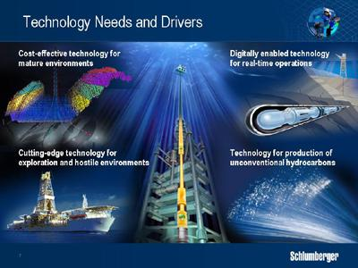

We look at technology as fitting into one of four very large categories that give rise to products and services within one or more of our technology segments.

The first category includes cost-effective technologies directed at maintaining production from today’s aging reservoir base. These include seismic imaging techniques to identify existing, but by-passed production at the field level, as well as new cased-hole wireline logging surveys at the level of the individual well. They include drilling techniques to be able to position new wells to tap such production. And they include new stimulation technologies to boost production as well as technologies that can optimize production from a given well completion.

Secondly we need technology for the oilfield of the future which will have the objective of increasing recovery factors and which will require equipment enabled for real-time operation. This is partly about hardware, but it’s also about bridging the gaps between the operational and business sides of the industry with a growing need for information to move with sufficient speed to enable decisions to be taken in a proactive manner. Parts of this technology already exist, such as real-time drilling where a well is steered in real time by reference to geology, and real-time production where a well’s performance is monitored and controlled from a remote location.

Thirdly, the economics of deepwater operations and frontier exploration are so sensitive to error that improved reservoir definition with high-resolution seismic surveys, advanced logging and innovative new production and completion technologies is vital. Reliability in these, and indeed in all aspects of deepwater operations is mandatory.

Finally, the technologies for the production of unconventional hydrocarbons such as heavy oil, tight gas and coal bed methane will be of increasing importance as we move forward.

8

HOWARD WEIL ENERGY CONFERENCE APRIL 4, 2005 PRESENTATION BY ANDREW GOULD
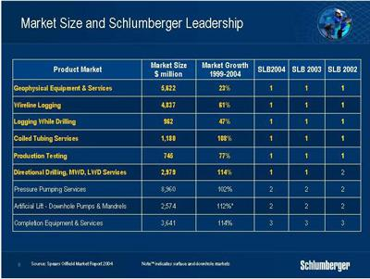

Schlumberger has always believed that you need to be number 1 or 2 to maintain overall market and technical leadership, or you need a plan to get there. You also need to have a clear idea of which technologies are going to most affect your customers’ operations. What you see here is an estimate by Spears of the total market size for the services where we have a market position. It shows that we rank first or second everywhere except for Completion Equipment and Services, yet even in this domain we are making gains in several key areas that include intelligent completions and remote monitoring of production.
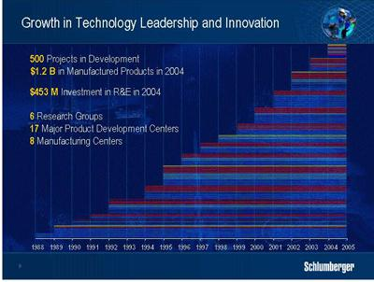

Our technology development organization is one of the largest in the E&P business and is fed by ideas that come from all over the organization as well as from outside. Half of them come directly from the field, thereby leveraging our geographical presence to represent the different technology needs of our clients in all parts of the world.

9

HOWARD WEIL ENERGY CONFERENCE APRIL 4, 2005 PRESENTATION BY ANDREW GOULD

In 2004, we received more than 2000 ideas, of which 700 made it to our opportunity portfolio. 300 of these were selected for implementation. At any one time there are a number of projects in concept, in feasibility, in development or in the process of commercialization. In 2004, we commercialized 60 separate projects that form part of various product offerings. In 2005 some 90 projects are scheduled for commercialization, showing an increasing rate of technology introduction. We consider the capacity of this organization to deliver quality technology as one of the prime factors of our differentiation within the service industry.

Let me give you an example from our recent introduction of the Scope family of MWD/LWD services
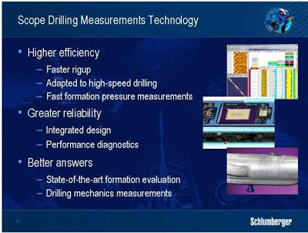

Five years ago the reliability and efficiency of drilling services equipment formed one of our clients’ top demands. The PowerDrive family of rotary steerable systems was part of our response and I’m sure you’re all aware of its industry-leading market position that has been won by through its superior technical performance.

In February this year we introduced the Scope family of MWD/LWD technology. I sincerely believe that Scope will be as successful in bringing efficiency and reliability to Drilling and Measurement services as Platform Express was in performing a similar breakthrough for Wireline in the mid 1990s.

Scope has been designed to exacting standards that dramatically improve drilling performance and well placement while setting new standards for reliability and data quality. Significantly faster data transmission enables information transfer from downhole to surface to keep up with the higher drilling rates that rotary steerable systems permit. Scope technology monitors mechanical drilling parameters to provide the driller with the information needed to drill efficiently, it provides the geologist with a wide range of state-of-the-art formation evaluation measurements to help reduce uncertainty, and it provides us with the tool diagnostics that we need to monitor tool performance and plan equipment maintenance.

10

HOWARD WEIL ENERGY CONFERENCE APRIL 4, 2005 PRESENTATION BY ANDREW GOULD

Scope technology was developed and tested in collaboration with customers on jobs as far apart as Indonesia and Norway to be sure that it catered to a variety of requirements. The new formation pressure measurement was field-tested for 8 clients over 23 different runs and exhibited performance equal to wireline-quality surveys. Scope LWD tools have already demonstrated the efficiency gains made possible by their single-collar design, showing improvements of up to 50%.

But it’s not all about technology.

The supply response will also require new business models and in this context I would like to discuss our Integrated Project Management activity that from now on I will refer to as IPM. This segment in my mind represents a large growth opportunity for Schlumberger.

IPM is a project management approach that enables Schlumberger to execute complex client projects successfully through the application of management, engineering and technology. IPM supplies a clear deliverable rather than one or several discrete services; its activities are characterized by long-term relationships that often lead from one project to another; and it offers opportunities for greater returns than if services were delivered discretely.

11

HOWARD WEIL ENERGY CONFERENCE APRIL 4, 2005 PRESENTATION BY ANDREW GOULD
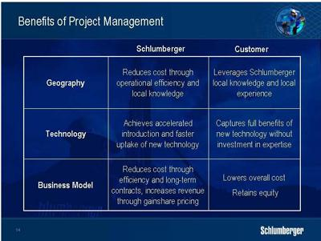

So just why is IPM significant? Why does it benefit the customer, and what is the advantage for Schlumberger? Firstly it is important to remember that Schlumberger did not decide to start IPM on its own. It was started in the mid-1990s in response to customers in the North Sea and elsewhere deciding they needed to outsource a larger part of the well construction process.

We believe that the greatest value for both the customer and Schlumberger comes through the combination of geographical presence and the focused application of technology. Schlumberger can maximize the share of the value that it receives from technology when it has the ability to select, integrate and deploy segment technologies to meet a defined deliverable. Schlumberger can also manage operational cost much more effectively in an IPM environment through more efficient deployment and utilization of field assets.

The customer leverages our experience and local knowledge; captures the full value of new technology without having to dedicate resources to its evaluation and selection; and expands his operational portfolio.

12

HOWARD WEIL ENERGY CONFERENCE APRIL 4, 2005 PRESENTATION BY ANDREW GOULD
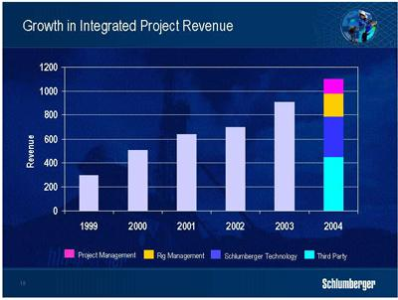

In the last five years we have seen revenues derived from IPM services grow almost fourfold to $1.1 billion. These revenues include four distinct components. The first comes from the IPM project management and engineering that includes an appropriate risk component. The second is the revenue that we derive from rig management activities most of which comes from the use of barges and land rigs that we own as well as operate. The third revenue stream is from the Schlumberger segment technologies deployed as part of the IPM solution. And the fourth and final component comes from the third party products and services that Schlumberger purchases to execute the project.
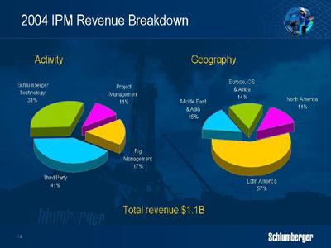

Looking at 2004 as a whole, here are the revenue components of our IPM activity, by revenue type and by geographical area. There are three points that I would like to emphasize.

13

HOWARD WEIL ENERGY CONFERENCE APRIL 4, 2005 PRESENTATION BY ANDREW GOULD

First, IPM revenue growth in 2004 was across all geographical areas with significant new contracts won in the Middle East, Asia, Russia and Europe.

Second, we are confident that we can generate superior margins through the use of Schlumberger technology in IPM projects. The ability to select a given technology to meet a declared goal, while managing its deployment directly, implies lower cost and higher margins. In addition, gainshare agreements where revenue is linked to performance offer the possibility to increase margins still further.

Third, although third party revenues do not offer the same margins, they do not require capital investment. As 90% of our IPM business is currently in well construction, costs are high as such projects involve considerable civil engineering – which Schlumberger does not provide – and considerable rig costs – where Schlumberger uses rigs that it does not own. The effect of having to pass through revenue for third-party products and services therefore has a dilutive effect on the overall Oilfield Services margin. We estimate that in 2004 the overall effect of their inclusion was approximately 90 basis points.

In 2004, these results were skewed by our short foray into the turnkey drilling business in the Gulf of Mexico where third-party revenues represented 80% of the total project costs.

As IPM moves forward, we expect our project mix to move more towards longer-term production-based activity where third party revenues will be less significant and where the potential for gainshare revenues is much greater.
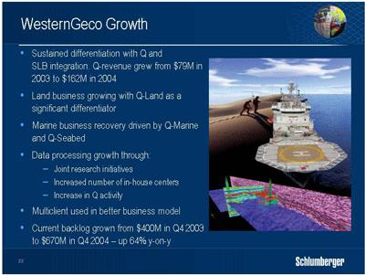

Before I move on to summarize the financial goals that we believe attainable in the light of our strategy, I would just like to make mention of progress at WesternGeco.

After five years of slow activity and disappointing results it is now clear that the industry is on the mend and that the plans that we have executed are showing results.

14

HOWARD WEIL ENERGY CONFERENCE APRIL 4, 2005 PRESENTATION BY ANDREW GOULD

The strong commodity prices and tightness in hydrocarbon supply and demand are leading to higher exploration budgets. These highlights are across the business with strong signals in multiclient sales, in land crew activity and in repeat business and long-term contracts for surveys that use clearly differentiated Q technology. Backlog at $670 million, is at its highest level in 4 years.

The technology story is of course in Q. In 2004 we doubled Q revenue from $79 million to $162 million, which equates to about 20% of our total acquisition and processing revenues and puts the technology firmly in line with our target for any new technology. These revenues were, and are being generated at significantly differentiated pricing premiums over conventional 3D surveys.

The total Q-Marine and Q-Seabed project count stands at 86, of which 39 represent repeat business. Furthermore, the ratio of 4D time-lapse survey work to pure 3D exploration or development surveys has fallen from around 30% to stabilize at 20%, measured in square kilometers terms, as the technology demonstrates the benefits of its superior fidelity, resolution and repeatability. Most recently we introduced the Q-Land system in the Middle East and initial results and customer interest are positive.

Let me now turn to our financial goals and results.
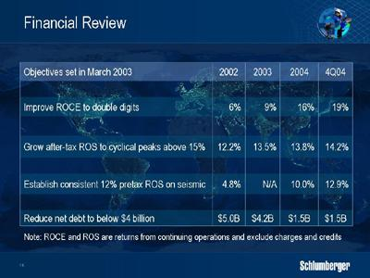

We see no reason to doubt that the CAGR of Schlumberger will be in double digits throughout the remainder of the decade. This growth may not be linear, as the industry will remain to some extent cyclical, but the 15% growth of 2004 over 2003 represents a strong start.

We are aiming for an after-tax return-on-sales, before minority interests, of 15% including WesternGeco. We ended 2004 for OFS at 13.8%, indicating that this goal is in sight but although strength is returning to the seismic business we continue to regard this overall goal as aggressive.

15

HOWARD WEIL ENERGY CONFERENCE APRIL 4, 2005 PRESENTATION BY ANDREW GOULD

Return on capital employed improved consistently over the last year reaching 19% in the fourth quarter of 2004.

Net debt fell to $1.46 billion at the end of the year, which is a level consistent with our overall financial structure. In addition, and in line with our strategy of not retaining more cash than we need to grow the business, we repurchased 5.15 million shares at an average cost of $62.20 per share as part of our announced repurchase plan. Finally last January the Board of Directors approved a 12% increase in the company dividend reflecting confidence that our revenues had indeed advanced to a new, and sustainable level.
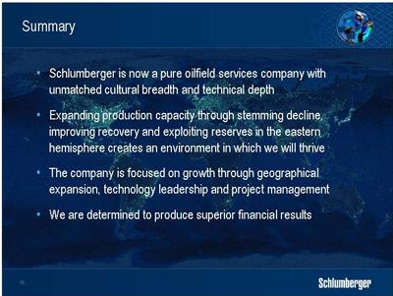

Ladies and Gentlemen, I have explained why we consider this the most favorable business climate that we have seen in the upstream industry since the early 1970s. The world’s requirements to renew and expand production capacity through stemming production decline, improving recovery factors and exploiting the extensive hydrocarbon reserves in the eastern hemisphere creates an environment in which Schlumberger will thrive.

Schlumberger is the leading provider of technology, project management and information solutions to the international E&P industry and has a clear record for growth, innovation and development. Our cultural breadth and technical depth is enormous. We have a strategy to extend our dominance through geographical growth, extending our technology portfolio and growing our project management business.

And we are determined to produce even more satisfactory financial results.

Thank you very much.

16

