SECURITIES AND EXCHANGE COMMISSION

Washington, D.C. 20549

FORM 8-K

CURRENT REPORT

Pursuant to Section 13 or 15(d) of the Securities Exchange Act of 1934

Date of Report (Date of earliest event reported): March 28, 2011

SCHLUMBERGER N.V. (SCHLUMBERGER LIMITED)

(Exact name of registrant as specified in its charter)

Curaçao

(State or other jurisdiction

of incorporation)

1-4601

(Commission File Number)

52-0684746

(IRS Employer

Identification No.)

42, rue Saint-Dominique, Paris, France 75007

5599 San Felipe, 17th Floor, Houston, Texas 77056

Parkstraat 83, The Hague, The Netherlands 2514 JG

(Addresses of principal executive offices and zip or postal codes)

Registrant’s telephone number in the United States, including area code: 713-375-3400

Check the appropriate box below if the Form 8-K filing is intended to simultaneously satisfy the filing obligation of the registrant under any of the following provisions:

- Written communications pursuant to Rule 425 under the Securities Act (17 CFR 230.425)

- Soliciting material pursuant to Rule 14a-12 under the Exchange Act (17 CFR 240.14a-12)

- Pre-commencement communications pursuant to Rule 14d-2(b) under the Exchange Act (17 CFR 240.14d-2(b))

- Pre-commencement communications pursuant to Rule 13e-4(c) under the Exchange Act (17 CFR 240.13e-4(c))

Item 7.01 Regulation FD Disclosure.

On March 28, 2011, Andrew Gould, Chairman and Chief Executive Officer of Schlumberger Limited (“Schlumberger”), addressed the oil and gas investment community at the 39th Annual Howard Weil Energy Conference in New Orleans, Louisiana. A copy of the presentation and slides is attached as Exhibit 99. Schlumberger has also posted this information on its website at www.slb.com/ir.

Forward-Looking Statements

The attached presentation contains “forward-looking statements” within the meaning of the federal securities laws, which include any statements that are not historical facts, such as Schlumberger’s forecasts or expectations regarding business outlook; growth for Schlumberger as a whole and for each segment (and for specified products or geographic areas within each segment); the integration of both Smith and Geoservices into Schlumberger’s business; the anticipated benefits of those transactions; oil and natural gas demand and production growth; oil and natural gas prices; improvements in operating procedures and technology; capital expenditures by Schlumberger and the oil and gas industry; the business strategies of Schlumberger’s customers; future global economic and geopolitical conditions; and future results of operations. These statements are subject to risks and uncertainties, including, but not limited to, the current global economic downturn; changes in exploration and production spending by Schlumberger’s customers and changes in the level of oil and natural gas exploration and development; general economic and business conditions in key regions of the world; geopolitical risk; pricing erosion; seasonal factors; changes in government regulations and regulatory requirements, including those related to offshore oil and gas exploration, radioactive sources, explosives, chemicals, hydraulic fracturing services and climate-related initiatives; continuing operational delays or program reductions as of result of the lifted drilling moratorium in the Gulf of Mexico; the inability to successfully integrate the merged Smith and Geoservices businesses and to realize expected synergies, the inability to retain key employees; the ability of technology to meet new challenges in exploration; and other risks and uncertainties described in this presentation, as well as under “Item 1A. Risk Factors” and elsewhere in Schlumberger’s most recent Form 10-K and other filings that we make with the Securities and Exchange Commission. If one or more of these or other risks or uncertainties materialize (or the consequences of such a development change), or should underlying assumptions prove incorrect, actual outcomes may vary materially from those forecasted or expected. Schlumberger disclaims any intention or obligation to update publicly or revise such statements, whether as a result of new information, future events or otherwise.

Item 9.01 Financial Statements and Exhibits.

(d) Exhibits

The following exhibit is furnished in response to Item 7.01:

99 Presentation at 39th Annual Howard Weil Energy Conference

SIGNATURE

Pursuant to the requirements of the Securities Exchange Act of 1934, the registrant has duly caused this report to be signed on its behalf by the undersigned hereunto duly authorized.

SCHLUMBERGER N.V.

(SCHLUMBERGER LIMITED)

By: /s/ Howard Guild

Howard Guild

Chief Accounting Officer

Date: March 28, 2011

Exhibit 99

Howard Weil Energy Conference 2011 Keynote
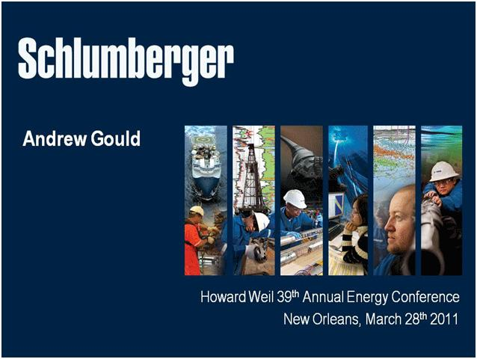

Ladies and gentlemen good morning—it’s a great pleasure to be back in New Orleans for the 39th Howard Weil Energy Conference.

In spite of the political turmoil and natural disasters that we have seen over the past two months, I’m going to try and convince you that the fundamentals for oil and gas remain unchanged, and that the case for investment in the premier oilfield services company has never been stronger.

To do this, I’m going to cover three topics.

First, I will review the macro environment for oil and gas, showing how this has evolved and how it is evolving. I’ll demonstrate that the theme of increasing complexity in finding and developing hydrocarbons remains valid, while new opportunities have arisen from technology or changed circumstances.

Second, I will describe how Schlumberger is uniquely positioned to address industry needs through size, technology offering, geographical presence, infrastructure, workforce, together with our industry-leading efforts to improve operational performance.

Finally, I’m going to outline some of our ambitions for the next five years.

1

Howard Weil Energy Conference 2011 Keynote
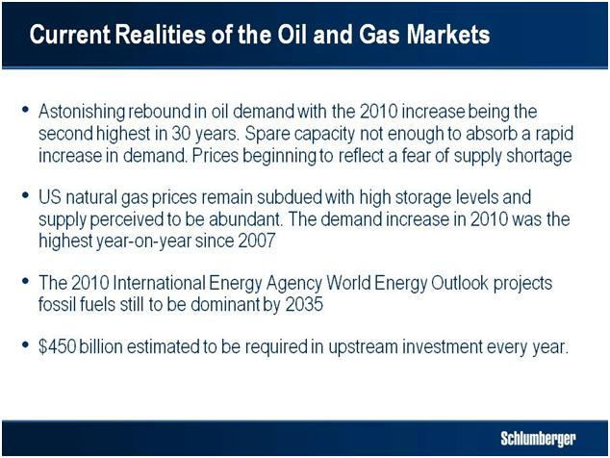

Looking at the broad picture, 2010 saw the most astonishing rebound in oil demand in recent history with the increase of 2.8 million barrels per day being the second highest in 30 years. The average demand increase in 2011 from the three principal forecasting agencies is for an additional 1.4 million barrels per day. While spare capacity, almost exclusively concentrated in the Middle East OPEC countries, is significantly higher than in 2006, it is not enough to absorb a rapid increase in demand and the rate at which new supply is added will decrease in the coming year. The absence of Libya from this market creates additional tensions and oil prices have recently begun to reflect a fear of supply shortage and disruption.

US natural gas prices on the other hand remain subdued with high levels of storage and the perception that supply is abundant and can be quickly increased. Following a 1.8% decrease in demand in 2009, the EIA has recently estimated a 5.4% increase in 2010 followed by a flat 2011 at 66.2 billion cubic feet per day. The 2010 increase is the largest year-on-year growth since 2007.

Longer term, the 2010 IEA World Energy Outlook projects fossil fuels still to be dominant by 2035, even if low carbon policies are implemented. They also predict natural gas to show the largest increase in absolute terms by that time.

To enable such growth in oil and gas supply, investment of some 450 billion dollars is estimated to be needed every year in upstream activity for the next 25 years.

2

Howard Weil Energy Conference 2011 Keynote
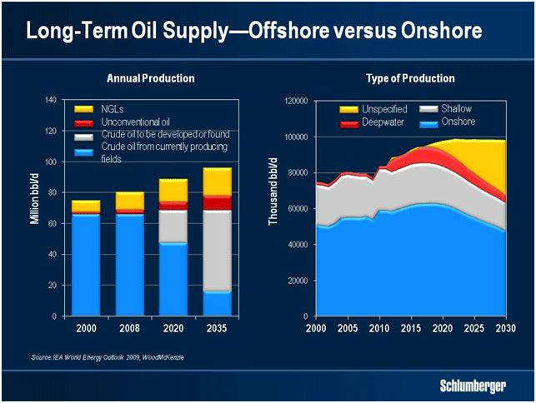

To illustrate the size of the task ahead, the IEA estimates that approximately half of the conventional oil production needed by the end of this decade has yet to be developed or discovered. By 2035, that figure may have increased to more than 70%.

Of this production, offshore activities—and deepwater operations in particular—merit significant attention. In the last ten years, more than half of all new oil and gas reserves discovered worldwide has been offshore. As a result, offshore oil could be supplying approximately one third of the world’s needs by the late 2020s. And by then, deepwater production will have increased to about one third of offshore supply, or approximately 10% of global supply.
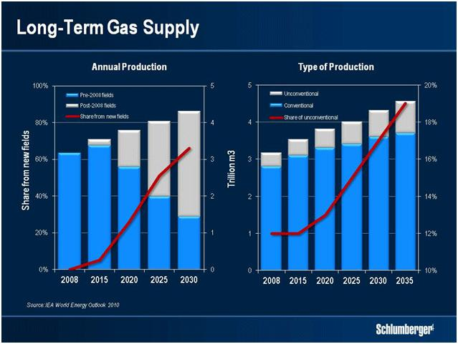

3

Howard Weil Energy Conference 2011 Keynote

For natural gas, the IEA projects demand to increase by 1.4 to 1.6% per year between 2008 and 2035, with the bulk of that increase coming from the non-OECD economies. Other forecasts are even more bullish, projecting annual growth rates of around 2.0%. In addition, a reassessment of the energy mix following the nuclear accident in Japan is likely to confirm higher demand growth for natural gas.

My task today is to convince you that absent a second economic shock and a further drop in demand, the industry will face an increasingly harder task of turning resources into reserves, and reserves into production—particularly for conventional oil.
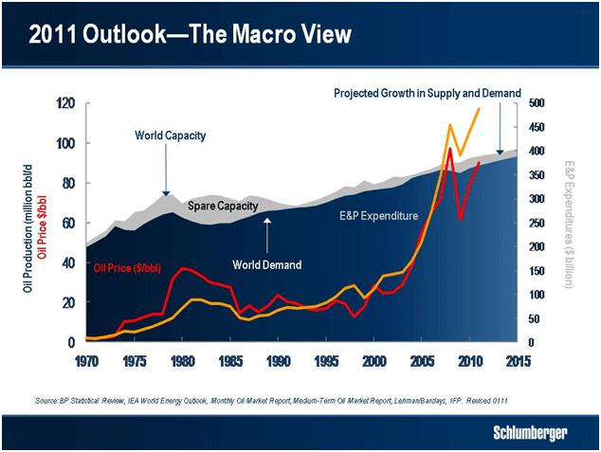

It is instructive to look at the broad context of the last decade to understand why this is so. That decade was marked by a fundamental shift in the security of supply argument, which, having been an OECD concern for the last hundred years, became China’s obsession, with it, and to some extent India, now driving demand. This is the first, and undoubtedly the most important, shift of the last decade.

The second shift of the decade was undoubtedly the emergence of Russia as the world’s single largest producer. Following the collapse of the Soviet Union, Russian production fell to as low as 6.1 million barrels per day. In the six years following 1999 it rose by more than 3 million barrels per day, becoming the major reason why oil prices had not risen faster earlier in the decade.

This leads me to the supply response. At the beginning of the decade when supply-demand balances started to tighten, the industry faced its first supply challenge in 25 years. In the years following 2003, the thin margin of excess capacity coupled with rapid price increases, led to the explosion in exploration and production capex from $130 billion in 2000 to $500 billion in 2008—a compound growth rate of over 18%.

4

Howard Weil Energy Conference 2011 Keynote

All of this led to a period of frantic growth in activity that has had major effects on the industry structure and I’d like now to look at some of the short- and long-term consequences.

The first, and by far the most important effect was the re-emergence of resource nationalism. This isn’t new, but in the 2000s resource nationalism was rife. Russia sought to capture a greater share of the rent. Venezuela closed again, and the Middle East did not open significantly. Mexico didn’t open at all. Libya opened but recent events have showed how transitory that was. Sanctions kept Iran and Sudan largely off limits. And after a spate of extraordinary discoveries, Brazil started to restrict access—not to investment but to foreign operators in the pre-salt domain.

The net result is that perhaps 75% of the world’s known conventional oil reserves are closed to international private capital today, while 60% of production originates from non-NOC operators.
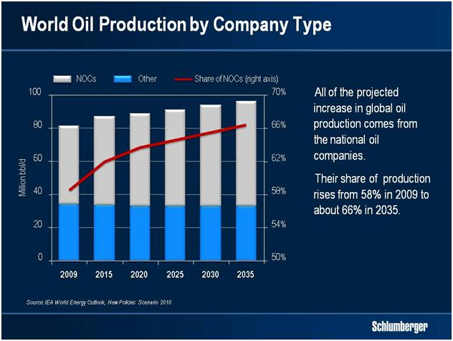

The consequence of this has been to give a whole new meaning to the words “major resource holder”. The range of national companies, both in structure and in competence is now vast. Some are major offshore operators, such as Statoil or Petrobras, while others have mastered complex project management, such as Saudi Aramco. Such companies are capable of competing with the best while other NOCs are emerging with increasingly large international portfolios.

All these restrictions led the industry, particularly the IOCs and independents, to opportunities offshore, in more remote and harsh environments, and to the heavier end of the hydrocarbon chain. In addition, discoveries of conventional oil accumulations became smaller, and therefore more difficult to produce economically.

5

Howard Weil Energy Conference 2011 Keynote

These sources of conventional oil production are increasingly complemented by unconventional oils, such as heavy or shale oils, which require massive projects of long duration that require huge amounts of capital. As a result, if there is one common characteristic in the oil exploration and development projects to be executed in the future, both for deep offshore and complex unconventional oils, it is that they will become more difficult and more expensive to execute.
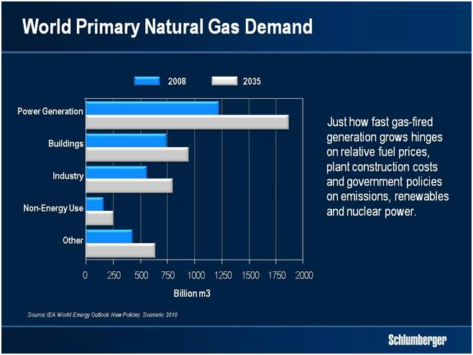

The 2000s were equally a decade of tremendous change for gas. Natural gas economics are governed by geography and by transportation to market. Today’s multiple sources of supply should allay fears of any rupture in supply to Western Europe, while shale gas in the USA has changed the dynamics of US supply. And the rapid development of deposits in Australasia has changed the availability of long-term supply for China, Korea and Japan.

However, two phenomena marked the 2000s. The first was the huge expansion in LNG capacity, which is still increasing due to projects begun in the late 2000s and which is expected to represent 15% of global capacity by 2020. This is essentially a play for very large companies as investments are massive, and projects long to come to market.

6

Howard Weil Energy Conference 2011 Keynote
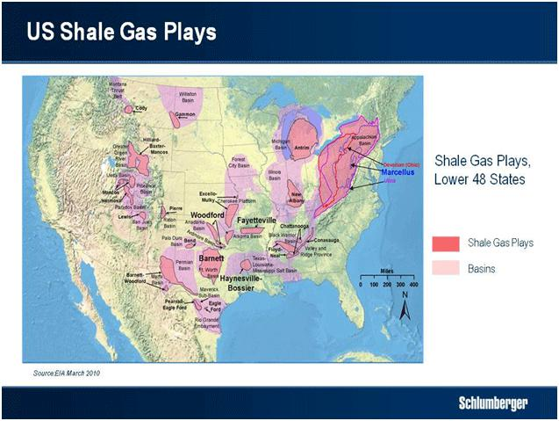

The second was the development of North American shale gas. The shale gas revolution required technology, market forces and entrepreneurship to make its production economic. And while today’s combination of horizontal wells and hydraulic fracturing has made certain shales economic, technology will have to move much further to systematically extract full value from every shale as current methods are both wasteful and expensive.

In the rest of the world, where knowledge of shales is vastly inferior to that of the US, countries and companies are actively searching to understand the prospectivity of their own deposits. Much remains to be done before we can be assured that the rest of the world’s shales are as prospective as those of the United States.

I have now outlined the context for supply and demand, and indicated how the industry will focus more and more on complex, difficult-to-reach resources.

Some of that focus has already occurred as the growth in new projects clearly shows.

7

Howard Weil Energy Conference 2011 Keynote
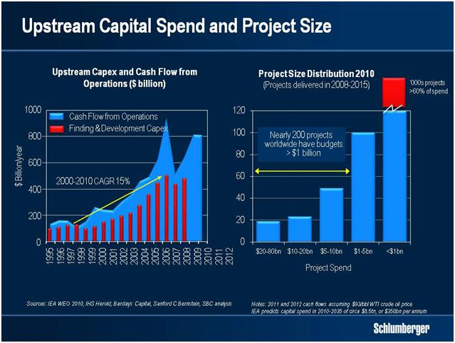

For example, the cost of new deepwater exploration and development projects in increasingly remote locations coupled with the complex logistics associated with areas such as Russia, the Caspian and Iraq are fundamentally changing the importance of project management and project execution. There are now over 200 exploration and production projects worldwide that have a budget in excess of $1 billion.

In addition, it is extraordinary that NOCs and Independents now represent over 80% of total industry capex spend. No less than 30 oil and gas companies have annual capex budgets in excess of $4 billion—up from only 10 in 2001. While not wishing to embarrass any of my customers, I would add that many Greenfield projects suffer significant cost overruns. Indeed, as a general rule 30% of such projects experience budget overruns of 50%.

Clearly, the service company that can bring the best in technology, process and workforce competency to limit such expense stands to gain the greatest advantage. In other words, the future will all be about raising the bar on execution.

8

Howard Weil Energy Conference 2011 Keynote
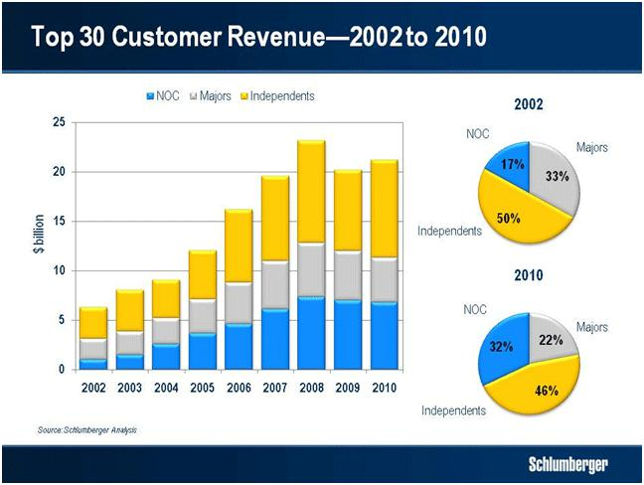

If I now compare our top 30 customers in 2010 to those of 2002, there has been little change. There were and are 5 super majors. In 2010 we counted 13 NOCs, up from 12 in 2002. On the other hand, there are 12 independents, down from 13. However, the shift in revenue between customer groups is extraordinary. In 2002 the super majors represented 33% of the top 30. This had declined to 22% by 2010. In the same period revenues from the NOCs almost doubled, while independents declined slightly.

However, there is another dynamic in our ability to meet our customers’ requirements. The consequences of the Deepwater Horizon tragedy where eleven men died and which led to the largest oil spill in US history will change some of the ways the service industry works forever.

9

Howard Weil Energy Conference 2011 Keynote
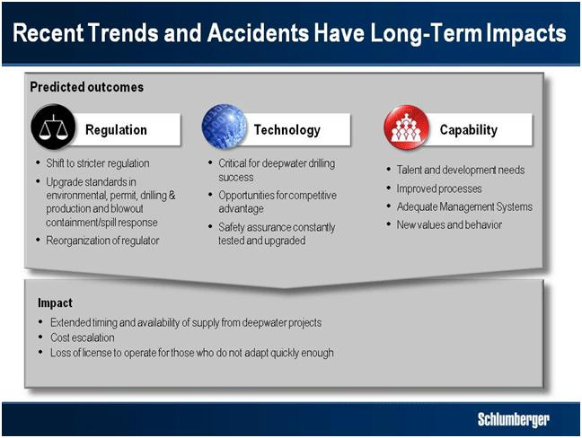

Among these, the reliability of technology as well as the operating efficiency in project planning and execution and the regulatory consequences of Macondo will add a new dimension to offshore operations in three areas—regulation, technology and capability. Stricter standards of regulation will require much improved process from the service industry. Technology will be needed to improve both safety as well as operational performance, and capability will need to be managed through improved processes.

It is therefore essential that our technology not only address the challenges of exploration and increased drilling intensity and the challenges of a changing customer base, larger projects, more remote operations, increasingly complex geological settings and higher pressures and temperatures. It must also respond to new deepwater requirements post Macondo and help mitigate higher operating costs, particularly offshore.

I would like now to look at these technologies in more detail beginning with exploration, where our own technology portfolio is unmatched and we are uniquely positioned to profit from increased exploration spend.

10

Howard Weil Energy Conference 2011 Keynote
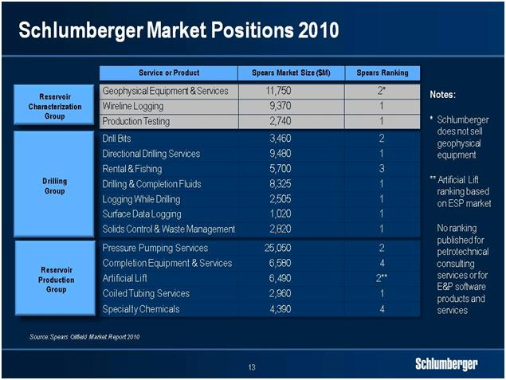

Whether in seismic through WesternGeco, in openhole wireline, logging while drilling or testing we are the leading player. Following the acquisition of the minority interest in WesternGeco in 2006, we are now in a position to provide customers with innovative processing and interpretation routines that allow us to move directly from seismic processing to Petrel workflow process and back again thus helping reduce risk and move more rapidly to field development planning. This has allowed Petrel to increase market penetration over the last year as it expands into the growing exploration market.
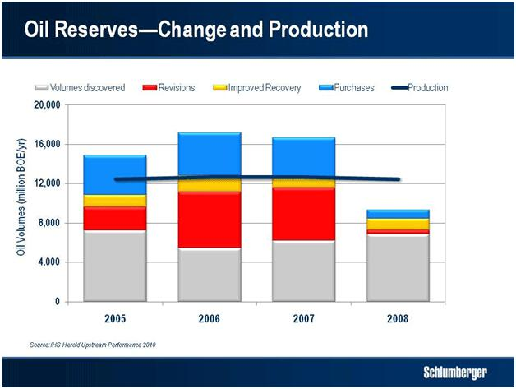

The significance of this is obvious when you look at industry performance as measured by a wide group of oil companies. This clearly shows that the world has been consuming

11

Howard Weil Energy Conference 2011 Keynote

considerably more oil than has been discovered, and the need to accelerate exploration is therefore a necessity. Exploration will be a key driver over the near term.
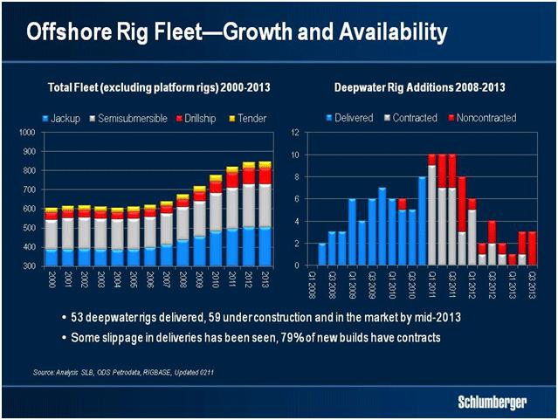

The availability of deepwater rigs will accelerate this as more deepwater provinces become active. We have recently signed an exploration contract for an ultra deepwater rig that will drill successively in Australia, East Timor, India, Indonesia and Mozambique. This type of roving exploration campaign is becoming increasingly common and you can imagine that the planning and logistics involved are extraordinarily complex. The exploration market is also one where the value of data is increasing.

Indeed, the intensity of exploration spend has increased much faster than overall upstream cost indexes. There are good reasons for this. Location, reservoir complexity and hydrocarbon composition all require higher technology to be properly addressed.

12

Howard Weil Energy Conference 2011 Keynote
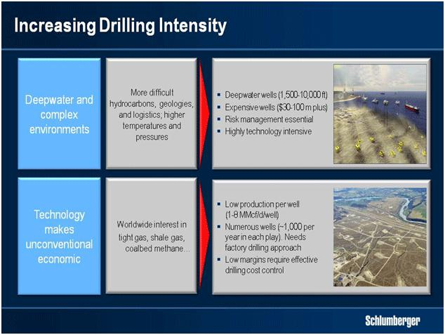

For some time we have stressed that maintaining production and bringing new reserves on line would require an increase in drilling intensity. The emphasis is not just on the number of wells to be drilled, but also on their increasing complexity and cost be it for expensive deepwater wells or for the technology required to make unconventional hydrocarbons economic through the introduction of practices such as factory drilling.
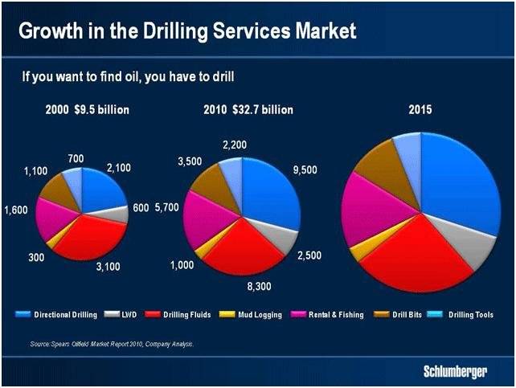

Given this context, in addition to investment in new technology, it is becoming increasingly apparent that the old adage of the oil industry holds truer than ever. If you want to find oil you have to drill. And if you want to produce unconventional gases or oils it is even truer.

13

Howard Weil Energy Conference 2011 Keynote
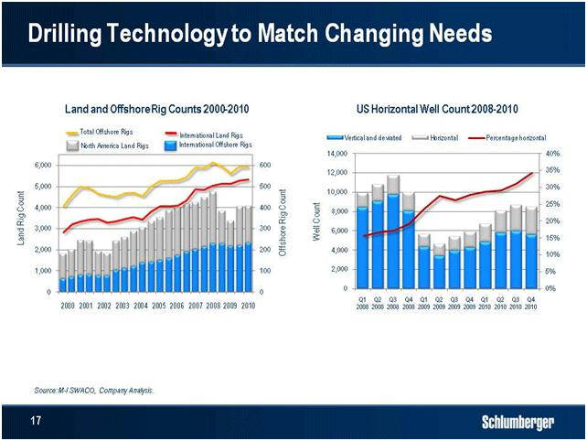

I have already referred to the increase in exploration and development offshore and in deepwater. At the same time differing hydrocarbon types require greater degrees of drilling technology—both to improve the reliability of operations and to reduce overall finding and development costs.

In addition to new exploration drilling technologies, drilling to help recover unconventional gases and unconventional oils requires technologies for better extraction, lower cost and smaller environmental footprint. The dramatic change in the North American well count from vertical to horizontal over a very short period of time demonstrates the extent to which this change is already underway.

Another area for increased drilling concerns those reserves already in production. Prolonging their exploitation and increasing their recovery represents a significant opportunity and it is here that increased drilling intensity is likely to make the biggest difference in the short to medium term. The rehabilitation of the productive capacity in Iraq is an example that implies higher rig counts and this pattern is likely to be increasingly seen around the world.

14

Howard Weil Energy Conference 2011 Keynote
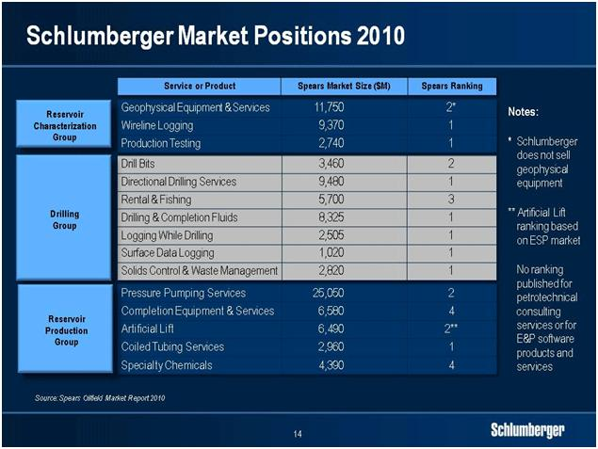

It is the technology needs for the market opportunities that I have just discussed that have led us to the acquisitions of Smith and Geoservices.

We believe that the combination of our own leading positions in directional drilling, measurement-while-drilling and logging-while-drilling with Smith’s positions in drill bits, drilling tools and drilling fluids through M-I SWACO together with our joint venture with National Oilwell Varco for wired drillpipe will allow us to help customers with the three components of the drilling workflow, drilling optimization, well placement and wellbore assurance.

Integrating the drilling workflow is complex, and will require a concerted effort all the way from research and engineering to well planning and wellsite operations. In doing so, we will need to transform the overall drilling process from being partly a form of art, to becoming a full-fledged science.

New drilling technology is also needed to stem production decline or increase recovery through an increase in reservoir contact with the well bore. In this market we hold a leading position. In well placement for example, which is perhaps the most important technology in enhancing recovery, we lead the market through our geosteering capabilities.

15

Howard Weil Energy Conference 2011 Keynote
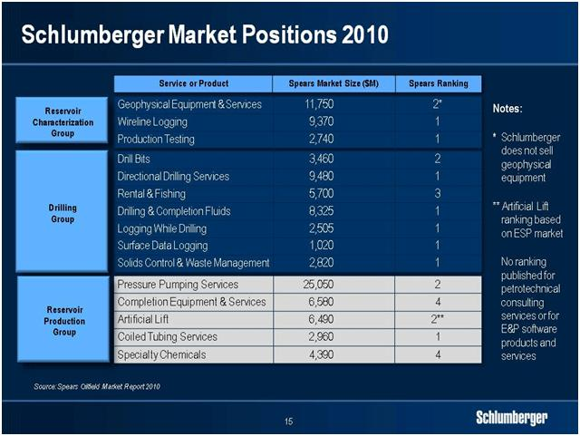

In other highly pertinent production-focused technologies, our advanced intelligent completion products are having considerable success in managing reservoir contact. Furthermore, our position in deepwater completions is strong.

In pressure pumping we are pleased with the progress that has been made in the North America stimulation market. We are excited by the initial success of HiWay fracture stimulation, and we occupy a leading position in the market in the rest of the world.

Lastly, Schlumberger leads the industry in the three principal methods of evaluating and treating old wells to enhance production. These are wireline production services, slickline and coiled tubing. In each of these markets we enjoy the number one position and are introducing increasingly differentiated technologies such as the ACTive Technology Platform, a coiled-tubing system that combines wireline-quality cased-hole measurements with coiled tubing to create a unique industry product.

16

Howard Weil Energy Conference 2011 Keynote
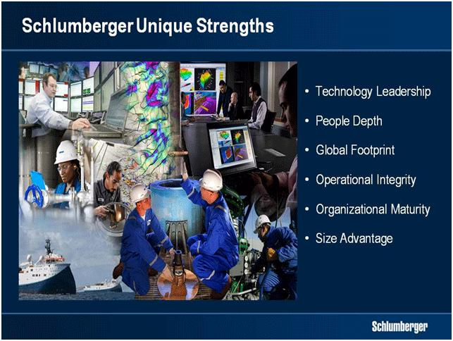

The application of our technology and our ability to grow is dependent on our building on a set of strengths that are unique to Schlumberger. I do not have time to go through them all in detail and therefore will concentrate today on technology leadership, global footprint, operational integrity, and organization. Our commitment to a fully diverse equal opportunity workforce is well known and forms a fundamental competitive advantage, as does our size.

From the company’s origins in wireline logging, we have over time expanded our technology portfolio into a wide range of oilfield services and products, establishing leadership positions in most of the markets we have entered. Today our portfolio is by far the broadest in the industry spanning 16 strong product lines.

By being able to offer the complete range of technologies in a workflow, we can eliminate this misalignment and ensure that all the focus is kept on solving the customer’s challenge. This is why we have organized and expanded our technology portfolio in line with the three main workflows of our customers— reservoir characterization, drilling, and production.

17

Howard Weil Energy Conference 2011 Keynote
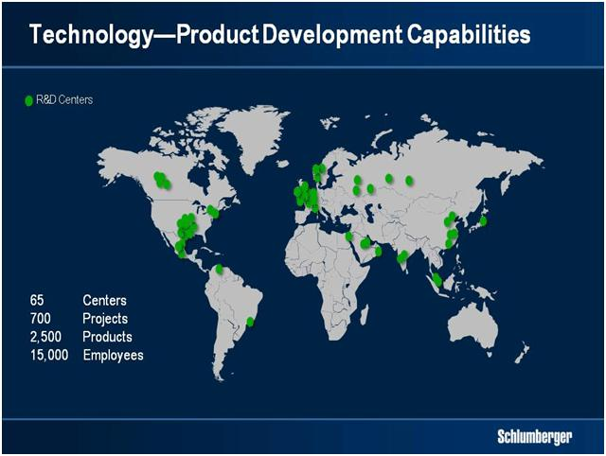

Supporting this technology portfolio is a product development machine made up of more than 15,000 people in 65 centers around the world. The global footprint of these centers mirrors that of our operations to enable close coordination between the two.

We invest more than USD 1 billion a year in product development ranging from ground-breaking research that drives innovation to detailed engineering of our next-generation commercial products. And today, our product development organization manages over 700 projects and supports more than 2,500 commercial products for our product lines.

In 2007, we conducted a comprehensive evaluation comparing our product and project performance against leading companies in other technology driven industries. From this work we concluded that we have huge potential for achieving better reliability and lowering the cost of ownership for our products. These changes represent one part of the “Excellence in Execution” program, which we started in 2007 and that will ensure that we widen our technology lead going forward.

18

Howard Weil Energy Conference 2011 Keynote
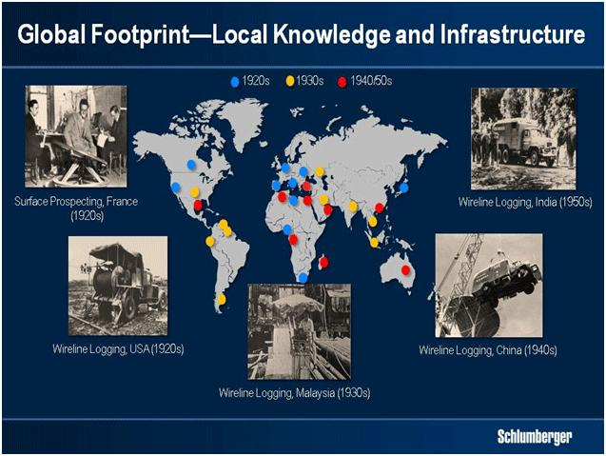

In terms of global footprint, our local knowledge and infrastructure is enormous and sustainable. We operate in approximately 80 countries, many of which for more than 70 years. Our long and rich history has created deep customer relationships and extensive local knowledge.
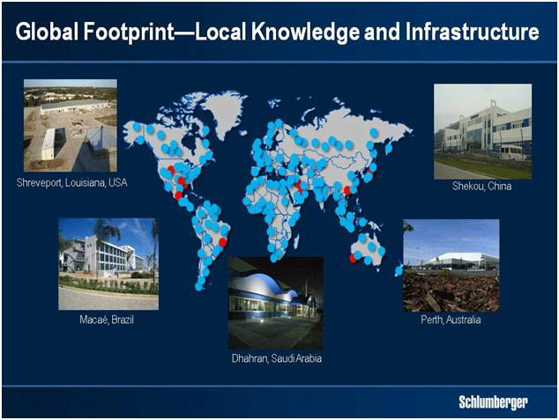

Throughout this time we have also made continuous investments in infrastructure and actively recruited and developed local talent. For example in 2009 alone, we recruited over 4,000 engineers and technicians globally, and we opened 9 new state-of-the-art facilities around the world.

19

Howard Weil Energy Conference 2011 Keynote

In addition to having created strongholds in most of the oil and gas basins around the world, our global footprint has other advantages. For example our operational flexibility allowed us in the two months following the imposition of the Gulf of Mexico moratorium to move 580 of our deepwater experts to new locations around the world.
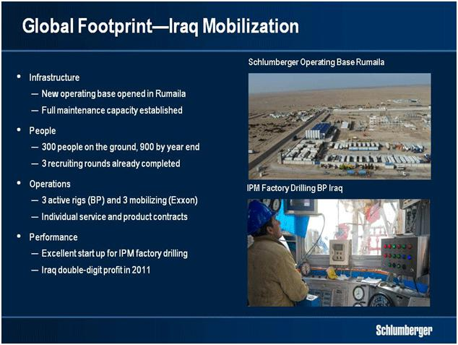

Iraq is another example of how we leverage our global footprint. Even though we were not the first to return to Iraq due to security concerns, we have quickly taken the lead in terms of operations on the ground. We have also won more than our fair share of the contracts so far awarded, and we are doing well in terms of field operations.

Today we have three rigs drilling for BP, and we have another three being mobilized for ExxonMobil. In addition, we have won a workover rig contract for ENI, as well as several individual products and services contracts for other operators. Indeed in the last week we were awarded two further products and services contracts valued at approximately $100 million.

20

Howard Weil Energy Conference 2011 Keynote
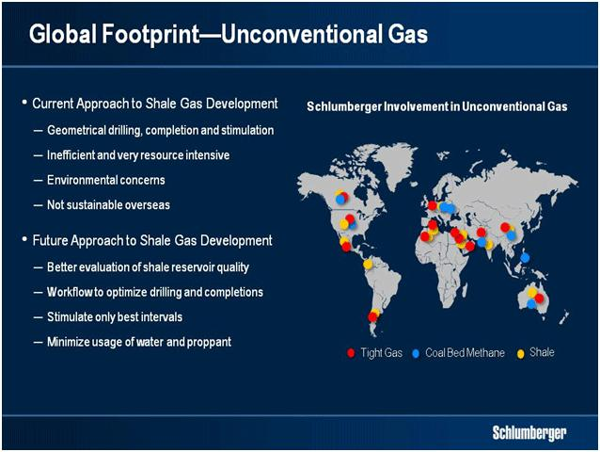

Our position within the worldwide unconventional gas market is another example of leveraging a global presence. In addition to our activity in North America we are engaged today in unconventional gas projects in all parts of the world. Looking at shale gas in particular we are convinced that the brute force approach established in North America will not be practical overseas, either from a financial or an operational standpoint and to exploit the full potential of shale gas globally, we will need to establish a workflow and corresponding technology offering built around better evaluation and characterization of shale gas reservoirs.
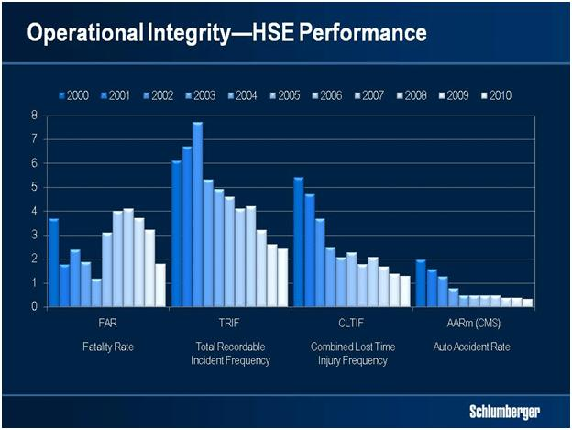

Moving to operational integrity, Schlumberger was one of the first in the industry to introduce a QHSE management system back in the early 1990s. Over the past 20 years

21

Howard Weil Energy Conference 2011 Keynote

we have established industry-leading performance within the areas of quality, health, safety and environment. The growing complexity and cost of oil and gas development is an opportunity to set ourselves further apart in terms of operational integrity, which is all the more important following the Deepwater Horizon incident.

Therefore in 2007 as part of the Excellence in Execution program, we started to look at what we could learn from other leading industries in terms of operational quality and reliability.
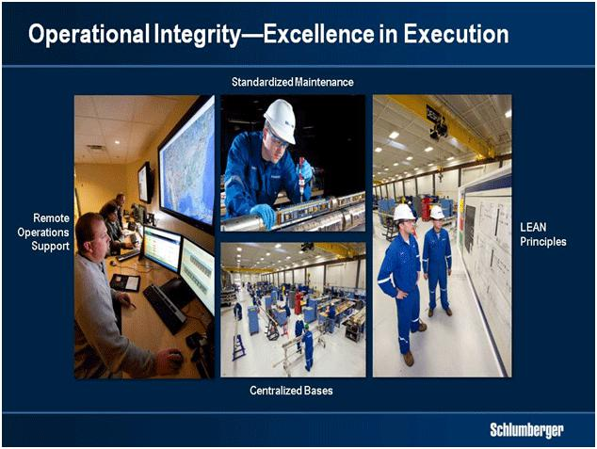

This operational side of Excellence in Execution targets field and wellsite operations in terms of people and process as well as product maintenance.

As part of our major drive towards better product maintenance we have over the past 4 years invested more than USD 500 million in building new and larger operations bases in all parts of the world. These new and larger bases enable standardization and more robust maintenance practices based on LEAN principles. This leads to reductions in maintenance times and in numbers of operational failures—factors that drive asset utilization. In North America pressure pumping for example, we have doubled our asset utilization during the past year based on these principles.

Our focus on operational integrity is also closely linked to people competency and having the right operational processes.

22

Howard Weil Energy Conference 2011 Keynote
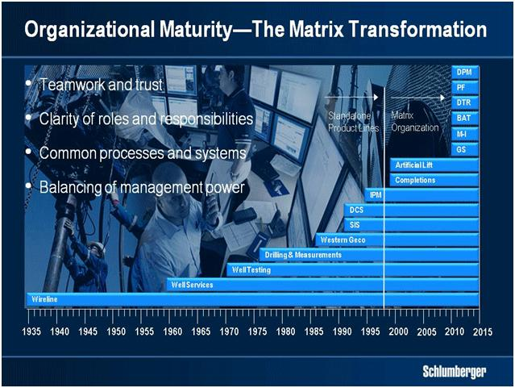

The maturity of our organizational model is also a distinct competitive advantage.

After having operated our product lines as standalone businesses since the company was founded, we moved to a matrix organization in 1998 creating the original GeoMarket structure. Transforming a set of standalone product lines into a matrix framework takes both time and investment, because it requires a step change in teamwork and trust, more clarity of roles and responsibilities, as well as common business processes and systems.

Thirteen years into the matrix transformation, we have successfully created a common customer interface and grown our IPM business significantly through the GeoMarket organization. We have also maintained or even strengthened the competitive position of all of our product lines.

But while we have made some progress on lowering the support costs and driving technology integration, we still have significant upside potential in these areas, which we are actively pursuing by giving the product lines management control of their day-to-day operations to allow the GeoMarket organization to focus more on support costs and technology integration.

23

Howard Weil Energy Conference 2011 Keynote
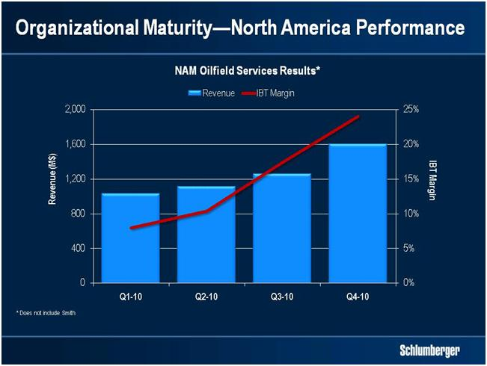

The recent restructuring of our North America operations is a good example of how we can use our maturity to tune and optimize the organization in a non-traditional market.

The standard GeoMarket model was never optimized for North America land, which is quite different from the traditional high-tier markets. Our restructuring created a separate focus on this business by organizing the product lines into the workflows of reservoir characterization, drilling, and production—and by centralizing overall business management as well as our shared support organization.

At the beginning of 2010 we told you that our North America performance would be fixed in 12 months. While our fourth-quarter results benefited from year end and IPM impacts, it is clear that we have made huge progress and that our ambition of being leaders in North America in both size and margins is now within reach.

Before ending, I need to update you on events affecting the current quarter. Firstly I would remind you as we did in the fourth-quarter conference call that the effect of year-end product deliveries and multiclient data sales does not repeat in the first quarter. This year, the pattern of a short drop in multiclient sales and the fluctuation in marine activity has been particularly pronounced. I would remind you all that the year-end surge in Multiclient sales contributed about three cents to our fourth-quarter earnings.

In addition, adverse weather materially impacted North America land and Australia, while the earthquake in Japan had a minimal effect on the quarter. Minor revenue disruptions due to political disturbances were felt in Ivory Coast, Yemen, Bahrain and Oman, and in Algeria due to logistics from Tunisia. Significant revenue disruption occurred in Egypt, Tunisia and Libya. The total after-tax effect of these events on the quarter is expected to be in the range of 8 to 10 cents. While activity has returned to

24

Howard Weil Energy Conference 2011 Keynote

normal in Egypt and Tunisia, we expect continued disruptions in Yemen, no short-term return of activity in Libya and uncertainty at the current time over activity in Bahrain.
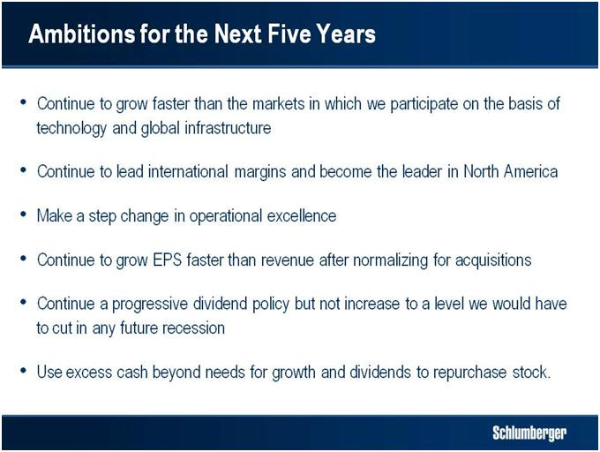

Schlumberger has doubled in size since 2005 and as the search for oil and gas becomes more global, more intense and more difficult there is no reason why the company should not, overtime, double in size again.

Today I have reviewed a very favorable macro scenario for Schlumberger that together with our technology portfolio and our unique structural strengths will allow us to meet our stated ambitions. We will be stronger for longer but it will mean raising the performance bar for our customers, our shareholders and our competition.

Our leadership in measurements combined with our international presence will put us in the forefront of exploring and developing unconventional gas plays outside North America.

Our position in IPM will provide a further leg to our growth—particularly in production enhancement and field development.

In all our activities, and particularly in deepwater, the investment we have made in Excellence in Execution will pay big dividends, and we will continue to produce exceptional financial results.

Ladies and gentlemen, this will be the last time I address this conference as CEO of Schlumberger. I would like to thank everybody for the kind attention you have given to

25

Howard Weil Energy Conference 2011 Keynote

my words over the last eight years and to Howard Weil for continuing to attract so many investors to listen to them.

Finally, I am conscious of leaving behind me a management team that I have every confidence will be able to execute the ambitions I have outlined.

Ladies and Gentlemen thank you for your attention.
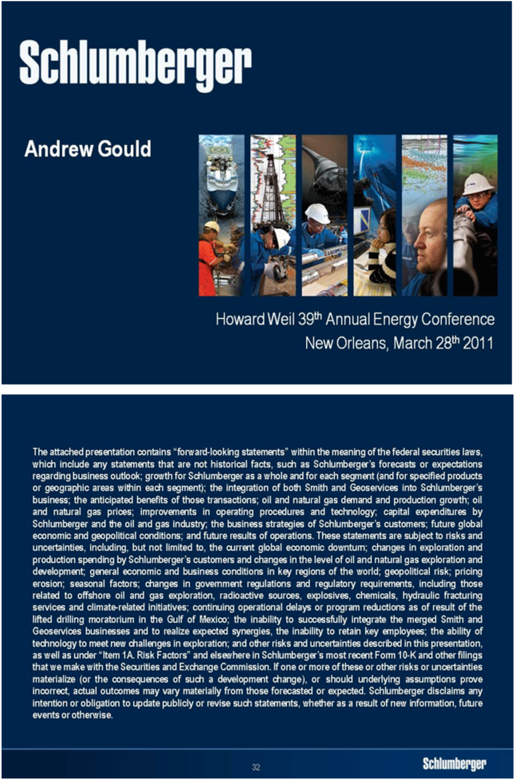

26

