Filed by Schlumberger N.V.
pursuant to Rule 425 under the Securities Act of 1933
and deemed filed pursuant to Rule 14a-12
under the Securities Exchange Act of 1934
Subject Company: ChampionX Corporation
Filers SEC File No.: 001-38441
Date: April 3, 2024

UNITED STATES
SECURITIES AND EXCHANGE COMMISSION
Washington, D.C. 20549

SCHEDULE 14A
Proxy Statement Pursuant to Section 14(a) of the
Securities Exchange Act of 1934

Filed by the Registrant ☒
Filed by a Party other than the Registrant ☐
Check the appropriate box:

☐ | Preliminary Proxy Statement

☐ | Confidential, for Use of the Commission Only (as permitted by Rule 14a-6(e)(2))

☐ | Definitive Proxy Statement

☐ | Definitive Additional Materials

☒ | Soliciting Material Pursuant to Section 240.14a-12
ChampionX Corporation
(Name of Registrant as Specified In Its Charter)
(Name of Person(s) Filing Proxy Statement, if other than the Registrant)
Payment of Filing Fee (Check the appropriate box):

☒ | No fee required.

☐ | Fee paid previously with preliminary materials.

☐ | Fee computed on table in exhibit required by Item 25(b) per Exchange Act Rule 12a6(i)(1) and 0-11

ChampionX Corporation distributed the below presentation to the Companys employees on April 2, 2024.

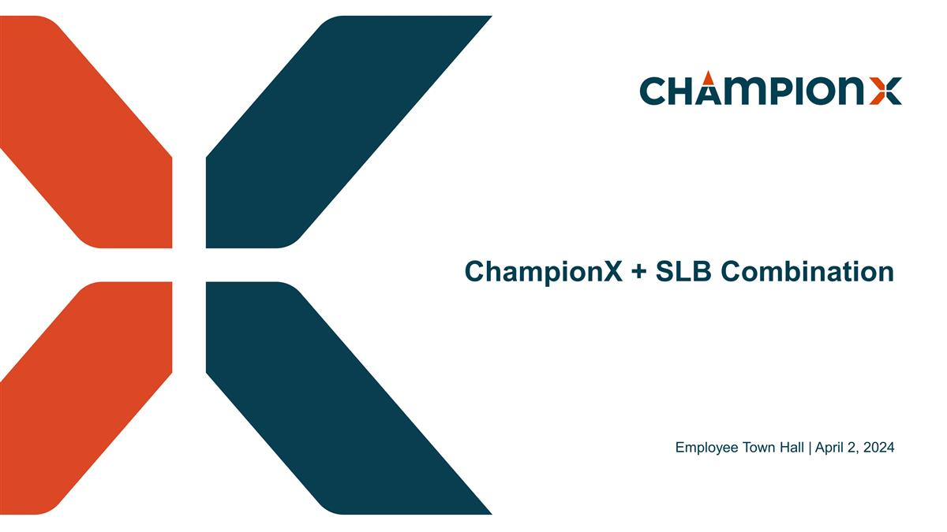
Employee Town Hall | April 2, 2024 ChampionX + SLB Combination

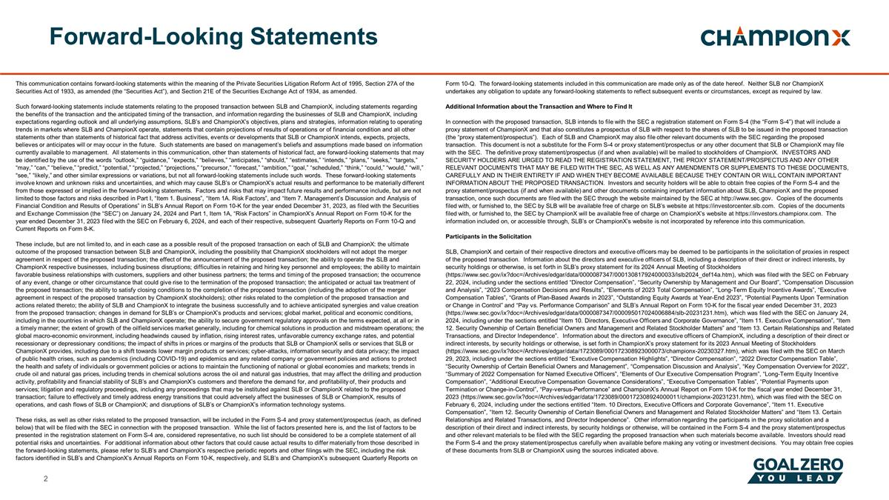
This communication contains forward-looking statements within the meaning of the Private Securities Litigation Reform Act of 1995, Section 27A of the Securities Act of 1933, as amended (the “Securities Act”), and Section 21E of the Securities Exchange Act of 1934, as amended. Such forward-looking statements include statements relating to the proposed transaction between SLB and ChampionX, including statements regarding the benefits of the transaction and the anticipated timing of the transaction, and information regarding the businesses of SLB and ChampionX, including expectations regarding outlook and all underlying assumptions, SLB’s and ChampionX’s objectives, plans and strategies, information relating to operating trends in markets where SLB and ChampionX operate, statements that contain projections of results of operations or of financial condition and all other statements other than statements of historical fact that address activities, events or developments that SLB or ChampionX intends, expects, projects, believes or anticipates will or may occur in the future. Such statements are based on management’s beliefs and assumptions made based on information currently available to management. All statements in this communication, other than statements of historical fact, are forward-looking statements that may be identified by the use of the words “outlook,” “guidance,” “expects,” “believes,” “anticipates,” “should,” “estimates,” “intends,” “plans,” “seeks,” “targets,” “may,” “can,” “believe,” “predict,” “potential,” “projected,” “projections,” “precursor,” “forecast,” “ambition,” “goal,” “scheduled,” “think,” “could,” “would,” “will,” “see,” “likely,” and other similar expressions or variations, but not all forward-looking statements include such words. These forward-looking statements involve known and unknown risks and uncertainties, and which may cause SLB’s or ChampionX’s actual results and performance to be materially different from those expressed or implied in the forward-looking statements. Factors and risks that may impact future results and performance include, but are not limited to those factors and risks described in Part I, “Item 1. Business”, “Item 1A. Risk Factors”, and “Item 7. Management’s Discussion and Analysis of Financial Condition and Results of Operations” in SLB’s Annual Report on Form 10-K for the year ended December 31, 2023, as filed with the Securities and Exchange Commission (the “SEC”) on January 24, 2024 and Part 1, Item 1A, “Risk Factors” in ChampionX’s Annual Report on Form 10-K for the year ended December 31, 2023 filed with the SEC on February 6, 2024, and each of their respective, subsequent Quarterly Reports on Form 10-Q and Current Reports on Form 8-K. These include, but are not limited to, and in each case as a possible result of the proposed transaction on each of SLB and ChampionX: the ultimate outcome of the proposed transaction between SLB and ChampionX, including the possibility that ChampionX stockholders will not adopt the merger agreement in respect of the proposed transaction; the effect of the announcement of the proposed transaction; the ability to operate the SLB and ChampionX respective businesses, including business disruptions; difficulties in retaining and hiring key personnel and employees; the ability to maintain favorable business relationships with customers, suppliers and other business partners; the terms and timing of the proposed transaction; the occurrence of any event, change or other circumstance that could give rise to the termination of the proposed transaction; the anticipated or actual tax treatment of the proposed transaction; the ability to satisfy closing conditions to the completion of the proposed transaction (including the adoption of the merger agreement in respect of the proposed transaction by ChampionX stockholders); other risks related to the completion of the proposed transaction and actions related thereto; the ability of SLB and ChampionX to integrate the business successfully and to achieve anticipated synergies and value creation from the proposed transaction; changes in demand for SLB’s or ChampionX’s products and services; global market, political and economic conditions, including in the countries in which SLB and ChampionX operate; the ability to secure government regulatory approvals on the terms expected, at all or in a timely manner; the extent of growth of the oilfield services market generally, including for chemical solutions in production and midstream operations; the global macro-economic environment, including headwinds caused by inflation, rising interest rates, unfavorable currency exchange rates, and potential recessionary or depressionary conditions; the impact of shifts in prices or margins of the products that SLB or ChampionX sells or services that SLB or ChampionX provides, including due to a shift towards lower margin products or services; cyber-attacks, information security and data privacy; the impact of public health crises, such as pandemics (including COVID-19) and epidemics and any related company or government policies and actions to protect the health and safety of individuals or government policies or actions to maintain the functioning of national or global economies and markets; trends in crude oil and natural gas prices, including trends in chemical solutions across the oil and natural gas industries, that may affect the drilling and production activity, profitability and financial stability of SLB’s and ChampionX’s customers and therefore the demand for, and profitability of, their products and services; litigation and regulatory proceedings, including any proceedings that may be instituted against SLB or ChampionX related to the proposed transaction; failure to effectively and timely address energy transitions that could adversely affect the businesses of SLB or ChampionX, results of operations, and cash flows of SLB or ChampionX; and disruptions of SLB’s or ChampionX’s information technology systems. These risks, as well as other risks related to the proposed transaction, will be included in the Form S-4 and proxy statement/prospectus (each, as defined below) that will be filed with the SEC in connection with the proposed transaction. While the list of factors presented here is, and the list of factors to be presented in the registration statement on Form S-4 are, considered representative, no such list should be considered to be a complete statement of all potential risks and uncertainties. For additional information about other factors that could cause actual results to differ materially from those described in the forward-looking statements, please refer to SLB’s and ChampionX’s respective periodic reports and other filings with the SEC, including the risk factors identified in SLB’s and ChampionX’s Annual Reports on Form 10-K, respectively, and SLB’s and ChampionX’s subsequent Quarterly Reports on Form 10-Q. The forward-looking statements included in this communication are made only as of the date hereof. Neither SLB nor ChampionX undertakes any obligation to update any forward-looking statements to reflect subsequent events or circumstances, except as required by law. Additional Information about the Transaction and Where to Find It In connection with the proposed transaction, SLB intends to file with the SEC a registration statement on Form S-4 (the “Form S-4”) that will include a proxy statement of ChampionX and that also constitutes a prospectus of SLB with respect to the shares of SLB to be issued in the proposed transaction (the “proxy statement/prospectus”). Each of SLB and ChampionX may also file other relevant documents with the SEC regarding the proposed transaction. This document is not a substitute for the Form S-4 or proxy statement/prospectus or any other document that SLB or ChampionX may file with the SEC. The definitive proxy statement/prospectus (if and when available) will be mailed to stockholders of ChampionX. INVESTORS AND SECURITY HOLDERS ARE URGED TO READ THE REGISTRATION STATEMENT, THE PROXY STATEMENT/PROSPECTUS AND ANY OTHER RELEVANT DOCUMENTS THAT MAY BE FILED WITH THE SEC, AS WELL AS ANY AMENDMENTS OR SUPPLEMENTS TO THESE DOCUMENTS, CAREFULLY AND IN THEIR ENTIRETY IF AND WHEN THEY BECOME AVAILABLE BECAUSE THEY CONTAIN OR WILL CONTAIN IMPORTANT INFORMATION ABOUT THE PROPOSED TRANSACTION. Investors and security holders will be able to obtain free copies of the Form S-4 and the proxy statement/prospectus (if and when available) and other documents containing important information about SLB, ChampionX and the proposed transaction, once such documents are filed with the SEC through the website maintained by the SEC at http://www.sec.gov. Copies of the documents filed with, or furnished to, the SEC by SLB will be available free of charge on SLB’s website at https://investorcenter.slb.com. Copies of the documents filed with, or furnished to, the SEC by ChampionX will be available free of charge on ChampionX’s website at https://investors.championx.com. The information included on, or accessible through, SLB’s or ChampionX’s website is not incorporated by reference into this communication. Participants in the Solicitation SLB, ChampionX and certain of their respective directors and executive officers may be deemed to be participants in the solicitation of proxies in respect of the proposed transaction. Information about the directors and executive officers of SLB, including a description of their direct or indirect interests, by security holdings or otherwise, is set forth in SLB’s proxy statement for its 2024 Annual Meeting of Stockholders (https://www.sec.gov/ix?doc=/Archives/edgar/data/0000087347/000130817924000033/lslb2024_def14a.htm), which was filed with the SEC on February 22, 2024, including under the sections entitled “Director Compensation”, “Security Ownership by Management and Our Board”, “Compensation Discussion and Analysis”, “2023 Compensation Decisions and Results”, “Elements of 2023 Total Compensation”, “Long-Term Equity Incentive Awards”, “Executive Compensation Tables”, “Grants of Plan-Based Awards in 2023”, “Outstanding Equity Awards at Year-End 2023”, “Potential Payments Upon Termination or Change in Control” and “Pay vs. Performance Comparison” and SLB’s Annual Report on Form 10-K for the fiscal year ended December 31, 2023 (https://www.sec.gov/ix?doc=/Archives/edgar/data/0000087347/000095017024006884/slb-20231231.htm), which was filed with the SEC on January 24, 2024, including under the sections entitled “Item 10. Directors, Executive Officers and Corporate Governance”, “Item 11. Executive Compensation”, “Item 12. Security Ownership of Certain Beneficial Owners and Management and Related Stockholder Matters” and “Item 13. Certain Relationships and Related Transactions, and Director Independence”. Information about the directors and executive officers of ChampionX, including a description of their direct or indirect interests, by security holdings or otherwise, is set forth in ChampionX’s proxy statement for its 2023 Annual Meeting of Stockholders (https://www.sec.gov/ix?doc=/Archives/edgar/data/1723089/000172308923000073/championx-20230327.htm), which was filed with the SEC on March 29, 2023, including under the sections entitled “Executive Compensation Highlights”, “Director Compensation”, “2022 Director Compensation Table”, “Security Ownership of Certain Beneficial Owners and Management”, “Compensation Discussion and Analysis”, “Key Compensation Overview for 2022”, “Summary of 2022 Compensation for Named Executive Officers”, “Elements of Our Executive Compensation Program”, “Long-Term Equity Incentive Compensation”, “Additional Executive Compensation Governance Considerations”, “Executive Compensation Tables”, “Potential Payments upon Termination or Change-in-Control”, “Pay-versus-Performance” and ChampionX’s Annual Report on Form 10-K for the fiscal year ended December 31, 2023 (https://www.sec.gov/ix?doc=/Archives/edgar/data/1723089/000172308924000011/championx-20231231.htm), which was filed with the SEC on February 6, 2024, including under the sections entitled “Item. 10 Directors, Executive Officers and Corporate Governance”, “Item 11. Executive Compensation”, “Item 12. Security Ownership of Certain Beneficial Owners and Management and Related Stockholder Matters” and “Item 13. Certain Relationships and Related Transactions, and Director Independence”. Other information regarding the participants in the proxy solicitation and a description of their direct and indirect interests, by security holdings or otherwise, will be contained in the Form S-4 and the proxy statement/prospectus and other relevant materials to be filed with the SEC regarding the proposed transaction when such materials become available. Investors should read the Form S-4 and the proxy statement/prospectus carefully when available before making any voting or investment decisions. You may obtain free copies of these documents from SLB or ChampionX using the sources indicated above. Forward-Looking Statements

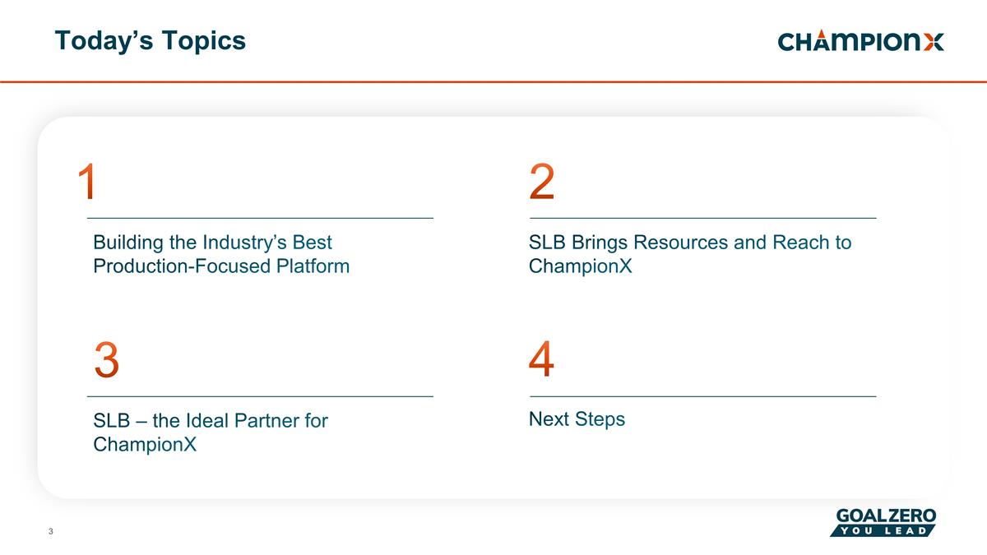
Today’s Topics 1 2 3 Building the Industry’s Best Production-Focused Platform SLB Brings Resources and Reach to ChampionX SLB – the Ideal Partner for ChampionX 4 Next Steps

Building the Industry’s Best Production-Focused Platform Next Chapter in ChampionX’s Journey Agreement to be acquired by SLB will create a leader in the production space with world-class production chemicals and artificial lift technologies Combined portfolios will drive customer value through deep industry expertise and digital integration, as well as enhanced equipment life and production optimization Complementary resources and reach will enhance our sophisticated production chemical, artificial lift, drilling technologies, digital and emissions expertise Expanded opportunities for employees as part of an industry leading company

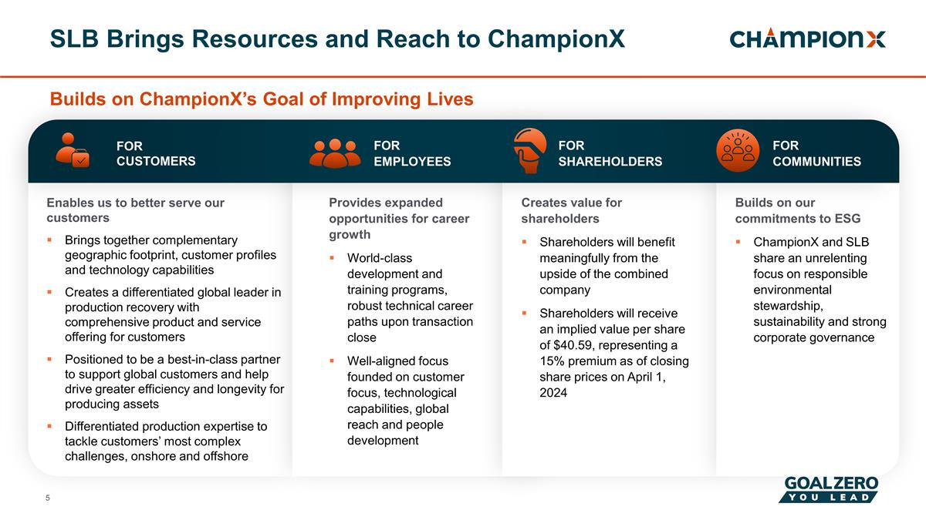
SLB Brings Resources and Reach to ChampionX Builds on ChampionX’s Goal of Improving Lives Enables us to better serve our customers Brings together complementary geographic footprint, customer profiles and technology capabilities Creates a differentiated global leader in production recovery with comprehensive product and service offering for customers Positioned to be a best-in-class partner to support global customers and help drive greater efficiency and longevity for producing assets Differentiated production expertise to tackle customers’ most complex challenges, onshore and offshore Builds on our commitments to ESG ChampionX and SLB share an unrelenting focus on responsible environmental stewardship, sustainability and strong corporate governance Creates value for shareholders Shareholders will benefit meaningfully from the upside of the combined company Shareholders will receive an implied value per share of $40.59, representing a 15% premium as of closing share prices on April 1, 2024 Provides expanded opportunities for career growth World-class development and training programs, robust technical career paths upon transaction close Well-aligned focus founded on customer focus, technological capabilities, global reach and people development FOR COMMUNITIES FOR SHAREHOLDERS FOR EMPLOYEES FOR CUSTOMERS


Corporate Overview

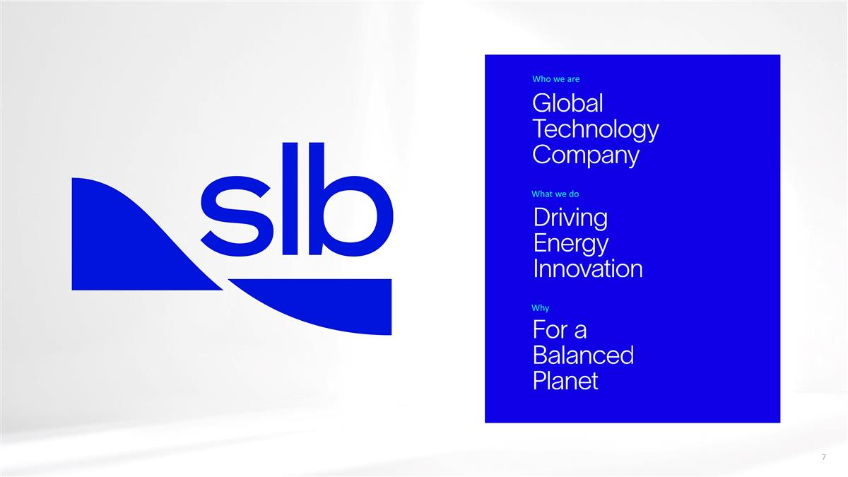
Who we are What we do Why

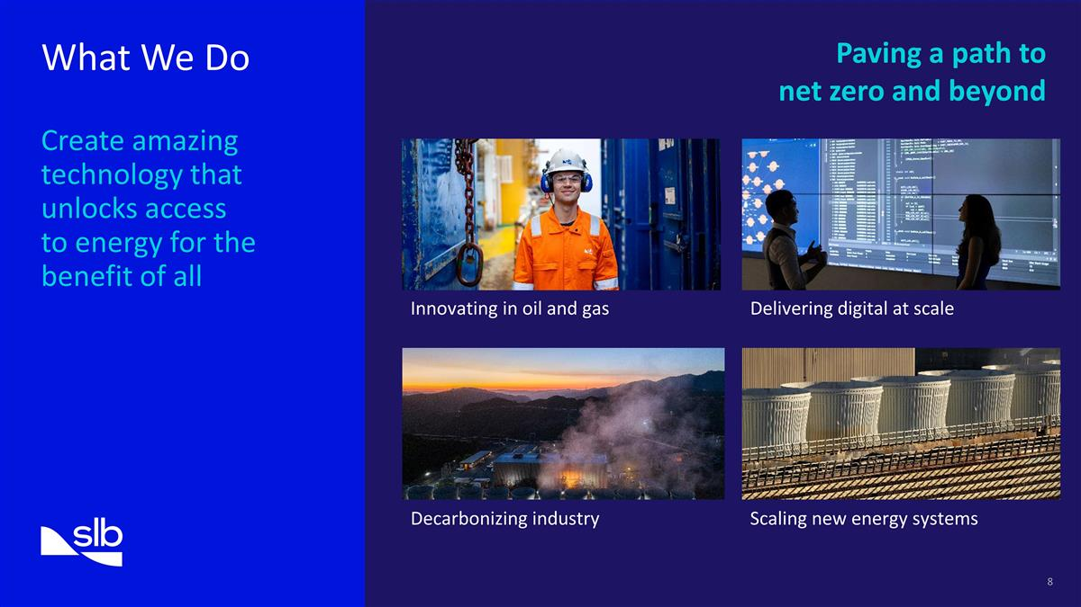
What We Do Create amazing technology that unlocks access to energy for the benefit of all Paving a path to net zero and beyond Scaling new energy systems Decarbonizing industry Delivering digital at scale Innovating in oil and gas

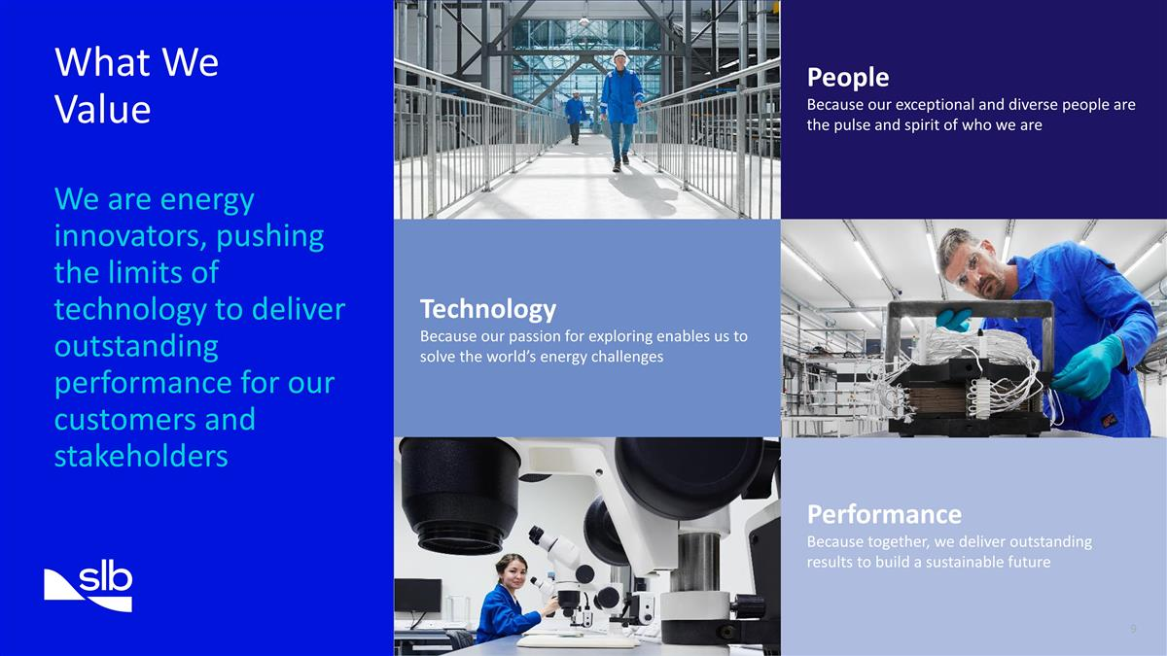
Technology Because our passion for exploring enables us to solve the world’s energy challenges People Because our exceptional and diverse people are the pulse and spirit of who we are Performance Because together, we deliver outstanding results to build a sustainable future What We Value We are energy innovators, pushing the limits of technology to deliver outstanding performance for our customers and stakeholders

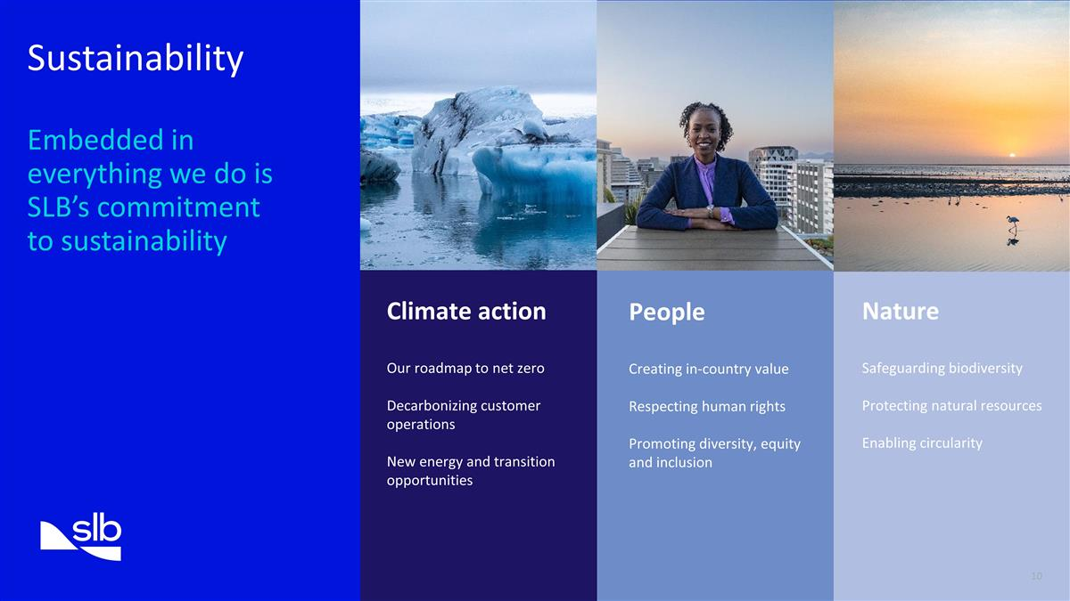
Sustainability Embedded in everything we do is SLB’s commitment to sustainability Climate action Our roadmap to net zero Decarbonizing customer operations New energy and transition opportunities People Creating in-country value Respecting human rights Promoting diversity, equity and inclusion Nature Safeguarding biodiversity Protecting natural resources Enabling circularity

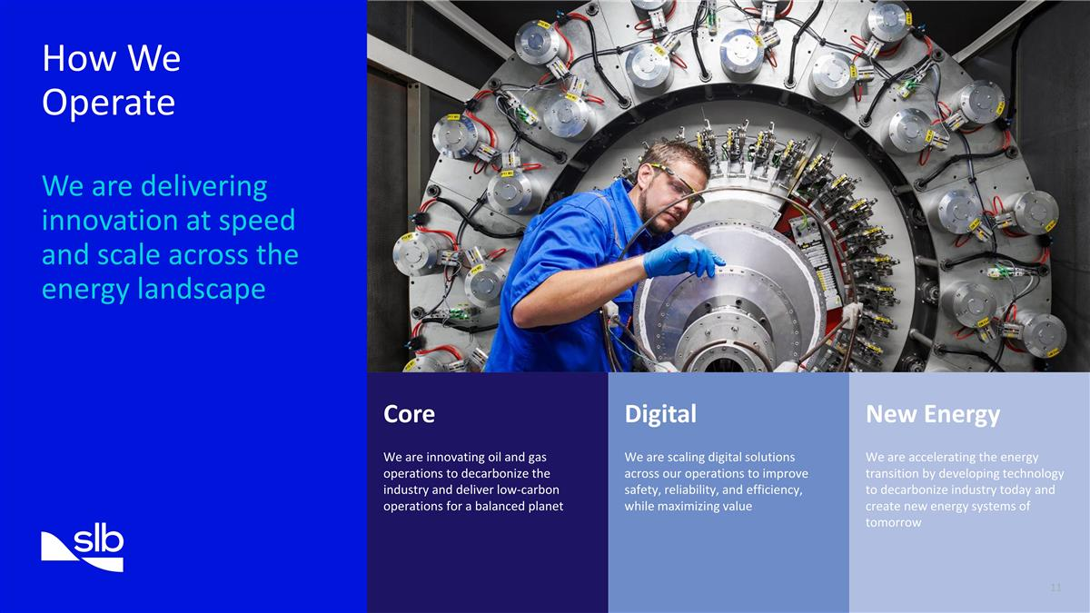
Core We are innovating oil and gas operations to decarbonize the industry and deliver low-carbon operations for a balanced planet Digital We are scaling digital solutions across our operations to improve safety, reliability, and efficiency, while maximizing value New Energy We are accelerating the energy transition by developing technology to decarbonize industry today and create new energy systems of tomorrow How We Operate We are delivering innovation at speed and scale across the energy landscape

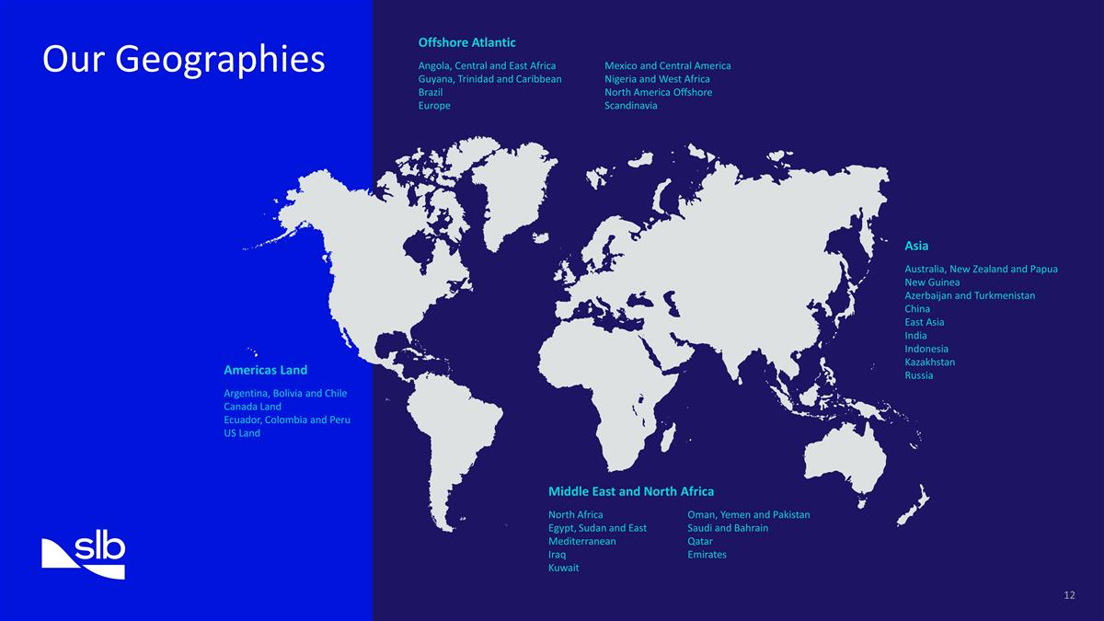
Our Geographies Americas Land Argentina, Bolivia and Chile Canada Land Ecuador, Colombia and Peru US Land Asia Australia, New Zealand and Papua New Guinea Azerbaijan and Turkmenistan China East Asia India Indonesia Kazakhstan Russia Offshore Atlantic Angola, Central and East Africa Guyana, Trinidad and Caribbean Brazil Europe Mexico and Central America Nigeria and West Africa North America Offshore Scandinavia Middle East and North Africa North Africa Egypt, Sudan and East Mediterranean Iraq Kuwait Oman, Yemen and Pakistan Saudi and Bahrain Qatar Emirates

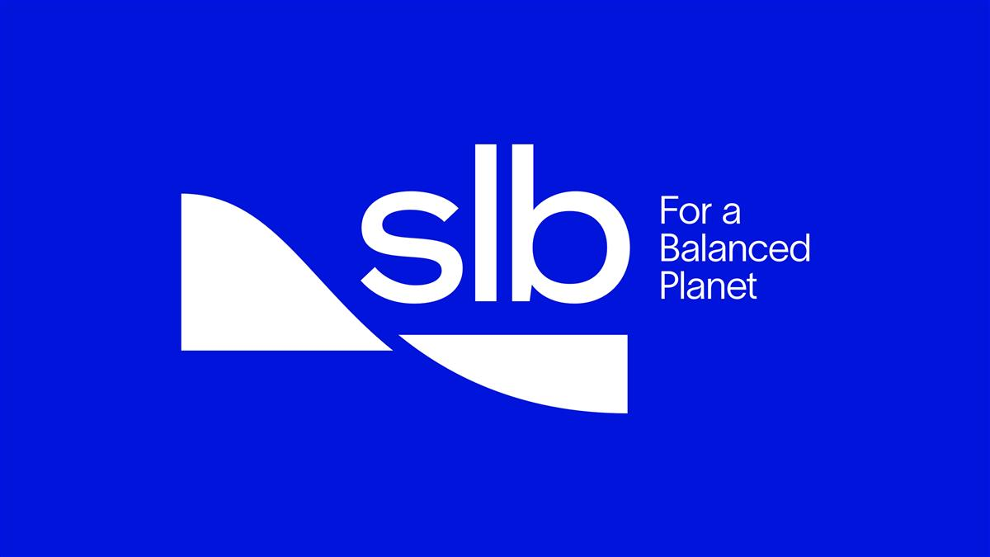

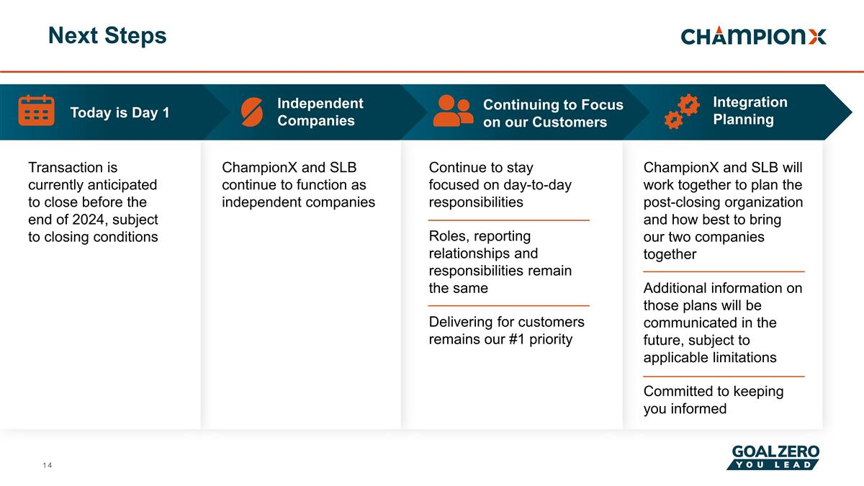
Next Steps ChampionX and SLB continue to function as independent companies ChampionX and SLB will work together to plan the post-closing organization and how best to bring our two companies together Additional information on those plans will be communicated in the future, subject to applicable limitations Committed to keeping you informed Continue to stay focused on day-to-day responsibilities Roles, reporting relationships and responsibilities remain the same Delivering for customers remains our #1 priority Transaction is currently anticipated to close before the end of 2024, subject to closing conditions Continuing to Focus on our Customers Integration Planning Independent Companies Today is Day 1

Forward-Looking Statements
This communication contains forward-looking statements within the meaning of the Private Securities Litigation Reform Act of 1995, Section 27A of the Securities Act of 1933, as amended (the Securities Act), and Section 21E of the Securities Exchange Act of 1934, as amended.
Such forward-looking statements include statements relating to the proposed transaction between SLB and ChampionX, including statements regarding the benefits of the transaction and the anticipated timing of the transaction, and information regarding the businesses of SLB and ChampionX, including expectations regarding outlook and all underlying assumptions, SLBs and ChampionXs objectives, plans and strategies, information relating to operating trends in markets where SLB and ChampionX operate, statements that contain projections of results of operations or of financial condition and all other statements other than statements of historical fact that address activities, events or developments that SLB or ChampionX intends, expects, projects, believes or anticipates will or may occur in the future. Such statements are based on managements beliefs and assumptions made based on information currently available to management. All statements in this communication, other than statements of historical fact, are forward-looking statements that may be identified by the use of the words outlook, guidance, expects, believes, anticipates, should, estimates, intends, plans, seeks, targets, may, can, believe, predict, potential, projected, projections, precursor, forecast, ambition, goal, scheduled, think, could, would, will, see, likely, and other similar expressions or variations, but not all forward-looking statements include such words. These forward-looking statements involve known and unknown risks and uncertainties, and which may cause SLBs or ChampionXs actual results and performance to be materially different from those expressed or implied in the forward-looking statements. Factors and risks that may impact future results and performance include, but are not limited to those factors and risks described in Part I, Item 1. Business, Item 1A. Risk Factors, and Item 7. Managements Discussion and Analysis of Financial Condition and Results of Operations in SLBs Annual Report on Form 10-K for the year ended December 31, 2023, as filed with the Securities and Exchange Commission (the SEC) on January 24, 2024 and Part 1, Item 1A, Risk Factors in ChampionXs Annual Report on Form 10-K for the year ended December 31, 2023 filed with the SEC on February 6, 2024, and each of their respective, subsequent Quarterly Reports on Form 10-Q and Current Reports on Form 8-K.
These include, but are not limited to, and in each case as a possible result of the proposed transaction on each of SLB and ChampionX: the ultimate outcome of the proposed transaction between SLB and ChampionX, including the possibility that ChampionX stockholders will not adopt the merger agreement in respect of the proposed transaction; the effect of the announcement of the proposed transaction; the ability to operate the SLB and ChampionX respective businesses, including business disruptions; difficulties in retaining and hiring key personnel and employees; the ability to maintain favorable business relationships with customers, suppliers and other business partners; the terms and timing of the proposed transaction; the occurrence of any event, change or other circumstance that could give rise to the termination of the proposed transaction; the anticipated or actual tax treatment of the proposed transaction; the ability to satisfy closing conditions to the completion of the proposed transaction (including the adoption of the merger agreement in respect of the proposed transaction by ChampionX stockholders); other risks related to the completion of the proposed transaction and actions related thereto; the ability of SLB and ChampionX to integrate the business successfully and to achieve anticipated synergies and value creation from the proposed transaction; changes in demand for SLBs or ChampionXs products and services; global market, political and economic conditions, including in the countries in which SLB and ChampionX operate; the ability to secure government regulatory approvals on the terms expected, at all or in a timely manner; the extent of growth of the oilfield services market generally, including for chemical solutions in production and midstream operations; the global macro-economic environment, including headwinds caused by inflation, rising interest rates, unfavorable currency exchange rates, and potential recessionary or depressionary conditions; the impact of shifts in prices or margins of the products that SLB or ChampionX sells or services that SLB or ChampionX provides, including due to a shift towards lower margin products or services; cyber-attacks, information security and data privacy; the impact of public health crises, such as pandemics (including COVID-19) and epidemics and any related company or government policies and actions to protect the health and safety of individuals or government policies or actions to maintain the functioning of national or global economies and markets; trends in crude oil and natural gas prices, including trends in chemical solutions across the oil and natural gas industries, that may affect the drilling and production activity, profitability and financial stability of SLBs and ChampionXs customers and therefore the demand for, and profitability of, their products and services; litigation and regulatory proceedings, including any proceedings that may be instituted against SLB or ChampionX related to the proposed transaction; failure to effectively and timely address energy transitions that could adversely affect the businesses of SLB or ChampionX, results of operations, and cash flows of SLB or ChampionX; and disruptions of SLBs or ChampionXs information technology systems.

These risks, as well as other risks related to the proposed transaction, will be included in the Form S-4 and proxy statement/prospectus (each, as defined below) that will be filed with the SEC in connection with the proposed transaction. While the list of factors presented here is, and the list of factors to be presented in the registration statement on Form S-4 are, considered representative, no such list should be considered to be a complete statement of all potential risks and uncertainties. For additional information about other factors that could cause actual results to differ materially from those described in the forward-looking statements, please refer to SLBs and ChampionXs respective periodic reports and other filings with the SEC, including the risk factors identified in SLBs and ChampionXs Annual Reports on Form 10-K, respectively, and SLBs and ChampionXs subsequent Quarterly Reports on Form 10-Q. The forward-looking statements included in this communication are made only as of the date hereof. Neither SLB nor ChampionX undertakes any obligation to update any forward-looking statements to reflect subsequent events or circumstances, except as required by law.
Additional Information about the Transaction and Where to Find It
In connection with the proposed transaction, SLB intends to file with the SEC a registration statement on Form S-4 (the Form S-4) that will include a proxy statement of ChampionX and that also constitutes a prospectus of SLB with respect to the shares of SLB to be issued in the proposed transaction (the proxy statement/prospectus). Each of SLB and ChampionX may also file other relevant documents with the SEC regarding the proposed transaction. This document is not a substitute for the Form S-4 or proxy statement/prospectus or any other document that SLB or ChampionX may file with the SEC. The definitive proxy statement/prospectus (if and when available) will be mailed to stockholders of ChampionX. INVESTORS AND SECURITY HOLDERS ARE URGED TO READ THE REGISTRATION STATEMENT, THE PROXY STATEMENT/PROSPECTUS AND ANY OTHER RELEVANT DOCUMENTS THAT MAY BE FILED WITH THE SEC, AS WELL AS ANY AMENDMENTS OR SUPPLEMENTS TO THESE DOCUMENTS, CAREFULLY AND IN THEIR ENTIRETY IF AND WHEN THEY BECOME AVAILABLE BECAUSE THEY CONTAIN OR WILL CONTAIN IMPORTANT INFORMATION ABOUT THE PROPOSED TRANSACTION. Investors and security holders will be able to obtain free copies of the Form S-4 and the proxy statement/prospectus (if and when available) and other documents containing important information about SLB, ChampionX and the proposed transaction, once such documents are filed with the SEC through the website maintained by the SEC at http://www.sec.gov. Copies of the documents filed with, or furnished to, the SEC by SLB will be available free of charge on SLBs website at https://investorcenter.slb.com. Copies of the documents filed with, or furnished to, the SEC by ChampionX will be available free of charge on ChampionXs website at https://investors.championx.com. The information included on, or accessible through, SLBs or ChampionXs website is not incorporated by reference into this communication.
Participants in the Solicitation
SLB, ChampionX and certain of their respective directors and executive officers may be deemed to be participants in the solicitation of proxies in respect of the proposed transaction. Information about the directors and executive officers of SLB, including a description of their direct or indirect interests, by security holdings or otherwise, is set forth in SLBs proxy statement for its 2024 Annual Meeting of Stockholders (https://www.sec.gov/ix?doc=/Archives/edgar/data/0000087347/000130817924000033/lslb2024_def14a.htm ), which was filed with the SEC on February 22, 2024, including under the sections entitled Director Compensation, Security Ownership by Management and Our Board, Compensation Discussion and Analysis, 2023 Compensation Decisions and Results, Elements of 2023 Total Compensation, Long-Term Equity Incentive Awards, Executive Compensation Tables, Grants of Plan-Based Awards in 2023, Outstanding Equity Awards at Year-End 2023, Potential Payments Upon Termination or Change in Control and Pay vs. Performance Comparison and SLBs Annual Report on Form 10-K for the fiscal year ended December 31, 2023 (https://www.sec.gov/ix?doc=/Archives/edgar/data/0000087347/000095017024006884/slb-20231231.htm), which was filed with the SEC on January 24, 2024, including under the sections entitled Item 10. Directors, Executive Officers and Corporate Governance, Item 11. Executive Compensation, Item 12. Security Ownership of Certain Beneficial Owners and Management and Related Stockholder Matters and Item 13. Certain Relationships and Related Transactions, and Director Independence. Information about the directors and executive officers of ChampionX, including a description of their direct or indirect interests, by security holdings or otherwise, is set forth

in ChampionXs proxy statement for its 2023 Annual Meeting of Stockholders (https://www.sec.gov/ix?doc=/Archives/edgar/data/1723089/000172308923000073/championx-20230327.htm ), which was filed with the SEC on March 29, 2023, including under the sections entitled Executive Compensation Highlights, Director Compensation, 2022 Director Compensation Table, Security Ownership of Certain Beneficial Owners and Management, Compensation Discussion and Analysis, Key Compensation Overview for 2022, Summary of 2022 Compensation for Named Executive Officers, Elements of Our Executive Compensation Program, Long-Term Equity Incentive Compensation, Additional Executive Compensation Governance Considerations, Executive Compensation Tables, Potential Payments upon Termination or Change-in-Control, Pay-versus-Performance and ChampionXs Annual Report on Form 10-K for the fiscal year ended December 31, 2023 (https://www.sec.gov/ix?doc=/Archives/edgar/data/1723089/000172308924000011/championx-20231231.htm), which was filed with the SEC on February 6, 2024, including under the sections entitled Item. 10 Directors, Executive Officers and Corporate Governance, Item 11. Executive Compensation, Item 12. Security Ownership of Certain Beneficial Owners and Management and Related Stockholder Matters and Item 13. Certain Relationships and Related Transactions, and Director Independence. Other information regarding the participants in the proxy solicitation and a description of their direct and indirect interests, by security holdings or otherwise, will be contained in the Form S-4 and the proxy statement/prospectus and other relevant materials to be filed with the SEC regarding the proposed transaction when such materials become available. Investors should read the Form S-4 and the proxy statement/prospectus carefully when available before making any voting or investment decisions. You may obtain free copies of these documents from SLB or ChampionX using the sources indicated above.

