SECURITIES AND EXCHANGE COMMISSION

Washington, D.C. 20549

FORM 8-K

CURRENT REPORT

Pursuant to Section 13 or 15(d) of the Securities Exchange Act of 1934

Date of Report (date of earliest event reported): September 26, 2006

SCHLUMBERGER N.V. (SCHLUMBERGER LIMITED)

(Exact name of registrant as specified in its charter)

Netherlands Antilles

1-4601

52-0684746

(State or other jurisdiction

of incorporation)

(Commission File Number)

(IRS Employer
Identification No.)

5599 San Felipe, 17th Floor, Houston, Texas, 77056

42, rue Saint-Dominique, Paris, France 75007

Parkstraat 83, The Hague, The Netherlands 2514 JG

(Addresses of principal executive offices and zip or postal codes)

Registrant’s telephone number in the United States, including area code: (713) 513-2000

Check the appropriate box below if the Form 8-K filing is intended to simultaneously satisfy the filing obligation of the registrant under any of the following provisions:

- Written communications pursuant to Rule 425 under the Securities Act (17 CFR 230.425)

- Soliciting material pursuant to Rule 14a-12 under the Exchange Act (17 CFR 240.14a-12)

- Pre-commencement communications pursuant to Rule 14d-2(b) under the Exchange Act (17 CFR 240.14d-2(b))

- Pre-commencement communications pursuant to Rule 13e-4(c) under the Exchange Act (17 CFR 240.13e-4(c))

Item 7.01 Regulation FD Disclosure.

On September 26, 2006, Schlumberger Limited (“Schlumberger”) hosted its 2006 Investor Conference in Sugar Land, Texas. The presentations by Andrew Gould, Schlumberger’s Chairman and Chief Executive Officer, and Ashok Belani, Schlumberger’s Chief Technical Officer, are available through Schlumberger’s website at www.SLB.com/ir and are also attached to this Current Report on Form 8-K as Exhibit 99.1.

The presentations and other statements we make at the 2006 Investor Conference contain forward looking statements, which include any statements that are not historical facts, such as our expectations regarding business outlook (including, without limitation, for the company as a whole and with respect to specified geographic areas); growth for Schlumberger as a whole and for each of Oilfield Services and WesternGeco (and for specified products or geographic areas within each segment); the supply of, and demand for, oil and natural gas; anticipated oil and natural gas production growth; earnings per share; operating margins; research and development spending; operating and capital expenditures by Schlumberger and the oil and gas industry; the business strategies of Schlumberger and its customers; the effects of the WesternGeco and PetroAlliance transactions; potential acquisitions; cash returns to shareholders; and future results of operations. These statements involve risks and uncertainties, including, but not limited to, the global economy; changes in exploration and production spending by Schlumberger customers and changes in the level of oil and natural gas exploration and development; general economic and business conditions in key regions of the world; political and economic uncertainty and socio-political unrest; and other factors detailed in our most recent Form 10-K and other filings with the Securities and Exchange Commission. If one or more of these risks or uncertainties materialize (or the consequences of such a development changes), or should underlying assumptions prove incorrect, actual outcomes may vary materially from those forecasted or expected. Schlumberger disclaims any intention or obligation to update publicly or revise such statements, whether as a result of new information, future events or otherwise.

Item 9.01 Financial Statements and Exhibits.

(d) Exhibits

The following exhibit is furnished in response to Item 7.01:

99.1 Presentations by Andrew Gould and Ashok Belani at 2006 Investor Conference

SIGNATURE

Pursuant to the requirements of the Securities Exchange Act of 1934, the registrant has duly caused this report to be signed on its behalf by the undersigned hereunto duly authorized.

SCHLUMBERGER N.V.

(SCHLUMBERGER LIMITED)

By: /s/ Howard Guild

Howard Guild

Chief Accounting Officer

Date: September 26, 2006

Exhibit 99.1

Schlumberger Investor Conference 2006 Executive Speech Final

IMPROVING PERFORMANCE—REDUCING RISK
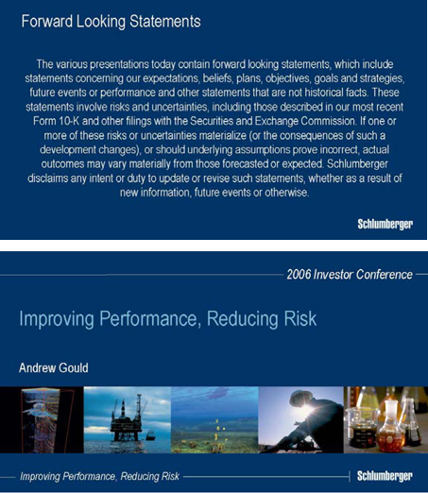

Good morning Ladies and Gentlemen and welcome to the Schlumberger Sugar Land Campus. Thank you for attending this event. We have an interesting day for you and I would like to spend forty minutes setting the scene.

In preparation for this event I looked back at the remarks I made at our previous investor conference in Ridgefield in June 2004. Like all predictions one makes, one always gets a few wrong or misses something but I cannot be unhappy with the number we got right.

Schlumberger Investor Conference 2006 Executive Speech Final
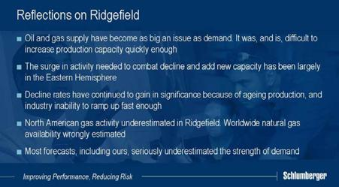

We were certainly right with the prediction that supply of oil and gas would be as big an issue as demand, and that it was going to be difficult to increase production capacity fast enough to relieve the short term tightness in supply and demand. We were also right to say that this would create the most favorable business climate for the oilfield services industry since the 1970s.

We were correct in identifying that the surge in activity needed to combat decline and add new capacity for oil would be largely in the Eastern Hemisphere. While rapid growth in North American natural gas activity hid this for a long time, the expansion in the East is becoming more and more obvious and is likely to continue.

We also hinted at the need to maintain production from existing fields but underestimated its difficulty. Decline rates have continued to gain in significance not only because of the age of the existing producing base, but also because the industry has been short of the resources needed to ramp up fast enough to do all the work required. Published operator production statistics support my contention.

Our remarks on natural gas were partially correct. We were right in predicting the service intensity of non-conventional natural gas, but we underestimated the overall increase in North American activity.

In our predictions, we also stated that “Schlumberger has always maintained that the lead indicator driving our business has been, and will remain, demand for oil and gas and that supply would follow as a result”. The mistake everybody made was to seriously underestimate the strength of demand.

Two years and three months later, the biggest question facing investors and industry players alike, is where are we in the cycle?

The markets have clearly decided. The WTI forward curve at 6 years is currently trading in the mid $60s. Long-dated natural gas contracts range between $7 and 8 per mmbtu.

Schlumberger Investor Conference 2006 Executive Speech Final

Futures prices like these are hardly indicative of a well-supplied market and it is important to understand why the market remains so tight.

I would therefore like to spend a few minutes looking at evolution of demand and how this has affected the supply response. This will gives us a very good indication of where we are.
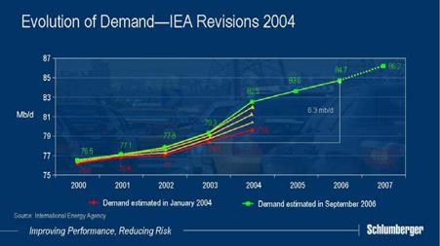

At the beginning of 2004, the IEA estimated that world demand in 2003 was 78.4 mb/d. Demand in the year to come was forecast to be an unremarkable 79.6 mb/d. Yet in the 9 months to October the forecast demand was increased no fewer than seven times. More importantly, the 2003 demand estimate was revised upwards by 900 kb/d in August based on data from non-OECD countries previously not included.

As we now know, world oil demand for 2004 finally reached 82.5 mb/d—more than 4 mb/d higher than the original estimate of 2003 demand and 3 mb/d higher than the original forecast for the year. I should point out that the IEA was not alone in misjudging the demand for oil—most other forecasting bodies also seriously underestimated demand.

Today, the IEA expects 2006 oil demand to be 84.7 mb/d, a colossal 6.3 mb/d of growth from the original estimate for 2003. Ladies and Gentlemen, I do not have to explain that adding as much production as that of Mexico and Norway combined in just three years is colossal task.

The result we know—a razor-thin cushion of spare production capacity often of crude types unsuited to current refining capacity, sustained higher prices, huge adjustments in the futures curves and extraordinary volatility exacerbated by geopolitical developments.

Schlumberger Investor Conference 2006 Executive Speech Final
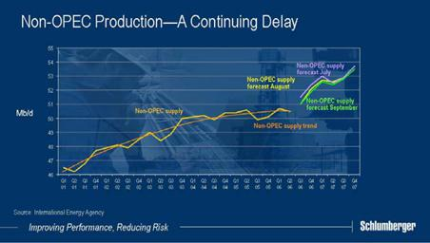

However, this wild escalation in demand was not the only factor with which producers had to contend in planning production growth. Non-OPEC supply consistently under-performed compared to IEA forecasts. In 2004 this supply grew by 1 mb/d, which was half a mb/d less than the original forecast made at the beginning of that year. In the following year, non-OPEC supply only increased by 100 kb/d, again considerably less than projected. If current forecasts for 2006 are to be believed, non-OPEC supply will have to grow by 1.5 mb/d in the second half of this year compared to the same period last year—this seems highly unlikely. The challenges of growing non-OPEC production while sustaining production in mature fields will require more investment than is currently being committed. As we all know, the shortfalls in non-OPEC production severely challenged OPEC to make up the difference in a climate where several members could not respond and in some cases even saw their own production decrease.

It must be said of course that exploration and production budgets were increased substantially from 2004 to 2006. Spending surveys have estimated this increase to be as much as 56%. But much of this has been due to cost inflation resulting from raw material demand, equipment shortages, skilled personnel salaries, and service costs. Accurate numbers are hard to establish but much of the additional investment has been swallowed by inflation and does not represent increased investment in production capacity.

Schlumberger Investor Conference 2006 Executive Speech Final
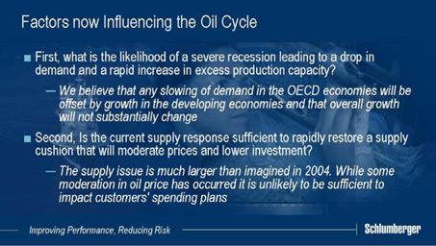

To judge the length of the oil cycle two questions remain. The first is any likelihood of a severe economic recession leading to a drop in demand resulting in a rapid increase in excess production capacity. We believe that any slowing of demand in the OECD economies through slower growth and energy conservation will be offset by growth in the developing economies and that overall world demand growth will not substantially change. I would remind you that 85% of world energy demand growth since 2000 has been in the emerging economies that already account for over half the world’s energy consumption. China alone accounted for one third of the increase in oil consumption.

The second question—the size of the supply response—is in fact much larger than we imagined in 2004. I’ve already mentioned the difficulty of increasing non-OPEC production without increased investment but I have not mentioned the new supply that is under development. This includes new deep-water fields, significant activity in Saudi Arabia as well as many other areas. They will all help, but our judgment is that they are not sufficient to make a significant difference to the overall supply balance for some years to come. While some moderation in commodity prices has occurred, it is unlikely to substantially impact our customers’ investment plans for oil.
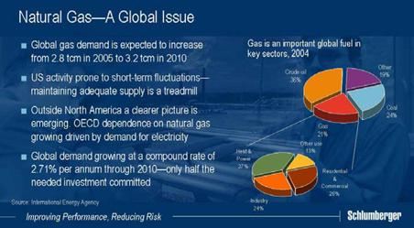

Schlumberger Investor Conference 2006 Executive Speech Final

Looking at natural gas, US activity is obviously prone to short-term price fluctuations. However, the fact remains that maintaining adequate supply is a treadmill, and any sustained reduction in activity will affect supply almost immediately.

Outside North America, a clearer picture of supply and demand is emerging. The IEA has indicated that OECD dependence on imported natural gas imports is growing fast driven by demand for gas-fired electricity as OECD gas production plateaus. Recently published data show demand rising at a compound annual rate of 2.71% through 2010 but only half the needed investment to achieve has been committed.

This is probably the first time that the industry has had to undertake such a large amount of gas activity at the same time as large-scale replacement and growth of oil production capacity. The number of large LNG projects underway dwarfs anything we have seen in previous cycles with as many as 30 projects to be commissioned in countries as widespread as Algeria, Nigeria, Qatar, Russia, Trinidad and Yemen.
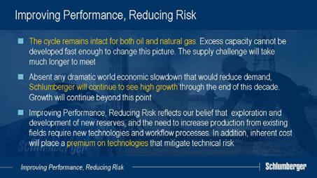

Our conclusion is that the cycle remains intact for both oil and natural gas. We cannot see excess supply capacity for either being developed fast enough to significantly change this picture. And although we remain convinced that the supply challenge will be met, this may take much longer and be more difficult to sustain than anybody originally anticipated.

We therefore repeat our expectation that, absent any dramatic world economic slowdown that would reduce hydrocarbon demand, Schlumberger will continue to see high growth through the end of this decade. In fact, our feeling is that this period of growth will last beyond the end of the decade and well into the next. Growth rates will eventually slow from today’s breakneck pace but remain way above what was experienced over the long slow industry adjustment post-1986. The world is realizing that the period of cheap hydrocarbon energy has ended and new and higher sustained levels of investment are necessary to meet demand.

Schlumberger Investor Conference 2006 Executive Speech Final

We believe that the finding and developing of new reserves, together with the need to increase production from existing fields, will require new technologies and new workflow processes to improve reservoir performance. In addition, the costs inherent in increasing reservoir recovery, and developing smaller reservoirs, will place a premium on services that can mitigate customers’ technical risks. Therefore our focus is on Improving Performance and Reducing Risk.

Before I describe how this will translate to growth for Schlumberger, I would like to set the context by saying something about general activity patterns and their consequences for the company.

The last two years have seen a significant shift in the dynamics of access to reserves. This has been the case in Latin America and in Russia, and also is the case in the Middle East where governments seek foreign investment for natural gas but not for oil. Estimates show that less than one quarter of total world oil reserves are currently available to international companies with a considerable portion of that figure held by new Russian companies.

In addition, and in a way not seen since the 1973 oil shocks, access to reserves has become an issue of energy security, particularly for the growing economies of Asia. As a result, many National Oil Companies have begun to expand beyond their borders and are therefore competing for access with the international industry.
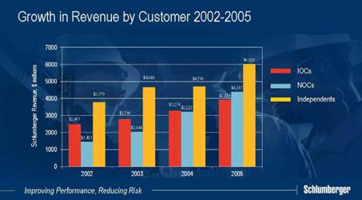

All of this has a significant effect on the activity and spending patterns of our customer base.

If you look at our revenues over the past four years the trends are significant. Revenues from the National Oil Companies, which have more than tripled, have grown the fastest. Within the international operators, revenues have increased by 60% and these two groups now represent a roughly equal weight in our portfolio. Revenues from independent operators have increased by about 50%, reflecting the recovery of the North American gas market as well as the increased activity of large independents in the international markets.

Schlumberger Investor Conference 2006 Executive Speech Final
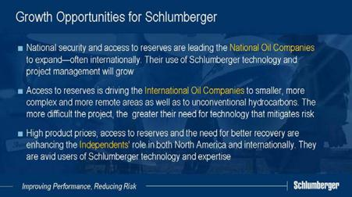

We draw three conclusions from this analysis.

First, the advent of energy as a matter of national security and the restriction on access to reserves has led to a new and growing role for the National Oil Companies. This role includes the exploitation of their domestic reserves while increasingly operating outside their national boundaries. We see this trend of “International National Oil Companies” continuing and the total NOC spend will continue to represent a greater proportion of our accessible market. Their use of us as a provider of technology and integrated project management services will continue to grow.

Second, the same lack of access has driven the International Oil Companies to smaller, more complex and more remote areas as well as to focus on gas and non-conventional hydrocarbons. Their emphasis on recovery factors will continue to increase and the more difficult the project, the greater their need for technology that mitigates risk. In addition, many IOC projects will be offshore where spread costs of operating rigs can exceed a million dollars a day. We see therefore see excellence in service execution, as being as essential for success as new technology and process.

Third, high prices, reserves access and the need for better recovery are enhancing the role of independents not only in North American natural gas but also in international markets. These companies are avid users of Schlumberger technology and reservoir expertise —often using us to supplement in-house resources for both geo-science and partial project management.

Perhaps the biggest change in the nature of the cycle since we last met two years ago has been the increased awareness of reserve depletion that has led to today’s emphasis on recovery, and the re-discovery of exploration.

Schlumberger Investor Conference 2006 Executive Speech Final
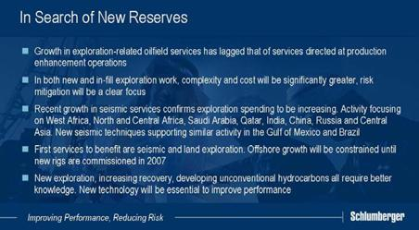

The low growth in exploration-related oilfield services from 2000 to 2004 clearly reflected the lack of exploration activity within the industry as a whole. This is now changing, and we predict that spending will continue to increase for a number of years to come. All customer groups are engaged in this effort, which is starting from one of the lowest levels the industry has seen.

This shift to exploration leads to domains that are more complex and costly. More remote operations, deeper geological horizons, deeper water, hotter temperature and higher pressure mean that best possible knowledge of reserves and their likely recovery is essential to mitigating the risks in project economics.

Exploration activity will focus on many areas in West Africa including Angola, Nigeria and Equatorial Guinea; in North and Central Africa in Algeria and Libya, Niger, Chad, and Mauritania; in the Middle East in Saudi Arabia and Qatar and the Far East in India and China. Central Asia will see extensive gas exploration. Russia will also see expanding exploration activity now that the easy production recovery in West Siberia has been achieved. But North and South America will not be ignored, as innovative seismic imaging techniques unlock new horizons in the Gulf of Mexico and Brazil attracts renewed interest.

While these areas include many prospects both on land and offshore we initially expect that land and marine seismic activity, and land exploration drilling, will capture the higher proportions of customer spend. Offshore exploration drilling meanwhile will be constrained until the 100 new rigs under construction, which include 20 floaters capable of working in water depths up to 10,000 feet, start to appear in late 2007.

However, what is perhaps equally significant in the short term is the increase in in-field exploration within known fields. This is driven by the need to identify and access by-passed or small accumulations of oil that can be tied back to existing infrastructure. For example, secure access and a reasonable fiscal regime are creating new North Sea activity that extends reserves in a province that was being abandoned by many major players only three years ago. In West Siberia, the production enhancement activity that restored

Schlumberger Investor Conference 2006 Executive Speech Final

production is now becoming more and more a by-passed oil recovery business. And in Saudi Arabia, the Maximum Reservoir Contact program that depends heavily on optimal well design and placement for effective drainage is growing rapidly. Similar efforts to increase recovery from existing fields will continue in many other parts of the world.

These two major trends in activity will become even more dependent on technology, global footprint and access to skilled personnel—areas in which Schlumberger delivers value. They are cumulative with the current extensive efforts to sustain existing production capacity and the growing efforts to develop unconventional hydrocarbons.

Understanding complex reservoir structures, quantifying reserves more precisely and determining potential for reserve extensions all require better knowledge. Such knowledge will depend on better measurements and better process through better technology. This industry-wide context places a considerable premium on our technology portfolio.

I would now like to update you on the three specific growth initiatives that we outlined in Ridgefield in June 2004. These initiatives are growth in geography, in technology, and through integrated project management.

At that time, we said that we felt that our largest geographical growth opportunities were in Russia, and to some extent China.
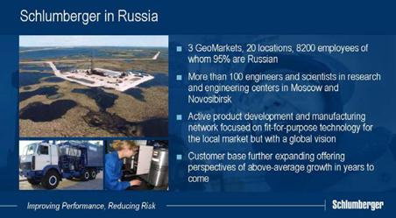

Our growth in Russia has been extraordinary and I would like to share with you the sheer scope of what has been achieved. In 1999 we made less than $50 million in revenue, by 2004 we reached half-a-billion and this year we will approach one-and-a-quarter billion. Over this time we have radically diversified our customer base to a point where we are no longer dependent on any one type of customer. There are now three GeoMarkets with 20 operating locations. We have made a number of successful acquisitions. Total headcount in Russia is more than 8200, of whom 95% are Russian making them the second largest population in Schlumberger after the US. More than 400 Russians have returned home after international assignment with a similar number are currently expatriate.

Schlumberger Investor Conference 2006 Executive Speech Final

In research and engineering more than 100 engineers and scientists are split between the Moscow research center and Novosibirsk engineering center. Research results and engineered products have already appeared. Certain of our major research disciplines have been moved to Moscow and the FibreFRAC* stimulation product that we showed in Ridgefield was in fact developed in the Russian technology organization.

Progress in manufacturing has been similar. Submersible pumps are made in Tyumen and our first Russian-made pumps are in operation. We also manufacture perforating guns and charges and Well Services primary units in significant quantities.

More importantly however, we do not think that our Russia growth story is over, and we anticipate being able to continue to grow above average rates for some years to come.
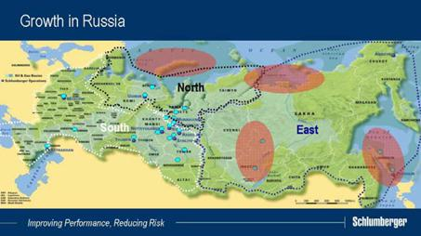

The bulk of our growth so far has been centered on the restoration of production from existing oil fields in Western Siberia and on IOC projects in Sakhalin. We consider these to be early phases in the development of Russian exploration and production activity and we are already seeing a shift in activity, both technologically and geographically.

In Western Siberia there has been a huge increase in re-entry sidetracking as a preferred drainage method. IPM has established a strong position in this market delivering geosteered sidetracks in approximately one-quarter of the time that it takes other service companies. Greenfield developments, and deeper and more complex formations are being evaluated in Western Siberia. The vast under-explored resources of the Russian Arctic, Eastern Siberia and Sakhalin are also under investigation. We have seen significant increases in exploration and development in Eastern Siberia that we predict will continue over the coming years. The relative complexity of much of this will ensure that the need for high technology is just as great as elsewhere in the world.

Schlumberger Investor Conference 2006 Executive Speech Final
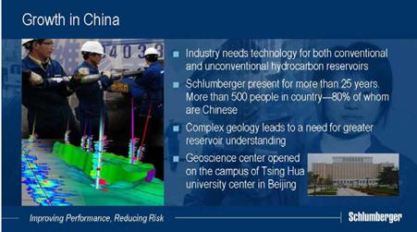

In China, the economic growth and energy security continues to drive the oil and gas industry to develop additional domestic supplies leading to increased activity in both conventional plays as well as more challenging and unconventional areas such as deep water and coal bed methane. Schlumberger has been conducting services for more than 25 years in mainland China, and we are uniquely positioned both in terms of our strong local workforce and our product offering to participate in this growth. The understanding of China’s complex reservoirs that we have developed through our Data and Consulting Services’ integrated study business directly translates into improved operations and results for our national clients, both domestic and international. We are growing fast but not on the same scale as Russia.
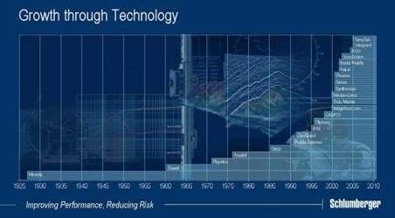

The second growth initiative is technology—both developed internally and acquired externally. I am going to leave the bulk of the technology discussion to Ashok Belani, our chief technical officer who will speak after me. Ashok will discuss internal technology developments but I would like to briefly discuss our M&A activity over the last two years.

Schlumberger Investor Conference 2006 Executive Speech Final

From the beginning of 2004 through the first half of 2006 we have spent a total of $3.3 billion on acquisitions. The two largest were the purchase of the 30% minority interest in WesternGeco and that of PetroAlliance the leading independent Russian oilfield services company. WesternGeco was accretive from the first day and the acquisition has removed the barriers to integration of the different measurement technologies that was not possible in a joint venture with a competitor. PetroAlliance brought significantly increased market access, an excellent reservoir of people with local operating knowledge, and a different client portfolio. In return we brought them technology that will considerably extend their potential.

We have also made other investments in Russia to enable market and technology access and acquisitions in Russia, China, the US and Europe for manufacturing capacity and vertical integration of certain small key technology suppliers. None of these has been worthy of individual mention, but collectively they begin to make a difference.

But perhaps more significantly we have made other acquisitions that extend or integrate our technology portfolio. Odegaard inversion software, and TerraTek geomechanical expertise have been the most recent public examples. Finally, we have purchased three portfolios of early disruptive technology of which AGO, a company active in controlled-source electromagnetic and magneto-telluric surveying, has been the most public. I mention this as a necessary cultural shift within the Schlumberger technology community to recognize that our portfolio is so broad that we cannot possibly invent or develop everything internally. Our acquisition strategy, particularly to extend our reservoir capability, is an important part of our technology-based growth.

I also mention it to allay any lingering concerns you may have that we will again be tempted to diversify away from the oilfield. We have more than enough to do.
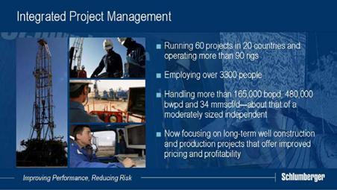

The third avenue for differentiated growth that we outlined is our ability to perform project management. In Ridgefield in 2004 in answer to a question from Jim Crandell, I speculated that IPM could represent 50% of Schlumberger by the end of the decade. This remark started a huge debate on the validity of IPM as a strategy, and our ability to

Schlumberger Investor Conference 2006 Executive Speech Final

succeed. While I was wrong on the scope of IPM in the immediate future, I remain convinced that it is, and will be a significant growth engine for Schlumberger.

The current market dynamics have meant that customer appetite for this service has grown significantly in the last two years.

Today, IPM is 60 projects in 20 countries, executing well construction and field management projects and running more than 90 rigs. We employ more than 3300 people and manage a production stream similar to that of a moderately sized independent. Total IPM revenue from all sources, including the revenue of associated Schlumberger services represented 9.2% of total revenue in 2005.

Over the last two years, IPM has focused on clear objectives, particularly in the well construction business. Progress has been made on pricing and on risk reduction. We have improved terms and conditions and have exited some of the poorer performing contracts. Return-on-sales dilution, caused by the rebilling of third-party services, has been reduced through increasing handling fees, or by direct customer payment. These actions have had a positive effect on returns, and year-to-date profitability in 2006 shows a spectacular improvement over 2005.
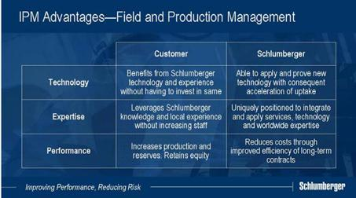

We have also concentrated on moving IPM more towards field and production management for both greenfield and brownfield projects. Schlumberger is uniquely positioned to integrate and apply its own services, technologies and geo-scientific knowledge. Customers are able to benefit from our technology and worldwide experience of best practice, without having to make their own investment in such expertise. IPM also allows customers to increase their effective staff. The outcome is an increase in production and reserves, and as Schlumberger does not take equity, the reserves remain with the client.

For Schlumberger, these projects provide the opportunity to apply and prove our own technology using our ability to find and train geoscientists worldwide. They provide a portfolio of longer-term contracts, where we can reduce our costs through improved efficiencies. Above all, IPM type work allows us to earn a superior return because we risk our service revenue against a return derived from any increase in production above and beyond an agreed base level.

Schlumberger Investor Conference 2006 Executive Speech Final
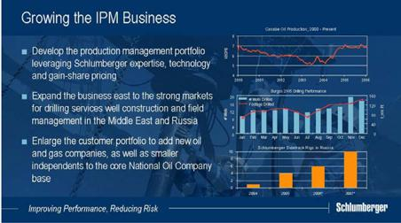

Production project revenue has grown rapidly over the past three years. While this is partly due to higher oil prices and increased service costs, is also due to strong performance on an expanding portfolio of projects. We have currently four major long-term production projects in the USA, Colombia, Romania and Malaysia with a number of minor projects elsewhere.

Today, our goal is to grow IPM at a much higher rate than the rest of the business. We expect field and production management projects to form an increasingly large proportion of our portfolio. We expect the current dependence on Latin America to reduce, and we see significant growth in the Middle East and Russia where there will be strong markets for well construction and other drilling services as well as for field management projects. The National Oil Companies will remain the major customers for IPM, but new entrants to the oil and gas business, as well as the smaller independents, will become significant customers.

We are now confident that we have a well-managed project management business that is limited in its growth only by the availability of sufficient people with the right skills.

Our conviction that the business climate will remain highly favorable has led us to revise our financial targets, but before discussing these I would like to review how we performed against targets set in our 2004 meeting.

Schlumberger Investor Conference 2006 Executive Speech Final
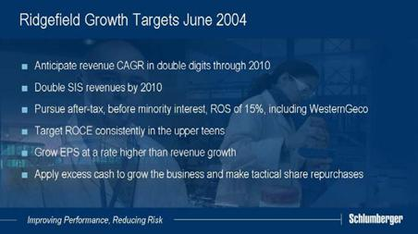

I’m happy to say that we surpassed all the financial objectives that we set ourselves as activity, new technology introductions and pricing power led too much greater growth and margin expansion than we had originally anticipated.

The improvement at WesternGeco, driven by activity, pricing, the success of Q technology, and a robust multi-client market, was particularly satisfying to us. We expect to see strong growth in Q activity again this year to reach a level almost double that of 2005. To meet demand for Q-marine surveys, we will be adding a 7th vessel next year and an 8th in 2008. Return-on-sales has increased from 6.1% in 2004 to 22.3% in the first half of 2006. While we ultimately see this being somewhat eroded by new capacity within the standard 3D seismic fleet, we do not think this will be much before 2009.

In the same period, robust cash flow allowed us to finance acquisitions, a large CAPEX program and return considerable funds to shareholders. Share buybacks from July 2004 until the end of the second quarter 2006 totaled 33.6 million shares, or $1.4 billion at an average cost of $41.6 per share. Dividends were increased by 12% in 2005, and 19% in 2006.

Schlumberger Investor Conference 2006 Executive Speech Final

The new financial targets that I am about to outline will again try to set an ongoing performance standard for us. I would remind you, they are all dependent on our demand scenario being reasonably accurate.

We have recently stated that we felt we would grow the company on average in the high teens through the end of the decade and we still see that today as the probable outcome. However, as I pointed out earlier, we also feel that substantial growth is likely to continue beyond the end of the decade.

We think that there will be some moderation of growth in certain services in the years to come due to capacity additions, particularly in North America, but this will be compensated by growth in North America and overseas of higher-value technology services as reserve extension and replacement become key issues.

With this growth profile we will continue to grow earnings faster than revenue.

Research and development as a percentage of revenue will increase slightly.

Capex, excluding capitalized multi-client surveys, should be around 10% of revenue at the predicted activity levels.

Acquisitions, mainly of emerging or complementary technologies to our existing portfolio will continue at about the same level as the recent past if you exclude the acquisition of the minority interest of WesternGeco.

We will continue to de-leverage the balance sheet and the net debt position should become non-material by the end of the decade.

Under these assumptions, the total cash return to shareholders through dividends and share buybacks will continue to increase.
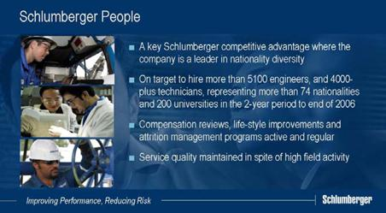

Schlumberger Investor Conference 2006 Executive Speech Final

Finally I’ve not yet mentioned the issue that perhaps has received more comment than any other in the industry, and that is the ability to access skilled professionals. This is a domain where Schlumberger has a reputation for being a leader in nationality diversity, which is a large part of the answer and which remains a key competitive advantage.

Schlumberger has a remarkable recruiting and training machine. In the two years through the end of 2006 we will have hired more than 5100 engineers and 4000-plus technicians of 74 nationalities representing 200 universities around the world. And we will have executed more than 650,000 training days for this population alone. While we have suffered attrition, this has been manageable and mostly to our customers or to life-style issues rather than to our competitors. We have carried out regular and substantial compensation reviews as well as life style improvements and intend to continue doing so. We have been able to keep pace with our growth albeit with a marked reduction in average seniority in the field. Our service quality has not significantly deteriorated despite this drop in seniority as processes, systems and real-time interaction have helped to compensate.

Today we have with us many of the top management of Schlumberger. Jean-Marc Perraud, Chief Financial Officer, Chakib Sbiti and Dalton Boutte, the Executive Vice Presidents for Oilfield Services and WesternGeco and Mark Corrigan who is Vice President of Operations managing the geographical Areas for Chakib.

We also have the Presidents of our three technology groups. Imran Kizilbash in charge of Reservoir Characterization, Doug Pferdehirt in charge of Reservoir Production, and Jeff Spath in charge of Reservoir Management. You will meet others as you visit the technology stands.

Finally, Ladies and Gentlemen, during the rest of the day we aim to convince you that our remarkable technology portfolio will allow us to produce superior growth in this period when the industry will be focusing on reserve extension and replacement so let me now introduce our Ashok Belani our Chief Technical Officer.

Ashok spent the first 20 years of his career in Schlumberger field operations and technology management. He then spent five years in Silicon Valley, where he was responsible for the management and sale of the Schlumberger semiconductor test business. At the beginning of 2006, he returned to Schlumberger as Chief Technical Officer.

Schlumberger Investor Conference 2006 Executive Speech Final
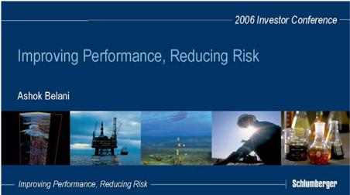

Thank you, Andrew. Good morning ladies and gentlemen.

I have found it very exciting to come back to Schlumberger and see the changes that the oilfield has gone through in this cycle. Certainly, one conclusion from my first round of visits to the technology centers has been that the pace of technology development and deployment has significantly increased.

As Andrew described earlier, the stakes are bigger – and in this cycle the industry conditions have created a sense of urgency resulting in faster technology uptake. The opportunities for differentiated technology to capture even more value are increasing every day. At this particular point in the cycle, the markets are telling us that very clearly. We remain committed to the thesis that investment in technology will differentiate us in the marketplace and help us produce superior results for Schlumberger and our clients.

My talk is divided into three sections. First, I will set the stage by describing the size and reach of our technology engine. Then I will link the industry cycle to our technology strategy. Finally, I would like to show you some important technology platforms relevant to today’s market, and this will also put the sessions for the rest of the day into context.

Schlumberger Investor Conference 2006 Executive Speech Final

One of the most impressive features of our technology organization is our global reach and footprint. From my experience working with some large hi-tech companies, Schlumberger is at the forefront of efficient technology development through a geographically dispersed organization, and even more importantly, at the forefront of supporting a global commercialization of the resulting products and services.

Since the last investor conference, we have added a number of centers in key places to further enhance our competitive advantage.

In Russia, we expanded our research center – giving it a well-defined charter based on fundamental science skill sets available in Russia. We inaugurated a new center for stimulation engineering in the Academic city near Novosibirsk in West Siberia, and a center for the engineering of artificial lift systems in Tyumen.

In 2002, we made a small acquisition in Edmonton providing innovative fluid property products and services, and rapidly integrated it into our technology organization. From being a focused technology organization in a niche, the center is now a significant contributor for products in seven of our business segments impacting as many as fifteen different projects.

In March of this year, we inaugurated a research center in Dhahran, Saudi Arabia on the campus of the Petroleum and Minerals University, where we are engaged closely with our customers in the Middle East on long-term solutions to the subsurface challenges of the region.

We have increased substantially our center in Beijing where we are building data acquisition and interpretation expertise.

We believe that our capability to integrate technologies from geographically spread locations is truly world class. Our capacity to develop, deploy and support services from these centers seamlessly is a key competitive advantage.
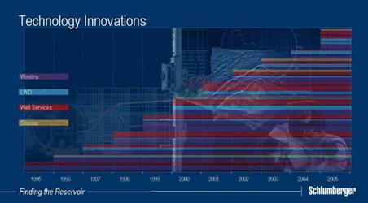

Schlumberger Investor Conference 2006 Executive Speech Final

This technology engine allows us to commercialize innovations at a very fast pace. Since 2003 we have introduced 9 major innovations for Wireline, 9 for Drilling and Measurements, 12 for pumping services and 3 major systems for seismic, to mention just four of our technology segments.
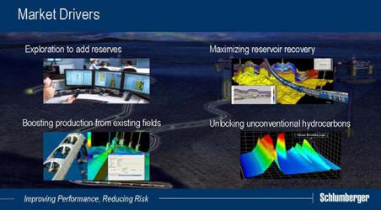

Andrew outlined macro trends, opportunities and our progress on realizing the growth we projected in Ridgefield. I will now describe these in more detail, and will focus on four main market drivers.

First is exploration. There has been a steep increase in exploration activity over the last two years, with every oil company having the reserves replacement ratio as their top objective. This presents challenging and exciting opportunities for us to mitigate the technical risk taken by our customers, through our significant leadership in seismic, borehole measurements and measurement integration.

Second is the urgency to increase production capacity at a sufficiently rapid pace – especially in the face of increasing shortage of personnel and technical expertise in our industry. As utilization rates have climbed, contract resources have become a challenge. We see opportunity in using technology to help improve the performance of our customers.

Next is maximization of reservoir recovery factor where the drive to increase recoverable reserves from known reservoirs puts into focus the development of new technologies and workflows to prolong reservoir life and optimize performance over the long term.

Finally, the focus on unconventional hydrocarbons has increased significantly over the last two years and this presents many long-term opportunities both for mitigating risk and improving performance.

Schlumberger Investor Conference 2006 Executive Speech Final
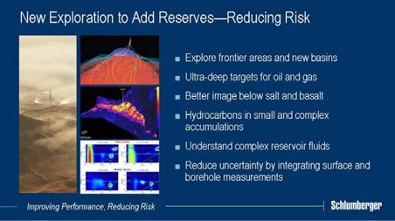

In exploration, many different market requirements drive our technology research and development activity. Increasingly, oil and gas companies, especially the larger ones, are exploring in frontier areas and new basins where costs are high and probability of success low. We are engaged in developments in the Russian and Canadian Arctic Seas, the Black Sea, parts of the Persian Gulf, the Red Sea and offshore India. As the remoteness and risk of these projects increases, the requirement for better measurements and characterization of the subsurface present substantial opportunity.

In addition, in the more conventional regions, the exploration challenge is focused on more complex accumulations. For example in the Gulf of Mexico, targets are deeper and hotter, in West Africa they are more difficult to evaluate and require complex completions. In the Gulf of Mexico, new hydrocarbon reservoirs have recently been found in complex geometrical structures below the salt canopies, which are difficult or impossible to find with conventional seismic measurement and processing methods.

In East Africa, India and some parts of the UK, targets below basalt caps are being explored, also posing new challenges to seismic data and interpretation.

In areas where gas exploration continues, targets are deeper in the subsurface and in deeper waters, for example in the Gulf of Mexico and in Australia. Higher pressures and complex wells make exploration testing and evaluation an interesting challenge.

As the resolution of seismic data increases, and the capability of borehole measurements to probe deeper into the reservoir increases, we finally see real opportunities in synergies between surface and borehole data, to significantly improve the reservoir characterization and evaluation.

Schlumberger Investor Conference 2006 Executive Speech Final
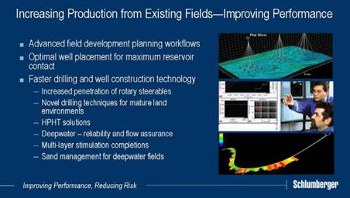

Production boosting is a vast subject. We covered some of it in Ridgefield in 2004 so I have listed only a few of the more important drivers to boosting production capacity here.

With the industry under-investment in people over the last two decades, the expert human resource shortage will continue to affect efficiency for the next 5-7 years. This has presented an opportunity to use technology to increase the workflow productivity within the oil company for field development and planning activities.

Our customers worldwide are continuously engaged in turning reserves and capital into production capacity. For a service organization, the global footprint, the diversity of the workforce and the well-supported deployment of advanced technology are critical factors in boosting efficiency. Among these, well placement and faster drilling are the most exciting areas of innovation today. The pace of drilling activity is demonstrated by the rapid increase in footage drilled, growing at the compound rate of some 40% over the past three years. Vertical wells require high technology to drill faster – horizontal wells require different drilling tools to drill longer drain holes – all in an effort to improve performance.

The new reservoirs in the Caspian, West Africa, the Gulf of Mexico and Brazil are in unconsolidated sands, and require completions with sand control mechanisms, to ensure the productivity of the wells at a better rate and for longer life.

Similarly, gas reservoirs all over the world, in Russia, on land in the US and in Saudi Arabia all require advanced stimulation techniques to boost productivity and to increase the flow interface between the well and the formation.

The technology forefronts for deepwater developments, and for high-pressure, high temperature wells, are continuously being challenged as the capability of the industry advances. The risk factors for all these developments are high and the enabling technologies require continuous efforts in development and deployment, often in collaboration with customers.

Schlumberger Investor Conference 2006 Executive Speech Final
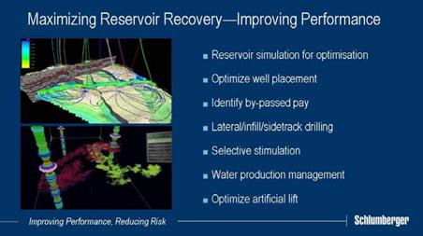

It is well known that historical reservoir recovery factors range anywhere between 20 and 50%. Customers are demanding that technology boost these figures by an additional 20 percent, which will make a significant impact on recoverable reserves.

All activities in the reservoir then need to be optimized based on accurate characterization or truly representative models of the subsurface and associated flow properties. With detailed knowledge obtained from integration of all measurements and other data, wells can be correctly placed to optimize recovery.

One strategy being used in the Middle East to boost production capacity and optimize the recovery is Maximum Reservoir Contact well, which results in the design of interesting well geometries with respect to producing formations. These require the full hole-size range of rotary steerable systems, and also the ability to see ahead of the bit to better place the well bore. No other technology provider has developed such deep-reading capability as a complete system.

Reservoir modeling enhances the capability to design and place the right completions hardware and then stimulate the formation for production. The well is tested to establish that it can drain the designed reservoir volume at the optimum rate, and then permanent measurements allow the monitoring of overall performance.

To identify bypassed fluids, or small un-drained accumulations in produced reservoirs, efficient time-lapse measurement techniques are being used, which require advancements in both the fidelity and resolution. And better reservoir characterization also provides the ability to place sidetrack, or infill wells, to drain bypassed zones efficiently. In some cases, selective stimulation techniques are required to accurately drain the right volumes into a well, as is the case in Saudi Arabia.

Another challenge in increasing recovery is the management of produced water. Water production in mature fields is increasingly common and there is growing demand for downhole water separation from many customers around the world.

Schlumberger Investor Conference 2006 Executive Speech Final

Finally, 90 percent of the wells today are on artificial lift where the energy requirements for lifting need to be optimized. This has become another fertile area for innovation.
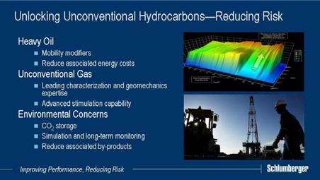

As we mentioned earlier, unconventional sources of hydrocarbon, such as heavy oil, unconventional gas and others, are becoming of greater significance. Such resources are plentiful in North and South America, and elsewhere around the world, and many of the major oil companies are engaged in the development of these alternate resources.

Production of these reserves is very different from that of conventional oil and gas, both in terms of technology and capability. For heavy oil and tight gas, there are many technical challenges being addressed to make these projects more viable. For other unconventional resources, there is today only a discovery process and there will be a lot of development to come.
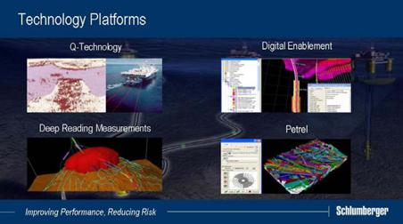

There are many technologies in our portfolio that address the market opportunities I have described. For today, we have selected four technology platforms, which are key answers to the market drivers, and demonstrate the new industry mindset of faster technology uptake.

Schlumberger Investor Conference 2006 Executive Speech Final
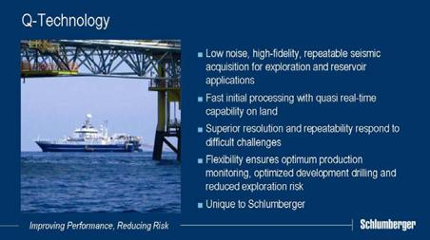

Five years ago we introduced a new approach to surface seismic acquisition known as Q*. Q represents a huge improvement in seismic signal quality and fidelity and provides improved, low-noise, repeatable measurements that reveal subtle and complex details of the subsurface.

Since its introduction, Q has proved its worth as both an exploration and reservoir management tool. For example, a Q-Marine* survey was recently acquired on the Petrobras Marlim complex off the coast of Brazil. The objectives included establishing a baseline survey for reservoir monitoring, a repeat survey for characterization, and an exploration element to evaluate nearby targets. The flexibility of Q enabled all three objectives to be met on the same survey - this would otherwise require three conventional surveys with different acquisition parameters.
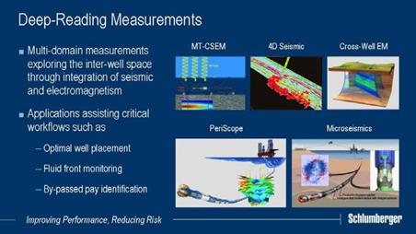

Some of the most impressive innovations are being made in the area of deep-reading measurements away from the borehole and into the reservoir. Resistivity measurements can now “see”15-20 ft from the borehole while sonic measurements are truly three-dimensional and can investigate up to 30 ft away. Measurements made while drilling can sense 15 ft from the borehole, and in a new development, up to 100ft away. Cross-well

Schlumberger Investor Conference 2006 Executive Speech Final

electromagnetics can detect inter-well targets at up to 500ft. These characterization technologies are unique to Schlumberger, and have only begun to be exploited by our customers. The initial applications are already valuable, and there is immense potential to develop many more applications from these data-rich measurements.

The next enabler is the real-time enablement of oilfield operations and processes.
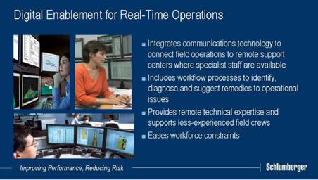

It is increasingly the case that job execution can be monitored remotely. This allows appropriate expertise to be connected to the wellsite for better decision making, and young engineers can be coached and supported, thereby helping with the shortage of trained and experienced personnel.

One example of this in practice is our own drilling operations support center in Aberdeen. The center, which can monitor up to 28 drilling operations worldwide simultaneously operates 24 hours a day, 7 days a week and houses operations engineers, drilling experts, and geo-science specialists under the same roof. We have 23 such Operations Support Centers around the world, with 14 more planned to be ready before the end of the year.
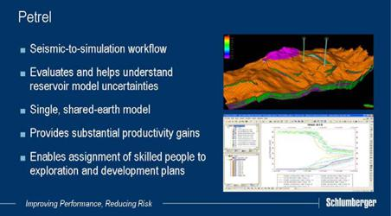

Schlumberger Investor Conference 2006 Executive Speech Final

Lastly I would like to talk about changes in process. One of the most significant products in the market that is helping to improve performance and reduce risk is the Schlumberger Petrel* workflow process software. The ability of Petrel to evaluate and test the various uncertainties in the information is key to mitigating risk in field development.

The Petrel platform integrates all geo-science disciplines in a user-friendly and intuitive manner. The seamless coupling of geophysics, geology and reservoir engineering allows the right wells to be drilled in the right places, and produced optimally, while gaining better control of the uncertainties associated with any particular reservoir model.

Petrel is based on a shared-earth model that enables dramatic productivity gains and increased collaboration practices at a time when access to skilled people is often a determining factor in the successful execution of exploration or development plans. We think this is very exciting, and Jeff will show you more, later.

The oil and gas industry has traditionally been very conservative in its adoption of new technology. As I mentioned earlier, the uptake of technologies has increased significantly and I would like to show you what I mean by looking at the uptake of the four technology platforms that we have just discussed.
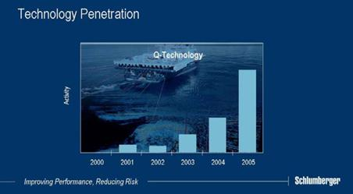

The Q-technology* platform has grown rapidly since its initial introduction. You’ll remember that there was some skepticism upon its rollout, but you’ll also remember the industry context—there was little exploration seismic and the focus was on time-lapse reservoir surveys. That has now dramatically changed and Q revenues have been climbing strongly.

In 2005 we more than doubled Q revenue from $162 million to $399 million. Revenues for the first half of 2006 confirm continuing strength with these results being generated at significantly differentiated pricing premiums over conventional 3D surveys. You will hear the details in Dalton’s presentation later.

Schlumberger Investor Conference 2006 Executive Speech Final
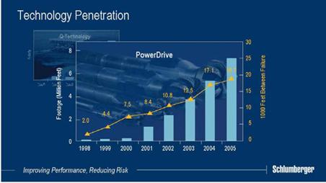

I have used PowerDrive* rotary-steerable system technology as a proxy for the uptake of digital enablement. The reason is simple. Complex wellbores often require offsite experts who access multiple data streams in real time. You can clearly see that this is another technology that has enjoyed rapid success and the data here show two facets of this. In addition to the year-on-year increases in footage drilled, we have also seen just as rapid an increase in the reliability of the technology. This is a key advantage when total drilling costs can now exceed $1M per day.
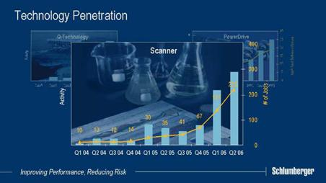

Next we have the unique, deep reading Scanner* family of characterization measurements. You can see the total uptake of the Scanner family since introduction, and as I have highlighted earlier, this has only just begun.

Schlumberger Investor Conference 2006 Executive Speech Final
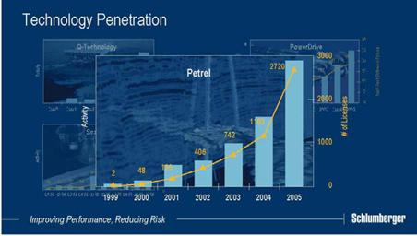

Finally, Petrel. Industry response to Petrel has been phenomenal, resulting in accelerated introduction to an increasing number of asset teams. 17 of the world’s top oil and gas producers and 500 other companies use the software. No fewer than 80 companies have already adopted it as their standard within the last 18 months. Petrel will continue to evolve at a rapid pace to further impact exploration processes and to expand towards a full reservoir management solution.
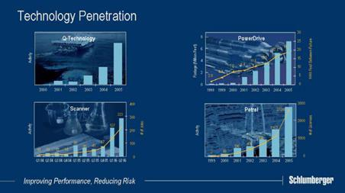

These graphs clearly illustrate the new mindset of the oil and gas industry. When technology is differentiated and clearly addresses the market drivers, the penetration rates and the resulting growth can be very attractive.

Schlumberger Investor Conference 2006 Executive Speech Final
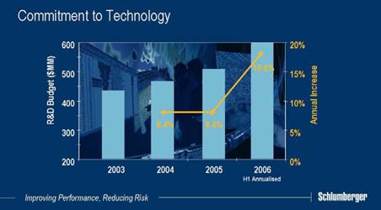

This very encouraging situation drives our increasing investment into technology funding. Schlumberger has consistently grown research and development funding over the past 5 years but in 2006 we increased it by 18.6%, and as Andrew said before, will increase again as a percentage of revenue. As the cycle continues to provide growth opportunities, the capabilities of our technology engine will produce technologies that will improve the performance of our customers, and reduce the risks on their investments.

For the rest of the day, we will show you a cross section of these technologies. We cover these over five stations, and each of you will visit them all, each group starting at a different station.
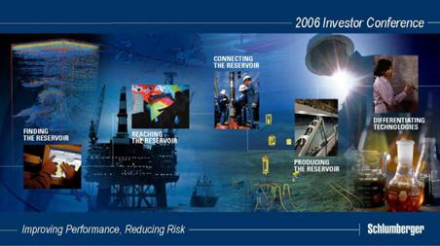

All five are shown on this slide and I will just outline the story.

The first part of the story is called “Finding the Reservoir”. This is focused on Schlumberger seismic measurements, where we demonstrate the power of our Q platform technologies and the opportunities provided by integrated offerings to a changing customer base.

Schlumberger Investor Conference 2006 Executive Speech Final

In “Reaching the Reservoir”, the second presentation, we will show how Schlumberger drilling and measurements technologies have advanced. Integrating with the Petrel reservoir model enables us to place the well in the best part of the reservoir for the best performance with low technical risk. We will demonstrate how these drilling workflows have helped customers add reserves and improve production.

The next stop “Connecting the Reservoir”, describes how we have made completions intelligent by using the knowledge of the Petrel reservoir model. Schlumberger is using its portfolio of reservoir measurement and characterization technologies to position itself for growth in this increasingly sophisticated market.

In “Producing the Reservoir”, we will discuss how the continuous flow of information, much of which is available in real time, can be used to improve the initial reservoir model while monitoring production over time. The continuous updating of the reservoir model through Petrel enables maximum workflow efficiency and increased productivity.

Finally, the foundation of Schlumberger lies in metrology which is the understanding of measurement technology for reservoir characterization. This is critical to differentiation in reservoir-centric oilfield services. The fifth presentation, “Differentiating Technologies”, will clearly demonstrate the benefits of measurement, and the advantages that Schlumberger brings to the market.

Jean-Francois Poupeau will now cover the logistics of your visit. We hope that you will enjoy your day, and we look forward to answering your questions. Thank you.

* Mark of Schlumberger

