Filed by Schlumberger N.V.
pursuant to Rule 425 under the Securities Act of 1933
and deemed filed pursuant to Rule 14a-12
under the Securities Exchange Act of 1934
Subject Company: ChampionX Corporation
Filers SEC File No.: 001-38441
Date: April 3, 2024

UNITED STATES
SECURITIES AND EXCHANGE COMMISSION
Washington, D.C. 20549

SCHEDULE 14A
Proxy Statement Pursuant to Section 14(a) of the
Securities Exchange Act of 1934

Filed by the Registrant ☒
Filed by a Party other than the Registrant ☐
Check the appropriate box:

☐ | Preliminary Proxy Statement

☐ | Confidential, for Use of the Commission Only (as permitted by Rule 14a-6(e)(2))

☐ | Definitive Proxy Statement

☐ | Definitive Additional Materials

☒ | Soliciting Material Pursuant to Section 240.14a-12
ChampionX Corporation
(Name of Registrant as Specified In Its Charter)
(Name of Person(s) Filing Proxy Statement, if other than the Registrant)
Payment of Filing Fee (Check the appropriate box):

☒ | No fee required.

☐ | Fee paid previously with preliminary materials.

☐ | Fee computed on table in exhibit required by Item 25(b) per Exchange Act Rule 12a6(i)(1) and 0-11

On April 2, 2024, ChampionX Corporation posted the following investor presentation to its website.

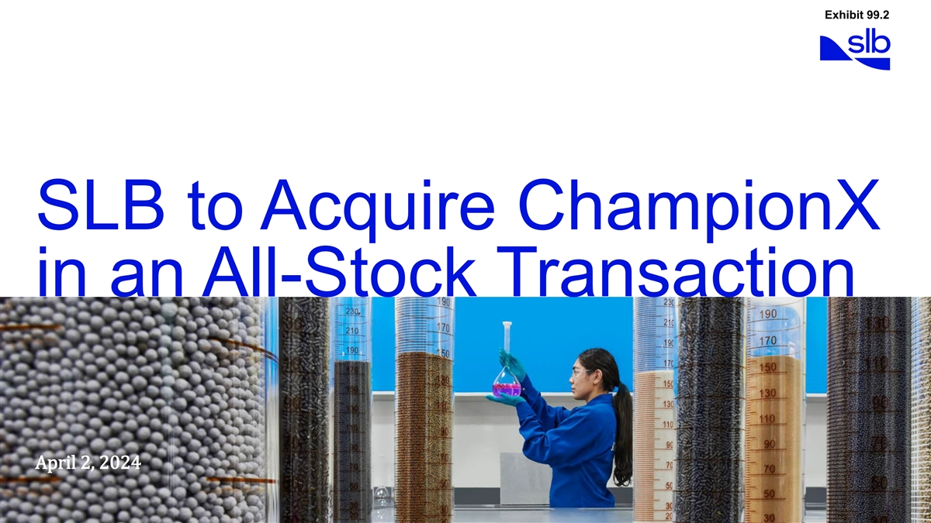
Exhibit 99.2 SLB to Acquire ChampionX in an All-Stock Transaction April 2, 2024

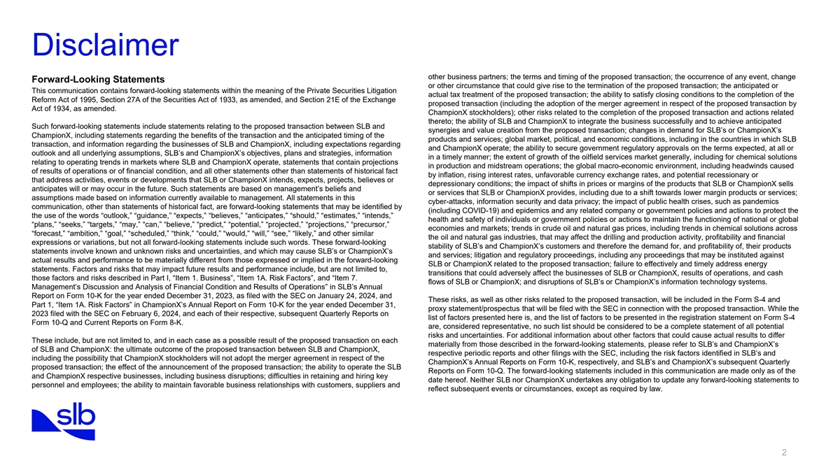
Disclaimer other business partners; the terms and timing of the proposed transaction; the occurrence of any event, change Forward-Looking Statements or other circumstance that could give rise to the termination of the proposed transaction; the anticipated or This communication contains forward-looking statements within the meaning of the Private Securities Litigation actual tax treatment of the proposed transaction; the ability to satisfy closing conditions to the completion of the Reform Act of 1995, Section 27A of the Securities Act of 1933, as amended, and Section 21E of the Exchange proposed transaction (including the adoption of the merger agreement in respect of the proposed transaction by Act of 1934, as amended. ChampionX stockholders); other risks related to the completion of the proposed transaction and actions related thereto; the ability of SLB and ChampionX to integrate the business successfully and to achieve anticipated Such forward-looking statements include statements relating to the proposed transaction between SLB and synergies and value creation from the proposed transaction; changes in demand for SLB’s or ChampionX’s ChampionX, including statements regarding the benefits of the transaction and the anticipated timing of the products and services; global market, political, and economic conditions, including in the countries in which SLB transaction, and information regarding the businesses of SLB and ChampionX, including expectations regarding and ChampionX operate; the ability to secure government regulatory approvals on the terms expected, at all or outlook and all underlying assumptions, SLB’s and ChampionX’s objectives, plans and strategies, information in a timely manner; the extent of growth of the oilfield services market generally, including for chemical solutions relating to operating trends in markets where SLB and ChampionX operate, statements that contain projections in production and midstream operations; the global macro-economic environment, including headwinds caused of results of operations or of financial condition, and all other statements other than statements of historical fact by inflation, rising interest rates, unfavorable currency exchange rates, and potential recessionary or that address activities, events or developments that SLB or ChampionX intends, expects, projects, believes or depressionary conditions; the impact of shifts in prices or margins of the products that SLB or ChampionX sells anticipates will or may occur in the future. Such statements are based on management’s beliefs and or services that SLB or ChampionX provides, including due to a shift towards lower margin products or services; assumptions made based on information currently available to management. All statements in this cyber-attacks, information security and data privacy; the impact of public health crises, such as pandemics communication, other than statements of historical fact, are forward-looking statements that may be identified by (including COVID-19) and epidemics and any related company or government policies and actions to protect the the use of the words “outlook,” “guidance,” “expects,” “believes,” “anticipates,” “should,” “estimates,” “intends,” health and safety of individuals or government policies or actions to maintain the functioning of national or global “plans,” “seeks,” “targets,” “may,” “can,” “believe,” “predict,” “potential,” “projected,” “projections,” “precursor,” economies and markets; trends in crude oil and natural gas prices, including trends in chemical solutions across “forecast,” “ambition,” “goal,” “scheduled,” “think,” “could,” “would,” “will,” “see,” “likely,” and other similar the oil and natural gas industries, that may affect the drilling and production activity, profitability and financial expressions or variations, but not all forward-looking statements include such words. These forward-looking stability of SLB’s and ChampionX’s customers and therefore the demand for, and profitability of, their products statements involve known and unknown risks and uncertainties, and which may cause SLB’s or ChampionX’s and services; litigation and regulatory proceedings, including any proceedings that may be instituted against actual results and performance to be materially different from those expressed or implied in the forward-looking SLB or ChampionX related to the proposed transaction; failure to effectively and timely address energy statements. Factors and risks that may impact future results and performance include, but are not limited to, transitions that could adversely affect the businesses of SLB or ChampionX, results of operations, and cash those factors and risks described in Part I, “Item 1. Business”, “Item 1A. Risk Factors”, and “Item 7. flows of SLB or ChampionX; and disruptions of SLB’s or ChampionX’s information technology systems. Management’s Discussion and Analysis of Financial Condition and Results of Operations” in SLB’s Annual Report on Form 10-K for the year ended December 31, 2023, as filed with the SEC on January 24, 2024, and These risks, as well as other risks related to the proposed transaction, will be included in the Form S-4 and Part 1, “Item 1A. Risk Factors” in ChampionX’s Annual Report on Form 10-K for the year ended December 31, proxy statement/prospectus that will be filed with the SEC in connection with the proposed transaction. While the 2023 filed with the SEC on February 6, 2024, and each of their respective, subsequent Quarterly Reports on list of factors presented here is, and the list of factors to be presented in the registration statement on Form S-4 Form 10-Q and Current Reports on Form 8-K. are, considered representative, no such list should be considered to be a complete statement of all potential risks and uncertainties. For additional information about other factors that could cause actual results to differ These include, but are not limited to, and in each case as a possible result of the proposed transaction on each materially from those described in the forward-looking statements, please refer to SLB’s and ChampionX’s of SLB and ChampionX: the ultimate outcome of the proposed transaction between SLB and ChampionX, respective periodic reports and other filings with the SEC, including the risk factors identified in SLB’s and including the possibility that ChampionX stockholders will not adopt the merger agreement in respect of the ChampionX’s Annual Reports on Form 10-K, respectively, and SLB’s and ChampionX’s subsequent Quarterly proposed transaction; the effect of the announcement of the proposed transaction; the ability to operate the SLB Reports on Form 10-Q. The forward-looking statements included in this communication are made only as of the and ChampionX respective businesses, including business disruptions; difficulties in retaining and hiring key date hereof. Neither SLB nor ChampionX undertakes any obligation to update any forward-looking statements to personnel and employees; the ability to maintain favorable business relationships with customers, suppliers and reflect subsequent events or circumstances, except as required by law. 2

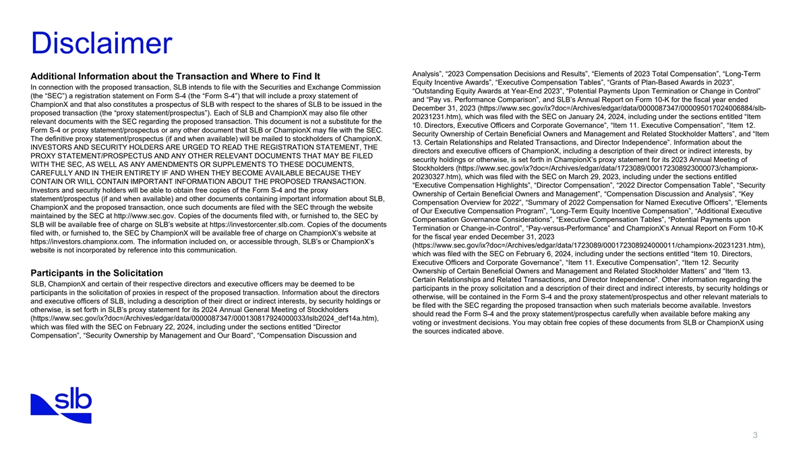
Disclaimer Analysis”, “2023 Compensation Decisions and Results”, “Elements of 2023 Total Compensation”, “Long-Term Additional Information about the Transaction and Where to Find It Equity Incentive Awards”, “Executive Compensation Tables”, “Grants of Plan-Based Awards in 2023”, In connection with the proposed transaction, SLB intends to file with the Securities and Exchange Commission “Outstanding Equity Awards at Year-End 2023”, “Potential Payments Upon Termination or Change in Control” (the “SEC”) a registration statement on Form S-4 (the “Form S-4”) that will include a proxy statement of and “Pay vs. Performance Comparison”, and SLB’s Annual Report on Form 10-K for the fiscal year ended ChampionX and that also constitutes a prospectus of SLB with respect to the shares of SLB to be issued in the December 31, 2023 (https://www.sec.gov/ix?doc=/Archives/edgar/data/0000087347/000095017024006884/slb- proposed transaction (the “proxy statement/prospectus”). Each of SLB and ChampionX may also file other 20231231.htm), which was filed with the SEC on January 24, 2024, including under the sections entitled “Item relevant documents with the SEC regarding the proposed transaction. This document is not a substitute for the 10. Directors, Executive Officers and Corporate Governance”, “Item 11. Executive Compensation”, “Item 12. Form S-4 or proxy statement/prospectus or any other document that SLB or ChampionX may file with the SEC. Security Ownership of Certain Beneficial Owners and Management and Related Stockholder Matters”, and “Item The definitive proxy statement/prospectus (if and when available) will be mailed to stockholders of ChampionX. 13. Certain Relationships and Related Transactions, and Director Independence”. Information about the INVESTORS AND SECURITY HOLDERS ARE URGED TO READ THE REGISTRATION STATEMENT, THE directors and executive officers of ChampionX, including a description of their direct or indirect interests, by PROXY STATEMENT/PROSPECTUS AND ANY OTHER RELEVANT DOCUMENTS THAT MAY BE FILED security holdings or otherwise, is set forth in ChampionX’s proxy statement for its 2023 Annual Meeting of WITH THE SEC, AS WELL AS ANY AMENDMENTS OR SUPPLEMENTS TO THESE DOCUMENTS, Stockholders (https://www.sec.gov/ix?doc=/Archives/edgar/data/1723089/000172308923000073/championx- CAREFULLY AND IN THEIR ENTIRETY IF AND WHEN THEY BECOME AVAILABLE BECAUSE THEY 20230327.htm), which was filed with the SEC on March 29, 2023, including under the sections entitled CONTAIN OR WILL CONTAIN IMPORTANT INFORMATION ABOUT THE PROPOSED TRANSACTION. “Executive Compensation Highlights”, “Director Compensation”, “2022 Director Compensation Table”, “Security Investors and security holders will be able to obtain free copies of the Form S-4 and the proxy Ownership of Certain Beneficial Owners and Management”, “Compensation Discussion and Analysis”, “Key statement/prospectus (if and when available) and other documents containing important information about SLB, Compensation Overview for 2022”, “Summary of 2022 Compensation for Named Executive Officers”, “Elements ChampionX and the proposed transaction, once such documents are filed with the SEC through the website of Our Executive Compensation Program”, “Long-Term Equity Incentive Compensation”, “Additional Executive maintained by the SEC at http://www.sec.gov. Copies of the documents filed with, or furnished to, the SEC by Compensation Governance Considerations”, “Executive Compensation Tables”, “Potential Payments upon SLB will be available free of charge on SLB’s website at https://investorcenter.slb.com. Copies of the documents Termination or Change-in-Control”, “Pay-versus-Performance” and ChampionX’s Annual Report on Form 10-K filed with, or furnished to, the SEC by ChampionX will be available free of charge on ChampionX’s website at for the fiscal year ended December 31, 2023 https://investors.championx.com. The information included on, or accessible through, SLB’s or ChampionX’s (https://www.sec.gov/ix?doc=/Archives/edgar/data/1723089/000172308924000011/championx-20231231.htm), website is not incorporated by reference into this communication. which was filed with the SEC on February 6, 2024, including under the sections entitled “Item 10. Directors, Executive Officers and Corporate Governance”, “Item 11. Executive Compensation”, “Item 12. Security Ownership of Certain Beneficial Owners and Management and Related Stockholder Matters” and “Item 13. Participants in the Solicitation Certain Relationships and Related Transactions, and Director Independence”. Other information regarding the SLB, ChampionX and certain of their respective directors and executive officers may be deemed to be participants in the proxy solicitation and a description of their direct and indirect interests, by security holdings or participants in the solicitation of proxies in respect of the proposed transaction. Information about the directors otherwise, will be contained in the Form S-4 and the proxy statement/prospectus and other relevant materials to and executive officers of SLB, including a description of their direct or indirect interests, by security holdings or be filed with the SEC regarding the proposed transaction when such materials become available. Investors otherwise, is set forth in SLB’s proxy statement for its 2024 Annual General Meeting of Stockholders should read the Form S-4 and the proxy statement/prospectus carefully when available before making any (https://www.sec.gov/ix?doc=/Archives/edgar/data/0000087347/000130817924000033/lslb2024_def14a.htm), voting or investment decisions. You may obtain free copies of these documents from SLB or ChampionX using which was filed with the SEC on February 22, 2024, including under the sections entitled “Director the sources indicated above. Compensation”, “Security Ownership by Management and Our Board”, “Compensation Discussion and 3

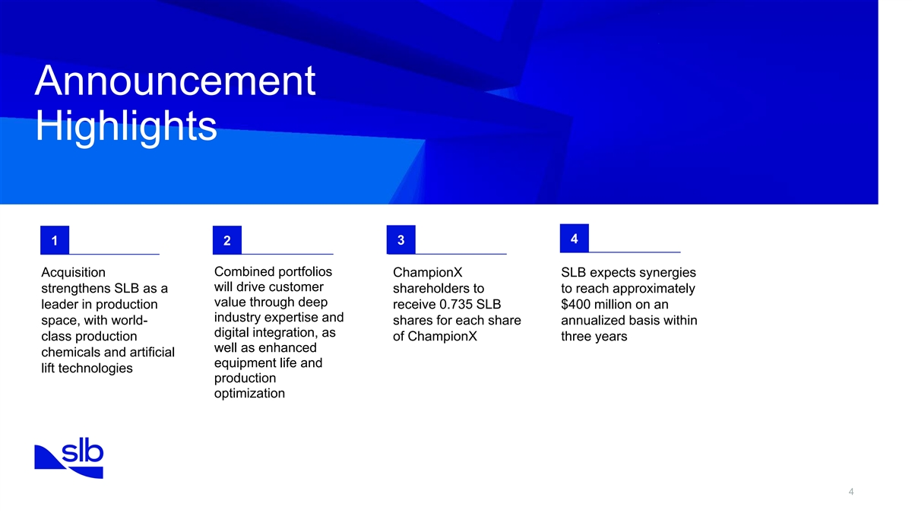
Announcement Highlights 4 1 2 3 Combined portfolios Acquisition ChampionX SLB expects synergies will drive customer strengthens SLB as a shareholders to to reach approximately value through deep leader in production receive 0.735 SLB $400 million on an industry expertise and space, with world- shares for each share annualized basis within digital integration, as class production of ChampionX three years well as enhanced chemicals and artificial equipment life and lift technologies production optimization 4

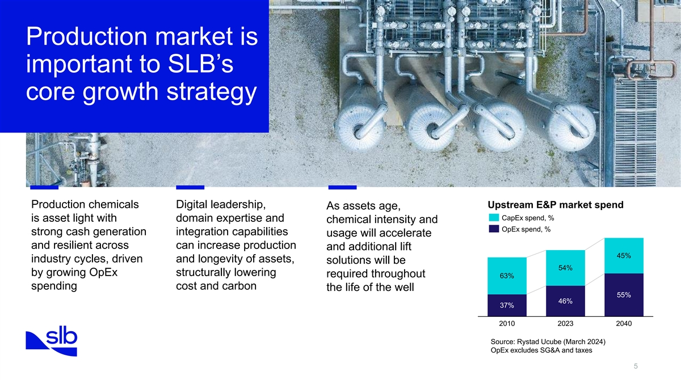
Production market is important to SLB’s core growth strategy Production chemicals Digital leadership, Upstream E&P market spend As assets age, CapEx spend, % is asset light with domain expertise and chemical intensity and OpEx spend, % strong cash generation integration capabilities usage will accelerate and resilient across can increase production and additional lift 45% industry cycles, driven and longevity of assets, solutions will be 54% by growing OpEx structurally lowering required throughout 63% spending cost and carbon the life of the well 55% 46% 37% 2010 2023 2040 Source: Rystad Ucube (March 2024) OpEx excludes SG&A and taxes 5

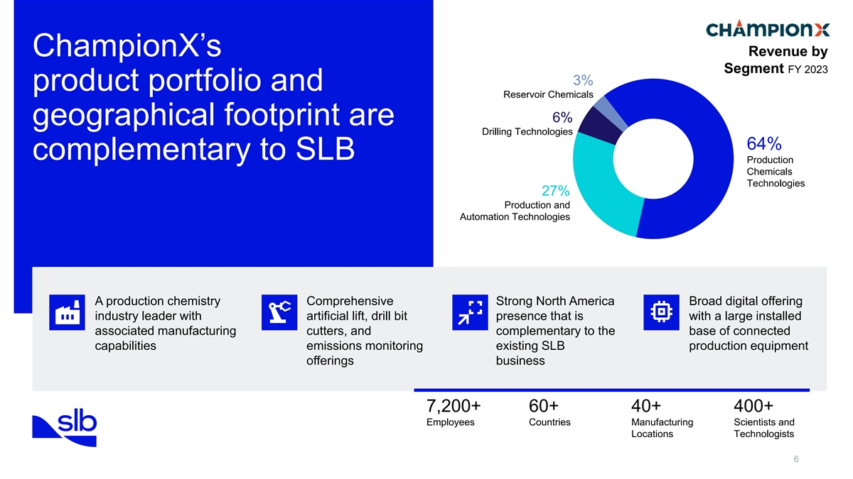
Revenue by ChampionX’s Segment FY 2023 3% product portfolio and Reservoir Chemicals 6% geographical footprint are Drilling Technologies 64% complementary to SLB Production Chemicals Technologies 27% Production and Automation Technologies A production chemistry Comprehensive Strong North America Broad digital offering industry leader with artificial lift, drill bit presence that is with a large installed associated manufacturing cutters, and complementary to the base of connected capabilities emissions monitoring existing SLB production equipment offerings business 7,200+ 60+ 40+ 400+ Employees Countries Manufacturing Scientists and Locations Technologists 6

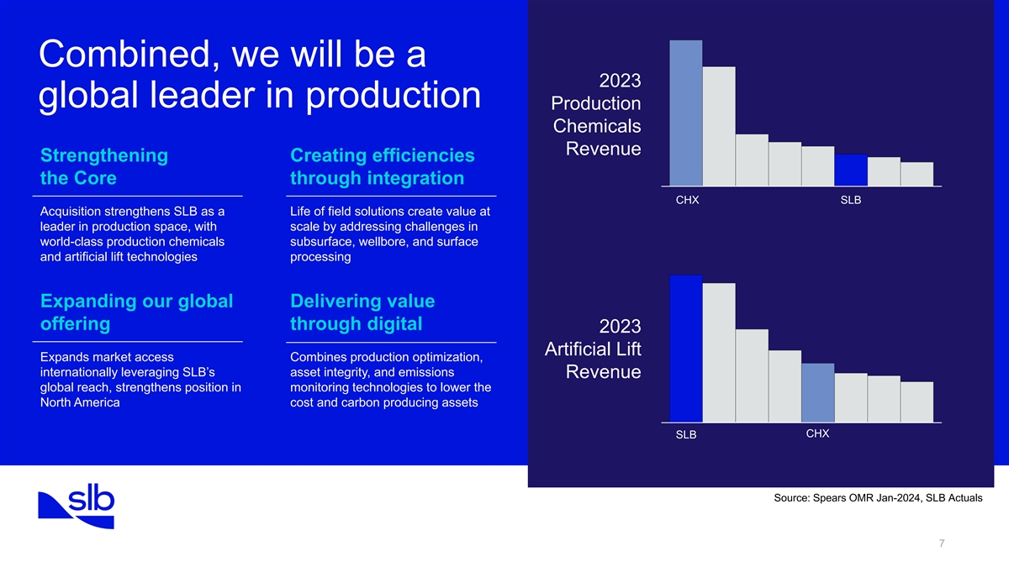
Combined, we will be a 2023 global leader in production Production Chemicals Revenue Strengthening Creating efficiencies the Core through integration CHX SLB Acquisition strengthens SLB as a Life of field solutions create value at leader in production space, with scale by addressing challenges in world-class production chemicals subsurface, wellbore, and surface and artificial lift technologies processing Expanding our global Delivering value offering through digital 2023 Artificial Lift Expands market access Combines production optimization, internationally leveraging SLB’s asset integrity, and emissions Revenue global reach, strengthens position in monitoring technologies to lower the North America cost and carbon producing assets CHX SLB Source: Spears OMR Jan-2024, SLB Actuals 7

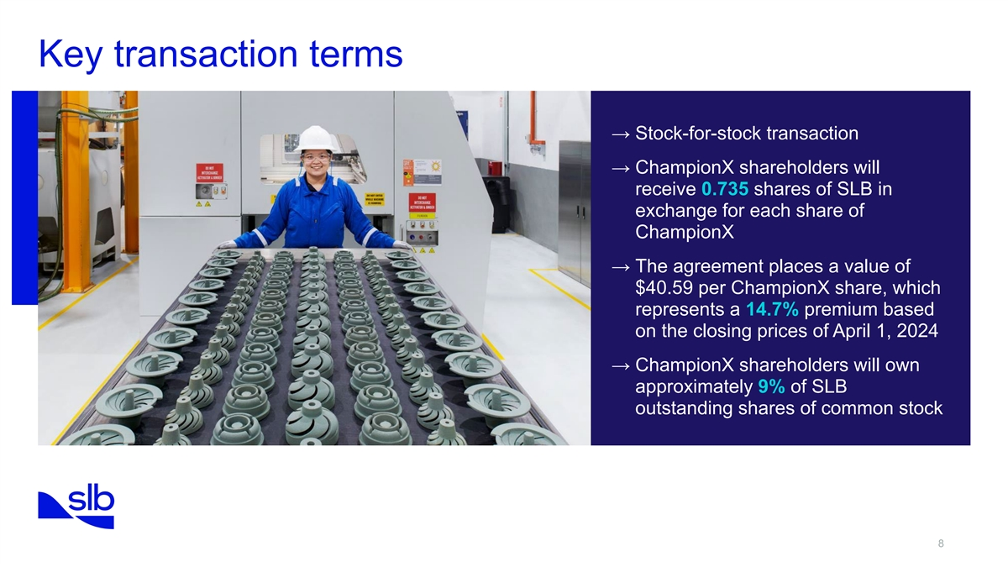
Key transaction terms → Stock-for-stock transaction → ChampionX shareholders will receive 0.735 shares of SLB in exchange for each share of ChampionX → The agreement places a value of $40.59 per ChampionX share, which represents a 14.7% premium based on the closing prices of April 1, 2024 → ChampionX shareholders will own approximately 9% of SLB outstanding shares of common stock 8

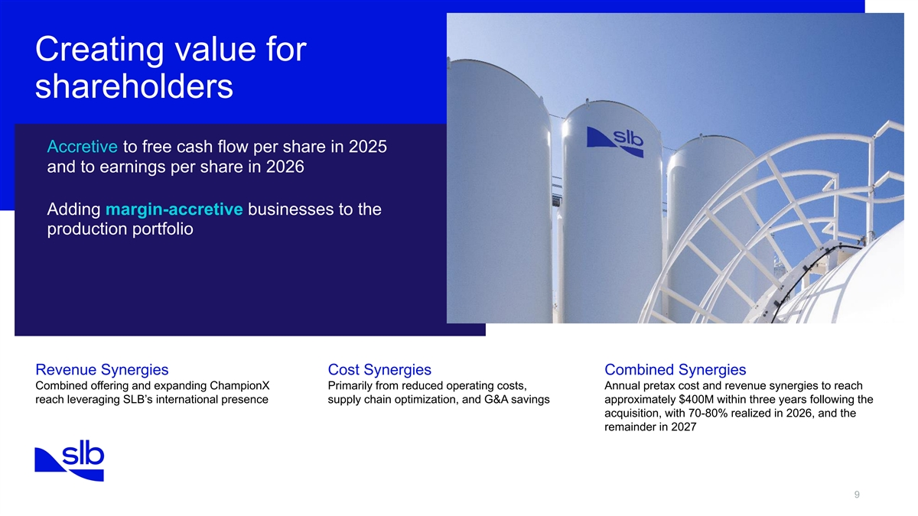
Creating value for shareholders Accretive to free cash flow per share in 2025 and to earnings per share in 2026 Adding margin-accretive businesses to the production portfolio Revenue Synergies Cost Synergies Combined Synergies Combined offering and expanding ChampionX Primarily from reduced operating costs, Annual pretax cost and revenue synergies to reach reach leveraging SLB’s international presence supply chain optimization, and G&A savings approximately $400M within three years following the acquisition, with 70-80% realized in 2026, and the remainder in 2027 9

Forward-Looking Statements
This communication contains forward-looking statements within the meaning of the Private Securities Litigation Reform Act of 1995, Section 27A of the Securities Act of 1933, as amended (the Securities Act), and Section 21E of the Securities Exchange Act of 1934, as amended.
Such forward-looking statements include statements relating to the proposed transaction between SLB and ChampionX, including statements regarding the benefits of the transaction and the anticipated timing of the transaction, and information regarding the businesses of SLB and ChampionX, including expectations regarding outlook and all underlying assumptions, SLBs and ChampionXs objectives, plans and strategies, information relating to operating trends in markets where SLB and ChampionX operate, statements that contain projections of results of operations or of financial condition and all other statements other than statements of historical fact that address activities, events or developments that SLB or ChampionX intends, expects, projects, believes or anticipates will or may occur in the future. Such statements are based on managements beliefs and assumptions made based on information currently available to management. All statements in this communication, other than statements of historical fact, are forward-looking statements that may be identified by the use of the words outlook, guidance, expects, believes, anticipates, should, estimates, intends, plans, seeks, targets, may, can, believe, predict, potential, projected, projections, precursor, forecast, ambition, goal, scheduled, think, could, would, will, see, likely, and other similar expressions or variations, but not all forward-looking statements include such words. These forward-looking statements involve known and unknown risks and uncertainties, and which may cause SLBs or ChampionXs actual results and performance to be materially different from those expressed or implied in the forward-looking statements. Factors and risks that may impact future results and performance include, but are not limited to those factors and risks described in Part I, Item 1. Business, Item 1A. Risk Factors, and Item 7. Managements Discussion and Analysis of Financial Condition and Results of Operations in SLBs Annual Report on Form 10-K for the year ended December 31, 2023, as filed with the Securities and Exchange Commission (the SEC) on January 24, 2024 and Part 1, Item 1A, Risk Factors in ChampionXs Annual Report on Form 10-K for the year ended December 31, 2023 filed with the SEC on February 6, 2024, and each of their respective, subsequent Quarterly Reports on Form 10-Q and Current Reports on Form 8-K.
These include, but are not limited to, and in each case as a possible result of the proposed transaction on each of SLB and ChampionX: the ultimate outcome of the proposed transaction between SLB and ChampionX, including the possibility that ChampionX stockholders will not adopt the merger agreement in respect of the proposed transaction; the effect of the announcement of the proposed transaction; the ability to operate the SLB and ChampionX respective businesses, including business disruptions; difficulties in retaining and hiring key personnel and employees; the ability to maintain favorable business relationships with customers, suppliers and other business partners; the terms and timing of the proposed transaction; the occurrence of any event, change or other circumstance that could give rise to the termination of the proposed transaction; the anticipated or actual tax treatment of the proposed transaction; the ability to satisfy closing conditions to the completion of the proposed transaction (including the adoption of the merger agreement in respect of the proposed transaction by ChampionX stockholders); other risks related to the completion of the proposed transaction and actions related thereto; the ability of SLB and ChampionX to integrate the business successfully and to achieve anticipated synergies and value creation from the proposed transaction; changes in demand for SLBs or ChampionXs products and services; global market, political and economic conditions, including in the countries in which SLB and ChampionX operate; the ability to secure government regulatory approvals on the terms expected, at all or in a timely manner; the extent of growth of the oilfield services market generally, including for chemical solutions in production and midstream operations; the global macro-economic environment, including headwinds caused by inflation, rising interest rates, unfavorable currency exchange rates, and potential recessionary or depressionary conditions; the impact of shifts in prices or margins of the products that SLB or ChampionX sells or services that SLB or ChampionX provides, including due to a shift towards lower margin products or services; cyber-attacks, information security and data privacy; the impact of public health crises, such as pandemics (including COVID-19) and epidemics and any related company or government policies and actions to protect the health and safety of individuals or government policies or actions to maintain the functioning of national or global economies and markets; trends in crude oil and natural gas prices, including trends in chemical solutions across the oil and natural gas industries, that may affect the drilling and production activity, profitability and financial stability of SLBs and ChampionXs customers and therefore the demand for, and profitability of, their products and services; litigation and regulatory proceedings, including any proceedings that may be instituted against SLB or ChampionX related to the proposed transaction; failure to effectively and timely address energy transitions that could adversely affect the businesses of SLB or ChampionX, results of operations, and cash flows of SLB or ChampionX; and disruptions of SLBs or ChampionXs information technology systems.

These risks, as well as other risks related to the proposed transaction, will be included in the Form S-4 and proxy statement/prospectus (each, as defined below) that will be filed with the SEC in connection with the proposed transaction. While the list of factors presented here is, and the list of factors to be presented in the registration statement on Form S-4 are, considered representative, no such list should be considered to be a complete statement of all potential risks and uncertainties. For additional information about other factors that could cause actual results to differ materially from those described in the forward-looking statements, please refer to SLBs and ChampionXs respective periodic reports and other filings with the SEC, including the risk factors identified in SLBs and ChampionXs Annual Reports on Form 10-K, respectively, and SLBs and ChampionXs subsequent Quarterly Reports on Form 10-Q. The forward-looking statements included in this communication are made only as of the date hereof. Neither SLB nor ChampionX undertakes any obligation to update any forward-looking statements to reflect subsequent events or circumstances, except as required by law.
Additional Information about the Transaction and Where to Find It
In connection with the proposed transaction, SLB intends to file with the SEC a registration statement on Form S-4 (the Form S-4) that will include a proxy statement of ChampionX and that also constitutes a prospectus of SLB with respect to the shares of SLB to be issued in the proposed transaction (the proxy statement/prospectus). Each of SLB and ChampionX may also file other relevant documents with the SEC regarding the proposed transaction. This document is not a substitute for the Form S-4 or proxy statement/prospectus or any other document that SLB or ChampionX may file with the SEC. The definitive proxy statement/prospectus (if and when available) will be mailed to stockholders of ChampionX. INVESTORS AND SECURITY HOLDERS ARE URGED TO READ THE REGISTRATION STATEMENT, THE PROXY STATEMENT/PROSPECTUS AND ANY OTHER RELEVANT DOCUMENTS THAT MAY BE FILED WITH THE SEC, AS WELL AS ANY AMENDMENTS OR SUPPLEMENTS TO THESE DOCUMENTS, CAREFULLY AND IN THEIR ENTIRETY IF AND WHEN THEY BECOME AVAILABLE BECAUSE THEY CONTAIN OR WILL CONTAIN IMPORTANT INFORMATION ABOUT THE PROPOSED TRANSACTION. Investors and security holders will be able to obtain free copies of the Form S-4 and the proxy statement/prospectus (if and when available) and other documents containing important information about SLB, ChampionX and the proposed transaction, once such documents are filed with the SEC through the website maintained by the SEC at http://www.sec.gov. Copies of the documents filed with, or furnished to, the SEC by SLB will be available free of charge on SLBs website at https://investorcenter.slb.com. Copies of the documents filed with, or furnished to, the SEC by ChampionX will be available free of charge on ChampionXs website at https://investors.championx.com. The information included on, or accessible through, SLBs or ChampionXs website is not incorporated by reference into this communication.
Participants in the Solicitation
SLB, ChampionX and certain of their respective directors and executive officers may be deemed to be participants in the solicitation of proxies in respect of the proposed transaction. Information about the directors and executive officers of SLB, including a description of their direct or indirect interests, by security holdings or otherwise, is set forth in SLBs proxy statement for its 2024 Annual Meeting of Stockholders (https://www.sec.gov/ix?doc=/Archives/edgar/data/0000087347/000130817924000033/lslb2024_def14a.htm ), which was filed with the SEC on February 22, 2024, including under the sections entitled Director Compensation, Security Ownership by Management and Our Board, Compensation Discussion and Analysis, 2023 Compensation Decisions and Results, Elements of 2023 Total Compensation, Long-Term Equity Incentive Awards, Executive Compensation Tables, Grants of Plan-Based Awards in 2023, Outstanding Equity Awards at Year-End 2023, Potential Payments Upon Termination or Change in Control and Pay vs. Performance Comparison and SLBs Annual Report on Form 10-K for the fiscal year ended December 31, 2023 (https://www.sec.gov/ix?doc=/Archives/edgar/data/0000087347/000095017024006884/slb-20231231.htm), which was filed with the SEC on January 24, 2024, including under the sections entitled Item 10. Directors, Executive Officers and Corporate Governance, Item 11. Executive Compensation, Item 12. Security Ownership of Certain Beneficial Owners and Management and Related Stockholder Matters and Item 13. Certain Relationships and Related Transactions, and Director Independence. Information about the directors and executive officers of ChampionX, including a description of their direct or indirect interests, by security holdings or otherwise, is set forth

in ChampionXs proxy statement for its 2023 Annual Meeting of Stockholders (https://www.sec.gov/ix?doc=/Archives/edgar/data/1723089/000172308923000073/championx-20230327.htm ), which was filed with the SEC on March 29, 2023, including under the sections entitled Executive Compensation Highlights, Director Compensation, 2022 Director Compensation Table, Security Ownership of Certain Beneficial Owners and Management, Compensation Discussion and Analysis, Key Compensation Overview for 2022, Summary of 2022 Compensation for Named Executive Officers, Elements of Our Executive Compensation Program, Long-Term Equity Incentive Compensation, Additional Executive Compensation Governance Considerations, Executive Compensation Tables, Potential Payments upon Termination or Change-in-Control, Pay-versus-Performance and ChampionXs Annual Report on Form 10-K for the fiscal year ended December 31, 2023 (https://www.sec.gov/ix?doc=/Archives/edgar/data/1723089/000172308924000011/championx-20231231.htm), which was filed with the SEC on February 6, 2024, including under the sections entitled Item. 10 Directors, Executive Officers and Corporate Governance, Item 11. Executive Compensation, Item 12. Security Ownership of Certain Beneficial Owners and Management and Related Stockholder Matters and Item 13. Certain Relationships and Related Transactions, and Director Independence. Other information regarding the participants in the proxy solicitation and a description of their direct and indirect interests, by security holdings or otherwise, will be contained in the Form S-4 and the proxy statement/prospectus and other relevant materials to be filed with the SEC regarding the proposed transaction when such materials become available. Investors should read the Form S-4 and the proxy statement/prospectus carefully when available before making any voting or investment decisions. You may obtain free copies of these documents from SLB or ChampionX using the sources indicated above.

