Filing pursuant to Rule 425 under the

Securities Act of 1933, as amended

Deemed filed under Rule 14a-12 under the

Securities Exchange Act of 1934, as amended

Filer: Schlumberger N.V. (Schlumberger Limited)

Subject Company: Cameron International Corporation

Commission File No.: 1-13884
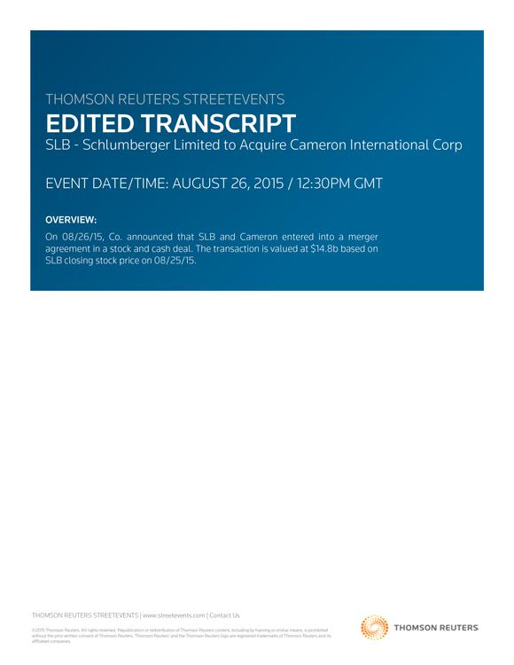

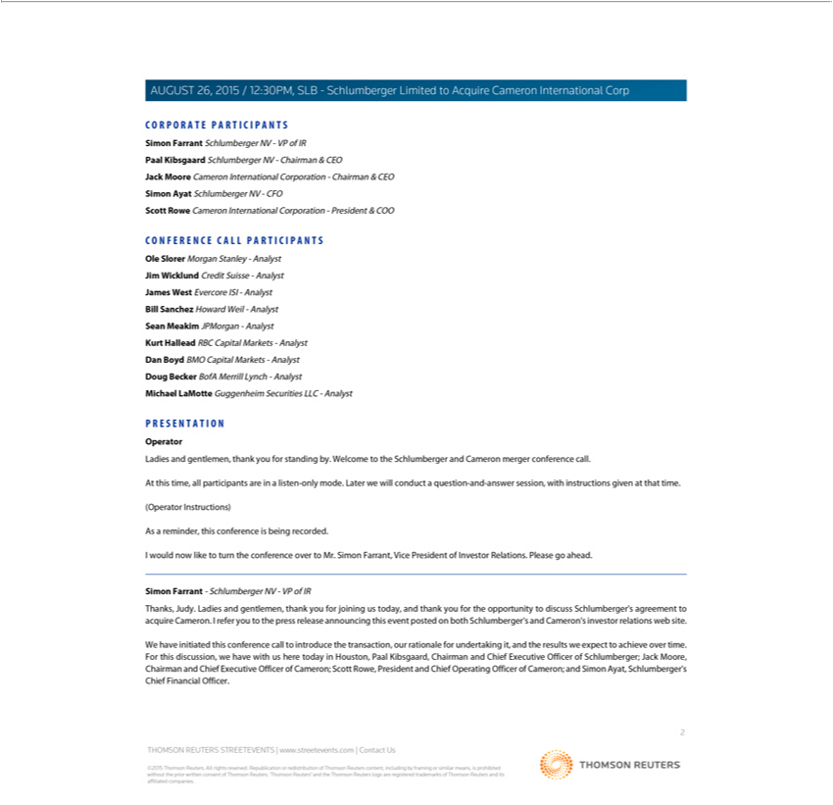

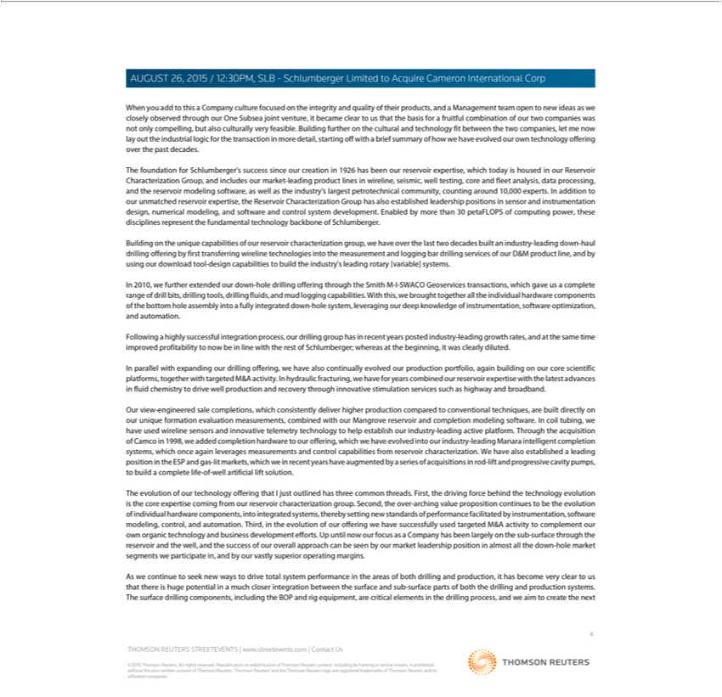

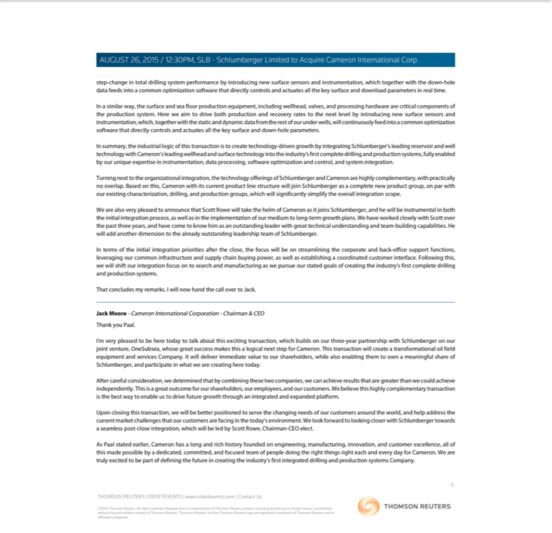

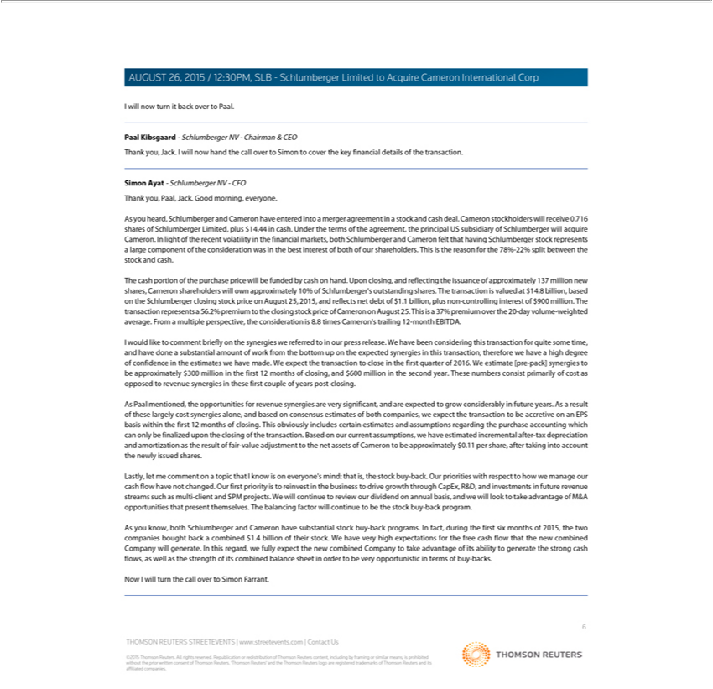

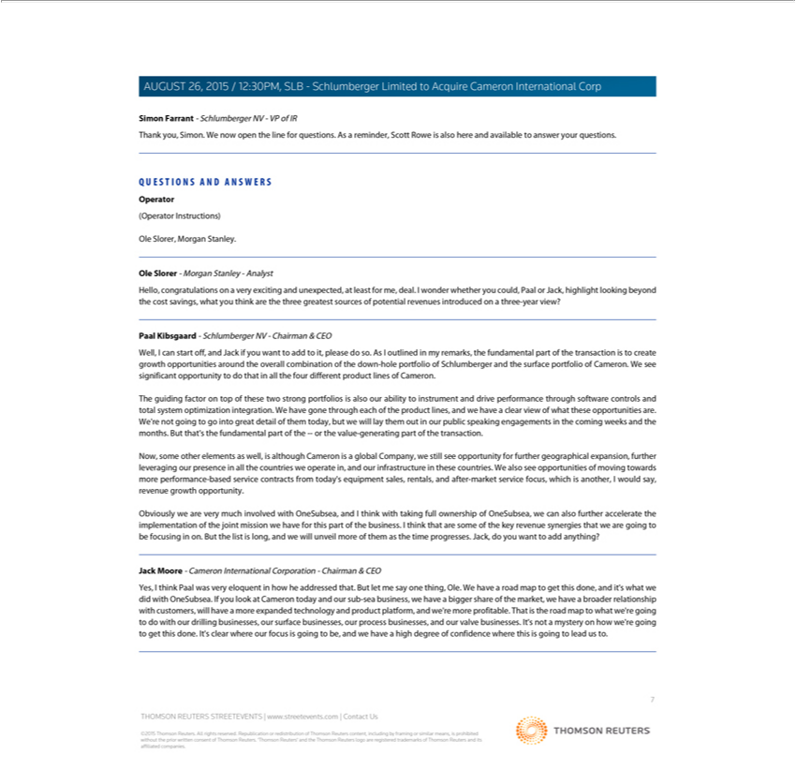

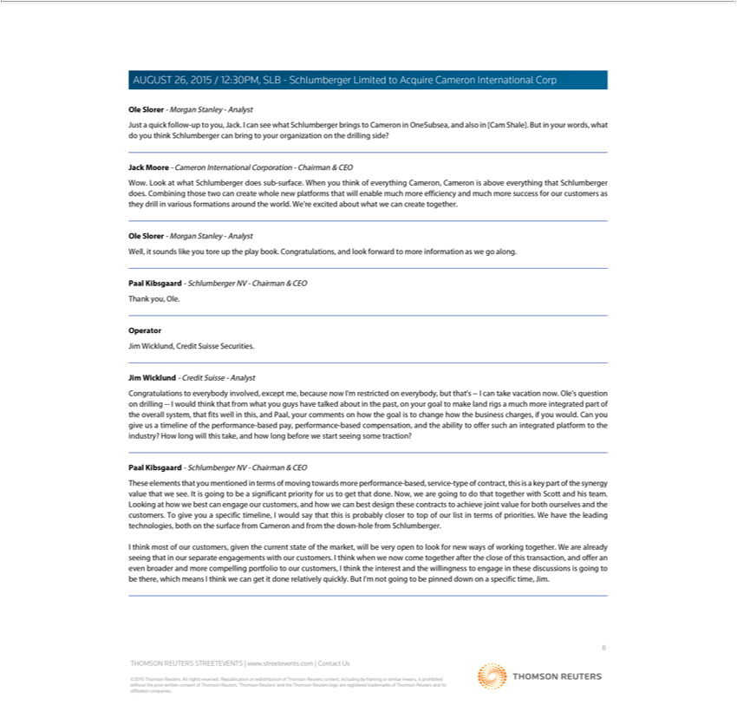

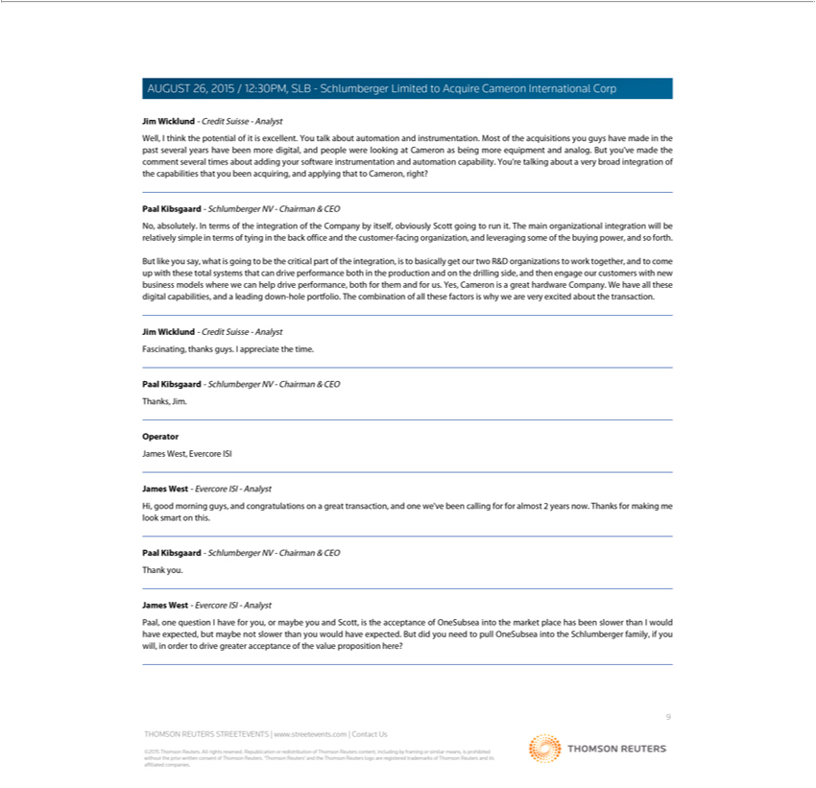

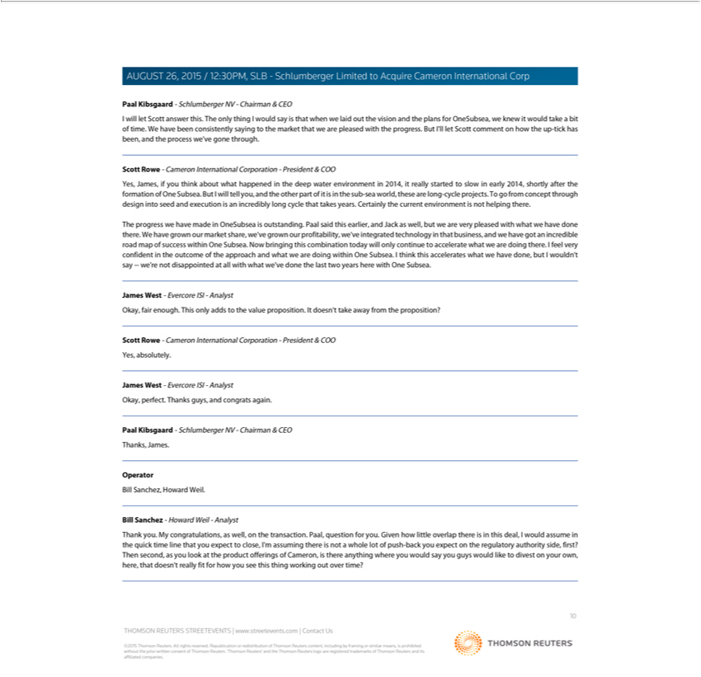

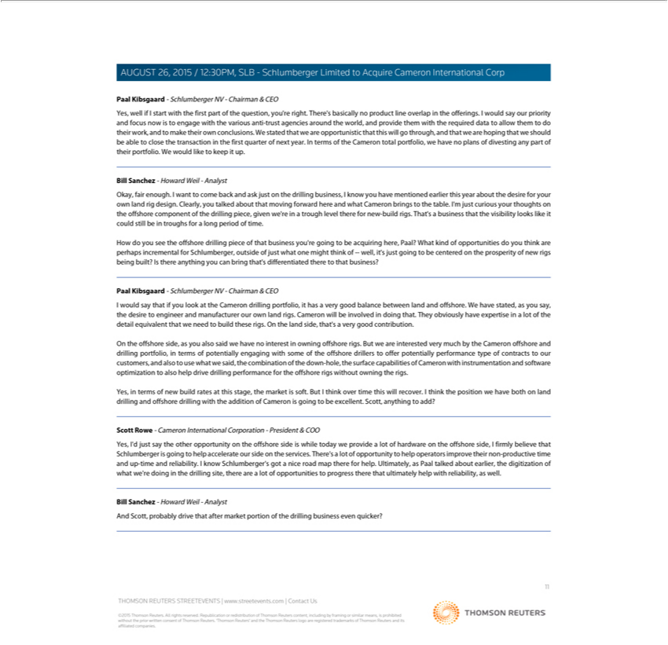

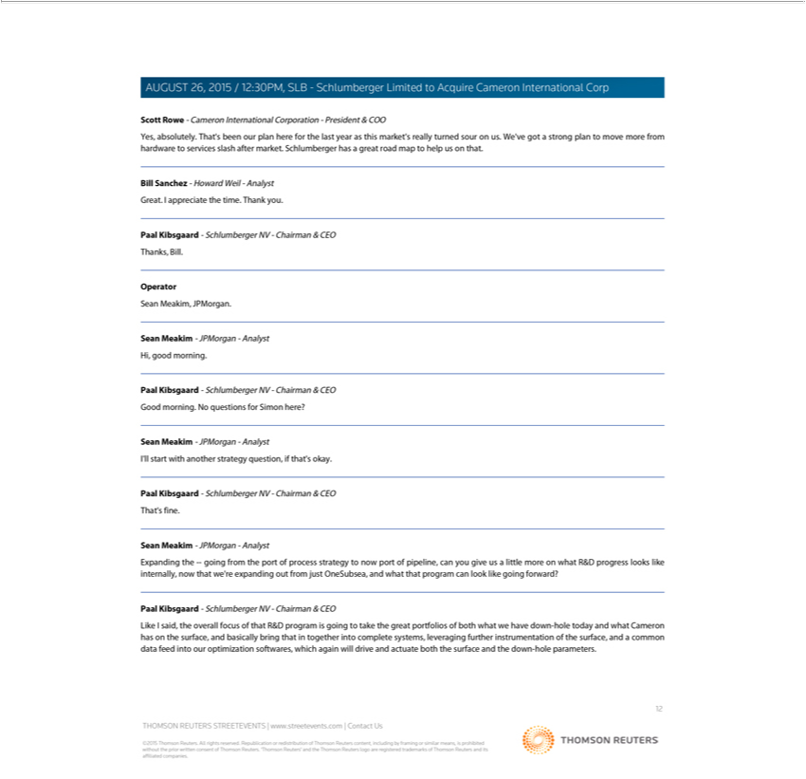

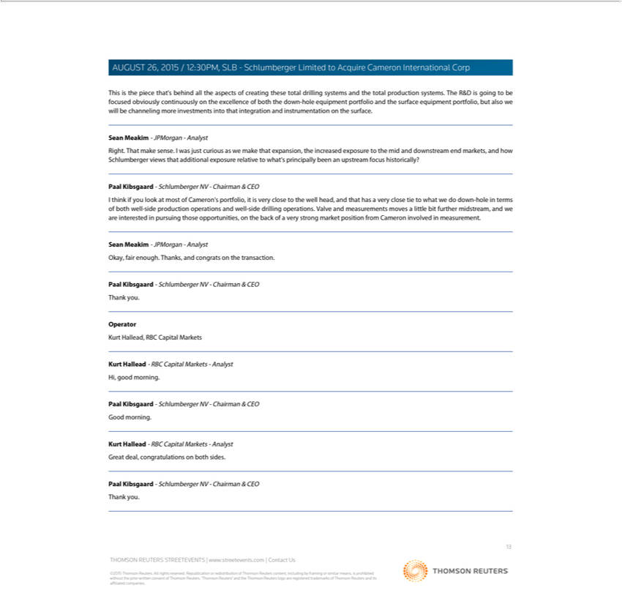

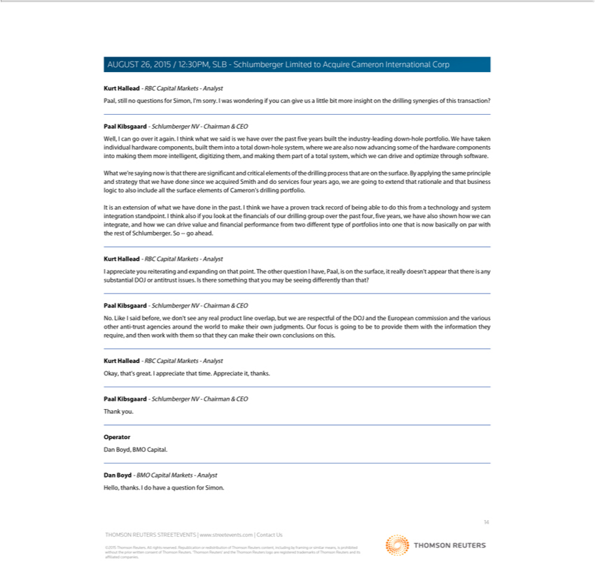

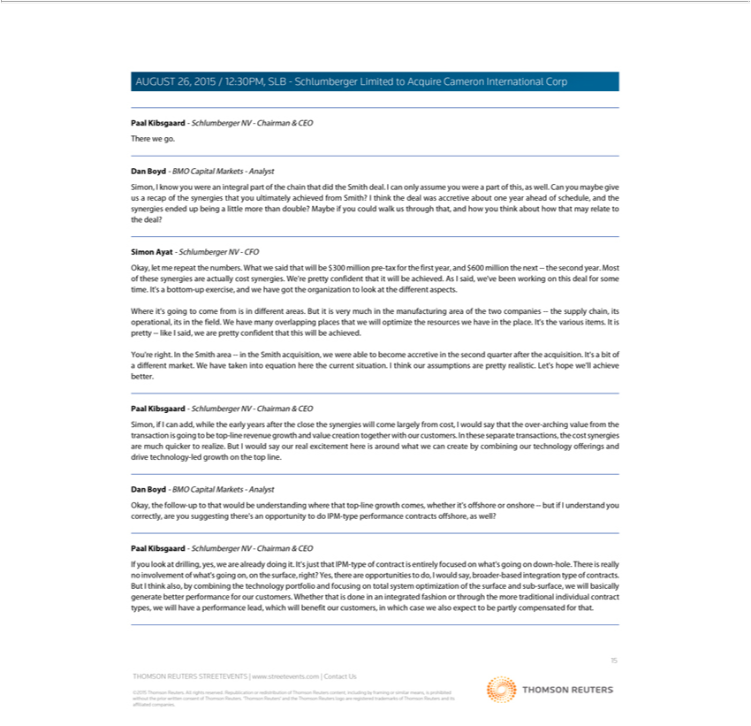

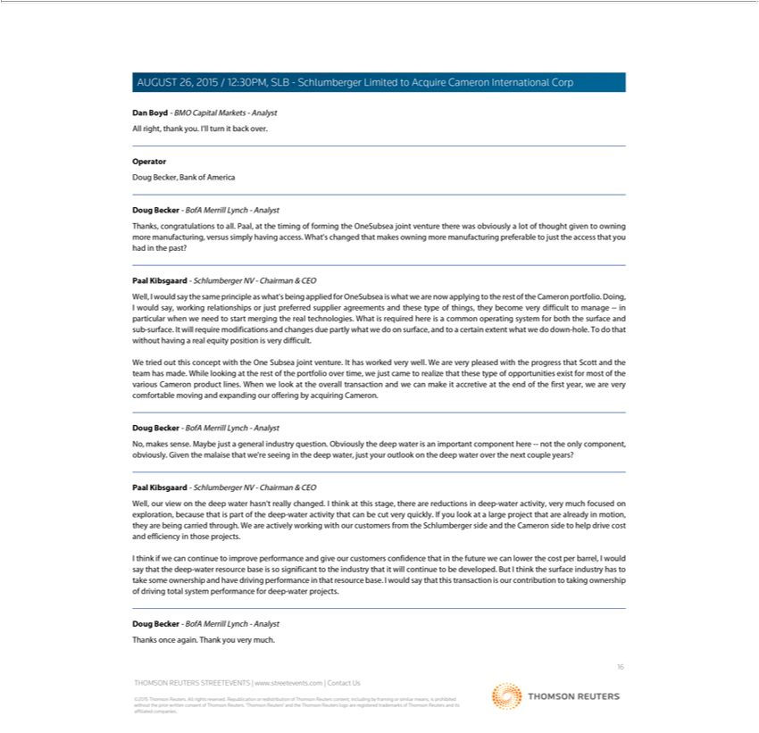

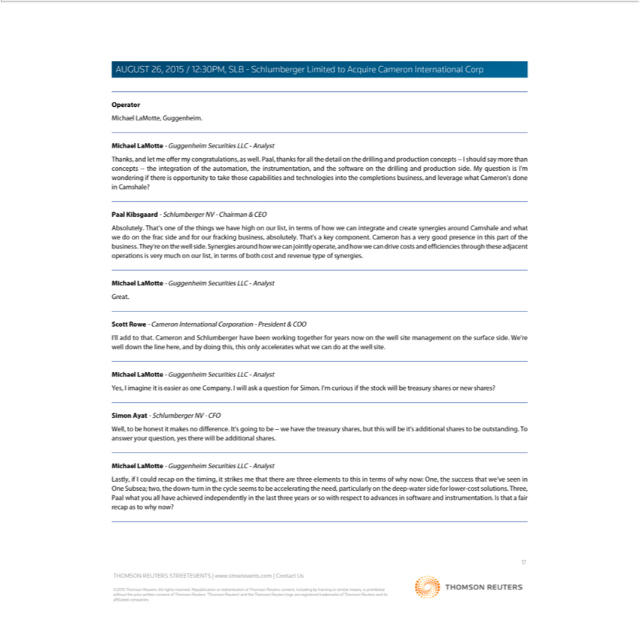

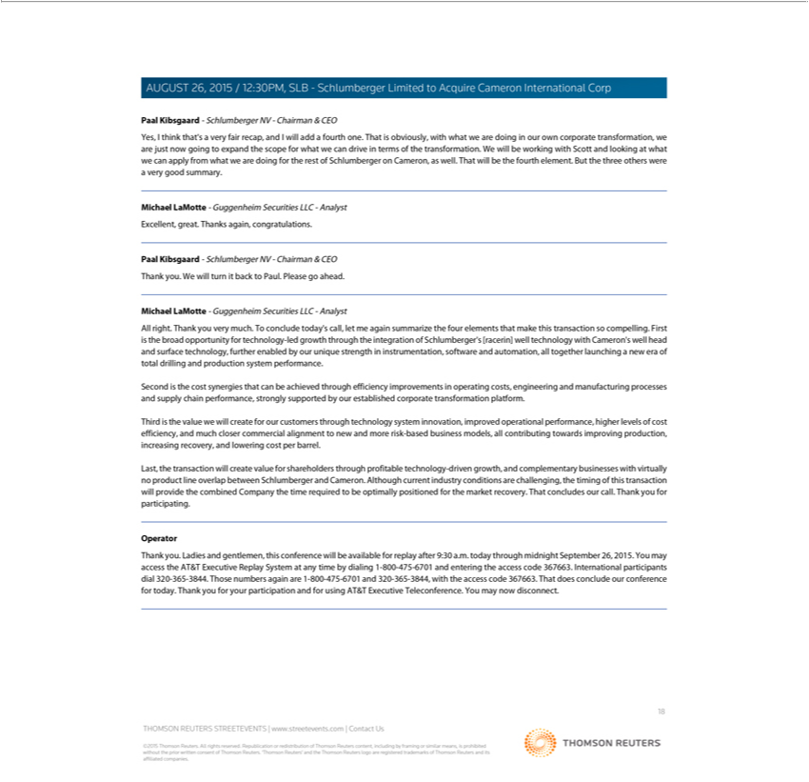

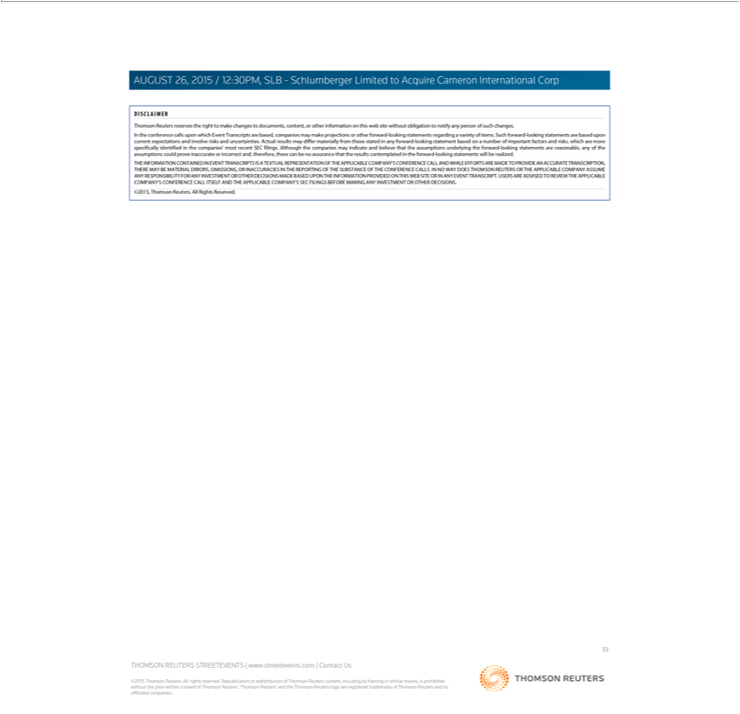

Forward-Looking Statements

This material includes “forward-looking statements” within the meaning of Section 27A of the Securities Act of 1933, as amended, and Section 21E of the Securities Exchange Act of 1934, as amended. The opinions, forecasts, projections, expected timetable for completing the proposed transaction, benefits and synergies of the proposed transaction, future opportunities for the combined company and products, future financial performance and any other statements regarding Schlumberger’s and Cameron’s future expectations, beliefs, plans, objectives, financial conditions, assumptions or future events or performance that are not statements of historical fact, are forward-looking statements. Schlumberger can give no assurance that such expectations will prove to have been correct. These statements are subject to, among other things, satisfaction of the closing conditions to the merger, the risk that the contemplated merger does not occur, negative effects from the pendency of the merger, the ability to successfully integrate the merged businesses and to realize expected synergies, failure to obtain the required vote of Cameron’s stockholders, the timing to consummate the proposed transaction, the ability to successfully integrate the merged businesses and other risk factors that are discussed in Schlumberger’s and Cameron’s most recent Annual Reports on Form 10-K as well as each company’s other filings with the SEC available at the SEC’s Internet site (http://www.sec.gov). Actual results may differ materially from those expected, estimated or projected. Forward-looking statements speak only as of the date they are made, and Schlumberger undertakes no obligation to publicly update or revise any of them in light of new information, future events or otherwise.

Additional Information

This communication does not constitute an offer to buy or sell or the solicitation of an offer to buy or sell any securities or a solicitation of any vote or approval. This communication relates to a proposed business combination between Schlumberger and Cameron. In connection with this proposed business combination, Schlumberger and Cameron may file one or more proxy statements, registration statements, proxy statement/prospectus or other documents with the Securities and Exchange Commission (the “SEC”). This communication is not a substitute for any proxy statement, registration statement, proxy statement/prospectus or other document Schlumberger or Cameron may file with the SEC in connection with the proposed transaction.

STOCKHOLDERS ARE URGED TO READ THE PROXY STATEMENT/PROSPECTUS, THE REGISTRATION STATEMENT AND OTHER DOCUMENTS THAT MAY BE FILED WITH THE SEC REGARDING THE TRANSACTION CAREFULLY AND IN THEIR ENTIRETY IF AND WHEN THEY BECOME AVAILABLE BECAUSE THEY WILL CONTAIN IMPORTANT INFORMATION ABOUT THE PROPOSED TRANSACTION THAT SHOULD BE READ CAREFULLY BEFORE ANY DECISION IS MADE WITH RESPECT TO THE PROPOSED TRANSACTION. These materials will be made available to stockholders of Cameron at no expense to them. Investors will be able to obtain free copies of these documents (if and when available) and other documents filed with the SEC by Schlumberger and/or Cameron through the

website maintained by the SEC at http://www.sec.gov. Copies of the documents filed with the SEC by Schlumberger will be available free of charge on Schlumberger’s internet website at http://www.slb.com. Copies of the documents filed with the SEC by Cameron will be available free of charge on Cameron’s internet website at http://www.c-a-m.com. You may also read and copy any reports, statements and other information filed by Cameron or Schlumberger with the SEC at the SEC public reference room at 100 F Street N.E., Room 1580, Washington, D.C. 20549. Please call the SEC at (800) 732-0330 or visit the SEC’s website for further information on its public reference room.

Participants in Solicitation

Cameron, Schlumberger, their respective directors and certain of their respective executive officers may be considered, under SEC rules, participants in the solicitation of proxies in connection with the proposed transaction. Information about the directors and executive officers of Schlumberger is set forth in its Annual Report on Form 10-K for the year ended December 31, 2014, which was filed with the SEC on January 29, 2015, and its proxy statement for its 2015 annual meeting of stockholders, which was filed with the SEC on February 19, 2015. Information about the directors and executive officers of Cameron is set forth in its Annual Report on Form 10-K for the year ended December 31, 2014, which was filed with the SEC on February 20, 2015, and its proxy statement for its 2015 annual meeting of stockholders, which was filed with the SEC on March 27, 2015. These documents can be obtained free of charge from the sources indicated above. Additional information regarding the participants in the proxy solicitation and a description of their direct and indirect interests in the transaction, by security holdings or otherwise, will be contained in the proxy statement/prospectus and other relevant materials to be filed with the SEC when they become available.

