UNITED STATES

SECURITIES AND EXCHANGE COMMISSION

Washington, DC 20549

SCHEDULE 14A INFORMATION

PROXY STATEMENT PURSUANT TO SECTION 14(A)

OF THE SECURITIES EXCHANGE ACT OF 1934
(Amendment No. ___)

Filed by the Registrant Filed by a Party other than the Registrant
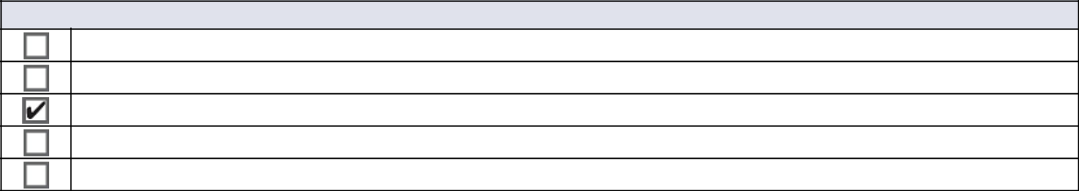

Check the appropriate box:

Preliminary Proxy Statement

Confidential, for Use of the Commission Only (as permitted by Rule 14A-6(e)(2))

Definitive Proxy Statement

Definitive Additional Materials

Soliciting Material under §240.14a-12
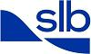

SCHLUMBERGER N.V. (SCHLUMBERGER LIMITED)

(Name of Registrant as Specified in Its Charter)

(Name of Person(s) Filing Proxy Statement if other than the Registrant)
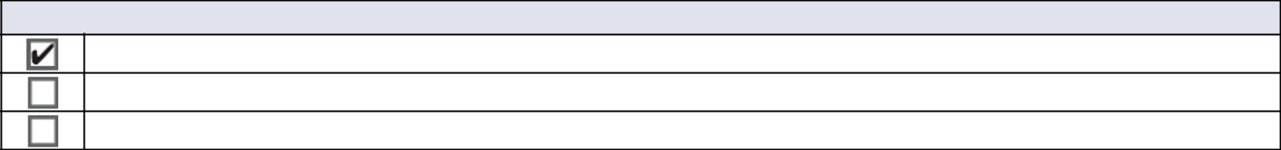

Payment of Filing Fee (Check all boxes that apply):

No fee required

Fee paid previously with preliminary materials

Fee computed on table in exhibit required by Item 25(b) per Exchange Act Rules 14a-6(i)(1) and 0-11

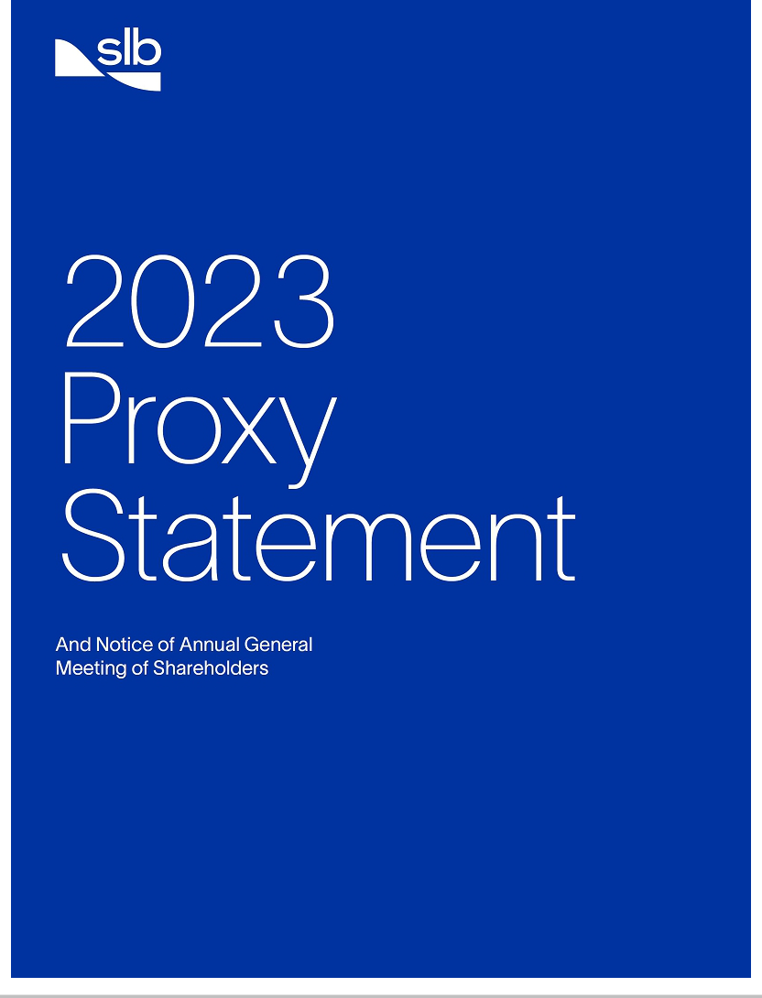

Notice of 2023 Annual General Meeting of Shareholders
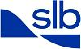

Items of Business


- Election of 11 director nominees.

- Advisory vote on the frequency of future advisory votes on executive compensation.

- Advisory “say-on-pay” approval of our executive compensation.

- Approval of certain annual financial statements for the year ended December 31, 2022.

- Ratification of the appointment of our independent auditor, PricewaterhouseCoopers LLP.

Such other matters as may properly be brought before the meeting.

By order of the Board of Directors,

Dianne B. Ralston

Chief Legal Officer and Secretary

February 23, 2023

Wednesday, April 5, 2023

10:00 a.m. Curaçao time

Curaçao Marriott Beach Resort, John F Kennedy Boulevard, 3 Piscadera Bay, Willemstad, Curaçao

Record Date

February 8, 2023

How to Cast Your Vote

Please refer to the enclosed proxy materials or to the information forwarded by your bank, broker, or other nominee to determine which voting methods are available to you. Shareholders with shares registered in their names with SLB’s transfer agent may authorize a proxy:

By Internet By Telephone

www.proxypush.com/SLB (866) 240-5191

By Mail

Sign, date, and mail your proxy card

If you are a beneficial holder of SLB common stock, you should follow any instructions provided by your bank, broker, or other nominee. See “Meeting Information” in this proxy statement.
Proxy Voting

Your vote is very important. Whether or not you plan to attend the annual general meeting in person, please (i) sign, date, and promptly return the enclosed proxy card in the enclosed envelope, or (ii) grant a proxy and give voting instructions by telephone or internet, so that you may be represented at the meeting. Voting instructions are provided on your proxy card or on the voting instruction form provided by your broker. Brokers are not permitted to vote on certain proposals and may elect not to vote on any of the proposals unless you provide voting instructions. Voting your shares will help to ensure that your interests are represented at the meeting.

Important Information About Meeting Attendance

Depending on the level of COVID-19 protocols in effect at the time, your ability to attend the 2023 Annual General Meeting of Shareholders (the 2023 AGM) in person may be restricted or may require additional safeguards, which could include face coverings, proof of vaccination, proof of a negative COVID-19 test result within a specified number of days, and maintaining appropriate social distancing. Please review www.proxydocs.com/SLB for any updates to the “Meeting Information” section of this proxy statement prior to traveling.

Important Notice Regarding the Availability of Proxy Materials

for the Annual General Meeting of Shareholders to be Held on April 5, 2023
This Notice and Proxy Statement, our Annual Report on Form 10-K for the fiscal year ended December 31, 2022, and our 2022 Annual Report to Shareholders are each available free of charge at https://investorcenter.slb.com and www.proxydocs.com/SLB.

Table of Contents

Proxy Executive Summary | 4
Voting at the 2023 Annual General Meeting | 4
Our Director Nominees | 5
Governance Highlights | 5
We Are SLB | 6
Leader in Global Diversity | 7
Spotlight on: 2022 Investor Day | 8
2022 Executive Compensation Highlights | 8
Forward-Looking Statements | 9

ITEM 1. Election of Directors |  |  |  | 10
Director Qualifications and Diversity |  |  |  | 10
Our Director Nominees |  |  |  | 12
Corporate Governance |  |  |  | 18
Proactive Shareholder Engagement |  |  |  | 18
Independent Chairman of the Board |  |  |  | 18
Board Oversight of Risk Management |  |  |  | 19
Board Oversight of Sustainability |  |  |  | 20
Board Refreshment Processes |  |  |  | 20
Board and Committee Evaluations |  |  |  | 22
Director Orientation and Education |  |  |  | 22
Board Committees |  |  |  | 23
Board Attendance |  |  |  | 23
Code of Conduct |  |  |  | 23
Corporate Governance Guidelines |  |  |  | 24
Director Independence |  |  |  | 24
Certain Relationships and Related Person Transactions |  |  |  | 24
Communicating with Our Board |  |  |  | 24
Director Compensation |  |  |  | 25
Stock Ownership Information |  |  |  | 27
ITEM 2. Advisory Vote on the Frequency of Future Advisory Votes on Executive Compensation |  |  |  | 29
ITEM 3. Advisory Approval of Our Executive Compensation |  |  |  | 30
Compensation Committee Report |  |  |  | 30
Compensation Discussion and Analysis |  |  |  | 31
Executive Overview |  |  |  | 32
Overview of Compensation Decisions for 2022 |  |  |  | 33
Framework for Setting 2022 Executive Compensation |  |  |  | 34
Elements of 2022 Total Direct Compensation |  |  |  | 36
Other Aspects of Our Executive Compensation Program |  |  |  | 45
Executive Compensation Governance |  |  |  | 47
Executive Compensation Tables |  |  |  | 50
Summary Compensation Table |  |  |  | 50
Grants of Plan-Based Awards in 2022 |  |  |  | 51
Outstanding Equity Awards at Year-End 2022 |  |  |  | 52
Option Exercises and Stock Vested in 2022 |  |  |  | 54
Pension Benefits |  |  |  | 54
Nonqualified Deferred Compensation |  |  |  | 56
Potential Payments Upon Termination or Change in Control |  |  |  | 57
Equity Compensation Plan Information |  |  |  | 59
CEO Pay Ratio |  |  |  | 60
Pay vs. Performance Comparison |  |  |  | 61
ITEM 4. Approval of Financial Statements and Dividends |  |  |  | 64
ITEM 5. Ratification of Appointment of Independent Auditors for 2023 |  |  |  | 65
Audit Committee Report |  |  |  | 66
Meeting Information |  |  |  | 67
Other Information |  |  |  | 69
Appendix A |  |  |  | A-1
2023 Proxy Statement |  | 3
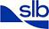

Back to Contents


Proxy Executive Summary

This summary is provided for your reference. However, before voting, you should carefully review this entire proxy statement and, particularly with respect to agenda Item 4, our 2022 Annual Report to Shareholders.

All references in this proxy statement to “SLB,” “the Company,” “we,” or “our” are to Schlumberger Limited (Schlumberger N.V.) and its subsidiaries. Website references throughout this document are provided for convenience only, and the content on the referenced websites is not incorporated by reference into this document.

This proxy statement is first being made available to our shareholders on or about February 23, 2023.

Voting at the 2023 Annual General Meeting (pages 67–68)

The 2023 AGM will be held at:

Meeting Date: | Wednesday, April 5, 2023
Place: | Curaçao Marriott Beach Resort
 | John F Kennedy Boulevard, 3, Piscadera Bay
 | Willemstad, Curaçao
Time: | 10:00 a.m. Curaçao time
Record Date: | February 8, 2023

Each shareholder of record at the close of business on February 8, 2023 (the record date) is entitled to one vote for each share registered in such shareholder’s name. If your shares are registered in your name with SLB’s transfer agent, you may vote in person at the 2023 AGM, or you may authorize a proxy to vote your shares by one of the following methods:

By Internet By Telephone By Mail

www.proxypush.com/SLB (866) 240-5191 Sign, date, and mail your proxy card

If you are a beneficial owner of SLB common stock (i.e., you hold your shares on the record date through a broker, bank, or other nominee), you should follow the voting instructions provided by your bank, broker, or other nominee.

If you plan to attend the 2023 AGM in person, see “Meeting Information” beginning on page 67 for the requirements for admission to the meeting. Whether or not you plan to attend the 2023 AGM in person, please (i) sign, date, and promptly return the enclosed proxy card in the enclosed envelope, or (ii) grant a proxy and give voting instructions by telephone or internet, so that you may be represented at the meeting.

Voting Matters

 | Our Board’s | Vote Required for | Page Reference
Item | Recommendation | Election / Approval | (for more detail)
1 Election of 11 director nominees to our Board of Directors (the Board). | FOR | Majority of
 | each nominee | votes cast for | 10
 |  | the nominee

- Advisory vote on the frequency of future advisory votes on executive compensation.

- Advisory “say-on-pay” approval of our executive compensation.

- Approval of our consolidated balance sheet at December 31, 2022, our consolidated statement of income for the year ended December 31, 2022, and the declarations of dividends by our Board in 2022.

ONE YEAR | Majority of | 29
ONE YEAR | votes cast | 29
FOR | Majority of | 30
FOR | votes cast | 30
 | Majority of
FOR | votes cast | 64

5 |  | Ratification of the appointment of PricewaterhouseCoopers LLP (PwC) as |  |  |  | FOR | Majority of | 65
 |  | our independent auditor for 2023. |  |  |  | FOR | votes cast | 65
 |  |  |  | 4 |  |  |  | 2023 Proxy Statement

Back to Contents
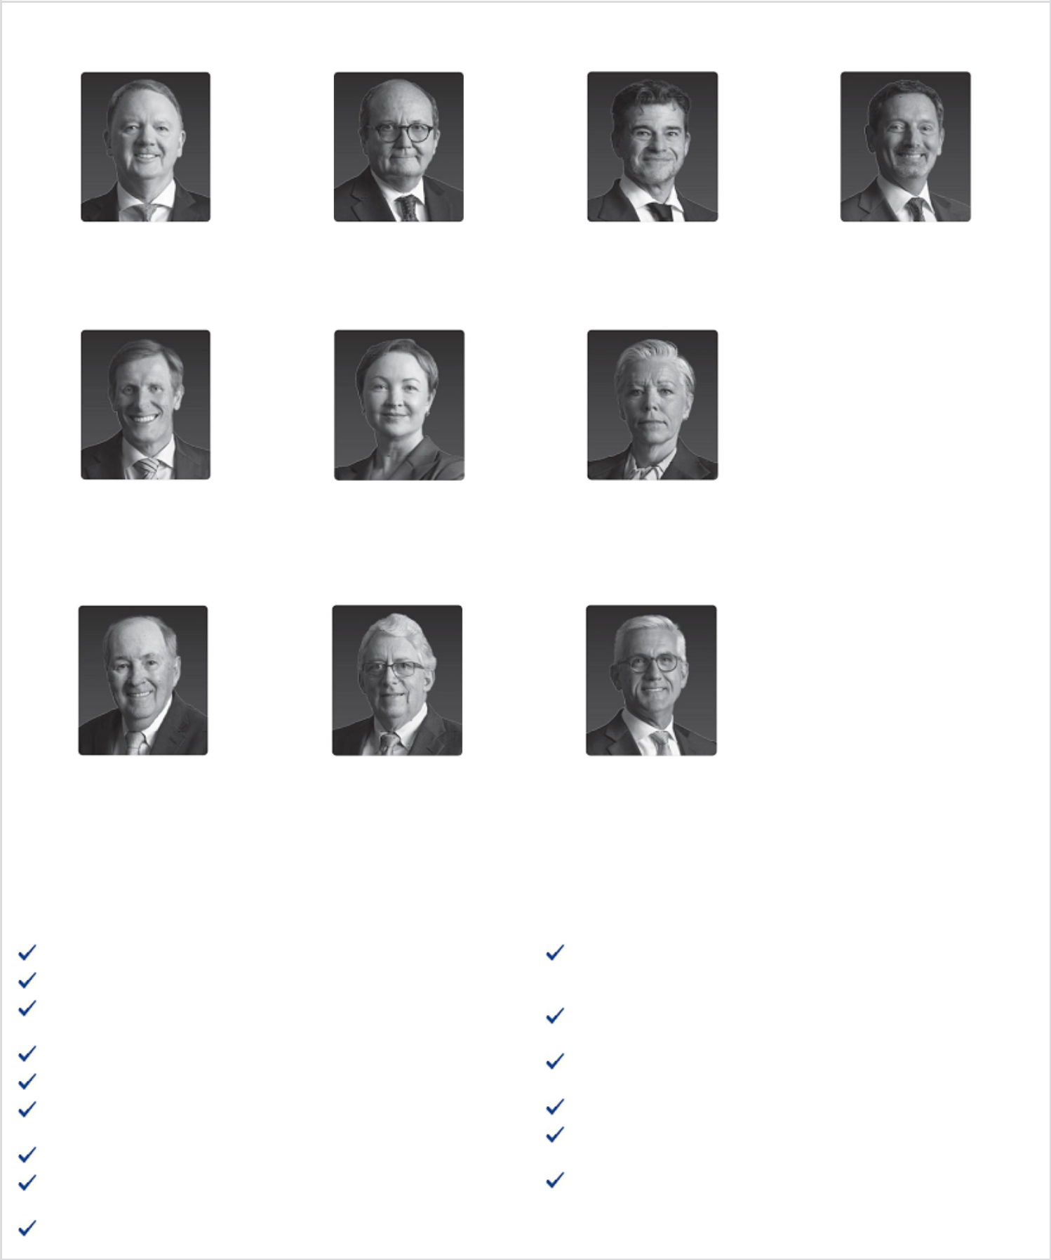

Our Director Nominees (pages 12–17)

Peter Coleman | Patrick de La Chevardière
Former CEO and | Former Chief Financial Officer
Managing Director | Total S.A.
Woodside Petroleum Ltd.

Samuel Leupold | Tatiana Mitrova
Former Chief Executive Officer | Research Fellow
Ørsted Wind Power A/S | SIPA Center on Global
 | Energy Policy
 | Columbia University

Mark Papa | Jeff Sheets
Former Chairman and CEO | Former EVP and CFO
Centennial Resource | ConocoPhillips
Development

Governance Highlights (pages 18–24)

Independent Chairman of the Board, separate from CEO No staggered board; all directors are elected annually

Fully independent Audit, Compensation, and Nominating and Governance committees

Regular executive sessions of non-employee directors Majority vote standard for uncontested director elections

Annual performance evaluations of Board, its committees, and individual directors

100% Board attendance in 2022

Comprehensive risk assessment process designed to identify and manage enterprise-wide risks

Proactive shareholder engagement

Miguel Galuccio | Olivier Le Peuch
Chairman and CEO | Chief Executive Officer
Vista | SLB

Maria Moræus Hanssen | Vanitha Narayanan
Former Deputy CEO | Former Chairman and
and COO | Managing Director
Wintershall Dea GmbH | IBM India

Ulrich Spiesshofer

Former President and CEO

ABB Ltd.

Director nominees reflect the gender, racial and ethnic, cultural and geographical diversity of our global operations, as well as diverse experience, skills, and tenure

Demonstrated commitment to Board refreshment, with every director joining the Board within the last six years

Non-employee director tenure limits of 75 years of age or 10 years of service—whichever comes first

No hedging or pledging of our stock by executives or directors

Robust stock ownership guidelines for SLB executives and directors

No lobbying or making financial or in-kind contributions to political parties or candidates

2023 Proxy Statement |  | 5

Back to Contents


We Are SLB

A global technology company that drives energy innovation for a balanced planet

2022 was transformative for SLB. We launched our bold new SLB brand identity—reinforcing our leadership position in technology, digital, and sustainability in the energy industry—and we demonstrated our ability to deliver superior earnings in this early phase of a structural upcycle in energy. We set new safety, operational, and performance benchmarks for our customers and strengthened our market position both internationally and in North America.

Highlights of our 2022 financial performance⁽¹⁾ include:

 |  |  | Grew GAAP earnings |  |  |  | Strengthened balance
 | Grew revenue |  |  |  | Expanded income |  | Strengthened balance
 | Grew revenue |  | per share (EPS) by |  | Expanded income |  | sheet by reducing both
 | Grew revenue |  |  |  | before taxes margin to |  | sheet by reducing both
 | 23% | 81% |  |  | before taxes margin to |  | gross and net debt by
 | 23% |  |  |  | 15.2% |  | gross and net debt by
 | 23% |  |  |  | 15.2% |  | $1.7 billion
 | year on year |  | year on year |  | 15.2% |  | $1.7 billion
 | Increased dividend |  | Grew EPS, excluding |  | Expanded adjusted |  | Ended 2022 with 1.4x
 | 40% in April 2022 |  | charges & credits, by |  | EBITDA margin to |  | Ended 2022 with 1.4x
 | 40% in April 2022 |  | 70% |  | EBITDA margin to |  | net debt to adjusted
 | 43% in January 2023 |  | 70% |  | 23.0% |  | EBITDA ratio—lowest level
 | 43% in January 2023 |  | year on year |  | 23.0% |  | since 2016

In 2022, we executed our strategy across our Three Engines of Growth—our Core, Digital, and New Energy—and successfully leveraged the breadth of our portfolio and our competitive strengths to deliver peer-leading outcomes for our customers and shareholders.

In our Core Divisions, we expanded pretax segment operating margins and launched new products, services, and solutions that increase efficiency and lower operational emissions. Our fit-for-basin, technology access and Transition Technologies* portfolios fueled growth and margin expansion in every Division in 2022. And we continue to strengthen our Core portfolio for growth and position for future resilience and shareholder returns through strategic initiatives such as the announced subsea joint venture with Aker Solutions and Subsea 7.

In Digital, we had strong growth in exploration data, Innovation Factori* and artificial intelligence solution sales, and the adoption of our new digital technologies is accelerating. We ended the year with more than 70% growth in Delfi* users, and our software-as-a-service (SaaS) revenue more than doubled. We continue to build adjacent expansion opportunities for our digital business, both in the operations data space and beyond oil and gas, such as carbon management.

In New Energy, we progressed technology development milestones, established new partnerships, and made new investments to develop a focused, yet comprehensive portfolio that offers promising growth opportunities for the future. Today, this portfolio comprises five business areas: carbon solutions, hydrogen, geothermal and geoenergy, critical minerals, and stationary energy storage. We are also accelerating our R&D efforts to develop technology solutions that address hard-to-abate industrial and power generation emissions.

In Sustainability, we reduced our Scope 1 and 2 carbon emissions intensity as compared to 2021. We also launched several new Transition Technologies to support the decarbonization of oil and gas, as well as our SLB End-to-end Emissions Solutions (SEES) methane elimination business.

We also advanced our technology leadership, safety and operations integrity performance, and service quality differentiation, leading to more contract awards, higher technology adoption, and increased pricing premiums.

Finally, we demonstrated our commitment to Superior Shareholder Returns. We increased our dividend by 40% in April 2022, followed by a further 43% increase in January 2023, and we resumed our share buyback program in January 2023.

Looking to 2023, we believe the market fundamentals are aligned with what we do best—innovating and outperforming for our customers. With our bold new brand and identity founded on technology and innovation, our strategy with sustainability at its heart, and our strong financial and operational results through the early phase of the current upcycle, we believe we have set a very solid foundation for strong performance and shareholder value creation in 2023 and into the next decade.

- For definitions of adjusted EBITDA, adjusted EBITDA margin, free cash flow, free cash flow margin, EPS excluding charges and credits, and net debt, as well as reconciliations of these non-GAAP measures to their most comparable GAAP measures, see Appendix A.

- Mark of SLB

6 2023 Proxy Statement

Back to Contents
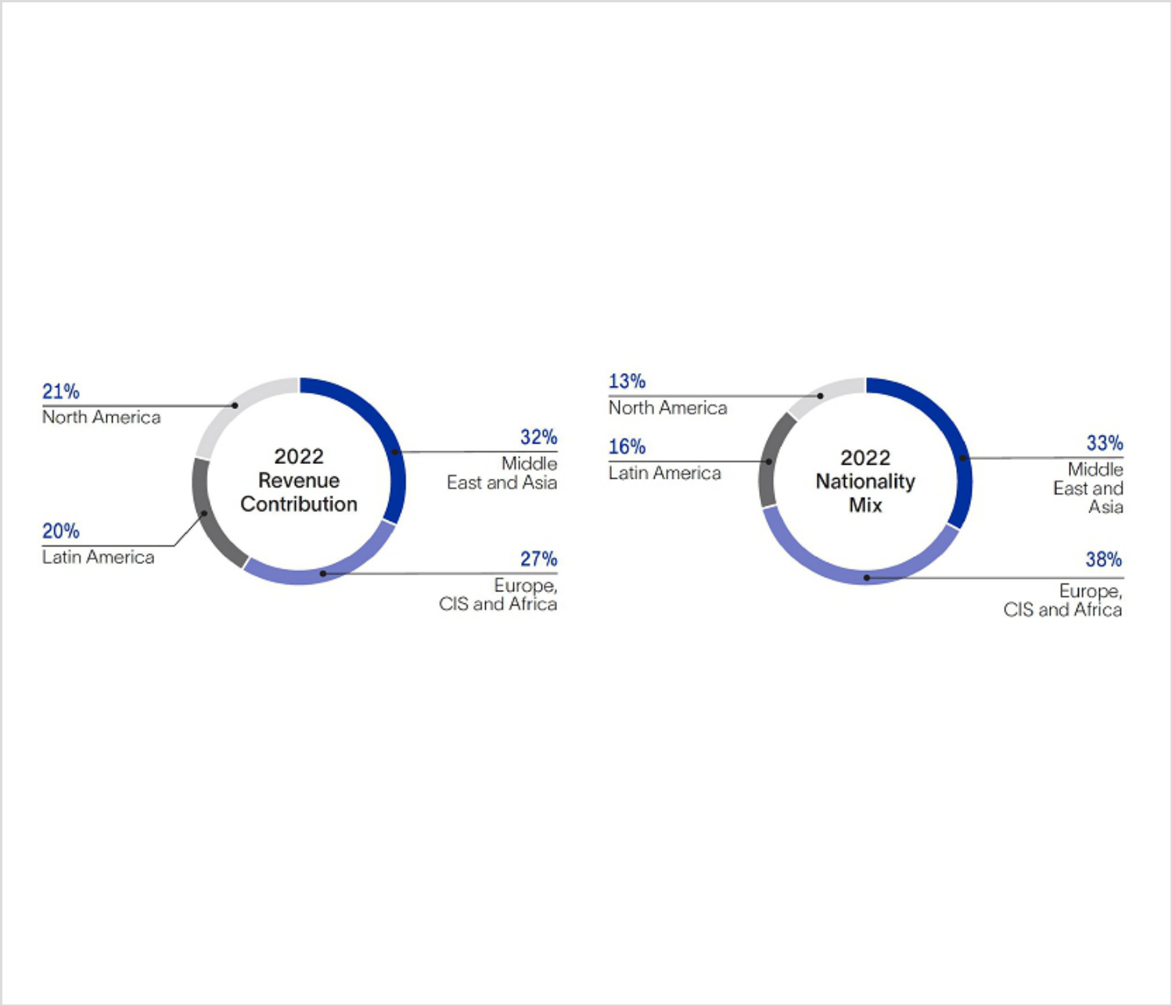

Leader in Global Diversity

Nationality and Cultural Diversity

As a leading global technology company, with a workforce consisting of approximately 99,000 people in more than 100 countries, one of SLB’s greatest strengths is the diversity of our people. We believe that our ability to attract, develop, motivate, and retain a highly competent and diverse workforce has been paramount to our success for many decades. We recognize that cultivating diversity and promoting inclusion are essential to attracting the best talent from around the world and enabling creativity and innovation to drive business success.

Our national and cultural diversity is based in our philosophy to recruit and develop people from the communities where we work. As a result, we maintain a workforce nationality mix aligned to the revenue derived from the countries in which we work, as reflected in the charts below. Our long-standing commitment to national and cultural diversity, which is seen throughout every layer of SLB—including our executive team and the Board— fosters a culture that is global in outlook, yet local in practice. Our nationally and culturally diverse Board and 10-member executive leadership team collectively represent 14 nationalities across six continents.

Gender Balance

In addition to nationality and cultural diversity, gender balance is an important part of our diversity, equity, and inclusion strategy. We are committed to leading our industry in gender diversity, and we are on track to reach our interim milestone of having women represent 25% of our salaried employees by 2025. Our next milestone is for women to comprise 30% of our salaried employees by 2030. Our 2025 and 2030 targets include executive roles and all other salaried positions.

Women represent 30% of our executive team as of January 31, 2023, and 27% of our director nominees for the 2023 AGM. Approximately 19.5% of our company (excluding contractors) and 23.8% of our salaried employees were women as of December 31, 2022.

Race and Ethnicity

As a truly global company with a rich legacy of national and cultural diversity, it is important that we do not limit our definitions of racial and ethnic diversity to the common classifications used in the United States, both for our executive team and for the Board. For further discussion regarding the racial and ethnic diversity of our Board, see “Election of Directors—Director Qualifications and Diversity” on page 10 of this proxy statement.

2023 Proxy Statement |  | 7

Back to Contents
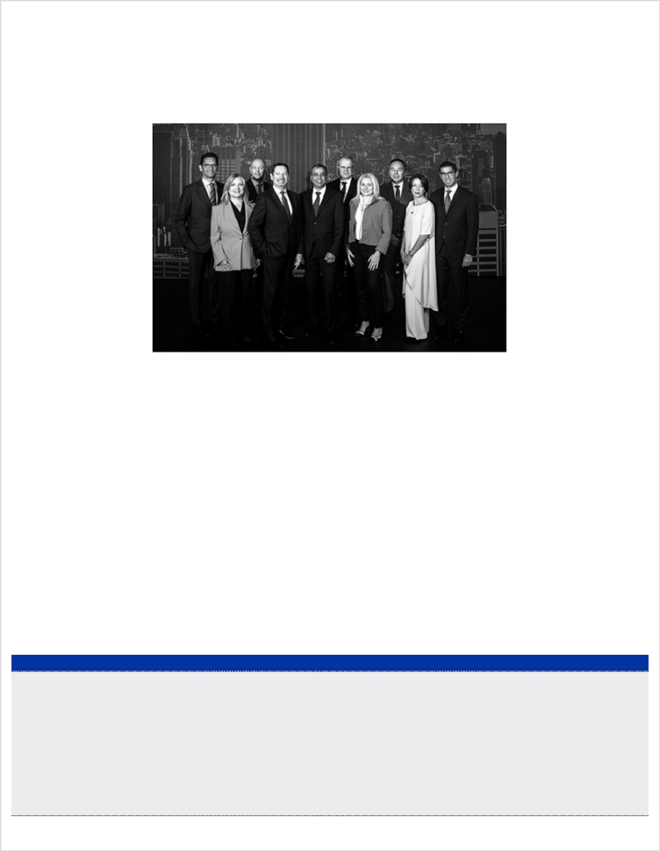

Spotlight on: 2022 Investor Day

In November, we held our 2022 Investors Conference in New York City, USA as a platform to demonstrate SLB’s potential to deliver differentiated growth and returns over the next few years. The conference was focused on SLB’s strategies to advance Energy Innovation, Lower Carbon and Higher Value within the context of today’s global energy dynamics, which require bold new technologies and ideas, digital transformation and a deep commitment to sustainability. The conference also included a series of technology immersion sessions showcasing our leadership and key offerings in our Core, Digital and New Energy.

From left to right: SLB executive leadership team members Gavin Rennick, Dianne

Ralston, Demosthenis Pafitis, Olivier Le Peuch, Rajeev Sonthalia, Stephane Biguet,

Katharina Beumelburg, Khaled Al Mogharbel, Carmen Rando Bejar, and Abdellah

Merad.

2022 Executive Compensation Highlights (pages 30–60)

As more fully discussed in the “Compensation Discussion and Analysis” section of this proxy statement, below are some key actions that our

Compensation Committee took with respect to our named executive officers’ 2022 compensation:

- Diversified LTI Program Structure — Our NEOs continued to receive a mix of long-term incentive (LTI) grants in 2022, with 75% of their target LTI opportunity awarded in the form of performance share units (PSUs), and 25% awarded in the form of three-year, time-based restricted stock units (RSUs). As in 2021, payout under the 2022 PSUs will be contingent on achieving absolute free cash flow margin (FCF margin), relative return on capital employed (ROCE), and relative total shareholder return (TSR) performance goals over respective three-year periods.

- Rigorous PSU Performance Targets — In setting LTI performance targets for 2022, the Compensation Committee emphasized and encouraged ambitious outperformance by increasing the maximum performance goal for the FCF margin PSUs as compared to 2021, and continuing to set an above-median target performance goal for the TSR PSUs. In addition, based on shareholder feedback, the Committee adjusted the comparator group for our TSR PSUs to include our direct competitors and the S&P Global 1200 Energy Index, to focus on TSR outperformance relative to our direct competitors while expanding the group to include the broader energy market.

- Performance-Aligned Incentive Payouts — Our NEOs’ short-term incentive (STI) payouts were based on strong 2022 adjusted EBITDA results, partially offset by below-target 2022 free cash flow results, and their LTI payouts were based on exceptional multi-year ROCE and free cash flow conversion results.

Short-Term Incentive Results

- Average NEO Payout — 80% — Our NEOs earned an average 2022 cash incentive payout of 80%.

- Adjusted EBITDA Payout — 157% — Our 2022 adjusted EBITDA⁽¹⁾ was $6.462 billion, representing a 31% increase over 2021, and resulting in a payout of 157% of target for the adjusted EBITDA component of our 2022 cash incentive plan.

- Zero FCF Payout — Our 2022 free cash flow⁽¹⁾ of $1.418 billion was below the minimum performance target under our annual cash incentive plan. As a result, our CEO and other NEOs earned no payout under the free cash flow component of our 2022 cash incentive plan.

Long-Term Incentive Results

- Our CEO did not receive an LTI award in 2020 and therefore did not earn any 2020 PSUs.

- For our other NEOs, the 2020 LTI payout was based on: (i) SLB’s average annual ROCE for the three-year performance period, which was 407 basis points (bps) above the average ROCE of the comparator group, (ii) SLB’s absolute 2022 ROCE of 13%, and (iii) SLB’s cumulative FCF conversion rate of 192% from 2020 to 2021— which far exceeded the maximum performance goal for the 2020 FCF conversion PSUs.

- As a result, our NEOs, other than our CEO, earned 250% of the target shares of SLB stock under the 2020 PSUs.

- For reconciliations of adjusted EBITDA and free cash flow to their most comparable GAAP measures, see Appendix A.

8 2023 Proxy Statement

Back to Contents


- CEO and CFO Compensation Increases in Line with Market Trends — In light of SLB’s strong 2021 financial results—which surpassed all of the Company’s annual financial targets—as well as peer comparator data showing that our CEO’s 2021 compensation was below the median of our general industry peer group, the Compensation Committee recommended, and the independent members of the Board approved, an 11% increase to our CEO’s 2022 base salary and a 14% increase in his target LTI grant value. The Committee also approved a 4% base salary increase for our CFO, Mr. Biguet, and a 9% increase in his target LTI grant value, after considering the Company’s excellent 2021 financial performance, as well as peer comparator data and internal pay equity considerations. For details regarding these market increases, see “— Elements of 2022 Total Direct Compensation—Base Salary” and “—Long-Term Equity Incentive Awards”.

- ESG Objectives for All NEOs — All of our NEOs had strategic personal objectives related to sustainability, SLB New Energy, or health, safety and environmental (HSE) performance goals.

Below is a summary of some of our executive compensation best practices and policies.

What We Do

At Risk Pay — A significant portion of our executives’ compensation is at risk, based on a mix of absolute and relative financial metrics.

Performance-Based Cash Incentive Awards — At least 70% of our executives’ target 2022 cash incentive opportunity is based on achieving rigorous quantitative Company financial goals.

Robust Stock Holding Requirements — Our CEO is required to own an amount of SLB shares valued at six times (6x) his annual salary; our EVPs must own at least three times (3x) their annual salaries; and all other executive officers must own at least two times (2x) their annual salaries.

Mandatory Retention of Shares — Executives must retain 50% of the net shares they acquire upon the exercise of stock options and the vesting of PSUs and RSUs, until they achieve the required ownership level under our stock ownership guidelines.

Annual Peer Compensation Review — We annually review all officer compensation opportunities against our peer groups.

What We Don’t Do

No gross-ups on excise taxes.

No repricing or exchanging options without shareholder approval.

No hedging or pledging of SLB stock by executive officers or directors.

No LTI or annual cash incentive payouts if we fail to achieve pre-established minimum performance criteria.

No excessive perquisites to our executive officers.

No executive pension or insurance plans exclusively for executives.

No change-in-control agreements, and no automatic acceleration of equity awards upon a change in control.

PSUs and RSUs do not accrue or pay dividends or dividend equivalents or have voting rights prior to vesting.

We do not dilute our shareholders with excessive employee equity grants. Our 2022 “burn rate,” or stock awards granted as a percentage of common shares outstanding, was only 0.65%.

Forward-Looking Statements

This proxy statement includes forward-looking statements within the meaning of the Private Securities Litigation Reform Act of 1995. All statements other than statements of historical or current facts made in this document are forward-looking. We use words such as anticipates, believes, expects, future, intends, and similar expressions to identify forward-looking statements. Forward-looking statements reflect management’s current expectations and are inherently uncertain, and actual results or outcomes could differ materially for a variety of reasons. Risks and uncertainties that could cause our actual results to differ significantly from management’s expectations are described in our 2022 Annual Report on Form 10-K.

Forward-looking and other statements in this proxy statement regarding our environmental, social, governance (ESG) and other sustainability plans and goals are not an indication that these statements are necessarily material to investors or required to be disclosed in our filings with the Securities and Exchange Commission (SEC). In addition, historical, current, and forward-looking ESG and sustainability-related statements may be based on standards for measuring progress that are still developing, internal controls and processes that continue to evolve, and assumptions that are subject to change in the future.

2023 Proxy Statement |  | 9

Back to Contents

ITEM 1. Election of Directors

All of our directors are elected annually at our annual general meeting of shareholders. We recommend that you vote “FOR” each of the 11 director nominees, to be elected to serve until our 2024 AGM (or until their death, resignation or removal). Each of the nominees is currently a director and was previously elected by our shareholders at our 2022 AGM.

If any nominee is unable or unwilling to serve, the Board may decrease the size of the Board or designate a substitute nominee. If the Board designates a substitute nominee, proxies may be voted for that substitute nominee. The Board knows of no reason why any nominee would be unable or unwilling to serve if elected.

At the 2023 AGM, votes may not be cast for a greater number of persons than the number of director nominees named in this proxy statement. Shares represented by properly executed proxies and not revoked will be voted in accordance with the instructions indicated on those proxy cards. If you have properly executed your proxy card and you have not given specific voting instructions, your shares will be voted in accordance with our Board’s recommendations.

The Board of Directors recommends a vote FOR each director nominee.

Director Qualifications and Diversity

The Nominating and Governance Committee believes that SLB director nominees should have the following characteristics:

- be persons of integrity and honesty,

- be able to exercise sound, mature and independent business judgment in the best interests of our shareholders as a whole,

- be recognized leaders in business or professional activity,

- have background and experience that will complement those of other Board members,

- be willing and able to actively participate in Board and committee meetings and related activities,

- be able to work professionally and effectively with other Board members and SLB management,

- be available to remain on the Board long enough to make an effective contribution, and

- have no material relationship with competitors, customers or other third parties that could present realistic possibilities of conflicts of interest or legal issues.

In the judgment of the Board, all director nominees are able to execute their duties as members of the Board and to devote the necessary time and attention to SLB, as required by our Corporate Governance Guidelines. In addition, there are no family relationships among any SLB executive officers and directors.

Board Diversity Policy

The Nominating and Governance Committee supports SLB’s diversity ambitions that its Board should reflect the gender, racial and ethnic, cultural and geographical diversity of our global operations. The Board seeks out women and nationally, racially and ethnically diverse candidates to include in the pool of qualified candidates from which potential director nominees are chosen. As reflected in the summary chart on page 11, our 11 director nominees represent ten nationalities across five continents, and three directors are women.

Given our multinational footprint and culture, we endeavor to have a global perspective on diversity, including racial and ethnic diversity. This perspective includes respecting local legal requirements regarding the tracking and use of personal data pertaining to under-represented populations. Certain countries have data privacy laws prohibiting the collection or disclosure of race and ethnicity classification data, reflecting historical concerns that such data could be used to foster, rather than eliminate, discrimination. In addition, local definitions of race and ethnicity and related classifications, as well as the definition of under-represented groups, vary from country to country.

As a result, U.S.-centric racial and ethnic classifications as used for EEO-1 data collection purposes are applicable only to our three directors who are U.S. citizens. For our U.S. directors, we provide in the summary chart on page 11 race and ethnicity disclosures based on classifications commonly used in the United States. For all other directors, we asked if they wished to voluntarily disclose their ethnic or racial background and, if so, how they self-identify based on the classifications most relevant to their home countries. We provide self-identifications for non-U.S. directors in the summary chart on page 11. In keeping with international data privacy laws, we have not included racial or ethnic information for director nominees who did not authorize disclosure.

10 2023 Proxy Statement

Back to Contents

Summary of Director Nominee Skills and Characteristics

We believe our director nominees provide a well-rounded set of expertise to assist in effective oversight of SLB management.

The following chart summarizes the qualifications of our director nominees, including knowledge, skills, experiences and other attributes that the Board believes are relevant to their Board and committee service. Each director nominee possesses numerous other skills and experience not identified in the following chart, as further detailed in their biographies beginning on page 12 of this proxy statement.

Substantial Knowledge, Skills and Experience

Current or former chief executive officer

Energy industry and operations

Finance and accounting

Science, technology and engineering

Energy transition and sustainability

Digital innovation

Digital transformation

Information security

Strategy development & implementation

International business

Risk management

Economic modeling

Health, safety and environmental

Mergers and acquisitions

Academic relations

Government, regulatory & public policy

Demographics

Nationality

Argentina

Australia

France

Germany

Israel

Norway

Russia

Switzerland

United Kingdom

United States

Racial and Ethnicity Characteristics for U.S. Directors

Asian or Indian

White or Caucasian

Non-U.S. Directors Electing to Self-Identify Racial or Ethnicity Characteristics

Two or More Ethnicities

White or Caucasian

Gender | M | M | M |  | M | M | F | F | F | M | M | M
Other Attributes
Independence
Tenure | 2 | 4 | 6 |  | 4 | 2 | 5 | 3 | 2 | 5 | 4 | 2
2023 Proxy Statement |  |  | 11

Back to Contents

Our Director Nominees

The nominees for election to the Board, together with information regarding each nominee’s qualifications, are set forth below.

Peter Coleman,

Independent Director
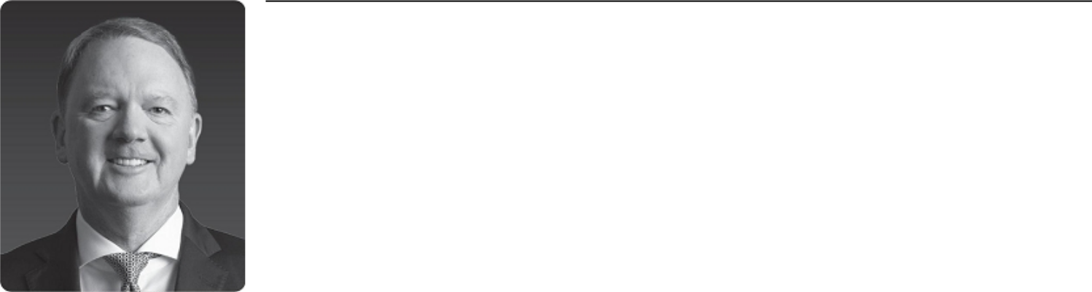

Former CEO and Managing Director, | Nationality
Woodside Petroleum Ltd. | Australia
Director since 2021 | SLB Board Committees
Age: 62 | • | Nominating and Governance
Other Current Public Boards | • | Finance
• Allkem Limited | Other Experience and Education
 | • | MBA, Deakin University
Former Public Directorships | • Bachelor of Engineering, Monash University
Held During the Past Five Years | • Chair of the Australia-Korea Foundation
• Woodside Petroleum Ltd.

PETER COLEMAN is the former Chief Executive Officer, Executive Director and Managing Director of Woodside Petroleum Ltd., Australia’s largest independent gas producer, having served in that role from 2011 until his retirement in June 2021. Prior to joining Woodside, Mr. Coleman spent 27 years with the ExxonMobil group in a variety of roles, including Vice President Asia Pacific from 2010 to 2011 and Vice President Americas from 2008 to 2010. Since 2012, he has been an adjunct professor of corporate strategy at the University of Western Australia Business School. Since November 2022, he has served as chair of Allkem Limited, a global lithium chemicals company, having served as a director since October 2022. He has also served as chairman of the board of Infinite Blue Energy, an Australian green hydrogen renewable energy company, since August 2021, as chair of H2EX, an Australian hydrogen exploration start-up, since April 2022, and as chair of DIRECT Infrastructure, an Australian-based offshore wind developer, since June 2022.

Relevant Skills and Expertise

Mr. Coleman brings to the Board decades of experience in the oil and gas industry, including as the former CEO and Chairman of Australia’s largest independent gas producer. The Board benefits from his expertise in strategic planning, as well as his extensive business experience in Australia and Asia, regions that are strategically important to SLB’s operations.

12 2023 Proxy Statement

Back to Contents

Patrick de La Chevardière,

Independent Director
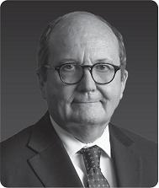

Former Chief Financial Officer, Total S.A.

Director since 2019

Age: 65

Other Current Public Boards

• Michelin (Compagnie Générale des Établissements Michelin SCA)

Former Public Directorships Held During the Past Five Years

• None

Nationality

France

SLB Board Committees

- Audit, Chair

- Finance

Other Experience and Education

- Experienced director of several French-based public companies
- Diplôme d’Ingénieur, an engineering degree, École Centrale de Paris

PATRICK DE LA CHEVARDIÈRE is the former Chief Financial Officer of Total S.A., a French multinational integrated oil and gas company. He served as Total’s CFO and as a member of its executive committee from 2008 until his retirement in August 2019. Prior to that, he served in a variety of finance and operational roles with Total over his 37-year career, including as Deputy Chief Financial Officer from 2003 to 2008, Vice President, Asia for Refining & Marketing from 2000 to 2003, and Vice President, Operations and Subsidiaries from 1995 to 2000. Since June 2020, Mr. de La Chevardière has also served as a member and chairman of the audit committee of the supervisory board of Michelin, a French multinational tire manufacturer. He also previously served on the boards of directors of two other French-based public companies, Sanofi-Aventis and Compagnie Générale de Géophysique.

Relevant Skills and Expertise

Mr. de La Chevardière brings to the Board financial and industry experience as a former CFO of a large multinational oil and gas company. The Board benefits from his customer-focused perspective on the oilfield services industry, and from his experience across the entire oil and gas value chain, from exploration, operations, production, trading and marketing to refining and new energies.

Miguel Galuccio,

Non-Executive Director
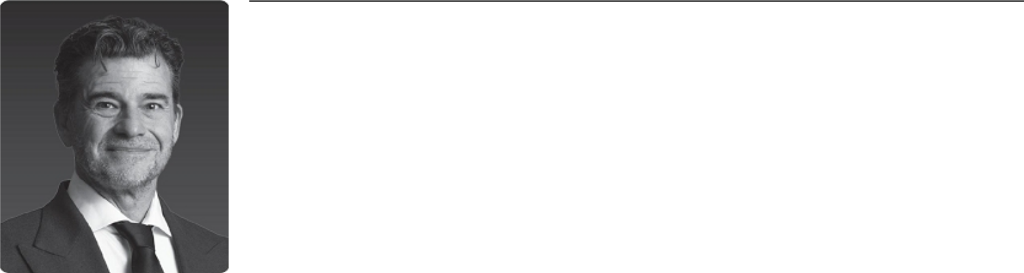

Chairman and Chief Executive Officer, Nationality

Vista Argentina and United Kingdom

Director since 2017 SLB Board Committees

Age: 54 • Finance, Chair

Other Current Public Boards Other Experience and Education

• Vista • Bachelor of Science in Petroleum Engineering, Instituto

Tecnológico de Buenos Aires

Former Public Directorships • SLB training and expertise

Held During the Past Five Years • Latin America energy policy expertise

• None

MIGUEL GALUCCIO founded and is the Chairman and Chief Executive Officer of Vista, the first listed independent energy company to operate and produce in the Vaca Muerta formation in Argentina, having held that position since 2017. In 2016, he co-founded GRIDX, a science-based company builder that creates and invests in biotech startups in Latin America, where he currently acts as chairman. Prior to that, from 2012 to 2016, he served as Chairman and Chief Executive Officer of YPF, Argentina’s largest energy company. From 1999 to 2012, he was an employee of SLB and held several international positions, his last being President, SLB Production Management. Prior to his employment at SLB, he served in various executive positions at YPF and its subsidiaries from 1994 to 1999, including YPF International.

Relevant Skills and Expertise

Mr. Galuccio brings to the Board leadership and operational expertise from his experience as former chairman and chief executive officer of Argentina’s largest energy company, which under his leadership became the world’s largest producer of shale oil outside of North America. He has valuable insight into the domestic and international energy policies of Argentina, Mexico, Venezuela and Ecuador, as well as extensive experience negotiating with SLB customers in Latin America, Russia and China. He also remains active in the oil and gas exploration and production industry as a chief executive officer of an oil and gas company.

2023 Proxy Statement |  | 13

Back to Contents

Olivier Le Peuch,

SLB Chief Executive Officer
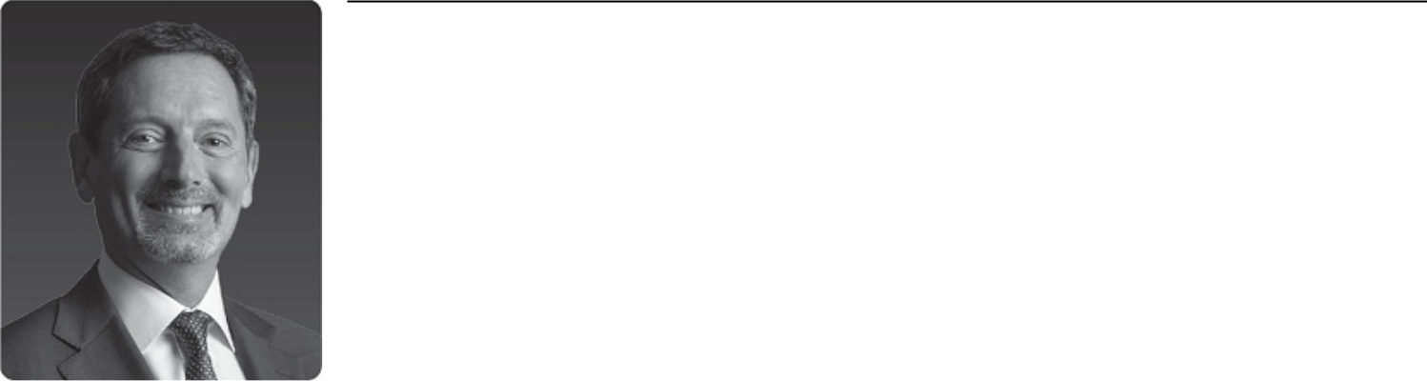

Chief Executive Officer,

SLB

Nationality

France

Director since 2019

Age: 59

SLB Board Committees

• None

Other Current Public Boards

• None

Former Public Directorships

Other Experience and Education

• Master’s Degree in Microelectronics, Bordeaux University of

Science

• SLB training and expertise

Held During the Past Five Years
• None

OLIVIER LE PEUCH has been SLB’s Chief Executive Officer and a member of the Board since August 2019. He was SLB’s Chief Operating Officer from February 2019 to July 2019. Prior to that, he served in a variety of global management positions, including Executive Vice President, Reservoir and Infrastructure from May 2018 to February 2019, President of the Cameron Group from 2017 to May 2018, President of SLB Completions from 2014 to 2017, and Vice President of Engineering, Manufacturing and Sustaining from 2010 to 2014. Earlier in his career, Mr. Le Peuch was GeoMarket Manager for the North Sea and President of Software Integrated Solutions. He has been with SLB since 1987 and began his career as an electrical engineer.

Relevant Skills and Expertise

Mr. Le Peuch brings to the Board a unique operational perspective and thorough knowledge of SLB’s operational activities worldwide as a result of his service in various global leadership positions at SLB. The Board believes that Mr. Le Peuch’s service as our CEO is an important link between management and the Board, enabling the Board to perform its oversight function with the benefit of his perspectives on SLB’s business and operations.

Samuel Leupold,

Independent Director
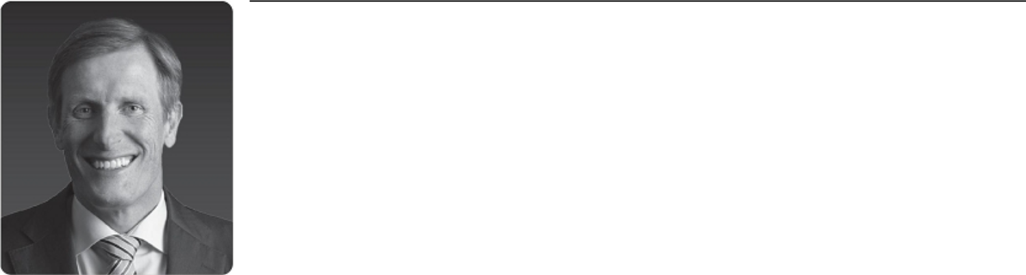

Former Chief Executive Officer, | Nationality
Ørsted Wind Power A/S | Switzerland
Director since 2021 | SLB Board Committees
Age: 52 | • | Audit
 | • | Finance
Other Current Public Boards | • New Energy and Innovation
• Enel SpA | Other Experience and Education
Former Public Directorships | • Master’s Degree in Mechanical Engineering, Swiss Federal
Held During the Past Five Years |  | Institute of Technology (Zurich)
• None | • | MBA, INSEAD (Fontainebleau)
 | • Energy transition and sustainability expertise

SAMUEL LEUPOLD is the former chief executive officer of Ørsted Wind Power A/S, the principal subsidiary of Ørsted AS, a Danish renewable energy company, where he led Ørsted Wind Power to become the world’s leading developer, operator and owner of offshore wind assets during his tenure from 2013 to March 2018. Since May 2019, Mr. Leupold has served as an independent senior advisor supporting international clients in the energy and infrastructure sectors through his consultancy firm, Leupold Advisory. In addition, since May 2020, Leupold has been an independent non-executive member of the board at Enel SpA, one of Europe’s largest utilities focused on sustainability and the energy transition. He has also served as chair of Corio Generation, a specialist offshore wind business and Macquarie Green Investment Group portfolio company, since March 2022.

Relevant Skills and Expertise

Mr. Leupold brings to the Board operational experience as the former chief executive officer of a renewable energy company, as well as significant experience in energy transition and sustainability. The Board benefits from his expertise on these issues as SLB seeks to implement our net-zero ambition and our strategy to deploy sustainable technologies to provide access to energy for the benefit of all.

14 2023 Proxy Statement

Back to Contents

Tatiana Mitrova,

Independent Director


Research Fellow, | Nationality
Center on Global Energy Policy, | Israel and Russia
School of International and Public
Affairs at Columbia University | SLB Board Committees
 | • | Audit
Director since 2018 | • | Finance
Age: 48 | • New Energy and Innovation
Other Current Public Boards | Other Experience and Education
• None | • PhD in Economics, Moscow State University
 | • Senior Visiting Research Fellow at Oxford Institute for Energy
Former Public Directorships |  | Studies
Held During the Past Five Years
• PAO Novatek

TATIANA MITROVA has been a research fellow at the Center on Global Energy Policy at the School of International and Public Affairs at Columbia University since 2016. She has also been a visiting professor at the Paris School of International Affairs, part of the Paris Institute of Political Studies, since 2014. From 2017 to December 2020, she served as executive director of the Energy Centre of the Moscow School of Management SKOLKOVO, a graduate business school, where she also served as a professor until February 2022. She was also the head of research in the Oil and Gas Department in the Energy Research Institute of the Russian Academy of Sciences from 2011 to February 2022, and an assistant professor at the Gubkin Russian State University of Oil and Gas from 2008 to February 2022. She was previously a member of the board of directors of PAO Novatek from April 2020 to September 2022 and Unipro PJSC from 2014 to 2017.

Relevant Skills and Expertise

Dr. Mitrova brings to the Board valuable expertise regarding energy market dynamics and the various factors affecting supply and demand for SLB’s products and services, as well as expertise relating to sustainability, decarbonization and the new energy economy. The Board values Dr. Mitrova’s knowledge of Russian and Central Asian energy markets and related risks, as well as her ties to the academic community. Her global economic perspective provides insight into emerging markets and trends, and is useful for the development of SLB’s global business strategy.

Maria Moræus Hanssen,

Independent Director


Former Deputy Chief Executive Officer |  | Nationality
and Chief Operating Officer, |  | Norway
Wintershall Dea GmbH |  | SLB Board Committees
Director since 2020 |  | • New Energy and Innovation, Chair
Age: 58 |  | • | Compensation
Other Current Public Boards |  | • | Nominating and Governance
• | Alfa Laval AB | Other Experience and Education
• | Scatec Solar ASA | • Former CEO of multiple E&P companies
 |  | • Master’s Degrees in Petroleum Engineering, Norwegian
Former Public Directorships |  |  | University of Science and Technology, and Petroleum
Held During the Past Five Years |  |  | Economics and Management, IFP School
• | Yara International ASA | • Corporate director certificate from Harvard Business School
 |  |  | (2021)

MARIA MORÆUS HANSSEN is the former Deputy CEO and Chief Operating Officer of Wintershall Dea GmbH, a German-based oil and gas producer, having served in that role from May 2019 to December 2019 following the merger between DEA Deutsche Erdoel AG (DEA) and Wintershall Holding GmbH. Prior to that, she served as CEO of DEA and chair of its management board from January 2018 until April 2019. Before joining DEA, she served as CEO of ENGIE E&P International SA and Head of the E&P Business Unit for the ENGIE Group in Paris from 2015 to 2017. Ms. Moræus Hanssen served in various management and operations roles at Aker from 2008 to 2013, Statoil (now Equinor) from 2007 to 2008, and Norsk Hydro from 1992 to 2007. She has served on the boards of Scandinavian public companies Alfa Laval AB since April 2019 and Scatec Solar ASA since April 2020, and also serves in director and chair roles on various private company and non-profit boards. She previously served as deputy chairman and audit committee chair of Yara International from 2015 to May 2019.

Relevant Skills and Expertise

Ms. Moræus Hanssen brings to the Board leadership and operational expertise as the former CEO of several European E&P companies. The Board values her insight into the domestic and international energy policies of Norway, Germany, France and other countries that are strategically important to SLB, as well as her experience addressing risks related to the energy transition.

2023 Proxy Statement |  | 15

Back to Contents

Vanitha Narayanan,

Independent Director


Former Chairman and Managing |  | Nationality
Director, |  | United States of America
IBM India |  | SLB Board Committees
Director since 2021 |  | • | Compensation
Age: 63 |  | • | Nominating and Governance
Other Current Public Boards |  | Other Experience and Education
• | ReNew Power | • MBA, University of Houston
• | HCL Technologies | • First woman chairperson of American Chamber of Commerce
 |  |  | in India (AMCHAM India)
Former Public Directorships

Held During the Past Five Years

- None

VANITHA NARAYANAN is the former Chairman and Managing Director of IBM India, a subsidiary of IBM, a multinational technology corporation. Over her career spanning three decades at IBM, she held senior executive positions with responsibility for digital businesses in the United States, Asia-Pacific and India regions, including as Chairman of IBM India from January 2017 to March 2018 and Managing Director from 2013 to 2016. During her tenure, IBM India was one of IBM’s fastest-growing growth markets. Most recently, Ms. Narayanan served as Managing Director for a strategic telecommunications client of IBM’s from April 2018 until her retirement in 2020, leading a strategic 5G business partnership. Since August 2020, she has served as a director of ReNew Power, one of the largest renewable power companies in India, where she serves as a member of the audit and ESG committees. She has also been a director of HCL Technologies since July 2021, where she serves as a member of the nominating and remuneration committee.

Relevant Skills and Expertise

Ms. Narayanan brings to the Board a wealth of global leadership and technology experience, particularly in the Asia-Pacific and India geographies. The Board values Ms. Narayanan’s digital expertise leading global technology businesses, as SLB continues to implement its digital strategy.

Mark Papa,

Independent Chairman of the SLB Board of Directors
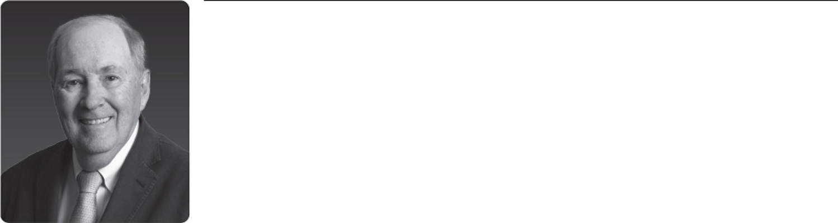

Former Chairman and CEO, |  | Nationality
Centennial Resource Development |  | United States of America
Director since 2018 |  | SLB Board Committees
Age: 76 |  | • Nominating and Governance, Chair
Other Current Public Boards |  | Other Experience and Education
• | None | • Former chairman and CEO of two public oil and gas
 |  | companies
Former Public Directorships |  | • MBA, University of Houston
Held During the Past Five Years |  | • Bachelor of Science in Petroleum Engineering, University of
• | Centennial Resource Development | Pittsburgh
• | Oil States International | • North American energy industry pioneer

MARK PAPA is the former Chief Executive Officer and Chairman of the Board of Centennial Resource Development, an independent oil and natural gas producer, having served in that role from 2016 until his retirement in March 2020. From 2015 to December 2019, Mr. Papa served as an advisor to Riverstone Holdings, a private equity firm specializing in energy investments. Prior to that, Mr. Papa was Chairman and CEO of EOG Resources, an independent oil and gas company, from 1999 to 2013, and he served as a member of EOG’s board of directors from 1999 until 2014. He worked at EOG for 32 years in various management positions. Mr. Papa also served on the board of Oil States International, an international field services company, from 2001 to August 2018.

Relevant Skills and Expertise

Mr. Papa brings decades of experience in the oil and gas industry and a unique insight into the North American market. He is a pioneer in the U.S. shale oil industry and built EOG Resources into one of the most profitable U.S. shale companies. He provides the Board with key insights on the U.S. shale market and SLB’s customers in North America. He also brings extensive leadership experience to the Board through his experience as CEO and chairman of multiple public companies. Mr. Papa has been involved in succession planning, compensation, employee management and the evaluation of acquisition opportunities, and provides the Board with valuable insight regarding the challenges and opportunities facing SLB in these areas.

16 2023 Proxy Statement

Back to Contents

Jeff Sheets,

Independent Director


Former EVP and Chief Financial Officer, |  | Nationality
ConocoPhillips |  | United States of America
Director since 2019 |  | SLB Board Committees
Age: 65 |  | • | Compensation, Chair
Other Current Public Boards |  | • | Audit
• | Enerplus Corporation | Other Experience and Education
• | Westlake Corporation | • MBA, University of Houston
 |  | • Bachelor of Science in Chemical Engineering, Missouri
Former Public Directorships |  |  | University of Science and Technology
Held During the Past Five Years
- None

JEFF SHEETS is the former EVP and Chief Financial Officer of ConocoPhillips Company, a public international oil and gas company, having served in that role from 2010 until his retirement in 2016. Prior to that, Mr. Sheets served at ConocoPhillips and its predecessor companies for more than 36 years in a variety of finance, engineering and strategic planning roles. Since 2017, Mr. Sheets has served on the board of directors of Enerplus Corporation, a Canadian oil and gas company, where he chairs the audit and risk management committee and is a member of the compensation committee. He also has served since January 2018 on the board of directors of Westlake Corporation, an international manufacturer and supplier of petrochemicals and related products, where he chairs the nominating and governance committee and is a member of the audit, compensation and corporate risk committees. Mr. Sheets is a member of the Board of Trustees at the Missouri University of Science and Technology.

Relevant Skills and Expertise

Mr. Sheets brings to the Board financial and operational expertise as a former chief financial officer of a large upstream oil and gas company. The Board benefits from Mr. Sheets’ expertise in developing and implementing corporate strategy in the oil and gas industry, as well as his significant finance, capital management and allocation, and mergers and acquisitions experience.

Ulrich Spiesshofer,

Independent Director
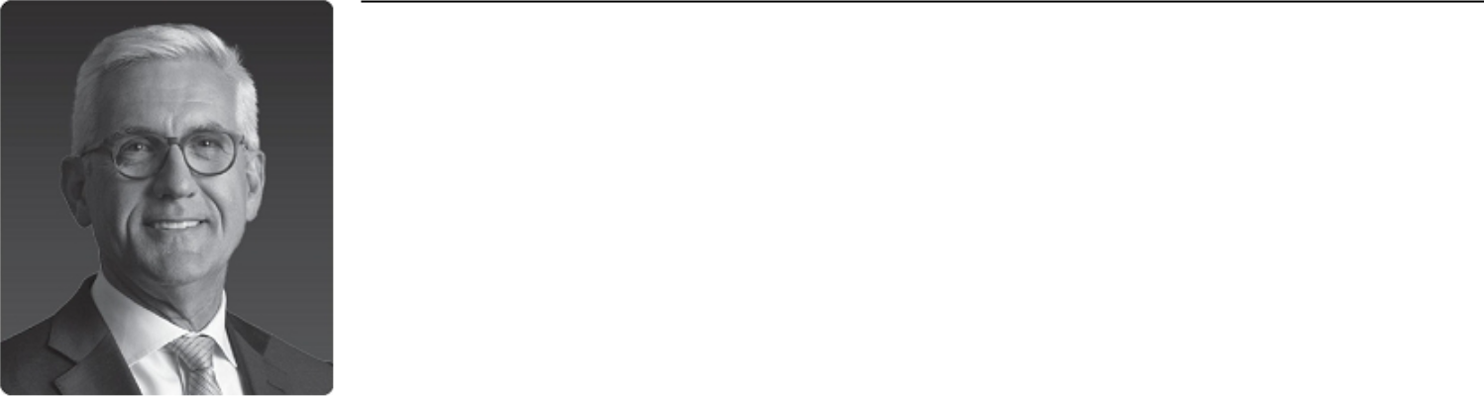

Former President and CEO, | Nationality
ABB Ltd. | Germany and Switzerland
Director since 2021 | SLB Board Committees
Age: 58 | • Compensation
Other Current Public Boards | • New Energy and Innovation
• Infineon Technologies | Other Experience and Education
 | • PhD in Economics, Universität Stuttgart
Former Public Directorships | • Master’s Degree in Management and Engineering, Universität
Held During the Past Five Years | Stuttgart
• None | • Digital transformation, restructuring and portfolio management
 | expertise

ULRICH SPIESSHOFER is the former president and Chief Executive Officer of ABB Ltd., a multinational technology-focused corporation, having served in that role from 2013 to April 2019 and as an ABB executive committee member from 2005 to April 2019. Under Dr. Spiesshofer’s leadership, ABB transformed into a global leader in digital industries and a respected technology company at the nexus of industrial products and services, robotics and software. Since June 2020, he has served as a senior advisor at The Blackstone Group L.P. (Blackstone), and in this capacity he has chaired the advisory boards of Sabre Industries since January 2021 and Schenck Process since May 2021, and has served as a director of TDI-USA Holdings LLC since December 2021, all Blackstone portfolio companies. He has also served as a director of Infineon Technologies since February 2020, where he chairs the strategy and technology committee.

Relevant Skills and Expertise

Dr. Spiesshofer brings to the Board more than 30 years of global leadership experience in industries ranging from oil and gas to power and electrification to automation and digitalization. The Board values his industrial sector expertise and his business transformation experience leveraging digital technologies, products and services.

2023 Proxy Statement |  | 17

Proactive shareholder engagement
Independent Chairman of the Board, separate from CEO
No staggered board; all directors are elected annually
Fully independent Audit, Compensation, and Nominating and Governance committees
Regular executive sessions of non-employee directors
Majority vote standard for uncontested director elections
Annual performance evaluations of Board, its committees, and individual directors
100% Board attendance in 2022
Comprehensive risk assessment process designed to identify and manage enterprise-wide risks
Back to Contents

Corporate Governance

We are committed to strong corporate governance, which we believe is critical to achieving our performance goals and to retaining the trust of our stakeholders. Our governance practices include:

Director nominees reflect the gender, racial and ethnic, cultural and geographical diversity of our global operations, as well as diverse experience, skills, and tenure

Demonstrated commitment to Board refreshment, with every director joining the Board within the last six years

Non-employee director tenure limits of 75 years of age or 10 years of service—whichever comes first

No hedging or pledging of our stock by executives or directors

Robust stock ownership guidelines for SLB executives and directors

No lobbying or making financial or in-kind contributions to political parties or candidates
Proactive Shareholder Engagement

Our relationship and on-going dialogue with our shareholders are important parts of our Board’s corporate governance commitment. Our investor relations, sustainability, legal, and human resources teams engage with shareholders
throughout the year to seek their views on key matters, and then inform our Board and management about the issues and emerging governance trends that our shareholders tell us matter most to them. The chairs of our Compensation and Nominating and Governance committees also participate in our engagement efforts when requested. These engagements routinely cover executive compensation, corporate governance, company strategy and performance, sustainability, human rights and other current and emerging issues. For details about our 2022 Investors Conference, see “Spotlight on: 2022 Investor Day” on page 8 of this proxy statement.

Independent Chairman of the Board

One of the Board’s key responsibilities is to evaluate and determine an appropriate board leadership structure to provide independent oversight of SLB management. The Board believes that there is no single, generally accepted board leadership structure that is appropriate for all companies, and that the right structure may even vary for a single company as circumstances change. As a result, our independent directors, upon the recommendation of the Nominating and Governance Committee, consider the Board’s leadership structure at least annually. The Board welcomes and takes under consideration any input received from our shareholders regarding the Board’s leadership structure, and informs shareholders of any change in the Board’s leadership structure in any amended Corporate Governance Guidelines that we publish on our website and describe in our annual proxy statements.

Since 2019, our independent directors have separated the roles of CEO and Chairman of the Board, to allow our CEO to focus on leading SLB’s complex international business operations, while the Chairman provides the Board experienced and independent leadership. Mr. Papa currently serves as independent Chairman of the Board, and in that role, sets the agenda for and leads all Board meetings and all executive sessions of the non-executive directors.

The Board is currently conducting a search for a director to succeed Mr. Papa as independent chair of the Board. We expect the chair search process to be concluded in 2023 and expect Mr. Papa to retire after an appropriate handover with his successor. We do not expect Mr. Papa to stand for re-election at the Company’s 2024 annual general meeting of shareholders.

In considering its leadership structure, the Board took into account that SLB’s current governance practices provide for strong independent leadership, active participation by our independent directors and independent evaluation of, and communication with, many members of senior management. The Board believes that its risk oversight programs would be effective under a variety of board leadership frameworks and therefore do not materially affect the Board’s choice of leadership structure.

18 2023 Proxy Statement

Back to Contents

Board Oversight of Risk Management

The Board and its committees are actively involved in overseeing SLB’s risk management. The full Board routinely assesses SLB’s major risks and mitigation measures, in order to promote our shareholders’ and other stakeholders’ interests in SLB’s business continuity, long-term resilience, financial strength, and overall success. We believe that our Board composition provides SLB with robust and well-rounded experience to assist in effective oversight of SLB management, as reflected on the chart on page 11 of this proxy statement. In addition, the Board delegates to its committees responsibility for overseeing certain types of risk, as reflected in the chart below, and the committees in turn report regularly to the Board on activities in their respective areas of oversight.


Board of Directors

- The full Board oversees assessment of major risks facing SLB, determining the extent to which such risks are applicable and, to the extent the Board deems it appropriate, evaluating mitigation measures. The risks that the Board routinely considers relate to financial, geopolitical, strategic, regulatory, competitive, reputational, climate-related, and operational risks.

- The full Board oversees risk management by the CEO and our senior management team, by reviewing major financial objectives, critical strategies, and long-term plans, including allocation of capital, significant proposed business acquisitions and divestitures, operating performance, sustainability, and shareholder returns.


Audit

Committee

- Financial reporting and internal controls

- Major financial risk exposures

- Cybersecurity risks

- Finance-related compliance allegations

- Independent audit and internal audit

Compensation

Committee

- Compensation philosophy and policy, including addressing:

  - Pay-for-performance linkage and alignment to shareholder interests

  - Retention risk

  - Management succession

Nominating and

Governance

Committee

- Ethics and compliance risks, including trade compliance, anti-bribery, anti-money laundering, and human rights, and related significant allegations

- Related person transactions

- Board refreshment and Board and CEO succession

- Sustainability program, including acute and chronic climate risks

- Progress toward our net-zero ambition


Finance

Committee

- Appropriate leverage and related commitments, including climate-related funding

- Currency management, including non-U.S. currency fluctuation

- Financial risks related to M&A and strategic transactions

- Pension liabilities

New Energy and

Innovation Committee

- Critical risks and opportunities of:

  - Targeted new energy sectors

  - Critical innovation initiatives

SLB Senior Management

Day-to-day responsibility for:

- Identifying, assessing, monitoring, and managing the major risks to SLB through our enterprise risk management operational process

- Implementing effective risk mitigation measures, response plans and controls

- Integrating risk analysis into business decisions and performance objectives

Our senior management team has developed a comprehensive strategic planning and enterprise risk management process for identifying, assessing, and managing risk. Through this process, we identify key risks through a bi-annual corporate-level risk mapping exercise, which involves the CEO and other members of SLB senior management, along with a bottom-up operational (field-level) risk assessment by SLB’s various geographies, businesses, and functions. From time to time, the process also includes third-party assessments, external risk surveys, and facilitated workshops with SLB executives. Our executive leadership team has established an enterprise risk management committee to oversee this risk identification process and to monitor the implementation of mitigation processes. Our executive leadership team updates the Board at least annually as risks that could impact the implementation of the Company’s strategy are identified or evolve.

2023 Proxy Statement |  | 19

Back to Contents

Board Oversight of Sustainability

Today, the world faces the trilemma of providing secure and affordable energy to meet growing demand, while rapidly decarbonizing for a sustainable future. With nearly a century of market and technology leadership, SLB is well positioned to be a leader in the energy transition. The evolving marketplace will require bold new technologies and ideas, digital transformation, and a deep commitment to sustainability.

As part of this commitment, the Board and its committees oversee the performance and management of various environmental, social and other sustainability issues, including our energy transition strategy, emissions reduction targets, climate change, sustainability reporting, workforce health and safety, human rights, diversity, equity and inclusion in our workforce, and ethics and compliance. For example:

- The Board oversees SLB’s long- and short-term strategy, including monitoring portfolio advancements that focus on decarbonizing our Core businesses—such as our Transition Technologies and emissions monitoring portfolios—as well as our SLB New Energy investments in low-carbon and carbon-neutral energy technologies. The Board oversees the Company’s roadmap to reach its 2050 net zero commitment that is inclusive of Scope 3 emissions and includes interim Scope 1, 2, and 3 emissions reduction milestones.

- The Board also oversees SLB’s enterprise risk management process, as discussed on the previous page under “—Board Oversight of Risk Management”, and reviews major risks facing SLB, including geopolitical risks, acute and chronic climate risks, and energy transition risks. We take a data-centric, scenario-based approach to managing climate and transition risk, and we use both the Task Force on Climate-Related Financial Disclosures (TCFD) recommendations and Sustainability Accounting Standards Board (SASB) standards as disclosure frameworks and methodology guides.

- The Nominating and Governance Committee oversees our sustainability programs, initiatives, and activities, and receives regular updates from senior management on the progress we are making toward a low-carbon future. This committee also monitors and reviews the effectiveness of SLB’s Ethics and Compliance program, including our Code of Conduct and all significant compliance allegations.

- The New Energy and Innovation Committee provides insights on the growth potential, maturity and viability of SLB’s targeted New Energy business sectors, and validates the sustainability impacts of growth opportunities.

- The Board’s other committees oversee sustainability-related topics within their respective areas of responsibility, such as the incorporation of sustainability and diversity metrics into our short-term incentive compensation programs (Compensation); the conduct of sustainability-related reviews by our internal audit team (Audit); operational risks such as cybersecurity (Audit); the disclosure of ESG risks (Audit and Nominating and Governance, jointly); and the development of our sustainable finance strategy, including financial instruments with rates linked to climate commitments (Finance).

Our line management is directly responsible for the management and mitigation of the environmental impact of our operations. Our Vice President of HSE is responsible for our environmental management systems, and our Vice President of Sustainability is responsible for our global sustainability strategy and programs. For details about our environmental management standard and how we manage environmental risk, see our annual Sustainability Report, available at https://www.slb.com/sustainability/.

Board Refreshment Processes

The Board is committed to thoughtful board refreshment and ongoing board succession planning. All of our director nominees joined the Board within the last six years, bringing diverse and evolving experience and leadership skills in areas that are strategically important to SLB. The chart below reflects some of the key skills and experience of the non-employee directors who joined the Board since 2019, offering continuing expertise in our core industry and operations, while enhancing expertise in financial and capital management, sustainability, new energy, and digital technologies and transformation. For further information on each of our director nominees, see “Election of Directors” beginning on page 10 of this proxy statement.
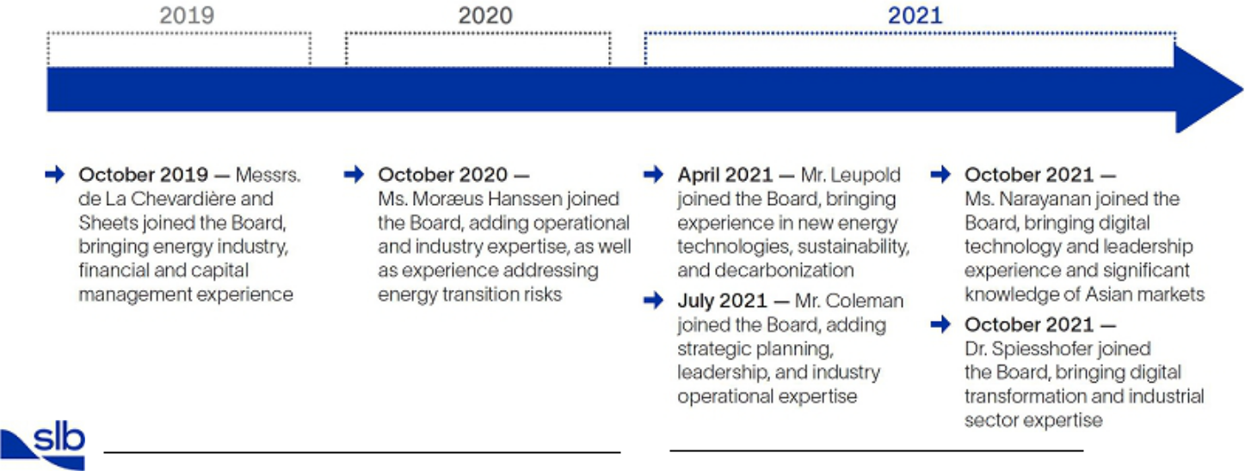

20 2023 Proxy Statement

Back to Contents

Board Term Limits and Retirement Age

Under our Corporate Governance Guidelines, non-executive directors are eligible to serve on the Board until age 75 or for a maximum ten-year term, whichever occurs first. Our Board may waive this policy on a case-by-case basis on the recommendation of the Nominating and Governance Committee if a waiver is in SLB’s best interests.

Business Continuity Waiver for Mr. Papa — Under the leadership of Mr. Papa, the Board’s independent Chairman, the Board has undergone significant refreshment and transition in recent years. In addition, an active search process for a successor to Mr. Papa as independent Board chair is ongoing. In light of these circumstances, and in order to facilitate a smooth Board leadership transition process, the Board waived the retirement age policy for Mr. Papa upon the recommendation of the Nominating and Governance Committee, because the Board believes that having Mr. Papa continue to serve as independent Chairman is in the best interests of SLB and its shareholders. We expect the chair search process to be concluded in 2023, and do not expect Mr. Papa to stand for re-election at the Company’s 2024 annual general meeting of shareholders.

Process for Selecting New Directors

The Nominating and Governance Committee assists the Board in identifying qualified individuals to join as new members. The Board seeks out individuals whose background, experience and skills complement those of other Board members. As a result, in evaluating potential nominees, the Committee takes into consideration the Board’s current composition, the potential nominee’s ability to contribute to the Board’s diversity, SLB’s existing and anticipated business needs, and the general qualifications of the potential nominees, as discussed above under “Election of Directors—Director Qualifications and Diversity.”

The Nominating and Governance Committee also recommends to the Board the number and names of persons to be proposed by the Board for election as directors at our AGM. In obtaining the names of possible director nominees, the Nominating and Governance Committee makes its own inquiries and receives suggestions from other directors and management. Consideration of new Board candidates typically involves a series of internal discussions, review of information regarding potential candidates, and interviews with selected candidates.

From time to time, the Nominating and Governance Committee retains executive search and board advisory consulting firms to assist in identifying and evaluating potential nominees. To further our diversity policy, we request that any such firms retained by us include women and nationally, racially and ethnically diverse candidates in the proposals they present to us.

The Nominating and Governance Committee will also consider nominees recommended by shareholders who meet the eligibility requirements for submitting shareholder proposals for inclusion in the next proxy statement and submit their recommendations in writing to: Nominating and Governance Committee Chair, c/o SLB Chief Legal Officer and Secretary, 5599 San Felipe, 17th Floor, Houston, Texas 77056. Such recommendations must be submitted by the deadline for shareholder proposals referred to under “Other Information—2024 Annual General Meeting of Shareholders” on page 69 of this proxy statement. Unsolicited recommendations must contain all of the information that would be required in a proxy statement soliciting proxies for the election of the candidate as a director, a description of all direct or indirect arrangements or understandings between the recommending security holder and the candidate, all other companies to which the candidate is being recommended as a nominee for director, and a signed consent of the candidate to cooperate with reasonable background checks and personal interviews, and to serve as a member of our Board, if elected.

2023 Proxy Statement |  | 21

Back to Contents

Board and Committee Evaluations

Each year, the Board and its committees conduct rigorous self-evaluations in order to assess the overall functioning, performance and effectiveness of the Board, its committees, and the individual non-employee directors. The Nominating and Governance Committee oversees this annual evaluation process. From time to time, these evaluations may be conducted using a third-party facilitator. The methodology for conducting Board and Committee self-evaluations is outlined in the chart below.

Initiate Evaluation Process Collect Evaluation Data Discuss Findings Implement Feedback


Upon the instruction of the Nominating and Governance Committee, written self-assessment questionnaires are distributed to each member of the Board.

These questionnaires seek anonymous, candid feedback from our directors on a variety of topics, including board composition and culture, committee effectiveness, strategic planning, risk management, peer evaluation, and succession planning.

Directors’ responses to the questionnaires are then aggregated into summary reports for the Board, each of its committees, and the chair of the Nominating and Governance Committee.

In 2022, the Nominating and Governance Committee engaged
a third-party facilitator to conduct one-on-one interviews with our directors as part of this annual self-evaluation process.

Each October, findings from the evaluation process are reviewed and discussed in executive session at each committee meeting and the full Board meeting. Based on these discussions, the directors may recommend improvements to the Board’s structure, processes, policies, or composition, or other changes.

In addition, the chair of the Nominating and Governance Committee may provide one-on-one feedback to individual directors as appropriate.

Finally, the Board, its committees, and (where appropriate) management work to implement the feedback from this evaluation process to improve Board performance and effectiveness.

Following this process, the Nominating and Governance Committee annually reviews— and makes recommendations to the Board regarding—its process for evaluating the effectiveness of the Board, its committees and individual directors.

Director Orientation and Education

Our director orientation and continuing education programs are designed to support our directors in fulfilling their responsibilities as members of the Board. First, all new directors participate in SLB’s director orientation program, to familiarize themselves with our business and operations, financial and performance strategies, controls and compliance systems, sustainability and HSE commitments, and industry dynamics. New directors also attend trainings with members of senior management focused on financial, industry- and committee-specific topics, as well as facility and well-site visits.

For new and incumbent directors, regular continuing education programs help our Board stay current on industry, corporate governance, risk management, cybersecurity, and other developments relevant to their work as directors. These programs may include presentations from SLB management or in-depth trainings developed by outside experts, as appropriate. For example, in 2022, the Audit Committee attended cybersecurity training sessions with SLB experts and external consultants.


From left to right: Vanitha Narayanan and Tatiana Mitrova, SLB

independent directors, and Mark Papa, independent Chairman of the

SLB Board, together with the other members of the Board, visited

SLB’s OneSubsea* facility in Horsøy, Norway during 2022.

22 2023 Proxy Statement

Back to Contents

Board Committees

The Board has five standing committees: Audit, Compensation, Nominating and Governance, Finance, and New Energy and Innovation. Each member of the Audit, Compensation and Nominating and Governance committees meets the independence and other requirements of the New York Stock Exchange (NYSE) listing standards and SEC rules (including the heightened requirements that apply to audit or compensation committee members, as applicable). In addition, each member of the Audit Committee is financially literate, and each of Mr. de La Chevardière and Mr. Sheets qualifies as an “audit committee financial expert” under applicable SEC rules.

The Nominating and Governance Committee nominates for Board approval directors to serve on and chair the Board’s committees. The following table reflects the membership of the Board’s standing committees as of February 1, 2023.

 |  |  | Nominating and |  | New Energy
 | Audit | Compensation | Governance | Finance | and Innovation
Name of Director | Committee | Committee | Committee | Committee | Committee
Peter Coleman |  |  | ● | ●
Patrick de La Chevardière | Chair |  |  | ●
Miguel Galuccio |  |  |  | Chair
Samuel Leupold | ● |  |  | ● | ●
Tatiana Mitrova | ● |  |  | ● | ●
Maria Moræus Hanssen |  | ● | ● |  | Chair
Vanitha Narayanan |  | ● | ●
Mark Papa⁽¹⁾ |  |  | Chair
Jeff Sheets | ● | Chair
Ulrich Spiesshofer |  | ● |  |  | ●

- Independent Chairman of the Board

Each standing committee operates under a written charter that sets forth the purposes, responsibilities and membership requirements of that committee. Each committee reviews the adequacy of its charter at least annually and recommends changes to the Board for approval. All committees also report regularly to the Board with respect to their activities. Committee charters are available on SLB’s website at https://www.slb.com/who-we-are/corporate-governance/.

Board Attendance

During 2022, the Board held four regular meetings, each including an executive session of non-employee directors led by the Board’s independent Chairman, as well as one special meeting. The Board’s standing committees held 18 meetings in 2022, which included five Audit Committee, four Compensation Committee, four Nominating and Governance Committee, one New Energy and Innovation Committee, and five Finance Committee meetings. Officers regularly attend Board meetings to present information on our business and strategy, and directors have worldwide access to our employees outside of Board meetings. From time to time between meetings, Board and committee members confer with each other and with management and independent consultants regarding relevant issues, and representatives of management may meet with these consultants on behalf of the relevant committee.

In 2022, our directors attended 100% of the meetings of the Board and its committees on which they served.

The Board’s policy regarding director attendance at our AGM is that directors are welcome, but not required, to attend. No director attended our 2022 AGM.

Code of Conduct

We have adopted a Code of Conduct that applies to all SLB directors, officers, and employees. Our Code of Conduct is available on our website at https://www.slb.com/who-we-are/guiding-principles/our-code-of-conduct.

2023 Proxy Statement |  | 23

Back to Contents

Corporate Governance Guidelines

We have adopted Corporate Governance Guidelines that our Board believes are consistent with our values, and that promote the effective functioning of our Board, its committees and the Company. At least annually, our Board reviews and, if appropriate, revises our Corporate Governance Guidelines to reflect the Board’s corporate governance objectives and commitments. Our Corporate Governance Guidelines are available on our website at https://www.slb.com/who-we-are/corporate-governance/guidelines.

Director Independence

Our Corporate Governance Guidelines provide that at least a majority of the Board must consist of independent directors, in accordance with the NYSE listing standards. In addition, our Board has adopted director independence standards that meet or exceed the independence requirements in the NYSE listing standards, and which can be found in our Corporate Governance Guidelines.

Based on the review and recommendation by the Nominating and Governance Committee, the Board has determined that each director nominee listed above under “Election of Directors—Our Director Nominees” is “independent” under NYSE listing standards and our director independence standards, except for our CEO and Mr. Galuccio. The Board has also determined that each member of the Audit Committee meets the heightened independence standards required for audit committee members under NYSE listing standards and the rules of the SEC, and that each member of the Compensation Committee meets the heightened independence standards for compensation committee members under NYSE listing standards. Additionally, former director Henri Seydoux, who served on the board until April 2022, was independent during the period he served on our Board.

Our Board’s independence determinations included a review of transactions that occurred since the beginning of 2020 with entities associated with our directors or members of their immediate family. In making its independence determinations, the Board considered that our independent directors serve as directors, trustees, outside consultants, or advisory board members at companies and universities that have had commercial business relationships with SLB. These relationships all involved ordinary course commercial transactions with SLB, which were less than the greater of $1 million or 1% of the other entity’s annual revenues during 2022, 2021 and 2020.

The Board also considered that SLB made charitable contributions to certain academic and other institutions with which some of our directors are currently affiliated, in each case involving less than $120,000 per year in 2022, 2021 and 2020. No director received any personal benefit from any such charitable contributions.

Certain Relationships and Related Person Transactions

The Board has a written policy governing the review, approval and ratification of “related person transactions.” Under SEC rules, as applied by the Board, “related persons” include any director, executive officer, director nominee, or greater than 5% shareholder of SLB since the beginning of the previous fiscal year, and their immediate family members. The policy applies to any transaction in which SLB is a participant and any related person has a direct or indirect material interest, where the amount involved exceeds $120,000, unless excluded under Item 404(a) of SEC Regulation S-K.

The Nominating and Governance Committee is responsible for reviewing and, where appropriate, approving or ratifying any related person transaction involving SLB and any related persons. The Nominating and Governance Committee approves only those related person transactions that are in, or are not inconsistent with, the best interests of SLB and its shareholders.

SLB has an ongoing commercial relationship with Vista Energy (Vista), where Mr. Galuccio serves as chairman of the board and chief executive officer.

In 2022, SLB contracted with Vista to deliver ordinary course oilfield services and products, and Vista paid SLB approximately $156 million.

Communicating with Our Board

The Board recommends that shareholders and other interested parties initiate communications with the Board, the Chairman or any Board committee by writing to our Chief Legal Officer and Secretary. This process assists the Board in reviewing and responding to communications by shareholders and other interested parties. The Board has instructed our Chief Legal Officer and Secretary to review correspondence directed to the Board (including to the Chairman and any Board committee) and, at the Secretary’s discretion, to forward those items that she deems appropriate for the Board’s consideration.

Communications can be sent to the following address: SLB Board of Directors c/o SLB Chief Legal Officer and Secretary, 5599 San Felipe, 17th Floor, Houston, Texas 77056.

24 2023 Proxy Statement

Back to Contents

Director Compensation

Our director compensation philosophy is to appropriately compensate our non-employee directors for the time, expertise and effort required to serve as a director of a large and complex global company, and to align the interests of our directors with those of our shareholders. Directors who are SLB employees do not receive compensation for serving on the Board.

Director Pay Components

Cash Compensation

Non-employee directors receive the following cash compensation:

- an annual cash retainer of $115,000;

- an annual fee of $10,000 for each committee membership;

- if the director is the chair of a committee, an annual fee of $20,000 in lieu of the fee for committee membership; and

- if the director is the independent Board Chairman, an additional $100,000 annual cash fee.

Equity Compensation

SLB annually grants shares of our common stock valued at approximately $190,000 for each non-employee director, or $290,000 for the independent Board Chairman. The shares are valued based on our closing stock price on the last business day of April of the grant year.

For 2022, our non-employee directors received the following grants of our common stock effective May 2, 2022:

- 4,871 shares to each non-employee director serving on that date (except for Mr. Papa and Ms. Narayanan, as discussed below); and

- 7,434 shares to Mr. Papa, our independent Board Chairman.

The following table provides information on the compensation paid to our non-employee directors in 2022.

Name | Fees Earned or Paid in Cash ($)⁽¹⁾ | Stock Awards ($)⁽²⁾ | Total ($)
Peter Coleman | 135,000 | 190,505 | 325,505
Patrick de La Chevardière | 145,000 | 190,505 | 335,505
Miguel Galuccio | 135,000 | 190,505 | 325,505
Samuel Leupold | 145,000 | 190,505 | 335,505
Tatiana Mitrova | 145,000 | 190,505 | 335,505
Maria Moræus Hanssen | 155,000 | 190,505 | 345,505
Vanitha Narayanan | 135,000 | 190,505 | 325,505
Mark Papa | 235,000 | 290,744 | 525,744
Henri Seydoux⁽³⁾ | 14,579 | — | 14,579
Jeff Sheets | 145,000 | 190,505 | 335,505
Ulrich Spiesshofer | 135,000 | 190,505 | 325,505

- The amounts reported reflect cash fees actually paid in 2022. Ordinarily, the annual cash retainer is paid in cash, but non-employee directors can elect to have their retainer paid in stock or deferred under the SLB 2004 Stock and Deferral Plan for Non-Employee Directors. In 2022, Ms. Narayanan deferred receipt of 100% of her cash director fees until the date she ceases to be an SLB director.

- The amounts reported reflect the aggregate grant date fair value of the stock awards computed in accordance with applicable accounting standards, based on the closing stock price on the applicable grant date. Amounts rounded to nearest dollar. A non-employee director may elect to defer the receipt of all or part of a stock award under the SLB 2004 Stock and Deferral Plan for Non-Employee Directors. In 2022, Ms. Narayanan deferred receipt of 100% of her annual stock award until the date she ceases to be an SLB director.

- Did not stand for re-election at our 2022 AGM.

Non-employee directors who begin their Board, Board Chair, committee or committee chair service after the AGM receive a prorated amount of annual compensation. SLB also reimburses non-employee directors for travel and other business expenses incurred in the performance of their services for us.

2023 Proxy Statement |  | 25

Back to Contents

Annual Director Pay Review

Our Compensation Committee annually reviews our non-employee director compensation, and periodically recommends that the Board approve updates to director pay. In 2022, the Committee’s director pay review took into account multiple factors including our director compensation philosophy, changes in market practices, the continued expansion of director and committee chair responsibilities, consultations with the Committee’s independent compensation consultant, Pay Governance, and feedback received during our shareholder engagements. Based on that review, the Committee determined that no changes in non-employee director compensation were necessary for 2022. The Committee has not increased the directors’ annual cash retainer, committee chair or membership fees, or annual stock grant value since 2017 (except in connection with separating the Chairman and CEO roles in 2019).

While the Committee is aware that other jurisdictions may have differing director compensation practices, the Committee believes it is in the best interests of SLB and our shareholders as a whole to align to market practice among NYSE-listed companies and companies with a large U.S. shareholder base. The Committee also believes that the interests of our non-employee directors are most aligned with the interests of our shareholders when a significant portion of director compensation is paid through stock grants.

Director Stock Ownership Guidelines

The Board believes that ownership of SLB stock by our directors aligns their interests with the interests of our shareholders. Accordingly, the Board has established a guideline that each non-employee director must, within five years of joining the Board, own a minimum dollar value of shares of SLB common stock equal to five times (5x) that director’s annual cash retainer. As of January 31, 2023, each of our non-employee directors who has been a Board member for at least five years was in compliance with these stock ownership guidelines.

Director Deferral Plan

Non-employee directors may elect to defer all or a portion of their annual stock or cash awards through the SLB 2004 Stock and Deferral Plan for Non-Employee Directors (the Directors Stock Plan). When directors elect to defer their stock award, their deferred compensation account is credited with a number of “stock units.” Each stock unit is equal in value to a share of our common stock, but because it is not an actual share of our common stock it does not have any voting rights. When directors elect to defer their cash award, they may choose to invest such deferred cash compensation into either (i) SLB common stock, (ii) money market equivalents, or (iii) an S&P 500 equivalent. Deferrals into a stock account are credited with dividend equivalents in the form of cash to be paid at the time of vesting and deferrals into the cash account are credited with gains or losses based on the monthly performance of the various investment options described above. Following retirement from our Board and depending on the director’s election, a non-employee director may receive the deferred compensation on the date of the director’s retirement or a date that is one year following the date of the director’s retirement.

26 2023 Proxy Statement

Back to Contents

Stock Ownership Information

Security Ownership by Management and Our Board

The following table sets forth information known to us with respect to beneficial ownership of our common stock as of January 31, 2023 by (i) each director and director nominee, (ii) each named executive officer, and (iii) all executive officers (as defined in Rule 3b-7 of the Securities Exchange Act of 1934, as amended (the Exchange Act)), and directors as a group (the D&O Group).

The number of shares beneficially owned as of January 31, 2023 includes shares of SLB common stock that the individual has the right to acquire within 60 days of January 31, 2023, including exercisable options to purchase our common stock, as well as RSUs and PSUs that will vest within 60 days. The table below does not include (i) shares of SLB common stock deferred under the Directors Stock Plan, or (ii) the number of shares earned but not yet issued under our 2020 ROCE PSUs, because SLB will finally determine the number of shares earned after the applicable comparator companies disclose their full-year audited 2022 results, as described under “Compensation Discussion and Analysis—Elements of 2022 Total Direct Compensation—Long-Term Equity Incentive Awards—Payouts Under Prior LTI Awards—PSUs Vesting in 2023” beginning on page 43 of this proxy statement. These same policies apply to the aggregate calculation for the D&O Group.

 | Beneficial Ownership of
 | SLB Common Stock
Name | Number of₍₁₎ | Percentage
Name | Shares | of Class
Khaled Al Mogharbel (NEO) | 645,725⁽²⁾ | <1%
Ashok Belani (NEO) | 707,357⁽³⁾ | <1%
Stephane Biguet (NEO) | 313,495⁽⁴⁾ | <1%
Peter Coleman | 10,606 | <1%
Patrick de La Chevardière | 25,460 | <1%
Miguel Galuccio | 34,660 | <1%
Olivier Le Peuch (NEO) | 904,916⁽⁵⁾ | <1%
Samuel Leupold | 12,143 | <1%
Abdellah Merad (NEO) | 268,357⁽⁶⁾ | <1%
Tatiana Mitrova | 29,144 | <1%
Maria Moræus Hanssen | 13,152 | <1%
Vanitha Narayanan | 3,695 | <1%
Mark Papa | 68,286 | <1%
Dianne Ralston (NEO) | 86,948 | <1%
Jeff Sheets | 25,460 | <1%
Ulrich Spiesshofer | 8,566 | <1%
All directors and executive officers as a group (24 persons) | 3,292,541⁽⁷⁾ | <1%

- Beneficial ownership is determined under the rules of the SEC and generally includes voting or investment power with respect to securities. Except as indicated in the below footnotes and subject to applicable community property laws, to our knowledge the persons named in this table have sole voting and investment power with respect to the securities listed. None of the shares are subject to any pledge.

- Includes options to purchase 308,000 SLB shares.

- Includes options to purchase 268,000 SLB shares.

- Includes options to purchase 99,000 SLB shares and 1,773 shares beneficially owned by Mr. Biguet’s children.

- Includes options to purchase 129,000 SLB shares.

- Includes options to purchase 64,000 SLB shares.

- Includes options to purchase 1,079,990 SLB shares, all of which are held by our executive officers. Excludes shares owned by Mr. Belani, who retired from his role as EVP, New Energy effective April 1, 2022, and was appointed Senior Strategic Advisor to the CEO, a non-executive officer position.

2023 Proxy Statement |  | 27

Back to Contents

Security Ownership by Certain Beneficial Owners

The following table sets forth information as of December 31, 2022 (except as otherwise noted) with respect to persons known by us to be the beneficial owners of more than 5% of our common stock, based solely on the information reported by such persons in their Schedule 13D and 13G filings with the SEC.

For each entity included in the table below, percentage ownership is calculated by dividing the number of shares reported as beneficially owned by such entity by the 1,428,189,537 shares of our common stock outstanding on January 31, 2023.

 | Beneficial Ownership of
 | SLB Common Stock
 | Number of | Percentage
Name and Address | Shares | of Class
The Vanguard Group⁽¹⁾ | 125,139,611 | 8.8%
100 Vanguard Blvd.
Malvern, PA 19355
BlackRock, Inc.⁽²⁾ | 107,803,887 | 7.5%
55 East 52nd Street
New York, NY 10055
State Street Corporation⁽³⁾ | 86,680,330 | 6.1%
State Street Financial Center
One Lincoln Street
Boston, MA 02111

- Based solely on a Statement on Schedule 13G/A filed on February 9, 2023. Such filing indicates that The Vanguard Group has shared voting power with respect to 1,885,561 shares, sole investment power with respect to 119,570,936 shares and shared investment power with respect to 5,568,675 shares.

- Based solely on a Statement on Schedule 13G/A filed on January 31, 2023. Such filing indicates that BlackRock, Inc. has sole voting power with respect to 95,233,711 shares and sole investment power with respect to 106,886,387 shares.

- Based solely on a Statement on Schedule 13G/A filed on February 7, 2023. Such filing indicates that State Street Corporation has shared voting power with respect to 79,798,276 shares and shared investment power with respect to 86,299,734 shares.

28 2023 Proxy Statement

Back to Contents

ITEM 2. Advisory Vote on the Frequency of Future Advisory Votes on Executive Compensation

Our Board is asking you to vote, on an advisory basis, on whether future advisory votes on executive compensation (as reflected in Item 3 below) should occur every year, every two years or every three years. This item, which is provided pursuant to Section 14A of the Exchange Act, is commonly referred to as a “say-on-frequency” resolution.

After careful consideration, our Board recommends that future advisory votes on executive compensation occur every year. We believe that an annual advisory vote on executive compensation will allow our shareholders to provide frequent, direct input on our compensation policies and practices and the resulting compensation for our named executive officers. Shareholders will have the opportunity to consider our most recent compensation decisions and focus on increasing long-term shareholder value, and to provide feedback to us in a timely way.

In making this recommendation, the Board considered that a majority of the votes cast at our 2017 AGM voted in favor of holding annual advisory votes on executive compensation. In addition, we are aware of the significant interest in executive compensation matters by investors and the general public, and value and encourage constructive dialogue with our shareholders on these matters.

This advisory resolution is non-binding on the Board. Although we currently believe that holding an advisory vote on executive compensation every year will reflect the right balance of considerations in the normal course, we will continue to periodically reassess that view and may provide for an advisory vote on executive compensation on a less frequent basis if long-term stability in our compensation program or other circumstances suggest that such a vote frequency would be more appropriate.

The Board of Directors recommends a vote to conduct future advisory votes on executive compensation every ONE YEAR.

2023 Proxy Statement |  | 29

Back to Contents

ITEM 3. Advisory Approval of Our Executive Compensation

Our Board is asking you to approve, on an advisory basis, the compensation of our NEOs as disclosed in this proxy statement. This item, which is provided pursuant to Section 14A of the Exchange Act, is commonly referred to as a “say-on-pay” resolution.

The Compensation Committee has structured our executive compensation program to achieve the following key objectives:

- to attract, motivate and retain talented executive officers,

- to motivate the achievement of companywide financial objectives, as well as other strategic personal objectives, while balancing rewards for short-term and long-term performance, and

- to align the interests of our executive officers with those of our shareholders,

each as described in the “Compensation Discussion and Analysis” section of this proxy statement.

Our Compensation Committee and the Board believe that the policies and procedures articulated in the “Compensation Discussion and Analysis” are effective in achieving our goals, and that the compensation of our NEOs as reported in this proxy statement has contributed to SLB’s short-term and long-term success. Therefore, we are asking our shareholders to approve the compensation of our NEOs by voting “FOR” the following resolution on an advisory basis:

RESOLVED, that the compensation paid to Schlumberger Limited’s named executive officers, as disclosed in this proxy statement, including the Compensation Discussion and Analysis, compensation tables and narrative discussion, is hereby APPROVED on an advisory basis.

This vote is non-binding, but our Board and the Compensation Committee will review and consider the voting results when making future decisions regarding our executive compensation program.

Although annual “say-on-pay” advisory votes are not required by our bylaws, the Board currently believes that having our shareholders provide annual feedback on our compensation practices supports effective governance. As a result, the next “say-on-pay” advisory vote will occur in 2024, unless the Board modifies its policy on the frequency of holding “say-on-pay” advisory votes.

The Board of Directors recommends a vote FOR this Item 3.

Compensation Committee Report

The Compensation Committee has reviewed and discussed the Compensation Discussion and Analysis with SLB’s management. Based on that review and discussion, the Compensation Committee recommended to the Board of Directors that the Compensation Discussion and Analysis be included in this proxy statement.

Submitted by the Compensation Committee of the SLB Board of Directors

Jeff Sheets, Chair |  | Maria Moræus Hanssen | Vanitha Narayanan |  | Ulrich Spiesshofer
 |  |  | 30 |  |  | 2023 Proxy Statement

Back to Contents

Compensation Discussion and Analysis

This Compensation Discussion and Analysis (CD&A) describes our compensation policies and practices as they relate to our six named executive officers (NEOs) identified below.

Named Executive Officers | Title
Olivier Le Peuch | Chief Executive Officer
Stephane Biguet | Executive Vice President and Chief Financial Officer
Khaled Al Mogharbel | Executive Vice President, Geographies
Abdellah Merad | Executive Vice President, Core Services and Equipment
Dianne Ralston | Chief Legal Officer and Secretary
Ashok Belani | Senior Strategic Advisor to the CEO; Former Executive Vice President, New Energy

The purpose of the CD&A is to explain the elements of our NEOs’ 2022 compensation, the criteria for selecting these elements, the decisions our Compensation Committee made with respect to the 2022 compensation of our NEOs, and the reasons for those decisions.

 |  | CD&A Table of Contents
 |  | Executive Overview |  | 32
 |  | Overview of Compensation Decisions for 2022 |  | 33
 |  | Framework for Setting 2022 Executive Compensation |  | 34
 |  | Program Design and Pay-for-Performance Philosophy |  | 34
 |  | At-Risk Pay Mix |  | 35
 |  | Responsiveness to Shareholder Feedback |  | 35
 |  | Elements of 2022 Total Direct Compensation |  | 36
 |  | Base Salary |  | 36
 |  | Annual Cash Incentive Awards |  | 36
 |  | Long-Term Equity Incentive Awards |  | 39
 |  | Other Benefits |  | 44
 |  | Other Aspects of Our Executive Compensation Program |  | 45
 |  | Competition for Our Executive Talent |  | 45
 |  | Our Peer Group Companies |  | 46
 |  | Executive Compensation Governance |  | 47
 |  | No Employment Agreements with Current NEOs |  | 47
 |  | Stock Ownership and Holding Requirements |  | 47
 |  | Anti-Hedging and Anti-Pledging |  | 47
 |  | 10b5-1 Trading Plans |  | 47
 |  | Clawback Policy |  | 47
 |  | Process for Setting Executive Compensation |  | 48
2023 Proxy Statement |  |  |  | 31

Back to Contents

Executive Overview

We are SLB—a global technology company that drives energy innovation for a balanced planet

2022 was transformative for SLB. We launched our bold new SLB brand identity—reinforcing our leadership position in technology, digital, and sustainability in the energy industry—and we demonstrated our ability to deliver superior earnings in this early phase of a structural upcycle in energy. We set new safety, operational, and performance benchmarks for our customers and strengthened our market position both internationally and in North America.

Highlights of our 2022 financial performance⁽¹⁾ include:

 |  |  |  |  |  |  | Strengthened balance
 | Grew revenue |  | Grew GAAP EPS by |  | Expanded income |  | Strengthened balance
 | Grew revenue |  |  |  | Expanded income |  | sheet by reducing both
 | 23% | 81% |  |  | before taxes margin to |  | sheet by reducing both
 | 23% |  |  |  | before taxes margin to |  | gross and net debt by
 | 23% |  |  |  | 15.2% |  | gross and net debt by
 | year on year |  | year on year |  | 15.2% |  | $1.7 billion
 | Increased dividend |  | Grew EPS, excluding |  | Expanded adjusted |  | Ended 2022 with 1.4x
 | 40% in April 2022 |  | charges & credits, by |  | Expanded adjusted |  | Ended 2022 with 1.4x
 | 40% in April 2022 |  | 70% |  | EBITDA margin to |  | net debt to adjusted
 | 43% in January 2023 |  | 70% |  | 23.0% |  | EBITDA ratio—lowest level
 | 43% in January 2023 |  | year on year |  | 23.0% |  | since 2016



In 2022, we executed our strategy across our Three Engines of Growth—our Core, Digital, and New Energy—and successfully leveraged the breadth of our portfolio and our competitive strengths to deliver peer-leading outcomes for our customers and shareholders.

In our Core Divisions, we expanded pretax segment operating margins and launched new products, services, and solutions that increase efficiency and lower operational emissions. Our fit-for-basin, technology access and Transition Technologies portfolios fueled growth and margin expansion in every Division in 2022. And we continue to strengthen our Core portfolio for growth and position for future resilience and shareholder returns through strategic initiatives such as the announced subsea joint venture with Aker Solutions and Subsea 7.

In Digital, we had strong growth in exploration data, Innovation Factori and artificial intelligence solution sales, and the adoption of our new digital technologies is accelerating. We ended the year with more than 70% growth in Delfi users, and our SaaS revenue more than doubled. We continue to build adjacent expansion opportunities for our digital business, both in the operations data space and beyond oil and gas, such as carbon management.

In New Energy, we progressed technology development milestones, established new partnerships, and made new investments to develop a focused, yet comprehensive portfolio that offers promising growth opportunities for the future. Today, this portfolio comprises five business areas: carbon solutions, hydrogen, geothermal and geoenergy, critical minerals, and stationary energy storage. We are also accelerating our R&D efforts to develop technology solutions that address hard-to-abate industrial and power generation emissions.

In Sustainability, we reduced our Scope 1 and 2 carbon emissions intensity as compared to 2021. We also launched several new Transition Technologies to support the decarbonization of oil and gas, as well as our SLB End-to-end Emissions Solutions (SEES) methane elimination business.

We also advanced our technology leadership, safety and operations integrity performance, and service quality differentiation, leading to more contract awards, higher technology adoption, and increased pricing premiums.

Finally, we demonstrated our commitment to Superior Shareholder Returns. We increased our dividend by 40% in April 2022, followed by a further 43% increase in January 2023, and we resumed our share buyback program in January 2023.

Looking to 2023, we believe the market fundamentals are aligned with what we do best—innovating and outperforming for our customers. With our bold new brand and identity founded on technology and innovation, our strategy with sustainability at its heart, and our strong financial and operational results leading into the current upcycle, we believe we have set a very solid foundation for strong performance and shareholder value creation in 2023 and into the next decade.

- For definitions of adjusted EBITDA, adjusted EBITDA margin, free cash flow, free cash flow margin, EPS excluding charges and credits, and net debt, as well as reconciliations of these non-GAAP measures to their most comparable GAAP measures, see Appendix A.

32 2023 Proxy Statement

Back to Contents

Overview of Compensation Decisions for 2022

In making decisions regarding 2022 executive compensation, our Compensation Committee continued to focus on:

- strengthening pay-for-performance alignment,

- motivating and incentivizing outperformance,

- maintaining stability and retaining our top talent through business cycles, and

- appropriately compensating our executives for effectively deploying capital, generating strong cash flow, and creating long-term shareholder value.

In this context, and as more fully discussed elsewhere in this CD&A, below are some key actions that our Compensation Committee took with respect to our NEOs’ 2022 compensation.

- Diversified LTI Program Structure — Our NEOs continued to receive a mix of LTI grants in 2022, with 75% of their target LTI opportunity awarded in the form of PSUs, and 25% awarded in the form of three-year, time-based RSUs. As in 2021, payout under the 2022 PSUs will be contingent on achieving absolute FCF margin, relative ROCE, and relative TSR performance goals over respective three-year periods.

- Rigorous PSU Performance Targets — In setting LTI performance targets for 2022, the Committee emphasized and encouraged ambitious outperformance by increasing the maximum performance goal for the FCF Margin PSUs as compared to 2021, and continuing to set an above-median target performance goal for the TSR PSUs. In addition, based on shareholder feedback, the Committee adjusted the comparator group for our TSR PSUs to include our direct competitors and the S&P Global 1200 Energy Index, to focus on TSR outperformance relative to our direct competitors while expanding the group to include the broader energy market.

- Performance-Aligned Incentive Payouts — Our NEOs’ STI payouts were based on strong 2022 adjusted EBITDA results, partially offset by below-target 2022 free cash flow results, and their LTI payouts were based on exceptional multi-year ROCE and free cash flow conversion results.

 | Short-Term Incentive Results |  | Long-Term Incentive Results
• | Average NEO Payout — 80% — Our NEOs earned an average 2022 | • | Our CEO did not receive an LTI award in 2020 and therefore did not earn
 | cash incentive payout of 80%. |  | any 2020 PSUs.
• | Adjusted EBITDA Payout — 157% — Our 2022 adjusted EBITDA⁽¹⁾ | • | For our other NEOs, the 2020 LTI payout was based on: (i) SLB’s
 | was $6.462 billion, representing a 31% increase over 2021, and |  | average annual ROCE for the three-year performance period, which was
 | resulting in a payout of 157% of target for the adjusted EBITDA |  | 407 bps above the average ROCE of the comparator group, (ii) SLB’s
 | component of our 2022 cash incentive plan. |  | absolute 2022 ROCE of 13%, and (iii) SLB’s cumulative FCF conversion
• | Zero FCF Payout — Our 2022 free cash flow⁽¹⁾ of $1.418 billion was |  | rate of 192% from 2020 to 2021—which far exceeded the maximum
• |  |  | performance goal for the 2020 FCF conversion PSUs.
 | below the minimum performance target under our annual cash incentive | • | As a result, our NEOs, other than our CEO, earned 250% of the target
 | plan. As a result, our CEO and other NEOs earned no payout under the | •
 |  |  | shares of SLB stock under the 2020 PSUs.
 | free cash flow component of our 2022 cash incentive plan. |  | shares of SLB stock under the 2020 PSUs.

  - CEO and CFO Compensation Increases in Line with Market Trends — In light of SLB’s strong 2021 financial results—which surpassed all of the Company’s annual financial targets—as well as peer comparator data showing that our CEO’s 2021 compensation was below the median of our general industry peer group, the Committee recommended, and the independent members of the Board approved, an 11% increase to our CEO’s 2022 base salary and a 14% increase in his target LTI grant value. The Committee also approved a 4% base salary increase for our CFO, Mr. Biguet, and a 9% increase in his target LTI grant value, after considering the Company’s excellent 2021 financial performance, as well as peer comparator data and internal pay equity considerations. We held flat the base salaries and target LTI grant values for our other NEOs, except for Mr. Merad, whose compensation was adjusted in connection with a promotion in April 2022. For details regarding these market increases, see “—Elements of 2022 Total Direct Compensation—Base Salary” and “—Long-Term Equity Incentive Awards”.

  - ESG Objectives for All NEOs — All of our NEOs had strategic personal objectives related to sustainability, SLB New Energy, or HSE performance goals.

- For reconciliations of adjusted EBITDA and free cash flow to their most comparable GAAP measures, see Appendix A.

2023 Proxy Statement |  | 33

Back to Contents

Framework for Setting 2022 Executive Compensation

Program Design and Pay-for-Performance Philosophy

Our 2022 executive compensation program consisted of three primary elements, comprising our executives’ total direct compensation: LTI equity incentive awards (PSUs and RSUs), STI (annual) cash incentive awards, and base salary. Within these elements, 75% of our executives’ 2022 target LTI equity awards and 100% of their annual cash incentive awards were performance-based. These elements have allowed us to remain competitive and attract, retain, and motivate top executive talent whose interests are aligned with those of our shareholders.

The chart below sets out the primary elements of our NEOs’ 2022 total direct compensation, certain key features of each element, and how each of these compensation elements supports our strategy.

Type Element

Free Cash

Flow Margin

PSUs

(25%)

 |  | Performance-
Key Features | How Element Supports Our Strategy | Based? | At Risk?
 | • Aligns with our publicly disclosed financial
Absolute performance metric, based | ambition of achieving double-digit FCF margin
on our FCF margin over a three- | • Encourages our NEOs to generate high-quality
year period | • Encourages our NEOs to generate high-quality
year period | revenue, which translates into strong free cash
 | flow in line with our capital stewardship program
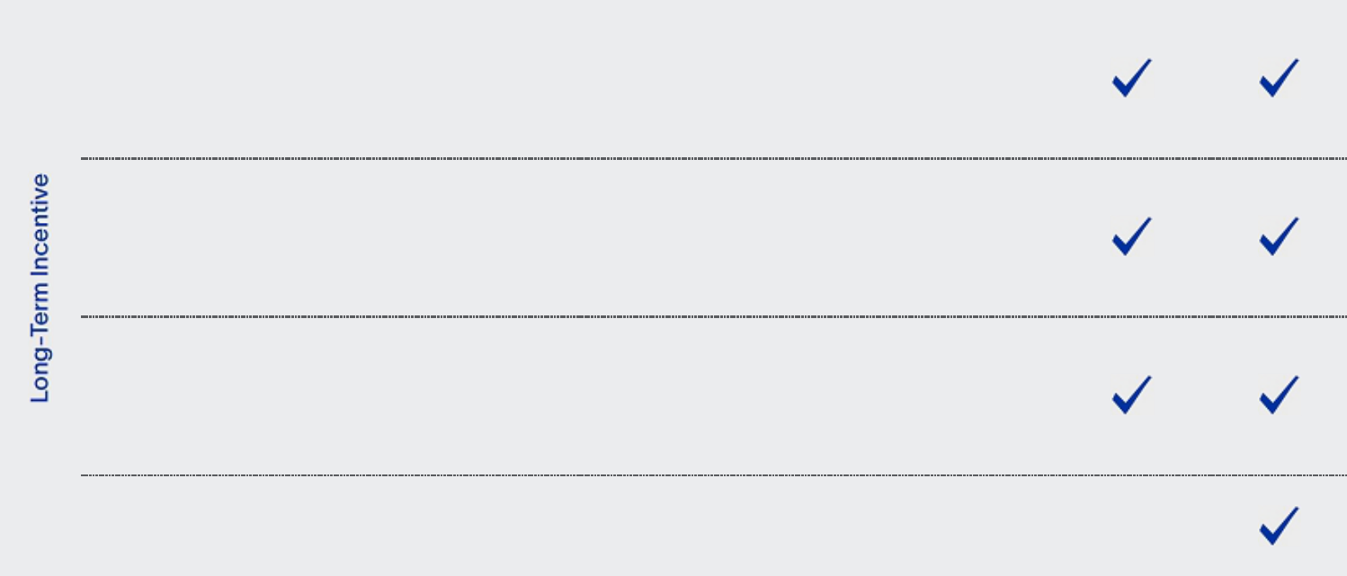

Return on

Capital

Employed

PSUs

(25%)

Total

Shareholder

Return PSUs

(25%)

Time-Based

RSUs

(25%)

Relative performance metric, comparing our average annual ROCE over a three-year period to that of our direct competitors

Relative performance metric, comparing our cumulative TSR over a three-year period to that of our direct competitors, as well as the S&P Global 1200 Energy Index

Cliff vesting after three years, subject to continued employment

- Measures the efficiency of our capital employed relative to direct competitors, consistent with our strategic priorities

- Motivates and rewards executives for relative outperformance on a key financial metric

- Directly aligns executive LTI payouts with shareholder value creation

- Uses a clear and objective metric to evaluate our performance against our direct competitors and against the broader energy sector

- Promotes stability and retention of our executive team through business cycles
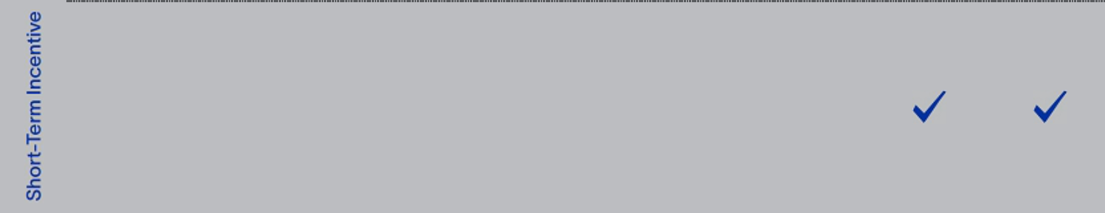

Annual Cash Incentive Award

70% based on achieving quantitative financial objectives, evenly split between adjusted EBITDA and free cash flow targets

30% based on strategic personal objectives

- Adjusted EBITDA reflects the quality of SLB’s earnings

- Free cash flow goals encourage our NEOs to continue strengthening our balance sheet, so we can sustainably return value to shareholders while making focused investments in future growth areas

- Personal objectives, detailed on page 38, align to our strategic focus areas

Base Salary

• Provides a base level of competitive cash

Only fixed compensation element compensation when all other pay elements are

variable or contingent on performance

34 2023 Proxy Statement

Back to Contents

In setting our executives’ compensation, our Compensation Committee believes that:

- the pay of our NEOs and other executives should be strongly linked to performance that is evaluated against financial and strategic personal objectives, and should balance incentivizing outperformance, ensuring retention, and maximizing shareholder value,

- our performance-based LTI and cash incentive awards should utilize clear, quantitative financial metrics that are closely aligned with our corporate strategy and stated external objectives and should be effective through all industry cycles,

- LTI awards should encourage the creation of long-term shareholder value, align our executives’ compensation with our shareholder returns, and incentivize our executives to achieve difficult but attainable strategic and financial goals that support our long-term performance and our leadership position in our industry,

- our executive compensation structure should enable us to recruit, develop, motivate, and retain top global talent, both in the short term and long term, and

- stock ownership guidelines, which require our executives to hold stock acquired through LTI awards, should further align the interests of our executives with those of our other shareholders.

At-Risk Pay Mix

Our executive compensation program is designed so that the higher an executive’s position in the Company, the greater the percentage of compensation that is “at risk”. At-risk compensation refers to an executive’s LTI awards and annual cash incentive opportunity. We believe that having a significant portion of our executives’ compensation at risk more closely aligns their interests with Company interests and with the interests of our shareholders.

As illustrated below, approximately 90% of our CEO’s 2022 target total direct compensation was at risk, and approximately 84% of our other NEOs’ 2022 target total direct compensation was at risk.
CEO 2022 Target Pay Mix _{Other NEO 2022 Target Pay Mix}(1)
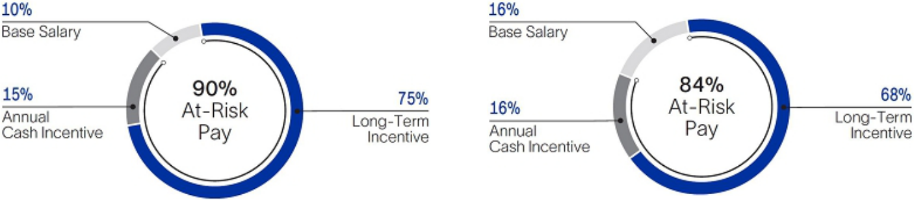

- Does not include pay mix for Mr. Belani, who retired from his role as EVP, New Energy effective April 1, 2022, and was appointed Senior Strategic Advisor to the CEO, a non-executive officer position.

Based on market data provided by Pay Governance, our Compensation Committee’s independent compensation consultant, the pay mix of our NEOs is well-aligned with that of the companies in our two main executive compensation peer groups, as described in “Other Aspects of Our Executive Compensation Program—Our Peer Group Companies” on page 46.

In January 2022, the Committee concluded that the mix of base salary, target annual cash incentive, and target LTI was appropriate for each of our NEOs, based on the relative size of direct compensation elements of companies in our main executive compensation peer groups, as well as internal factors.

Responsiveness to Shareholder Feedback

Our executive compensation program was largely designed and implemented in response to, and as a product of, past discussions with our shareholders. For example, in 2021, based on shareholder feedback, we introduced our three-year relative TSR PSUs to more directly align LTI payouts with
shareholder value creation, and we set the target performance goal above median at the 60th percentile. In 2022, our Compensation Committee adjusted the comparator group for our TSR PSUs to include the S&P Global 1200 Energy Index, based on feedback that our shareholders also evaluate our TSR performance against the broader energy sector.

In 2022, our executive compensation program received the support of more than 95% of the votes cast at our annual meeting. As a result, and based on past shareholder feedback, our Compensation Committee believes that our overall compensation program design is well-supported by our shareholders.

2023 Proxy Statement |  | 35

Back to Contents

Elements of 2022 Total Direct Compensation

Base Salary

Base salary is the fixed portion of an executive’s annual compensation, providing some stability of income since the other compensation elements are at risk. Our Compensation Committee annually reviews and approves the base salary levels for our executive officers (other than the CEO) after considering comparable salaries for executives with similar responsibilities in our main executive compensation peer groups, comparisons to internal peer positions, recent Company performance, individual performance, business experience and potential, and the CEO’s recommendations. The Committee annually reviews the base salary of our CEO in executive session and recommends his base salary amount to the independent members of the Board for approval, based on the criteria described above.

In January 2022, our Compensation Committee reviewed the base salaries of each of our NEOs in line with the factors described above. Based on comparative market data and other factors, the Committee determined to maintain the base salaries of Mr. Al Mogharbel, Mr. Belani, Mr. Merad, and Ms. Ralston at their then-current levels for 2022, and approved an increase to Mr. Biguet’s 2022 base salary from $770,000 to $800,000. In evaluating Mr. Le Peuch’s 2022 compensation, the Committee considered SLB’s strong 2021 financial results, and that Mr. Le Peuch’s 2021 total direct compensation was below the median of our general industry peer group and below his peers’ compensation at our two largest energy services competitors. In light of these factors, as well as SLB’s leading position in the energy services industry, the Committee recommended, and the independent members of the Board approved, an increase to Mr. Le Peuch’s base salary for 2022 from $1,400,000 to $1,550,000.

In April 2022, in connection with Mr. Merad’s promotion to the role of EVP, Core Services and Equipment, and in light of internal pay equity considerations, the Committee approved an increase to Mr. Merad’s base salary from $750,000 to $800,000, effective April 1, 2022.

Annual Cash Incentive Awards

We pay performance-based annual cash incentives to our executives to foster a results-driven, pay-for-performance culture, and to align executives’ interests with those of our shareholders. Annual cash incentive awards are earned according to the achievement of financial and strategic personal objectives. Our Compensation Committee selects performance measures that it believes support our strategy and strike a balance between motivating our executives to increase near-term financial and operating results and driving profitable long-term Company growth and value for shareholders.

For 2022, 70% of our NEOs’ target cash incentive opportunity was based on achieving quantitative financial objectives, and 30% was based on pre-established strategic personal objectives. The financial portion of the target plan was evenly split between adjusted EBITDA and free cash flow performance goals. The total maximum cash incentive payout for 2022 was 200% of target—consistent with our 2021 cash incentive plan—and the weighted payout range for each metric as a percentage of target is reflected by the outer bars in the 2022 Cash Incentive Opportunity Mix chart.

2022 Cash Incentive Opportunity Mix
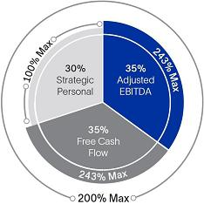

Our Compensation Committee considered the factors in the table below, in selecting adjusted EBITDA and free cash flow as the quantitative financial performance measures for our 2022 cash incentive plan.

Adjusted EBITDA

Why this metric? • The Committee considers adjusted EBITDA to be a

good indicator of the quality of our earnings.

• Investors and market analysts often value SLB by

reference to a multiple of adjusted EBITDA, so this metric aligns our NEOs’ 2022 compensation to a key market valuation method.

• A portion of our line management’s 2022 cash

incentive opportunity was based on EBITDA performance goals, so this metric aligns executive compensation with line management.

Free Cash Flow

- Free cash flow goals encourage our NEOs to continue strengthening our balance sheet, so we can sustainably return value to shareholders while making focused investments in future growth areas, such as SLB New Energy and digital.

- Free cash flow has been critical to achieving our net debt reduction goals over the past several years. In line with our external commitments, by year-end 2022 we had reduced our net-debt-to-adjusted-EBITDA ratio to 1.4x.

- The Committee also considers free cash flow to be a good indicator of the efficiency of capital management.

36 2023 Proxy Statement

Back to Contents

In setting Company financial targets and performance goals, as well as our NEOs’ strategic personal objectives, the Committee believes it is important to establish criteria that are realistically attainable, yet still challenging in an uncertain global economy. In addition, in approving free cash flow performance goals for the 2022 cash incentive plan, the Committee considered that these goals differ in important ways from the FCF margin goals contained in the LTI portion of our NEOs’ compensation program. Whereas the annual cash incentive portion focuses solely on the absolute amount of free cash flow we generate over a one-year period, our FCF margin PSU payout is calculated as free cash flow divided by our revenue over a three-year period. Because FCF margin measures how efficiently we convert revenue into cash, it is a good indicator of the business’s ability to generate high-quality revenue over the long term and, therefore, is complementary to the free cash flow metric in our annual cash incentive program.

Adjusted EBITDA Targets and Results

The process used to set annual adjusted EBITDA targets starts with a review of plans and projections following bottom-up planning from the field. Adjusted EBITDA targets may increase or decrease year-over-year, taking into account, among other things, our cash requirements, industry cycles, anticipated customer spending, activity growth potential, pricing, the introduction of new technology, strategic M&A activity, and commodity prices.

Based on the foregoing, in January 2022 the Committee set the minimum performance goal 12% higher than SLB’s actual 2021 adjusted EBITDA results. The Committee set the target performance goal based on our then-current internal forecast, which was 11% higher than the minimum goal and 24% higher than our actual 2021 results, and set the maximum performance goal 15% higher than target and 42% higher than our actual 2021 results. The Committee believed an aggressive maximum performance goal would motivate our executives to significantly outperform market expectations and our internal forecast.

The following table reflects our NEOs’ full-year adjusted EBITDA targets and corresponding potential payouts for 2022.

 |  | Potential Payout as a %
Performance Targets⁽¹⁾ |  | of Target Opportunity⁽¹⁾
Less than $5.50 billion |  | 0%
$5.50 billion | Minimum | 50%
$6.10 billion | Target | 100%
$7.00 billion | Maximum | 243%

- For adjusted EBITDA results between any two performance targets, payout is prorated. No cash incentive is earned if we do not achieve the minimum adjusted EBITDA target.

Our 2022 adjusted EBITDA was $6.462 billion, representing a 31% increase over 2021. As a result, and applying the payout matrix immediately above, our Compensation Committee approved a payout of 157% of target—or 65% of the maximum payout opportunity—for the adjusted EBITDA component of our 2022 cash incentive plan.

Free Cash Flow Targets and Results

The process used to set annual free cash flow targets starts with a review of plans and projections following bottom-up planning from the field. Free cash flow targets may increase or decrease year-over-year, taking into account the same factors listed above for adjusted EBITDA. The following table reflects our NEOs’ full-year free cash flow targets and corresponding potential payouts for 2022, as approved by our Compensation Committee in January 2022.

 |  | Potential Payout as a % of
Performance Targets⁽¹⁾ |  | Target Opportunity⁽¹⁾
Less than $2.30 billion |  | 0%
$2.30 billion | Minimum | 50%
$2.65 billion | Target | 100%
$3.20 billion | Maximum | 243%

- For free cash flow results between any two performance targets, payout is prorated. No cash incentive is earned if we do not achieve the minimum free cash flow target.

The Committee set the target performance goal based on our then-current internal free cash flow forecast for 2022, which was 15% higher than our target cash flow generation goal from the prior year. The Committee believed the above performance goals appropriately reflected a change in the industry cycle, because execution of SLB’s strategy in 2022 and outperformance through the upcycle would require increased capital investment in line with anticipated activity increases.

Our 2022 free cash flow was $1.418 billion. Because we did not achieve our threshold free cash flow performance target, our CEO and other NEOs earned no payout under the free cash flow component of our 2022 cash incentive plan.

2023 Proxy Statement |  | 37

Back to Contents

Strategic Personal Objectives

The following table reflects our NEOs’ 2022 strategic personal objectives and their achievements against those performance goals.
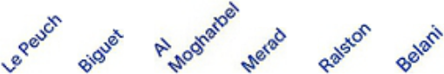

Performance Goal |  |  |  |  |  |  |  |  |  | Achievement
Strategic Planning and Sustainability
Reduce SLB’s Scope 3 emissions, using a pre-established CO₂e target |  |  |  |  |  |  |  |  |  | Achieved
based on “customer-avoided” emissions. These avoided emissions are
driven by sales from our Transition Technologies portfolio, which helps us
and our customers reduce carbon emissions while strengthening our
commercial model.
Oversee completion and roll-out of near- and mid-term corporate strategy, in |  |  |  |  |  |  |  |  |  | Achieved
line with sustainability and New Energy priorities.
Launch M&A program aligned with near- and mid-term corporate portfolio |  |  |  |  |  |  |  |  |  | Achieved
strategy based on scenario planning.
Oversee enhancements to our carbon emissions reporting, due diligence, |  |  |  |  |  |  |  |  |  | Achieved
internal controls, and auditing processes, and meet related quantitative
milestones.
Digital Growth and Technology Innovation
Increase digital revenue—enabled by digital penetration—above a pre- |  |  |  |  |  |  |  |  |  | Substantially
established target. |  |  |  |  |  |  |  |  |  | achieved
Secure a minimum number of technology access projects exceeding a |  |  |  |  |  |  |  |  |  | Partially
threshold contract value. |  |  |  |  |  |  |  |  |  | achieved
Accelerate development of new technologies, Transition Technologies and |  |  |  |  |  |  |  |  |  | Achieved
fit-for-basin technologies, based on a specified revenue target.
Core Growth
Increase revenue generated from fit-for-basin technologies above a pre- |  |  |  |  |  |  |  |  |  | Achieved
established target.
Increase total revenue year over year by a target percentage exceeding the |  |  |  |  |  |  |  |  |  | Achieved
rig count increase.
Achieve international revenue growth as a percentage exceeding that of |  |  |  |  |  |  |  |  |  | Achieved
direct competitors.
New Energy Innovation
Oversee development of near- and mid-term New Energy growth strategy, |  |  |  |  |  |  |  |  |  | Achieved
as well as revenue and market analysis.
Secure a minimum number of large carbon capture and sequestration |  |  |  |  |  |  |  |  |  | Substantially
projects, and execute identified key partnerships and acquisitions. |  |  |  |  |  |  |  |  |  | achieved
Achieve certain milestones in other New Energy ventures. |  |  |  |  |  |  |  |  |  | Substantially
 |  |  |  |  |  |  |  |  |  | achieved
HSE Performance
Fatality-free. |  |  |  |  |  |  |  |  |  | Mostly not
 |  |  |  |  |  |  |  |  |  | achieved
% of 2022 payout opportunity earned under strategic personal |  |  | 93% |  | 88% | 88% | 79% | 75% | 76%
objectives
 |  | 38 |  |  |  |  |  |  |  | 2023 Proxy Statement

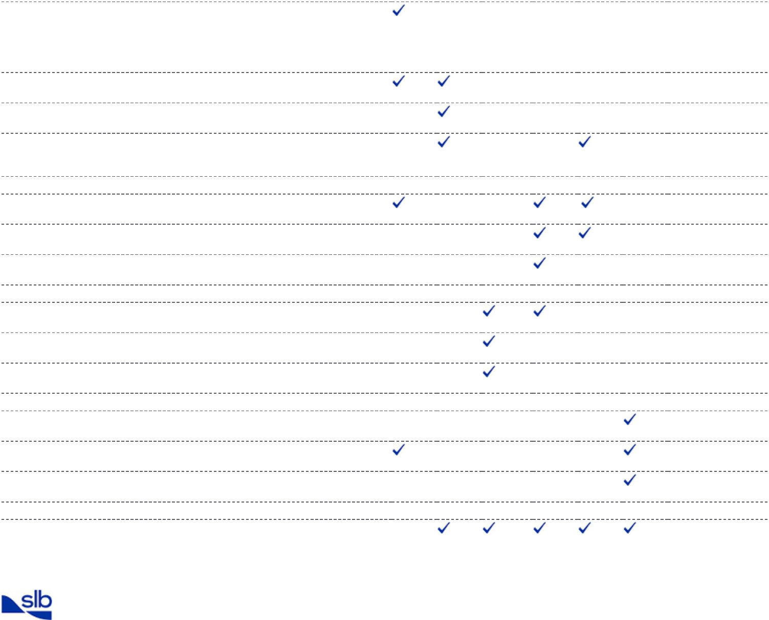

Back to Contents

As discussed on page 36 above, 30% of our NEOs’ target 2022 cash incentive opportunity was tied to achieving quantitative and qualitative performance goals specific to their roles within SLB. These may relate to: financial goals, such as profitability, revenue growth, capital management or cost reduction; performance achievements, such as contract awards or operational reliability or HSE objectives; non-financial or sustainability-related goals that are important to SLB’s strategy and reputation, such as carbon emissions reduction, ethics and compliance, or people-related objectives including diversity and gender balance; and other business priorities, including energy transition services and technologies.

Each January, our Compensation Committee reviews and, subject to approval by the Board’s independent directors, approves our CEO’s strategic personal objectives for that year. The Committee also annually assesses our CEO’s performance against his strategic personal objectives established for the prior year, to determine the appropriate payout for the 30% portion of his annual cash incentive opportunity tied to his personal objectives. The CEO reviews and approves the strategic personal objectives of the other NEOs and assesses their performance against their pre-approved objectives in a similar way. The Committee annually approves the aggregate annual cash incentive payouts for all executive officers, including the payout portion related to an executive’s strategic personal objectives.

Summary of 2022 Cash Incentive Results

In January 2022, our Compensation Committee determined to leave the target annual cash incentive opportunity for all NEOs unchanged from 2021, following a review of market data indicating that our NEOs’ target annual cash incentive opportunity (as a percentage of base salary) was competitively positioned. As a result, the 2022 target cash incentive for our CEO was 150% of his base salary and for our other NEOs it was 100% of base salary. The following table reflects our NEOs’ full-year 2022 annual cash incentive results, together with relevant weightings of the different components and payouts under each component.

 | Incentive |  | Financial Objectives |  |  |  |  | Personal Objectives |  |  | Total 2022
 | Incentive | Adjusted EBITDA |  |  | Free Cash Flow |  |  |  |  |  | Total 2022
 | Opportunity |  | Payout |  |  | Payout |  |  | Payout |  | Incentive
 | as % of | Weight | Result |  | Weight | Result |  | Weight | Result |  | Paid as %
Name | Base Salary | (%) | (%) |  | (%) | (%) |  | (%) | (%) |  | of Target⁽¹⁾
O. Le Peuch | 150% | 35 | 157 |  | 35 | 0 |  | 30 | 93 |  | 83%
S. Biguet | 100% | 35 | 157 |  | 35 | 0 |  | 30 | 88 |  | 81%
K. Al Mogharbel | 100% | 35 | 157 |  | 35 | 0 |  | 30 | 88 |  | 81%
A. Merad | 100% | 35 | 157 |  | 35 | 0 |  | 30 | 79 |  | 79%
D. Ralston | 100% | 35 | 157 |  | 35 | 0 |  | 30 | 75 |  | 78%
A. Belani⁽²⁾ | 100% | 35 | 157 |  | 35 | 0 |  | 30 | 76 |  | 78%

- Equals the sum of the financial and strategic personal portions of the annual cash incentive achieved, shown as a percentage of base salary.

- Prorated for the three-month period that Mr. Belani served as EVP, New Energy.

Long-Term Equity Incentive Awards

LTI awards are designed to give NEOs and other high-value employees a long-term stake in SLB, incentivize the creation of sustained shareholder value, and act as long-term retention and motivation tools—aligning employee and shareholder interests over the long term.

Since 2021, our Compensation Committee has awarded to our NEOs and other executives a diversified mix of LTI grants, with 75% of their target LTI opportunity awarded in the form of PSUs—with payout contingent on achieving absolute and relative performance goals over three-year periods—and 25% awarded in the form of three-year, time-based RSUs. The Committee believes that our current LTI program appropriately balances the following Committee objectives:

- closely aligning PSU performance metrics with our long-term strategy, publicly disclosed financial objectives, and total shareholder return,

- aligning pay-for-performance and creating shareholder value,

- maintaining a mix of absolute and relative PSU metrics, in light of the cyclicality of our industry,

- motivating and incentivizing outperformance relative to our direct competitors and the broader energy sector, and

- promoting the stability and retention of our executive team through business cycles with awards of time-based RSUs.

2023 Proxy Statement |  | 39

Back to Contents

As in 2021, the 2022 LTI program consisted of four types of grants, equally weighted at target performance:
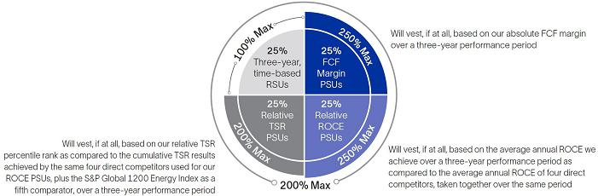

The maximum overall payout opportunity under the 2022 LTI program was 200% of target—consistent with 2021 and in line with market practice. The maximum payout opportunity for each type of LTI award is reflected by the outer bars in the chart above.

For details regarding LTI grants made to our NEOs in 2019 and 2020, see “—Payouts Under Prior LTI Awards” beginning on page 43.

How We Determined the Target Value of 2022 LTI Equity Awards

The value of an executive’s LTI grant increases with their level of responsibility at SLB. For our CEO and the other NEOs, it is the largest element of their compensation. In determining the value of LTI awards granted to our NEOs, our Compensation Committee (in recommending that the Board approve the CEO’s awards) and the CEO (in recommending awards for the other NEOs) first consider market data regarding the LTI value for the most comparable positions in our main executive compensation peer groups, as well as several other factors, such as:

- SLB’s financial and operating performance,

- the size and mix of the executive’s total direct compensation,

- internal pay equity,

- retention,

- the executive’s contribution to SLB’s success, and

- the level of competition for executives with comparable skills and experience.

In January 2022, our Compensation Committee reviewed the target annual LTI awards to each of our NEOs in line with the factors described in this section. Based on its review of comparator peer group data and internal pay equity considerations, the Committee determined to hold annual target LTI grant values flat for Mr. Al Mogharbel, Mr. Belani, and Ms. Ralston. The Committee approved an increase in Mr. Biguet’s 2022 target LTI grant date fair value from $3.2 million to $3.5 million, after considering SLB’s strong financial performance in 2021 and that Mr. Biguet’s 2021 compensation was below his peers’ compensation at our two largest energy services competitors, as well as internal equity factors.

In evaluating Mr. Le Peuch’s target LTI award in January 2022, our Compensation Committee considered the success of the Company’s returns-focused strategy and execution in the prior year, as well as SLB’s strong 2021 financial results—which surpassed all of the Company’s annual financial targets. The Committee also considered that Mr. Le Peuch’s 2021 compensation was below his peers’ compensation at our two largest energy services competitors, and below the median of our general industry peer group. In light of these factors, as well as SLB’s leading position in the energy services industry, the Compensation Committee recommended, and the independent members of the Board approved, an increase in Mr. Le Peuch’s 2022 target LTI grant date fair value from $10.5 million to $12 million.

In April 2022, in connection with Mr. Merad’s promotion to the role of EVP, Core Services and Equipment, and in light of internal pay equity considerations, the Committee approved an increase in his 2022 target LTI grant date fair value from $3.2 million to $3.5 million.

40 2023 Proxy Statement

Back to Contents

2022 Absolute FCF Margin PSUs — Performance Measures and Goals

In January 2022, our Compensation Committee set goals for the 2022 FCF Margin PSUs based on our absolute FCF margin over a three-year performance period (January 1, 2022 to December 31, 2024). At the end of the performance period, the Committee will certify our three-year cumulative absolute FCF margin and then determine the percentage of shares earned based on the graph below.

2022 FCF Margin PSU Payout Matrix
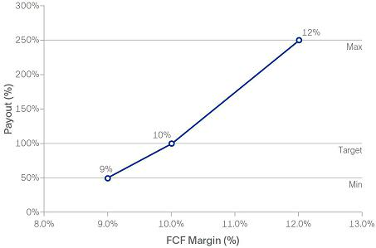

The number of 2022 FCF Margin PSUs that will vest and convert to shares as of the vesting date can range from 0% to 250% of target, depending on our absolute FCF margin performance over the three-year period, but in no event will payout relating to this metric exceed 250% of target.

For 2022, the Committee increased the maximum performance goal for the FCF margin PSUs to 12.0%, to reflect SLB’s strong free cash flow performance in the prior year. In maintaining the other performance goals for these PSUs consistent with 2021, the Committee believed that the target performance goal was conservative with respect to capital consumption, while not being overly aggressive so as to disincentivize investment in growth and planned working capital increases in line with anticipated activity increases. As illustrated in the graph above, no SLB shares will be earned if our FCF margin over the three-year performance period is less than the minimum performance goal of 9.0%.

FCF margin is calculated as free cash flow divided by revenue. FCF margin measures how efficiently we convert revenue into free cash flow, and is an indicator of capital efficiency. In selecting absolute FCF margin as the performance metric for 25% of our NEOs’ 2022 target LTI grant date fair value, the Committee considered that this metric was aligned with our capital allocation strategy and publicly disclosed financial objective of achieving double-digit FCF margin. The Committee also believes that tying a portion of our NEOs’ LTI payout to FCF margin encourages our executives to:

- maintain capital discipline,

- generate sufficient cash flow to allow for increased returns to shareholders and net debt reduction,

- make key investments and capital expenditures in line with our stated strategy, including our energy transition strategy, and

- increase SLB’s liquidity.

The Committee also sought to maintain a mix of absolute (FCF margin) and relative (ROCE and TSR) metrics in our NEOs’ PSU awards, to effectively manage industry cycles.

Free cash flow represents cash flow from operations less capital expenditures, Asset Performance Solutions investments and exploration data costs capitalized.

2023 Proxy Statement |  | 41

Back to Contents

2022 Relative ROCE PSUs — Performance Measures and Goals

In January 2022, our Compensation Committee set goals for the 2022 ROCE PSUs based on our average annual ROCE over a three-year performance period (January 1, 2022 to December 31, 2024), as compared to the average annual ROCE of the following direct competitors, taken together over the same period: Halliburton, Baker Hughes, TechnipFMC, and NOV (together the ROCE comparator group). At the end of the performance period, the Committee will certify our average ROCE and that of the ROCE comparator group as a whole, and then determine the percentage of shares earned based on the graph below.

2022 Relative ROCE PSU Payout Matrix
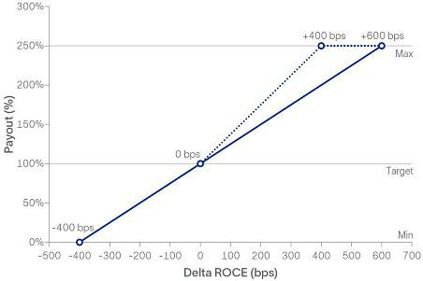

The number of 2022 ROCE PSUs that will vest and convert to shares as of the vesting date can range from 0% to 250% of target, depending on our relative ROCE performance over the three-year period, but in no event will payout relating to this metric exceed 250% of target. As illustrated in the graph above, consistent with the ROCE PSUs granted in 2021:

- If our average annual ROCE over the three-year performance period is four percentage points or more below the average of the ROCE comparator group, then no 2022 ROCE PSUs will vest and no shares will be earned. This is because our Compensation Committee believes our executives should not receive PSU payouts for significantly low relative ROCE performance.

- If our average annual ROCE over the three-year performance period is equal to that of the average of the ROCE comparator group as a whole, then the 2022 ROCE PSUs will vest at 100% of target. If our average annual ROCE over that period is higher than that of the average of the ROCE comparator group as a whole, then the 2022 ROCE PSUs will vest between 101% and 250% of target, as shown by the solid line in the graph above.

- In addition, if both (x) our absolute, single-year ROCE is greater than 10% in 2024, and (y) our average annual ROCE over the three-year performance period exceeds that of the average of the ROCE comparator group as a whole, then the 2022 ROCE PSUs will vest at an increased rate (up to a maximum of 250%), as shown by the dotted line in the graph above.

ROCE is a measure of the efficiency of our capital employed, and is a comprehensive indicator of long-term Company and management performance, measured in a way that is tracked and understood by many of our investors. Our Compensation Committee has based a portion of our NEOs’ LTI awards on a relative ROCE metric since 2016 because this metric allows us to directly compare how efficiently we deploy our capital against our direct competitors. The Committee also believes that tying a portion of our executives’ LTI payout to achieving our capital efficiency goals and comparing these results to our competitors will motivate our executives to focus on outperformance, and will result in increased revenue and improved margins. In selecting ROCE as the performance metric for 25% of our NEOs’ 2022 target LTI grant date fair value, the Committee also considered that ROCE performance goals align executives’ potential ROCE PSU payouts with SLB’s goal of achieving ROCE above its weighted average cost of capital.

We calculate ROCE as a ratio, the numerator of which is (a) net income excluding charges and credits, plus (b) after tax net interest expense, and the denominator of which is (x) stockholders’ equity, including non-controlling interests (average of beginning and end of each quarter in the year), plus (y) net debt (average of beginning and end of each quarter in the year). Our Compensation Committee has discretion to cap payouts on the 2022 ROCE PSUs at 100% of target in the event of material asset impairments attributable to M&A transactions and other management decisions.

42 2023 Proxy Statement

Back to Contents

2022 Relative TSR PSUs — Performance Measures and Goals

In January 2022, our Compensation Committee set goals for the 2022 TSR PSUs based on our relative TSR percentile rank, as compared to the cumulative TSR results achieved by the four direct competitors used for the 2022 ROCE PSUs, plus the S&P Global 1200 Energy Index as a fifth comparator (each a TSR comparator), over a three-year performance period (January 20, 2022 to December 31, 2024). At the end of the performance period, the Committee will certify the three-year, cumulative TSR results for us and for each TSR comparator, based on the average of the 20 trading days prior to the start and end of the performance period. The Committee will then determine our percentile rank relative to the five TSR comparators, as well as the percentage of shares earned based on the table below.

Relative TSR | Performance | % of Target Shares
Percentile Rank | Targets | Earned (Payout %)⁽¹⁾
Below 25th percentile |  | 0%
25th percentile | Minimum | 25%
60th percentile | Target | 100%
100th percentile | Maximum | 200%

(1) Number of shares determined by straight-line interpolation between performance levels.

As in 2021, the number of 2022 TSR PSUs that will vest and convert to shares as of the vesting date can range from 0% to 200% of target, depending on our relative TSR performance over the three-year period, but in no event will payout relating to this metric exceed 200% of target. In maintaining the maximum payout opportunity for the 2022 TSR PSUs at 200%, which is below the maximum payout for the 2022 FCF Margin PSUs and 2022 ROCE PSUs, the Committee considered that management’s efforts would more directly affect FCF margin and ROCE, whereas management had less control over SLB’s TSR relative to that of the TSR comparator companies, due to external market and economic influences.

As illustrated by the table in this section, our Compensation Committee set the target performance goal above median at the 60th percentile, consistent
with 2021. No SLB shares will be earned if our three-year, cumulative TSR is in the bottom 25th percentile rank as compared to that of the individual TSR comparator companies.

Target set above median relative TSR performance

In January 2022, our Compensation Committee reviewed the peer companies used to assess relative TSR performance under our LTI program, based on market data and a TSR correlation analysis prepared by Pay Governance. Following this review, the Committee adjusted the TSR comparator group as compared to 2021, to better focus on outperformance relative to our direct competitors and the broader energy market. For 2022, the Committee assessed our relative performance under both our TSR PSUs and our ROCE PSUs against Halliburton, Baker Hughes, TechnipFMC, and NOV, because it believes the most appropriate TSR and ROCE comparisons are against our direct competitors in the energy services industry. The Committee included a fifth comparator for the 2022 TSR PSUs—the S&P Global 1200 Energy Index—based on shareholder feedback that our investors also evaluate our TSR performance against the broader energy sector.

Payouts Under Prior LTI Awards

Stock Options

Prior to 2017, SLB granted a significant portion of its LTI compensation to executives in the form of stock options. Beginning in 2017, SLB ended its practice of granting stock options to executive officers. As of December 31, 2022, all of our NEOs’ outstanding stock options were “underwater.”

PSUs Vesting in 2022

As previously disclosed in the proxy statement for our 2022 AGM, in January 2022 our Compensation Committee approved payout results for the PSUs issued to our NEOs in 2019, based on the Committee’s previously approved performance criteria. Our NEOs earned 250% of target under the free cash flow conversion PSUs issued in 2019, based on our achievement of a cumulative free cash flow conversion rate of 166% for the two-year performance period applicable to those PSUs. In addition, our NEOs earned 182% of target under the relative ROCE PSUs issued in 2019, based on our average annual ROCE over the three-year performance period being 327 basis points above the average annual ROCE of five of our direct competitors taken together over the same period. These competitors were Halliburton, Baker Hughes, TechnipFMC, Weatherford International, and NOV (the prior ROCE comparator companies). For additional details, see the Option Exercises and Stock Vested in 2022 table on page 54 of this proxy statement.

PSUs Vesting in 2023

In January 2020, our Compensation Committee approved PSU awards to our NEOs (other than the CEO) as follows, in each case subject to a three-year relative TSR modifier:

- With respect to 50% of our NEOs’ 2020 target LTI grant date fair value, payout was conditioned based on the percentage of our cumulative net income, excluding charges and credits, converted to free cash flow from January 1, 2020 to December 31, 2021 (the 2020 FCF Conversion PSUs).

- With respect to 50% of our NEOs’ 2020 target LTI grant date fair value, payout was conditioned based on our average annual ROCE achieved over a three-year performance period as compared to the average annual ROCE of the prior ROCE comparator companies, taken together over the same period (the 2020 ROCE PSUs).

Our CEO, Mr. Le Peuch, did not receive an LTI award in 2020 because he had received a PSU award in 2019 in connection with his promotion to CEO, in lieu of a 2020 award.

2023 Proxy Statement |  | 43

Back to Contents

In January 2022, the Committee determined that we achieved a cumulative free cash flow conversion rate of 192% for the two-year performance period applicable to the 2020 FCF Conversion PSUs, representing achievement of 250% of target, based on the Committee’s previously approved performance criteria. These PSUs also were subject to the relative TSR modifier, which would have caused payouts to be reduced by 25% if our three-year, cumulative

TSR was in the bottom 33rd percentile rank as compared to the individual companies comprising the Philadelphia Oil Services Sector index as of January 2020. In January 2023, the Committee determined that the relative TSR modifier did not trigger a negative adjustment to the 2020 PSU payouts, because

SLB’s TSR ranked at the 85th percentile. As a result, in January 2023, our NEOs (other than the CEO) earned 250% of target under the 2020 FCF Conversion PSUs.

In January 2023, the Committee also approved the results for the 2020 ROCE PSUs using the Committee’s previously approved performance criteria. Specifically, the Committee determined that in 2022, SLB had achieved absolute, single-year ROCE of 13%—as a result, the 2020 ROCE PSUs had been earned at 250% of target, based on SLB’s average annual ROCE being 407 basis points above the average of the prior ROCE comparator companies through the third quarter of 2022, which was the then-most recent fiscal period end reported by all the prior ROCE comparator companies. Because not all the prior ROCE comparator companies had reported their 2022 audited results as of January 2023, the Committee approved a preliminary issuance of 80% of the shares earned under the 2020 ROCE PSUs. Any additional shares finally determined to have been earned by our NEOs (other than the CEO) will be issued after all the prior ROCE comparator companies disclose their full-year 2022 audited results.

Unvested PSUs

All of the PSUs granted to our NEOs since 2021 will vest, if at all, only after a three-year performance period. At the end of the applicable performance periods, the Committee will determine the number of shares ultimately earned under these unvested PSUs based on the extent of achievement of the applicable performance goals.

Other Benefits

Officer Departure Guidelines

Our Compensation Committee has approved guidelines covering, among other things, LTI vesting, salary, benefits, and other compensation matters for officers departing SLB, either because they are eligible for retirement, early retirement or special retirement, or because they are involuntarily terminated (if not eligible for retirement). These guidelines are a non-binding framework referenced by management in its executive succession planning, with flexibility as required by specific situations.

Under the guidelines, we may, at our discretion, enter into agreements with outgoing officers whereby they would remain employed by SLB during the agreement term and receive annual cash payments that would generally be less than their pre-termination annual base salary. In addition, outgoing officers would receive a prorated cash incentive award payment with respect to the year of their departure. They would also receive benefits such as medical coverage and life and disability insurance during the agreement term, and would continue to vest in previously granted LTI awards—but would not receive any new LTI awards—during the term. In exchange, the outgoing officers must agree to non-competition, non-solicitation, and non-disparagement covenants, and generally would agree to be available to SLB for a portion of their business time during the term.

Agreement with Senior Strategic Advisor

As previously disclosed in the proxy statement for our 2022 AGM, SLB entered into an agreement with Mr. Belani in connection with his decision to retire from his role as SLB’s EVP, New Energy, effective as of April 1, 2022. Under the terms of the agreement, Mr. Belani currently serves as Senior Strategic Advisor to our CEO through March 31, 2024, supporting certain technology and innovation projects. Mr. Belani has also agreed to certain restrictive covenants under the agreement, including three-year non-competition and non-solicitation undertakings, as well as confidentiality and non-disparagement undertakings and a waiver and release of claims.

In consideration for his services as Senior Strategic Advisor, the restrictive covenants, and the waiver and release, Mr. Belani will continue to receive certain benefits and payments through March 31, 2024, including a cash payment in each year of the term equal to his base salary prior to retiring from his EVP role. During the term, he will also continue to participate in our health, welfare, and insurance plans for which he is eligible as an employee, and will continue to accrue benefits under our pension and profit-sharing plans. In addition, because Mr. Belani remains an employee and qualifies for retirement treatment under the terms of our LTI award agreements, his outstanding LTI awards will continue to vest in accordance with the terms applicable to those grants.

As a global technology company driving energy innovation, we believe that our greatest competitive strengths are our people and our intellectual property. Mr. Belani led SLB New Energy from its launch in 2020 through March 2022, and prior to that, he served for over a decade as SLB’s Chief Technology Officer and EVP, Technology. He has critical knowledge about our technology and innovation strategy, important relationships with SLB New Energy’s strategic partners and joint ventures, and deep ties to the scientific community within SLB and externally. Thus, our Compensation Committee believed it to be in the best interest of SLB and our shareholders to enter into an agreement with Mr. Belani to secure his continued support on key technology and innovation projects where his expertise and significant contacts will benefit the advancement of SLB’s strategy. In addition, the agreement secures his covenant not to compete with us and prohibits him from soliciting key employees for a period of three years. If the undertakings in the agreement are breached, we may immediately stop payment of all cash amounts that would otherwise be due to Mr. Belani, all outstanding equity awards will be subject to cancellation, and we may require repayment of consideration previously paid or vested under the agreement.

44 2023 Proxy Statement

Back to Contents

Broadly Available Benefit Plans

We seek to provide benefit plans, such as medical coverage and life and disability insurance, on a country-by-country basis in line with market conditions. Where the local practice is considered to be less than the SLB minimum standard, we generally enhance the local plans to meet the SLB standard plan. Our NEOs are eligible for the same benefit plans provided to other employees, including medical coverage and life and disability insurance, as well as supplemental plans chosen and paid for by employees who wish to obtain additional coverage. There are no special insurance plans for our NEOs.

In line with our aim to encourage long-term careers with SLB and to promote retention, retirement plans are provided, where possible and according to local market practice, for all employees, including NEOs. For details regarding our pension plans and nonqualified deferred compensation plans, see “Executive Compensation Tables—Pension Benefits,” “—Nonqualified Deferred Compensation,” “—Potential Payments Upon Termination or Change in Control—Retirement Plans,” and “—Retiree Medical” and the accompanying narratives beginning on page 54 of this proxy statement.

Limited Perquisites

We provide only limited perquisites to our NEOs, which are identified in the footnotes to the Summary Compensation Table.

Other Aspects of Our Executive Compensation Program

Competition for Our Executive Talent

A primary consideration of our Compensation Committee in overseeing our executive compensation program is the need to motivate and retain what it believes is the best executive talent in our industry. We are a global technology company, driving energy innovation for a balanced planet, and the Committee believes that delivering financial and operational outperformance and long-term shareholder returns depends on our ability to attract, develop, and retain the best talent globally. A highly competitive compensation package is critical to this objective.

As a result, the Committee generally seeks to target total direct compensation for our NEOs between the 50th and 75th percentiles of our two main
executive compensation peer groups. The Committee may also position an NEO who is new to a position at or below the 50th percentile for a period of time. An NEO’s target total direct compensation depends on a variety of factors, including tenure in a particular position, individual and Company performance, and internal pay equity.

Competition for executive talent in our industry is exceptionally fierce. The Committee believes that the 50th to 75th percentile range is appropriate for us to target in light of SLB’s leading position in our industry, and because our executives are very highly sought after, both by our direct competitors and by other leading oil and gas, advanced extractive, technology-driven manufacturing, and engineering-focused companies, including companies focused on the new energy economy.

In approving this target range and when setting compensation for 2022, the Committee considered that many current and former senior executives of leading companies in various industries have previously served in senior management at SLB. Former members of senior SLB management have either been, or are, senior executives at the competitors, customers, and other technology- and engineering-focused companies listed in the table below.

Baker Hughes* | TechnipFMC* | Weatherford | BAE Systems*
(past Chairman and CEO, | (current Chairman, CEO | (past acting CEO | (current CEO,
current CHRO and CLO, and | and CTO, and past Chairman, | and CFO, and other senior | CFO and CHRO)
other senior executives) | CEO and CHRO) | executives)

Engie |  |  | Bureau Veritas |  |  |  | CGG |  |  | BG Group
(current CEO) |  |  | (current CEO) |  |  |  | (current CEO and CFO) |  |  | (past Chairman and COO)
ConocoPhillips* |  |  |  | YPF |  |  | Kuwait Airlines |  |  | Technip Energies
(past CTO) |  |  | (past CEO) |  |  |  | (current CEO) |  |  | (current CLO and other senior
 |  |  |  |  |  |  |  |  |  | executives)
Patterson-UTI Energy |  |  |  | NESR |  |  | Lufkin Industries |  |  | Nexans
(current CEO) |  | (current CEO, CFO and COO) |  |  |  |  | (current CEO) |  |  | (current CHRO)
Expro |  |  |  | Nabors |  |  | Noble Corporation |  |  | NexTier Oilfield Solutions
(current CEO, and |  |  | (current CFO and |  |  |  | (current CLO) |  |  | (current CEO, CFO, COO
past CEO and CFO) |  |  | other senior executives) |  |  |  |  |  |  | and other senior executives)
Valaris |  |  |  | Flowserve |  |  | Borr Drilling |  |  | Archer
(past CEO and CLO) |  |  | (current CEO) |  |  |  | (current CEO and past CFO) |  |  | (current CEO)
Seadrill |  |  |  | Jacobs
(past COO) |  |  | (current senior executive)
CEO = Chief Executive Officer |  |  | CTO = Chief Technology Officer |  |  |  |  | * Included in our main executive
CFO = Chief Financial Officer |  |  |  | CLO = Chief Legal Officer / General Counsel
 |  |  |  |  |  |  |  |  | compensation peer groups
COO = Chief Operating / Commercial Officer |  |  |  | CHRO = Chief Human Resources Officer
2023 Proxy Statement |  |  |  |  | 45

Back to Contents

Our Peer Group Companies

Our Compensation Committee considers formal executive compensation survey data prepared by Pay Governance when it reviews and determines executive compensation, and when considering changes to our executive compensation program. The Committee considers data for the companies comprising our two main executive compensation peer groups—our core industry peer group and our general industry peer group. The Committee believes these peer groups together provide the robust market data necessary to assess the current and future talent markets available to our executive officers, both in the oil and gas sector and in other advanced extractive, technology-driven manufacturing, and industrial engineering-focused sectors. General industry peer group comparisons are particularly relevant for non-operations positions, where skills and experience may be easily transferable to other industries. In addition, the evolving energy industry environment creates challenges in maintaining a robust peer group comprising solely oilfield services and upstream companies, given decreases in individual company scope, as well as bankruptcies and consolidations in recent cycles.

The Committee annually reviews the specific selection criteria for our main executive compensation peer groups, such as competition for business or executive talent, revenue, market capitalization, and scope of international operations. Pay Governance annually recommends for the Committee’s review the addition or removal of companies from these peer groups, based on the Committee’s selection criteria. As a general matter, the Committee selects suitable comparator companies such that the companies in these peer groups, at the median, approximate SLB’s estimated revenue in the then-current year and its then-current market capitalization. The Committee modifies its peer group criteria as appropriate while seeking a satisfactory degree of stability, to provide a consistent basis for comparison.

In July 2021, our Compensation Committee reviewed and approved the companies listed below to comprise our two main executive compensation peer groups, effective for 2022 executive compensation decisions.

Core Industry Peer Group

This peer group comprises ten companies in the energy sector, primarily in the oilfield services and equipment and upstream oil and gas industries, with 2020 revenues between $6.1 billion and $42.9 billion. SLB was
positioned at the 90th percentile of this peer group in terms of 2020 revenue,

and at the 72nd percentile of this peer group in terms of market capitalization as of April 2021.

Our Compensation Committee made no changes to this peer group for 2022 compensation decisions, as compared to 2021. The Committee identified the companies in this peer group as being broadly comparable to SLB in terms of revenue and market value, and also competing with us for business or executive talent. Several members of this peer group frequently seek to recruit SLB executives for their senior executive roles. See “— Competition for Our Executive Talent” on page 45.

General Industry Peer Group

Baker Hughes

BHP Group

ConocoPhillips

EOG Resources

Halliburton

Imperial Oil

NOV

Occidental Petroleum

Suncor Energy

TechnipFMC

This peer group comprises 25 mature, advanced extractive, technology-driven manufacturing, and industrial engineering-focused companies, including companies focused on the new energy economy, that have annual revenues, market valuations, and global scopes that are similar to SLB’s. The companies in this peer group had 2020 revenues between $8.9 billion and $44.6 billion, non-U.S. revenue generally greater than 20% of consolidated revenue, and market capitalization greater than $12 billion. This peer group focuses on SLB’s current and future executive talent markets beyond the oil and gas sector, given the competencies needed for SLB’s future success.

In July 2021, our Compensation Committee, applying the selection criteria above, removed two companies that did not meet the Committee’s revenue criteria (Lockheed Martin and HP Inc.), and added four new companies, as identified by asterisks at right. As a result of the foregoing, SLB
was positioned at the 41st percentile of this peer group in terms of 2020

revenue, and at the 20th percentile of this peer group in terms of market capitalization as of April 2021.

3M Company | Emerson Electric
ABB | Freeport-McMoRan
Air Products and Chemicals* | General Dynamics
Anglo American | Honeywell International
BAE Systems | Johnson Controls International
Carrier Global* | Koninklijke Philips
Caterpillar | Linde*
Compagnie de Saint-Gobain | LyondellBasell Industries
Corning* | Rio Tinto
Deere & Company | Rolls-Royce Holdings
Dow | Schneider Electric
DuPont de Nemours | Trane Technologies
Eaton

46 2023 Proxy Statement

Back to Contents

Executive Compensation Governance

No Employment Agreements with Current NEOs

Our currently serving NEOs do not have employment, severance or change-in-control agreements with SLB, and they serve at the will of the Board. This enables SLB to terminate their employment using judgment as to the necessity or terms of any severance arrangement and based on specific circumstances at the time they cease being executive officers. For details regarding our agreement with our former EVP New Energy, see “—Elements of 2022 Total Direct Compensation—Other Benefits—Agreement with Senior Strategic Advisor” on page 44.

Stock Ownership and Holding Requirements

Our Board and Compensation Committee strongly believe in linking executive long-term rewards to shareholder value. Our executive stock ownership guidelines require our executives to hold a minimum dollar value of SLB shares based on the table below.

Title | Stock Ownership Multiple
Chief Executive Officer | 6x base salary
Executive Vice Presidents | 3x base salary
Executive officers (non-EVP) | 2x base salary
Other EVP direct reports and Presidents | 1x base salary

All executives subject to the guidelines must retain 50% of the net shares they acquire upon the exercise of stock options and after the vesting of PSUs and RSUs, after payment of applicable taxes, until they achieve the required ownership level.

Under the guidelines, our executives have five years to satisfy the ownership requirements. After the five-year period, executives who have not met their minimum stock ownership requirement must retain 100% of the net shares they acquire upon stock option exercises and any vesting of PSUs and RSUs until they achieve their required ownership level. Stock ownership for the purpose of these guidelines does not include shares underlying vested or unvested stock options, unvested RSUs or unvested PSUs.

As of January 31, 2023, all of our NEOs were in compliance with our stock ownership guidelines.

Anti-Hedging and Anti-Pledging

Our executive officers and directors are prohibited from using any strategies or products (such as derivative securities or short-selling techniques) to hedge, directly or indirectly, against potential changes in the value of SLB shares. In addition, our executive officers and directors, as well as certain other key employees, are prohibited from holding SLB securities in a margin account or pledging SLB securities as collateral for a loan. Our insider trading policy strongly discourages, but does not prohibit, other employees from engaging in speculative transactions, including hedging or other financial mechanisms, holding SLB securities in a margin account or pledging SLB securities.

10b5-1 Trading Plans

On November 17, 2022, Mr. Biguet entered into a 10b5-1 trading plan with his broker, to sell 75,000 shares of SLB common stock over a 12-month period beginning on March 20, 2023. The trading plan also contemplates the exercise (and subsequent sales) of up to 53,000 outstanding stock options.

Clawback Policy

Our Board has adopted a clawback policy to recoup performance-based incentive compensation, whether paid in the form of equity or cash, in the event of specified restatements of financial results. Under this policy, if financial results are restated due to fraud or other intentional misconduct, our Compensation Committee will review any performance-based or incentive compensation paid to executive officers who are found to be personally responsible for the fraud or other intentional misconduct that caused, in whole or in part, the need for the restatement. Based on that review, the Committee will take any actions it deems appropriate or necessary, including recoupment of any amounts paid in excess of the amounts that would have been paid based on the restated financial results. In addition, our PSU awards and any shares of stock issued upon the vesting of PSU awards are subject to recoupment under the terms of those awards.

2023 Proxy Statement |  | 47

Back to Contents

Process for Setting Executive Compensation

Compensation Committee Review

Our Compensation Committee reviews the elements of our NEOs’ total direct compensation throughout the year, to evaluate whether each element remains competitive with the companies in our two main executive compensation peer groups. In making compensation decisions, the Committee relies on its own judgment after reviewing external market data, and also considers the following factors:

- the executive’s scope of responsibilities, as well as leadership, management and technical expertise, growth potential, and position in our reporting structure,

- overall Company and individual performance,

- retention needs,

- the recommendations of our CEO (except with respect to his own compensation), and

- internal pay equity.

Each January, the Committee evaluates all elements of executive officer compensation, after reviewing the prior year’s results and the achievement of Company financial objectives and each officer’s strategic personal objectives. The purpose of this annual evaluation is to determine whether any changes in an officer’s compensation may be appropriate. The CEO does not participate in the Committee’s deliberations regarding his own compensation. At the Committee’s request, the CEO reviews with the Committee the performance of the other executive officers, but no other NEO has any input in executive compensation decisions. Our Compensation Committee gives substantial weight to the CEO’s evaluations and recommendations because he is particularly able to assess the other executive officers’ performance and contributions to SLB. Our Chief People Officer assists the CEO in developing the other executives’ performance reviews and reviewing external market data to determine the CEO’s executive compensation recommendations.

The table below summarizes the approximate timing of significant annual executive compensation events.

Event

Establish Company financial objectives and CEO strategic personal objectives

Review and approve the peer group companies used for compensation benchmarking

Pay Governance provides analysis for our Compensation Committee to evaluate year-to-date compensation decisions in light of year-to-date comparative data, and to prepare for the annual executive officer compensation review in January

Evaluate Company and executive performance (achievement of objectives established in previous year) and recommend annual cash incentive payout based on those results

Review and recommend executive base salaries and determine equity-based grants

Timing

January of each year with respect to the current year

July of each year for compensation in the following year

October of each year for compensation in the following year

Results approved in January of each year for annual cash incentive compensation with respect to the prior year. The annual cash incentive earned for the prior year is paid in February of the current year

January of each year for base salaries for that year and for equity-based grants

Equity Grant Practices

Our Compensation Committee is responsible for granting long-term equity-based compensation under our omnibus stock incentive plans. The Committee approves a preliminary budget for equity-based grants for the following year at each October meeting. Awards for the CEO are granted by the Committee following approval by the independent members of the Board. Awards for executive officers other than the CEO are granted by the Committee and discussed with the Board. Management determines the allocation of equity-based grants for other groups within the Company and individual recommendations are made by the heads of the groups and approved by the CEO. In addition to considering the value of each equity-based award, management and the Committee also consider, as an additional factor in approving long-term equity awards, the overall potential shareholder dilution impact and burn rate, which is the rate at which awards are granted as a percentage of SLB shares outstanding.

The regular Board and Compensation Committee meeting schedule is set at least a year in advance, with meetings held quarterly in mid-January, mid-April, mid-July, and mid-October. Annual grants of equity-based awards to our NEOs and other executives, as well as to other eligible employees, are made at the Committee’s January meeting. Additionally, specific grants may be made at other Committee meetings to recognize an employee’s promotion, change in responsibility or specific achievement, or to achieve other key compensation objectives, such as retention. Generally, the Committee sets the grant date for equity awards as the Committee meeting date, which is usually two days in advance of the Company’s announcement of earnings. The Company does not time the release of material non-public information for the purpose of affecting the values of equity grants. At the time equity grant decisions are made, our Compensation Committee is aware of the earnings results, but it does not adjust the size or the mix of grants to reflect possible market reaction.

In addition, PSUs and RSUs do not accrue or pay dividends or dividend equivalents prior to vesting.

48 2023 Proxy Statement

Back to Contents

Independent Compensation Consultant

Our Compensation Committee has retained Pay Governance as its independent consultant with respect to executive compensation matters, as well as non-employee director compensation matters. Pay Governance works with SLB’s Total Rewards team to compile annual compensation data for each executive officer, and to compare the compensation opportunities of our executive officers with those at comparable roles at companies in our main executive compensation peer groups. Pay Governance also annually prepares an analysis of competitive non-employee director compensation levels and market trends using the same two main peer groups as are used for the annual executive officer compensation review.

Pay Governance reports only to, and acts solely at the direction of, our Compensation Committee. The Committee has assessed the independence of Pay Governance pursuant to SEC rules and has concluded that its work did not raise any conflict of interest that would prevent Pay Governance from independently representing our Compensation Committee.

2023 Proxy Statement |  | 49

Back to Contents

Executive Compensation Tables

Summary Compensation Table

The following table sets forth information regarding the total compensation paid to our NEOs for fiscal years 2022, 2021 and 2020.

 |  |  |  |  | Change
 |  |  |  |  | in Pension
 |  |  |  |  | Value &
 |  |  |  |  | Nonqualified
 |  |  |  | Non-Equity | Deferred
 |  |  | Stock | Incentive Plan | Compensation | All Other
 |  | Salary | Awards | Compensation | Earnings | Compensation | Total
Name | Year | ($) | ($)⁽²⁾ | ($)⁽³⁾ | ($)⁽⁴⁾ | ($)⁽⁵⁾ | ($)
Olivier Le Peuch | 2022 | 1,550,000 | 11,999,949 | 1,929,750 | — | 234,058 | 15,713,757
Chief Executive Officer | 2021 | 1,400,000 | 10,499,803 | 3,916,100 | 802,703 | 176,896 | 16,795,502
 | 2020 | 1,383,846 | — | 2,251,200 | 1,844,619 | 170,419 | 5,650,084
Stephane Biguet | 2022 | 850,000 | 3,499,993 | 690,650 | — | 139,327 | 5,179,970
Executive Vice President and Chief Financial | 2021 | 770,000 | 3,199,750 | 1,458,400 | 462,189 | 127,749 | 6,018,088
Officer | 2020 | 755,193 | 2,499,742 | 837,000 | 767,587 | 119,081 | 4,978,603
Khaled Al Mogharbel | 2022 | 900,000 | 3,499,993 | 731,250 | — | 169,951 | 5,301,194
Executive Vice President, Geographies | 2021 | 900,000 | 3,499,787 | 1,715,850 | — | 244,569 | 6,360,206
 | 2020 | 889,615 | 3,719,674 | 1,045,800 | 297,898 | 262,956 | 6,215,943
Abdellah Merad | 2022 | 787,500 | 3,499,995 | 620,150 | — | 290,716 | 5,198,361
Executive Vice President, Core Services and
Equipment
Dianne Ralston | 2022 | 750,022 | 3,199,948 | 581,250 | 361,028 | 94,160 | 4,986,408
Chief Legal Officer and Secretary
Ashok Belani⁽¹⁾ | 2022 | 900,000 | 3,600,030 | 174,950 | — | 98,544 | 4,773,524
Senior Strategic Advisor to the CEO; Former | 2021 | 900,000 | 3,600,241 | 1,670,850 | 11,685 | 58,374 | 6,241,150
EVP, New Energy | 2020 | 889,615 | 3,599,918 | 1,045,800 | 1,205,590 | 70,968 | 6,811,891

- Mr. Belani retired as our EVP, New Energy effective April 1, 2022, and was appointed Senior Strategic Advisor to the CEO.

- Includes the value of PSU and RSU awards. For 2022, each amount reflected in the “Stock Awards” column is the aggregate grant date fair value of (x) the 2022 FCF Margin PSUs, 2022 ROCE PSUs and 2022 TSR PSUs at target level performance, and (y) the 2022 RSUs that were granted to our NEOs. Each amount reflects an accounting expense and does not correspond to actual value that may be realized by an NEO in the future. The number of equity awards granted in 2022 to each NEO is provided in the Grants of Plan-Based Awards in 2022 table on page 51. PSUs and RSUs do not pay dividends or dividend equivalents or have voting rights prior to vesting. Accordingly, the fair value of the 2022 FCF Margin PSUs, 2022 ROCE PSUs and 2022 RSUs was the quoted market price of our common stock on the grant date less the present value of the expected dividends not received prior to vesting. The fair value of the 2022 TSR PSUs was determined based on a Monte Carlo simulation. Amounts may not add to values in Grants of Plan-Based Awards in 2022 table due to rounding.

The value of each NEO’s 2022 LTI grants at the applicable grant date, assuming achievement of the maximum performance level for all PSUs, would be: Mr. Le Peuch — $20,999,911; Mr. Biguet — $6,124,988; Mr. Al Mogharbel — $6,124,988; Mr. Merad — $6,124,982; Ms. Ralston — $5,599,911; and Mr. Belani — $6,300,047. The NEOs may never realize any value from these LTI grants and, to the extent that they do, the amounts realized may have no correlation to the amounts reported above.

- Annual cash incentive awards to our NEOs are reflected in the “Non-Equity Incentive Plan Compensation” column; as a result, we have excluded the “Bonus” column.

- The changes in pension value reported in this column represent the increase in the actuarial present value of an NEO’s accumulated benefit under all benefit and actuarial pension plans in which the NEO participates. This change in present value is not a current cash payment. It represents the change in the value of the NEO’s pensions, which are only paid after retirement. For 2022, due to the large increase in the discount rate over 2021, the change in present value is negative for the following NEOs: Mr. Le Peuch — $(595,110); Mr. Biguet — $(83,597); Mr. Al Mogharbel — $(568,112); Mr. Merad — $(447,204); and Mr. Belani — $(1,424,332). There are no nonqualified deferred compensation earnings reflected in this column because no NEO received above-market or preferential earnings on such compensation during 2022, 2021 or 2020.

- Relocation assistance is provided to all employees on a company-wide basis. The amount disclosed for Mr. Le Peuch consists of unfunded credits to the Restoration Savings Plan ($154,833), employer contributions to the SLB 401(k) Plan ($9,150), financial planning services ($13,000), and housing allowance ($57,075). The amount disclosed for Mr. Biguet consists of unfunded credits to the Restoration Savings Plan ($60,102), employer contributions to the SLB 401(k) Plan ($9,150), financial planning services ($13,000), and housing allowance ($57,075). The amount disclosed for Mr. Al Mogharbel consists of unfunded credits to the Restoration Savings Plan ($138,651), employer contributions to the SLB 401(k) Plan ($18,300), and financial planning services ($13,000). The amount disclosed for Mr. Merad consists of unfunded credits to the Restoration Savings Plan ($111,941), employer contributions to the SLB 401(k) Plan ($18,300), financial planning services ($13,000), vacation travel allowance ($30,475), and children’s education ($117,000). The amount disclosed for Ms. Ralston consists of unfunded credits to the Restoration Savings Plan ($56,248), employer contributions to the SLB 401(k) Plan ($18,300), financial planning services ($13,000), and club membership ($6,612). The amount disclosed for Mr. Belani consists of unfunded credits to the Restoration Savings Plan ($67,976), employer contributions to the SLB 401(k) Plan ($9,150), and vacation payout ($21,418).

50 2023 Proxy Statement

Back to Contents

Grants of Plan-Based Awards in 2022

The following table provides additional information regarding cash incentive and PSU and RSU awards granted to our NEOs in 2022.

 |  |  | Estimated Possible Payouts |  |  |  | Estimated Possible Payouts |  |  |  |  | Grant Date
 |  |  | Under Non-Equity Incentive |  |  |  | Under Equity Incentive |  |  |  | All Other | Fair Value
 |  |  | Plan Awards⁽²⁾ |  |  |  | Plan Awards⁽³⁾ |  |  |  | Stock | of Stock
 | Award | Grant | Threshold | Target | Maximum |  | Threshold | Target | Maximum |  | Awards | Awards
Name | Type⁽¹⁾ | Date | ($) | ($) | ($) |  | (#) | (#) | (#) |  | (#)⁽⁴⁾ | ($)⁽⁵⁾
O. Le Peuch |  |  | 820,725 | 2,150,625 | 4,652,325
 | FCFM PSU | 1/19/22 |  |  |  |  | 41,853 | 83,705 | 209,263 |  |  | 2,999,987
 | ROCE PSU | 1/19/22 |  |  |  |  | 1 | 83,705 | 209,263 |  |  | 2,999,987
 | TSR PSU | 1/19/22 |  |  |  |  | 18,699 | 74,794 | 149,588 |  |  | 2,999,987
 | 3-year RSU | 1/19/22 |  |  |  |  |  |  |  |  | 83,705 | 2,999,987
S. Biguet |  |  | 300,050 | 786,250 | 1,796,050
 | FCFM PSU | 1/19/22 |  |  |  |  | 12,207 | 24,414 | 61,035 |  |  | 874,998
 | ROCE PSU | 1/19/22 |  |  |  |  | 1 | 24,414 | 61,035 |  |  | 874,998
 | TSR PSU | 1/19/22 |  |  |  |  | 5,454 | 21,815 | 43,630 |  |  | 875,000
K. Al Mogharbel | 3-year RSU | 1/19/22 | 317,700 | 832,500 | 1,800,900 |  |  |  |  |  | 24,414 | 874,998
 | FCFM PSU | 1/19/22 |  |  |  |  | 12,207 | 24,414 | 61,035 |  |  | 874,998
 | ROCE PSU | 1/19/22 |  |  |  |  | 1 | 24,414 | 61,035 |  |  | 874,998
 | TSR PSU | 1/19/22 |  |  |  |  | 5,454 | 21,815 | 43,630 |  |  | 875,000
A. Merad | 3-year RSU | 1/19/22 | 277,988 | 728,438 | 1,575,788 |  |  |  |  |  | 24,414 | 874,998
 | FCFM PSU | 1/19/22 |  |  |  |  | 11,161 | 22,321 | 55,803 |  |  | 799,985
 | ROCE PSU | 1/19/22 |  |  |  |  | 1 | 22,321 | 55,803 |  |  | 799,985
 | TSR PSU | 1/19/22 |  |  |  |  | 4,987 | 19,945 | 39,890 |  |  | 799,994
 | 3-year RSU | 1/19/22 |  |  |  |  |  |  |  |  | 22,321 | 799,985
 | FCFM PSU | 4/19/22 |  |  |  |  | 896 | 1,792 | 4,480 |  |  | 75,013
 | ROCE PSU | 4/19/22 |  |  |  |  | 1 | 1,792 | 4,480 |  |  | 75,013
 | TSR PSU | 4/19/22 |  |  |  |  | 505 | 2,020 | 4,040 |  |  | 75,003
 | 3-year RSU | 4/19/22 |  |  |  |  |  |  |  |  | 1,799 | 75,018
D. Ralston |  |  | 264,758 | 693,770 | 1,500,794
 | FCFM PSU | 1/19/22 |  |  |  |  | 11,161 | 22,321 | 55,803 |  |  | 799,985
 | ROCE PSU | 1/19/22 |  |  |  |  | 1 | 22,321 | 55,803 |  |  | 799,985
 | TSR PSU | 1/19/22 |  |  |  |  | 4,987 | 19,945 | 39,890 |  |  | 799,994
A. Belani | 3-year RSU | 1/19/22 | 317,700 | 832,500 | 1,800,900 |  |  |  |  |  | 22,321 | 799,985
 | FCFM PSU | 1/19/22 |  |  |  |  | 12,556 | 25,112 | 62,780 |  |  | 900,014
 | ROCE PSU | 1/19/22 |  |  |  |  | 1 | 25,112 | 62,780 |  |  | 900,014
 | TSR PSU | 1/19/22 |  |  |  |  | 5,610 | 22,438 | 44,876 |  |  | 899,988
 | 3-year RSU | 1/19/22 |  |  |  |  |  |  |  |  | 25,112 | 900,014

- All equity grants were awarded under the 2017 SLB Omnibus Stock Incentive Plan (as amended and restated, the 2017 Incentive Plan).

- These columns show the possible cash incentive payouts for each NEO for fiscal year 2022 based on performance goals set for the year. Threshold, target and maximum possible payouts are based on the annual cash incentive range established for each NEO, which is expressed as a percentage of base salary for the year. Actual cash incentive amounts earned for 2022 are reflected in the “Non-Equity Incentive Plan Compensation” column of the Summary Compensation Table. For information about the 2022 cash incentive paid to our NEOs, see “Compensation Discussion and Analysis—Elements of 2022 Total Direct Compensation—Annual Cash Incentive Awards” beginning on page 36.

- Relates to PSUs, all of which are subject to a three-year performance period. See “Compensation Discussion and Analysis—Elements of 2022 Total Direct Compensation —Long-Term Equity Incentive Awards” beginning on page 39 for a detailed description of our PSUs, including the criteria to be applied in determining vesting of PSUs. “Threshold” represents the number of shares deliverable on achievement of the applicable threshold performance goal under each PSU grant. The PSU award agreements provide that no PSUs will vest unless a specified threshold level of performance is achieved. “Target” represents the number of shares deliverable on achievement of target performance under each PSU grant, and “Maximum” reflects the highest possible payout (250% of target for the 2022 FCF Margin PSUs and 2022 ROCE PSUs, and 200% of target for the 2022 TSR PSUs). PSUs do not accrue or pay dividends or dividend equivalents prior to vesting. Vested PSUs are paid in shares of our common stock.

2023 Proxy Statement |  | 51

Back to Contents

- Relates to RSUs, all of which will vest on the third anniversary of the applicable grant date, subject to continued employment with SLB. RSUs do not accrue or pay dividends or dividend equivalents prior to vesting. Vested RSUs are paid in shares of our common stock.

- With respect to PSU awards, this column reflects the grant date fair value for such PSUs at target. We calculated the grant date fair value of each PSU award by multiplying the number of PSUs at target by the applicable grant date fair values for the PSUs: (i) $35.84 for the FCF Margin PSUs and ROCE PSUs issued to our NEOs in January 2022; (ii) $40.11 for the TSR PSUs issued to our NEOs in January 2022; (iii) $41.86 for the FCF Margin PSUs and ROCE PSUs issued to Mr. Merad in April 2022 in connection with his promotion to the role of EVP, Core Services and Equipment; and (iv) $37.13 for the TSR PSUs issued to Mr. Merad in April 2022 in connection with his promotion. With respect to RSU awards, we calculated the grant date fair value by multiplying the number of RSUs by the applicable grant date fair value: (x) $35.84 for the RSUs issued to our NEOs in January 2022; and (y) $41.70 for the RSUs issued to Mr. Merad in April 2022 in connection with his promotion.

Outstanding Equity Awards at Year-End 2022

The following table provides additional information regarding outstanding and unexercised stock options and outstanding PSU and RSU awards for each of our NEOs as of December 31, 2022.

 |  |  | Option Awards |  |  |  |  |  |  |  |  | Stock Awards
 |  |  |  |  |  |  |  |  |  |  |  | Equity
 |  |  |  |  |  |  |  |  |  |  |  | Incentive |  | Equity
 |  |  |  |  |  |  |  |  |  |  | Market | Plan Awards: |  | Incentive
 |  |  | Number of | Number of |  |  |  |  |  | Number | Value of | Number of |  | Plan Awards:
 |  |  | Securities | Securities |  |  |  |  |  | of Shares | Shares or | Unearned |  | Market or Payout
 |  |  | Underlying | Underlying |  |  |  |  |  | or Units of | Units of | Shares, Units |  | Value of Unearned
 |  |  | Unexercised | Unexercised | Option |  |  |  |  | Stock That | Stock That | or Other Rights |  | Shares, Units or
 |  | Option/ | Options | Options | Exercise |  | Option |  |  | Have Not | Have Not | That Have Not |  | Other Rights That
 |  | PSU/RSU | Exercisable | Unexercisable | Price Expiration |  |  |  |  | Vested | Vested | Vested |  | Have Not Vested
Name | Grant Date |  | (#)⁽¹⁾ | (#)⁽¹⁾ | ($) |  | Date |  |  | (#) | ($)⁽²⁾ | (#) |  | ($)⁽²⁾
O. Le
Peuch | 4/18/2013 |  | 30,000 | — | 70.925 | 4/18/2023
 | 4/16/2014 |  | 30,000 | — | 100.555 | 4/16/2024
 | 4/16/2015 |  | 24,000 | — | 91.740 | 4/16/2025
 | 4/20/2016 |  | 30,000 | — | 80.525 | 4/20/2026
 | 1/19/2017 |  | 15,000 | — | 87.380 | 1/19/2027
 | 1/20/2021 |  |  |  |  |  |  |  |  |  |  | 220,580⁽³⁾ |  | 11,792,207
 | 1/20/2021 |  |  |  |  |  |  |  |  | 110,290⁽⁴⁾ | 5,896,103
 | 2/3/2021 |  |  |  |  |  |  |  |  |  |  | 96,440⁽⁵⁾ |  | 5,155,682
 | 1/19/2022 |  |  |  |  |  |  |  |  |  |  | 242,204⁽⁶⁾ |  | 12,948,226
 | 1/19/2022 |  |  |  |  |  |  |  |  | 83,705⁽⁷⁾ | 4,474,869
S. Biguet | 4/18/2013 |  | 20,000 | — | 70.925 | 4/18/2023
 | 10/17/2013 |  | 20,000 | — | 91.280 | 10/17/2023
 | 1/16/2014 |  | 13,000 | — | 88.765 | 1/16/2024
 | 1/15/2015 |  | 18,000 | — | 77.795 | 1/15/2025
 | 1/21/2016 |  | 28,000 | — | 61.920 | 1/21/2026
 | 1/15/2020 |  |  |  |  |  |  |  |  |  |  | 75,980⁽⁸⁾ |  | 4,061,891
 | 1/20/2021 |  |  |  |  |  |  |  |  |  |  | 67,220⁽³⁾ |  | 3,593,581
 | 1/20/2021 |  |  |  |  |  |  |  |  | 33,610⁽⁴⁾ | 1,796,791
 | 2/3/2021 |  |  |  |  |  |  |  |  |  |  | 29,390⁽⁵⁾ |  | 1,571,189
 | 1/19/2022 |  |  |  |  |  |  |  |  |  |  | 70,643⁽⁶⁾ |  | 3,776,575
 | 1/19/2022 |  |  |  |  |  |  |  |  | 24,414⁽⁷⁾ | 1,305,172
K. Al
Mogharbel | 4/18/2013 |  | 20,000 | — | 70.925 | 4/18/2023
 | 7/18/2013 |  | 50,000 | — | 78.305 | 7/18/2023
 | 1/16/2014 |  | 53,000 | — | 88.765 | 1/16/2024
 | 1/15/2015 |  | 71,000 | — | 77.795 | 1/15/2025
 | 1/21/2016 |  | 114,000 | — | 61.920 | 1/21/2026
 | 1/15/2020 |  |  |  |  |  |  |  |  |  |  | 113,060⁽⁸⁾ |  | 6,044,188
 | 1/20/2021 |  |  |  |  |  |  |  |  |  |  | 73,520⁽³⁾ |  | 3,930,379
 | 1/20/2021 |  |  |  |  |  |  |  |  | 36,760⁽⁴⁾ | 1,965,190
 | 2/3/2021 |  |  |  |  |  |  |  |  |  |  | 32,150⁽⁵⁾ |  | 1,718,739
 | 1/19/2022 |  |  |  |  |  |  |  |  |  |  | 70,643⁽⁶⁾ |  | 3,776,575
 | 1/19/2022 |  |  |  |  |  |  |  |  | 24,414⁽⁷⁾ | 1,305,172
 |  |  |  |  |  |  | 52 |  |  |  |  |  | 2023 Proxy Statement

Back to Contents
 |  |  | Option Awards |  |  |  |  |  | Stock Awards
 |  |  |  |  |  |  |  |  |  | Equity
 |  |  |  |  |  |  |  |  |  | Incentive | Equity
 |  |  |  |  |  |  |  |  | Market | Plan Awards: | Incentive
 |  |  | Number of | Number of |  |  |  | Number | Value of | Number of | Plan Awards:
 |  |  | Securities | Securities |  |  |  | of Shares | Shares or | Unearned | Market or Payout
 |  |  | Underlying | Underlying |  |  |  | or Units of | Units of | Shares, Units | Value of Unearned
 |  |  | Unexercised | Unexercised | Option |  |  | Stock That | Stock That | or Other Rights | Shares, Units or
 | Option/ |  | Options | Options | Exercise | Option |  | Have Not | Have Not | That Have Not | Other Rights That
 | PSU/RSU |  | Exercisable | Unexercisable | Price Expiration |  |  | Vested | Vested | Vested | Have Not Vested
Name | Grant Date |  | _{(#)}(1) | _{(#)}(1) | ($) | Date |  | (#) | _{($)}(2) | (#) | _{($)}(2)
A.
Merad | 4/18/2013 |  | 4,000 | — | 70.925 | 4/18/2023
 | 4/16/2014 |  | 20,000 | — | 100.555 | 4/16/2024
 | 4/16/2015 |  | 20,000 | — | 91.740 | 4/16/2025
 | 4/20/2016 |  | 20,000 | — | 80.525 | 4/20/2026
 | 1/15/2020 |  |  |  |  |  |  |  |  | 97,260⁽⁸⁾ | 5,199,520
 | 1/20/2021 |  |  |  |  |  |  |  |  | 67,220⁽³⁾ | 3,593,581
 | 1/20/2021 |  |  |  |  |  |  | 33,610⁽⁴⁾ | 1,796,791
 | 2/3/2021 |  |  |  |  |  |  |  |  | 29,390⁽⁵⁾ | 1,571,189
 | 1/19/2022 |  |  |  |  |  |  |  |  | 64,587⁽⁶⁾ | 3,452,821
 | 1/19/2022 |  |  |  |  |  |  | 22,321⁽⁷⁾ | 1,193,281
 | 4/19/2022 |  |  |  |  |  |  |  |  | 5,604⁽⁶⁾ | 299,590
 | 4/19/2022 |  |  |  |  |  |  | 1,799⁽⁹⁾ | 96,175
D. |  |  |  |  |  |  |  |  |  | 44,760⁽⁸⁾
Ralston | 12/1/2020 |  |  |  |  |  |  |  |  | 44,760⁽⁸⁾ | 2,392,870
 | 12/1/2020 |  |  |  |  |  |  | 34,604⁽¹⁰⁾ | 1,849,930
 | 1/20/2021 |  |  |  |  |  |  |  |  | 67,220⁽³⁾ | 3,593,581
 | 1/20/2021 |  |  |  |  |  |  | 33,610⁽⁴⁾ | 1,796,791
 | 2/3/2021 |  |  |  |  |  |  |  |  | 29,390⁽⁵⁾ | 1,571,189
 | 1/19/2022 |  |  |  |  |  |  |  |  | 64,587⁽⁶⁾ | 3,452,821
 | 1/19/2022 |  |  |  |  |  |  | 22,321⁽⁷⁾ | 1,193,281
A.
Belani | 1/17/2013 |  | 72,000 | — | 73.250 | 1/17/2023
 | 1/16/2014 |  | 60,000 | — | 88.765 | 1/16/2024
 | 1/15/2015 |  | 80,000 | — | 77.795 | 1/15/2025
 | 1/21/2016 |  | 128,000 | — | 61.920 | 1/21/2026
 | 1/15/2020 |  |  |  |  |  |  |  |  | 109,420⁽⁸⁾ | 5,849,593
 | 1/20/2021 |  |  |  |  |  |  |  |  | 75,640⁽³⁾ | 4,043,714
 | 1/20/2021 |  |  |  |  |  |  | 37,820⁽⁴⁾ | 2,021,857
 | 2/3/2021 |  |  |  |  |  |  |  |  | 33,060⁽⁵⁾ | 1,767,388
 | 1/19/2022 |  |  |  |  |  |  |  |  | 72,662⁽⁶⁾ | 3,884,511
 | 1/19/2022 |  |  |  |  |  |  | 25,112⁽⁷⁾ | 1,342,488

- All outstanding stock options vested ratably over five years.

- Market value is based on $53.46, the December 30, 2022 closing price of shares of our common stock, multiplied by the number of unvested PSUs or RSUs reflected in the previous column.

- Reflects the target number of FCF Margin PSUs and ROCE PSUs that were issued in January 2021 and that will vest, if at all, in January 2024, subject to the achievement of performance conditions.

- Reflects the number of three-year RSUs that were issued in January 2021 and that will vest on January 20, 2024, subject to continued employment with SLB through that date.

- Reflects the target number of TSR PSUs that were issued in February 2021 and that will vest, if at all, in January 2024, subject to the achievement of performance conditions.

- Reflects the target number of FCF Margin PSUs, ROCE PSUs, and TSR PSUs that were issued in January 2022 and, solely to Mr. Merad, April 2022, and that will vest, if at all, in January 2025, subject to the achievement of performance conditions.

- Reflects the number of three-year RSUs that were issued in January 2022 and that will vest on January 19, 2025, subject to continued employment with SLB through that date.

- Reflects the target number of free cash flow conversion PSUs and ROCE PSUs that were issued in January 2020 and, solely to Ms. Ralston, December 2020, and that were scheduled to vest in January 2023, subject to the achievement of performance conditions.

- Reflects the number of three-year RSUs that were issued to Mr. Merad in April 2022 and that will vest on April 19, 2025, subject to his continued employment with SLB through that date.

- In December 2020, SLB issued 103,810 RSUs to Ms. Ralston in connection with her appointment as Chief Legal Officer, of which 34,603 RSUs vested on December 1, 2021 and 34,603 RSUs vested on December 1, 2022. The remaining 34,604 RSUs will vest on December 1, 2023, subject to Ms. Ralston’s continued employment with SLB through that date.

2023 Proxy Statement |  | 53

Back to Contents

Option Exercises and Stock Vested in 2022

The following table provides additional information regarding stock options that were exercised and PSU and RSU awards that vested during 2022 for our NEOs.

 | Option Awards |  |  | Stock Awards
 | Number of Shares | Value Realized |  | Number of Shares | Value Realized
 | Acquired on Exercise | on Exercise |  | Acquired on Vesting | on Vesting
Name | (#) | ($) |  | (#) | ($)
O. Le Peuch | — | — |  | 903,787⁽¹⁾ | 33,181,010
S. Biguet | — | — |  | 90,720 | 3,330,631
K. Al Mogharbel | — | — |  | 269,808 | 10,203,307
A. Merad | — | — |  | 193,536 | 7,105,347
D. Ralston | — | — |  | 34,603 | 1,802,816
A. Belani | — | — |  | 217,728 | 7,993,515

- Reflects shares acquired upon vesting in 2022 with respect to three PSU awards made to Mr. Le Peuch in January 2019, April 2019 and August 2019. In connection with Mr. Le Peuch’s promotion to CEO in August 2019, he received a PSU award with a target value of $10.5 million, which served as and was granted in lieu of any 2020 LTI award. Because Mr. Le Peuch did not receive any LTI award in 2020, he will not vest in any PSUs or RSUs in 2023. As a result, the Stock Awards columns of the “Option Exercises and Stock Vested in 2023” table in our 2024 proxy statement will reflect zero shares acquired on vesting and zero value received on vesting for Mr. Le Peuch.

Pension Benefits

We maintain the following pension plans for our NEOs and other employees who began employment with SLB at times when new hires were eligible to participate. These plans provide for lifetime pensions upon retirement, based on years of service:

- Schlumberger Technology Corporation Pension Plan (STC Pension Plan);

- Schlumberger Technology Corporation Supplementary Benefit Plan (STC Supplementary Plan);

- Schlumberger Limited Supplementary Benefit Plan (SL Supplementary Plan); and

- Schlumberger International Staff Pension Plan (International Staff Pension Plan).

The following table and the discussion below provide information regarding pension benefits payable to our NEOs.

 |  | Number of Years | Present Value of
 |  | of Credited | Accumulated | Payments
Name | Plan Name | Service₍₁₎ | Benefits₍₂₎ | During Last
Name | Plan Name | (#) | ($) | Fiscal Year
O. Le Peuch | STC Pension Plan | 12.75 | 786,105 | —
 | STC Supplementary Plan | 7.25 | 1,069,300 | —
 | SL Supplementary Plan | 4.00 | 3,456,270 | —
 | International Staff Pension Plan | 6.50 | 2,014,993 | —
S. Biguet | STC Pension Plan | 8.41 | 494,481 | —
 | SL Supplementary Plan | 6.00 | 1,710,367 | —
 | International Staff Pension Plan | 3.70 | 181,607 | —
K. Al Mogharbel | International Staff Pension Plan | 16.20 | 1,273,524 | —
A. Merad | International Staff Pension Plan | 14.90 | 804,454 | —
D. Ralston | SL Supplementary Plan | 7.50 | 495,412 | —
A. Belani | STC Pension Plan | 20.33 | 1,192,840 | —
 | STC Supplementary Plan | 2.58 | 100,006 | —
 | SL Supplementary Plan | 17.75 | 5,577,768 | —
 | International Staff Pension Plan | 10.00 | 490,506 | —

- The “Number of Years of Credited Service” column reflects each NEO’s actual years of service as a participant in each plan.

- The present value of accumulated benefits is calculated using the Pri-2012 healthy retiree amount-weighted table for participants and the contingent survivor amount-weighted table for spouses, both with generational projection using SSA-2022, and a discount rate of 5.50% at December 31, 2022. Retirement in each case is assumed to be the earlier of normal retirement age or December 31, 2022 if the NEO is employed after normal retirement age, or, as to our U.S. plans, the date that the sum of the NEO’s age plus years of service has reached, or is expected to reach, 85, but not before the NEO reaches age 55. Additional assumptions that we use in calculating the present value of accumulated benefits are incorporated herein by reference to Note 16, “Pension and Other Postretirement Benefit Plans” to the Consolidated Financial Statements contained in our Annual Report on Form 10-K for the year ended December 31, 2022.

54 2023 Proxy Statement

Back to Contents

Tax-Qualified Pension Plan

The STC Pension Plan is a U.S. tax-qualified pension plan, funded through cash contributions made by SLB based on actuarial valuations and regulatory requirements. Benefits under the STC Pension Plan are based on an employee’s admissible compensation (generally base salary and cash incentive) for each year in which an employee participates in the plan, and the employee’s length of service with SLB.

Since 1989, the benefit earned under the STC Pension Plan has been 1.5% of admissible compensation for service prior to the employee’s completion of 15 years of active service and 2.0% of admissible compensation for service after completion of 15 years of active service. Normal retirement under the plan is at age 65; however, early retirement with a reduced benefit is possible at age 55 or as early as age 50 with 20 years of service. Mr. Biguet is eligible for early retirement with a reduced pension. Additionally, under the “rule of 85”, an employee or executive officer who terminates employment after age 55 and whose combined age and service is 85 or more, is eligible for retirement with an unreduced pension. Messrs. Le Peuch and Belani are eligible for retirement with an unreduced pension under the rule of 85. The benefits are usually paid as a lifetime annuity.

In 2004, we amended the STC Pension Plan to generally provide that employees hired on or after October 1, 2004 would not be eligible to participate. Newly hired employees are eligible to participate in an enhanced defined contribution plan, which provides a Company matching contribution depending on an employee’s 401(k) contribution, as well as a Company discretionary profit sharing contribution based on our profitability in a given year.

Supplementary Benefit Plans—Nonqualified Pension

The SL Supplementary Plan and the STC Supplementary Plan each provide non-tax-qualified pension benefits. Each of these plans, which have substantially identical terms, provides an eligible employee with benefits equal to the benefits that the employee is unable to receive under a qualified pension plan due to the Internal Revenue Code limits on (1) annual compensation that can be taken into account under qualified plans and (2) annual benefits that can be provided under qualified plans.

The retirement eligibility rules under SLB’s nonqualified pension plans are the same as under the STC Pension Plan. These benefits are subject to forfeiture if the employee leaves SLB before the age of 50 with five years of service, engages in certain dishonest acts or has violated a confidentiality arrangement with us. Reduced benefits are paid to an employee upon separation from service, provided the employee has attained the age of 55, or if earlier, age 50 with 20 years of service. Messrs. Le Peuch and Belani are eligible for retirement with an unreduced pension under the rule of 85, described above. Mr. Biguet and Ms. Ralston are eligible for early retirement with a reduced pension. These nonqualified plan benefits are payable in cash from SLB’s general assets and are intended to qualify as “excess benefit plans” exempt from certain requirements of Title I of the Employee Retirement Income Security Act of 1974.

International Staff Pension Plan

We maintain the International Staff Pension Plan for certain employees who work in many different countries over the course of their careers, and who otherwise would be unable to accumulate any meaningful pension. Most of the NEOs have either been in the International Staff Pension Plan at some time during their career prior to becoming an executive officer or are in the plan because of their current assignment. This plan provides for a lifetime annuity upon retirement based on a specified number of years of service. The plan is funded through cash contributions made by SLB together with mandatory contributions by employees.

Prior to 2010, benefits under this plan were based on a participant’s admissible compensation (base salary, geographical or rotational coefficient, as applicable, and cash incentive) for each year in which the employee participated in the plan and the employee’s length of service. The benefit earned up to year-end 2009 is 2.4% of admissible compensation prior to completion of 15 years of service, and 3.2% of admissible compensation for each year of service after 15 years. Following the completion of 20 years of service, the benefit earned with respect to the first 15 years of service is increased to 3.2%. Benefits are payable upon normal retirement age, at or after age 55, or upon early retirement with a reduction, at or after age 50 with 20 years of service. With respect to pension rights accrued prior to 2010, Messrs. Le Peuch and Belani are eligible for normal retirement with no reduction, and Messrs. Al Mogharbel and Biguet are eligible for early retirement with a reduced pension. Since January 1, 2010, the benefit earned has been equal to 3.5% of admissible compensation regardless of an employee’s years of service. Benefits earned on or after this date are payable upon normal retirement age, at or after age 60, or upon early retirement at or after age 55 with a reduced pension. With respect to pension rights accrued in 2010 or later, Messrs. Al Mogharbel, Biguet, and Merad will become eligible for normal retirement upon reaching age 60 and early retirement upon reaching age 55.

2023 Proxy Statement |  | 55

Back to Contents

Nonqualified Deferred Compensation

The following table and the discussion below provide information regarding nonqualified deferred compensation payable to our NEOs.

 |  | Executive | Company | Aggregate | Aggregate | Aggregate
 |  | Contributions | Contributions | Earnings | Withdrawals/ | Balance at
 |  | in Last FY | in Last FY | in Last FY | Distributions | Last FYE
Name | Plan Name | ($)⁽¹⁾ | ($)⁽²⁾ | ($) | ($) | ($)⁽³⁾
O. Le Peuch | SL Supplementary Plan | — | — | (16,380) | — | 99,926
 | International Staff Profit Sharing Plan | — | — | (261,045) | — | 1,436,099
 | Restoration Savings Plan | 2,580,550 | 154,833 | (559,780) | — | 5,557,957
S. Biguet | SL Supplementary Plan | — | — | (524) | — | 17,900
 | International Staff Profit Sharing Plan | — | — | (73,044) | — | 424,370
 | Restoration Savings Plan | 560,952 | 60,102 | (175,502) | — | 1,500,536
K. Al Mogharbel | SL Supplementary Plan | — | — | (28,879) | — | 162,210
 | International Staff Profit Sharing Plan | — | — | (130,915) | — | 720,209
 | Restoration Savings Plan | 231,085 | 138,651 | (272,152) | — | 2,683,405
A. Merad | SL Supplementary Plan | — | — | (528) | — | 2,965
 | International Staff Profit Sharing Plan | — | — | (96,699) | — | 531,972
 | Restoration Savings Plan | 111,941 | 111,941 | 29,968 | — | 643,578
D. Ralston | Restoration Savings Plan | 187,492 | 56,248 | 21,880 | — | 281,625
A. Belani | SL Supplementary Plan | — | — | (111,626) | — | 726,834
 | International Staff Profit Sharing Plan | — | — | (197,662) | — | 1,325,613
 | Restoration Savings Plan | 135,951 | 67,975 | (51,892) | — | 3,649,483

- Represents an NEO’s elective contributions to the Restoration Savings Plan of a portion of base salary and non-equity incentive plan compensation.

- Represents SLB’s contributions to each NEO’s SL Supplementary Plan, International Staff Profit Sharing Plan and Restoration Savings Plan accounts, as applicable, which amounts are also reported as 2022 “All Other Compensation” in the Summary Compensation Table.

- Represents each NEO’s account balances for the Restoration Savings Plan, the SL Supplementary Plan and the International Staff Profit Sharing Plan, as applicable.

Supplementary Benefit Plans—Nonqualified Profit Sharing

The SL Supplementary Plan provides eligible employees, including our NEOs, with certain non-tax-qualified defined contribution benefits, including discretionary Company profit sharing contributions that are not permissible under a tax-qualified plan due to Internal Revenue Code limits on (1) annual compensation that can be taken into account under the qualified plan and (2) annual benefits that can be provided under the qualified plan. These nonqualified plan benefits are credited with earnings and losses based on employee investment elections. An employee forfeits rights under the nonqualified plans if the employee terminates employment before completing four years of service, engages in certain dishonest acts or has violated a confidentiality arrangement with us. These nonqualified plan benefits are paid in a lump-sum payment following the end of the year in which the employee terminates active service, or the employee can elect to receive payment in installments of five or ten years following the termination of service.

International Staff Profit Sharing Plan

SLB maintains the International Staff Profit Sharing Plan, which provides for an annual employer contribution based on admissible compensation (base salary, geographical or rotational coefficient, as applicable, and cash incentive). Amounts allocated to the participants’ accounts share in investment gains and/or losses of the trust fund and are generally distributed in a lump sum upon the satisfaction of certain conditions on termination of employment or, upon the employee’s election, may be converted to additional pension rights under the International Staff Pension Plan. Benefits earned under the International Staff Profit Sharing Plan will be forfeited upon a determination by the International Staff Profit Sharing Plan’s administrator that the employee’s separation from service was due to circumstances of fraud or misconduct detrimental to us or any customer.

56 2023 Proxy Statement

Back to Contents

Restoration Savings Plan

The Restoration Savings Plan, a nonqualified deferred compensation plan, provides certain defined contribution benefits for our NEOs and other eligible employees. The Restoration Savings Plan allows an eligible employee to defer compensation (and receive an associated employer match) that the employee cannot otherwise defer under a tax-qualified plan because of Internal Revenue Code limits on the amount of compensation that can be taken into account. STC maintains the STC Restoration Savings Plan with substantially identical terms.

An eligible employee may elect in advance to defer a percentage (from 1% to 50%) of admissible compensation (generally base salary and cash incentive) over the Internal Revenue Code annual compensation limits. We make matching contributions with respect to each employee’s deferrals. For employees who participate in any SLB tax-qualified pension plan, the amount of the matching contribution equals 50% of the first 6% deferred by the employee. For employees who do not participate in any SLB tax-qualified pension plan, the matching contribution is 100% of the first 6% deferred by the employee. The match is made each payroll period and is not contingent on SLB’s profitability. Employees’ accounts are credited with earnings based on their investment elections. All NEOs are 100% vested in their Restoration Savings Plan matching contributions and related earnings.

An employee’s vested account balance is paid in a single lump sum (subject to tax withholding) following the participant’s death, qualifying disability, retirement or other qualifying termination of employment or, subject to certain limitations, the employee can elect to receive payment in installments of five or ten years following the termination of employment. However, employees forfeit all benefits under the plan if a determination is made that they have engaged in certain dishonest acts or violated a confidentiality arrangement with us. Payment to key employees is delayed six months following separation from service.

Potential Payments Upon Termination or Change in Control

Our NEOs generally receive the same benefits as our other employees. As is the case with our other compensation arrangements, any differences are generally due to local (country-specific) requirements. In line with this practice, our NEOs do not have employment or severance agreements during their service with us as executive officers. Nor do our NEOs have change in control agreements or “golden parachutes”. Our NEOs serve at the will of the Board, which enables SLB to terminate their employment using judgment as to the necessity or terms of any severance arrangement and based on specific circumstances at the time they cease being executive officers. For details regarding our agreement with Mr. Belani, see “Compensation Discussion and Analysis—Elements of 2022 Total Direct Compensation—Other Benefits—Agreement with Senior Strategic Advisor” on page 44.

All employees who receive equity awards, including our NEOs, are subject to the same terms and conditions in the event of a termination or change in control, except for certain stock options that were assumed in connection with our acquisition of Cameron International Corporation (Cameron), none of which are held by our NEOs.

Termination of Employment

PSUs and RSUs

If a PSU or RSU holder’s employment with SLB terminates prior to an applicable vesting date, that holder’s PSUs and RSUs will be treated as follows:

- If the holder’s employment terminates due to death or disability, the target number of PSUs will immediately vest, and all unvested RSUs will immediately vest in full.

- If the holder’s employment terminates due to retirement or, with Compensation Committee approval, early retirement or special retirement, the holder will vest in PSUs on the regularly scheduled vesting dates, with the number of PSUs determined as if the holder’s employment had not been terminated.

- If the holder’s employment terminates due to retirement or, with Compensation Committee approval, early retirement, the holder will vest in RSUs on the regularly scheduled vesting dates.

- If an individual terminates employment for another reason, no additional vesting is provided and the individual will automatically forfeit all outstanding PSUs and RSUs without any additional consideration by SLB.

For these purposes, “retirement,” “early retirement,” “special retirement” and “disability” have the meanings assigned to those terms in the applicable PSU and RSU award agreements. The applicable date of “retirement,” “early retirement” or “special retirement” takes into consideration the completion of any active employment period, including employment pursuant to our officer departure guidelines described on page 44.

2023 Proxy Statement |  | 57

Back to Contents

Stock Options

If a stock option holder’s employment with SLB terminates, that holder’s outstanding options will be treated as follows:

Reason for Termination of Employment | Vesting | Post-Employment Exercise Period
Voluntary termination with SLB consent or termination | No additional vesting | Exercisable (to the extent exercisable at termination)
by SLB other than for cause |  | at any time within three months after termination.
Termination by SLB for cause | None | Vested and unvested options forfeited immediately.
Retirement | Continued vesting as if still | Exercisable for 10 years from original grant date.
 | employed with SLB
Special Retirement | No additional vesting | Exercisable (to the extent exercisable at termination)
 |  | at any time during the 60-month period after
 |  | termination due to retirement or during the remainder
 |  | of the option period, whichever is shorter.
Death or Disability | Full immediate vesting | Exercisable at any time during the 60-month period
 |  | after termination due to death or disability or during
 |  | the remainder of the option period, whichever is
 |  | shorter.

Notwithstanding the vesting and exercisability provisions described above, an option holder may forfeit the right to exercise stock options, and may have certain prior option exercises rescinded, if the option holder engages in “detrimental activity” within one year after termination of employment (or five years after termination of employment in the event of retirement or disability).

Change in Control

Under our omnibus incentive plans, in the event of a merger, consolidation, acquisition of property or stock, separation, spinoff, reorganization or liquidation (each a Corporate Transaction), our Board may, in its sole discretion, (i) provide for the substitution of a new award (or other arrangement) for or assumption of any award, (ii) provide for accelerated vesting of any awards, or (iii) decide to cancel any awards and deliver to the holders cash in an amount that our Board determines in its sole discretion is equal to the fair market value of such awards on the date of such event. However, no current agreement with respect to our outstanding RSUs, PSUs and stock options currently provides for any definitive special treatment upon such a Corporate Transaction.

The following table sets forth the value of the unvested RSUs and PSUs (at target) and the intrinsic value of the unvested stock options held by each NEO as of December 31, 2022, that would become vested upon the occurrence of a Corporate Transaction, assuming that the Board elects to accelerate the vesting of RSUs, PSUs and stock options as provided in the previous paragraph. Due to the various factors that could affect the nature and amount of any benefits provided upon these events, any amounts actually paid or distributed may be different. Factors that could affect these amounts include the time during the year of any such event, the price of SLB common stock and SLB’s achievement of any relevant performance metric.

 | Upon Corporate Transaction
 | Value of Unvested RSUs and | Intrinsic Value
 | PSUs (at Target) | of Unvested Options
Name | ($)⁽¹⁾ | ($)⁽²⁾
O. Le Peuch | 40,267,088 | —
S. Biguet | 16,105,199 | —
K. Al Mogharbel | 18,740,243 | —
A. Merad | 17,202,947 | —
D. Ralston | 15,850,462 | —
A. Belani | 18,909,550 | —

- Calculated by multiplying the December 30, 2022 closing price of our common stock ($53.46) by the number of outstanding, unvested RSUs and PSUs (at target) held by the executive as of that date.

- Reflects that the December 30, 2022 closing price of our common stock ($53.46) was lower than the exercise price of all stock options held by our NEOs as of that date.

58 2023 Proxy Statement

Back to Contents

Retirement Plans

Our pension plans and nonqualified deferred compensation plans include the same terms and conditions for all participating employees in the event of a termination or change in control. The Restoration Savings Plan provides for accelerated payment of vested account balances within 30 days following a change in control as defined under Internal Revenue Code section 409A. Other than the Restoration Savings Plan, none of our nonqualified plans provide for the accelerated payment of benefits upon a change in control. For more information on these plans, see the Pension Benefits table and accompanying discussion beginning on page 54 above and the Nonqualified Deferred Compensation table and accompanying discussion beginning on page 56 above.

The following table sets forth the amounts as of December 31, 2022 of benefit payments that would be accelerated under the Restoration Savings Plan upon a change in control.

 | Amount
Name | ($)
O. Le Peuch | 5,557,957
S. Biguet | 1,500,536
K. Al Mogharbel | 2,683,405
A. Merad | 643,578
D. Ralston | 281,625
A. Belani | 3,649,483

Retiree Medical

Subject to satisfying certain age, service and contribution requirements, most U.S. employees, including NEOs in the United States, are eligible to participate in a retiree medical program. Generally, this program provides comprehensive medical, prescription drug and vision benefits for retirees and their dependents until attaining age 65. The program also provides annual contributions to a health reimbursement arrangement that can be used to purchase medical coverage or Medicare supplemental coverage and other tax-deductible expenses.

Equity Compensation Plan Information

The following table sets forth the following information as of December 31, 2022 for all equity compensation plans approved and not approved by our shareholders.

 |  |  | (c)
 | (a) | (b) | Number of securities
 | Number of | Weighted- | remaining available
 | securities to | average | for
 | be issued upon | exercise price of | future issuance under
 | exercise of | such outstanding | equity compensation
 | outstanding | options, warrants | plans (excluding
 | options, warrants | and rights | securities reflected in
Plan category | and rights | ($)⁽¹⁾ | column (a))
Equity compensation plans approved by security holders | 33,525,663 | 70.41 | 48,886,386⁽²⁾
Equity compensation plans not approved by security holders⁽³⁾ | 1,575,266 | 68.28 | —
Total | 35,100,929 | 70.31 | 48,886,386⁽²⁾

- The weighted average price does not take into account shares issuable upon the vesting of outstanding PSUs or RSUs, which have no exercise price.

- Includes 570,973 shares of common stock issuable under the Directors Stock Plan at December 31, 2022.

- Consists solely of options that were assumed in connection with our 2016 acquisition of Cameron, none of which are held by our NEOs.

Equity compensation plans approved by our shareholders include the Directors Stock Plan, as amended and restated; the 2017 Incentive Plan; the 2013 SLB Omnibus Stock Incentive Plan, as amended and restated; the 2010 SLB Omnibus Stock Incentive Plan, as amended and restated (the 2010 Incentive Plan); the French Sub Plan under the 2010, 2013 and 2017 SLB Omnibus Stock Incentive Plans, as amended and restated; the SLB Discounted Stock Purchase Plan, as amended and restated; the SLB 2008 Stock Incentive Plan, as amended and restated (the 2008 Incentive Plan); and the SLB 2005 Stock Incentive Plan, as amended and restated (the 2005 Incentive Plan). There are no securities issuable under the 2010 Incentive Plan, the 2008 Incentive Plan or the 2005 Incentive Plan, other than shares of our common stock issuable upon the exercise of stock options currently outstanding.

2023 Proxy Statement |  | 59

Back to Contents

CEO Pay Ratio

Based on the methodology described below, our CEO’s 2022 total compensation was 142 times that of our median employee.

For 2022, we used the same median employee that we had identified as of October 2020. There have been no changes in our employee population or our compensation arrangements since October 2020 that we believe would result in a significant change in our pay ratio disclosure or our median employee. As in 2020 and 2021, our median employee was a full-time, salaried employee working in Nigeria as a technical sales professional. To calculate that employee’s total compensation, we first calculated all of the elements of the employee’s compensation for 2022, and then converted this total compensation amount to U.S. dollars using a blended exchange rate representing the average exchange rate during 2022 (i.e. 422 Nigerian Naira to one U.S. dollar). The resulting 2022 total compensation of our median employee was $110,784. Our CEO’s total compensation for 2022 was $15,713,757 (as reflected in the Summary Compensation Table).

Our pay ratio is affected by many factors, and may not be comparable to the pay ratios reported by other companies, even in the technology and energy services industries. For example, the following factors may affect the comparability of our pay ratio:

- our large global workforce, which may have significantly lower wages than U.S.- or European-based wages;

- varied methodologies for calculating total compensation for both the median employee and our CEO, which may include exclusions that SLB has elected not to make; and

- varied currency exchange rates.

60 2023 Proxy Statement

Back to Contents

Pay vs. Performance Comparison

As discussed in the CD&A above, our Compensation Committee has implemented an executive compensation program designed to link a substantial portion of our NEOs’ realized compensation to the achievement of SLB’s financial, operational, and strategic objectives, and to align our executive pay with changes in the value of our shareholders’ investments. The following table sets forth additional compensation information for our NEOs, calculated in accordance with SEC regulations, for fiscal years 2022, 2021 and 2020.

 |  |  |  |  | Value of Initial Fixed $100
 |  |  | Average | Average | Investment Based on: |  |  | (Stated in millions)
 | Summary |  | Summary | Compensation
 | Compensation | Compensation | Compensation | Actually Paid |  | Peer Group
 | Table | Actually Paid | Table Total for | to Non-CEO | Total | Total |  | Net Income | Adjusted
 | Total for CEO | to CEO | Non-CEO NEOs | NEOs | Shareholder | Shareholder |  | (Loss) | EBITDA
Name | ($)⁽¹⁾ | ($)⁽²⁾ | ($)⁽³⁾ | _{($)}(2)(3) | Return | Return⁽⁴⁾ |  | ($) | ($) | (5)
2022 | 15,713,757 | 39,478,899 | 5,087,891 | 17,341,223 | $142.09 | $146.82 |  | 3,492 | 6,462
2021 | 16,795,502 | 32,392,156 | 6,353,971 | 13,116,171 | $78.43 | $82.83 |  | 1,928 | 4,925
2020 | 5,650,084 | (10,610,514) | 6,081,217 | 2,190,708 | $56.19 | $63.45 |  | (10,486) | 4,313

- The dollar amounts reported are the amounts of total compensation reported for our CEO, Mr. Le Peuch, in the Summary Compensation Table for fiscal years 2022, 2021 and 2020. Mr. Le Peuch served as CEO for each of the years presented.

- The dollar amounts reported represent the amount of “compensation actually paid”, as computed in accordance with SEC rules. The dollar amounts do not reflect the actual amounts of compensation paid to our CEO or other NEOs during the applicable year, but also include (i) the year-end value of equity awards granted during the reported year, (ii) the change in the value of equity awards that were unvested at the end of the prior year, measured through the date the awards vested or were forfeited, or through the end of the reported fiscal year, and (iii) certain pension-related costs.

- For 2022, reflects compensation information for our NEOs, other than our CEO, as described in the CD&A of this proxy statement. For 2021, reflects compensation information for Mr. Al Mogharbel, Mr. Belani, and Mr. Biguet, as well as Hinda Gharbi, SLB’s former EVP, Services and Equipment. For 2020, reflects compensation information for Mr. Al Mogharbel, Mr. Belani, and Mr. Biguet, as well as Ms. Gharbi and Simon Ayat, SLB’s former EVP and Chief Financial Officer.

- Reflects cumulative total shareholder return of the Philadelphia Oil Services Sector (OSX) index, as of December 31, 2022, weighted according to the constituent companies’ market capitalization at the beginning of each period for which a return is indicated. The OSX is the peer group used by SLB for purposes of Item 201(e) of Regulation S-K under the Exchange Act in SLB’s Annual Report on Form 10-K for the year ended December 31, 2022.

- Adjusted EBITDA represents income before taxes, excluding charges and credits, depreciation and amortization, interest expense, and interest income. For a reconciliation of net income attributable to SLB on a GAAP basis to adjusted EBITDA, see Appendix A.

To calculate the amounts in the “Compensation Actually Paid to CEO” column in the table above, the following amounts were deducted from and added to (as applicable) our CEO’s “Total” compensation as reported in the Summary Compensation Table (SCT):

 |  |  |  | Reported
 | Summary |  |  | Change in the
 | Compensation | Reported |  | Actuarial Present | Pension Benefit
 | Table Total for | Value of Equity | Equity Award | Value of Pension | Adjustments | Compensation
 | CEO | Awards for CEO | Adjustments for CEO | Benefits for CEO | for CEO | Actually Paid to CEO
Year | ($) | _{($)}(1) | _{($)}(2) | _{($)}(3) | _{($)}(4) | ($)
2022 | 15,713,757 | (11,999,949) | 35,564,073 | — | 201,018 | 39,478,899
2021 | 16,795,502 | (10,499,803) | 26,690,503 | (802,703) | 208,657 | 32,392,156
2020 | 5,650,084 | — | (14,488,584) | (1,844,619) | 72,605 | (10,610,514)

- Represents the grant date fair value of the equity awards to our CEO, as reported in the “Stock Awards” column in the SCT for each applicable year.

- Represents the year-over-year change in the fair value of equity awards to our CEO, as itemized in the table below. No awards vested in the year they were granted.

 | 2022 | 2021 | 2020
Fair Value of Equity Awards for CEO | ($) | ($) | ($)
As of year-end for awards granted during the year | 20,140,255 | 17,159,320 | —
Year-over-year increase (decrease) of unvested awards granted in prior years | 9,171,658 | 9,400,936 | (14,003,835)
Increase (decrease) from prior fiscal year–end for awards that vested during the year | 6,252,160 | 130,247 | (484,749)
Total Equity Award Adjustments | 35,564,073 | 26,690,503 | (14,488,584)

- Represents the change in the actuarial present value of our CEO’s accumulated benefit under all benefit and actuarial pension plans in which he participates, as reported in the “Change in Pension Value & Nonqualified Deferred Compensation Earnings” column in the SCT for each applicable year.

- Represents the actuarially determined service cost for services rendered under all benefit and actuarial pension plans in which our CEO participates during each applicable year.

2023 Proxy Statement |  | 61

Back to Contents

To calculate the amounts in the “Average Compensation Actually Paid to Non-CEO NEOs” column in the table above, the following amounts were deducted from and added to (as applicable) the average of the “Total” compensation of our non-CEO named executive officers for each applicable year, as reported in the SCT for that year:

 |  |  |  | Average Reported
 | Average |  |  | Change in the
 | Summary | Average |  | Actuarial Present | Average | Average
 | Compensation | Reported Value of | Average Equity | Value of Pension | Pension Benefit | Compensation
 | Table Total for | Equity Awards for | Award Adjustments | Benefits for Non- | Adjustments for | Actually Paid to
 | Non-CEO NEOs | Non-CEO NEOs | for Non-CEO NEOs | CEO NEOs | Non-CEO NEOs | Non-CEO NEOs
Year | ($) | _{($)}(1) | _{($)}(2) | _{($)}(3) | _{($)}(4) | ($)
2022 | 5,087,891 | (3,459,992) | 15,684,764 | (72,206) | 100,764 | 17,341,223
2021 | 6,353,971 | (3,449,891) | 10,304,511 | (257,982) | 165,563 | 13,116,171
2020 | 6,081,217 | (3,403,834) | 297,042 | (889,632) | 105,915 | 2,190,708

- Represents the average of the grant date fair value of the equity awards to our named executive officers (other than our CEO), as reported in the “Stock Awards” column in the SCT for each applicable year.

- Represents the average of the year-over-year change in the fair value of equity awards to our named executive officers (other than our CEO), as itemized in the table below. No awards vested in the year they were granted.

 | 2022 | 2021 | 2020
Fair Value of Equity Awards for Non-CEO NEOs | ($) | ($) | ($)
As of year-end for awards granted during the year | 5,797,937 | 5,637,984 | 4,258,414
Year-over-year increase (decrease) of unvested awards granted in prior years | 8,699,829 | 4,543,201 | (3,520,367)
Increase (decrease) from prior fiscal year-end for awards that vested during the year | 1,186,999 | 123,326 | (441,004)
Total Equity Award Adjustments | 15,684,764 | 10,304,511 | 297,042

- Represents the average change in the actuarial present value of the accumulated benefits to our named executive officers (other than our CEO), under all benefit and actuarial pension plans in which they participate, as reported in the “Change in Pension Value & Nonqualified Deferred Compensation Earnings” column in the SCT for each applicable year.

- Represents the average of the actuarially determined service cost for services rendered under all benefit and actuarial pension plans in which our named executive officers (other than our CEO) participate during each applicable year.

Pay-for-Performance Alignment

The following table identifies the five most important financial performance measures used by our Compensation Committee to link the “compensation actually paid” (CAP) to our CEO and other NEOs in 2022, calculated in accordance with SEC regulations, to company performance. The role of each of these performance measures on our NEOs’ compensation is discussed in the CD&A above.

Financial Performance Measures

Adjusted EBITDA

Free Cash Flow

Free Cash Flow Margin

Return on Capital Employed

Total Shareholder Return

The charts on the following page reflect that the CAP over the three-year period ended December 31, 2022 aligns to trends in SLB’s TSR, net income and adjusted EBITDA results over the same period. In addition, the chart titled “CAP vs. Total Shareholder Return (SLB and OSX)” reflects that SLB’s TSR over this three-year period aligns closely to OSX TSR over the same period. In 2020, the negative CAP for Mr. Le Peuch was primarily impacted by the fact that he did not receive an LTI award that year, as well as stock price depreciation. In 2021, CAP for our CEO and other NEOs was primarily impacted by SLB’s share price appreciation of 43%. For 2022, CAP for our CEO and other NEOs was primarily impacted by SLB’s share price appreciation of 70%, partially offset by performance of unvested PSUs.

62 2023 Proxy Statement

Back to Contents

CAP vs. Total Shareholder Return

(SLB and OSX)
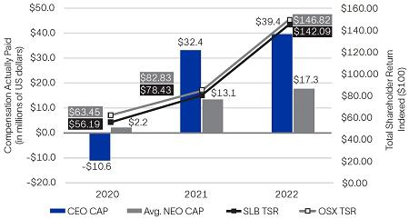

CAP vs. Net Income
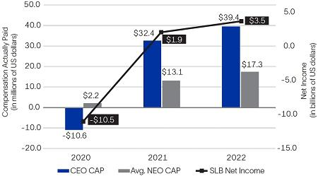

CAP vs. Adjusted EBITDA
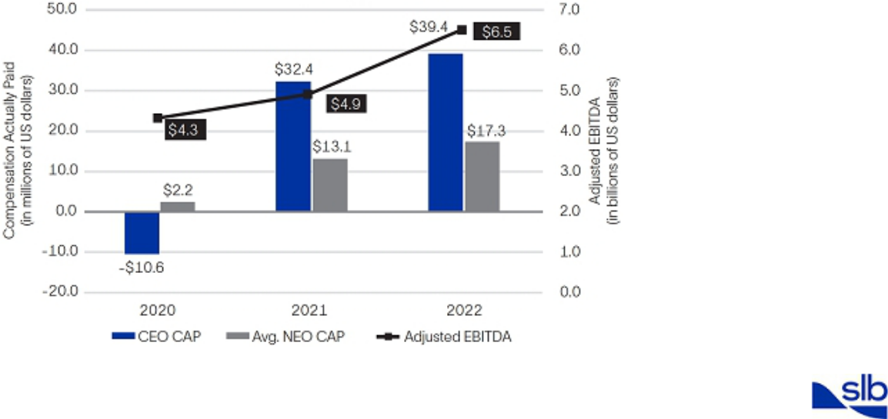

2023 Proxy Statement |  | 63

Back to Contents

ITEM 4. Approval of Financial Statements and Dividends

Following completion of the audit procedures performed by PwC, we are asking you to approve the following financial statements that are included in our 2022 Annual Report to Shareholders:

- our consolidated balance sheet at December 31, 2022;

- our consolidated statement of income for the year ended December 31, 2022; and

- the declarations of dividends by our Board in 2022.

You should refer to our 2022 Annual Report to Shareholders in considering this agenda item.

The Board of Directors recommends a vote FOR this Item 4.

64 2023 Proxy Statement

Back to Contents

ITEM 5. Ratification of Appointment of Independent Auditors for 2023

PwC has been selected by our Audit Committee as the independent registered public accounting firm to audit SLB’s annual financial statements for the year ending December 31, 2023. Although ratification is not required by our bylaws or otherwise, as a matter of good corporate governance, we are asking you to ratify, on an advisory basis, the appointment of PwC as our independent auditor for the year ending December 31, 2023. If the appointment is not ratified, the Audit Committee will consider whether it is appropriate to select another independent registered public accounting firm.

A representative of PwC is expected to attend our 2023 AGM, and will be available to respond to appropriate questions.

The Board of Directors recommends a vote FOR this Item 5.

Fees Paid to PwC

PwC has billed SLB the fees set forth in the table below for:

- the audit of SLB’s 2022 and 2021 annual financial statements and reviews of SLB’s quarterly financial statements and other audit services, and

- the other services described below that were billed in 2022 and 2021.

(Stated in thousands) | Year Ended December 31,
(Stated in thousands) |  |  | 2022 |  |  | 2021
Audit Fees⁽¹⁾ | $ |  | 13,122 |  | $ | 12,250
Audit-Related Fees⁽²⁾ |  |  | 634 |  |  | 534
Tax Fees⁽³⁾ |  |  | 2,993 |  |  | 1,560
All Other Fees⁽⁴⁾ |  |  | 44 |  |  | —
Total | $ |  | 16,793 |  | $ | 14,344

- Includes fees for integrated and statutory audits.

- Consists of fees for employee benefit plan audits and other audit-related items.

- Consists of fees for tax compliance, tax planning and other tax services.

- Consists of fees for advisory services.

The Audit Committee considers the provision of services by PwC not related to the audit of SLB’s annual financial statements and reviews of SLB’s interim financial statements when evaluating PwC’s independence.

Audit Committee’s Pre-Approval Policy and Procedures

The Audit Committee has a policy to pre-approve all services provided to Schlumberger Limited and its subsidiaries by SLB’s independent registered public accounting firm. The Committee has adopted a schedule for annual approval of the audit and related audit plan, as well as approval of other anticipated audit-related services; anticipated tax compliance, tax planning and tax advisory services; and other anticipated services. In addition, the Committee (or an authorized committee member acting under delegated authority of the committee) will consider any proposed services not approved as part of this annual process. For 2022 and 2021, audit and non-audit services were pre-approved by the Audit Committee.

Shareholder Feedback

At our 2022 AGM, the proposal to ratify the appointment of PwC as our independent auditor for 2022 received the support of 92% of the votes cast. In selecting PwC as SLB’s independent auditor for 2023, the Audit Committee considered this substantial support of our shareholders, as well as PwC’s substantial experience auditing SLB’s complex global accounts and the regulatory requirement that the PwC lead engagement partner rotate every five years.

2023 Proxy Statement |  | 65

Back to Contents

Audit Committee Report

During 2022, the Audit Committee periodically reviewed and discussed SLB’s consolidated financial statements with Company management and PwC, SLB’s independent registered public accounting firm, including matters raised by the independent registered public accounting firm pursuant to applicable Public Company Accounting Oversight Board (PCAOB) requirements. The Audit Committee also discussed with Company management and PwC the evaluation of SLB’s reporting and internal controls undertaken in connection with certifications made by SLB’s Chief Executive Officer and Chief Financial Officer in SLB’s periodic SEC filings pursuant to the Sarbanes-Oxley Act of 2002. The Audit Committee also reviewed and discussed such other matters as it deemed appropriate, including SLB’s compliance with Section 404 and other relevant provisions of the Sarbanes-Oxley Act of 2002 and rules adopted or proposed to be adopted by the SEC and the NYSE. The Audit Committee also reviewed with PwC the matters required to be discussed by the independent registered public accounting firm with the Audit Committee under applicable requirements of the PCAOB and the SEC.

PwC provided the Audit Committee with the required PCAOB disclosures and letters concerning its independence with respect to the Company, and the Audit Committee discussed PwC’s independence with them.

Based on the foregoing reviews and discussions, the Audit Committee recommended that the Board include the audited consolidated financial statements in SLB’s Annual Report on Form 10-K for the year ended December 31, 2022, as filed with the SEC on January 25, 2023.

Submitted by the Audit Committee of the SLB Board of Directors

Patrick de La Chevardière, Chair |  | Samuel Leupold |  | Tatiana Mitrova | Jeff Sheets
 |  |  | 66 |  |  | 2023 Proxy Statement

Back to Contents

Meeting Information

This proxy statement is furnished in connection with the solicitation by the SLB Board of Directors of proxies to be voted at SLB’s 2023 AGM, which will be held at the Curaçao Marriott Beach Resort, John F Kennedy Boulevard, 3, Piscadera Bay, Willemstad, Curaçao, on Wednesday, April 5, 2023 beginning at 10:00 a.m., Curaçao time, and at any postponement(s) or adjournment(s) thereof.

To be admitted to the meeting, shareholders of record and beneficial owners as of the close of business on February 8, 2023 must present a passport or other government-issued identification with a photograph and, for beneficial owners, proof of ownership as of February 8, 2023, such as the Notice of Internet Availability (defined below), and/or the top half of the proxy card or voting instruction card that was sent to you with this proxy statement.

In addition, depending on the level of COVID-19 protocols in effect at the time, your ability to attend the 2023 AGM in person may be restricted or may require additional safeguards, which could include face coverings, proof of vaccination, proof of a negative COVID-19 test result within a specified number of days, and maintaining appropriate social distancing. Please review www.proxydocs.com/SLB for any updates prior to traveling.

This proxy statement is first being made available to our shareholders on February 23, 2023. The Chairperson of the meeting will determine the procedures for conducting the meeting and will limit the meeting to those matters properly brought by or at the direction of our Board or properly presented by a shareholder.

Internet Availability of Proxy Materials

This year we are using the internet as the primary means of furnishing proxy materials to shareholders. We are sending a Notice of Internet Availability of Proxy Materials (the Notice of Internet Availability) to our shareholders with instructions on how to access the proxy materials online or request a printed copy of the materials. Shareholders may follow the instructions in the Notice of Internet Availability to elect to receive future proxy materials in print by mail or electronically by email. We encourage shareholders to take advantage of the availability of the proxy materials online to help reduce the environmental impact of our AGMs. Our proxy materials are also available at https://investorcenter.slb.com, as well as at www.proxydocs.com/SLB.

Record Date

Each shareholder of record at the close of business on the record date, February 8, 2023, is entitled to one vote for each director nominee and one vote for each of the other proposals to be voted on with respect to each share registered in the shareholder’s name. A shareholder of record is a person or entity who held shares on the record date registered in the shareholder’s name on the records of Computershare Trust Company, N.A. (Computershare), SLB’s stock transfer agent. On the record date, February 8, 2023, there were 1,427,601,663 shares of SLB common stock outstanding and entitled to vote. Persons who held shares on the record date through a broker, bank, or other nominee are referred to as beneficial owners.

Proxies

Shares cannot be voted at the meeting unless the owner of record is present in person or is represented by proxy. SLB is incorporated in Curaçao and, in accordance with Curaçao law, meetings of shareholders are held in Curaçao. Because many shareholders cannot personally attend the meeting, it is necessary that a large number be represented by proxy.

Quorum

Holders of at least one-half of the outstanding shares entitled to vote at the meeting must be present in person or represented by proxy to constitute a quorum for the taking of any action at the meeting. Abstentions and proxies submitted on your behalf by brokers, banks, or other holders of record that do not indicate a vote because they do not have discretionary voting authority and have not received instructions from the beneficial owner of the shares as to how to vote on a proposal (so-called broker non-votes) will be considered as present for quorum purposes. If a quorum is not present at the meeting, the Board may call a second general meeting of shareholders, at which the quorum requirement will not apply.

Votes Required to Adopt Proposals

To be elected, director nominees must receive a majority of the votes cast, which means the number of votes cast “for” a director nominee must exceed the number of votes cast “against” that nominee. Approval of each of the other matters on the agenda also requires the affirmative vote of the majority of the votes cast.

2023 Proxy Statement |  | 67

Back to Contents

Important Voting Information for Beneficial Owners

If your SLB shares are held for you in street name (i.e., you own your shares through a brokerage, bank, or other institutional account), you are considered the beneficial owner of those shares, but not the record holder. This means that you vote by providing instructions to your broker rather than directly to SLB. Brokers are not permitted to vote on certain proposals and may not vote on any of the proposals unless you provide voting instructions. Therefore, unless you provide specific voting instructions, your shares may not be represented or voted at the meeting.

Effect of Abstentions and Broker Non-Votes

Brokers holding shares must vote according to specific instructions they receive from the beneficial owners of those shares. If brokers do not receive specific instructions, brokers may in some cases vote the shares in their discretion, but are not permitted to vote on certain proposals and may elect not to vote on any of the proposals unless you provide voting instructions. If you do not provide voting instructions and the broker elects to vote your shares on some but not all matters, it will result in a “broker non-vote” for the matters on which the broker does not vote. Abstentions occur when you provide voting instructions but instruct the broker to abstain from voting on a particular matter instead of voting for or against the matter. Abstentions and broker non-votes will be considered as present for quorum purposes, but they are not considered as votes cast and will not be counted in determining the outcome of the vote on the election of directors or on any of the other proposals.

How to Cast Your Vote

Shareholders with shares registered in their names with Computershare may authorize a proxy:

By Internet

www.proxypush.com/SLB

By Telephone


(866) 240-5191

By Mail


Sign, date, and mail your proxy card

The internet and telephone voting facilities for shareholders of record will close at 11:59 p.m. Eastern time on Tuesday, April 4, 2023. The internet and telephone voting procedures have been designed to authenticate shareholders and to allow you to vote your SLB shares and to confirm that your instructions have been properly recorded.

Many banks and brokerage firms participate in programs that also permit beneficial owners to direct their vote by the internet or telephone. If you are a beneficial owner whose shares are held in an account at a bank or brokerage firm that participates in such a program, you may direct the vote of those shares by the internet or telephone by following the instructions on any voting instruction form or electronic voting instructions that you receive from your bank or brokerage firm.

All shares entitled to vote and represented by properly executed proxies received prior to the meeting and not revoked will be voted at the meeting in accordance with your instructions. If you are a shareholder with shares registered in your name with Computershare and you submit a properly executed proxy card but do not direct how to vote on each item, the persons named as proxies will vote as the Board recommends on each proposal.

Changing Your Vote or Revoking Your Proxy

If you are a shareholder of record, you can change your vote or revoke your proxy at any time by timely delivering a properly executed, later-dated proxy (including an internet or telephone vote by April 4, 2023) or by voting by ballot at the meeting. If you hold shares through a broker, bank, or other holder of record, you must follow the instructions of your broker, bank, or other holder of record to change or revoke your voting instructions.

68 2023 Proxy Statement

Back to Contents

Other Information

2024 Annual General Meeting of Shareholders

We intend to file a proxy statement and WHITE proxy card with the SEC in connection with the Board’s solicitation of proxies for our 2024 AGM. Shareholders may obtain a copy of our 2024 proxy statement (and any amendments and supplements thereto) and other documents as and when filed with the SEC without charge from the SEC’s website at www.sec.gov.

In order for a shareholder proposal to be considered for inclusion in the proxy statement for our 2024 AGM pursuant to Exchange Act Rule 14a-8, or for director nominations to be included pursuant to SLB’s proxy access bylaw provisions, such proposals or notice of nominations must be received by the
Secretary of the Company, 5599 San Felipe, 17th Floor, Houston, Texas 77056, no later than October 26, 2023, and, in the case of a proxy access nomination, no earlier than September 26, 2023.

For shareholder proposals to be introduced for consideration at our 2024 AGM other than pursuant to Rule 14a-8 and for shareholder candidates to be nominated for election as directors other than pursuant to our proxy access bylaw provisions, notice must be delivered to the Secretary of the Company at our executive offices in Houston, Texas, not later than 120 days nor earlier than 150 days before the first anniversary of the date of the 2023 AGM. Accordingly, any such notice must be received no earlier than November 7, 2023, and no later than December 7, 2023, and must otherwise satisfy the requirements of our bylaws. Under the rules of the Exchange Act, we may use discretionary authority to vote with respect to any proposal not included in our proxy materials that is properly presented by a shareholder in person at the 2024 AGM if the shareholder making the proposal fails to meet these deadlines and fails to satisfy the requirements of Rule 14a-4 under the Exchange Act.

Further, to comply with the SEC’s universal proxy rules, if a shareholder intends to solicit proxies in support of director nominees submitted under these advance notice provisions, then we must receive proper written notice that sets forth all information required by Rule 14a-19 under the Exchange Act, delivered to the Secretary of the Company at our executive offices in Houston, Texas, by February 5, 2024 (or, if the 2024 AGM is called for a date that is more than 30 days before or more than 30 days after such anniversary date, then notice must be provided not later than the close of business on the later of

the 60th day prior to the 2024 AGM or the 10th day following the date on which public announcement of the 2024 AGM is made). The notice requirement under Rule 14a-19 is in addition to the applicable advance notice requirements under our bylaws as described above.

Annual Report

Shareholders may obtain a copy of our most recent Form 10-K filed with the SEC, including financial statements and schedules, without charge by writing to our Investor Relations Department, 5599 San Felipe, 17th Floor, Houston, Texas 77056, or by calling (713) 375-3535.

Proxy Solicitation Costs

SLB will pay the cost of furnishing proxy materials to all shareholders and of soliciting proxies by mail and telephone. We have retained D.F. King & Co., Inc. and its affiliate to assist in the solicitation of proxies for a fee estimated at $17,050 plus reasonable expenses. SLB directors, officers and employees may also solicit proxies for no additional compensation. We will reimburse brokerage firms, fiduciaries, and custodians for their reasonable expenses in forwarding the solicitation material to beneficial owners.

2023 Proxy Statement |  | 69

Back to Contents

Other Matters

As of the date of this proxy statement, we know of no other business that will be presented at the meeting other than the matters described in this proxy statement. If any additional matters are properly presented at the meeting, we intend to vote the enclosed proxy in accordance with the discretion of the persons named in the proxy.

Please sign, date, and return the accompanying proxy in the enclosed envelope at your earliest convenience.

By order of the Board of Directors,
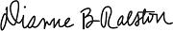

Dianne B. Ralston

Chief Legal Officer and Secretary

Houston, Texas

February 23, 2023

70 2023 Proxy Statement

Back to Contents

Appendix A

Non-GAAP Financial Measures

This proxy statement includes non-GAAP financial measures, including free cash flow, free cash flow margin, adjusted EBITDA, adjusted EBITDA margin, earnings per share, excluding charges and credits, net income, excluding charges and credits, and net debt. Certain of these measures are used by management as performance metrics when determining incentive compensation for our executive officers. Below is a reconciliation of these non-GAAP financial measures to the comparable GAAP measures.

 | (Stated in millions)
 |  | Year Ended
 |  | Dec. 31, 2022
Cash flow from operations | $ | 3,720
Capital expenditures |  | (1,618)
Asset Performance Solutions investments |  | (587)
Exploration data capitalized |  | (97)
Free cash flow | $ | 1,418

Free cash flow represents cash flow from operations less capital expenditures, Asset Performance Solutions investments and exploration data costs capitalized. Management believes that free cash flow is an important liquidity measure for the Company and that it is useful to investors and management as a measure of SLB’s ability to generate cash. Free cash flow does not represent the residual cash flow available for discretionary expenditures. Free cash flow is a non-GAAP financial measure that should be considered in addition to, not as a substitute for or superior to, cash flow from operations.

Free cash flow margin is calculated as free cash flow divided by revenue. Free cash flow margin measures how efficiently SLB converts revenue into free cash flow, and is an indicator of capital efficiency.

 | (Stated in millions)
 |  | Year Ended
 |  | Dec. 31, 2022
Net income attributable to SLB – GAAP basis | $ | 3,441
Net income attributable to noncontrolling interests |  | 51
Tax expense |  | 779
Income before taxes | $ | 4,271
Charges and credits:
Gain on Arabian Drilling Company equity investment |  | (107)
Gain on sale of Liberty shares |  | (325)
Gain on repurchase of bonds |  | (11)
Loss on Blue Chip Swap transactions |  | 139
Gain on sale of real estate |  | (43)
Depreciation and amortization |  | 2,147
Interest expense |  | 490
Interest income |  | (99)
Adjusted EBITDA | $ | 6,462

Adjusted EBITDA represents income before taxes, excluding charges and credits, depreciation and amortization, interest expense, and interest income. Management believes that adjusted EBITDA is an important profitability measure for SLB and that it allows investors and management to more efficiently evaluate SLB’s operations period over period and to identify operating trends that could otherwise be masked. Adjusted EBITDA is a non-GAAP financial measure that should be considered in addition to, not as a substitute for or superior to, other measures of financial performance prepared in accordance with GAAP.

Adjusted EBITDA margin is calculated as adjusted EBITDA divided by revenue. For full-year 2022, adjusted EBITDA margin of 23.0% was calculated based on adjusted EBITDA of $6.462 billion divided by revenue of $28.091 billion.

2023 Proxy Statement |  | A-1

Back to Contents
 |  |  |  |  | (Stated in millions, except per share amounts)
 |  |  |  |  | Year Ended Dec. 31, 2022
 |  |  |  |  |  |  | Noncont. |  |  |  | Diluted
 |  |  | Pretax |  | Tax |  | Interests |  | Net |  | _{EPS}(1)
Net income attributable to SLB – GAAP basis |  | $ | 4,271 | $ | 779 | $ | 51 | $ | 3,441 | $ | 2.39
Gain on Arabian Drilling Company equity investment |  |  | (107) |  | (3) |  | – |  | (104) |  | (0.07)
Gain on sale of Liberty shares |  |  | (325) |  | (37) |  | – |  | (288) |  | (0.21)
Gain on repurchase of bonds |  |  | (11) |  | (2) |  | – |  | (9) |  | (0.01)
Loss on Blue Chip Swap transactions |  |  | 139 |  | - |  | – |  | 139 |  | 0.10
Gain on sale of real estate |  |  | (43) |  | (2) |  | – |  | (41) |  | (0.03)
Net income attributable to SLB, excluding charges |  | $ | 3,924 | $ | 735 | $ | 51 | $ | 3,138 | $ | 2.18
and credits
(1) Does not add due to rounding.
 |  |  |  |  |  |  |  |  | (Stated in millions)
 |  |  |  |  |  |  |  |  |  | At Dec. 31, 2022
Cash |  |  |  |  |  |  |  |  | $ |  | 1,655
Short-term investments |  |  |  |  |  |  |  |  |  |  | 1,239
Short-term borrowings and current portion of long-term debt |  |  |  |  |  |  |  |  |  |  | (1,632)
Long-term debt |  |  |  |  |  |  |  |  |  |  | (10,594)
Net debt |  |  |  |  |  |  |  |  | $ |  | (9,332)

Net debt represents gross debt less cash and short-term investments. Management believes that net debt provides useful information regarding the level of SLB’s indebtedness by reflecting cash and investments that could be used to repay debt. Net debt is a non-GAAP financial measure that should be considered in addition to, not as a substitute for or superior to, total debt.

A-2 2023 Proxy Statement

Back to Contents

This page intentionally left blank

Back to Contents

This page intentionally left blank

Back to Contents
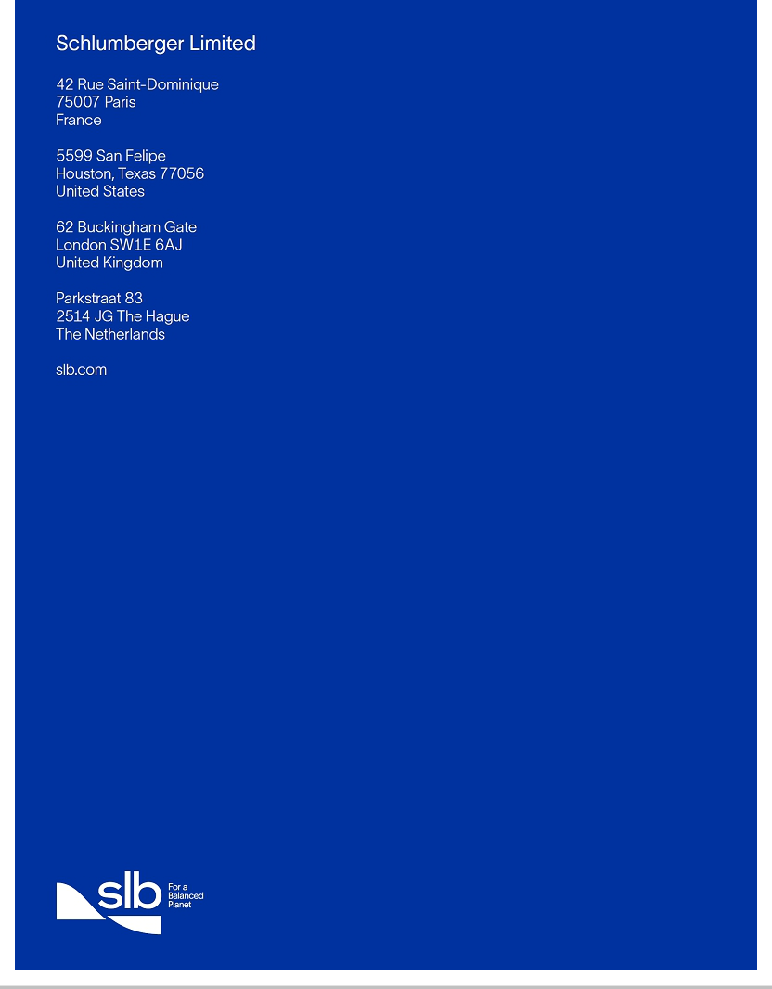

Back to Contents
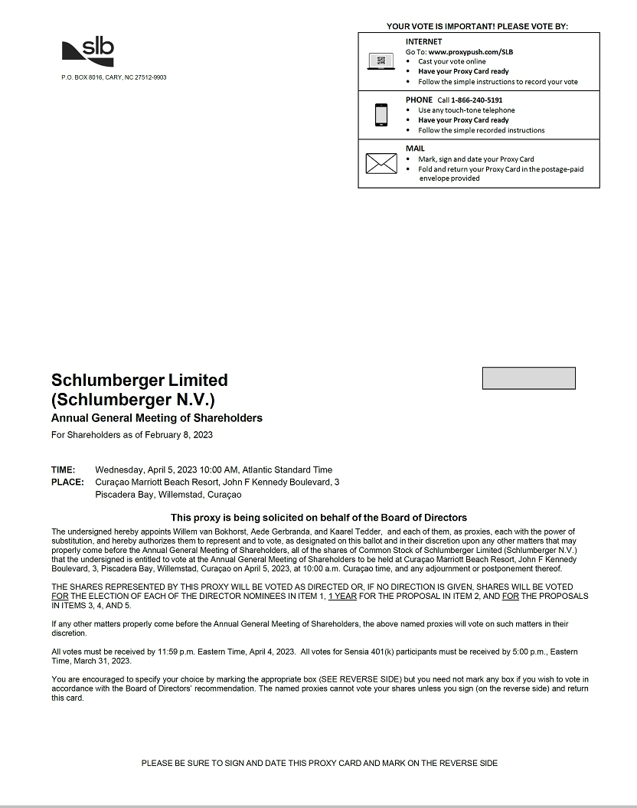

Back to Contents


