SECURITIES AND EXCHANGE COMMISSION

Washington, D.C. 20549

FORM 8-K

CURRENT REPORT

Pursuant to Section 13 or 15(d) of

the Securities Exchange Act of 1934

Date of Report (date of earliest event reported): June 15, 2004

SCHLUMBERGER N.V.

(SCHLUMBERGER LIMITED)
(Exact name of registrant as specified in its charter)

Netherlands Antilles | 1-4601 | 52-0684746
(State or other jurisdiction | (Commission | (IRS Employer
of incorporation) | File Number) | Identification No.)
153 East 53rd Street, 57th Floor
New York, New York |  | 10022-4624
42, rue Saint-Dominique
Paris, France |  | 75007
Parkstraat 83,
The Hague,
The Netherlands |  | 2514 JG
(Addresses of principal executive offices) |  | (Zip or Postal Codes)

Registrant’s telephone number in the United States, including area code: (212) 350-9400

Item 7. Financial Statements and Exhibits.

(c) Exhibits

The following exhibit is furnished in response to Item 9:

99.1 Presentation at Investor Event held on June 15, 2004

Item 9. Regulation FD Disclosure

On June 15, 2004, Andrew Gould, Chairman and CEO of Schlumberger Limited (“Schlumberger”) and other members of the Schlumberger management team will host an investor event at the Schlumberger-Doll Research Center in Ridgefield, Connecticut. A copy of the presentations by Andrew Gould, Chakib Sbiti and Dalton Boutte are attached as Exhibit 99.1. Schlumberger has also posted this information on its website at www.slb.com/ir. A transcript of the event’s Q& A session will be posted on the web site later in the day.

The attached presentation and other statements Schlumberger makes contain forward looking statements, which include any statements that are not historical facts, such as Schlumberger’s expectations regarding business outlook; revenue, earnings and sales growth for Schlumberger as a whole and for each of Oilfield Services, Schlumberger Information Solutions and WesternGeco; after-tax return on sales; return on capital employed; opportunities for geographic growth; opportunities for growth in technology, in Schlumberger’s customer base and in new business models; Schlumberger’s ability to maintain a competitive advantage in technology; Schlumberger’s ability to expand its project management services; the use of free cash, the growth in revenues at WesternGeco due to Q seismic technology; oil and natural gas demand and production growth; operating and capital expenditures by the oil and gas industry; the business strategies of Schlumberger’s customers; the benefits of the GeoMarket organizational structure; pricing; and future results of operations. These statements involve risks and uncertainties, including,

but not limited to, the extent and timing of a rebound in the global economy; changes in exploration and production spending by Schlumberger’s customers; changes in the level of oil and natural gas exploration and development; improved pricing and realization of cost reduction and cost savings targets associated with the seismic business; general economic and business conditions in key regions of the world, including the Middle East, the Caspian, Russia, China and Venezuela; political and economic uncertainty in Venezuela and Nigeria and further socio-political unrest in the Persian Gulf and/or Asia; terrorism; and other factors detailed in Schlumberger’s most recent Form 10-K, Form 10-Q and other filings with the Securities and Exchange Commission. If one or more of these risks or uncertainties materialize (or the consequences of such a development changes), or should underlying assumptions prove incorrect, actual outcomes may vary materially from those forecasted or expected. Schlumberger disclaims any intention or obligation to update publicly or revise such statements, whether as a result of new information, future events or otherwise.

SIGNATURE

Pursuant to the requirements of the Securities Exchange Act of 1934, the registrant has duly caused this report to be signed on its behalf by the undersigned hereunto duly authorized.

SCHLUMBERGER N.V.

(SCHLUMBERGER LIMITED)

By: /s/ Jean-Marc Perraud
Jean-Marc Perraud
Executive Vice President and
Chief Financial Officer

Date: June 15, 2004

EXHIBIT 99.1

Schlumberger Limited – Andrew Gould


Ladies and Gentlemen Good Morning. Welcome to Ridgefield and thank you for joining us today. We have an important program for you and we are looking forward to describing the future opportunities that we see for Schlumberger. I will make some introductory remarks and the management team will give the rest of this morning’s presentations.

I will briefly address 3 subjects. First a review of the fundamentals of the oil and gas industry and how they will affect the oilfield services business. Second, I will show how Schlumberger is uniquely positioned to grow as a result of these industry trends. Finally, I will present a progress report on the financial goals that I presented to you in March of 2003 together with a new set of goals for Schlumberger as the world’s leading oilfield services company.

Ladies and gentlemen, Schlumberger is again a pure oilfield services company. Our global presence and our workforce are unmatched in the industry. We have an unrivalled position in our chosen technology segments with an astonishing record for technology innovation and development. We have completed an internal strategy review involving over 200 employees from the CEO to the field operations managers, working in 8 study teams and 15 workshop groups, and with input from the top 120 managers and two external surveys. We have a three-part strategy that will underpin our growth. I am proud that following the disposal of the non-oilfield activity we have a clear purpose, clear values and well-defined long-term objectives. The enthusiasm and competence demonstrated by our people is amazing, and I’m sure that you will see this today as we explain some of the key elements of our growth plans.

1 of 31

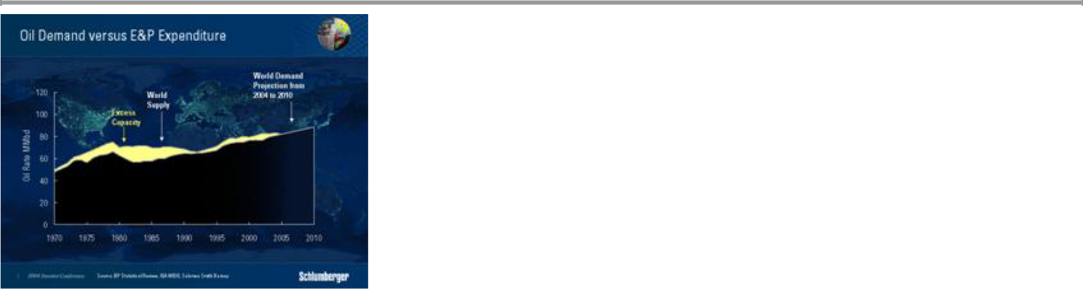

In terms of the industry fundamentals, Schlumberger has always maintained that the lead indicator driving our business has been, and will remain, the demand for oil and gas, and that the supply would follow as a result. Since the early 1970s, supply has never been an issue and, as we well know, the removal of pricing power from the producing nations in the 1980s was due to a drop in demand. The amplitude of the price drop in the eighties was made worse by the abundance of new supply created in the high price era of the 70s. The result was that in 1985 the world had a surplus excess production capacity of more than 15 million barrels a day. In the years following 1985, oil prices remained low and there was little incentive for the large reserves owners to fund additional capacity.

We have now had a long period of limited investment in new production capacity, during which time more and more oil and gas reservoirs have entered their mature production phase. Accelerating demand requires additional capacity. However, in the oil and gas industry, investment in new capacity must respond to both the increase in demand, as well as to a decline in the existing production base. By way of example, the North Sea, Alaska and Mexico that were the three big capacity additions following the oil price shocks of the 1970s are no longer in their first youth. Ladies and Gentlemen, as the chart shows in the yellow area between demand and supply, the world is running on a very narrow margin of excess production capacity at a time when geopolitical tensions and domestic politics in some producing nations have made supply subject to risk.

Against this scenario, demand forecasts have again been revised upwards on the strength of an improving US economy, growth in China in particular and Asia in general. 2003 already saw global annual demand growth increase to more than 2.1%, and 2004 is expected to exhibit similar or even stronger growth.

For the first time in the industry’s collective working memory, supply is as much an issue as demand. I have no doubt that the industry will solve the supply issue, but it is difficult to see how enough production capacity can be brought on line fast enough to change the short-term tightness in the supply-demand balance which is reflected in current prices. As one respected oil research analyst commented last week in a discussion on the speculative position in oil, “All this decade the best position to have taken in oil is a structural long,

2 of 31

and we do not believe anything has changed recently to alter that position as far as the rest of this decade is concerned”.
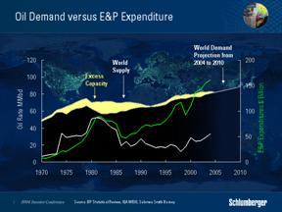

All recent forecasts have noted that in the coming decade the amount of capital investment and operating expenditures need to sustain and increase oil and gas production will have to increase. The IEA figure of $6 trillion of capital investment between now and 2030 has been widely used.

This is normal following the period of under-investment, and will lead to a long cycle of improved demand for oilfield services. However, two words of caution are necessary. First this picture depends on a continued sustained increase in demand that in turn depends on economic growth. Second, the current geopolitical tensions are such that they could cause major disruptions in supply that would limit economic growth in the short term.

It is also important as well to look at how this investment will need to be distributed. Only approximately one quarter of the oil investment figure will be needed to grow capacity. The remaining three-quarters will be needed to replace existing capacity lost through production decline. New oil production is expected to come from Russia, the Caspian, the deepwater Gulf of Mexico, Brazil, and West Africa but as much as 70% of conventional new production will occur in non-OECD countries implying an increasing call on Middle-East OPEC producers.

Gas presents a slightly different picture, with plentiful supply in almost all parts of the world with the possible exception of the continental US. The IEA predicts that gas consumption will double in the next 30 years and that almost half of the total investment figure will need to be spent on exploration and production.

I’d like now to take a look at the evolution of Schlumberger Oilfield Services revenue versus the rig count as this contains important information about the evolution of our business. The revenue figures exclude WesternGeco, and have been restated for comparison purposes.

3 of 31

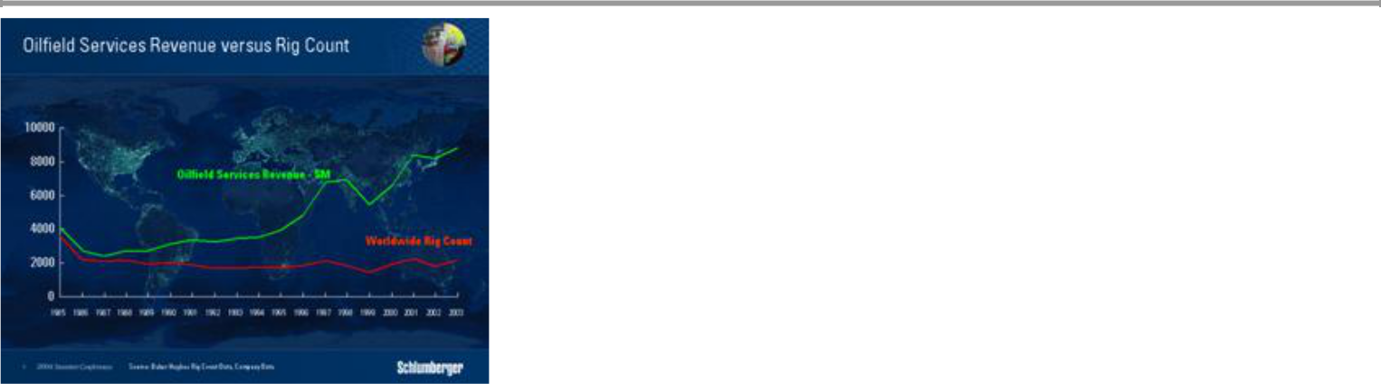

You can immediately see that there has really been no direct correlation between revenue and rig count since the late 1980s. Obviously this is partly due to the evolution of our portfolio of products and services. It is also due the continual contribution that technology has made to the industry’s capability to drill fewer dry wells both in exploration and development and fewer, but better wells from surface. The other is the relentless move towards the need to maintain production from oilfields that have been in service for longer and longer, with consequent declines in performance, work that often does not require the use of a drilling rig. We estimate today that 40% of our revenue, excluding WesternGeco, comes from operations that do not require the presence of a drilling rig. You’ve all heard me say before that 70% of today’s oil comes from fields that have been in production for more than thirty years. The result of this is the need to stem production decline while increasing ultimate reservoir recovery. This is a fine technical challenge for the industry in addition to that of adding capacity from the exploitation of new reserves that increasingly lie in more and more complex environments.
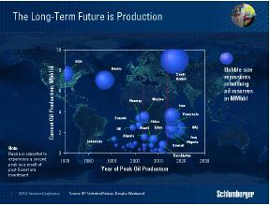

When we look at this chart of production and reserves two important facts emerge, both of which form the basis of our strategy to grow Schlumberger. First, the size of the bubbles shows the remaining reserves in a number of major producing countries, and it is clear that apart from activity in the harsh environments of deepwater, the growing portion of future new exploration and development will be in the Eastern Hemisphere areas

4 of 31

which play to Schlumberger’s technical and cultural strengths. Second, if you look at the positions of the bubbles relative to horizontal timeline, which indicate the points of peak production in a given area, it is abundantly clear that the E&P industry is becoming more and more production based. In the same way that production peaked in the lower 48 in 1970, and has probably subsequently peaked in areas such as the North Sea, it will peak in many other areas in the next ten years. This scenario implies that we must focus technology and services to address the opportunities created by the need to slow decline, while increasing ultimate recovery as extending field life will become an important element of supply.

This picture is the cornerstone of our future growth. New and increased investment in additional production capacity, largely in the international and deepwater markets where Schlumberger is strongest, coupled with the requirement to prolong production from existing reservoirs, will be reflected in higher levels of oilfield service activity for many years to come. There are three key avenues that we intend to exploit in addition to maintaining our leading position in exploration and development technology for harsh and complex environments.
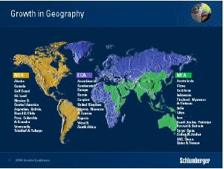

First, Schlumberger already has enormous geographical spread, however, our strong positions in the strategically important areas for new production in the Middle East, the Caspian and in deepwater regions still leave us room to grow in these areas. But without a doubt the area where we still have the largest opportunity is in Russia as well as to some extent in China. Schlumberger has approached these areas just as we approached the United States seventy years ago, developing technology locally, forging academic links, hiring Russian or Chinese engineers and technicians, becoming part of the local landscape.

5 of 31

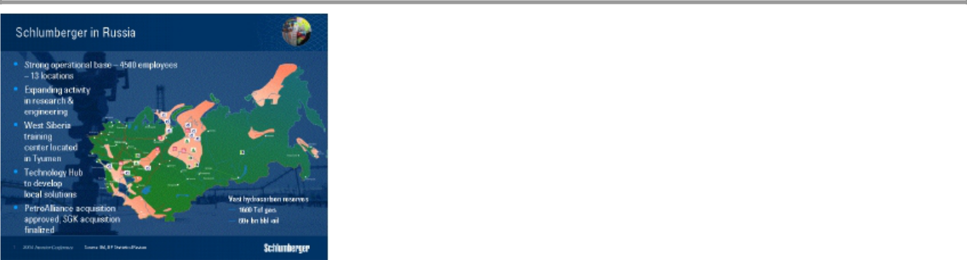

Our revenue and net income in Russia have doubled in three years and will grow close to another 30% in 2004 without the revenue from acquisitions. We currently employ some 4500 people in Russia, making Russian nationals the fourth-largest group in Schlumberger. We are expanding our activities in research and engineering led by our research center located on the campus of the Moscow State University. The first tranche of the PetroAlliance acquisition that we announced last year has been closed. We have finalized the acquisition of SGK, a joint venture with which we have been associated for the past 4 years. There will of course be upsets along the way, but Russia is capable of equaling Saudi Arabia in liquids production, and possesses tremendous reserves of gas. The position in China is more complex but we have adopted the same approach and by way of illustration the Beijing Geoscience Center is now home to almost 100 scientists engaged on the development of software and interpretation techniques for worldwide deployment.

The key to success in new geographic areas is the extent to which technology can be adapted to that area. Cultural barriers can block the way to confidence and understanding. Our long standing policy of hiring the best from every country in which we work has given us an ability to call on virtually any nationality, even at a high management level to give credibility to our technology offering. This is important when managing the issues associated with mature production. We are, as an industry, proud and conservative, and it is not easy to convince people who have been managing a field for twenty years that their methods or technologies need to change. I take the example of Western Siberia where huge efforts in persuasion and training were necessary to achieve adoption of Western methods from other areas to improve production.

6 of 31

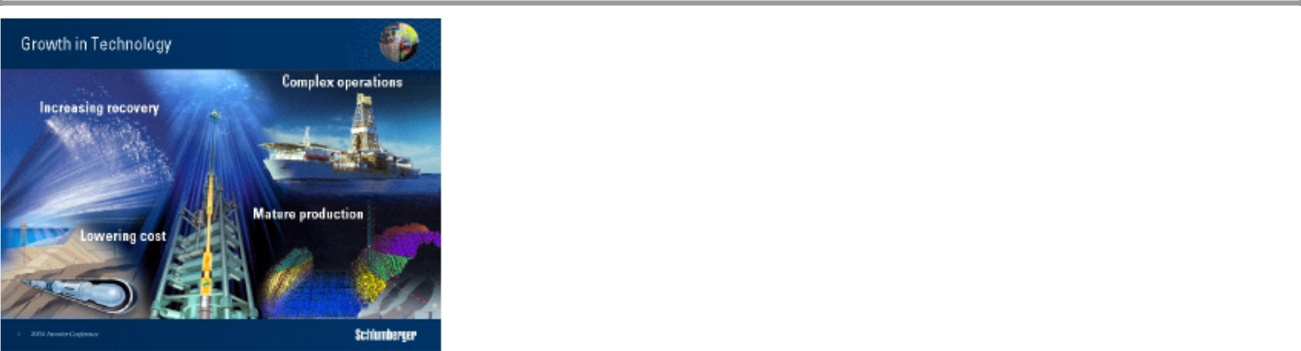

The second avenue for growth is through technology, both developed internally and acquired externally.

Why? simply because technology remains fundamental to the continued success of the Exploration and Production business. It is one of the main sources of competitive advantage for Schlumberger and we have demonstrated again and again our ability to grow winners through technology. Over the last 20 years the industry has provided technology that has lowered F&D costs in a period of sustained low commodity prices. Technology has not only enabled the industry to lower costs but has also speeded up decline through more efficient reservoir drainage. The question that we face today is can technology help manage mature production in a manner that maximizes current production without lowering ultimate recovery?

So how is Schlumberger positioned to respond to this need for technology?
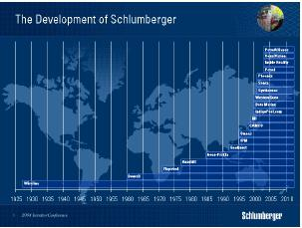

Schlumberger growth in technology is from both internal development and acquisitions. We have focused on building a strong portfolio of competencies that we believe are needed to respond to the challenges of the industry. We have spun-off capital-intensive activities, formed joint ventures in others and pursued acquisitions of specific technologies where synergy and opportunity exist. The moves in software, information

7 of 31

management, infrastructure solutions and business consulting for example, have led to an organization capable of helping customers streamline their core operational processes. The acquisition of Camco provided a platform for us to leverage our own measurement expertise into the subsurface that added to our activity in intelligent completions. It also led to the acceleration of our development of directional drilling systems and to an expanding line of artificial lift solutions to which we have added specialist technologies such as Phoenix pump optimization methodology and the Sensa fiber-optic measurement portfolio.

These moves, taken in step with a wide range of internally developed products and service have created a portfolio targeted at growth in the production-oriented market of today and we will show you how they fit together during the technology presentations this afternoon. We expect this pattern of complementary technology acquisition with its subsequent enhancement and integration into our portfolio to be a feature of our future growth.
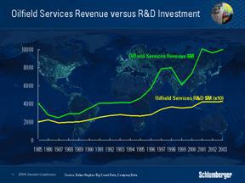

This enhancement of products and services brought in through acquisitions does not in anyway reduce our commitment to using R&D to make our service lines leaders in their particular technology. Technology development has always been critical to the success of Schlumberger. We are recognized as being the number one or number two player in almost all of our chosen technology segments and where we are not, we have a definite plan to become a leader. We have always maintained a long-term commitment to research and development that we have modulated but never dramatically cut during industry cycles. This is of significance not only from a competitive viewpoint, but also from the perspective of the role that the service industry plays in supplying technology for upstream E&P. Ever since the oil price crash of the mid-1980s, R&D spending by the oil companies has steadily decreased while that of the service companies has become a greater proportion of the total and today provides some 30% of the total industry spend.

As a result of this commitment, our own technical innovations have come at a constant rate and, in fact, at the current time the rate of introduction of new products and services is accelerating. Satish Pai, Schlumberger technology vice-president will outline the ability and flexibility of the technical organization later this morning.

8 of 31

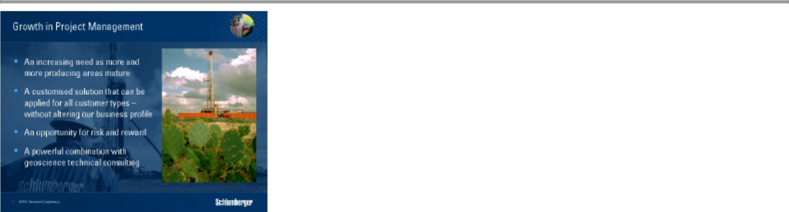

Finally the third avenue of growth for Schlumberger will be our ability to perform project management. Our experience in using our own technology, our capacity to engineer well and reservoir solutions and the vast local knowledge our GeoMarket structure brings us make this a natural extension of our service offering. I have stated this in the past but am more and more confident that this will happen as the size of the task in managing mature production across an increasing number of countries and basins becomes more critical.

It is important that you understand that this is a service we will perform for all types of customer who request it. It does not in any circumstances alter Schlumberger’s business profile, we will not take equity in oil and gas properties and the risk we take will be limited to the project execution and the performance of our own technology.

Last year in New York, I outlined the growing success of our IPM segment. Conceived largely as a well construction business, as confirmed by the successful execution of projects such as Burgos and Chicontepec in Mexico, it is now developing more and more expertise in the execution of projects designed to boost production in mature areas. IPM manages our own services and a host of other subcontractors who conduct operations that we need but do not want as part of our portfolio.

A critical element of this approach to both well construction and production management is our geoscience technical consulting organization that we call Data and Consulting Services. This is separate from SIS, our software, data management and infrastructure services organization. This organization has two roles. It supports the individual needs of the Schlumberger businesses for geologists, geophysicists, petrophysicists and reservoir engineers and other technical disciplines. It provides the multidisciplinary expertise needed to perform reservoir-scale studies for clients, or indeed for IPM. This organization has had a revenue CAGR of 15% in the last 5 years.

The joint expertise of the DCS and IPM in executing projects that use and apply the whole range of Schlumberger technologies to our customers problems is critical, particularly as the industry moves more and more to management of mature production where resources in the coming years will be inadequate for all that needs to be done.

9 of 31

These activities will be a major source of growth. Chakib Sbiti will talk to you about this at length.

The total industry spend in operating expenditure to sustain production is probably in excess of $200 billion with the major part being spent by the oil companies themselves. We estimate the total service portion to be $30 billion and growing.

Let me now update you on the progress we have made against the financial goals we set in March 2003 and then articulate some financial goals we have set for the future.
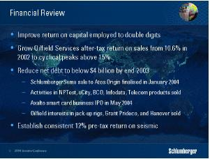

In March 2003 we set a number of clear financial goals and, now 14 months later, we have made good progress. Earnings from continuing operations have consistently grown faster than revenue. Return on capital employed rose to 13.3% in the last quarter, well into double figures, significantly higher than the corresponding figure in 2003. After-tax return on sales for Oilfield Services reached 13.8% in the same quarter—a level much more consistent with our performance in previous cycles and consistent with the timing of the current cycle.

Our divestiture program of the non-Oilfield businesses is substantially complete and total proceeds raised since the beginning of the year 2004 are $2.7 Billion.

As a result our net debt is well below $2 billion and is at a level consistent with the longer-term capital structure of Schlumberger.

The most difficult challenge that we set ourselves was to return Western-Geco to sustainable profitability. Continuing overcapacity in both the land, marine and multi-client data markets made this a daunting task. Our approach has been threefold, to bring capacity and cost down to appropriate levels, to reflect a proper carrying value for the data library, and to continue aggressive introduction of Q technology. The keys to success are industry discipline in managing capacity and above all the clear demonstration of the differentiation in Q technology. Dalton Boutte, president of WesternGeco, will update you later this morning on our progress.

Now let me turn to the future.

10 of 31

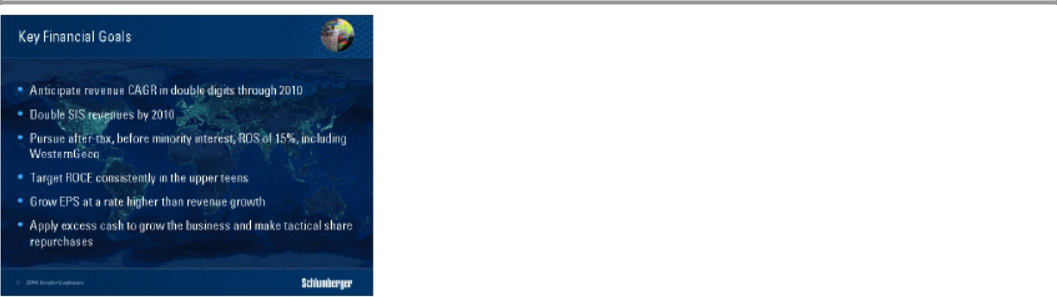

We anticipate that the CAGR of Schlumberger will be in double digits throughout the remainder of the decade as the favorable business conditions and growth plans we have put in place materialize. This growth may not be linear as the industry will remain to some extent cyclical.

Revenue at Schlumberger Information Systems will double by 2010 as customers move more and more to rethink their core operational processes in a digital world.

We will aim for an after tax return on sales before minority interests of 15% including Western-Geco. This is a readily attainable goal for OFS but is ambitious for Western-Geco.

We will target a return on capital employed consistently in the upper teens.

The projections we have made show that at the current level of net debt we will generate cash. Our policy will be not to retain cash in the company beyond the requirements of the business. We will apply cash to fund any requirements we may have to grow the business either through acquisitions or through internal developments, to the extent that cash remains beyond this we will use it to tactically repurchase the company’s shares.

Schlumberger policy has always been to increase dividend when a new plateau of earnings is reached. It is a position we would like to maintain and therefore we will not envisage any increase in the dividend until such time as earnings move to a plateau that would materially change the current payout ratio.

11 of 31

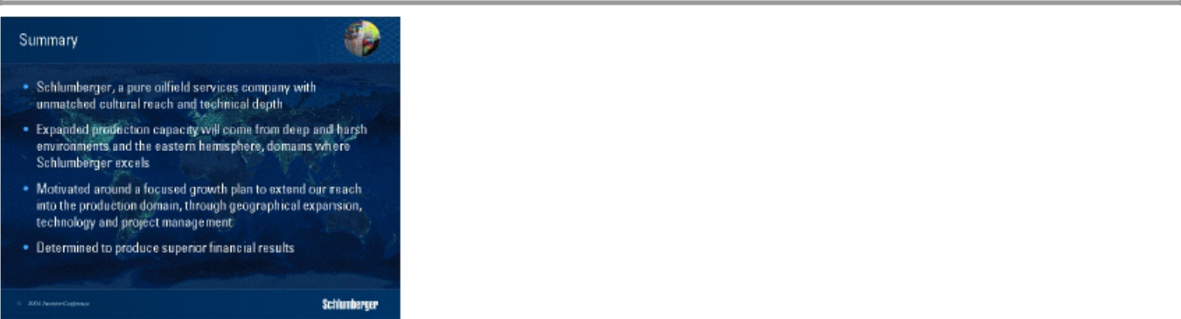

Ladies and Gentlemen, I began this talk with a description of the investment climate for Oil and Gas in the coming years. It is perhaps the most favorable business climate we have seen in the upstream industry since the early 1970’s. The world’s requirements to renew and expand production capacity through stemming production decline, improving recovery factors and exploiting the extensive hydrocarbon reserves in the eastern hemisphere creates an environment in which Schlumberger will thrive.

Schlumberger has transformed itself over the last fifteen months into a pure oilfield services company with a clear record for growth, technology innovation and development. Our cultural breadth and technical depth is enormous. We are focused and motivated around a plan to extend our dominance into the production domain through geographical growth, extending our technology portfolio and creating a large project management business.

Finally, many of you have made several visits to this facility for events such as this, and I would like to tell you that this will be the last. Schlumberger is not abandoning research. On the contrary our renewed commitment to oilfield services means that we want our research community to be in the position to work on longer-range technologies to ensure our continuing technical lead. To ensure both this, and the interaction of our researchers with some of the best academic minds, we are moving Doll Research to Cambridge, Massachussetts where it will be situated in proximity to one of the most vibrant scientific communities in the world. Ridgefield Doll has been at the core of Schlumberger technical success over the last 55 years. I have no doubt that Cambridge Doll will be equally successful.

Thank you for your attention. I would now like to introduce Chakib Sbiti – EVP OFS. 12 of 31

Oilfield Services – Chakib Sbiti


Thank you Andrew, and good morning ladies and gentlemen. For the last ten years we have grown Oilfield Services at a compound rate of 10.6%. We have done this through developing our technology offering, leading our core businesses and focusing on strategic world areas. This morning I’m going to tell you how we will grow for the next ten years.
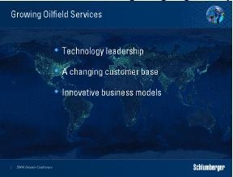

There are three opportunities for growth—in technology, in the changes in our customer base and in new business models. They all offer a compelling story for growth but more importantly, their combination constitutes a unique opportunity for Schlumberger.

13 of 31

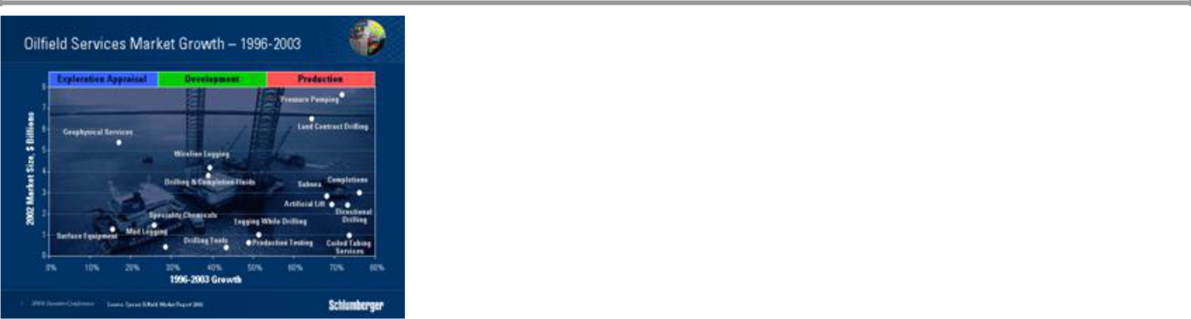

First technology. This chart, based on Spear’s data, plots total market size for individual services against revenue growth rate over the period 1996 to 2003. Each dot represents a service, and they fall into three groups. The highest growth rates over the period are for services that increase production and recovery, next come services for developing new fields, while the lowest growth is for exploration services.

While the growth rates for pressure pumping, coiled tubing services, artificial lift, and production testing all reflect the need to maintain production from existing fields, I’m sure you realize that there will be a new wave of exploration activity in the future that will also need access to new technology.
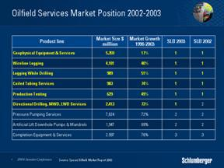

The Schlumberger position in markets in which we participate is strong. Schlumberger has a record of building technology leaders through innovation, organic growth and through appropriate acquisitions. You have seen us do this in Drilling & Measurements – a success story that began in 1977 with the purchase of The Analysts – and you have seen us do it with Schlumberger Information Solutions – a development that began with the purchase of GeoQuest in 1992.

14 of 31

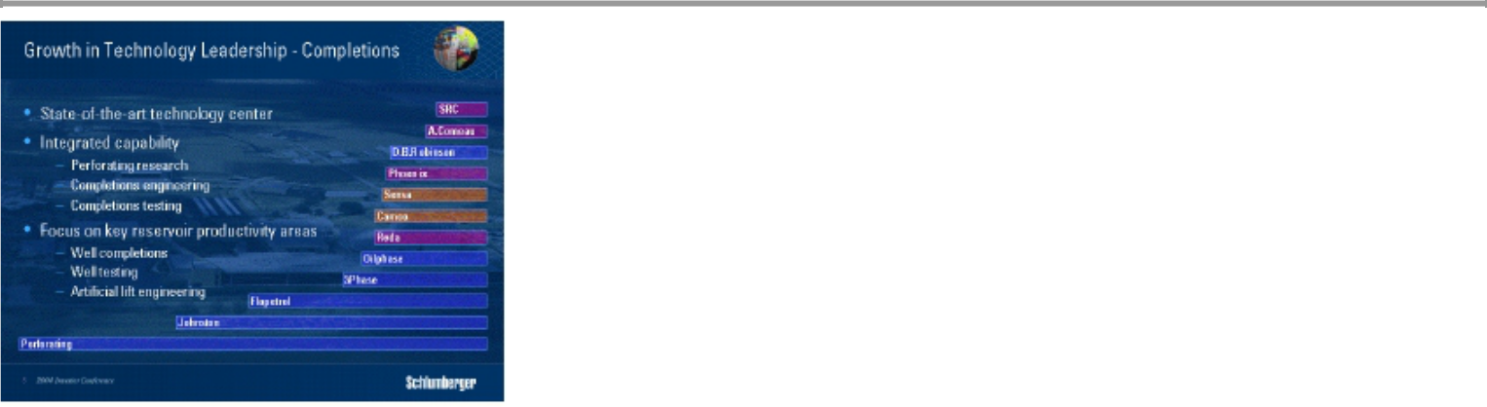

Now we are doing it with Well Completions and Productivity or WCP.

Two months ago, we completed a new development phase of the Reservoir Completions Center in Rosharon, Texas.

This state of the art facility house the industry’s most advanced perforating research laboratory. It offers the ability to engineer the complex completions that are becoming the norm in many new markets. And it can test and simulate the deployment of a fully integrated completion system prior to shipping anywhere in the world.

These capabilities have already allowed us to penetrate new markets. For example, we are currently testing a full completions system for a project that was awarded to us a few months ago by a major customer in West Africa.
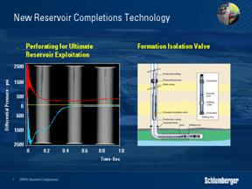

I would just like to mention two examples of products that have been developed by this expanding technology center.

PURE, is the latest Schlumberger perforating breakthrough. Clean perforations that mean better well performance result from a pressure underbalance in the well. PURE creates this underbalance dynamically during the perforating operations itself. More than 100 successful tests have been performed so far, with remarkable market uptake.

15 of 31

The FIV, or Formation Isolation Valve is a technique that protects the formation during perforating of high-profile deepwater HPHT wells. It is the result of a specific request to Schlumberger by BP and has now become the tool of choice in more than 90% of recent applications of this type around the world, and specifically in Brazil, the Gulf of Mexico and West Africa.

Ladies and Gentlemen, our determination in becoming an industry “Completion” leader is very strong and we are focused on ensuring that we will succeed.
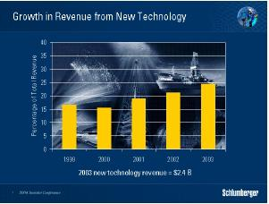

Among other things, the value of new technology lies in the revenue and commanding premium it generates. One metric we use tracks new technology as a percentage of our revenue over the preceding five-year period. This also serves as an indicator on market uptake. As you can see, new technology revenues have been increasing steadily over the past five years to reach an amazing 2.4 Billions per year in 2003.

These figures explain why we have always believed that commitment to R&D is fundamental to continuing growth and leadership in our industry.
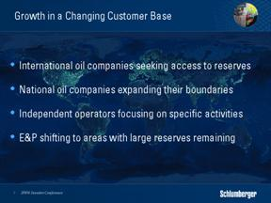

Let me now talk to you about our second opportunity. Our client base continues to evolve and consists today of 3 main categories.

16 of 31

International oil companies who are seeking access to worldwide reserves.

National oil companies who are expanding outside their natural boundaries, be they technical or geographical.

A new wave of independent operators is focusing on very specific activities such as the rehabilitation of mature producing assets.

The E&P business is shifting more and more to those areas of the world that contain the remaining large reserves.

These changes are of fundamental importance for Schlumberger. Today, of the top 25 upstream companies ranked by production capacity, no less than 17 are owned by governments or are in Russia.
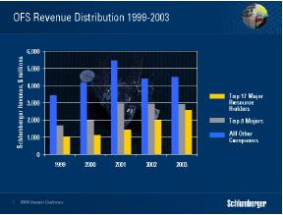

This evolution explains why we observe a steady increase in revenue that we receive from the major resource holders. Clearly, the opportunities of the future are tied to these changes and this implies a need for global geographic strength coupled with local knowledge and expertise

International oil companies have the freedom to manage their portfolio by selling, acquiring or outsourcing. Major resource holders are focused on the management of their assets over their lifetime. They seek new ways of working with technology providers such as Schlumberger.

The markets of Russia, Mexico, Latin America and Asia are clear examples of this trend. These markets represent a combination of three critical factors – dominant major resource holders, mature reservoirs, and the need for step changes in production and well construction practices.

17 of 31

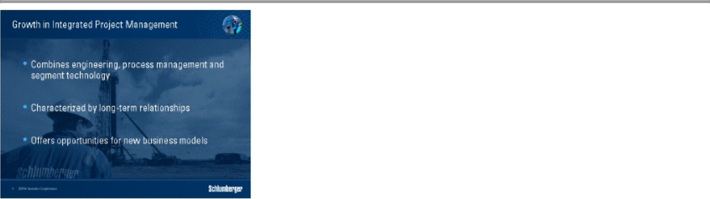

Integrated Project Management represents the third growth opportunity for Schlumberger. I would like to explain how this service is structured, and why we believe it offers prospects for accelerating growth. It is important to understand that IPM offers a combination of engineering, process management and understanding of Schlumberger segment technologies. IPM activity is characterized by long-term relationships between the customer and Schlumberger. It also offers scope for new working relationships with customers that offer innovative ways to capture the value inherent to technology.

Nowhere is this more evident of course than in our activity in Mexico, where the Burgos gas well construction project is now in its seventh year with clear benefits in the field performance and where the Chicontepec project has already outperformed our original targets in term of drilling efficiency and well production.

In his talk, Andrew introduced the opportunity we have in the Production area. The focus is on maximizing post-plateau production and ultimate recovery. Such an approach is very resource intensive and is often the reason why large companies are divesting such properties to smaller, more-specialized operators.

IPM is responding to this need by offering production management services.

Through production management work, we develop a thorough understanding of the field that lead to successful deployment of fit-or-purpose technology. This is an ideal scenario for Schlumberger to demonstrate and capture the value of single or combined technologies in integrated packages.

18 of 31

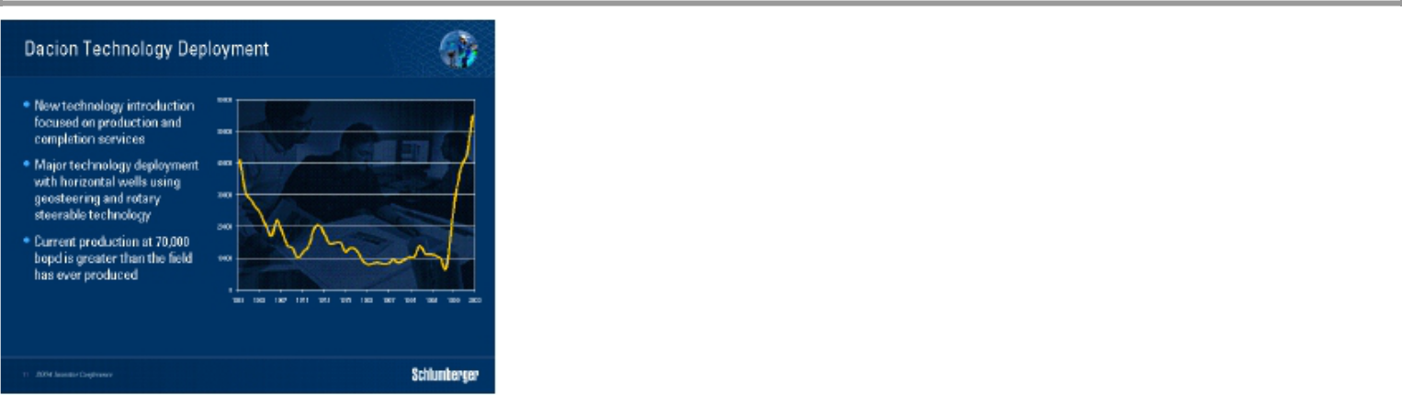

In the Dacion field in Venezuela, for example, Schlumberger has been managing operations for the past six years. We have deployed critical technologies in well construction and reservoir production. These have resulted in an amazing new level of peak production that exceeds that achieved during the field’s previous 30-year history.

The shift towards production services and production management work also offer opportunities for innovative commercial terms. With the deployment of focused fit-for-purpose technology, we are able to risk services to the limit of their commercial value. The return comes from any increase in production above and beyond an agreed base case.
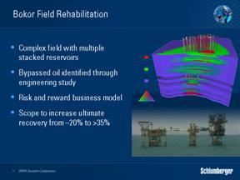

In Malaysia, the Bokor field is another excellent example. Last year we signed an alliance agreement with the major resource holder, PETRONAS Carigali, to redevelop this complex field, which had been on production for more than 20 years. Production had dropped significantly over that time and the project is seeking to increase production and ultimate recovery through a combination of data analysis, technology selection and subsequent technology deployment.

Schlumberger conducted an up front commercial detailed engineering study to assess the viability of the project.

19 of 31

Schlumberger also committed to commercial terms that discounted service pricing when production failed to reach agreed levels, but rewarded production improvement above the base case up to an agreed cap.

For all these projects it is important to note that our aim is to ensure these new business models all yield superior returns when compared to the standard relationships in our GeoMarkets.
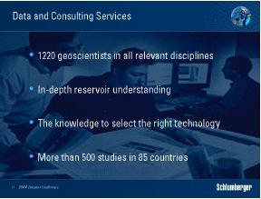

But projects like Bokor also draw on another key Schlumberger advantage – that of the Data and Consulting Services organization. We could not have executed the front-end engineering study in Bokor without the expertise of this business segment.

This organization of more than 1200 experts worldwide is significant in that it constitutes one of the largest Geoscientist communities in the industry. DCS professionals are focused on understanding reservoirs problems. Their understanding of Schlumberger technology portfolio allows them to identify the best solutions for candidate wells or fields in a production management. We will be showing you this afternoon the process by which DCS teams select candidate wells and how they make their technology choices. This will set the scene for the technologies that we will be demonstrating afterwards.
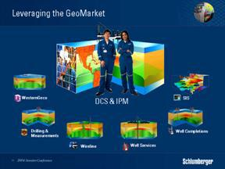

20 of 31

We are able to work in this way because of a few basic concepts that governs the GeoMarket organization. The GeoMarket is the strategic point of contact with the customer. It provides the perfect environment for IPM & DCS to leverage on the strength of all technology segments. It’s really about understanding locally our client’s problems and being able to deliver.

It’s important to realize that that 90% of the personnel in a GeoMarket are specialists in their own particular technology segment be that Wireline, Well Services and so on. The remaining personnel represent common infrastructure shared between the segments and result in a lower total cost of operations for Schlumberger.
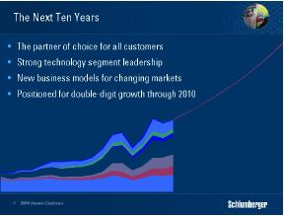

To summarize then, Schlumberger Oilfield Services is structured to be the partner of choice for all customers no matter how they choose to operate.

We are committed to developing strong technology segment leaders. We offer our customers the capability to combine these into an integrated package when appropriate. We have a strong understanding of the reservoir and we are capable to deploy technologies with unmatched efficiency. We see no other way of developing this capability than through the GeoMarket organization as proven by our success in Mexico and Russia.

Satish Pai and his colleagues will demonstrate to you later that we are extremely focused on the execution of technology development, deployment and service delivery. We also intend to maximize our returns through smart technology introduction and commensurate pricing.

Finally, and on the basis of our current segments portfolio, Schlumberger Oilfield Services has delivered a compound annual growth rate of 10.6 percent over the past ten years. 80% of it has come from organic growth and the remainder from acquisitions.

Given all you have heard so far, rest assured that we are committed to exceeding this performance in the coming decade.

21 of 31

WesternGeco – Dalton Boutte
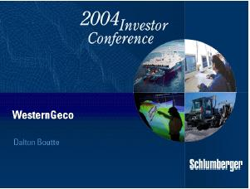

“Creating value for our customers has not proven difficult for WesternGeco over the past few years. The challenge has been to retain a fair portion of that value . .

. . .

Good morning, Ladies & Gentlemen, my name is Dalton Boutte, and I’m going to tell you about our response to that challenge.”

I’ll do this within the context of the four business lines of WesternGeco – that is, multi-client sales, land and marine acquisition, and data processing – all of which includes Q technology. I will also give you a summary of our Q results through the second quarter and what we anticipate for the remainder of 2004. We’ll first cover the changing multi-client business, focusing on our investments and the current library, as well as what you should expect to see from WesternGeco in the coming quarters.
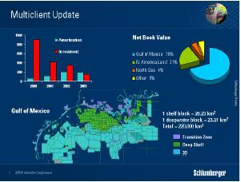

The multi-client library has been one of the biggest challenges that we’ve faced over the past few years. The burden of managing its growing amortization when the overall business was declining brought us to this conclusion that the business model had to change. In short, the model had to transition from a model centered on high-risk,

22 of 31

speculative surveys to a model that is increasingly dominated by custom designed surveys aimed at specific reservoirs. The most valuable lesson learned from the impairment charges was that a business model that works in the Gulf of Mexico couldn’t easily be exported to other parts of the world without serious repercussions.

Currently, over 70% of the remaining net book value of our multi-client library is in the Gulf of Mexico, where block size, block turnover and a large interested client base combine to make the multi-client model work well. Our total coverage of the Gulf of Mexico includes some 220,000 square kilometres of contiguous data located on the continental shelf, in the deep water and in the transition zones. These surveys, particularly those on the continental shelf and in the transition zone, offer significant value, because many of these areas would be difficult to survey today due to platform structures, permitting problems, or both.

Since the impairments, we have constrained our investments in new multi-client acquisitions and focused on providing “value-added” advanced data processing and reservoir enhancements to existing surveys. This was one of the reasons for our strong multi-client sales in the last quarter of 2003 and the first quarter of 2004. We have, of course, been helped by the renewed interest in the Gulf of Mexico primarily from US based independents.

What does this mean for the future of our multi-client business? It means that we will remain disciplined in our investments in multi-client, focusing first on value-added enhancements such as depth imaging that can be applied to existing surveys. We will continue to seek opportunities for multi-client acquisitions, but with a stringent focus on the balance between risk and reward, and focused on groups of clients who will significantly pre-fund surveys in order to have access to the latest technology. A good example of this is a survey that we are acquiring today in the Gulf of Mexico that is more than 90% pre-funded and will bring a more equitable return to WesternGeco.
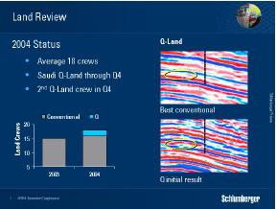

Moving on to our land acquisition business, which until recently has been centered on reductions to the cost base or eliminating operations in non-profitable markets such as US land. These actions led us to an average crew count of around 15 for 2003, significantly below the 34 active crews that we employed in 2001. Our current goal is to average 18

23 of 31

crews throughout 2004, and today we have 19 crews working around the world – almost half of them in the Middle East. The recent award of long- term contracts for three crews for a Shell consortium in Saudi Arabia and two crews in Sudan makes this a very achievable target. We are also on target for significant expansion in Russia fuelled by the acquisition of PetroAlliance, which will ultimately add at least 5 active crews in that region.

In March we completed the first Q-Land survey in the Minigish field in Kuwait. The main objective of this survey was to record higher frequencies at the reservoir level, which translates into better resolution and of course better definition of reserves. As you can see from the seismic section on the top right, where red and blue represent different formations, and white signifies “no data”, the reservoir is simply not definable with conventional 3D. However, on the section below, with only preliminary Q processing, you can clearly see an event that in this case, is the reservoir.

We are encouraged by these early results, which show significant improvements in resolution. We will show other examples of Q-Land data in the afternoon session. The Q-Land contract recently signed with Saudi Aramco guarantees the backlog of the first Q-Land crew through the end of 2004, and builds on the excitement surrounding Q-Land. We have scheduled a second Q-Land crew to be deployed in the fourth quarter and plan further deployments in 2005, based, of course, on customer demand.

Our focus will continue to be on providing enhanced, cost-effective solutions that help our customers throughout the asset management cycle. This is particularly important in areas of complex imaging and reservoir problems. This depth of expertise adds value to our customers’ results as well as the results of WesternGeco.
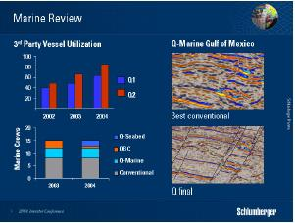

In Marine, we have reduced the fleet from 27 vessels at the time of the merger to the current size of twelve 3D vessels, plus 3 ocean bottom cable or OBC crews.

Eight of the 3D vessels are equipped with conventional streamers and 4 with Q-Marine. We don’t plan any further reduction of the fleet.

24 of 31

Through May, our total fleet utilization was 73% versus 66% at the same time last year. As the backlog continues to grow, we are optimistic about the vessel utilization through the remainder of 2004. By the end of June, we will be at 100% utilization of the Q vessels on proprietary surveys for the first time – and we expect a high level of utilization for the Q vessels to continue for the rest of the year. We will carefully monitor client demand in order to determine when to convert additional vessels to Q-Technology.

Since its deployment in 2001, Q-Marine has provided value to our customers in two very distinct ways. First, because of its calibrated source, enhanced fidelity and digitally recorded single sensor data, we are able to provide a frequency response with Q that is typically 40% greater than with conventional 3D seismic.

In this example, the data shown on the top right is a conventional 3D section from the Gulf of Mexico. Below that is a Q section over the same reservoir, on the same scale. The difference is clear, even to the casual observer. This enhanced frequency translates into higher resolution and thus a clearer definition of the reservoir, giving our customers a far superior estimate of reserves.

The second benefit to our customers comes from the steerable streamers that guarantee better repeatability. This also allows us to come much closer to offshore structures avoiding expensive and time-consuming under- shooting. The enhanced fidelity coupled with steerable streamers give us an excellent advantage in the growing time-lapse or 4D market.

Q is not the only technology for conducting 4D surveys. However, with conventional technology, it typically takes at least two years before the 4D signal is strong enough to show a measurable amplitude difference that can be used in interpretation.
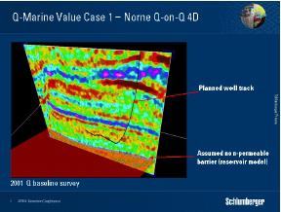

The unique benefits of Q-Technology are best illustrated through two examples. In 2003 Statoil was preparing to drill a horizontal well into the producing Norne field offshore Norway. Geological maps of this field assumed a non-permeable barrier, as indicated here. In order to ensure that there were no surprises in the drilling program, Statoil conducted a second 3D Q survey over Norne, and subtracted the two to determine if a 4D signature could be seen after only 21 months. The result not only confirmed a signature,

25 of 31

but also confirmed that the oil / water contact had risen by 9 meters! That would have put the new well dangerously close to the water contact and would have resulted in early water encroachment and eventually early abandonment.

Here is the revised drilling plan based on the Q data. Statoil waited for these results before finalizing their plan, and today they are producing water-free oil. Equally impressive was the fact that the preliminary results were available to Statoil within 11 days of acquisition. So, in this example, it’s easy to see where the value lies for Statoil. For WesternGeco, the value is in the establishment of a long-term relationship with repeat business and with a company at the leading edge of 4D interpretation.
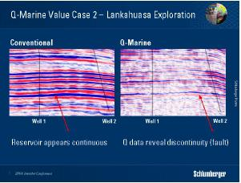

An even more compelling example of value creation is the example of Lankahuasa on the Mexican side of the Gulf of Mexico. Well number 1 was drilled, and resulted in a discovery, which according to conventional 3D, was believed to contain significant reserves. The first offset, Well 2, was drilled on what appeared to be the same structure, but it turned out dry. Pemex was in the process of drilling the second offset when they commissioned WesternGeco to do a Q pilot test.

26 of 31

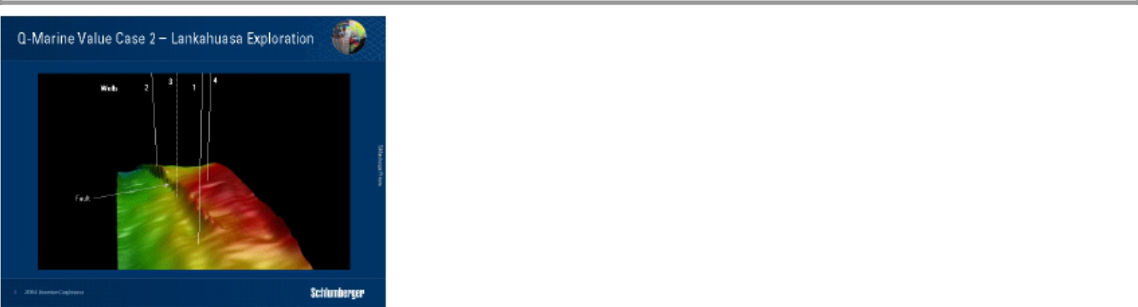

The resultant Q survey showed events that weren’t seen on the previous conventional surveys, including a fault that would have intersected Well 3. Based on this, Pemex re-positioned Well 3 to the position shown as Well 4, which is up dip to the original discovery, but on the same structure -- and that well proved to be commercial. The value of Q to Pemex is quite obvious as it is leading to a more efficient field development plan, which would have been difficult without the higher resolution of Q. The value for WesternGeco will be realized through a long-term relationship requiring acquisition, processing and interpretation in Mexico.

These are indeed compelling illustrations of the value that Q provides our customers. There are cases, however where Q in the towed marine configuration cannot provide information that would enable our customers to make decisions about their field. It is for this reason that Q – Seabed was developed – that is, to provide high fidelity multi-component information when events such as a gas cloud or gas chimneys render towed streamer data inadequate. The Q – Seabed system uses the best available fidelity, ocean- bottom coupling, and is rated to 1500 meters of water.

The first commercial system is scheduled for deployment in the third quarter of this year, and based on the success of our beta testing; we plan to deploy a second system in the fourth quarter. One example that you will see in the afternoon session is from the Mediterranean, where a gas chimney between two discoveries rendered field development and reserves estimates, virtually impossible without a tool such as Q seabed.

27 of 31

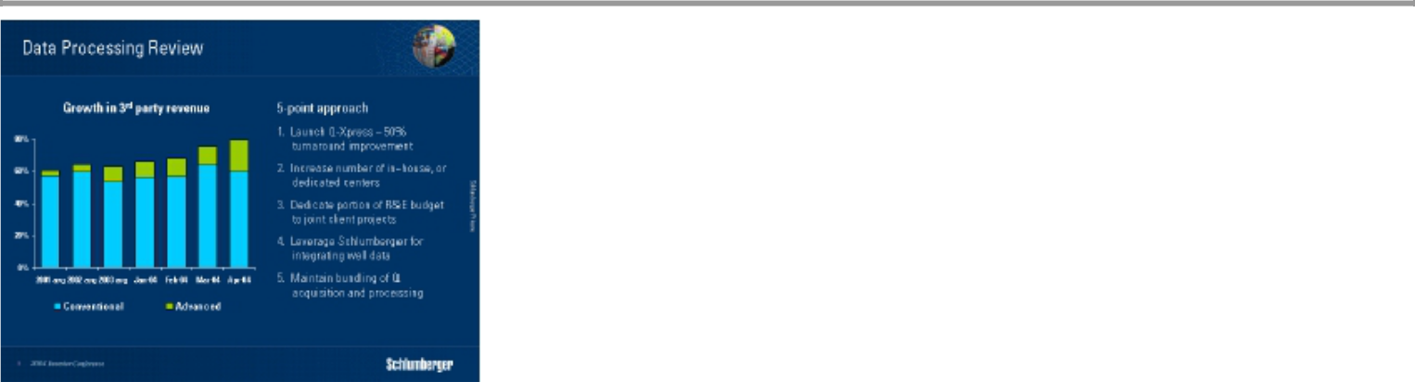

Now, lets shift our focus to the data processing business, where we have seen the largest increase in competition due to the low entry barriers and, up to now, little differentiation. The problem for WesternGeco was amplified by the reduction in multi-client investment, which was a captive market for our Data Processing business line. Our challenge now is to grow the 3rd party revenues as the multi-client revenues are reduced.

In order to offset this decline and to position WesternGeco’s data processing business at a strategic advantage, we adopted a five-pronged approach. First, we launched the Q – Xpress project aimed at significantly improving the turn-around time of our products to our customers. One result was the 4D Norne survey that you have seen, where the preliminary results were delivered in just 11 days. While initially focused on Q, these improvements can be applied to conventional processing as well.

The second approach was to increase the number of in-house or dedicated DP centers. These centers reside in clients’ offices and provide valuable insights into our customers’ objectives and challenges. A recent award in Moscow is a step in this direction.

The third approach is to dedicate a portion of the Data Processing R&E budget to joint client projects. We have signed an agreement with one of the super-majors and have two other agreements in progress.

Fourthly, we have leveraged the strengths of Schlumberger to integrate well data at all stages in the processing sequence. Some of these joint projects with Schlumberger will be covered in the afternoon session.

Finally, we have maintained the bundling of Q acquisition and processing, ensuring that as Q continues to gain traction, the processing revenues will grow as quickly as the acquisition revenues.

With this 5-part approach in place, I am confident that our data processing revenues will continue to grow despite increasing competition.

28 of 31

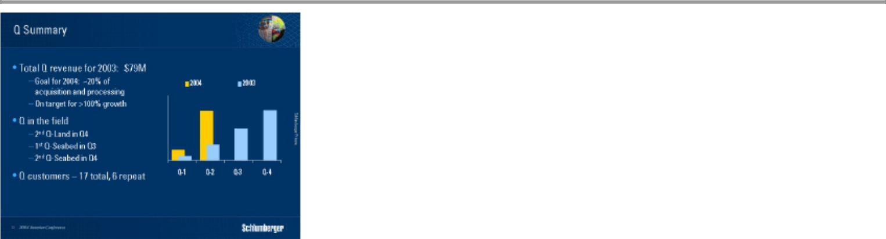

Now, I would like to make a few comments on the general progress of Q thus far. In 2003 we generated just under $80M in Q revenues and are on target to more than double this amount in 2004. If we succeed at this, Q revenues will approach 20% of our total acquisition and processing revenues, which is in line with Schlumberger’s expectations for returns on Q technology. We will accomplish this while maintaining a significant pricing premium over conventional 3D. The launch of the second Q-Land crew coupled with two Q-Seabed crews in the second half of 2004 give us every reason to believe we will exceed this target.

We are as encouraged by the repeat business for Q with customers such as Pemex and Statoil who are using Q for multiple surveys in 2004. We are also excited about our new Q customers, which include Hydro, Danish Oil and Natural Gas Company, and Amerada Hess just to mention a few. Our major focus remains on securing long-term commitments for the Q vessels, and long termed land contracts.
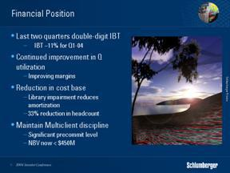

Q revenues are undoubtedly beginning to have a positive impact on our financial position. The 2003 impairment, the overall reduction in our cost base including a 33% reduction in headcount, and strong multi-client sales have also positively influenced the 11% income before tax, achieved in the first quarter of 2004. Differentiation is the key to continued success as our customers move to more custom designed surveys aimed at improving reserves estimates and recovery through enhanced technology.

29 of 31

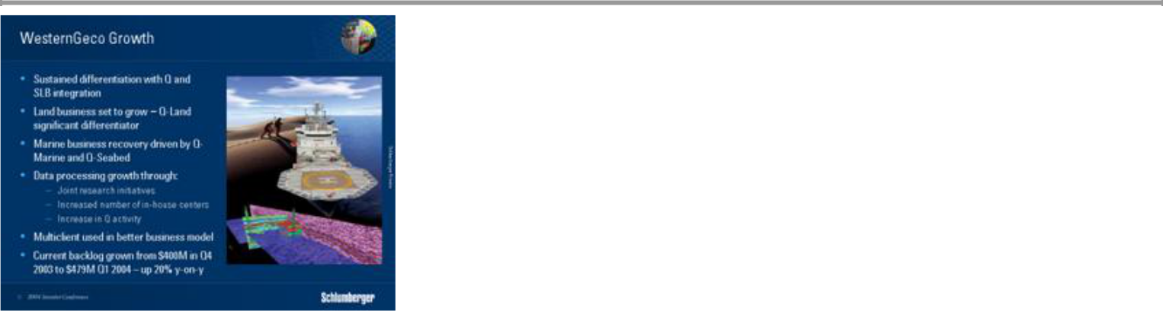

In summary, I am happy to have had the opportunity today to share my optimism about the future of WesternGeco. Our land acquisition business is poised to grow due to recent contracts in Saudi and Sudan, as well as increased Q-Land projects. The marine business will grow primarily through a greater use of Q-Marine and the introduction of Q-Seabed. The processing business will see growth primarily based on joint research initiatives, an increase in the number of in-house centers, and through an increase in Q activity. Multi-client surveys will be a tool used as originally intended – to provide customer groups access to the latest in technology while providing a more equitable distribution of the value to WesternGeco.

Our current backlog has grown from $400 million in the fourth quarter of 2003 to $479 million in the first quarter of 2004, and we expect further growth in the coming quarter. This, coupled with the overall increase in global exploration activity, and our position with Q in the reservoir, gives us cause for optimism regarding our future.
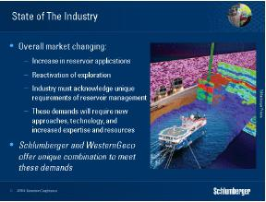

I would like to close with a few general comments about the seismic industry and the bigger picture. We expect to see reservoir applications grow over the next few years, but success will depend upon the industry recognizing that reservoir seismic is fundamentally different from exploration 3D. It requires attention to detail, but we must also acknowledge that exploration cycle times are not appropriate for reservoir management, where reservoir engineers and asset managers must make business decisions by the clock

30 of 31

and not the calendar. These conflicting demands will require new approaches, new technology, and an overall increase in expertise and resources.

The success stories in the coming years will be those energy companies that harness seismic measurements in new ways to add value to their business. For this, WesternGeco with Q, and Schlumberger with its workflows and tools, provides a uniquely valuable combination, which will drive both immediate business growth and future technical developments.

Ladies and gentlemen, I am confident about the future of the seismic business and based on the progress that we have made so far, I am even more confident about the future of WesternGeco.

31 of 31

