UNITED STATES

SECURITIES AND EXCHANGE COMMISSION
Washington, D.C. 20549

FORM 8-K

CURRENT REPORT

Pursuant to Section 13 or 15(d)
of the Securities Exchange Act of 1934

Date of Report (Date of earliest event reported): October 17, 2025

SLB N.V. (SLB LIMITED)

(Exact name of registrant as specified in its charter)

Curaçao

1-4601

52-0684746

(State or other jurisdiction
of incorporation)

(Commission
File Number)

(IRS Employer
Identification No.)

42 rue Saint-Dominique, Paris, France 75007

5599 San Felipe, Houston, Texas, U.S.A. 77056
62 Buckingham Gate, London, United Kingdom SW1E 6AJ

Parkstraat 83, The Hague, The Netherlands 2514 JG

(Addresses of principal executive offices and zip or postal codes)

Registrant’s telephone number in the United States, including area code: (713) 513-2000

Check the appropriate box below if the Form 8-K filing is intended to simultaneously satisfy the filing obligation of the registrant under any of the following provisions (see General Instruction A.2. below):

- Written communications pursuant to Rule 425 under the Securities Act (17 CFR 230.425)

- Soliciting material pursuant to Rule 14a-12 under the Exchange Act (17 CFR 240.14a-12)

- Pre-commencement communications pursuant to Rule 14d-2(b) under the Exchange Act (17 CFR 240.14d-2(b))

- Pre-commencement communications pursuant to Rule 13e-4(c) under the Exchange Act (17 CFR 240.13e-4(c))

Securities registered pursuant to Section 12(b) of the Act:

 |  | Trading |  | Name of each exchange
Title of each class |  | Symbol(s) |  | on which registered
common stock, par value $0.01 per share |  | SLB |  | New York Stock Exchange

Indicate by check mark whether the registrant is an emerging growth company as defined in Rule 405 of the Securities Act of 1933 (§230.405 of this chapter) or Rule 12b-2 of the Securities Exchange Act of 1934 (§240.12b-2 of this chapter).

Emerging growth company ☐

If an emerging growth company, indicate by check mark if the registrant has elected not to use the extended transition period for complying with any new or revised financial accounting standards provided pursuant to Section 13(a) of the Exchange Act. ☐

Item 2.02 Results of Operations and Financial Condition.

The Third-Quarter 2025 Earnings Release and Supplemental Unaudited Pro Forma Historical Consolidated Financial Information

furnished as Exhibit 99 hereto, which is incorporated by reference into this Item 2.02, was posted on the SLB internet website
(https://investorcenter.slb.com/financials/quarterly-results) on October 17, 2025. In accordance with General Instructions B.2. of Form 8-K,

the information will not be deemed “filed” for purposes of Section 18 of the Securities Exchange Act of 1934, as amended (the “Exchange
Act”), nor will it be deemed incorporated by reference in any filing under the Securities Act of 1933, as amended (the “Securities Act”),

except as expressly set forth by specific reference in such a filing.

Item 7.01 Regulation FD Disclosure.

On October 17, 2025, SLB issued a press release, a copy of which is furnished with this Form 8-K as Exhibit 99 and incorporated into this Item 7.01 by reference. In accordance with General Instruction B.2. of Form 8-K, the information will not be deemed “filed” for purposes of Section 18 of the Exchange Act, nor will it be deemed incorporated by reference in any filing under the Securities Act, except as expressly set forth by specific reference in such a filing.

Also, see Item 2.02, “Results of Operations and Financial Condition.”

Item 9.01 Financial Statements and Exhibits.

- Exhibits

The exhibit listed below is furnished pursuant to Item 9.01 of this Form 8-K.

- 99 Third-Quarter 2025 Earnings Release and Supplemental Unaudited Pro Forma Historical Consolidated Financial Information. 104 Cover Page Interactive Data File (embedded within the Inline XBRL document).

SIGNATURES

Pursuant to the requirements of the Securities Exchange Act of 1934, the Registrant has duly caused this report to be signed on its behalf by the undersigned hereunto duly authorized.

SLB LIMITED

/s/ Howard Guild

Howard Guild

Chief Accounting Officer

Date: October 17, 2025

Exhibit 99

News Release
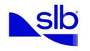

SLB Announces Third-Quarter 2025 Results

- Revenue of $8.93 billion increased 4% sequentially and decreased 3% year on year

- GAAP EPS of $0.50 decreased 32% sequentially and 40% year on year

- EPS, excluding charges and credits, of $0.69 decreased 7% sequentially and 22% year on year

- Net income attributable to SLB of $739 million decreased 27% sequentially and 38% year on year

- Adjusted EBITDA of $2.06 billion was flat sequentially and decreased 12% year on year

- Cash flow from operations was $1.68 billion and free cash flow was $1.10 billion, including $153 million of acquisition-related payments

- Board approved quarterly cash dividend of $0.285 per share

HOUSTON, October 17, 2025 — SLB (NYSE: SLB) today announced results for the third-quarter 2025.

Third-Quarter Results

 |  |  |  |  |  |  |  |  |  |  |  |  |  | (Stated in millions, except per share amounts)
 |  |  |  |  | Three Months Ended |  |  |  |  |  |  |  |  |  | Change
 |  | Sept. 30, |  |  |  |  | Jun. 30, |  |  |  | Sept. 30,
 |  |  | 2025 |  |  |  |  | 2025 |  |  |  | 2024 |  | Sequential |  | Year-on-year
Revenue |  | $ | 8,928 |  |  |  | $ | 8,546 |  |  | $ | 9,159 |  | 4% |  | -3%
Income before taxes - GAAP basis | $ |  | 1,000 |  |  | $ |  | 1,285 |  | $ |  | 1,507 |  | -22% |  | -34%
Income before taxes margin - GAAP basis |  |  | 11.2% |  |  |  |  | 15.0% |  |  |  | 16.5% |  | -383 bps |  | -525 bps
Net income attributable to SLB - GAAP basis | $ |  | 739 |  |  | $ |  | 1,014 |  | $ |  | 1,186 |  | -27% |  | -38%
Diluted EPS - GAAP basis | $ |  | 0.50 |  |  | $ |  | 0.74 |  | $ |  | 0.83 |  | -32% |  | -40%
Adjusted EBITDA* | $ |  | 2,061 |  |  | $ |  | 2,051 |  | $ |  | 2,343 |  | 0% |  | -12%
Adjusted EBITDA margin* |  |  | 23.1% |  |  |  |  | 24.0% |  |  |  | 25.6% |  | -92 bps |  | -249 bps
Pretax segment operating income* | $ |  | 1,626 |  |  | $ |  | 1,584 |  | $ |  | 1,902 |  | 3% |  | -14%
Pretax segment operating margin* |  |  | 18.2% |  |  |  |  | 18.5% |  |  |  | 20.8% |  | -32 bps |  | -255 bps
Net income attributable to SLB, excluding
charges & credits* | $ |  | 1,027 |  |  | $ |  | 1,016 |  | $ |  | 1,271 |  | 1% |  | -19%
Diluted EPS, excluding charges & credits* | $ |  | 0.69 |  |  | $ |  | 0.74 |  | $ |  | 0.89 |  | -7% |  | -22%
Revenue by Geography
International | $ |  | 6,916 |  |  | $ |  | 6,847 |  | $ |  | 7,425 |  | 1% |  | -7%
North America |  |  | 1,930 |  |  |  |  | 1,655 |  |  |  | 1,687 |  | 17% |  | 14%
Other |  |  | 82 |  |  |  |  | 44 |  |  |  | 47 |  | n/m |  | n/m
 | $ |  | 8,928 |  |  | $ |  | 8,546 |  | $ |  | 9,159 |  | 4% |  | -3%

SLB acquired ChampionX during the third quarter of 2025. Third-quarter 2025 results reflect two months of activity from the acquired ChampionX businesses, which contributed $579 million of revenue, $139 million of adjusted EBITDA and $108 million of pretax segment operating income. Excluding the impact of this acquisition, SLB’s third-quarter 2025 global revenue decreased 2% sequentially and 9% year on year; international third-quarter 2025 revenue decreased 1% sequentially and 9% year on year; and North America third-quarter 2025 revenue decreased 7% sequentially and 9% year on year.

- These are non-GAAP financial measures. See sections titled “Charges & Credits”, “Divisions” and “Supplementary Information” for details.

n/m = not meaningful

Revenue by Division

Digital

Reservoir Performance

Well Construction

Production Systems

All Other

Eliminations

Pretax segment operating income

Digital

Reservoir Performance

Well Construction

Production Systems

All Other

Eliminations

Pretax segment operating margin

Digital

Reservoir Performance

Well Construction

Production Systems

All Other

Eliminations

 |  |  |  |  |  |  |  |  |  |  | (Stated in millions)
 | Three Months Ended |  |  |  |  |  |  |  |  | Change
Sept. 30, |  |  |  | Jun. 30, |  |  | Sept. 30,
 | 2025 |  |  |  | 2025 |  |  | 2024 |  | Sequential |  | Year-on-year
$ | 658 |  |  | $ | 591 |  | $ | 638 |  | 11% |  | 3%
 | 1,682 |  |  |  | 1,691 |  |  | 1,823 |  | -1% |  | -8%
 | 2,967 |  |  |  | 2,963 |  |  | 3,312 |  | 0% |  | -10%
 | 3,474 |  |  |  | 2,932 |  |  | 3,037 |  | 18% |  | 14%
 | 397 |  |  |  | 583 |  |  | 554 |  | -32% |  | -28%
 | (250) |  |  |  | (214) |  |  | (205) |  | n/m |  | n/m
$ | 8,928 |  |  | $ | 8,546 |  | $ | 9,159 |  | 4% |  | -3%
$ | 187 |  |  | $ | 153 |  | $ | 190 |  | 22% |  | -2%
 | 312 |  |  |  | 314 |  |  | 367 |  | -1% |  | -15%
 | 558 |  |  |  | 551 |  |  | 714 |  | 1% |  | -22%
 | 559 |  |  |  | 491 |  |  | 518 |  | 14% |  | 8%
 | 96 |  |  |  | 155 |  |  | 188 |  | -38% |  | -49%
 | (86) |  |  |  | (80) |  |  | (75) |  | n/m |  | n/m
$ | 1,626 |  |  | $ | 1,584 |  | $ | 1,902 |  | 3% |  | -14%
 | 28.4% |  |  |  | 25.9% |  |  | 29.8% |  | 250 bps |  | -135 bps
 | 18.5% |  |  |  | 18.6% |  |  | 20.1% |  | -7 bps |  | -159 bps
 | 18.8% |  |  |  | 18.6% |  |  | 21.5% |  | 22 bps |  | -273 bps
 | 16.1% |  |  |  | 16.7% |  |  | 17.1% |  | -66 bps |  | -98 bps
 | 24.2% |  |  |  | 26.7% |  |  | 34.0% |  | -244 bps |  | -975 bps
 | n/m |  |  |  | n/m |  |  | n/m |  | n/m |  | n/m
 | 18.2% |  |  |  | 18.5% |  |  | 20.8% |  | -32 bps |  | -255 bps

Digital and Production Systems third-quarter 2025 results reflect two months of activity from ChampionX, which contributed $20 million of Digital revenue and $575 million of Production Systems revenue. Excluding the impact of this acquisition, Digital third-quarter 2025 revenue increased 8% sequentially and was flat year on year, while Production Systems revenue decreased 1% sequentially and 5% year on year.

Commencing in the third quarter of 2025, SLB began reporting its Digital business as a standalone Division and its Asset Performance Solutions (APS), Data Center Solutions and SLB Capturi businesses in the All Other category. Prior periods have been recast to conform to the current period presentation.

n/m = not meaningful

Resilience Amidst Evolving Market Dynamics

“The third quarter played out in line with our expectations as our revenue increased sequentially supported by two months’ additional ChampionX revenue, further growth in Digital and the resilient performance of our Core business. SLB improved revenue despite the backdrop of a fully supplied oil market, an uncertain geopolitical environment and subdued commodity prices.

“In this context, international markets — while facing challenges in some regions — are demonstrating resilience, with several countries across the Middle East and Asia continuing to show robust growth. Looking ahead, we expect OPEC+ production releases to support investment across many countries where SLB is well established,” said SLB Chief Executive Officer Olivier Le Peuch.

Production and Recovery Business Aligned to Enable Customers’ Changing Priorities

“As industry economics tighten, customers are increasingly prioritizing production and recovery solutions to offset decline by unlocking incremental barrels at the lowest possible cost. At the same time, they continue to accelerate the most critical FIDs and execute in-flight development projects.

“SLB has a differentiated opportunity to support customers on this journey — leveraging our subsurface expertise, production technology, portfolio integration and digital/AI capabilities — to unlock new value for mature assets and consequently expand our addressable market.

“ChampionX enhances our portfolio and underscores the value of expanding our presence in the less cyclical production market.

“I am confident in the position we are taking in the production and recovery market, and I look forward to deepening our collaboration with our customers to unlock more barrels. I am also excited by the progress we have made integrating the ChampionX team into SLB, and I am thankful for their performance and contribution this quarter,” said Le Peuch.

Digital Delivering Differentiated Growth and Margins

“Digital continues to transform the oil and gas industry, and this has been our fastest-growing business in recent years. We have been on a long journey to digitize the oilfield — from modeling and planning to operations and automation — recognizing that digital transformation is essential for unlocking the highest levels of efficiency, safety and sustainability in prospect selection, reservoir management and hydrocarbon recovery.

“By leveraging software, AI, data analytics, automation and IoT, we are unlocking productivity for geoscientists and engineers, driving a step change in efficiency and safety in operations, and supporting our customers to deliver better wells and higher-producing assets. As such, SLB Digital solutions are increasingly mission critical for our customers to stay ahead on innovation, efficiency and AI deployment.

“We are reporting Digital as a standalone division for the first time and are sharing details of the four revenue categories where SLB offers solutions for our customers: Platforms & Applications, Digital Operations, Digital Exploration and Professional Services.

“Our Digital business delivered revenue growth both sequentially and year on year. This high-margin and growing business is a true differentiator and reflects our industry leadership in this domain,” Le Peuch said.

International Markets to Lead Future Activity Rebound

“Looking ahead, it is more likely that the international markets will lead an activity rebound when supply and demand rebalance, supported by sustained investment for oil capacity, gas expansion projects and a constructive outlook for deepwater. SLB is well positioned to benefit from such a recovery.

“In the near term, we foresee revenue growth in the fourth quarter driven by the international markets, Digital and a full quarter of activity from the acquired ChampionX businesses,” Le Peuch concluded.

Other Events

During the quarter, SLB repurchased 3.2 million shares of its common stock for a total purchase price of $114 million. For the first nine-months of 2025, SLB repurchased a total of 60.0 million shares of its common stock for a total purchase price of $2.41 billion.

On July 16, 2025, SLB completed its acquisition of ChampionX. The combined portfolio, technology capabilities and digital leadership will position SLB to create value for its customers and stakeholders by increasing its exposure to the growing production and recovery market while delivering best-in-class workflow integration across production chemicals and artificial lift.

On October 16, 2025, SLB’s Board of Directors approved a quarterly cash dividend of $0.285 per share of outstanding common stock, payable on January 8, 2026, to stockholders of record on December 3, 2025.

Third-Quarter Revenue by Geographical Area

Third-quarter revenue of $8.93 billion increased 4% sequentially with international revenue increasing 1% and North America revenue increasing 17%. This reflects two months of activity from the acquired ChampionX businesses, which contributed revenue of $579 million, consisting of $387 million in North America and $ 171 million in the international markets. Excluding the impact of this acquisition, international third-quarter 2025 revenue declined 1% and North America third-quarter 2025 revenue declined 7% sequentially. International revenue slightly decreased due to the production interruption on the APS project in Ecuador and North America revenue declined due to the divestiture of the APS project in Canada.

 |  |  |  |  |  |  |  |  |  | (Stated in millions)
As reported |  | Three Months Ended |  |  |  |  |  |  |  | Change
 |  | Sept. 30, |  |  | Jun. 30, |  | Sept. 30,
 |  | 2025 |  |  | 2025 |  | 2024 |  | Sequential |  | Year-on-year
North America |  | $ 1,930 |  |  | $1,655 |  | $ 1,687 |  | 17% |  | 14%
Latin America | 1,482 |  |  | 1,492 |  |  | 1,689 |  | -1% |  | -12%
Europe & Africa* | 2,434 |  |  | 2,369 |  |  | 2,434 |  | 3% |  | 0%
Middle East & Asia | 3,000 |  |  | 2,986 |  |  | 3,302 |  | 0% |  | -9%
Eliminations & other |  | 82 |  |  | 44 |  | 47 |  | n/m |  | n/m
 |  | $ 8,928 |  |  | $8,546 |  | $ 9,159 |  | 4% |  | -3%
International | $ 6,916 |  |  | $6,847 |  |  | $ 7,425 |  | 1% |  | -7%
North America | $ 1,930 |  |  | $1,655 |  |  | $ 1,687 |  | 17% |  | 14%

- Includes Russia and the Caspian region n/m = not meaningful
The following table and commentary are presented on a pro forma basis assuming that ChampionX was acquired on January 1, 2024.

 |  |  |  |  |  |  |  |  |  |  | (Stated in millions)
Pro forma |  | Three Months Ended |  |  |  |  |  |  |  |  | Change
 |  | Sept. 30, |  |  | Jun. 30, |  | Sept. 30,
 |  | 2025 |  |  | 2025 |  |  | 2024 |  | Sequential |  | Year-on-year
North America |  | $ 2,134 |  |  | $2,219 |  | $ | 2,240 |  | -4% |  | -5%
Latin America | 1,507 |  |  | 1,568 |  |  |  | 1,758 |  | -4% |  | -14%
Europe & Africa* | 2,462 |  |  | 2,456 |  |  |  | 2,535 |  | 0% |  | -3%
Middle East & Asia | 3,032 |  |  | 3,075 |  |  |  | 3,398 |  | -1% |  | -11%
Eliminations & other |  | 94 |  |  | 80 |  |  | 83 |  | n/m |  | n/m
 |  | $ 9,229 |  |  | $9,398 |  | $ | 10,014 |  | -2% |  | -8%
International | $ 7,001 |  |  | $7,099 |  |  | $ | 7,691 |  | -1% |  | -9%
North America | $ 2,134 |  |  | $2,219 |  |  | $ | 2,240 |  | -4% |  | -5%

- Includes Russia and the Caspian region n/m = not meaningful

International

Pro forma revenue in Latin America of $1.51 billion decreased 4% sequentially. Higher offshore drilling activity in Guyana was more than offset by reduced APS revenue due to production interruption arising from a pipeline disruption in Ecuador and lower drilling and fracturing activity in Argentina.

Year on year, pro forma revenue declined 14%, primarily due to a significant reduction in land drilling activity in Mexico and reduced APS revenue in Ecuador.

Europe & Africa pro forma revenue of $2.46 billion was flat sequentially with improved activity in Sub-Saharan Africa and offshore Scandinavia being offset by lower activity in Europe and North Africa.

Year on year, pro forma revenue declined 3% as strong activity in North Africa, Europe and Azerbaijan was more than offset by reduced deepwater activity in offshore Angola, Central & East Africa.

Pro forma revenue in the Middle East & Asia of $3.03 billion decreased 1% sequentially as robust activity in Iraq, Oman, United Arab Emirates, Egypt, India, East Asia, Indonesia, China and Australia was more than offset by activity declines in Saudi Arabia.

Year on year, pro forma revenue declined 11% as higher revenue in the United Arab Emirates, Iraq, Kuwait, Oman and China was more than offset by significantly reduced activity in Saudi Arabia. Declines were also noted in Australia and East Asia.

North America

North America pro forma revenue of $2.13 billion decreased 4% sequentially. The decline stemmed from the absence of APS revenue of $97 million following the divestiture of the interest in the Palliser project in Canada, coupled with lower activity in U.S. land due to reduced rig count. These declines were partially offset by higher digital exploration offshore and increased revenue from data center solutions.

Year on year, pro forma revenue declined 5%, driven by the divestiture of the APS project in Canada, coupled with a sharp decline in U.S.

land drilling activity, partially offset by growth in data center solutions.

Third-Quarter Results by Division

Digital

 |  |  |  |  |  |  |  |  |  |  |  |  |  | (Stated in millions)
 |  |  | Three Months Ended |  |  |  |  |  |  |  |  |  |  | Change
 |  | Sept. 30, |  |  |  | Jun. 30, |  |  |  | Sept. 30,
 |  |  | 2025 |  | 2025 |  |  |  |  |  | 2024 |  | Sequential |  | Year-on-year
Revenue
International | $ |  | 500 |  | $ |  | 462 |  | $ |  | 509 |  | 8% |  | -2%
North America |  |  | 156 |  |  |  | 126 |  |  |  | 128 |  | 24% |  | 22%
Other |  |  | 2 |  |  |  | 3 |  |  |  | 1 |  | n/m |  | n/m
 |  | $ | 658 |  | $ |  | 591 |  | $ |  | 638 |  | 11% |  | 3%
Pretax operating income
Pretax operating income | $ |  | 187 |  | $ |  | 153 |  | $ |  | 190 |  | 22% |  | -2%
Pretax operating margin |  |  | 28.4% |  |  |  | 25.9% |  |  |  | 29.8% |  | 250 bps |  | -135 bps
Adjusted EBITDA* |  |  | 215 |  |  |  | 186 |  |  |  | 229 |  | 16% |  | -6%
Adjusted EBITDA margin* |  |  | 32.7% |  |  |  | 31.5% |  |  |  | 35.9% |  | 123 bps |  | -322 bps

- These are non-GAAP financial measures. See reconciliation in the section “Supplementary Information” for details. n/m = not meaningful

 |  |  |  |  |  |  |  |  |  |  |  | (Stated in millions)
 |  |  | Three Months Ended |  |  |  |  |  |  |  | Change
 | Sept. 30, |  |  | Jun. 30, |  |  | Sept. 30,
 |  | 2025 | 2025 |  |  |  |  | 2024 |  | Sequential |  |  | Year-on-year
Revenue
Platforms & Applications | $ | 273 | $ |  | 266 |  | $ | 262 |  | 3% |  | 4%
Digital Operations |  | 131 |  |  | 94 |  |  | 89 |  | 39% |  | 47%
Digital Exploration |  | 80 |  |  | 63 |  |  | 111 |  | 28% |  | -28%
Professional Services |  | 174 |  |  | 168 |  |  | 176 |  | 3% |  | -1%
 | $ | 658 | $ |  | 591 |  | $ | 638 |  | 11% |  | 3%

Digital third-quarter 2025 results include two months of activity from ChampionX, which contributed $20 million of Digital revenue.

Digital revenue of $658 million increased 11% sequentially driven by a robust increase in Digital Operations revenue which reflects the impact of ChampionX as well as organic growth, a strong increase in Digital Exploration revenue, and higher revenue in Platforms & Applications.

Year on year, Digital revenue increased 3% driven by strong growth in Digital Operations revenue, reflecting both organic growth and the impact of ChampionX as well as higher revenue in Platforms & Applications, partially offset by a decline in Digital Exploration revenue.

Annual recurring revenue (ARR) for the Digital Division as of September 30, 2025, was $926 million compared to $869 million for the same period last year.

Digital pretax operating margin of 28% expanded 250 basis points (bps) sequentially. Profitability improved due to strong Digital Exploration activity, robust revenue growth from Digital Operations and higher Platforms & Applications revenue.

Year on year, pretax operating margin contracted 135 bps due to substantially lower Digital Exploration revenue, partially mitigated by improved profitability in Digital Operations and Platforms & Applications.

Please refer to the section “Supplementary Information” (Question 11) for description of the revenue categories comprising the Digital Division. Please refer to Question 12 for the revenue, pretax operating income and adjusted EBITDA of the Digital Division for the first nine months of 2025 and first nine months of 2024. For the definition of ARR, please refer to Question 13.

Reservoir Performance

 |  |  |  |  |  |  |  |  |  |  |  |  | (Stated in millions)
 |  |  | Three Months Ended |  |  |  |  |  |  |  |  | Change
 |  | Sept. 30, |  |  | Jun. 30, |  |  |  | Sept. 30,
 |  |  | 2025 |  |  | 2025 |  |  |  | 2024 |  | Sequential |  | Year-on-year
Revenue
International | $ |  | 1,536 |  | $ | 1,541 |  | $ |  | 1,676 |  | 0% |  | -8%
North America |  |  | 143 |  |  | 148 |  |  |  | 145 |  | -3% |  | -1%
Other |  |  | 3 |  |  | 2 |  |  |  | 2 |  | n/m |  | n/m
 |  | $ | 1,682 |  | $ | 1,691 |  |  | $ | 1,823 |  | -1% |  | -8%
Pretax operating income
Pretax operating income | $ |  | 312 |  | $ | 314 |  | $ |  | 367 |  | -1% |  | -15%
Pretax operating margin |  |  | 18.5% |  |  | 18.6% |  |  |  | 20.1% |  | -7 bps |  | -159 bps
Adjusted EBITDA* |  |  | 422 |  |  | 421 |  |  |  | 464 |  | 0% |  | -9%
Adjusted EBITDA margin* |  |  | 25.1% |  |  | 24.9% |  |  |  | 25.4% |  | 22 bps |  | -34 bps

- These are non-GAAP financial measures. See reconciliation in the section “Supplementary Information“ for details. n/m = not meaningful
Reservoir Performance revenue of $1.68 billion declined 1% sequentially as higher activity in Europe & Africa was more than offset by lower revenue in the Middle East & Asia, mainly due to lower intervention and stimulation activity in Saudi Arabia.

Year on year, revenue dropped 8%, primarily due to lower activity in Saudi Arabia and Mexico. These decreases were partially mitigated by robust activity in Argentina, United Arab Emirates, Kuwait and Qatar.

Reservoir Performance pretax operating margin of 19% was essentially flat sequentially and contracted 159 bps year on year due to lower profitability in evaluation and intervention.

Well Construction

 |  |  |  |  |  |  |  |  |  |  |  |  | (Stated in millions)
 |  |  | Three Months Ended |  |  |  |  |  |  |  |  | Change
 |  | Sept. 30, |  |  | Jun. 30, |  |  |  | Sept. 30,
 |  |  | 2025 |  |  | 2025 |  |  |  | 2024 |  | Sequential |  | Year-on-year
Revenue
International | $ |  | 2,371 |  | $ | 2,394 |  | $ |  | 2,675 |  | -1% |  | -11%
North America |  |  | 527 |  |  | 512 |  |  |  | 581 |  | 3% |  | -9%
Other |  |  | 69 |  |  | 57 |  |  |  | 56 |  | n/m |  | n/m
 |  | $ | 2,967 |  | $ | 2,963 |  |  | $ | 3,312 |  | 0% |  | -10%
Pretax operating income
Pretax operating income | $ |  | 558 |  | $ | 551 |  | $ |  | 714 |  | 1% |  | -22%
Pretax operating margin |  |  | 18.8% |  |  | 18.6% |  |  |  | 21.5% |  | 22 bps |  | -273 bps
Adjusted EBITDA* |  |  | 728 |  |  | 720 |  |  |  | 875 |  | 1% |  | -17%
Adjusted EBITDA margin* |  |  | 24.5% |  |  | 24.3% |  |  |  | 26.4% |  | 25 bps |  | -189 bps

- These are non-GAAP financial measures. See reconciliation in the section “Supplementary Information“ for details. n/m = not meaningful
Well Construction revenue of $2.97 billion was flat sequentially. Higher revenue in offshore Guyana and North America, coupled with higher land activity in Iraq, Oman and Asia, were offset by declines in drilling activity in Saudi Arabia, Argentina, Qatar and United Arab Emirates.

Year on year, revenue fell 10%, driven by a broad reduction in drilling activity across Mexico, Saudi Arabia, Namibia, North America and Asia. These decreases were partially offset by stronger performance in the United Arab Emirates, Guyana, North Africa, Iraq and Kuwait.

Well Construction pretax operating margin of 19% was up 22 bps sequentially but declined 273 bps year on year. Margin compression year on year stemmed from the widespread activity reductions in North America and several international markets.

Production Systems

 |  |  |  |  |  |  |  |  |  |  |  |  |  | (Stated in millions)
As reported |  |  |  | Three Months Ended |  |  |  |  |  |  |  |  | Change
 | Sept. 30, |  |  |  |  | Jun. 30, |  |  | Sept. 30,
 |  | 2025 |  |  |  | 2025 |  |  |  | 2024 |  | Sequential |  | Year-on-year
Revenue
International | $ | 2,440 |  | $ |  | 2,243 |  | $ |  | 2,373 |  | 9% |  | 3%
North America |  | 1,008 |  | $ |  | 685 |  | $ |  | 657 |  | 47% |  | 54%
Other |  | 26 |  | $ |  | 4 |  | $ |  | 7 |  | n/m |  | n/m
 | $ | 3,474 |  | $ |  | 2,932 |  | $ |  | 3,037 |  | 18% |  | 14%
Pretax operating income
Pretax operating income | $ | 559 |  | $ |  | 491 |  | $ |  | 518 |  | 14% |  | 8%
Pretax operating margin |  | 16.1% |  |  |  | 16.7% |  |  |  | 17.1% |  | -66 bps |  | -98 bps
Adjusted EBITDA* |  | 690 |  |  |  | 582.137 |  |  |  | 610 |  | 18.5% |  | 13%
Adjusted EBITDA margin* |  | 19.9% |  |  |  | 19.9% |  |  |  | 20.1% |  | 0 bps |  | -22 bps

- These are non-GAAP financial measures. See reconciliation in the section “Supplementary Information” for details. n/m = not meaningful
Production Systems as-reported revenue of $3.47 billion increased 18% sequentially and 14% year on year, reflecting two months of activity from the acquired ChampionX production chemicals and artificial lift businesses, which contributed $575 million of revenue and pretax operating income of $106 million. Excluding the impact of this acquisition, Production Systems third-quarter 2025 revenue decreased 1% sequentially and 5% year on year.

Production Systems pretax operating margin of 16% contracted 66 bps sequentially and 98 bps year on year. The sequential margin contraction was primarily driven by an unfavorable geographical mix in completions and lower subsea margins. The year-on-year decline was driven by an unfavorable geographic mix primarily impacting surface production systems and completions. These declines were partially offset by the accretive margin contribution from ChampionX.

The following table and commentary are presented on a pro forma basis assuming that ChampionX was acquired on January 1, 2024.

 |  |  |  |  |  |  |  |  |  |  | (Stated in millions)
Pro forma | Three Months Ended |  |  |  |  |  |  |  |  | Change
 | Sept. 30, |  |  | Jun. 30, |  | Sept. 30,
 | 2025 |  | 2025 |  |  | 2024 |  | Sequential |  |  | Year-on-year
Revenue
International | $ 2,527 |  | $2,496 |  |  | $ 2,639 |  | 1% |  | -4%
North America | 1,211 |  | 1,247 |  |  | 1,206 |  | -3% |  | 0%
Other | 36 |  |  | 38 |  | 42 |  | n/m |  |  | n/m
 | $ 3,774 |  |  | $3,780 |  | $ 3,887 |  | 0% |  | -3%

Production Systems pro forma revenue of $3.77 billion was flat sequentially. Increased sales of valves and production chemicals was offset by lower sales of completions.

Year on year, pro forma revenue declined 3% due to decreased sales of subsea production systems, completions and surface production systems, partially offset by higher sales of artificial lift and production chemicals.

All Other

Commencing in the third quarter of 2025, SLB began reporting its APS, Data Center Solutions and SLB Capturi in the All Other category.

Prior periods have been recast to conform to the current period presentation.

Revenue of $397 million declined 32% sequentially and 28% year on year due to lower APS revenue following the divestiture of the interest in the Palliser asset in Canada, and the full month of production interruption arising from the pipeline disruption in Ecuador. These revenue declines were partially offset by higher Data Center Solutions revenue, which grew 26% sequentially and 98% year on year.

Pretax operating income of $96 million declined both sequentially and year on year due to lower APS revenue following the divestiture of the APS project in Canada and the production interruption in Ecuador.

Quarterly Highlights

CORE

Contract Awards

SLB continues to win new contract awards that align with SLB’s strengths in the Core. Notable highlights include the following:

- Offshore Brazil, SLB was awarded a major contract by Petrobras to provide services and technology for up to 35 ultra-deepwater wells in the strategically important Santos Basin. As part of its project scope, SLB will deploy advanced electric completions technologies and digital solutions that deliver precise, real-time production intelligence and improved reservoir management to optimally produce these valuable and hard-to-access resources.

- Offshore Norway, SLB OneSubsea™ was awarded an engineering, procurement and construction (EPC) contract by Equinor for a 12-well, all-electric subsea production system in the Fram Sør field. The award follows a collaborative, year-long front-end engineering design phase, where Equinor and SLB OneSubsea jointly matured the project, culminating in the development plan and FID. As part of the resulting EPC scope, SLB OneSubsea will deliver four subsea templates and 12 all-electric subsea trees, eliminating the need for hydraulic fluid supplied by the host platform and keeping topside modifications to a minimum.

- In Uzbekistan, Yangi Kon, the project office under the Reconstruction and Development Fund, awarded SLB a contract for integrated well construction. The scope includes drilling the country’s deepest high-pressure, high-temperature well, targeting a total depth of 7,500 meters in the fourth quarter of 2025. SLB will provide the rig and deliver key services, including directional drilling, logging while drilling, wireline and testing, cementing, drilling and completions fluids, and wellheads. The project also covers all necessary infrastructure, such as access roads and water wells.

- In Colombia, SLB, through the recently acquired ChampionX, was awarded a six-year contract by Ecopetrol to deploy Oil Lift™ technology. Under this agreement, SLB will be the first call provider for progressing cavity pumps, driveheads and rod locks. This award reflects the superior quality and reliability of SLB artificial lift solutions, which were key factors in earning Ecopetrol’s confidence. This contract strengthens SLB’s regional position with a key operator and opens pathways to deploy additional technologies to support Ecopetrol’s long-term production goals.

- In India, SLB, through the recently acquired ChampionX, received a purchase order from Essar to supply 100 Oil Lift progressing cavity pumps. This order demonstrates SLB’s ability to deliver reliable, high-quality artificial lift solutions that meet both technical requirements and commercial expectations.

Technology and Innovation

Notable technology introductions and deployments in the quarter include the following:

- SLB announced a definitive agreement to acquire RESMAN Energy Technology, a global leader in wireless reservoir surveillance solutions. RESMAN’s advanced chemical tracers provide unmatched precision and accuracy in tracking water, gas, oil and CO2 movement within reservoirs and wells, delivering critical insights to optimize production and recovery. RESMAN’s cutting-edge tracer technology enables operators to monitor reservoir flow without disruption, offering unparalleled accuracy at parts per trillion detection levels. These insights are vital for well performance and reservoir monitoring across oil and gas, CO2 storage and geothermal applications, helping operators enhance production and improve recovery.

- SLB introduced the OnWave™ autonomous logging platform that enables more efficient and reliable acquisition of formation evaluation measurements in any well condition. This first-of-its-kind technology autonomously acquires multiple, high-fidelity measurements downhole, without the need of a wireline unit and wireline cable. The OnWave platform’s cable-free design takes less than half the time to deploy compared with conventional wireline platforms, while enabling drillpipe rotation and mud circulation during logging operations, to enhance well safety and minimize stuck pipe events.

- In Norway, an SLB OneSubsea subsea compressor system recently came online at Shell’s Ormen Lange field, the second largest gas field in Norway. This OneSubsea compressor system will help Shell, the operator for the Ormen Lange field, unlock 30–50 billion cubic meters of additional gas reserves for export to Europe. The Ormen Lange Phase 3 project sets a record for the deepest installation of a subsea compression system in water depths more than 900 meters below sea level. The gas will be delivered to the Nyhamna gas plant 120 kilometers away — setting another record as the longest subsea step-out.

- In Oman, SLB and Petroleum Development Oman (PDO) enhanced production from its longest horizontal well in a tight clastic formation using an integrated stimulation solution. Precise wireline ThruBit Dipole™ acoustic service deployment and data acquisition was achieved with an angled hole finder and tool taxi, logging the target reservoir sections to deliver critical stress and geomechanical data. Now™ accelerated answer products, with Acoustics Now, enabled near real-time interpretation to optimize fracturing stage design. Eight engineered stages, including BroadBand Sequence™ fracturing service in the final three, achieved 100% placement and completed the well 26.5 days ahead of plan. Eliminating contingency cleanouts and repeated fracturing jobs saved an estimated 50 metric tons of CO2e and 4,500 barrels of water. PDO plans to replicate this success in future wells.

- Also in Oman, bp and SLB deployed Hiway Flex™ customizable flow-channel fracturing technology across multiple formations in the Block-61 gas field. Designed for challenging environments prone to screenout, the fracturing technology improved proppant placement efficiency, eliminating the need for standby coiled tubing units. The deployment enabled a measurable reduction in well intervention costs and increased operational reliability. Early flowback and production data indicate enhanced reservoir contact and fracture conductivity, with treated wells delivering more than 50% higher gas output compared with offset wells using conventional methods.

- Offshore Guyana, SLB and ExxonMobil Guyana Limited (EMGL) executed the first deployment of the Ora™ probe for focused sampling in July. The Ora platform captured uncontaminated samples in complex environments, which reduced cleanup time from an average of three hours to under one hour, saving rig time and mitigating sticking risks. EMGL also deployed PressureXpress™ reservoir pressure-while-logging service and the SLB intelligent pretesting digital solution, which leveraged AI-driven automation to improve pressure acquisition by 50%. The combined solutions saved more than 10 hours of rig time, demonstrating these solutions as valuable options for formation sampling workflows in the region.

DIGITAL

SLB is deploying digital technology at scale, partnering with customers to migrate their technology and workflows into the cloud, to embrace new AI-enabled capabilities, and to leverage insights to elevate their performance. Notable highlights include the following:

- In Abu Dhabi, SLB and AIQ will closely collaborate to advance AIQ’s continued development and deployment of its ENERGYai agentic AI solution across ADNOC’s subsurface operations. ENERGYai combines large language model (LLM) technology with cutting-edge agentic AI, which is trained for specific workflows across ADNOC’s upstream value chain. AIQ and SLB will jointly design and deploy new agentic AI workflows across ADNOC’s subsurface operations, including for geology, seismic explorations and reservoir modeling, supported by SLB’s Lumi™ data and AI platform and other digital technologies.

- SLB and SBM Offshore, a global leader in Floating Production Storage and Offloading (FPSO) solutions, announced an agreement to enter into an exclusive digital alliance to optimize the performance of offshore production systems. The alliance brings together SLB’s digital and domain expertise in subsurface, subsea, and surface production and recovery with SBM Offshore’s digital and FPSO life cycle capabilities. The companies will leverage their respective digital capabilities to create an AI-powered digital ecosystem that enhances FPSO digital asset management — improving uptime performance and reducing total cost of ownership for offshore operators. The digital ecosystem will integrate SBM Offshore’s operational workflows, data and life cycle expertise with SLB’s digital technologies, including its OptiSite™ solutions which are enabled by Cognite Data Fusion, as part of SLB’s Lumi data and AI platform.

- SLB acquired Stimline Digital AS, a leading cloud-based software company for the energy sector specializing in well intervention. Stimline Digital’s IDEX™ platform provides operators with a powerful visualization canvas and collaborative environment to optimize the planning and execution of well intervention operations. Integrating the IDEX platform into SLB’s data environment will provide advanced intervention applications for planning and modeling which gives operators the ability to create intelligent, data-driven workflows — enabling greater consistency, efficiency and performance for well interventions.

- Offshore Angola, SLB and TotalEnergies Angola deployed its first autonomous drilling system from a Block 17/06 deepwater rig, resulting in increased drilling speed, fewer downlinks and 32 hours of potential rig savings over two drilling sections. The system integrated DrillPlan™ and DrillOps™ solutions, Neuro™ autonomous directional drilling and Presspro RT™ software into a continuous feedback loop — automatically recommending drilling parameters as conditions changed. The system improved trajectory control and optimized tripping, hole cleaning and torque and drag follow-up. With faster, more informed decisions and seamless remote collaboration, this operation set a new benchmark for drilling efficiency and performance.

- In Norway, SLB was awarded a contract by the government-owned Petoro for generative AI to better optimize drilling resources by combining near-term and longer-term field development plans. Delivered through SLB’s Innovation Factori™ AI collaboration workspace, the solution leverages a combination of the FDPlan™ agile field development planning solution and domain AI models on the Lumi data and AI platform. By automating extraction from structured and unstructured data, this integrated approach enhances decision making and improves overall field performance.

- In Indonesia, SLB was awarded a contract by MedcoEnergi to implement advanced AI, generative AI and machine learning capabilities through the Lumi data and AI platform. This open platform integrates technology from SLB and third parties to enable data-driven insights, automate routine workflows and identify emerging trends within complex datasets. Using the Lumi platform, including data science technologies from Dataiku, MedcoEnergi is positioned to foster innovation, enhance operational agility and increase its competitive edge in the long term.

- In Kuwait, SLB was awarded a five-year master service agreement by Kuwait Oil Company (KOC) for consultancy services in exploration and development. SLB will deploy advanced digital solutions — including generative AI for production optimization and reservoir performance — to accelerate decision making, enhance operational efficiency and support KOC’s strategic vision for a digitally integrated future.

- In the Netherlands, SLB and Energie Beheer Nederland (EBN) signed a three-year contract to use the Lumi data and AI platform. The Lumi platform transforms how energy companies leverage data to deliver trusted intelligence and actionable insights that drive increased efficiency and performance. EBN is dedicated to ensuring a sustainable, reliable and affordable energy supply for the Netherlands, which digital technology such as the Lumi platform helps deliver by driving innovation and efficiency.

- In the United States, SLB entered a partnership with a Houston-based global independent energy company to deploy OptiSite facility, equipment and pipeline solutions. The AI and digital twin driven solutions offer unprecedented visibility into production operations, providing automated, data-driven insights tailored to user roles and responsibilities. OptiSite solutions are enabled by the SLB Operations Data Foundation and powered by Cognite Data Fusion. The initiative will bring immediate improvements in the customer’s facility uptime and safety, while paving the way for integrated AI, cloud and edge technologies to enhance pipeline throughput performance via autonomous operations.

NEW ENERGY

SLB continues to participate in the global transition to low-carbon energy systems through innovative technology and strategic partnerships, including the following:

- In the North Sea, SLB was awarded a technologies and services contract for carbon storage site development by the Northern Endurance Partnership, an incorporated joint venture between bp, Equinor and TotalEnergies. SLB will deploy its Sequestri™ carbon storage solutions portfolio — which includes technologies specifically engineered and qualified for the development of carbon storage sites — to construct six carbon storage wells. The project scope includes drilling, measurement, cementing, fluids, completions, wireline and pumping services.

FINANCIAL TABLES

Condensed Consolidated Statement of Income

Periods Ended September 30,

Revenue
Interest & other income ⁽¹⁾

Expenses
Cost of revenue ⁽¹⁾

Research & engineering
General & administrative
Merger & integration ⁽¹⁾
Restructuring & other ⁽¹⁾

Interest

(Stated in millions, except per share amounts)

Third Quarter |  |  | Nine Months
2025 | 2024 |  | 2025 | 2024
- 8,928 $9,159 $25,963 $27,005

78 96 408 265

7,370 | 7,237 | 21,185 | 21,506
170 | 187 | 522 | 557
72 | 90 | 256 | 305
143 | 33 | 226 | 60
109 | 65 | 402 | 176
142 | 136 | 432 | 381

Income before taxes ⁽¹⁾ | $ | 1,000 |  | $ | 1,507 |  | $ | 3,348 |  | $ |  | 4,285
Tax expense ⁽¹⁾ |  | 226 |  |  | 289 |  |  | 697 |  |  |  | 824
Net income ⁽¹⁾
Net income ⁽¹⁾ | $ | 774 |  | $ | 1,218 |  | $ | 2,651 |  | $ |  | 3,461
Net income attributable to noncontrolling interests ⁽¹⁾ |  | 35 |  |  | 32 |  |  | 101 |  |  |  | 95
Net income attributable to SLB ⁽¹⁾
Net income attributable to SLB ⁽¹⁾ | $ | 739 |  | $ | 1,186 |  | $ | 2,550 |  | $ |  | 3,366
Diluted earnings per share of SLB ⁽¹⁾ | $ | 0.50 |  | $ | 0.83 |  | $ | 1.80 |  | $ |  | 2.34
Average shares outstanding
Average shares outstanding |  | 1,471 |  |  | 1,417 |  |  | 1,396 |  |  |  | 1,425
Average shares outstanding assuming dilution |  | 1,488 |  |  | 1,432 |  |  | 1,414 |  |  |  | 1,441
Depreciation & amortization included in expenses ⁽²⁾
Depreciation & amortization included in expenses ⁽²⁾ | $ | 638 |  | $ | 640 |  | $ | 1,911 |  | $ |  | 1,871

- See section entitled “Charges & Credits” for details.
- Includes depreciation of fixed assets and amortization of intangible assets, exploration data costs, and APS investments.

Condensed Consolidated Balance Sheet

 |  |  |  | (Stated in millions)
Assets |  |  | Sept. 30, |  |  |  | Dec. 31,
 |  |  |  | 2025 |  |  |  | 2024
Current Assets
Cash and short-term investments |  |  | $ | 3,585 |  | $ |  | 4,669
Receivables |  |  |  | 9,101 |  |  |  | 8,011
Inventories |  |  |  | 5,321 |  |  |  | 4,375
Other current assets |  |  |  | 1,461 |  |  |  | 1,515
 |  |  |  | 19,468 |  |  |  | 18,570
Investment in affiliated companies |  |  |  | 1,691 |  |  |  | 1,635
Fixed assets |  |  |  | 7,999 |  |  |  | 7,359
Goodwill |  |  |  | 17,007 |  |  |  | 14,593
Intangible assets |  |  |  | 5,089 |  |  |  | 3,012
Other assets |  |  |  | 3,839 |  |  |  | 3,766
 |  |  | $ | 55,093 |  | $ |  | 48,935
Liabilities and Equity
Current Liabilities
Accounts payable and accrued liabilities |  |  | $ | 10,857 |  | $ |  | 10,375
Estimated liability for taxes on income |  |  |  | 814 |  |  |  | 982
Short-term borrowings and current portion of long-term debt |  |  |  | 1,923 |  |  |  | 1,051
Dividends payable |  |  |  | 443 |  |  |  | 403
 |  |  |  | 14,037 |  |  |  | 12,811
Long-term debt |  |  |  | 10,843 |  |  |  | 11,023
Other liabilities |  |  |  | 3,291 |  |  |  | 2,751
 |  |  |  | 28,171 |  |  |  | 26,585
Equity |  |  |  | 26,922 |  |  |  | 22,350
 |  |  | $ | 55,093 |  | $ |  | 48,935

Liquidity

 |  |  |  |  |  |  |  |  |  |  |  |  |  |  |  | (Stated in millions)
Components of Liquidity |  |  |  | Sept. 30, |  |  |  |  | Jun. 30, |  |  |  | Sept. 30, |  |  |  |  |  | Dec. 31,
Components of Liquidity |  |  |  |  | 2025 |  |  |  | 2025 |  |  |  |  | 2024 |  |  |  |  |  | 2024
Cash and short-term investments |  |  |  | $ | 3,585 |  |  | $ | 3,747 |  |  |  | $ | 4,462 |  |  |  |  | $ | 4,669
Short-term borrowings and current portion of long-term debt |  |  |  |  | (1,923) |  |  |  | (2,807) |  |  |  |  | (1,059) |  |  |  |  |  | (1,051)
Long-term debt |  |  |  |  | (10,843) |  |  |  | (10,891) |  |  |  |  | (11,864) |  |  |  |  |  | (11,023)
Net Debt ⁽¹⁾
 |  |  |  | $ | (9,181) |  | $ |  | (9,951) |  |  | $ |  | (8,461) |  |  |  |  | $ | (7,405)
Details of changes in liquidity follow:
 |  |  |  |  |  |  |  |  |  | Nine |  |  |  |  |  | Third |  |  |  | Nine
Periods Ended September 30, |  |  |  |  |  |  |  |  |  | Months |  |  |  |  | Quarter |  |  |  |  | Months
 |  |  |  |  |  |  |  |  | 2025 |  |  |  |  |  |  | 2025 |  |  |  | 2024
Net income |  |  |  |  |  |  |  |  |  | $ 2,651 |  |  |  |  | $ | 774 |  |  |  | $ 3,461
Amortization of inventory purchase accounting fair value adjustment |  |  |  |  |  |  |  |  |  |  |  | 66 |  |  |  | 66 |  |  |  | —
Gain on sale of APS project |  |  |  |  |  |  |  |  | (149) |  |  |  |  |  |  | — |  |  |  | —
Impairment of equity method investment |  |  |  |  |  |  |  |  |  |  |  | 121 |  |  |  | 52 |  |  |  | —
Depreciation and amortization |  |  |  |  |  |  |  |  | 1,911 |  |  |  |  |  |  | 638 |  |  |  | 1,871
Stock-based compensation expense |  |  |  |  |  |  |  |  |  |  |  | 257 |  |  |  | 89 |  |  |  | 244
Change in working capital |  |  |  |  |  |  |  |  | (1,273) |  |  |  |  |  |  | 128 |  |  |  | (1,495)
Other |  |  |  |  |  |  |  |  |  | (100) |  |  |  |  |  | (65) |  |  |  | 131
Cash flow from operations |  |  |  |  |  |  |  |  |  | $ 3,484 |  |  |  | $ |  | 1,682 |  |  | $ 4,212
Capital expenditures
 |  |  |  |  |  |  |  |  |  | (1,178) |  |  |  |  |  | (409) |  |  |  | (1,322)
APS investments |  |  |  |  |  |  |  |  | (312) |  |  |  |  |  |  | (87) |  |  |  | (390)
Exploration data capitalized |  |  |  |  |  |  |  |  |  | (168) |  |  |  |  |  | (85) |  |  |  | (141)
Free cash flow ⁽³⁾ |  |  |  |  |  |  |  |  |  | 1,826 |  |  |  |  |  | 1,101 |  |  |  | 2,359
Dividends paid
 |  |  |  |  |  |  |  |  |  | (1,176) |  |  |  |  |  | (403) |  |  |  | (1,144)
Stock repurchase program |  |  |  |  |  |  |  |  | (2,414) |  |  |  |  |  |  | (114) |  |  |  | (1,236)
Proceeds from employee stock plans |  |  |  |  |  |  |  |  |  |  |  | 230 |  |  |  | 117 |  |  |  | 244
Proceeds from sale of APS project |  |  |  |  |  |  |  |  |  |  |  | 338 |  |  |  | — |  |  |  | —
Proceeds from sale of ChampionX Drilling Technologies business |  |  |  |  |  |  |  |  |  |  |  | 286 |  |  |  | 286 |  |  |  | —
Business acquisitions and investments, net of cash acquired |  |  |  |  |  |  |  |  | (144) |  |  |  |  |  |  | (97) |  |  |  | (552)
Net debt assumed in connection with ChampionX acquisition |  |  |  |  |  |  |  |  | (133) |  |  |  |  |  |  | (133) |  |  |  | —
Purchases of Blue Chip Swap securities |  |  |  |  |  |  |  |  | (167) |  |  |  |  |  |  | (44) |  |  |  | (136)
Proceeds from sale of Blue Chip Swap securities |  |  |  |  |  |  |  |  |  |  |  | 144 |  |  |  | 42 |  |  |  | 92
Taxes paid on net settled stock-based compensation awards |  |  |  |  |  |  |  |  |  |  |  | (61) |  |  |  | (6) |  |  |  | (86)
Other |  |  |  |  |  |  |  |  |  |  |  | (34) |  |  |  | (3) |  |  |  | 27
(Increase) decrease in Net Debt before impact of changes in foreign exchange rates |  |  |  |  |  |  |  |  |  | (1,305) |  |  |  |  |  | 746 |  |  |  | (432)
Impact of changes in foreign exchange rates on net debt |  |  |  |  |  |  |  |  |  | (471) |  |  |  |  |  | 24 |  |  |  | (53)
(Increase) decrease in Net Debt |  |  |  |  |  |  |  |  |  | (1,776) |  |  |  |  |  | 770 |  |  |  | (485)
Net Debt, beginning of period |  |  |  |  |  |  |  |  |  | (7,405) |  |  |  |  |  | (9,951) |  |  |  | (7,976)
Net Debt, end of period |  |  |  |  |  |  |  |  |  | $(9,181) |  |  |  | $ |  | (9,181) |  |  | $(8,461)

- “Net Debt” represents gross debt less cash and short-term investments. Management believes that Net Debt provides useful information to investors and management regarding the level of SLB’s indebtedness by reflecting cash and investments that could be used to repay debt. Net Debt is a non-GAAP financial measure that should be considered in addition to, not as a substitute for or superior to, total debt.

- Includes depreciation of fixed assets and amortization of intangible assets, exploration data costs and APS investments.
- “Free cash flow” represents cash flow from operations less capital expenditures, APS investments, and exploration data costs capitalized. Management believes that free cash flow is an important liquidity measure for the company and that it is useful to investors and management as a measure of SLB’s ability to generate cash. Once business needs and obligations are met, this cash can be used to reinvest in the company for future growth or to return to shareholders through dividend payments or share repurchases. Free cash flow does not represent the residual cash flow available for discretionary expenditures. Free cash flow is a non-GAAP financial measure that should be considered in addition to, not as a substitute for or superior to, cash flow from operations.

Charges & Credits

In addition to financial results determined in accordance with US generally accepted accounting principles (GAAP), this third-quarter 2025 earnings release also includes non-GAAP financial measures (as defined under the SEC’s Regulation G). In addition to the non-GAAP financial measures discussed under “Liquidity”, SLB net income, excluding charges & credits, as well as measures derived from it (including diluted EPS, excluding charges & credits; effective tax rate, excluding charges & credits; adjusted EBITDA and adjusted EBITDA margin) are non-GAAP financial measures. Management believes that the exclusion of charges & credits from these financial measures provide useful perspective on SLB’s underlying business results and operating trends, and a means to evaluate SLB’s operations period over period. These measures are also used by management as performance measures in determining certain incentive compensation. The foregoing non-GAAP financial measures should be considered in addition to, not as a substitute for or superior to, other measures of financial performance prepared in accordance with GAAP. The following is a reconciliation of certain of these non-GAAP measures to the comparable GAAP measures. For a reconciliation of adjusted EBITDA to the comparable GAAP measure, please refer to the section titled “Supplementary Information” (Question 9).

 |  |  |  | (Stated in millions, except per share amounts)
 |  |  |  |  |  | Third Quarter 2025
 |  |  |  |  |  |  | Noncont. |  |  |  |  |  |  |  | Diluted
 | Pretax |  |  | Tax |  |  | Interests |  |  |  |  | Net |  |  |  | EPS*
Net income attributable to SLB (GAAP basis) | $1,000 |  |  | $ 226 |  |  | $ | 35 |  |  | $ | 739 |  |  | $ | 0.50
Amortization of inventory purchase accounting fair value adjustment ⁽¹⁾ | 66 |  | 15 |  |  |  |  | — |  |  |  | 51 |  |  |  | 0.03
Acquisition-related professional fees ⁽²⁾ | 61 |  |  | — |  |  |  | — |  |  |  | 61 |  |  |  | 0.04
Workforce reductions ⁽³⁾ | 57 |  | 4 |  |  |  |  | — |  |  |  | 53 |  |  |  | 0.03
Acquisition-related employee benefits ⁽²⁾ | 54 |  | 2 |  |  |  |  | — |  |  |  | 52 |  |  |  | 0.03
Impairment of equity-method investment ⁽³⁾ | 52 |  | 4 |  |  |  |  | — |  |  |  | 48 |  |  |  | 0.03
Other merger and integration ⁽²⁾ | 28 |  | 2 |  |  |  |  | 3 |  |  |  | 23 |  |  |  | 0.02
Net income attributable to SLB, excluding charges & credits
Net income attributable to SLB, excluding charges & credits | $1,318 |  | $ 253 |  |  | $ |  | 38 |  | $ |  | 1,027 |  | $ |  | 0.69
 |  |  |  |  | Second Quarter 2025
 |  |  |  |  |  |  | Noncont. |  |  |  |  |  |  |  | Diluted
 | Pretax |  |  | Tax |  |  | Interests |  |  |  |  | Net |  |  |  | EPS
Net income attributable to SLB (GAAP basis) | $1,285 |  |  | $ 237 |  |  | $ | 34 |  |  | $ | 1,014 |  |  | $ | 0.74
Impairment of equity-method investment ⁽³⁾ | 69 |  | 12 |  |  |  |  | — |  |  |  | 57 |  |  |  | 0.04
Workforce reductions ⁽³⁾ | 66 |  | 3 |  |  |  |  | — |  |  |  | 63 |  |  |  | 0.05
Acquisition-related professional fees ⁽²⁾ | 7 |  |  | — |  |  |  | — |  |  |  | 7 |  |  |  | 0.01
Other merger and integration ⁽²⁾ | 28 |  | 4 |  |  |  |  | 4 |  |  |  | 20 |  |  |  | 0.01
Gain on sale of Palliser APS project ⁽⁴⁾ | (149) |  | (4) |  |  |  |  | — |  |  |  | (145) |  |  |  | (0.11)
Net income attributable to SLB, excluding charges & credits | $1,306 |  | $ 252 |  |  | $ |  | 38 |  | $ |  | 1,016 |  | $ |  | 0.74

Net income attributable to SLB (GAAP basis)
Workforce reductions ⁽³⁾
Amortization of inventory purchase accounting fair value adjustment ⁽¹⁾
Other merger and integration ⁽²⁾

Net income attributable to SLB, excluding charges & credits

Net income attributable to SLB (GAAP basis)
Workforce reductions ⁽³⁾
Impairment of equity-method investment ⁽³⁾
Acquisition-related professional fees ⁽²⁾
Amortization of inventory purchase accounting fair value adjustment ⁽¹⁾
Acquisition-related employee benefits ⁽²⁾
Other merger and integration ⁽²⁾
Gain on sale of Palliser APS project ⁽⁴⁾

Net income attributable to SLB, excluding charges & credits

Net income attributable to SLB (GAAP basis)
Workforce reductions ⁽³⁾
Amortization of inventory purchase accounting fair value adjustment ⁽¹⁾
Other merger and integration ⁽²⁾

Net income attributable to SLB, excluding charges & credits

(Stated in millions, except per share amounts)

Third Quarter 2024
 |  |  |  |  |  |  |  |  |  |  |  | Noncont. |  |  |  |  |  |  |  |  | Diluted
 |  |  | Pretax |  |  |  |  | Tax |  |  |  | Interests |  |  |  |  | Net |  |  |  | EPS
 |  |  | $1,507 |  |  |  |  | $289 |  |  |  | $ | 32 |  |  |  | $1,186 |  |  |  | $0.83
65 |  |  |  |  | 10 |  |  |  |  |  |  |  | — |  |  | 55 |  |  |  | 0.04
14 |  |  |  |  | 4 |  |  |  |  |  |  |  | 3 |  |  | 7 |  |  |  |  | —
 |  |  | 33 |  |  |  |  | 6 |  |  |  |  | 4 |  |  |  | 23 |  |  | 0.02
$1,619 |  |  |  |  | $309 |  |  |  |  |  | $ |  | 39 |  |  | $1,271 |  |  |  | $0.89
 |  |  |  |  |  |  |  |  | Nine Months 2025
 |  |  |  |  |  |  |  |  |  |  | Noncont. |  |  |  |  |  |  |  |  | Diluted
 | Pretax |  |  |  |  | Tax |  |  |  |  | Interests |  |  |  |  | Net |  |  |  | EPS*
 | $3,348 |  |  |  |  | $697 |  |  |  |  | $ |  | 101 |  |  | $2,550 |  |  |  | $ 1.80
281 |  |  |  |  | 19 |  |  |  |  |  |  |  | — |  |  | 262 |  |  |  | 0.19
121 |  |  |  |  | 16 |  |  |  |  |  |  |  | — |  |  | 105 |  |  |  | 0.07
80 |  |  |  |  | 5 |  |  |  |  |  |  |  | — |  |  | 75 |  |  |  | 0.05
66 |  |  |  |  | 15 |  |  |  |  |  |  |  | — |  |  | 51 |  |  |  | 0.04
54 |  |  |  |  | 2 |  |  |  |  |  |  |  | — |  |  | 52 |  |  |  | 0.04
93 |  |  |  |  |  | — |  |  |  |  |  |  | 12 |  |  | 81 |  |  |  | 0.06
 | (149) |  |  |  | (4) |  |  |  |  |  |  |  | — |  |  | (145) |  |  |  | (0.10)
$3,894 |  |  |  |  | $750 |  |  |  |  |  | $ |  | 113 |  |  | $3,031 |  |  |  | $ 2.14
 |  |  |  |  |  |  |  |  | Nine Months 2024
 |  |  |  |  |  |  |  |  |  |  |  | Noncont. |  |  |  |  |  |  |  |  | Diluted
 |  |  | Pretax |  |  |  |  | Tax |  |  |  | Interests |  |  |  |  | Net |  |  |  | EPS*
 |  | $4,285 |  |  |  |  | $824 |  |  |  |  | $ | 95 |  |  |  | $3,366 |  |  |  | $2.34
176 |  |  |  |  | 27 |  |  |  |  |  |  |  | — |  |  | 149 |  |  |  | 0.10
43 |  |  |  |  | 12 |  |  |  |  |  |  |  | 9 |  |  | 22 |  |  |  | 0.02
 |  | 60 |  |  |  |  | 9 |  |  |  |  |  | 11 |  |  | 40 |  |  |  | 0.03
 |  | $4,564 |  |  |  |  | $872 |  |  |  | $ |  | 115 |  |  | $3,577 |  |  |  | $2.48

- Does not add due to rounding.
- Classified in Cost of revenue in the Condensed Consolidated Statement of Income.
- Classified in Merger & integration in the Condensed Consolidated Statement of Income.
- Classified in Restructuring & other in the Condensed Consolidated Statement of Income.
- Classified in Interest & other income in the Condensed Consolidated Statement of Income.

Divisions

 |  |  |  |  |  |  | Three Months Ended |  |  |  |  |  | (Stated in millions)
 |  | Sept. 30, 2025 |  |  |  |  |  | Jun. 30, 2025 |  |  |  |  | Sept. 30, 2024
 |  |  |  |  | Income |  |  |  |  | Income |  |  |  |  |  | Income
 |  |  |  |  | Before |  |  |  |  | Before |  |  |  |  |  | Before
 |  | Revenue |  |  | Taxes |  |  | Revenue |  | Taxes |  |  | Revenue |  |  | Taxes
Digital |  | $ 658 |  |  | $ 187 |  |  | $ 591 |  | $ 153 |  |  | $ 638 |  |  | $ 190
Reservoir Performance | 1,682 |  |  | 312 |  |  | 1,691 |  |  | 314 |  | 1,823 |  |  | 367
Well Construction | 2,967 |  |  | 558 |  |  | 2,963 |  |  | 551 |  | 3,312 |  |  | 714
Production | 3,474 |  |  | 559 |  |  | 2,932 |  |  | 491 |  | 3,037 |  |  | 518
All other | 397 |  |  | 96 |  |  | 583 |  |  | 155 |  | 554 |  |  | 188
Eliminations & other | (250) |  |  |  | (86) |  | (214) |  |  | (80) |  | (205) |  |  | (75)
Pretax segment operating income |  |  |  |  | 1,626 |  |  |  |  | 1,584 |  |  |  |  | 1,902
Corporate & other |  |  |  | (203) |  |  |  |  |  | (169) |  |  |  |  | (187)
Interest income⁽¹⁾ |  |  |  | 37 |  |  |  |  |  | 30 |  |  |  |  | 36
Interest expense⁽¹⁾ |  |  |  | (142) |  |  |  |  |  | (139) |  |  |  |  | (132)
Charges & credits⁽²⁾ |  |  |  |  | (318) |  |  |  |  | (21) |  |  |  |  | (112)

$ 8,928 |  |  | $1,000 |  |  |  | $ 8,546 |  |  |  | $1,285 |  |  |  | $ 9,159 |  |  |  | $1,507
 |  |  |  |  |  |  |  |  |  |  |  |  |  |  |  |  | (Stated in millions)
 |  |  |  |  |  |  |  |  |  |  | Nine Months Ended
 |  |  |  |  |  |  | Sept. 30, 2025 |  |  |  |  |  |  |  |  |  | Sept. 30, 2024
 |  |  |  |  |  |  |  |  |  |  | Income |  |  |  |  |  |  |  |  | Income
 |  |  |  |  |  |  |  |  |  |  | Before |  |  |  |  |  |  |  |  | Before
 |  |  |  |  |  | Revenue |  |  |  |  |  | Taxes |  |  |  | Revenue |  |  |  | Taxes
Digital |  |  |  |  |  | $ | 1,836 |  |  |  | $ 465 |  |  |  |  | $ 1,734 |  |  |  | $ 370
Reservoir Performance |  |  |  |  |  |  | 5,072 |  |  |  | 908 |  |  |  | 5,368 |  |  |  | 1,082
Well Construction |  |  |  |  |  |  | 8,908 |  |  |  | 1,698 |  |  |  | 10,090 |  |  |  | 2,145
Production |  |  |  |  |  |  | 9,247 |  |  |  | 1,520 |  |  |  | 8,808 |  |  |  | 1,390
All Other |  |  |  |  |  |  | 1,542 |  |  |  | 414 |  |  |  | 1,535 |  |  |  | 588
Eliminations & other |  |  |  |  |  |  | (642) |  |  |  | (239) |  |  |  | (530) |  |  |  | (171)
Pretax segment operating income |  |  |  |  |  |  |  |  |  |  | 4,766 |  |  |  |  |  |  |  | 5,404
Corporate & other |  |  |  |  |  |  |  |  |  |  | (550) |  |  |  |  |  |  |  | (568)
Interest income⁽¹⁾ |  |  |  |  |  |  |  |  |  |  | 103 |  |  |  |  |  |  |  | 98
Interest expense⁽¹⁾ |  |  |  |  |  |  |  |  |  |  | (425) |  |  |  |  |  |  |  | (370)
Charges & credits⁽²⁾ |  |  |  |  |  |  |  |  |  |  | (546) |  |  |  |  |  |  |  | (279)
 |  |  |  |  |  | $25,963 |  |  |  |  | $3,348 |  |  |  | $27,005 |  |  |  | $4,285

- Excludes amounts which are included in the segments’ results.
- See section entitled “Charges & Credits” for details.

 |  |  |  |  |  | Three Months Ended Sept. 30, 2025 |  |  |  |  |  |  | (Stated in millions)
 |  |  |  |  |  | Pretax
 |  |  |  |  | Operating |  |  | Depreciation and |  |  |  | Net Interest |  |  | Adjusted
 | Revenue |  |  |  | Income |  |  | Amortization ⁽¹⁾ |  |  |  | Income ⁽²⁾ |  |  | EBITDA
Digital | $ | 658 |  |  | $ | 187 |  | $ | 28 |  |  | $ | — |  | $ | 215
Reservoir Performance | $ 1,682 |  |  | $ |  | 312 |  | $ | 110 |  | $ |  | — |  | $ | 422
Well Construction | $ 2,967 |  |  | $ |  | 558 |  | $ | 170 |  | $ |  | — |  | $ | 728
Production Systems | $ 3,474 |  |  | $ |  | 559 |  | $ | 131 |  | $ |  | — |  | $ | 690
 |  |  |  |  |  | Three Months Ended Jun. 30, 2025
 |  |  |  |  |  | Pretax
 |  |  |  |  | Operating |  |  | Depreciation and |  |  |  | Net Interest |  |  | Adjusted
 | Revenue |  |  |  | Income |  |  | Amortization ⁽¹⁾ |  |  |  | Income ⁽²⁾ |  |  | EBITDA
Digital | $ | 591 |  |  | $ | 153 |  | $ | 33 |  |  | $ | — |  | $ | 186
Reservoir Performance | $ 1,691 |  |  | $ |  | 314 |  | $ | 107 |  | $ |  | — |  | $ | 421
Well Construction | $ 2,963 |  |  | $ |  | 551 |  | $ | 169 |  | $ |  | — |  | $ | 720
Production Systems | $ 2,932 |  |  | $ |  | 491 |  | $ | 91 |  | $ |  | — |  | $ | 582
 |  |  |  |  |  | Three Months Ended Sept. 30, 2024
 |  |  |  |  |  | Pretax
 |  |  |  |  | Operating |  |  | Depreciation and |  |  |  | Net Interest |  |  | Adjusted
 | Revenue |  |  |  | Income |  |  | Amortization ⁽¹⁾ |  |  |  | Income ⁽²⁾ |  |  | EBITDA
Digital | $ | 638 |  |  | $ | 190 |  | $ | 39 |  |  | $ | — |  | $ | 229
Reservoir Performance | $ 1,823 |  |  | $ |  | 367 |  | $ | 102 |  | $ |  | (5) |  | $ | 464
Well Construction | $ 3,312 |  |  | $ |  | 714 |  | $ | 166 |  | $ |  | (5) |  | $ | 875
Production Systems | $ 3,037 |  |  | $ |  | 518 |  | $ | 92 |  | $ |  | (1) |  | $ | 610
- Includes depreciation of fixed assets and amortization of intangible assets, APS and exploration data costs.
- Excludes interest income and interest expense recorded at the corporate level.

Supplementary Information

Frequently Asked Questions

- What is the capital investment guidance for the full-year 2025?

Capital investment (consisting of capex, exploration data costs and APS investments) for the full-year 2025 is still expected to be approximately $2.4 billion, reflecting the impact of the ChampionX acquisition. Capital investment for the full-year 2024 was $2.6 billion.

- What were the cash flow from operations and free cash flow for the third quarter of 2025?

Cash flow from operations for the third quarter of 2025 was $1.68 billion and free cash flow was $1.10 billion, including $153 million of acquisition-related payments.

- What was included in “Interest & other income” for the third quarter of 2025?

“Interest & other income” for the third quarter of 2025 was $78 million. This consisted of interest income of $37 million and earnings of equity method investments of $41 million.

- How did interest income and interest expense change during the third quarter of 2025?

Interest income of $37 million for the third quarter of 2025 increased $7 million sequentially. Interest expense of $142 million was flat sequentially.

- What is the difference between SLB’s consolidated income before taxes and pretax segment operating income?

The difference consists of corporate items, charges and credits, and interest income and interest expense not allocated to the segments, as well as stock-based compensation expense, amortization expense associated with certain intangible assets, certain centrally managed initiatives, and other nonoperating items.

- What was the effective tax rate (ETR) for the third quarter of 2025?

The ETR for the third quarter of 2025, calculated in accordance with GAAP, was 22.6% as compared to 18.4% for the second quarter of 2025. Excluding charges and credits, the ETR for the third quarter of 2025 was 19.2% as compared to 19.3% for the second quarter of 2025.

- How many shares of common stock were outstanding as of September 30, 2025, and how did this change from the end of the previous quarter?

There were 1.494 billion shares of common stock outstanding as of September 30, 2025, and 1.351 billion shares outstanding as of June 30, 2025.

 |  | (Stated in millions)
 | Shares outstanding at June 30, 2025 | 1,351
 | New shares issued for ChampionX holders | 141
 | Shares issued under employee stock purchase plan | 4
 | Shares issued to optionees, less shares exchanged | —
 | Vesting of restricted stock | 1
 | Stock repurchase program | (3)
 | Shares outstanding at September 30, 2025 | 1,494

- What was the weighted average number of shares outstanding during the third quarter of 2025 and second quarter of 2025? How does this reconcile to the average number of shares outstanding, assuming dilution, used in the calculation of diluted earnings per share?

The weighted average number of shares outstanding was 1.471 billion during the third quarter of 2025 and 1.352 billion during the second quarter of 2025. The following is a reconciliation of the weighted average shares outstanding to the average number of shares outstanding, assuming dilution, used in the calculation of diluted earnings per share.

 |  |  |  | (Stated in millions)
 | Third Quarter |  |  | Second Quarter
 | 2025 |  |  | 2025
Weighted average shares outstanding | 1,471 |  |  | 1,352
Unvested restricted stock | 17 |  |  | 14
Assumed exercise of stock options | — |  |  | —
Average shares outstanding, assuming dilution | 1,488 |  |  | 1,366

- What was SLB’s adjusted EBITDA in the third quarter of 2025, the second quarter of 2025, the third quarter of 2024, the first nine months of 2025, and the first nine months of 2024? What was SLB’s adjusted EBITDA margin for those periods?

SLB’s adjusted EBITDA was $2.061 billion in the third quarter of 2025, $2.051 billion in the second quarter of 2025, and

$2.343 billion in the third quarter of 2024. SLB’s adjusted EBITDA margin was 23.1% in the third quarter of 2025, 24.0% in the second quarter of 2025, and 25.6% in the third quarter of 2024, and was calculated as follows:

 |  |  |  |  |  |  |  |  |  | (Stated in millions)
 |  | Third Quarter |  |  |  | Second Quarter |  |  |  |  |  | Third Quarter
 |  |  |  | 2025 |  |  |  | 2025 |  |  |  | 2024
 | Net income attributable to SLB |  | $ | 739 |  |  | $ | 1,014 |  |  | $ | 1,186
 | Net income attributable to noncontrolling
 | interests |  |  | 35 |  |  |  | 34 |  |  |  | 32
 | Tax expense |  |  | 226 |  |  |  | 237 |  |  |  | 289
Income before taxes |  | $ |  | 1,000 |  | $ |  | 1,285 |  | $ |  | 1,507
 | Charges & credits |  |  | 318 |  |  |  | 21 |  |  |  | 112
 | Depreciation and amortization |  |  | 638 |  |  |  | 633 |  |  |  | 640
 | Interest expense |  |  | 142 |  |  |  | 142 |  |  |  | 136
 | Interest income |  |  | (37) |  |  |  | (30) |  |  |  | (52)
 | Adjusted EBITDA | $ |  | 2,061 |  | $ |  | 2,051 |  | $ |  | 2,343
Revenue
 |  | $ |  | 8,928 |  | $ |  | 8,546 |  | $ |  | 9,159
 | Adjusted EBITDA margin |  |  | 23.1% |  |  |  | 24.0% |  |  |  | 25.6%

SLB’s adjusted EBITDA was $6.133 billion in the first nine months of 2025 and $6.687 billion in the first nine months of 2024. SLB’s adjusted EBITDA margin was 23.6% in the first nine months of 2025 and 24.8% in the first nine months of 2024, and was calculated as follows:

 |  |  |  |  |  |  |  |  | (Stated in millions)
 |  | Nine Months |  |  |  | Nine Months
 |  |  |  | 2025 |  |  |  | 2024 |  | Change
 | Net income attributable to SLB |  | $ | 2,550 |  |  | $ | 3,366
 | Net income attributable to noncontrolling interests |  |  | 101 |  |  |  | 95
 | Tax expense |  |  | 697 |  |  |  | 824
Income before taxes |  | $ |  | 3,348 |  | $ |  | 4,285
 | Charges & credits |  |  | 546 |  |  |  | 279
 | Depreciation and amortization |  |  | 1,911 |  |  |  | 1,871
 | Interest expense |  |  | 432 |  |  |  | 381
 | Interest income |  |  | (104) |  |  |  | (129)
 | Adjusted EBITDA | $ |  | 6,133 |  | $ |  | 6,687 |  | -8%
Revenue
 |  | $ |  | 25,963 |  |  |  | 27,005 |  | -4%
 | Adjusted EBITDA margin |  |  | 23.6% |  |  |  | 24.8% |  | -114 bps

- What were the components of depreciation and amortization expense for the third quarter of 2025, the second quarter of 2025, the third quarter of 2024, the first nine months of 2025, and the first nine months of 2024?

The components of depreciation and amortization expense for the third quarter of 2025, the second quarter of 2025, and the third quarter of 2024 were as follows:

Depreciation of fixed assets

Amortization of intangible assets

Amortization of APS investments

Amortization of exploration data costs

capitalized

 |  |  |  |  |  | (Stated in millions)
Third Quarter |  |  | Second Quarter |  |  |  |  | Third Quarter
 |  | 2025 |  |  | 2025 |  |  | 2024
 | $ | 453 |  | $ | 408 |  | $ | 394
 |  | 101 |  |  | 82 |  |  | 87
 |  | 60 |  |  | 115 |  |  | 124
 |  | 24 |  |  | 28 |  |  | 35
$ |  | 638 | $ |  | 633 | $ |  | 640

The components of depreciation and amortization expense for the first nine months of 2025 and the first nine months of 2024 were as follows:

 |  |  |  | (Stated in millions)
 | Nine Months |  |  |  | Nine Months
 |  | 2025 |  |  | 2024
Depreciation of fixed assets | $ | 1,258 |  | $ | 1,155
Amortization of intangible assets |  | 265 |  |  | 250
Amortization of APS investments |  | 285 |  |  | 355
Amortization of exploration data costs capitalized |  | 103 |  |  | 111
 | $ | 1,911 |  | $ | 1,871

- What are the revenue categories in the Digital Division that offer solutions to SLB’s customers?

Within Digital, revenue is generated from four key solutions — Platforms & Applications, Digital Operations, Digital Exploration and Professional Services.

Platforms & Applications includes SLB’s cloud technologies such as the Delfi™ and Lumi platforms, along with a suite of specialized, domain-focused applications such as Petrel™ and Techlog™ offered as SaaS subscription or perpetual licenses. These platforms and applications automate complex models to simulate the impact of reservoir development plans and aid in the planning of key operations such as drilling, completion and production designs. Additionally, they unlock data and utilize AI and machine learning to reduce cycle time and improve efficiency of workflows to allow customers to make better, faster decisions to improve their project economics and reservoir performance.

Revenue is recurring (with exception of one-off license sales) underpinned by a substantial base of annual recurring revenue (ARR) from a globally installed base, complemented by customer adoption of new cloud-based capabilities and IoT-enabled solutions. This category has best-in-class retention rates and limited churn.

Digital Operations combines the unique strengths of SLB’s oilfield services with advanced digital technologies to deliver more reliable, efficient and autonomous field operations. By integrating connected solutions with Performance Live™ digital service delivery centers, customers gain real-time monitoring, remote decision making and automated execution across their workflows from autonomous drilling to automated well intervention, all while reducing costs and improving project economics.

Revenue is generated from the same customer base as the Core divisions and is, therefore, repeatable. Additionally, a portion of the revenue is recurring in nature.

To incentivize the Core divisions — Well Construction, Reservoir Performance and Production Systems — and Digital to develop and promote this category, the resulting revenue is recognized in both the respective Core division as well as in the Digital Division. This effect is eliminated in consolidation.

Digital Exploration represents SLB’s exploration data business. The exploration data library is a differentiated asset library of seismic surveys and other subsurface data that customers rely on for better exploration and development decisions. These licensed datasets also support carbon storage design and monitoring. The library covers key exploration and producing basins worldwide and datasets are refreshed and reprocessed to benefit from the latest imaging algorithms and AI technologies, enabled by high performance cloud computing.

Revenue is generated from one-time, non-transferable license sales and is therefore non-recurring in nature.

Professional Services includes consulting and other services required to support customers’ digital transformations. These services include transition support from on-prem to cloud-based digital solutions, data clean-up and migration, workflow automation — including deployment of workflow solutions built within SLB’s global network of Innovation Factori workspaces — and training to further enable customers’ digital transformations.

Revenue in this category is largely project-based, and repetitive engagements with the same customers are common. These services generate pull-through opportunities across other digital revenue streams.

- How much revenue was generated from each of the categories comprising the Digital Division in the first nine months of 2025 and first nine months of 2024? What is the pretax operating income and adjusted EBITDA of the Digital Division for those periods?

Digital revenue, pretax operating income, and adjusted EBITDA in the first nine months of 2025 and first nine months of 2024 are detailed as follows:

 |  |  | Nine Months Ended |  |  |  |  |  |  | Change
 |  | Sept. 30, |  |  | Sept. 30,
 |  |  | 2025 |  |  |  | 2024 |  | Year-on-year
Revenue
Platforms & Applications | $ |  | 775 |  | $ |  | 722 |  | 7%
Digital Operations |  |  | 302 |  |  |  | 211 |  | 43%
Digital Exploration |  |  | 253 |  |  |  | 296 |  | -15%
Professional Services |  |  | 506 |  |  |  | 505 |  |  | 0%
 | $ |  | 1,836 |  | $ |  | 1,734 |  | 6%
Pretax operating income | $ |  | 465 |  | $ |  | 370 |  | 26%
Pretax operating margin |  |  | 25.3% |  |  |  | 21.3% |  |  | 399 bps
Adjusted EBITDA* | $ |  | 582 |  | $ |  | 495 |  | 17%
Adjusted EBITDA margin* |  |  | 31.7% |  |  |  | 28.6% |  |  | 313 bps

- In Digital, what is the definition of annual recurring revenue (ARR) and what is the ARR as of September 30, 2025?

ARR represents the annual value of recurring subscription and maintenance revenues from Platforms & Applications, along with the recurring portion of Digital Operations, providing a measure of predictable revenue over the next 12 months. This is calculated based on the trailing twelve months (TTM) revenue and excludes one-time license sales and variable usage fees.

ARR as of September 30, 2025, was $926 million, compared to $869 million for the same period last year.

- What is the Data Center Solutions business and where is it reported?

The Data Center Solutions business designs and manufactures critical infrastructure components — such as modular data center enclosures, cooling systems and other hardware — for hyperscalers and enterprises. By leveraging scalable, standardized production with rapid lead times, and rigorous quality assurance, SLB provides configurable solutions that balance cost efficiency, reliability and customization to meet accelerating data center demand.

AI-driven data demand is fueling rapid growth, and this business is going to be a material and meaningful contributor to SLB’s portfolio in the future. This business is reported in All Other category.

- How much revenue is generated from the Data Center Solutions business?

Data Center Solutions revenue was $331 million for the first nine months of 2025 and $138 million for the first nine months of 2024, representing 140% growth.

- What Divisions comprise SLB’s Core business and what were their revenue and pretax operating income for the third quarter of 2025, the second quarter of 2025, and the third quarter of 2024?

SLB’s Core business comprises the Reservoir Performance, Well Construction, and Production Systems Divisions. SLB’s Core business revenue and pretax operating income for the third quarter of 2025, the second quarter of 2025, and the third quarter of

2024 are calculated as follows:

Revenue

Reservoir Performance

Well Construction

Production Systems

Pretax Operating Income

Reservoir Performance

Well Construction

Production Systems

Pretax Operating Margin

Reservoir Performance

Well Construction

Production Systems

 |  |  |  |  |  |  |  |  |  |  | (Stated in millions)
 | Three Months Ended |  |  |  |  |  |  |  |  |  | Change
Sept. 30, |  |  | Jun. 30, |  |  |  | Sept. 30,
 | 2025 |  |  | 2025 |  |  |  | 2024 |  | Sequential |  | Year-on-year
$ | 1,682 |  | $ | 1,691 |  | $ |  | 1,823
 | 2,967 |  |  | 2,963 |  |  |  | 3,312
 | 3,474 |  |  | 2,932 |  |  |  | 3,037
$ | 8,123 |  | $ | 7,586 |  | $ |  | 8,172 |  | 7% |  | -1%
$ | 312 |  | $ | 314 |  | $ |  | 367
 | 558 |  |  | 551 |  |  |  | 714
 | 559 |  |  | 491 |  |  |  | 518
$ | 1,429 |  | $ | 1,356 |  | $ |  | 1,599 |  | 5% |  | -11%
 | 18 .5% |  |  | 18.6% |  |  |  | 20.1%
 | 18 .8% |  |  | 18.6% |  |  |  | 21.5%
 | 16 .1% |  |  | 16.7% |  |  |  | 17.1%
 | 17 .6% |  |  | 17.9% |  |  |  | 19.6% |  | -29 bps |  | -197 bps

Production Systems third-quarter 2025 results reflect two months of activity from ChampionX, which contributed $575 million of Production Systems revenue for the Core. Excluding the impact of this acquisition, Core revenue was flat sequentially and decreased 8% year on year.

About SLB

SLB (NYSE: SLB) is a global technology company driving energy innovation for a balanced planet. With a global presence in more than 100 countries and employees representing almost twice as many nationalities, we work each day on innovating oil and gas, delivering digital at scale, decarbonizing industries, and developing and scaling new energy systems that accelerate the energy transition. Find out more at slb.com.

Conference Call Information

SLB will hold a conference call to discuss the earnings press release and business outlook on Friday, October 17, 2025. The call is scheduled to begin at 9:30 a.m. U.S. Eastern time. To access the call, which is open to the public, please contact the conference call operator at +1 (833) 470-1428 within North America, or +1 (646) 844-6383 outside of North America, approximately 10 minutes prior to the call’s scheduled start time, and provide the access code 188290. At the conclusion of the conference call, an audio replay will be available until October 24, 2025, by dialling +1 (866) 813-9403 within North America, or +1 (929) 458-6194 outside of North America, and providing the access code 405384. The conference call will be webcasted simultaneously at https://events.q4inc.com/attendee/686550547 on a listen-only basis. A replay of the webcast will also be available at the same website until October 24, 2025.

Investors

Media

James R. McDonald — SVP, Investor Relations & Industry Affairs, SLB
Joy V. Domingo — Director of Investor Relations, SLB
Tel: +1 (713) 375-3535

investor-relations@slb.com

Josh Byerly — SVP of Global Communications, SLB
Moira Duff — Director of External Communications, SLB

Tel: +1 (713) 375-3407
media@slb.com

Forward-Looking Statements

This third-quarter 2025 earnings press release, as well as other statements we make, contain “forward-looking statements” within the meaning of the federal securities laws, which include any statements that are not historical facts. Such statements often contain words such as “expect,” “may,” “can,” “believe,” “predict,” “plan,” “potential,” “projected,” “projections,” “precursor,” “forecast,” “outlook,” “expectations,” “estimate,” “intend,” “anticipate,” “ambition,” “goal,” “target,” “scheduled,” “think,” “should,” “could,” “would,” “will,” “see,” “likely,” and other similar words. Forward-looking statements address matters that are, to varying degrees, uncertain, such as statements about our financial and performance targets and other forecasts or expectations regarding, or dependent on, our business outlook; growth for SLB as a whole and for each of its Divisions (and for specified business lines, geographic areas, or technologies within each Division); the benefits of the ChampionX acquisition, including the ability of SLB to integrate the ChampionX business successfully and to achieve anticipated synergies and value creation from the acquisition; oil and natural gas demand and production growth; oil and natural gas prices; forecasts or expectations regarding energy transition and global climate change; improvements in operating procedures and technology; capital expenditures by SLB and the oil and gas industry; our business strategies, including digital and “fit for basin,” as well as the strategies of our customers; our capital allocation plans, including dividend plans and share repurchase programs; our APS projects, joint ventures, and other alliances; the impact of the ongoing or escalating conflicts on global energy supply; access to raw materials; future global economic and geopolitical conditions; future liquidity, including free cash flow; and future results of operations, such as margin levels. These statements are subject to risks and uncertainties, including, but not limited to, changing global economic and geopolitical conditions; changes in exploration and production spending by our customers, and changes in the level of oil and natural gas exploration and development; the results of operations and financial condition of our customers and suppliers; the inability to achieve our financial and performance targets and other forecasts and expectations; the inability to achieve our net-zero carbon emissions goals or interim emissions reduction goals; general economic, geopolitical, and business conditions in key regions of the world; foreign currency risk; inflation; changes in monetary policy by governments; tariffs; pricing pressure; weather and seasonal factors; unfavorable effects of health pandemics; availability and cost of raw materials; operational modifications, delays, or cancellations; challenges in our supply chain; production declines; the extent of future charges; the inability to recognize efficiencies and other intended benefits from our business strategies and initiatives, such as digital or new energy, as well as our cost reduction strategies; changes in government regulations and regulatory requirements, including those related to offshore oil and gas exploration, radioactive sources, explosives, chemicals, and climate-related initiatives; the inability of technology to meet new challenges in exploration; the competitiveness of alternative energy sources or product substitutes; and other risks and uncertainties detailed in this press release and our most recent Forms 10-K, 10-Q, and 8-K filed with or furnished to the Securities and Exchange Commission (the “SEC”).

If one or more of these or other risks or uncertainties materialize (or the consequences of any such development changes), or should our underlying assumptions prove incorrect, actual results or outcomes may vary materially from those reflected in our forward-looking statements. Forward-looking and other statements in this press release regarding our environmental, social, and other sustainability plans and goals are not an indication that these statements are necessarily material to investors or required to be disclosed in our filings with the SEC. In addition, historical, current, and forward-looking environmental, social, and sustainability-related statements may be based on standards for measuring progress that are still developing, internal controls and processes that continue to evolve, and assumptions that are subject to change in the future. Statements in this press release are made as of the date of this release, and SLB disclaims any intention or obligation to update publicly or revise such statements, whether as a result of new information, future events, or otherwise.

Unaudited Pro Forma Historical Consolidated

Financial Information

SLB

UNAUDITED PRO FORMA HISTORICAL CONSOLIDATED FINANCIAL INFORMATION

On July 16, 2025, SLB completed the acquisition of ChampionX Corporation (“ChampionX”) in an all-stock transaction. ChampionX is a global leader in chemistry solutions, artificial lift systems, and highly engineered equipment and technologies that help companies drill for and produce oil and gas safely, efficiently, and sustainably around the world.

Under the terms of the agreement, ChampionX shareholders received 0.735 shares of SLB common stock in exchange for each ChampionX share. At the closing of the transaction ChampionX shareholders received approximately 141 million shares of SLB common stock valued at $4.9 billion.

ChampionX’s Drilling Technologies business, which generated revenue of $212 million in 2024 and $97 million during the six months ended June 30, 2025, was disposed of concurrently with the closing of SLB’s acquisition of ChampionX.

SLB previously reported its results on the basis of four Divisions: Digital & Integration, Reservoir Performance, Well Construction, and Production Systems. Commencing the third quarter of 2025, SLB’s Digital business is reported as a separate Division. Additionally, Asset Performance Solutions (“APS”), Data Center Solutions and SLB Capturi, businesses are now reported in the All Other category. The acquired ChampionX’s businesses are predominantly reported in SLB’s Production Systems Division, with the exception of its digital business which is reported in SLB’s Digital Division.

SLB has prepared the accompanying unaudited pro forma historical consolidated information (“Pro Forma Information”), giving effect to the new Digital Division; the reporting of SLB’s APS, Data Center Solutions and SLB Capturi businesses in the All Other category; and the acquisition of ChampionX, and disposition of ChampionX’s Drilling Technologies business as if these transactions had occurred on January 1, 2024.

The Pro Forma Information is based upon the respective historical consolidated statements of income of SLB and ChampionX. The Pro Forma Information has been adjusted to reflect pro forma events that are directly attributable to the transaction and factually supportable. As such, the Pro Forma Information does not reflect any cost savings, operating synergies or revenue enhancements that the combined companies may achieve as a result of the transaction, the costs to integrate the operations of SLB and ChampionX, or the costs necessary to achieve these cost savings, operational synergies and revenue enhancements.

The Pro Forma Information has been presented for informational purposes only and is not necessarily indicative of what the combined company’s results of operations would have been had the transaction actually been completed as of January 1, 2024. In addition, the Pro Forma Information does not purport to project the future operating results of the combined company.

1

SLB

UNAUDITED PRO FORMA HISTORICAL CONSOLIDATED FINANCIAL INFORMATION

The Pro Forma Information reflects the following adjustments:

- The elimination of ChampionX’s historical amortization expense associated with ChampionX’s pre-acquisition intangible assets. ChampionX’s pretax amortization expense was $54 million in 2024 and $23 million for the first six months of 2025.

- The exclusion of ChampionX’s Drilling Technologies business.

- Amortization expense associated with fair value adjustments to intangible assets acquired in this transaction of approximately $29 million per quarter on a pretax basis. This amortization expense is reflected within “Corporate & other” in the accompanying Pro Forma Information.

- Certain historical ChampionX costs, primarily related to stock-based compensation, were reclassified to “Corporate & other” to align with SLB’s presentation.

- The issuance of approximately 141 million shares of SLB’s common stock in connection with this transaction.

Following the presentation of the Pro Forma Information is a summary of Charges & credits recorded in each period, as well as a reconciliation of SLB net income attributable to SLB to adjusted EBITDA and a reconciliation of pro forma diluted earnings per share including charges and credits to pro forma diluted earnings per share excluding charges and credits.

Net income attributable to SLB, excluding charges & credits, as well as measures derived from it (including diluted EPS, excluding charges & credits; effective tax rate, excluding charges & credits; adjusted EBITDA; and the adjusted EBITDA margin) are non-GAAP financial measures. Management believes that the exclusion of charges & credits from these financial measures provides useful perspective on SLB’s underlying business results and operating trends, and a means to evaluate SLB’s operations period over period. These measures are also used by management as performance measures in determining certain incentive compensation. The foregoing non-GAAP financial measures should be considered in addition to, not as a substitute for or superior to, other measures of financial performance prepared in accordance with GAAP.

2

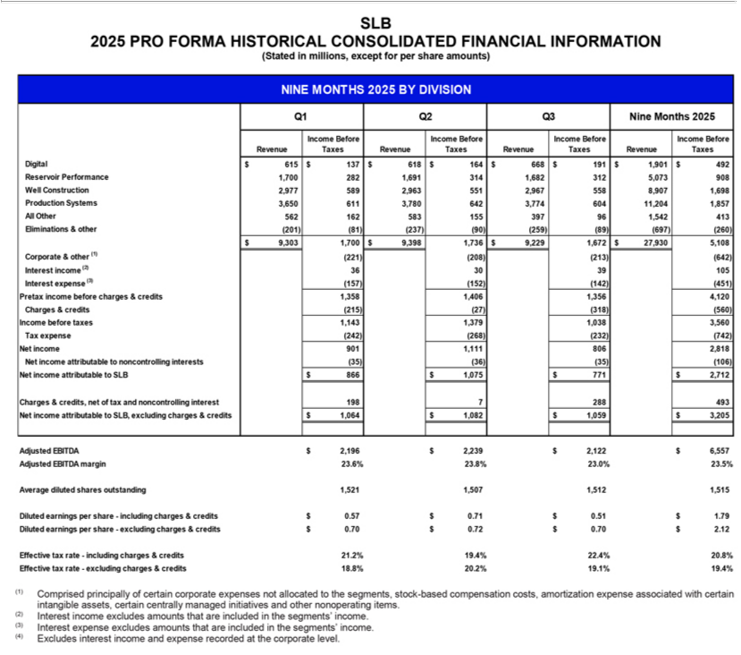

3

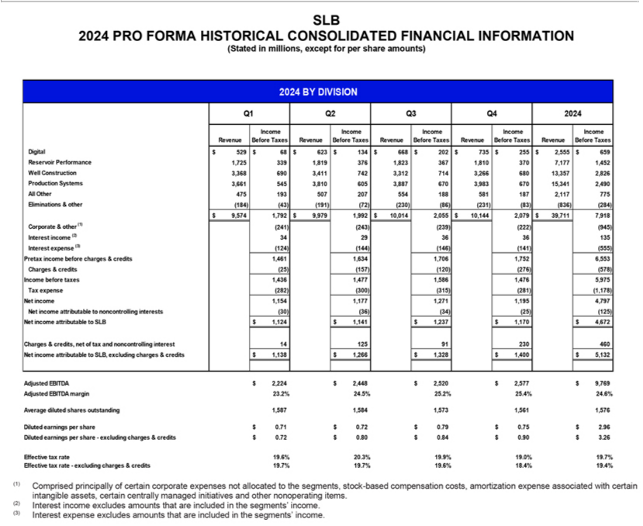

4

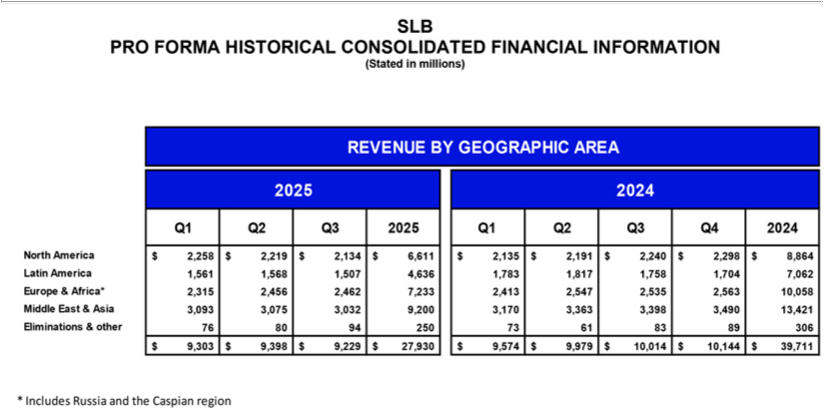

5

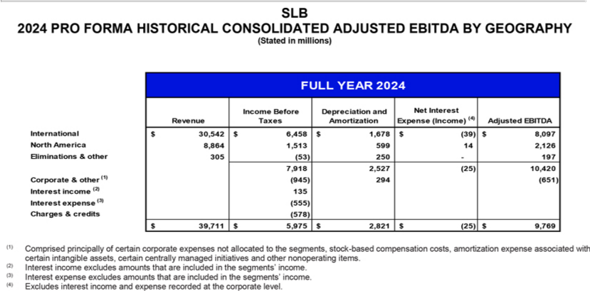

6

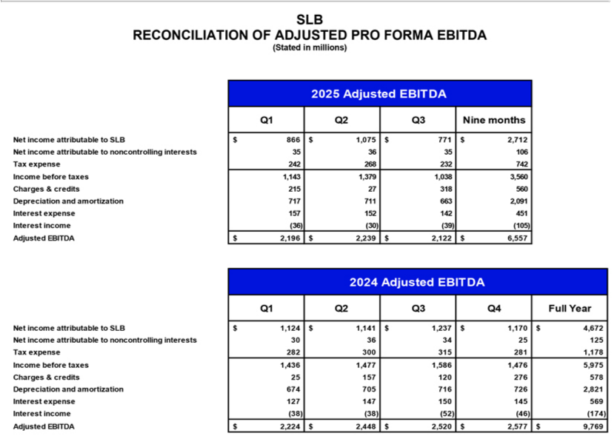

7

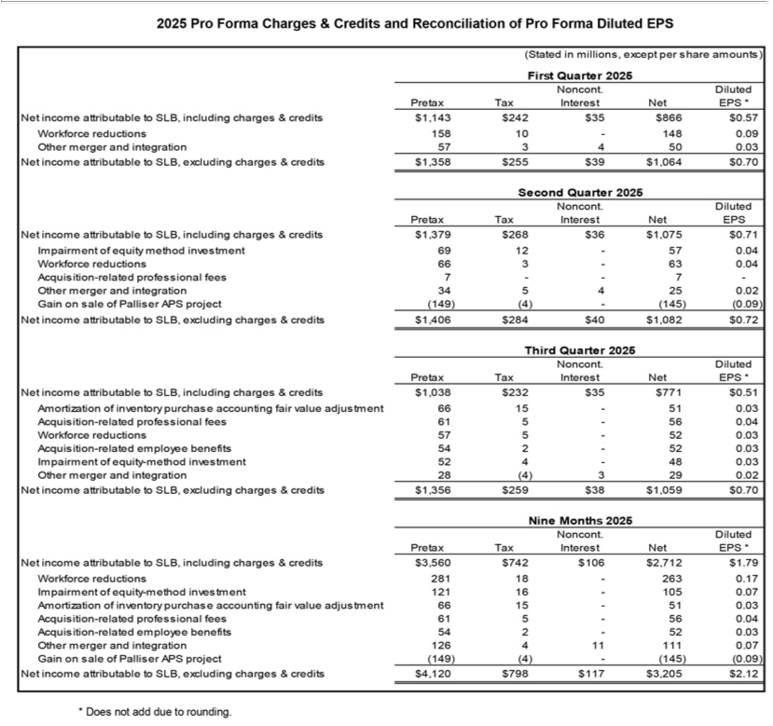

8

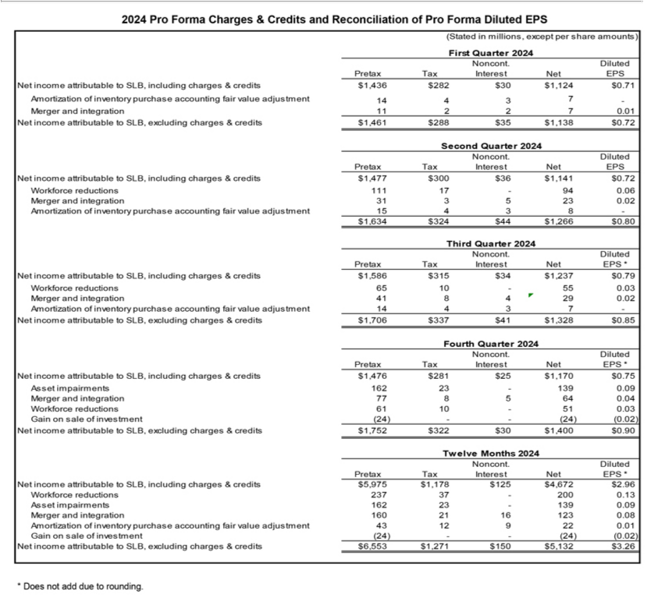

9

