Filed by Schlumberger N.V. (Schlumberger Limited)
Pursuant to Rule 425 of the Securities Act of 1933, as amended,
and deemed filed pursuant to Rule 14a-12 of the Securities Exchange Act of 1934, as amended Schlumberger N.V. (Schlumberger Limited) (File No.: 1-4601)

Subject Company: Smith International, Inc. (File No: 1-8514)

Completions Town Hall Meeting Schlumberger & Smith International Merger

May 17, 2010

Background

Schlumberger:suppliestechnology,informationsolutionsandintegrated
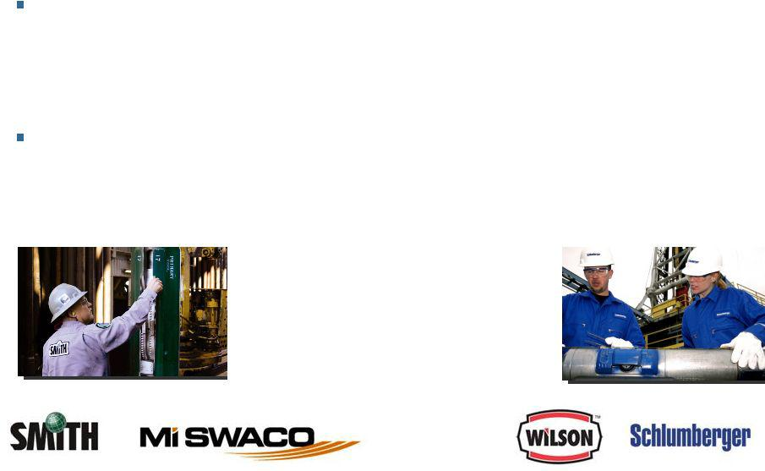

project management that optimize reservoir performance for customers working in the oil and gas industry

Smith:threeoperatingsegmentsthattogetherprovidecomprehensive

products, services and solutions that extend from the rig floor to the bit, for drilling and evaluation, and for the life of the well, through completion and production

Smith’s drilling technologies and other

products and expertise complement

Schlumberger, resulting in extended

offerings worldwide.

Merger Overview
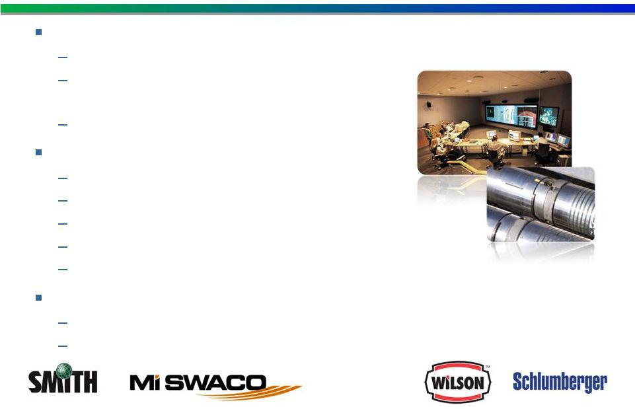

To improve drilling performance for our customers

Optimized drilling system designs—range of drilling environments New product development—evolving

drilling challenges

Improved total system reliability

Enhance completions offerings

Liner Hanger Systems

Liner Hangers for gas wells moncoborempletions

Completion Operations in US Land

Completion equipment for Multistage Fracturing

Completion equipment for selective water injection

Expand opportunities for Smith brands

Increase access to new business opportunities Access to SLB R&D

Smith/Geoservices: Complementary Offerings
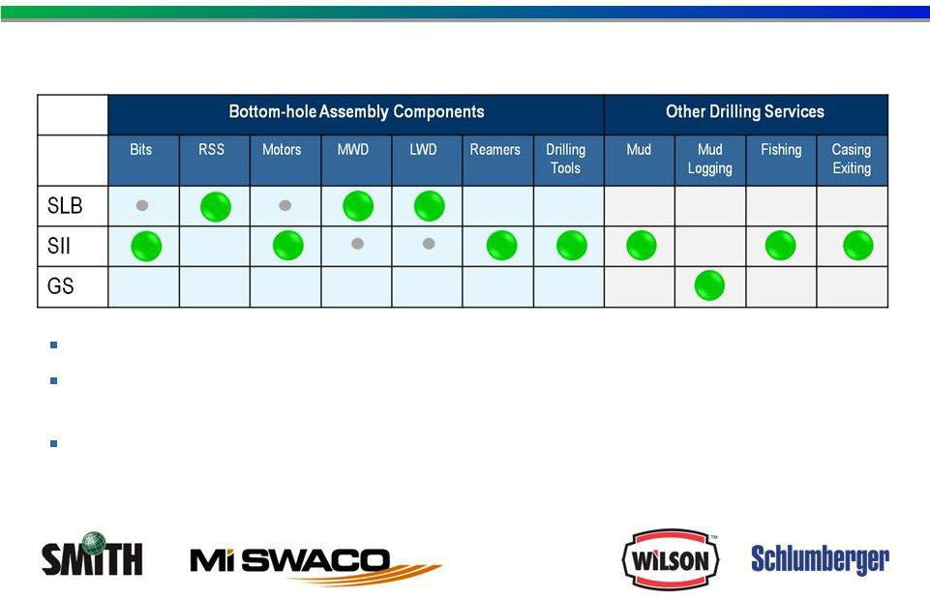

Market Positions in Drilling Sub-Segments

Complementary offerings enable improved drilling performancelowertotalandwell cost

Bottom-hole assembly optimization comes from directional drilling, measurement-while-drilling and logging-while-drilling with drill bits and drilling tools

Borehole hydraulics optimization will be enhanced through combining DD, MWD, & LWD with drill bits, drilling tools, downholemeasurements and drilling fluids

Completions
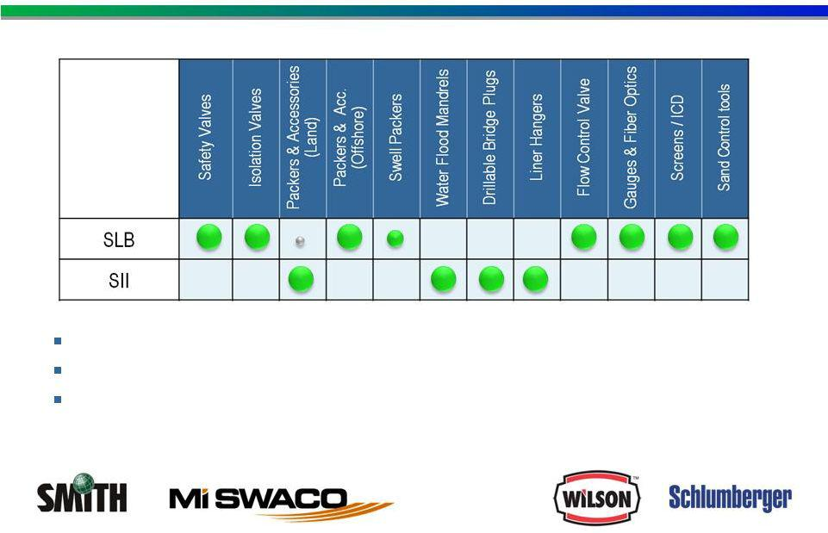

Complementary Completions offerings

Smith strengths: Liner hangers; Land packers and accessories

Schlumberger strengths: Reservoir monitoring and control; Sand control; Deepwater barrier valves and packers.

Merger Overview
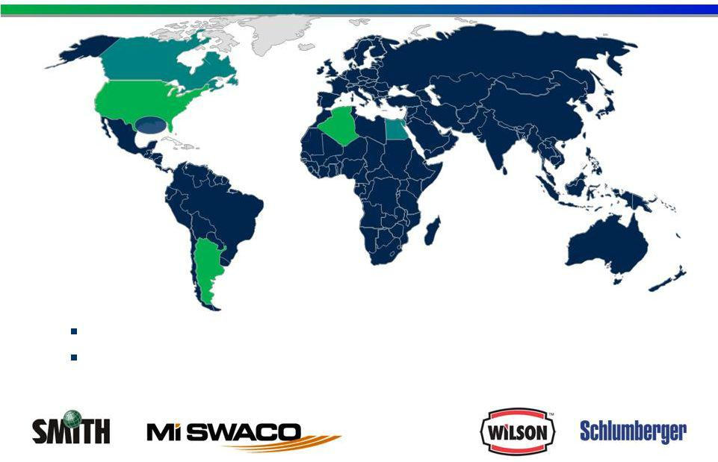

Complementary geographic footprint

Smith Completions operate primarily in countries where Schlumberger has very limited presence, i.e., US Land, Argentina, Algeria

Integration Process
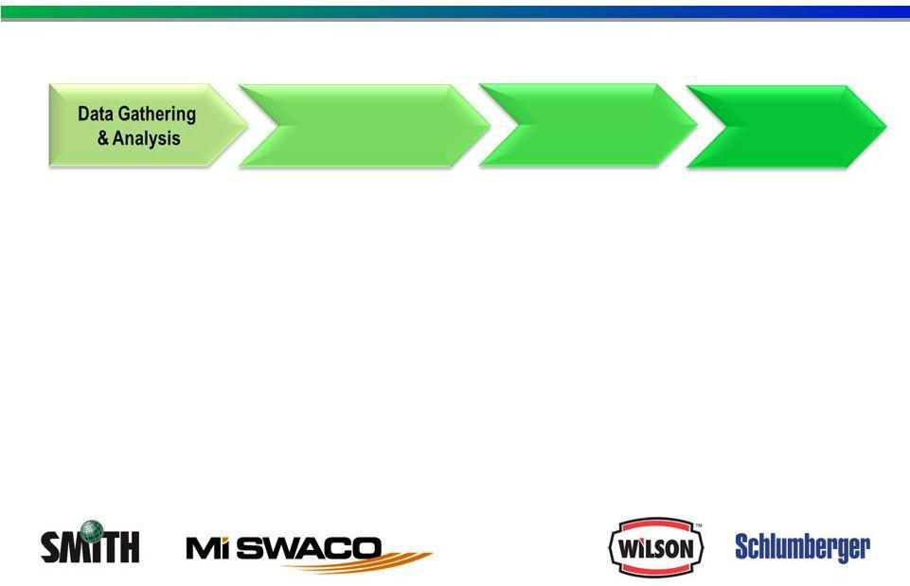

Sign |  | Close
Strategic | Detailed | Execution
Recommendations | Planning | Execution

To facilitate this integration, the following groups are in place comprised of equal representation from Schlumberger and Smith:

Executive Steering Committee (ESC)

Integration Management Office (IMO)

Integration Teams

Integration Team Objectives
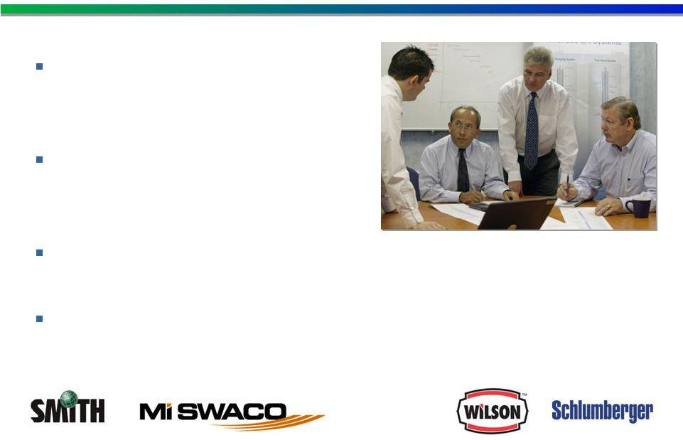

Process for decision-making based on “best of the best”approach

To define a detailed organizational model post-closing

To define financial reporting

To ensure a smooth transition

process

Integration Guidelines
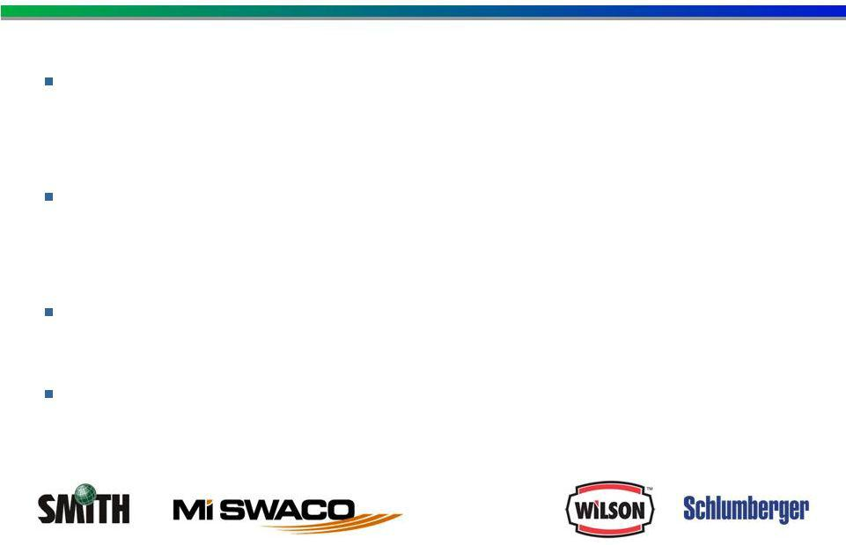

Integration team and process are focused on addressing your questions/concerns

Commitment to continuous communications (subject to the limitations imposed by the regulatory approval processes)

Legal guidelines must be followed in each phase of integration

Some information may not be available until post-merger

Integration Guidelines
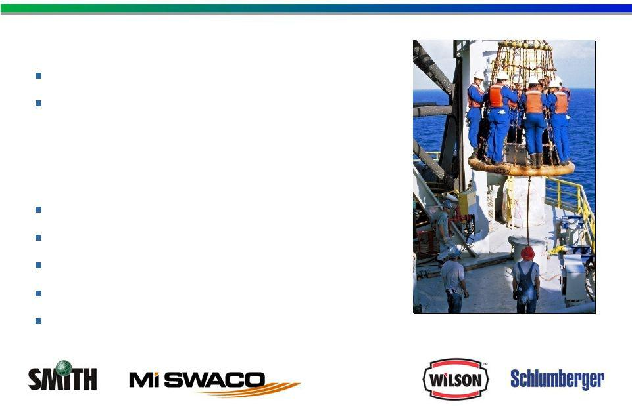

Pre-Merger

Business as usual until merger closes

Both companies remain separate and independent

Not to be Discussed until Post-Merger Pricing information
Customer details

R&D plans / new products

Sales & Marketing policies

…..

How Does This Merger Affect You
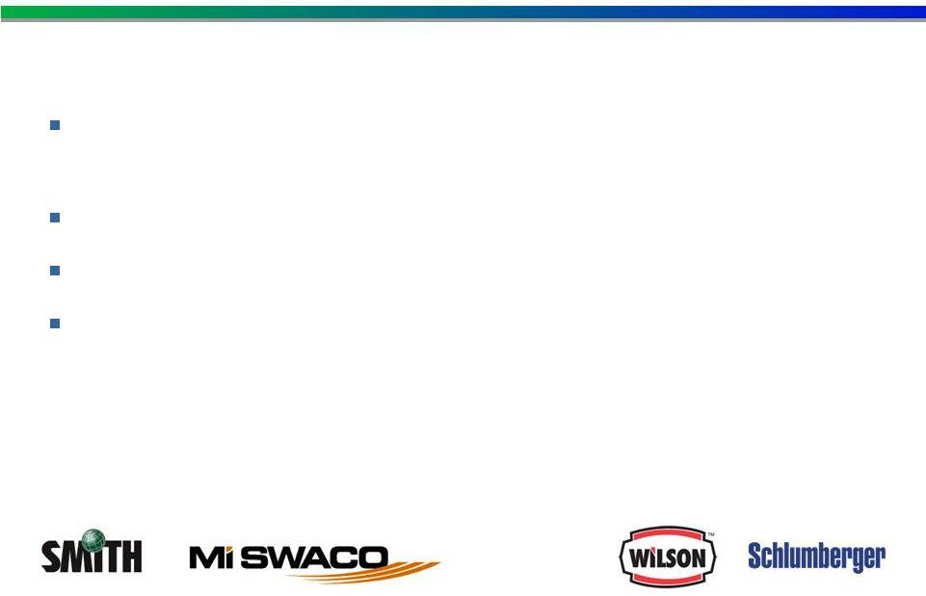

Merged Organization Structure

Smith International Inc. will not be a separate business unit of Schlumberger

Smith brand names have high market value and will be protected No plans to divest any part of Smith International Inc. “Best of the Best”approach will be applied

Forward-Looking Statements

The attached presentation includes “forward-looking statements” within the meaning of Section 27A of the Securities Act of 1933, as amended, and Section 21E of the Securities Exchange Act of 1934, as amended. The opinions, forecasts, projections, or other statements other than statements of historical fact, are forward-looking statements. The Company can give no assurance that such expectations will prove to have been correct. These statements are subject to, among other things, satisfaction of the closing conditions to the merger, the risk that the contemplated merger does not occur, negative effects from the pendency of the merger, the ability to successfully integrate the merged businesses and to realize expected synergies and other risk factors that are discussed in Schlumberger’s and Smith’s most recent 10-Ks as well as each company’s other filings with the SEC available at the SEC’s Internet site (http://www.sec.gov). Actual results may differ materially from those expected, estimated or projected.

Forward-looking statements speak only as of the date they are made, and we undertake no obligation to publicly update or revise any of them in light of new information, future events or otherwise.

Additional Information

Schlumberger has filed with the Securities and Exchange Commission a registration statement on Form S-4 containing a preliminary proxy statement/prospectus of Schlumberger and Smith and other documents related to the proposed transaction. STOCKHOLDERS ARE URGED TO READ THE DEFINITIVE PROXY STATEMENT/PROSPECTUS AND REGISTRATION STATEMENT REGARDING THE PROPOSED TRANSACTION WHEN IT BECOMES AVAILABLE BECAUSE IT WILL CONTAIN IMPORTANT INFORMATION ABOUT THE PROPOSED TRANSACTION. These documents will contain important information about the proposed transaction that should be read carefully before any decision is made with respect to the proposed transaction. These materials will be made available to the shareholders of Smith at no expense to them. Investors and security holders will be able to obtain the documents (when available) free of charge at the SEC’s web site, www.sec.gov. In addition, such materials (and all other documents filed with the SEC) will be available free of charge at www.smith.com or www.slb.com. You may also read and copy any reports, statements and other information filed by Smith or Schlumberger with the SEC at the SEC public reference room at 100 F Street N.E., Room 1580, Washington, D.C. 20549. Please call the SEC at (800) 732-0330 or visit the SEC’s website for further information on its public reference room.

Each company’s directors and executive officers and other persons may be deemed, under SEC rules, to be participants in the solicitation of proxies in connection with the proposed transaction. Information regarding Schlumberger’s directors and officers can be found in its proxy statement filed with the SEC on March 4, 2010 and information regarding Smith’s directors and officers can be found in its proxy statement filed with the SEC on April 13, 2009. Additional information regarding the participants in the proxy solicitation and a description of their direct and indirect interests in the transaction, by security holdings or otherwise, will be contained in the definitive proxy statement/prospectus and other relevant materials when they become available.

