UNITED STATES

SECURITIES AND EXCHANGE COMMISSION

Washington, DC 20549

SCHEDULE 14A INFORMATION

PROXY STATEMENT PURSUANT TO SECTION 14(A)

OF THE SECURITIES EXCHANGE ACT OF 1934

(Amendment No. ___)

Filed by the Registrant Filed by a Party other than the Registrant
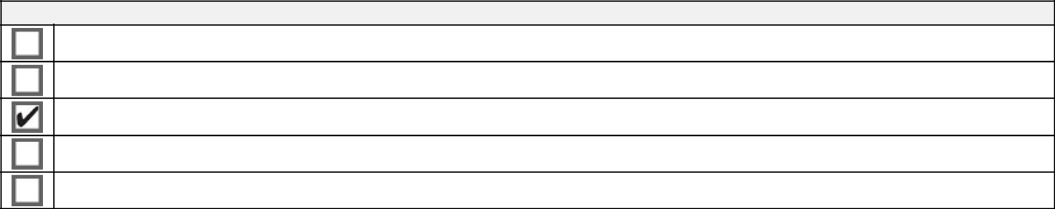

Check the appropriate box:

Preliminary Proxy Statement

Confidential, for Use of the Commission Only (as permitted by Rule 14A-6(e)(2))

Definitive Proxy Statement

Definitive Additional Materials

Soliciting Material under §240.14a-12
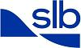

SCHLUMBERGER N.V. (SCHLUMBERGER LIMITED)

(Name of Registrant as Specified in Its Charter)

(Name of Person(s) Filing Proxy Statement if other than the Registrant)
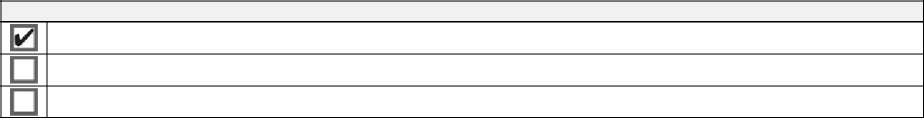

Payment of Filing Fee (Check all boxes that apply):

No fee required

Fee paid previously with preliminary materials

Fee computed on table in exhibit required by Item 25(b) per Exchange Act Rules 14a-6(i)(1) and 0-11

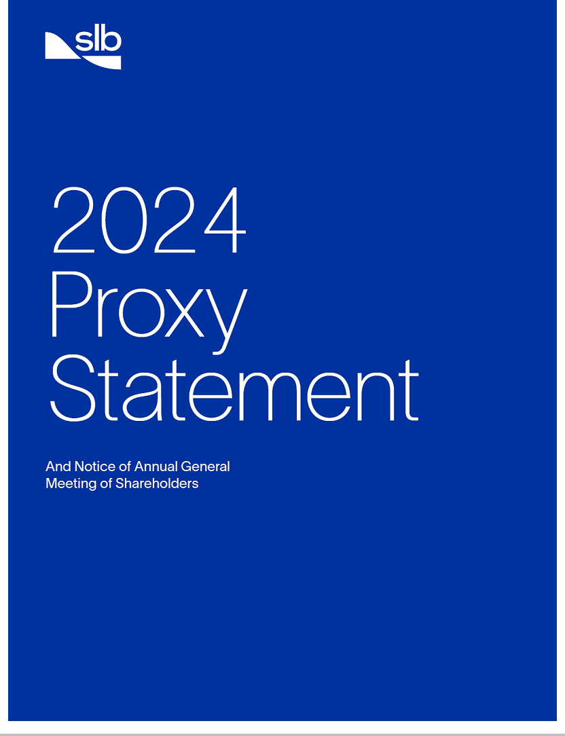

2023 Highlights


$33.14 billion

total revenue

$2.0 billion

returned to shareholders through dividends and share repurchases

$4.20 billion

net income attributable to SLB

$8.11 billion

adjusted EBITDA⁺

$6.64 billion

cash flow from operations

$4.04 billion

free cash flow⁺

Safety and Sustainability

Fatality-Free

operations

15% Scope 1 & 2

emissions intensity reduction* vs 2022

13% Scope 3

emissions intensity reduction* vs 2022

More than $1 billion
of revenue generated by

Transition Technologies™ portfolio

Inclusivity and Culture
40% | 30% | 24.6% | Code of Conduct
 |  |  | Launched new

of Board committees |  | women in executive |  | women in salaried
chaired by women |  | leadership |  | population

Together with Integrity

- See Appendix A for non-GAAP reconciliations

- Excludes acquired Aker Solutions subsea business


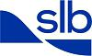
A Message from the Board of Directors

February 22, 2024

Dear SLB Shareholder,

2023 was a remarkable year at SLB—marked by widespread revenue growth, margin expansion, and exceptional cash flow. As a result, we returned $2.0 billion to shareholders in 2023 through dividends and share repurchases. We also recently increased our dividend by 10%, our third increase in the past two years and reflecting a cumulative 120% increase since the beginning of 2022. Furthermore, we announced plans to increase share repurchases in 2024, as we target to return more than $2.5 billion to shareholders in 2024.

During the year, our Board concluded a multi-year board refreshment exercise by appointing Mr. Jim Hackett as our new independent Board Chair. Mr. Hackett brings extensive knowledge of the global energy industry, both as the former Chairman and CEO of a global energy production and midstream company, and through his extensive governance experience as a board chair and director at numerous public companies serving the energy industry. This appointment demonstrates SLB’s commitment to balanced and ongoing board succession planning, with half of our non-executive director nominees joining the Board since 2021, bringing expertise in areas that are strategic for SLB.

We are actively embedding sustainability in everything we do, redefining the role that a global technology company in energy can play in the transition. In 2023, we reduced our emissions intensity—the amount of carbon emissions produced per dollar of revenue—across Scope 1, 2, and 3, in support of SLB’s 2025 emission reduction commitment. Further, our Transition Technologies™ portfolio generated more than $1 billion of revenue in 2023, as SLB continues to become our customers’ partner of choice for enhancing efficiency and reducing emissions.

Finally, we achieved our lowest recordable injury rate and highest level of operational reliability on record. These accomplishments are driving customer satisfaction and value creation for SLB, our customers, and our shareholders.

Overall, our impressive full-year results showcase SLB’s continued ability to deliver superior earnings, generate exceptional cash flows, and maintain a strong balance sheet. These achievements are a testament to the performance of our teams of dedicated women and men across the globe, the support of our partners, and the loyalty of our customers.

We thank you for your investment in SLB and for the opportunity to serve you and our Company as directors.

Sincerely,

Your Board of Directors

All references in this proxy statement to “SLB,” “the Company,” “we,” or “our” are to Schlumberger Limited (Schlumberger N.V.) and its subsidiaries.

Website references throughout this document are provided for convenience only, and the content on the referenced websites is not incorporated by reference into this document.

This proxy statement includes forward-looking statements within the meaning of the Private Securities Litigation Reform Act of 1995. All statements other than statements of historical or current facts made in this document are forward-looking. We use words such as anticipates, believes, expects, future, intends, goal, target, ambition, will, and similar expressions to identify forward-looking statements. Forward-looking statements reflect management’s current expectations and are inherently uncertain, and actual results or outcomes could differ materially for a variety of reasons. Risks and uncertainties that could cause our actual results to differ significantly from management’s expectations include, but are not limited to, changing global economic and geopolitical conditions; changes in exploration and production spending by SLB’s customers and changes in the level of oil and natural gas exploration and development; the results of operations and financial condition of SLB’s customers and suppliers; SLB’s inability to achieve its financial and performance targets and other forecasts and expectations; SLB’s inability to achieve net-zero carbon emissions goals or interim emissions reduction goals; general economic, geopolitical, and business conditions in key regions of the world; the ongoing conflict in Ukraine; foreign currency risk; inflation; changes in monetary policy by governments; pricing pressure; weather and seasonal factors; unfavorable effects of health pandemics; availability and cost of raw materials; operational modifications, delays, or cancellations; challenges in SLB’s supply chain; production declines; the extent of future charges; SLB’s inability to recognize efficiencies and other intended benefits from its business strategies and initiatives, such as digital or new energy, as well as its cost reduction strategies; changes in government regulations and regulatory requirements, including those related to offshore oil and gas exploration, radioactive sources, explosives, chemicals, and climate-related initiatives; the inability of technology to meet new challenges in exploration; the competitiveness of alternative energy sources or product substitutes; and other risks and uncertainties detailed in SLB’s Annual Report on Form 10-K for the fiscal year ended December 31, 2023 (2023 Annual Report), and other filings that we make with the SEC. If one or more of these or other risks or uncertainties materialize (or the consequences of any such development changes), or should our underlying assumptions prove incorrect, actual results or outcomes may vary materially from those reflected in our forward-looking statements. Forward-looking and other statements in this proxy statement regarding our environmental, social, governance (ESG) and other sustainability plans and goals are not an indication that these statements are necessarily material to investors or required to be disclosed in our filings with the SEC. In addition, historical, current, and forward-looking ESG and sustainability-related statements may be based on standards for measuring progress that are still developing, internal controls and processes that continue to evolve, and assumptions that are subject to change in the future.

For definitions of adjusted EBITDA, free cash flow, free cash flow margin, and net debt, as well as reconciliations of these non-GAAP measures to their most comparable GAAP measures, see Appendix A.

Emissions intensity data in this proxy statement do not reflect the impact of the Aker Solutions subsea business, which was acquired in the fourth quarter of 2023.

Notice of 2024 Annual General Meeting of Shareholders


Items of Business


- Election of 11 director nominees.

- Advisory “say-on-pay” approval of our executive compensation.

- Approval of certain annual financial statements for the year ended December 31, 2023.

- Ratification of the appointment of our independent auditor, PricewaterhouseCoopers LLP.

Such other matters as may properly be brought before the meeting.

By order of the Board of Directors,

Dianne B. Ralston

Chief Legal Officer and Secretary

February 22, 2024

Wednesday, April 3, 2024

9:00 a.m. Curaçao time

Curaçao Marriott Beach Resort

John F Kennedy Boulevard, 3, Piscadera Bay
Willemstad, Curaçao

Record Date

February 7, 2024

How to Cast Your Vote

Please refer to the enclosed proxy materials or to the information forwarded by your bank, broker, or other nominee to determine which voting methods are available to you. Shareholders with shares registered in their names with SLB’s transfer agent may authorize a proxy:

By Internet By Telephone

www.proxypush.com/SLB (866) 240-5191

By Mail

Sign, date, and mail your proxy card

If you are a beneficial holder of SLB common stock, you should

follow any instructions provided by your bank, broker, or other
nominee. See “Information About the Meeting” in this proxy
statement.
Proxy Voting
Your vote is very important. Whether or not you plan to attend the annual general meeting in person, please sign, date, and promptly return your proxy card by mail, or alternatively please grant a proxy and give voting instructions by telephone or internet, so that you may be represented at the meeting. Voting instructions are provided on your proxy card or on the voting instruction form provided by your broker. Brokers are not permitted to vote on certain proposals and may elect not to vote on any of the proposals unless you provide voting instructions. Voting your shares will help to ensure that your interests are represented at the meeting.

Important Notice of Internet Availability of Proxy Materials

for the Annual General Meeting of Shareholders to be Held on April 3, 2024
This Notice, the Proxy Statement, the Notice of Internet Availability of Proxy Materials (Notice of Internet Availability), and our 2023 Annual Report are each available free of charge at https://investorcenter.slb.com and www.proxydocs.com/SLB.

Table of Contents

Proxy Summary |  |  |  | 6
Voting at the 2024 Annual General Meeting |  |  |  | 6
2023 Performance Highlights |  |  |  | 7
Our Director Nominees |  |  |  | 8
Governance Highlights |  |  |  | 8
2023 Executive Compensation Highlights |  |  |  | 9
Leader in Global Diversity |  |  |  | 10
Item 1. Election of Directors |  |  |  | 12
Skills and Experience of Our Director Nominees |  |  |  | 12
Corporate Governance |  |  |  | 19
New Independent Chair |  |  |  | 19
Leadership Structure |  |  |  | 19
New SLB Code of Conduct Launched in 2023 |  |  |  | 19
Effective Board Oversight of Risk Management |  |  |  | 20
Proactive Shareholder Engagement |  |  |  | 22
Director Selection and Qualifications |  |  |  | 22
Comprehensive Director Orientation and Education |  |  |  | 23
Rigorous Evaluation Processes |  |  |  | 24
Board Committees |  |  |  | 24
Meeting Attendance |  |  |  | 25
Director Independence |  |  |  | 25
Corporate Governance Guidelines |  |  |  | 26
Certain Relationships and Related Person Transactions |  |  |  | 26
Compensation Committee Interlocks and Insider Participation |  |  |  | 26
How to Communicate with Our Board |  |  |  | 26
Director Compensation |  |  |  | 27
Stock Ownership Information |  |  |  | 29
ITEM 2. Advisory Approval of Our Executive Compensation |  |  |  | 31
Compensation Committee Report |  |  |  | 31
Compensation Discussion and Analysis |  |  |  | 32
2023 Compensation Decisions and Results |  |  |  | 33
Framework for Setting 2023 Executive Compensation |  |  |  | 34
Elements of 2023 Total Compensation |  |  |  | 36
Other Aspects of Our Executive Compensation Program |  |  |  | 46
Executive Compensation Governance |  |  |  | 48
Executive Compensation Tables |  |  |  | 50
Summary Compensation Table |  |  |  | 50
Grants of Plan-Based Awards in 2023 |  |  |  | 51
Outstanding Equity Awards at Year-End 2023 |  |  |  | 52
Option Exercises and Stock Vested in 2023 |  |  |  | 53
Pension Benefits |  |  |  | 54
Nonqualified Deferred Compensation |  |  |  | 55
Potential Payments Upon Termination or Change in Control |  |  |  | 57
Equity Compensation Plan Information |  |  |  | 59
CEO Pay Ratio |  |  |  | 59
Pay vs. Performance Comparison |  |  |  | 60
ITEM 3. Approval of Financial Statements and Dividends |  |  |  | 63
ITEM 4. Ratification of Appointment of Independent Auditors for 2024 |  |  |  | 64
Audit Committee Report |  |  |  | 65
Information About the Meeting |  |  |  | 66
Appendix A |  |  |  | A-1
2024 Proxy Statement |  | 5
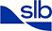

Back to Contents


Proxy Summary

This summary highlights information contained elsewhere in this proxy statement. This summary does not contain all of the information you should consider, and you should carefully review this entire proxy statement and our 2023 Annual Report before voting.

Voting at the 2024 Annual General Meeting

The 2024 Annual General Meeting of Shareholders (the 2024 AGM) will be held at:

Meeting Date: | Wednesday, April 3, 2024
Place: | Curaçao Marriott Beach Resort
 | John F Kennedy Boulevard, 3, Piscadera Bay
 | Willemstad, Curaçao
Time: | 9:00 a.m. Curaçao time
Record Date: | February 7, 2024

Each shareholder of record at the close of business on February 7, 2024 (the record date) is entitled to one vote for each share registered in that shareholder’s name. If your shares are registered in your name with SLB’s transfer agent, you may vote in person at the 2024 AGM, or you may authorize a proxy to vote your shares by one of the following methods:

By Internet By Telephone By Mail

www.proxypush.com/SLB (866) 240-5191 Sign, date, and mail your proxy card

If you are a “beneficial” owner of SLB common stock—which means you held your shares on the record date through a broker, bank, or other nominee—you should follow the voting instructions provided by your bank, broker, or nominee.

If you plan to attend the 2024 AGM in person, see “Information About the Meeting” beginning on page 66 for the requirements for admission to the meeting. Whether or not you plan to attend the 2024 AGM in person, please sign, date, and promptly return your proxy card by mail, or alternatively please grant a proxy and give voting instructions by telephone or internet, so that you may be represented at the meeting.

Voting Matters

 |  | Our Board’s | Vote Required for | Refer
Item |  | Recommendation | Election / Approval | to Page
1 | Election of 11 director nominees to our Board of Directors (the Board). | FOR | Majority of
 |  | each nominee | votes cast for | 12
 |  |  | nominee
2 | Advisory “say-on-pay” approval of our executive compensation. | FOR | Majority of | 31
 |  | FOR | votes cast | 31

- Approval of our consolidated balance sheet at December 31, 2023, our consolidated statement of income for the year ended December 31, 2023, and the declarations of dividends by our Board in 2023.

- Ratification of the appointment of PricewaterhouseCoopers LLP (PwC) as our independent auditor for 2024.

FOR | Majority of | 63
FOR | votes cast | 63
FOR | Majority of | 64
FOR | votes cast | 64

This proxy statement is first being made available to our shareholders on or about February 22, 2024.

6 2024 Proxy Statement

Back to Contents


2023 Performance Highlights

“A remarkable year of broad, resilient, and durable growth.

Our performance and returns-focused strategy, combined with
our differentiated market positioning and digital capabilities,
will drive profitable growth and further margin expansion,

building on our strong foundation for long-term growth.”

Olivier Le Peuch, SLB CEO

In 2023, SLB fulfilled the Company’s full-year financial targets, surpassing our revenue target and generating exceptional cash flows.

2023 Financial Performance Highlights

$33.14 billion

revenue

+18% year on year

$4.20 billion

net income attributable to SLB

+22% year on year

$2.0 billion

returned to shareholders through

dividends and share repurchases

$6.64 billion

cash flow from operations

+78% year on year

$8.11 billion
adjusted EBITDA⁺

+25% year on year

16%

return on capital employed

highest level since 2014

$4.04 billion
free cash flow⁺

+185% year on year

1.0X
net-debt-to-adjusted-EBITDA⁺ ratio
lowest level since 2016

2023 financial performance across our Core business, comprising Reservoir Performance, Well Construction, and Production Systems, was fueled by strong growth in the international and offshore markets. SLB continued to benefit from long-cycle developments, capacity expansions, and exploration and appraisal activities, particularly in the Middle East, where revenue reached a record high, and across offshore basins in Brazil, Angola, US Gulf of Mexico, Guyana, and Norway.

Digital continued its strong growth momentum, delivering more than $2 billion in revenue in 2023. Our success in Digital was driven by further adoption of our new digital technology platforms—comprised of cloud, edge, and AI—as more customers embrace the integration of connected and autonomous, data, and AI solutions.

And in New Energy—which offers a significant opportunity to use SLB’s experience and scale to drive innovation for a low-carbon economy beyond oil and gas—we continued building businesses and forging partnerships across industries to focus on five key areas: carbon capture and storage, geothermal and geoenergy, critical minerals, energy storage, and hydrogen.

As we advanced these three engines of growth, we also continued to deliver for our customers and stakeholders by achieving our lowest recordable injury rate and highest level of operational reliability on record. This is also reflected in industry surveys, where we are growing customer satisfaction through performance and value creation.

On our road map to net zero, we reduced emissions intensity—the amount of carbon emissions produced per dollar of revenue—across Scope 1, 2, and 3, in support of SLB’s 2025 emission reduction commitment. And we saw continued adoption by our customers of our Transition Technologies portfolio, which generated more than $1 billion of revenue in 2023.

Finally, we continued to demonstrate our commitment to superior shareholder returns. We returned $2.0 billion to shareholders in 2023 in the form of dividends and share repurchases, and we announced plans to increase share repurchases in 2024, as we target to return more than $2.5 billion to shareholders in 2024.

With momentum across our three engines of growth and our returns-focused strategy in place, we look forward to building on this success and delivering value for our shareholders in the years ahead.

+ See Appendix A for definitions of adjusted EBITDA, free cash flow, and net debt, as well as reconciliations to their most comparable GAAP measures.

2024 Proxy Statement |  | 7

Back to Contents
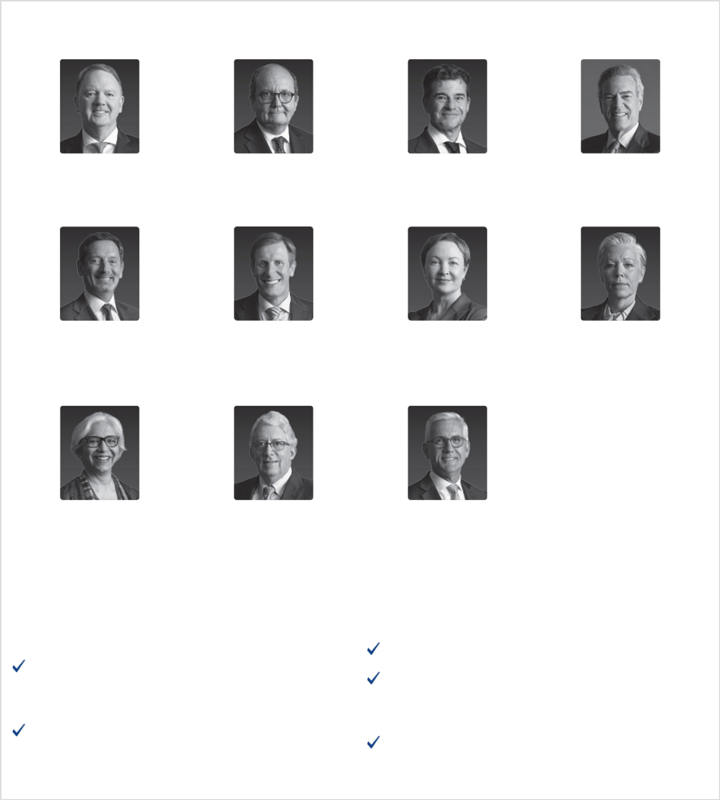

Our Director Nominees

Peter Coleman | Patrick de La Chevardière | Miguel Galuccio | Jim Hackett
Former CEO and | Former Chief Financial Officer | Chairman and CEO | President
Managing Director | TotalEnergies SE | Vista | Tessellation Services
Woodside Petroleum Ltd.

Olivier Le Peuch | Samuel Leupold | Tatiana Mitrova | Maria Moræus Hanssen
Chief Executive Officer | Former Chief Executive Officer | Research Fellow | Former Deputy CEO
SLB | Ørsted Wind Power A/S | SIPA Center on Global | and COO
 |  | Energy Policy | Wintershall Dea GmbH
 |  | Columbia University

Vanitha Narayanan | Jeff Sheets | Ulrich Spiesshofer
Former Chairman and | Former EVP and CFO | Former President and CEO
Managing Director | ConocoPhillips | ABB Ltd.
IBM India

Governance Highlights

New Independent Board Chair appointed in 2023

No staggered board; all directors are elected annually

Fully independent Audit, Compensation, and Nominating and Governance committees

Regular executive sessions of non-employee directors Majority vote standard for uncontested director elections

Annual performance evaluations of Board, its committees, and individual directors

99% average Board attendance in 2023

Launched new Code of Conduct – Together with Integrity in 2023

40% of Board committees are chaired by female directors

Demonstrated commitment to Board refreshment, with half of non-executive director nominees joining since 2021

Non-employee director tenure limits of 75 years of age or 10 years of service—whichever comes first

No hedging or pledging of our stock by SLB executives or directors Robust stock ownership guidelines for SLB executives and directors

No lobbying or making financial or in-kind contributions to political parties or candidates

Proactive shareholder engagement

8 2024 Proxy Statement

Back to Contents
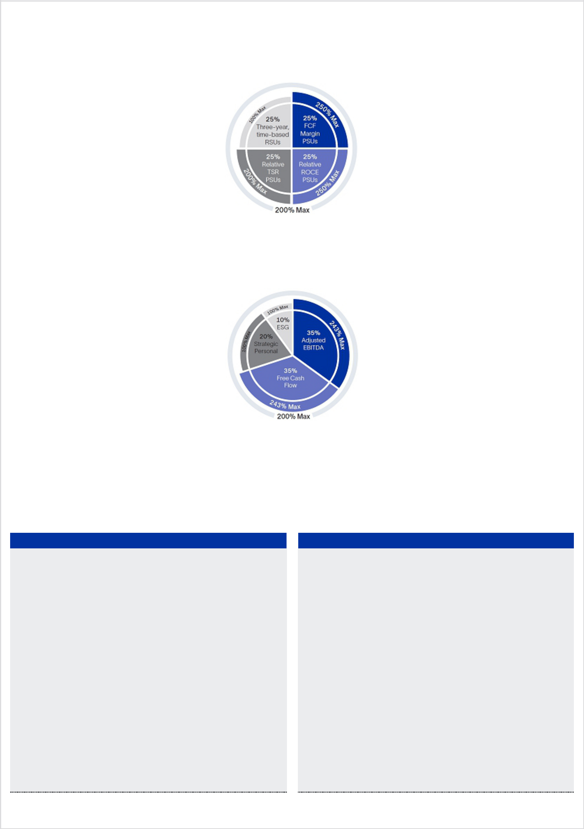

2023 Executive Compensation Highlights

Below is a summary of key elements of our 2023 executive compensation program, as further detailed under “Compensation Discussion and Analysis” (the CD&A) beginning on page 32 of this proxy statement.

Diversified LTI Program Structure with Rigorous PSU Performance Targets

In 2023, our NEOs continued to receive a mix of long-term incentive (LTI) grants, with 75% of their target LTI opportunity awarded in the form of performance share units (PSUs), and 25% awarded in the form of three-year, time-based restricted stock units (RSUs). As in 2022, payout under the 2023 PSUs will be contingent on achieving rigorous absolute free cash flow margin (FCF margin), relative return on capital employed (ROCE), and relative total shareholder return (TSR) performance goals over a three-year period.

Strategy-Focused STI Program with Emissions Reduction Objectives for All NEOs

In 2023, we continued to tie 70% of our NEOs’ target short-term incentive (STI) opportunity to Company financial goals—namely, full-year adjusted

EBITDA and free cash flow—to ensure our executives remained focused on profitable, sustainable growth. In addition, we incorporated into our 2023

STI plan a new quantitative component focused on reducing our Scope 3 emissions intensity and improving gender diversity.

Performance-Aligned LTI and STI Payouts

Our NEOs’ LTI award payouts in 2023 were based on SLB’s strong multi-year ROCE results, as well as achieving target under our three-year FCF margin PSUs, partially offset by below-target relative TSR performance. Our NEOs also earned performance-aligned 2023 STI payouts based on SLB’s strong adjusted EBITDA and exceptional free cash flow results, together with key sustainability and workforce diversity achievements during the year.

Long-Term Equity Incentive Results

Total LTI Award Payout — 127% — Our NEOs earned total LTI

payouts of 127% of target with respect to their three-year LTI awards (including RSUs vested at 100%) that were granted in 2021 and vested in January 2024.

Target FCF Margin PSU Payout — Our NEOs earned 100% of the target shares of SLB stock under the FCF margin PSUs that they received in 2021, because SLB achieved its target three-year,

cumulative FCF margin⁺ of 10.0%.

Strong Relative and Absolute ROCE Results — Our NEOs earned 250% of the target shares of SLB stock under the ROCE PSUs they received in 2021, based on SLB’s average annual ROCE for the three-year performance period, which was 477 bps above the average ROCE of the comparator group, together with SLB’s absolute 2023 ROCE of 16%.

Below-Target TSR Payout — Our NEOs earned 59% of the target shares of SLB stock under the TSR PSUs they received in 2021. This payout was based on SLB’s relative TSR percentile rank of 41% as compared to the three-year cumulative TSR results achieved by eight comparator companies in our core industry.

Short-Term Cash Incentive Results

Average STI Payout — 151% — Our NEOs earned an average 2023 cash incentive payout of 151% of target.

Adjusted EBITDA⁺ — $8.107 billion — Our 2023 adjusted

EBITDA of $8.107 billion represented a 25% increase over 2022, resulting in achievement of 119% of the target payout.

Free Cash Flow⁺ — $4.038 billion — Our 2023 free cash

flow of $4.038 billion represented a 185% increase over 2022, resulting in achievement of 243% of the target payout.

Achieved Emissions and Gender Diversity Targets — In 2023, we reduced our Scope 3 emissions intensity by 13%* year on year. We also increased our percentage of women in salaried roles from 23.8% at year-end 2022 to 24.6% at year-end 2023. As a result, our NEOs earned 100% of the target payout.

- See Appendix A

- Excludes acquired Aker Solutions subsea business

2024 Proxy Statement

9

Back to Contents

Leader in Global Diversity

Workforce Diversity

As a leading global technology company that operates in more than 100 countries, with a workforce of approximately 111,000 people from diverse backgrounds, cultures, and nationalities, one of SLB’s greatest strengths is the diversity of our people. We believe that our ability to attract, develop, motivate, and retain a highly competent and diverse workforce has been paramount to our success for many decades. We recognize that cultivating diversity and promoting inclusion are essential to attracting the best talent from around the world and enabling creativity and innovation to drive business success.

Our long-standing commitment to national and cultural diversity is reflected in our workforce composition and our philosophy to recruit and develop people from the communities in which we operate. Our workforce nationality mix generally aligns with the revenue derived from the countries in which we work, as reflected in the charts below. This fosters a culture that is global in outlook, yet local in practice. With nearly 200 nationalities represented in SLB, and nine nationalities among our ten-member executive leadership team,our organization is a tapestry of various cultural backgrounds and perspectives.

SLB also recognizes the importance of gender diversity as a source of creativity, innovation, and competitive advantage. We are committed to leading our industry in this area and, in this regard, a number of years ago we established goals of having women represent 25% of our salaried workforce by 2025 and 30% by 2030. Our 2025 and 2030 targets include executive roles and all other salaried positions. Women represented 30% of our executive leadership team and 24.6% of our salaried workforce at year-end 2023.

Finally, as SLB is a truly global company with a rich legacy of national and cultural diversity, it is important that we do not limit our definitions of racial and ethnic diversity to the common classifications used in the United States. With respect to our U.S.-based employees and executives, our most recent EEO-1 Report is available on SLB’s website at https://www.slb.com/about/who-we-are/diversity-and-inclusion.


9 nationalities among executive leadership

30% women on SLB executive leadership team

40% of Board committees chaired by female directors

SLB does not make employment decisions, including decisions regarding hiring, promotion and compensation, on the basis of any legally protected characteristic, including nationality, race, or gender, but is focused on making opportunities to excel accessible to all. We implement this goal by adhering to employment laws in each of the countries in which we operate.

10 2024 Proxy Statement

Back to Contents

Board Diversity

A key component to the Board’s effective governance is its commitment to provide oversight and perspectives reflecting a diversity of independent views.

The members of SLB’s diverse Board represent ten nationalities spanning five continents. Three SLB directors are women—two of whom hold Board leadership positions chairing its Nominating and Governance and New Energy and Innovation committees. Our directors have an average age of 60 and have served on our Board for an average of four years.

The Nominating and Governance Committee supports SLB’s diversity ambition for its Board to reflect the gender, racial, and ethnic, cultural and geographical diversity of SLB’s global operations. As such, the Board seeks out women and nationally, racially, and ethnically diverse candidates to include in the pool of qualified candidates from which potential director nominees are chosen.

The following chart summarizes certain demographic characteristics of our director nominees.

Nationality

Argentina

Australia

France

Germany

Israel

Norway

Russia

Switzerland

United Kingdom

United States

Racial and Ethnicity Characteristics for U.S. Directors

East Asian or South Asian

White or Caucasian

Declined to Respond

Non-U.S. Directors Electing to Self-Identify Racial or Ethnicity Characteristics

Two or More Ethnicities

White or Caucasian

Other Demographic Information

Gender
(M – Male, F – Female, or DR – Declined to | M | M | M | DR | M | DR | F | F | F | M | M
Respond)
Age | 63 | 66 | 55 | 70 | 60 | 53 | 49 | 59 | 64 | 66 | 59

Given SLB’s multinational footprint and culture, we endeavor to have a global perspective on diversity. This perspective includes respecting local legal requirements regarding the tracking and use of personal data pertaining to under-represented populations. Certain countries have data privacy laws prohibiting the collection or disclosure of race and ethnicity classification data, reflecting historical concerns that such data could be used to foster, rather than eliminate, discrimination. In addition, local definitions of race and ethnicity and related classifications, as well as the definition of under-represented groups, vary from country to country.

As a result, U.S.-centric racial and ethnic classifications as used for EEO-1 data collection purposes are applicable only to our three directors who are U.S. citizens. For our U.S. directors, the chart above includes race and ethnicity disclosures based on classifications commonly used in the United States. For all other directors, we asked if they wished to voluntarily disclose their ethnic or racial background and, if so, how they self-identify based on the classifications most relevant to their home countries. We provide self-identifications for non-U.S. directors in the chart above. In keeping with international data privacy laws, we have not included racial or ethnic information for director nominees who did not authorize disclosure.

2024 Proxy Statement |  | 11

Back to Contents

ITEM 1. Election of Directors

All of SLB’s directors are elected annually at our AGM. The Board recommends that you vote FOR the election of each of our 11 director nominees to serve until our 2025 AGM (or until their earlier death, resignation, or removal).

Each of our director nominees is currently an SLB director and was previously elected by our shareholders at our 2023 AGM, except for our Board’s independent Chair, Mr. Hackett, who joined the Board after the AGM. Mr. Hackett succeeded Mr. Mark Papa, who retired from the Board in July 2023. The Board extends thanks and gratitude to Mr. Papa for his exceptional leadership and five years of service as a director, including four years serving as Chairman of the Board. For more information about Mr. Hackett’s appointment and our 2023 Board Chair succession process, see “Corporate Governance— New Independent Chair” on page 19 of this proxy statement.

If any director nominee is unable or unwilling to serve, the Board may decrease the size of the Board or designate a substitute nominee. If the Board designates a substitute nominee, proxies may be voted for that substitute nominee. Each of the director nominees has consented to stand for election and the Board knows of no reason why any nominee would be unable or unwilling to serve if elected.

At the 2024 AGM, votes may not be cast for a greater number of persons than the number of director nominees named in this proxy statement. Shares represented by properly executed proxies and not revoked will be voted in accordance with the instructions indicated on those proxy cards. If you have properly executed your proxy card and you have not given specific voting instructions, your shares will be voted in accordance with our Board’s recommendations.

The Board of Directors recommends a vote FOR each director nominee.

Skills and Experience of Our Director Nominees

Our Board believes our 11 director nominees provide a well-rounded set of expertise to assist in effective and independent oversight of SLB management. The following chart summarizes key qualifications of our director nominees—including knowledge, skills, experiences and other attributes that the Board believes are relevant to their Board and committee service.


Substantial Knowledge, Skills and

Experience

Current or former chief executive officer

Energy industry and operations

Finance and accounting

Science, technology and engineering

Energy transition and sustainability

Digital innovation

Digital transformation

Information security

Strategy development & implementation

International business

Risk management

Economic modeling

Health, safety and environmental

Mergers and acquisitions

Academic relations

Government, regulatory & public policy

Other Attributes

Independence
SLB Board Chair or Committee Chair
Tenure |  | 3 | 5 | 7 |  | <1 |  | 5 | 3 | 6 | 4 | 3 | 5 | 3
 |  |  |  |  |  | 12 |  |  |  |  |  | 2024 Proxy Statement

Back to Contents

Each director nominee possesses numerous other skills and experience not identified in the chart on page 12, as further detailed in their biographies below. For additional details on the Board’s process for identifying director nominees, see “Corporate Governance—Director Selection and Qualifications” on page 22 of this proxy statement.

Our Director Nominees

The nominees for election to the Board, together with information regarding each nominee’s qualifications, are set forth below. In the judgment of the Board, all director nominees are able to execute their duties as members of the Board and to devote the necessary time and attention to SLB, as required by our Corporate Governance Guidelines. In addition, there are no family relationships among any SLB executive officers and directors.

Peter Coleman,

Independent Director
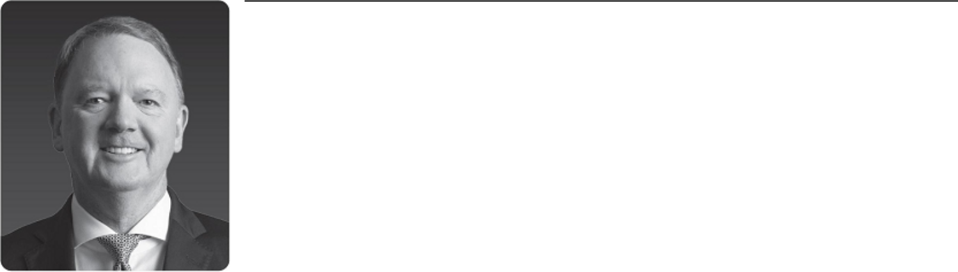

Former CEO and Managing Director, |  | SLB Board Committees
Woodside Petroleum Ltd. |  | • | Nominating and Governance
Director since 2021 |  | • | Finance
 |  | Other Experience and Education
Other Current Public Boards |  | • | MBA, Deakin University
• | Arcadium Lithium plc | • Bachelor of Engineering, Monash University
Former Public Director Roles |  | • Chair of the Australia-Korea Foundation
During the Past Five Years
• | Woodside Petroleum Ltd.
• | Allkem Limited

PETER COLEMAN is the former Chief Executive Officer, Executive Director and Managing Director of Woodside Petroleum Ltd., Australia’s largest independent gas producer, having served in that role from 2011 until his retirement in June 2021. Prior to joining Woodside, Mr. Coleman spent 27 years with the ExxonMobil group in a variety of roles, including Vice President Asia Pacific from 2010 to 2011 and Vice President Americas from 2008 to 2010. Since 2012, he has been an adjunct professor of corporate strategy at the University of Western Australia Business School. He has served as chair of Arcadium Lithium plc, a leading global lithium chemicals producer, since January 2024, following the merger of Livent Corp. with Allkem Limited, where he had served as a director from October 2022 and as chair from November 2022 through January 2024. He has also served as chairman of the board of Infinite Green Energy, an Australian green hydrogen renewable energy company, since August 2021, as chair of H2EX, an Australian hydrogen exploration start-up, since April 2022, and as chair of DIRECT Infrastructure, an Australian-based offshore wind developer, since June 2022.

Reason for Nomination

Mr. Coleman brings to the Board decades of experience in the energy industry, including as the former CEO and Managing Director of Australia’s largest independent gas producer. The Board benefits from his expertise in strategic planning, as well as his extensive business experience in Australia and Asia regions that are strategically important to SLB’s operations.

2024 Proxy Statement |  | 13

Back to Contents

Patrick de La Chevardière,

Independent Director
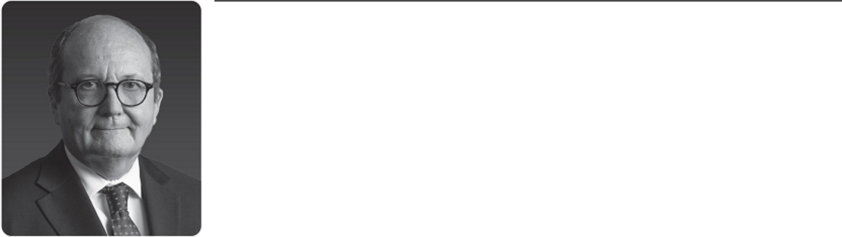

Former Chief Financial Officer, | SLB Board Committees
TotalEnergies SE | • | Audit, Chair
Director since 2019 | • | Finance
Director since 2019 | Other Experience and Education
Other Current Public Boards | • Experienced director of several French-based public companies
• Michelin (Compagnie Générale des | • Diplôme d’Ingénieur, an engineering degree, École Centrale de
Établissements Michelin SCA) |  | Paris

Former Public Director Roles

During the Past Five Years

- None

PATRICK DE LA CHEVARDIÈRE is the former Chief Financial Officer of TotalEnergies SE, a French multinational integrated oil and gas company. He served as TotalEnergies’ CFO and as a member of its executive committee from 2008 until his retirement in August 2019. Prior to that, he served in a variety of finance and operational roles with TotalEnergies over his 37-year career, including as Deputy Chief Financial Officer from 2003 to 2008, Vice President, Asia for Refining & Marketing from 2000 to 2003, and Vice President, Operations and Subsidiaries from 1995 to 2000. Since June 2020, Mr. de La Chevardière has also served as a member and chairman of the audit committee of the supervisory board of Michelin, a French multinational tire manufacturer. He also previously served on the boards of directors of two other French-based public companies, Sanofi-Aventis and Compagnie Générale de Géophysique.

Reason for Nomination

Mr. de La Chevardière brings to the Board financial and industry experience as a former CFO of a large multinational energy company. The Board benefits from his customer-focused perspective on the oilfield services industry, and from his experience across the entire energy value chain, from exploration, operations, production, trading, and marketing to refining and new energies.

Miguel Galuccio,

Non-Executive Director
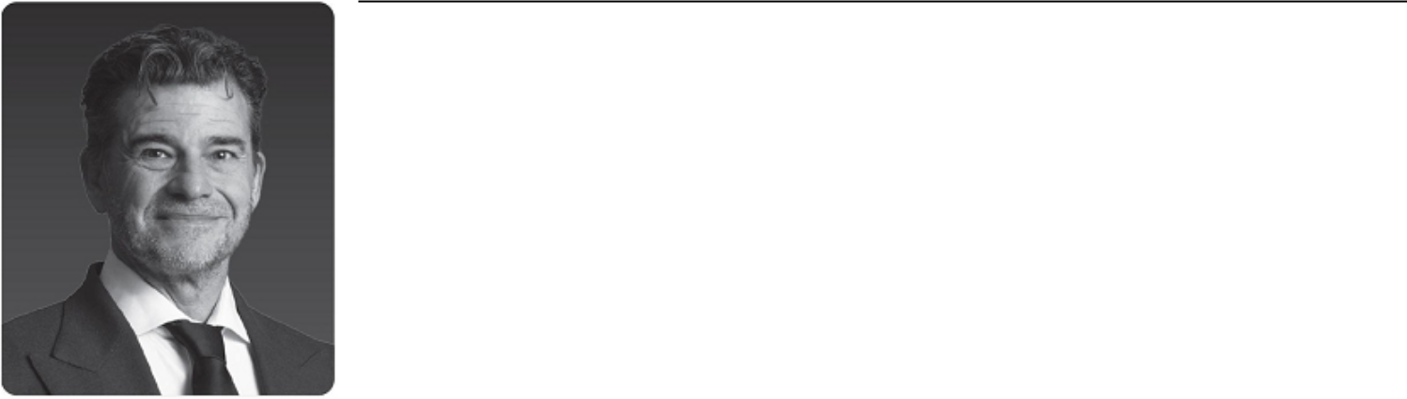

Chairman and Chief Executive Officer, | SLB Board Committees
Vista | • Finance, Chair
Director since 2017 | Other Experience and Education
 | • Bachelor of Science in Petroleum Engineering, Instituto
Other Current Public Boards | Tecnológico de Buenos Aires
• Vista | • SLB training and expertise
Former Public Director Roles | • Latin America energy policy expertise
During the Past Five Years
• None

MIGUEL GALUCCIO founded and is the Chairman and Chief Executive Officer of Vista Energy, S.A.B. de C.V. (Vista), the first listed independent energy company to operate and produce in the Vaca Muerta formation in Argentina, having held that position since 2017. In 2016, he co-founded GRIDX, a science-based incubation fund that creates and invests in biotech startups in Latin America, where he currently acts as chairman. Prior to that, from 2012 to 2016, he served as Chairman and Chief Executive Officer of YPF, Argentina’s largest energy company. From 1999 to 2012, he was an employee of SLB and held several international positions, his last being President, SLB Production Management. Prior to his employment at SLB, he served in various executive positions at YPF and its subsidiaries from 1994 to 1999, including YPF International. Mr. Galuccio is also a director of Nilus, a start-up company that develops technologies to lower the cost of living for low-income individuals.

Reason for Nomination

Mr. Galuccio brings to the Board leadership and operational expertise from his experience as former chairman and chief executive officer of Argentina’s largest energy company, which under his leadership became the world’s largest producer of shale oil outside of North America. He has valuable insight into the domestic and international energy policies of Argentina, Mexico, Venezuela, and Ecuador, and he brings a unique perspective of customer and company operations. He also remains active in the oil and gas exploration and production industry as a chief executive officer of an energy company.

14 2024 Proxy Statement

Back to Contents

Jim Hackett,

Independent Chair of the SLB Board of Directors
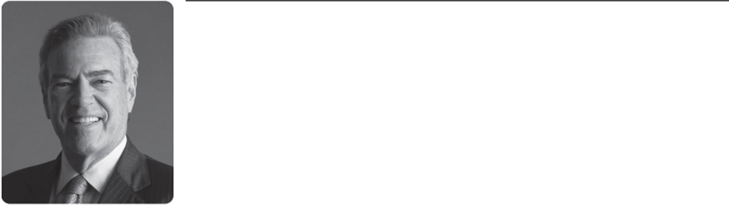

President, |  | SLB Board Committees
Tessellation Services |  | • None
Director since April 2023 |  | Other Experience and Education
 |  | • MBA, Harvard University Business School
Other Current Public Boards |  | • Master of Theological Studies, Harvard Divinity School
• | Enterprise Products Holdings | • Former Chairman of Board of the Federal Reserve Bank of
• | Fluor Corporation | Dallas
• | NuScale Power Corporation | • Former Chairman of National Petroleum Council (US)
 |  | • Board service for multiple public companies in the energy
Former Public Director Roles |  | services industry, including NOV, Halliburton, and Cameron
During the Past Five Years |  | International
• | Alta Mesa Resources
• | NOV Inc.

JIM HACKETT has been the president of Tessellation Services, a privately held consulting services firm, since 2013. He was previously the executive chairman of Alta Mesa Resources, an onshore exploration and production company, from 2018 to March 2020, and was a partner and senior advisor at Riverstone Holdings, a private energy investment firm, from 2013 to March 2020. Prior to that, Hackett served as executive chairman and CEO of Anadarko Petroleum Corporation from 2003 to 2013. Since December 2021, he has been the non-executive chair of NuScale Power Corporation, where he also serves as chair of the organization and compensation committee and as a member of the audit committee. He has also been a director of Enterprise Products Holdings since 2014, where he serves as chair of the governance committee and as a member of the capital projects committee; and a director of Fluor Corporation since 2016, with prior service from 2001 to 2015, where he serves as chair of the organization and compensation committee and as a member of the executive and commercial strategies and operational risk committees. He has also been a faculty member at Rice University and The University of Texas at Austin since 2017, and he serves on the boards of trustees at Rice University and Baylor College of Medicine.

Reason for Nomination

Mr. Hackett brings to the board extensive knowledge of the global energy industry, as the former Chairman and CEO of a global energy production and midstream company, as well as board chair and director service at numerous public companies serving the energy industry, and financial acumen as the former Chairman of the Board of the Federal Reserve Bank of Dallas. The Board benefits from his operational and financial leadership on business strategy as well as his insights into international energy markets.

Olivier Le Peuch,

SLB Chief Executive Officer
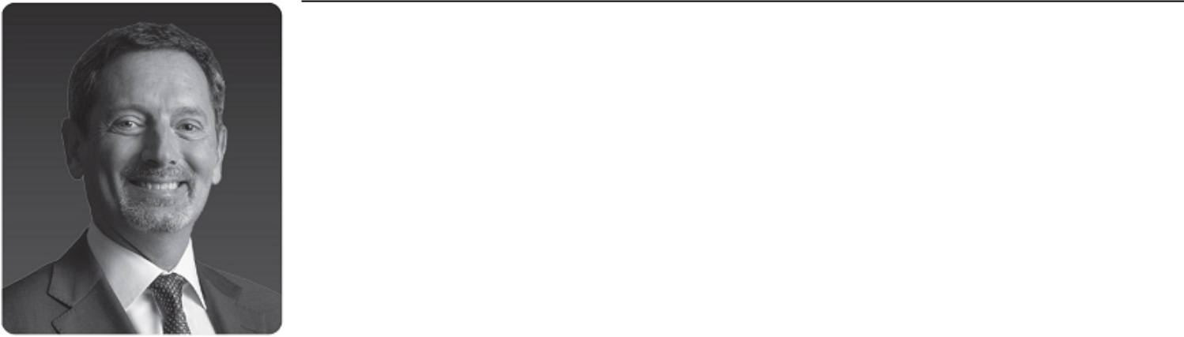

Chief Executive Officer, SLB | SLB Board Committees
Director since 2019 | • None
Director since 2019 | Other Experience and Education
Other Current Public Boards | • Master’s Degree in Microelectronics, Bordeaux University of
• None | Science
Former Public Director Roles | • SLB training and expertise
During the Past Five Years
• None

OLIVIER LE PEUCH has been SLB’s Chief Executive Officer and a member of the Board since August 2019. He was SLB’s Chief Operating Officer from February 2019 to July 2019. Prior to that, he served in a variety of global management positions, including Executive Vice President, Reservoir and Infrastructure from May 2018 to February 2019, President of the Cameron Group from 2017 to May 2018, President of SLB Completions from 2014 to 2017, and Vice President of Engineering, Manufacturing, and Sustaining from 2010 to 2014. Earlier in his career, Mr. Le Peuch was GeoMarket Manager for the North Sea and President of Schlumberger Information Solutions. He has been with SLB since 1987 and began his career as an electrical engineer.

Reason for Nomination

Mr. Le Peuch brings to the Board unparalleled knowledge of SLB’s operational activities worldwide and its technology differentiation as a result of his service in various global leadership positions at SLB. The Board believes that Mr. Le Peuch’s service as our CEO is an important link between management and the Board, enabling the Board to perform its oversight function with the benefit of his perspectives on SLB’s business and operations.

2024 Proxy Statement |  | 15

Back to Contents

Samuel Leupold,

Independent Director
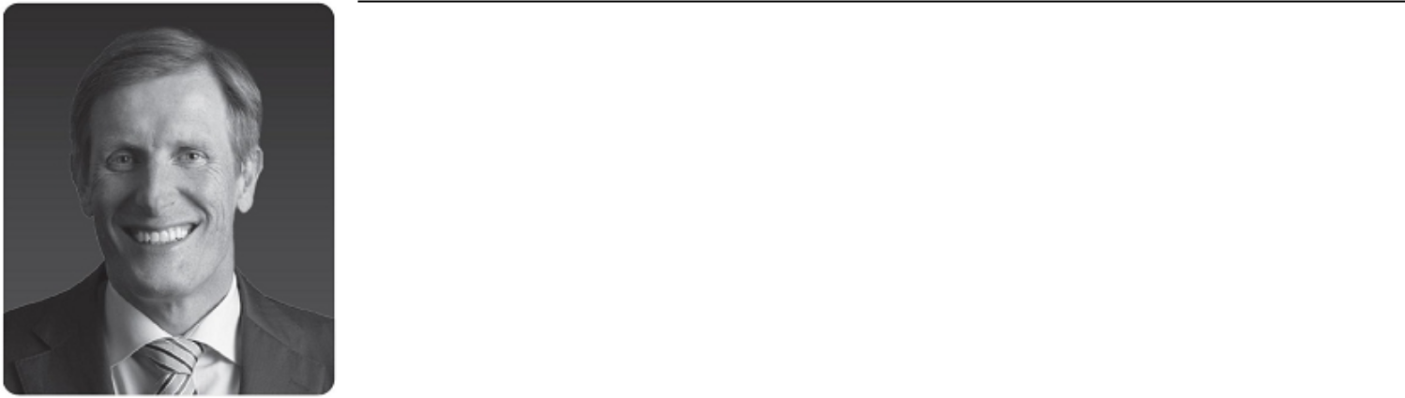

Former Chief Executive Officer, | SLB Board Committees
Ørsted Wind Power A/S | • | Audit
 | • | Finance
Director since 2021 | • New Energy and Innovation
Other Current Public Boards | Other Experience and Education
• None | • Master’s Degree in Mechanical Engineering, Swiss Federal
 |  | Institute of Technology (Zurich)
Former Public Director Roles | • | MBA, INSEAD (Fontainebleau)
During the Past Five Years | • Energy transition and sustainability expertise
• Enel SpA

SAMUEL LEUPOLD is the former chief executive officer of Ørsted Wind Power A/S, the principal subsidiary of Ørsted AS, a Danish renewable energy company, where he led Ørsted Wind Power to become the world’s leading developer, operator and owner of offshore wind assets during his tenure from 2013 to March 2018. Since May 2019, Mr. Leupold has served as an independent senior advisor supporting international clients in the energy and infrastructure sectors through his consultancy firm, Leupold Advisory. He has also served as chair of Corio Generation, a specialist offshore wind business and Macquarie Green Investment Group portfolio company, since March 2022, and as a director of Axpo Holding AG, Switzerland’s largest producer of renewable energy, since January 2024. Mr. Leupold previously served as a director of Enel SpA from May 2020 to May 2023.

Reason for Nomination

Mr. Leupold brings to the Board operational experience as the former CEO of a renewable energy company, as well as significant energy transition experience focused on the relationship between new energy generation and infrastructure capabilities. The Board benefits from his expertise on these issues as SLB seeks to implement our net-zero ambition and our strategy to deploy sustainable technologies to provide access to energy for the benefit of all.

Tatiana Mitrova,

Independent Director

Research Fellow, | SLB Board Committees
Center on Global Energy Policy, | • | Audit
School of International and Public | • | Finance
Affairs at Columbia University | • New Energy and Innovation
Director since 2018 | Other Experience and Education
 | • PhD in Economics, Moscow State University
Other Current Public Boards | • Senior Visiting Research Fellow at Oxford Institute for Energy
• None |  | Studies

Former Public Director Roles

During the Past Five Years

- PAO Novatek

TATIANA MITROVA has been a research fellow at the Center on Global Energy Policy at the School of International and Public Affairs at Columbia University since 2016. She has also been a visiting professor at the Paris School of International Affairs, part of the Paris Institute of Political Studies, since 2014. From 2017 to December 2020, she served as executive director of the Energy Centre of the Moscow School of Management SKOLKOVO, a graduate business school, where she also served as a professor until February 2022. She was also the head of research in the Oil and Gas Department in the Energy Research Institute of the Russian Academy of Sciences from 2011 to February 2022, and an assistant professor at the Gubkin Russian State University of Oil and Gas from 2008 to February 2022. She was previously a director of PAO Novatek from April 2020 to September 2022.

Reason for Nomination

Dr. Mitrova brings to the Board valuable expertise regarding energy market dynamics and the various factors affecting supply and demand for SLB’s products and services, as well as expertise relating to sustainability, decarbonization, and the new energy economy. The Board values Dr. Mitrova’s knowledge of international energy markets and related risks, as well as her ties to the academic community. Her global economic perspective provides insight into emerging markets and trends, and is useful for the development of SLB’s global business strategy.

16 2024 Proxy Statement

Back to Contents

Maria Moræus Hanssen,

Independent Director
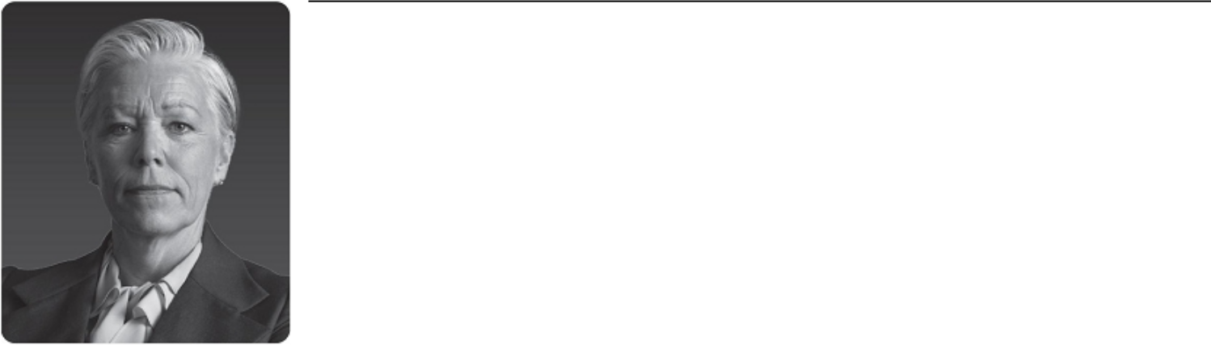

Former Deputy Chief Executive Officer |  | SLB Board Committees
and Chief Operating Officer, |  | • New Energy and Innovation, Chair
Wintershall Dea GmbH |  | • | Compensation
Director since 2020 |  | • | Nominating and Governance
 |  | Other Experience and Education
Other Current Public Boards |  | • Former CEO of multiple E&P companies
• | Kosmos Energy | • Master’s Degrees in Petroleum Engineering, Norwegian
• | Scatec ASA |  | University of Science and Technology, and Petroleum Economics
 |  |  | and Management, IFP School
Former Public Director Roles |  | • Corporate director certificate from Harvard Business School
During the Past Five Years |  |  | (2021)
- Alfa Laval AB

- Yara International ASA

MARIA MORÆUS HANSSEN is the former Deputy CEO and Chief Operating Officer of Wintershall Dea GmbH, a German-based energy producer, having served in that role from May 2019 to December 2019 following the merger between DEA Deutsche Erdoel AG (DEA) and Wintershall Holding GmbH. Prior to that, she served as CEO of DEA and chair of its management board from 2018 until April 2019. Before joining DEA, she served as CEO of ENGIE E&P International SA and head of the E&P business unit for the ENGIE Group in Paris from 2015 to 2017. Ms. Moræus Hanssen served in various management and operations roles at Aker from 2008 to 2013, Statoil (now Equinor) from 2007 to 2008, and Norsk Hydro from 1992 to 2007. She has served on the boards of Scatec ASA since April 2020, Kosmos Energy since April 2023, and Å Energi since June 2023, and also serves in director and chair roles on various private company and non-profit boards. She previously served as deputy chairman and audit committee chair of Yara International from 2015 to May 2019, and as a director of Alfa Laval AB from May 2019 to May 2023.

Reason for Nomination

Ms. Moræus Hanssen brings to the Board leadership and operational expertise as the former CEO of several European energy companies. The Board values her insight into the domestic and international energy policies of Norway, Germany, France, and other countries that are strategically important to SLB, as well as her experience addressing risks related to the energy transition.

Vanitha Narayanan,

Independent Director


Former Chairman and Managing |  | SLB Board Committees
Director, IBM India |  | • Nominating and Governance, Chair
Director since 2021 |  | • Compensation
 |  | Other Experience and Education
Other Current Public Boards |  | • MBA, University of Houston
• | ReNew Energy Global | • First woman chairperson of American Chamber of Commerce in
• | HCL Technologies | India (AMCHAM India)

Former Public Director Roles

During the Past Five Years

- None

VANITHA NARAYANAN is the former Chairman and Managing Director of IBM India, a subsidiary of IBM, a multinational information technology corporation. Over her career spanning three decades at IBM, she held senior executive positions with responsibility for digital businesses in the United States, Asia-Pacific, and India regions, including as Chairman of IBM India from January 2017 to March 2018 and Managing Director from 2013 to 2016. During her tenure, IBM India was one of IBM’s fastest-growing markets. Most recently, Ms. Narayanan led a strategic 5G partnership as Managing Director for one of IBM’s telecommunications clients from April 2018 until her retirement in 2020. Since August 2020, she has served as a director of ReNew Energy Global, one of the largest renewable power companies in India, where she chairs the remuneration committee and serves as a member of the audit and finance committees. She has also been a director of HCL Technologies since July 2021, where she chairs the nomination and remuneration committee.

Reason for Nomination

Ms. Narayanan brings to the Board a wealth of global leadership and technology experience, particularly in India and other Asian markets. The Board values Ms. Narayanan’s digital expertise leading global technology businesses as SLB continues to implement its digital and AI strategies.

2024 Proxy Statement |  | 17

Back to Contents

Jeff Sheets,

Independent Director
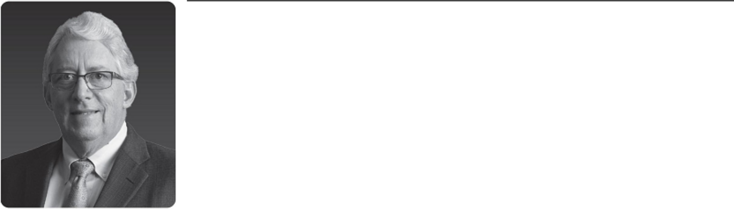

Former EVP and Chief Financial Officer, |  | SLB Board Committees
ConocoPhillips |  | • | Compensation, Chair
Director since 2019 |  | • | Audit
 |  | Other Experience and Education
Other Current Public Boards |  | • MBA, University of Houston
• | Enerplus Corporation | • Bachelor of Science in Chemical Engineering, Missouri University
• | Westlake Corporation |  | of Science and Technology

Former Public Director Roles

During the Past Five Years

- None

JEFF SHEETS is the former EVP and Chief Financial Officer of ConocoPhillips Company, a public international energy company, having served in that role from 2010 until his retirement in 2016. Prior to that, Mr. Sheets served at ConocoPhillips and its predecessor companies for more than 36 years in a variety of finance, engineering, and strategic planning roles. Since 2017, Mr. Sheets has served as a director of Enerplus Corporation, a Canadian energy company, where he chairs the audit and risk management committee and is a member of the compensation committee. He also has served since January 2018 as a director of Westlake Corporation, an international manufacturer and supplier of petrochemicals and related products, where he chairs the nominating and governance committee and is a member of the audit, compensation, and corporate risk committees. Mr. Sheets is a member of the Board of Trustees at the Missouri University of Science and Technology.

Reason for Nomination

Mr. Sheets brings to the Board financial and operational expertise as a former chief financial officer of a major energy company. The Board benefits from Mr. Sheets’ expertise in developing and implementing corporate strategy in the energy industry, as well as his significant finance, capital management and allocation, and mergers and acquisitions experience.

Ulrich Spiesshofer,

Independent Director
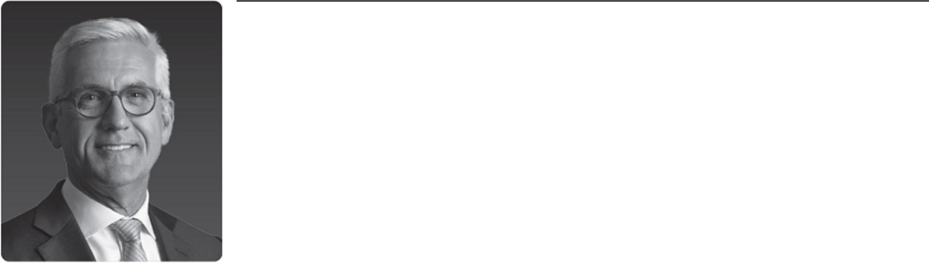

Former President and CEO, | SLB Board Committees
ABB Ltd. | • Compensation
Director since 2021 | • New Energy and Innovation
Director since 2021 | Other Experience and Education
Other Current Public Boards | • PhD in Economics, Universität Stuttgart
• Infineon Technologies | • Master’s Degree in Management and Engineering, Universität
 | Stuttgart
Former Public Director Roles | • Digital transformation, restructuring, and portfolio management
During the Past Five Years | expertise
• None

ULRICH SPIESSHOFER is the former president and Chief Executive Officer of ABB Ltd., a multinational technology-focused corporation, having served in that role from 2013 to April 2019 and as an ABB executive committee member from 2005 to April 2019. Under Dr. Spiesshofer’s leadership, ABB transformed into a global leader in digital industries and a respected technology company at the nexus of industrial products and services, robotics, and software. Since June 2020, he has served as a senior advisor at The Blackstone Group L.P. (Blackstone), and in this capacity he has chaired the advisory boards of Interplex Ltd since January 2023, Sabre Industries since January 2021, and Schenck Process from May 2021 to September 2023, and he has served as a director of TDI-USA Holdings LLC since December 2021—all Blackstone portfolio companies. He has also served as a director of Infineon Technologies since February 2020, where he is a member of the strategy and technology committee.

Reason for Nomination

Dr. Spiesshofer brings to the Board more than 30 years of global leadership experience in industries ranging from oil and gas to power and electrification to automation and digitalization. The Board values his industrial sector expertise and his business transformation experience leveraging digital technologies, products and services.

18 2024 Proxy Statement

Back to Contents

Corporate Governance

SLB is committed to strong corporate governance, which we believe is critical to achieving our performance goals and to retaining the trust of our stakeholders. This section describes SLB’s corporate governance policies and practices that foster the Board’s effective oversight of our business strategies and operations.

New Independent Chair
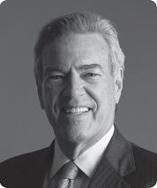

In 2023, the Board concluded its multi-year board refreshment exercise with its appointment of Mr. Jim Hackett as our new independent Board Chair. Mr. Hackett succeeded Mr. Mark Papa, who served in the Board Chair role from 2019 through June 2023, overseeing the Board during a key transitional period for SLB.

The Nominating and Governance Committee considered both internal and external candidates for the Chair’s role. They were impressed by Mr. Hackett’s extensive knowledge of the global energy industry, both as the former chairman and CEO of a global energy production and midstream company, and by his extensive governance and prior board chair experience at numerous public companies serving the energy industry.

The Committee also reviewed SLB’s Corporate Governance Guidelines, which set limits on our directors’ outside board commitments, and determined that Mr. Hackett’s board roles at other listed companies were consistent with our Guidelines, could benefit SLB, and would not detract from his ability to devote the necessary time and attention to SLB.

Jim Hackett

Leadership Structure

One of the Board’s key responsibilities is to evaluate and determine an appropriate board leadership structure to provide independent oversight of SLB management. The Board believes that there is no single, generally accepted board leadership structure that is appropriate for all companies, and that the right structure may even vary for a single company as circumstances change. As a result, our independent directors, upon the recommendation of the Nominating and Governance Committee, consider the Board’s leadership structure at least annually. The Board welcomes and takes under consideration any input received from our shareholders regarding the Board’s leadership structure, and informs shareholders of any change in the Board’s leadership structure in our current Corporate Governance Guidelines that we publish on our website and describe in our annual proxy statements.

Since 2019, our Board has separated the roles of CEO and Board Chair, to allow our CEO to focus on leading SLB’s complex international business operations, while the Chair provides the Board with experienced and independent leadership. Mr. Hackett currently serves as independent Board Chair, and in that role, sets the agenda for and leads all Board meetings and all executive sessions of the non-executive directors.

In considering its leadership structure, the Board took into account that SLB’s current governance practices provide for strong independent leadership, active participation by our independent directors, and independent evaluation of, and communication with, many members of senior management. The Board believes that its risk oversight programs would be effective under a variety of board leadership frameworks and therefore do not materially affect the Board’s choice of leadership structure.

New SLB Code of Conduct Launched in 2023

In April 2023, the Board approved and adopted a revised code of conduct titled “Together with Integrity — Our Code of Conduct.” The revised Code of Conduct aligns with the Company’s newly implemented cultural framework, is organized according to Company values and behaviors, and expands and re-emphasizes SLB’s core expectation for our officers, directors, employees, and suppliers to act with integrity in an evolving world. The revisions were designed to enhance the impact and relatability of the Code, providing clarity in an easily digestible style, including the addition of Integrity in Action guidance for practical application. In addition, the revised Code of Conduct emphasizes and reiterates reporting channels to help everyone feel empowered to speak up.

The roll-out of the revised Code of Conduct was a global campaign of engagement across the whole SLB organization. Our CEO and Chief Legal Officer led the management team in launching the Code of Conduct through both interactive virtual and live events, including localized events around the globe designed to engage and spread awareness and training on the values and expectations of the new Code of Conduct.

The revised Code of Conduct is available on SLB’s website at https://www.slb.com/about/who-we-are/our-code-of-conduct.

2024 Proxy Statement |  | 19

Back to Contents

Effective Board Oversight of Risk Management

The Board and its committees are actively involved in overseeing SLB’s risk management. We believe that our Board composition provides SLB with robust and well-rounded experience to assist in effective oversight of SLB management, as reflected on the chart on page 12 of this proxy statement.

The full Board routinely assesses SLB’s major risks and mitigation measures, in order to promote our shareholders’ and other stakeholders’ interests in SLB’s business continuity, long-term resilience, financial strength, and overall success. In addition, the Board delegates to its committees responsibility for overseeing certain types of risk, as reflected in the chart below, and the committees in turn report regularly to the Board on activities in their respective areas of oversight.


Board of Directors

The full Board oversees the assessment of major risks facing SLB, including determinations of the extent to which such risks are applicable, the potential impact of a risk, and the organization’s maturity in mitigating or managing the risk. The Board oversees risk management by the CEO and our senior management team, by reviewing major financial objectives, critical strategies, and long-term plans, including allocation of capital, significant proposed business acquisitions and divestitures, operating performance, and shareholder returns. See “—Enterprise Risk Management Process” on page 21 of this proxy statement.


Audit

Committee

- Financial reporting and internal controls

- Major financial risk exposures

- Cybersecurity risks

- Finance-related compliance allegations

- Independent audit and internal audit

Compensation

Committee

- Compensation philosophy and policy, including addressing:

  - Pay-for-performance linkage and alignment to shareholder interests

  - Retention risk

  - Management succession

Nominating and

Governance

Committee

- Board refreshment and Board and CEO succession

- Ethics and compliance risks, including trade compliance and anti-bribery, and significant allegations

- Related person transactions

- Effectiveness of sustainability program, including short- and long-term climate risks and progress toward our net zero ambition

- Effectiveness of human rights program


 | Finance |  | New Energy and
 | Committee |  | Innovation Committee
• Appropriate leverage and |  |  | • Critical risks and
 | related commitments |  | opportunities of:
• Currency management, |  |  | • Targeted new energy
 | including non-U.S. |  | sectors
 | currency fluctuation |  | • Critical innovation
• | Financial risks related to |  | initiatives
 | M&A and strategic
 | transactions
• | Pension liabilities

SLB Senior Management

Day-to-day responsibility for:

- Identifying, assessing, monitoring, and managing the major risks to SLB through our risk management process

- Implementing effective risk mitigation measures, response plans, and controls

- Integrating risk analysis into business decisions and performance objectives

20 2024 Proxy Statement

Back to Contents

Enterprise Risk Management Process

Our senior management team has developed a comprehensive strategic planning and enterprise risk management process for identifying, assessing, and managing risk.

This process begins with risk identification by our business lines and GeoUnits through an operational risk management exercise. Risks with impacts at this initial level are addressed with risk management or mitigation plans. Risks that have a wider potential impact are elevated for consideration at our Basin and Division levels, where the risks are either addressed or elevated for consideration at our executive leadership team level.

In addition, SLB has a team of functional experts and leaders that review inputs from the bottoms-up operational risk management exercise, while also considering key trends and developments in their fields, to ensure that the broadest set of potential risks are identified and assessed for potential impacts to the Company. The analysis of the impact of a potential risk includes assessing the potential financial or reputational impact, the potential impact to SLB’s ability to implement its strategy, the velocity of the risk (how quickly a risk could manifest), and the level of SLB’s existing response preparedness.

Our executive leadership team has established the Enterprise Risk Management and Disclosure Committee to oversee this risk identification process and to monitor the implementation of mitigation or management processes. This process also includes third-party assessments, external risk surveys, and facilitated workshops with SLB executives to provide opportunities for the Company to adjust with the evolving risk landscape.

Based on these comprehensive risk identification and assessment processes, SLB’s executive leadership team recommends to the Board those enterprise-level risks that should be overseen by the Board. Based on the experience of the Directors, the Board itself may identify additional risks to be included among the Company’s enterprise-level risks. The Board then reviews management’s risk response or mitigation plans. For certain risks, the Board or its committees will have primary risk response or mitigation responsibility. Our executive leadership team updates the Board on the enterprise risk management process at least annually, as risks that could impact the implementation of the Company’s strategy are identified or evolve.

The risks that the Board routinely reviews relate to financial, geopolitical, strategic, regulatory, competitive, governance, reputational, climate-related, and operational risks, including cybersecurity risks and risks relating to operations in regions with elevated geopolitical tensions. For additional information about risks resulting from SLB’s global operations, see “Risk Factors – Business and Operational Risks – Disruptions in the political, regulatory, economic, and social environments of the countries in which we operate could adversely affect our reputation, financial condition, results of operations and cash flows.” in Item 1A. in our 2023 Annual Report.

Environmental and Sustainability Oversight

Today, the world faces the challenge of providing secure and affordable energy to meet growing demand, while decarbonizing for a sustainable future. With nearly a century of market and technology leadership, SLB is well positioned and committed to being a leader in providing solutions to address this trilemma. As part of this commitment, the Board and its committees oversee the performance and management of various environmental, social, nature, and other sustainability issues, including our energy transition strategy, emissions reduction targets, climate change impact, sustainability reporting, workforce health and safety, human rights, workforce diversity, biodiversity, water resources, and ethics and compliance.

As shown in the chart on page 20, the Board oversees SLB’s long- and short-term strategy, including our roadmap to achieve our 2050 net-zero commitment, and the Board delegates to the Nominating and Governance Committee oversight of our sustainability programs, initiatives, and activities. The Board’s other committees oversee sustainability-related topics within their respective areas of responsibility, such as the incorporation of sustainability and diversity metrics into our incentive compensation programs (Compensation); the growth potential, maturity, and viability of our targeted New Energy business sectors (New Energy and Innovation); the conduct of sustainability-related reviews by our internal audit team (Audit); operational risks such as cybersecurity (Audit); and the disclosure of ESG risks (Audit and Nominating and Governance, jointly). For details about our sustainability programs and initiatives, see our most recent Impact Report, available on SLB’s website at https://www.slb.com/sustainability/.

Our line management is directly responsible for the management and mitigation of the environmental impact of our operations. Our Vice President of HSE is responsible for our environmental management systems, and our Vice President of Sustainability is responsible for our global sustainability strategy and programs. For details about our environmental management standard and how we manage environmental risk, see SLB’s health, safety, and environmental (HSE) website at https://www.slb.com/about/leadership-and-governance/hse.

Cybersecurity Oversight

The Audit Committee oversees SLB’s cybersecurity risk exposures and the steps taken by management to monitor and mitigate cybersecurity risks. The cybersecurity team briefs the Audit Committee on the effectiveness of SLB’s cyber risk management program, typically on a quarterly basis. In addition, cybersecurity risks are reviewed by the Board, at least annually, as part of the Company’s corporate risk mapping exercise. For additional information about our cybersecurity program, see Item 1C. Cybersecurity in our 2023 Annual Report.

2024 Proxy Statement |  | 21

Back to Contents

Proactive Shareholder Engagement

Our relationship and on-going dialogue with our shareholders are important parts of our Board’s corporate governance commitment. Our investor relations, sustainability, legal, and human resources teams engage with shareholders throughout the year to seek their views on key matters, and then inform our Board and management about the issues and emerging governance trends that our shareholders tell us matter most to them. The chairs of our Compensation and Nominating and Governance committees have also participated in our engagement efforts when requested. These engagements routinely cover executive compensation, corporate governance, company strategy and performance, sustainability, human rights, and other current and emerging issues.

We typically reach out to our largest institutional shareholders at least annually. We then report the feedback we receive to our Board and its relevant committees, allowing the Board to better understand our shareholders’ priorities and perspectives. In addition, we may engage with our large institutional shareholders at other times in the year when we believe that there are appropriate topics to discuss. For details about our recent shareholder outreach, see “Compensation Discussion and Analysis—Framework for Setting 2023 Executive Compensation—Responsiveness to Shareholder Feedback” beginning on page 35 of this proxy statement.

Director Selection and Qualifications

The Nominating and Governance Committee recommends the number and names of persons to be proposed by the Board for election as directors at our AGMs. The Committee also assists the Board in identifying qualified individuals to join as new Board members. In evaluating potential nominees, the Committee takes into consideration, among other factors:

- the Board’s current composition, including the skills, experience, and backgrounds of our incumbent directors as reflected in the chart on page 12 of this proxy statement,

- SLB’s existing and anticipated business needs, aligned to our strategic goals and initiatives,

- a potential nominee’s ability to contribute to the Board’s diversity, as discussed under “Leader in Global Diversity—Board Diversity” on page 11 of this proxy statement, and

- the personal characteristics and general qualifications that the Committee believes all nominees should possess, as listed in the chart at right.

Qualifications of Director Nominees


Integrity and honesty

Ability to exercise sound, mature, and independent business judgment

Recognized leaders in business or professional activity

Background and experience that will complement the experience and talents of the other Board members

Willingness and availability to actively participate in Board and committee meetings and related activities

Ability to work professionally and effectively with other Board members and SLB management

Availability to remain on the Board and its committees long enough to make an effective contribution

No material relationship with competitors or other third parties that could present realistic possibilities of conflicts of interest or legal issues

The general methodology for identifying candidates for nomination to the Board is outlined in the diagram below.
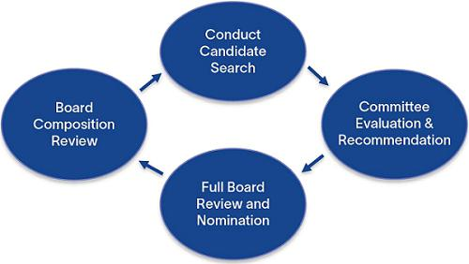

First, the Nominating and Governance Committee reviews the Board’s current composition, identifying key skills, experience, and backgrounds of potential candidates that would complement those of our other Board members.

Next, the Committee initiates a candidate search, making its own inquiries while also collecting suggestions from other directors and SLB management.

From time to time, the Committee retains executive search and board advisory consulting firms to assist in identifying and evaluating potential nominees.

Upon retaining these firms, we request that they include women and nationally, racially, and ethnically diverse candidates in the proposals they present to us.

The Nominating and Governance Committee then conducts a thorough evaluation of proposed new Board candidates, typically involving a series of internal discussions, interviews with selected candidates, and reviews of information about the candidates. Following this evaluation, the Committee

summarizes its findings and provides to the full Board its recommendations for nomination to the Board. The Board, upon the recommendation of the Nominating and Governance Committee, selects the director nominees to be elected at our next AGM.

22 2024 Proxy Statement

Back to Contents

Demonstrated Commitment to Board Refreshment

The Board is committed to thoughtful board refreshment and ongoing board succession planning. Half of SLB’s non-executive directors—including our new independent Chair—joined the Board since 2021, and all directors joined within the last seven years, bringing diverse and evolving experience and leadership skills in areas that are strategically important to SLB. Our directors have an average age of 60 and have served on our Board for an average of four years. Our non-executive directors are eligible to serve on the Board until age 75 or for a maximum ten-year term—whichever occurs first—under our Corporate Governance Guidelines.
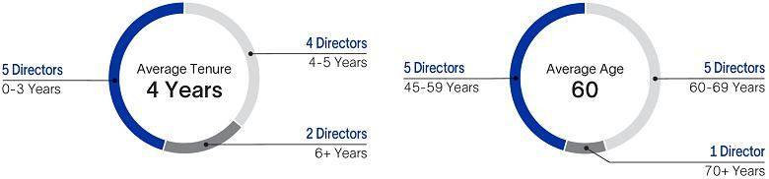

Nominees Recommended by Shareholders

The Nominating and Governance Committee will also consider nominees recommended by shareholders who meet the eligibility requirements for submitting shareholder proposals for inclusion in SLB’s next proxy statement and who submit their recommendations in writing to:

Nominating and Governance Committee Chair

c/o SLB Chief Legal Officer and Secretary

5599 San Felipe

Houston, Texas 77056

All recommendations must be submitted by the deadline for shareholder proposals referred to under “Information About the Meeting—Shareholder Proposals at 2025 AGM” on page 68 of this proxy statement. Unsolicited recommendations must contain all of the information that would be required in a proxy statement soliciting proxies for the election of the candidate as a director, a description of all direct or indirect arrangements or understandings between the recommending security holder and the candidate, all other companies to which the candidate is being recommended as a nominee for director, and a signed consent of the candidate to cooperate with reasonable background checks and personal interviews, and to serve as a member of our Board, if elected.

Comprehensive Director Orientation and Education

Our director orientation and continuing education programs are designed to support our directors in fulfilling their responsibilities as members of the Board. First, all new directors participate in SLB’s director orientation program, to familiarize themselves with our business and operations, financial and performance strategies, controls and compliance systems, sustainability and HSE commitments, industry dynamics, and corporate governance standards. New directors also attend trainings with members of senior management focused on financial, industry- and committee-specific topics, as well as facility and well-site visits.

For new and incumbent directors, regular continuing education programs help our Board stay current on industry, corporate governance, risk management, geopolitics, cybersecurity, and other developments relevant to their work as directors. These programs may include presentations from SLB management or in-depth trainings developed by outside experts, as appropriate. SLB encourages directors to attend external trainings related to their Board responsibilities, and provides resources for director education opportunities across a wide range of topics.

2024 Proxy Statement |  | 23

Back to Contents

Rigorous Evaluation Processes

Each year, the Board and its committees conduct rigorous evaluations in order to assess the overall functioning, performance, and effectiveness of the Board, its committees, and the individual directors. The Nominating and Governance Committee oversees this annual evaluation process. From time to time, these evaluations may be conducted using a third-party facilitator. The methodology for conducting Board and Committee evaluations is outlined in the chart below.


Initiate Evaluation Process

Upon the instruction of the Nominating and Governance Committee, written self-assessment questionnaires are distributed to each member of the Board.

These questionnaires seek anonymous, candid feedback from our directors on a variety of topics, including board composition and culture, committee effectiveness, strategic planning, risk management, peer evaluation, and succession planning.

Collect Evaluation Data

Directors’ responses to the questionnaires are then aggregated into summary reports for the Board, each of its committees, and the chair of the Nominating and Governance Committee.

In 2023, all questionnaires were distributed and responses collected through a third-party platform. Periodically, the Nominating and Governance Committee has also used a third-party facilitator to conduct one-on-one interviews with Board members as part of this annual evaluation process.

Discuss Findings

Each October, findings from the evaluation process are reviewed and discussed in executive session at each committee meeting and the full Board meeting. Based on these discussions, the directors may recommend improvements to the Board’s structure, processes, policies, or composition, or other changes.

In 2023, the Board Chair conducted one-on-one interviews with each director to seek additional insights and to provide feedback. The chair of the Nominating and Governance Committee reviews the Chair’s peer evaluation and provides feedback if appropriate.

Implement Feedback

Finally, the Board, its committees, and (where appropriate) management work to implement the feedback from this evaluation process to improve Board performance and effectiveness.

Following this process, the Nominating and Governance Committee annually reviews—and makes recommendations to the Board regarding—its process for evaluating the effectiveness of the Board, its committees, and individual directors.

Board Committees

The Board has five standing committees: Audit, Compensation, Nominating and Governance, Finance, and New Energy and Innovation. Each member of the Audit, Compensation, and Nominating and Governance committees meets the independence and other requirements of the New York Stock Exchange (NYSE) listing standards and SEC rules (including the heightened requirements that apply to audit or compensation committee members, as applicable).

In addition, each member of the Audit Committee is financially literate, and each of Mr. de La Chevardière and Mr. Sheets qualifies as an “audit committee financial expert” under applicable SEC rules.

The Nominating and Governance Committee nominates directors to serve on and chair the Board’s committees, for final approval by the full Board. The following table reflects the current membership of the Board’s standing committees.

 |  |  | Nominating and |  | New Energy
 | Audit | Compensation | Governance | Finance | and Innovation
Name of Director | Committee | Committee | Committee | Committee | Committee
Peter Coleman |  |  | l | l
Patrick de La Chevardière | Chair |  |  | l
Miguel Galuccio |  |  |  | Chair
Jim Hackett⁽¹⁾
Samuel Leupold | l |  |  | l | l
Tatiana Mitrova | l |  |  | l | l
Maria Moræus Hanssen |  | l | l |  | Chair
Vanitha Narayanan |  | l | Chair
Jeff Sheets | l | Chair
Ulrich Spiesshofer |  | l |  |  | l

- Independent Board Chair

24 2024 Proxy Statement

Back to Contents

Each standing committee operates under a written charter that sets forth the purposes, responsibilities, and membership requirements of that committee. Each committee reviews the adequacy of its charter at least annually and recommends changes to the Board for approval.

All committees also report regularly to the Board with respect to their activities. Committee charters are available on SLB’s website at https://www.slb.com/about/leadership-and-governance/corporate-governance.

Meeting Attendance

In 2023, our directors attended an average of 99% of the meetings of the Board and its committees on which they served, and no director attended fewer than 75% of the total number of meetings of the Board and its committees on which they served. Meetings of the Board and its committees were held in 2023 as follows:

 | # of Meetings⁽¹⁾
Board of Directors | 4
Audit Committee | 5
Compensation Committee | 4
Finance Committee | 4
New Energy and Innovation Committee | 3
Nominating and Governance Committee | 4

- All meetings were regularly scheduled; no special meetings were held in 2023.

At each 2023 Board meeting, the Board’s independent Chair led one or more executive session(s) of non-employee directors. In addition, SLB officers regularly attend Board meetings to present information on our business and strategy, and directors have worldwide access to our employees outside of Board meetings. From time to time between meetings, Board and committee members confer with each other, with management, and with independent consultants, and representatives of management may meet with these consultants on behalf of the relevant committee.

No director attended our 2023 AGM, in line with our Articles of Incorporation and with the Board’s policy that directors are welcome, but not required, to attend our AGMs.

Director Independence

Our Corporate Governance Guidelines provide that at least a majority of the Board must consist of independent directors, in accordance with the NYSE listing standards. In addition, our Board has adopted director independence standards that meet or exceed the independence requirements in the NYSE listing standards, and which can be found in our Corporate Governance Guidelines.

Based on the review and recommendation by the Nominating and Governance Committee, the Board has determined that:

- Each director nominee listed above under “Election of Directors—Our Director Nominees” is “independent” under NYSE listing standards and our director independence standards, except for our CEO and Mr. Galuccio.

- Each member of the Audit Committee meets the heightened independence standards required for audit committee members under NYSE listing standards and the rules of the SEC.

- Each member of the Compensation Committee meets the heightened independence standards for compensation committee members under NYSE listing standards and the rules of the SEC.

- Additionally, our former Board Chair, Mr. Papa, was independent during the period he served on our Board in 2023.

Our Board’s confirmation of the independence of our independent directors includes a review of transactions that occurred since the beginning of 2021 with entities associated with our directors or members of their immediate family.

In making its independence determinations, the Board considered that our independent directors serve as directors, trustees, outside consultants, or advisory board members at companies and universities that have had commercial business relationships with SLB. These relationships all involved commercial transactions in the ordinary course with SLB, which were less than the greater of $1 million or 1% of the other entity’s annual revenues during 2023, 2022, and 2021; except for transactions with Kosmos Energy (Kosmos), where Ms. Moræus Hanssen serves as a director, which involved commercial transactions in the ordinary course with SLB that were less than 5% of Kosmos’ 2023 and 2021 revenues.

As part of SLB’s ongoing support of STEM research and educational initiatives, for many years SLB has provided charitable contributions to, and has funded research collaborations with, universities and other non-profit organizations around the world. Our Board has voluntarily adopted an additional independence factor assessing charitable relationships in SLB’s Corporate Governance Guidelines. As a result, the Board reviews SLB’s charitable contributions to academic and other non-profit institutions with which our directors are affiliated.

Since the beginning of 2021, these contributions involved less than $120,000 per year, except for contributions to two universities where Mr. Hackett teaches or lectures—the University of Texas at Austin (contributions were less than $500,000 per year) and Rice University (contributions were less than $200,000 per year). Mr. Hackett had no involvement in any contributions made to these universities, most of which pre-dated his membership on the Board. No director received any personal benefit from any SLB charitable contributions.

2024 Proxy Statement |  | 25

Back to Contents

Corporate Governance Guidelines

We have adopted Corporate Governance Guidelines that our Board believes are consistent with our values, and that promote the effective functioning of our Board, its committees, and the Company. At least annually, our Board reviews and, if appropriate, revises our Corporate Governance Guidelines to reflect the Board’s corporate governance objectives and commitments. Our Corporate Governance Guidelines are available on SLB’s website at https://www.slb.com/about/leadership-and-governance/corporate-governance/guidelines.

Certain Relationships and Related Person Transactions

The Board has a written policy governing the review, approval, and ratification of “related person transactions.” Under SEC rules, as applied by the Board, “related persons” include any director, executive officer, director nominee, or greater than 5% shareholder of SLB since the beginning of the previous fiscal year, and their immediate family members. The policy applies to any transaction in which SLB is a participant and any related person has a direct or indirect material interest, where the amount involved exceeds $120,000, unless excluded under Item 404(a) of SEC Regulation S-K.

The Nominating and Governance Committee is responsible for reviewing and, where appropriate, approving or ratifying, any related person transaction involving SLB and any related persons. The Nominating and Governance Committee approves only those related person transactions that are in, or are not inconsistent with, the best interests of SLB and its shareholders.

SLB has an ongoing commercial relationship with Vista, where Mr. Galuccio serves as chairman of the board and chief executive officer. In 2023, SLB contracted in an arms’ length manner with Vista to deliver oilfield services and products in the ordinary course, for which Vista paid SLB approximately $275 million. These transactions between SLB and Vista render Mr. Galuccio non-independent under the NYSE listing rules and our Corporate Governance Guidelines.

Compensation Committee Interlocks and Insider Participation

During all of 2023, Mr. Sheets (Chair), Ms. Moræus Hanssen, Ms. Narayanan and Dr. Spiesshofer served on the Compensation Committee. None of the members of the Compensation Committee that served during 2023 is or has been an officer or employee of the Company or had any relationship that is required to be disclosed as a transaction with a related person. In addition, during 2023, none of our executive officers served as a member of the board of directors or compensation committee (or other board committee performing equivalent functions) of an entity that has one or more executive officers serving as members of our Board or our Compensation Committee.

How to Communicate with Our Board

We maintain a process for shareholders and others to direct communications to the Board, our independent Board Chair, or any Board member or committee by writing to our Chief Legal Officer and Secretary. This process assists the Board in reviewing and responding to communications by shareholders and other interested parties. The Board has instructed our Chief Legal Officer and Secretary to review correspondence directed to the Board (including to the Chair and any Board committee) and, at the Secretary’s discretion, to forward those items that she deems appropriate for the Board’s consideration. Communications can be sent to the following address:

SLB Board of Directors

c/o SLB Chief Legal Officer and Secretary

5599 San Felipe

Houston, Texas 77056

26 2024 Proxy Statement

Back to Contents

Director Compensation

Our director compensation philosophy is to appropriately compensate our non-employee directors for the time, expertise, and effort required to serve as a director of a large and complex global company, and to align the interests of our directors with those of our shareholders. Directors who are SLB employees do not receive compensation for serving on the Board.

Director Pay Components

Cash Compensation

Non-employee directors receive the following cash compensation:

- an annual cash retainer of $115,000;

- an annual fee of $10,000 for each committee membership;

- if the director is the chair of a committee, an annual fee of $20,000 in lieu of the fee for committee membership; and

- if the director is the independent Board Chair, an additional $100,000 annual cash fee.

Equity Compensation

We annually grant shares of SLB common stock valued at approximately $190,000 for each non-employee director, or $290,000 for our independent Board Chair.

For 2023, our non-employee directors received the following grants of SLB common stock on May 1, 2023:

- 6,085 shares to Mr. Hackett, who was our independent Board Chair from July 2023,

- 4,188 shares to Mr. Papa, who served as Board Chair until June 2023 and as a director until July 2023, and

- 3,850 shares to each other non-employee director.

The following table provides information on the compensation paid to our non-employee directors in 2023.

Name | Fees Earned or Paid in Cash ($) | Stock Awards ($)⁽¹⁾ | Total ($)
Peter Coleman | 135,000 | 189,228 | 324,228
Patrick de La Chevardière | 145,000 | 189,228 | 334,228
Miguel Galuccio | 135,000 | 189,228 | 324,228
Jim Hackett⁽²⁾ | 167,095 | 299,078 | 466,173
Samuel Leupold | 145,000 | 189,228 | 334,228
Tatiana Mitrova | 145,000 | 189,228 | 334,228
Maria Moræus Hanssen | 155,000 | 189,228 | 344,228
Vanitha Narayanan | 137,500 | 189,228 | 326,728
Mark Papa⁽³⁾ | 100,834 | 205,840 | 306,674
Jeff Sheets | 145,000 | 189,228 | 334,228
Ulrich Spiesshofer | 135,000 | 189,228 | 324,228

- Amounts reported reflect the aggregate grant date fair value of the stock awards computed in accordance with applicable accounting standards, based on the closing stock price on May 1, 2023, the grant date.

- Mr. Hackett was appointed as a member of the Board effective April 17, 2023, and as independent Chair effective July 1, 2023. As a result, on May 1, 2023, he received, in addition to his regular annual SLB stock grant for director service, 2,235 additional shares of our common stock reflecting a prorated amount for his Chair service beginning July 2023 and his director service beginning April 2023. He also received an additional $52,095 cash retainer during 2023, reflecting a prorated amount for his Chair service beginning July 2023.

- Mr. Papa served as SLB’s independent Board Chair through June 30, 2023. As a result, on May 1, 2023, he received, in addition to his regular annual SLB stock grant for director service, 338 additional shares of our common stock reflecting a prorated amount for his Chair service from May 1, 2023 through June 30, 2023. Mr. Papa retired from the Board on July 21, 2023, and his cash fees reflect a prorated amount.

Non-employee directors who begin their Board, Board Chair, committee, or committee chair service after the AGM receive a prorated amount of annual compensation. SLB also reimburses non-employee directors for travel, external board education opportunities, and other business expenses incurred in the performance of their services for us.

2024 Proxy Statement |  | 27

Back to Contents

Annual Director Pay Review

Our Compensation Committee annually reviews our non-employee director compensation, and periodically recommends that the Board approve updates to director pay. In 2023, the Committee’s director pay review took into account multiple factors including our director compensation philosophy, changes in market practices, the continued expansion of director and committee chair responsibilities, consultations with the Committee’s independent compensation consultant, Pay Governance, and feedback received during our shareholder engagements. Based on that review, the Committee determined that no changes in non-employee director compensation were necessary for 2023. The Committee has not increased the directors’ annual cash retainer, committee chair or membership fees, or annual stock grant value since 2017 (except in connection with separating the Chair and CEO roles in 2019).

While our Compensation Committee is aware that other jurisdictions may have differing director compensation practices, the Committee believes it is in the best interests of SLB and our shareholders as a whole to align to market practice among NYSE-listed companies and companies like SLB with a large U.S. shareholder base. The Committee also believes that the interests of our non-employee directors are most aligned with the interests of our shareholders when a significant portion of director compensation is paid through stock grants.

Director Stock Ownership Guidelines

The Board believes that ownership of SLB stock by our directors aligns their interests with the interests of our shareholders. Accordingly, the Board has established a guideline that each non-employee director must, within five years of joining the Board, own a minimum dollar value of shares of SLB common stock equal to five times (5x) that director’s annual cash retainer. Each of our non-employee directors who has been a Board member for at least five years is in compliance with these stock ownership guidelines.

Director Deferral Plan

Non-employee directors may elect to defer all or a portion of their annual stock or cash awards through the SLB 2004 Stock and Deferral Plan for Non-Employee Directors (the Directors Stock Plan). When directors elect to defer their stock award, their deferred compensation account is credited with a number of “stock units.” Each stock unit is equal in value to a share of our common stock, but because it is not an actual share of our common stock it does not have any voting rights. When directors elect to defer their cash award, they may choose to invest such deferred cash compensation into SLB common stock, or money market equivalents, or an S&P 500 equivalent. Deferrals into a stock account are credited with dividend equivalents in the form of cash to be paid at the time of vesting and deferrals into the cash account are credited with gains or losses based on the monthly performance of the various investment options described above. Following retirement from our Board and depending on the director’s election, a non-employee director may receive the deferred compensation on the date of the director’s retirement or a date that is one year following the date of the director’s retirement.

28 2024 Proxy Statement

Back to Contents

Stock Ownership Information

Security Ownership by Management and Our Board

The following table sets forth information as of January 31, 2024 regarding the beneficial ownership of SLB common stock by each director and director nominee, each named executive officer, and all SLB directors and executive officers as a group.

 | Beneficial Ownership of
 | SLB Common Stock
Name | Number of₍₁₎ | Percentage₍₂₎
Name | Shares | of Class
Khaled Al Mogharbel (NEO) | 542,220⁽³⁾ | <1%
Stephane Biguet (NEO) | 296,955⁽⁴⁾ | <1%
Peter Coleman | 14,456 | <1%
Patrick de La Chevardière | 28,810 | <1%
Miguel Galuccio | 38,510 | <1%
Jim Hackett | 6,085 | <1%
Olivier Le Peuch (NEO) | 1,176,881⁽⁵⁾ | <1%
Samuel Leupold | 15,593 | <1%
Abdellah Merad (NEO) | 371,507⁽⁶⁾ | <1%
Tatiana Mitrova | 32,994 | <1%
Maria Moræus Hanssen | 21,873 | <1%
Vanitha Narayanan | 7,545 | <1%
Dianne Ralston (NEO) | 209,649 | <1%
Jeff Sheets | 29,310 | <1%
Ulrich Spiesshofer | 12,416 | <1%
All directors and executive officers as a group (24 persons) | 3,738,430⁽⁷⁾ | <1%

- Beneficial ownership is determined under the rules of the SEC and generally includes voting or investment power with respect to securities. Except as indicated in the below footnotes and subject to applicable community property laws, to our knowledge the persons named in this table have sole voting and investment power with respect to the securities listed. None of the shares are subject to any pledge.

The number of shares beneficially owned includes shares of SLB common stock that the individual or group has the right to acquire within 60 days of January 31, 2024, including exercisable options to purchase SLB common stock, as well as RSUs and PSUs that will vest within 60 days. This column does not reflect (x) shares of SLB common stock deferred under the Directors Stock Plan, or (y) the number of shares earned but not yet issued under our 2021 ROCE PSUs, because SLB will finally determine the number of shares earned after the applicable comparator companies disclose their full-year audited 2023 results, as described under “Compensation Discussion and Analysis—Elements of 2023 Total Compensation—Long-Term Equity Incentive Awards—Payouts Under Prior LTI Awards—PSUs and RSUs Vesting in 2024” on page 45 of this proxy statement.

- Percentage ownership is calculated based on the 1,432,742,086 shares of our common stock outstanding on January 31, 2024.

- Includes options to purchase 185,000 SLB shares.

- Includes options to purchase 46,000 SLB shares and 1,773 shares beneficially owned by Mr. Biguet’s children.

- Includes options to purchase 99,000 SLB shares.

- Includes options to purchase 60,000 SLB shares.

- Includes options to purchase 887,888 SLB shares, all of which are held by our executive officers. Unless otherwise indicated, the address of each person listed on the table above is c/o SLB, 5599 San Felipe, Houston, Texas 77056.

2024 Proxy Statement |  | 29

Back to Contents

Security Ownership by Certain Beneficial Owners

The following table sets forth information as of December 31, 2023 with respect to persons known by us to be the beneficial owners of more than 5% of our common stock, based solely on the information reported by such persons in their Schedule 13D and 13G filings with the SEC.

For each entity included in the table below, percentage ownership is calculated by dividing the number of shares reported as beneficially owned by such entity by the 1,432,742,086 shares of our common stock outstanding on January 31, 2024.

 | Beneficial Ownership of
 | SLB Common Stock
 | Number of | Percentage
Name and Address | Shares | of Class
The Vanguard Group⁽¹⁾ | 132,254,196 | 9.2%
100 Vanguard Blvd.
Malvern, PA 19355 | 108,344,912 | 7.6%
BlackRock, Inc.⁽²⁾ | 108,344,912 | 7.6%
55 East 52nd Street
New York, NY 10055 | 84,804,647 | 5.9%
State Street Corporation⁽³⁾ | 84,804,647 | 5.9%
State Street Financial Center
One Lincoln Street
Boston, MA 02111 | 75,431,801 | 5.3%
T. Rowe Price Associates, Inc.⁽⁴⁾ | 75,431,801 | 5.3%
100 E. Pratt Street
Baltimore, MD 21202

- Based solely on a Statement on Schedule 13G/A filed on February 13, 2024. This filing indicates that The Vanguard Group has shared voting power with respect to 1,731,905 shares, sole investment power with respect to 126,446,801 shares and shared investment power with respect to 5,807,395 shares.

- Based solely on a Statement on Schedule 13G/A filed on February 6, 2024. This filing indicates that BlackRock, Inc. has sole voting power with respect to 98,480,988 shares and sole investment power with respect to 108,344,912 shares.

- Based solely on a Statement on Schedule 13G/A filed on January 30, 2024. This filing indicates that State Street Corporation has shared voting power with respect to 60,557,091 shares and shared investment power with respect to 84,755,731 shares.

- Based solely on a Statement on Schedule 13G filed on February 14, 2024. This filing indicates that T. Rowe Price Associates, Inc. has sole voting power with respect to 37,240,226 shares and sole investment power with respect to 75,303,985 shares.

30 2024 Proxy Statement

Back to Contents

ITEM 2. Advisory Approval of Our Executive Compensation

Our Board is asking you to approve, on an advisory basis, the compensation of our NEOs as disclosed in this proxy statement. This item, which is provided pursuant to Section 14A of the Exchange Act, is commonly referred to as a “say-on-pay” resolution.

The Compensation Committee has structured our executive compensation program to achieve the following key objectives:

- to attract, motivate, and retain talented executive officers,

- to motivate the achievement of companywide financial objectives, as well as other strategic objectives, while balancing rewards for short-term and long-term performance, and

- to align the interests of our executive officers with those of our shareholders,

each as described in the “Compensation Discussion and Analysis” section of this proxy statement.

Our Compensation Committee and the Board believe that the policies and procedures articulated in the “Compensation Discussion and Analysis” are effective in achieving our goals, and that the compensation of our NEOs, as reported in this proxy statement, has contributed to SLB’s short-term and long-term success. Therefore, we are asking our shareholders to approve the compensation of our NEOs by voting “FOR” the following resolution on an advisory basis:

RESOLVED, that the compensation paid to Schlumberger Limited’s named executive officers, as disclosed in this proxy statement, including the Compensation Discussion and Analysis, compensation tables and narrative discussion, is hereby APPROVED on an advisory basis.

This vote is non-binding, but our Board and the Compensation Committee will review and consider the voting results when making future decisions regarding our executive compensation program.

At our 2023 AGM, our shareholders supported, on an advisory basis, the Board’s proposal that the say-on-pay advisory vote occur on an annual basis. Although annual say-on-pay advisory votes are not required by our bylaws, the Board currently believes that having our shareholders provide annual feedback on our compensation practices supports effective governance. As a result, our proxy statement for our 2025 AGM will include a say-on-pay advisory proposal.

The Board of Directors recommends a vote FOR this Item 2.

Compensation Committee Report

The Compensation Committee has reviewed and discussed the Compensation Discussion and Analysis with SLB’s management. Based on that review and discussion, the Compensation Committee recommended to the Board of Directors that the Compensation Discussion and Analysis be included in this proxy statement.

Submitted by the Compensation Committee of the SLB Board of Directors





Jeff Sheets, Chair |  | Maria Moræus Hanssen |  | Vanitha Narayanan | Ulrich Spiesshofer
2024 Proxy Statement |  |  | 31

Back to Contents

Compensation Discussion and Analysis

This Compensation Discussion and Analysis (CD&A) describes our compensation policies and practices as they relate to our five named executive officers (NEOs) identified below. The purpose of the CD&A is to explain the elements of our NEOs’ 2023 compensation, the criteria for selecting these elements, the decisions our Compensation Committee made with respect to the 2023 compensation of our NEOs, and the reasons for those decisions.






Olivier Le Peuch | Stephane Biguet | Khaled Al Mogharbel | Abdellah Merad | Dianne Ralston
Chief Executive | EVP and Chief | EVP, | EVP, Core Services | Chief Legal Officer
Officer | Financial Officer | Geographies | and Equipment | and Secretary


CD&A Table of Contents

2023 Compensation Decisions and Results | 33
Framework for Setting 2023 Executive Compensation | 34
Program Design and Pay-for-Performance Philosophy | 34
At-Risk Pay Mix | 35
Responsiveness to Shareholder Feedback | 35
Best Practices in Executive Compensation Governance | 36
Elements of 2023 Total Compensation | 36
Base Salary | 36
Short-Term Cash Incentive Awards | 37
Long-Term Equity Incentive Awards | 41
Other Benefits | 45
Other Aspects of Our Executive Compensation Program | 46
Competition for Our Executive Talent | 46
Our Peer Group Companies | 47
Executive Compensation Governance | 48
No NEO Employment Agreements | 48
Stock Ownership and Holding Requirements | 48
Anti-Hedging and Anti-Pledging | 48
Process for Setting Executive Compensation | 48
Clawback Policy | 49

32 2024 Proxy Statement

Back to Contents

2023 Compensation Decisions and Results

In making decisions for 2023 executive compensation, our Compensation Committee continued to focus on strengthening pay-for-performance alignment, motivating and incentivizing outperformance, maintaining stability and retaining our top talent through business cycles, and appropriately compensating our executives for effectively deploying capital, generating strong cash flow, and creating long-term shareholder value.

In addition, the Committee considered that our executive compensation program received the support of nearly 97% of the votes cast at our 2023 AGM. Based on this overwhelming support, as well as direct shareholder feedback, the Committee maintained our executives’ long- and short-term incentive compensation programs largely consistent with 2022. Accordingly:

Diversified LTI Program Structure with Rigorous PSU Performance Targets
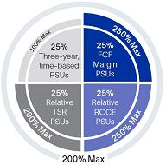

Our NEOs continued to receive a mix of LTI grants in 2023, with 75% of their target LTI opportunity awarded in the form of PSUs, and 25% awarded in the form of three-year, time-based RSUs. As in 2022, payout under the 2023 PSUs will be contingent on achieving rigorous absolute FCF margin, relative ROCE, and relative TSR performance goals over a three-year period.

Strategy-Focused STI Program with Emissions Reduction Objectives for All NEOs
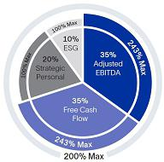

We continued to tie 70% of our NEOs’ target short-term cash incentive opportunity to Company financial goals—namely, full-year adjusted EBITDA and free cash flow—to ensure our executives remained focused on profitable, sustainable growth. In addition, we incorporated into our 2023 STI plan a new quantitative component focused on reducing our Scope 3 emissions intensity and improving gender diversity.

Performance-Aligned LTI and STI Payouts

Our NEOs’ LTI award payouts in 2023 were based on SLB’s strong multi-year ROCE results, as well as achieving target under our three-year FCF margin PSUs, partially offset by below-target relative TSR performance. Our NEOs also earned performance-aligned 2023 STI payouts based on SLB’s strong adjusted EBITDA and exceptional free cash flow results, together with key sustainability and workforce diversity achievements during the year.


Long-Term Equity Incentive Results

Total LTI Award Payout — 127% — Our NEOs earned total LTI

payouts of 127% of target with respect to their three-year LTI awards (including RSUs vested at 100%) that were granted in 2021 and vested in January 2024.

Target FCF Margin PSU Payout — Our NEOs earned 100% of the target shares of SLB stock under the FCF margin PSUs that they received in 2021, because SLB achieved its target three-year, cumulative FCF margin of 10.0%.

Strong Relative and Absolute ROCE Results — Our NEOs earned 250% of the target shares of SLB stock under the ROCE PSUs they received in 2021, based on SLB’s average annual ROCE for the three-year performance period, which was 477 bps above the average ROCE of the comparator group, together with SLB’s absolute 2023 ROCE of 16%.

Below-Target TSR Payout — Our NEOs earned 59% of the target shares of SLB stock under the TSR PSUs they received in 2021. This payout was based on SLB’s relative TSR percentile rank of 41% as compared to the three-year cumulative TSR results achieved by eight comparator companies in our core industry.

Short-Term Cash Incentive Results

Average STI Payout — 151% — Our NEOs earned an average 2023 cash incentive payout of 151% of target.

Adjusted EBITDA — $8.107 billion — Our 2023 adjusted

EBITDA of $8.107 billion represented a 25% increase over 2022, resulting in achievement of 119% of the target payout.

Free Cash Flow — $4.038 billion — Our 2023 free cash flow

of $4.038 billion represented a 185% increase over 2022, resulting in achievement of 243% of the target payout.

Achieved Emissions and Gender Diversity Targets — In 2023, we reduced our Scope 3 emissions intensity by 13% year on year. We also increased our percentage of women in salaried roles from 23.8% at year-end 2022 to 24.6% at year-end 2023. As a result, our NEOs earned 100% of the target payout.

2024 Proxy Statement |  | 33

Back to Contents

Framework for Setting 2023 Executive Compensation

Program Design and Pay-for-Performance Philosophy

Our 2023 executive compensation program consisted of three primary elements comprising our executives’ total compensation: LTI equity incentive awards (PSUs and RSUs), STI (annual) cash incentive awards, and base salary. Within these elements, 75% of our executives’ 2023 target LTI equity awards and 100% of their STI awards were performance-based. These elements have allowed us to remain competitive and attract, retain, and motivate top executive talent whose interests are aligned with those of our shareholders.

The table below sets out the primary elements of our NEOs’ 2023 total compensation, certain key features of each element, and how each of these compensation elements supports our strategy.

Type Element

25%

Free Cash Flow

Margin PSUs

 |  | Performance-
Key Features | How Elements Support Our Strategy | Based? | At Risk?
 | • Aligns with our financial ambition of achieving
Absolute performance metric, | double-digit FCF margin
based on our FCF margin over a | • Encourages our NEOs to generate high-quality
3-year period | revenue, which translates into strong free cash
 | flow
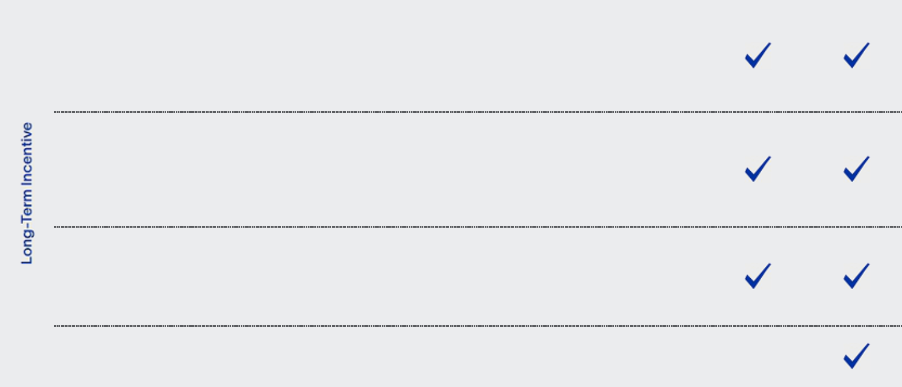

25%

Return on Capital Employed PSUs

25%

Total Shareholder Return PSUs

25%

Time-Based RSUs

Relative performance metric, comparing our average annual ROCE over a 3-year period to that of our direct competitors

Relative performance metric, comparing our cumulative TSR over a 3-year period to TSR of our direct competitors and S&P Global 1200 Energy Index

Cliff vesting after 3 years, if still employed by SLB

- Measures the efficiency of our capital employed relative to direct competitors, consistent with our strategic priorities

- Motivates and rewards our executives for relative outperformance on a key financial metric

- Directly aligns executive LTI payouts with shareholder value creation

- Uses a clear and objective metric to evaluate our performance against our direct competitors and against the broader global energy sector

- Promotes stability and retention of our executive team through business cycles
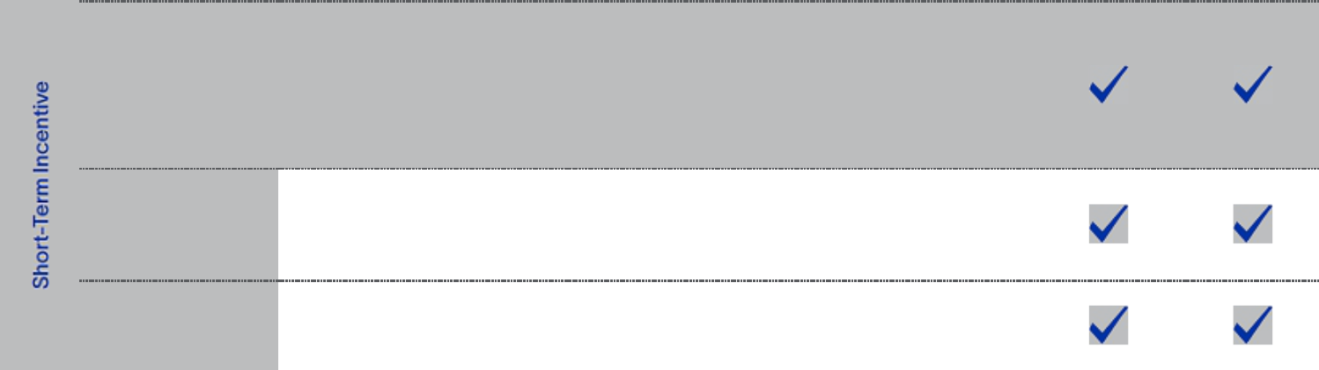

70%

Quantitative Company Financial Goals

10%

Quantitative ESG Goals

20%

Individual Goals

 | • | Adjusted EBITDA reflects the quality of SLB’s
Evenly split between achieving |  | earnings
adjusted EBITDA targets and | • | Strong free cash flow allows us to sustainably
free cash flow targets | • | Strong free cash flow allows us to sustainably
free cash flow targets |  | return value to shareholders through dividends and
 |  | stock repurchases
Targets to reduce Scope 3 | • | Aligns our executives’ annual compensation to our
emissions intensity and increase |  | emissions reduction and workforce diversity
gender diversity |  | strategies
Strategic personal objectives | • | Aligns to our strategic focus areas, as detailed on
Strategic personal objectives |  | page 40

 |  | Only fixed compensation | • | Provides a base level of competitive cash
Base Salary |  | Only fixed compensation |  | compensation, while all other pay elements are
 |  | element
 |  | element |  | variable or contingent on performance
 |  |  |  |  | 34 |  | 2024 Proxy Statement

Back to Contents

In setting our executives’ compensation, our Compensation Committee believes that:

- the pay of our NEOs and other executives should be strongly linked to performance that is evaluated against financial and strategic objectives, and should balance incentivizing outperformance, ensuring retention, and maximizing shareholder value,

- our performance-based LTI and STI awards should utilize clear, quantitative financial metrics that are closely aligned with our corporate strategy and stated external objectives and should be effective through all industry cycles,

- LTI awards should encourage the creation of long-term shareholder value, align our executives’ compensation with our shareholder returns, and incentivize our executives to achieve difficult but attainable strategic and financial goals that support our long-term performance and our leadership position in our industry,

- our executive compensation structure should enable us to recruit, develop, motivate, and retain top global talent, both in the short term and long term, and

- stock ownership guidelines, which require our executives to hold stock acquired through LTI awards, further align the interests of our executives with those of our other shareholders.

At-Risk Pay Mix

Our executive compensation program is designed so that the higher an executive’s position in the Company, the greater the percentage of compensation that is “at risk”. At-risk compensation refers to an executive’s LTI and STI awards. We believe that having a significant portion of our executives’ compensation at risk more closely aligns their interests with Company interests and with the interests of our shareholders.

Approximately 90% of our CEO’s 2023 target total compensation was at risk, and approximately 84% of our other NEOs’ 2023 target total compensation was at risk, as illustrated below.

CEO 2023 Target Pay Mix Other NEO 2023 Average Target Pay Mix
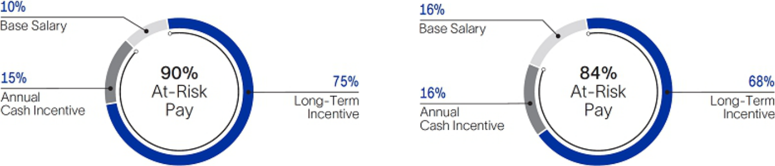

Based on market data provided by Pay Governance, our Compensation Committee’s independent compensation consultant, the pay mix of our NEOs is well-aligned with that of the companies in our two main executive compensation peer groups, as described in “Other Aspects of Our Executive Compensation Program—Our Peer Group Companies” on page 47.

In January 2023, the Committee concluded that the mix of base salary, target STI, and target LTI was appropriate for each of our NEOs, based on the proportion of compensation elements at companies in our main executive compensation peer groups, as well as internal factors.

Responsiveness to Shareholder Feedback

Our executive compensation program was largely designed and implemented in response to, and as a product of, past discussions with our shareholders. For example, in response to shareholder feedback, since 2021 our NEOs have received three-year relative TSR PSUs that directly align a
portion of their LTI payouts with shareholder value creation, with target performance goals set above median at the 60th percentile. Since 2022, the comparator group for our TSR PSUs has included the S&P Global 1200 Energy Index, based on feedback that our shareholders evaluate our TSR performance against both our competitors and the broader global energy sector. And for 2023, our Compensation Committee incorporated into our STI plan a new quantitative component focused on reducing our Scope 3 emissions intensity and improving gender diversity in our workforce, to align our executives’ compensation with SLB’s non-financial strategic objectives.

2024 Proxy Statement |  | 35

Back to Contents

In 2023, we contacted shareholders representing more than 50% of our outstanding common stock, to seek their views on our executive compensation program, as well as other governance and sustainability topics. Members of SLB management met with shareholders representing approximately 29% of our outstanding common stock, and received positive feedback on the design of our executive compensation program. In addition, our executive compensation program received the support of our shareholders:

- 97% of the votes cast at our 2023 AGM

- 95% of the votes cast at our 2022 AGM

- 95% of the votes cast at our 2021 AGM
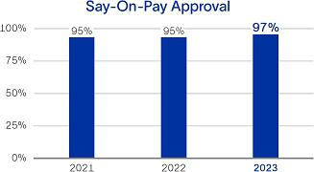

As a result, our Compensation Committee believes that our overall compensation program design is well-supported by our shareholders.

Best Practices in Executive Compensation Governance

Below is a summary of some of our executive compensation best practices and policies. For additional details, see “Executive Compensation Governance” beginning on page 48 of this proxy statement.

What We Do

At Risk Pay — A significant portion of our executives’ compensation is at risk, based on a mix of absolute and relative financial metrics.

Performance-Based STI Awards — At least 70% of our executives’ target 2023 STI opportunity is based on achieving rigorous quantitative Company financial goals.

Robust Stock Holding Requirements — Our CEO is required to own an amount of SLB shares valued at six times (6x) his annual base salary; our EVPs must own at least three times (3x) their annual base salaries; and all other executive officers must own at least two times (2x) their annual base salaries.

Mandatory Retention of Shares — Executives must retain 50% of the net shares they acquire upon the exercise of stock options and the vesting of PSUs and RSUs, until they achieve the required ownership level under our stock ownership guidelines.

Annual Peer Compensation Review — We annually review all officer compensation opportunities against our peer groups.

What We Don’t Do

No gross-ups on excise taxes.

No repricing or exchanging options without shareholder approval.

No hedging or pledging of SLB stock by executive officers or directors.

No LTI or STI payouts if we fail to achieve pre-established minimum performance criteria.

No excessive perquisites to our executive officers.

No executive pension or insurance plans exclusively for executives.

No change-in-control agreements, and no automatic acceleration of equity awards upon a change in control.

PSUs and RSUs do not accrue or pay dividends or dividend equivalents or have voting rights prior to vesting.
We do not dilute our shareholders with excessive employee equity grants. Our 2023 “burn rate,” or stock awards granted as a percentage of common shares outstanding, was only 0.48%.

Elements of 2023 Total Compensation

Base Salary

Base salary is the only fixed portion of an executive’s annual compensation, providing some stability of income since the other compensation elements are at risk. Our Compensation Committee annually reviews and approves the base salary levels for our executive officers (other than the CEO) after considering comparable salaries for executives with similar responsibilities in our main executive compensation peer groups, comparisons to internal peer positions, recent Company performance, individual performance, business experience and potential, economic trends, and the CEO’s recommendations. The Committee annually reviews the base salary of our CEO in executive session and recommends his base salary amount to the independent members of the Board for approval, based on the criteria described above.

In January 2023, our Compensation Committee reviewed the base salaries of each of our NEOs, and made no changes to their base salaries for 2023.

36 2024 Proxy Statement

Back to Contents

Short-Term Cash Incentive Awards

We pay performance-based short-term (annual) cash incentives to our executives to foster a results-driven, pay-for-performance culture, and to align executives’ interests with those of our shareholders. STI awards are earned according to the achievement of quantitative Company financial and non-financial objectives, as well as strategic objectives. Our Compensation Committee selects performance measures that it believes support our strategy and strike a balance between motivating our executives to increase near-term financial and operating results and driving profitable long-term Company growth and value for shareholders.

For 2023, 70% of our NEOs’ target STI opportunity was based on achieving quantitative Company financial objectives, 10% was based on achieving quantitative Company non-financial objectives, and 20% was based on strategic personal objectives. The financial portion of the target plan was evenly split between adjusted EBITDA and free cash flow performance goals. The total maximum STI payout for 2023 was 200% of target—consistent with 2022—and the weighted payout range for each metric as a percentage of target is reflected by the outer bars in the 2023 STI Opportunity Mix chart below.
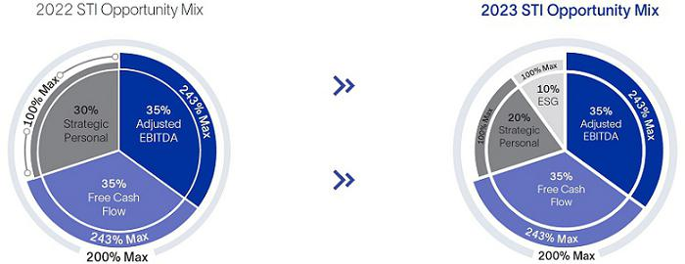

In January 2023, our Compensation Committee determined to leave the target STI opportunity for all NEOs unchanged from 2022, following a review of market data indicating that our NEOs’ target STI opportunity (as a percentage of base salary) was competitively positioned. As a result, the 2023 target STI opportunity for our CEO was 150% of his base salary and for our other NEOs it was 100% of base salary.

The following table reflects our NEOs’ full-year 2023 STI results, together with relevant weightings of the different components and payouts under each component.

 |  | SLB Financial Objectives |  |  |  |  |  | SLB Non-Financial
 | STI Opportunity | Adjusted EBITDA |  |  | Free Cash Flow |  |  | Objectives |  |  | Personal Objectives |  |  | Total 2023
 | STI Opportunity |  | Payout |  |  | Payout |  |  | Payout |  |  | Payout |  | Total 2023
 | as % of | Weight | Result |  | Weight | Result |  | Weight | Result |  | Weight | Result |  | STI Paid as
Name | Base Salary | (%) | (%) |  | (%) | (%) | (%) |  | (%) |  | (%) | (%) |  | % of Target⁽¹⁾⁽²⁾
O. Le Peuch | 150% | 35 | 119 |  | 35 | 243 | 10 |  | 100 |  | 20 | 95 |  | 151%
S. Biguet | 100% | 35 | 119 |  | 35 | 243 | 10 |  | 100 |  | 20 | 96 |  | 151%
K. Al Mogharbel | 100% | 35 | 119 |  | 35 | 243 | 10 |  | 100 |  | 20 | 96 |  | 151%
A. Merad | 100% | 35 | 119 |  | 35 | 243 | 10 |  | 100 |  | 20 | 100 |  | 152%
D. Ralston | 100% | 35 | 119 |  | 35 | 243 | 10 |  | 100 |  | 20 | 100 |  | 152%

- Equals the sum of the financial, non-financial, and personal portions of the STI achieved, shown as a percentage of base salary.

- In January 2024, due to factors not contemplated in the 2023 forecast, our Compensation Committee applied a discretionary downward adjustment to reduce all executive payouts by 5% under our 2023 STI plan.

2024 Proxy Statement |  | 37

Back to Contents

Quantitative Company Financial Objectives

In setting quantitative Company financial targets and performance goals, our Compensation Committee believes it is important to establish criteria that are realistically attainable, yet still challenging in an uncertain global economy. In selecting the financial performance measures and setting targets for our 2023 STI plan, the Committee considered the factors in the table below.

 | Adjusted EBITDA
Why did the Committee | • The Committee considers adjusted EBITDA to be a good
select this metric? | indicator of the quality of our earnings.
 | • Investors and market analysts often value SLB by
 | reference to an EBITDA multiple, so this metric aligns our
 | NEOs’ compensation to a key market valuation method.
 | • A portion of our line management’s 2023 cash incentive
 | opportunity was based on EBITDA performance goals, so
 | this metric aligns executive pay with line management’s.

Free Cash Flow

- Free cash flow is a critical element of a strong balance sheet, and it allows us to sustainably return value to shareholders through dividends and stock repurchases, while making focused investments in future growth opportunities, such as SLB New Energy and digital.

- Free cash flow has also allowed us to achieve our net debt reduction goals in recent years.

- The Committee also considers free cash flow to be a good indicator of the efficiency of capital management.

What is the Committee’s process for setting performance goals?

The Committee begins with a review of management’s plans and projections following bottom-up planning from the field. Adjusted EBITDA and free cash flow targets may increase or decrease year-on-year, taking into account, among other things, industry cycles, anticipated customer spending, activity growth potential, pricing, the introduction of new technology, strategic M&A activity, and commodity prices.

In addition, the Compensation Committee has discretion at the completion of the year to make adjustments to payouts based on conditions not anticipated in management’s plans.

Adjusted EBITDA Targets and Results

In January 2023, our Compensation Committee increased the minimum, target and maximum performance goals under the adjusted EBITDA portion of our NEOs’ 2023 STI opportunity, and set target at $8.00 billion based on SLB’s full-year forecast. This target performance goal was 31% higher than our 2022 target and 24% higher than SLB’s actual 2022 adjusted EBITDA.

The following table reflects our NEOs’ full-year adjusted EBITDA targets and corresponding potential payouts for 2023.

 |  | Potential Payout as a %
Performance Targets⁽¹⁾ |  | of Target Opportunity⁽¹⁾
< $7.40 billion |  | 0%
$7.40 billion | Minimum | 50%
$8.00 billion | Target | 100%
$8.80 billion | Maximum | 243%

- For adjusted EBITDA results between any two performance targets, payout is prorated. No cash incentive is earned if we do not achieve the minimum adjusted EBITDA target.

Our 2023 adjusted EBITDA was $8.107 billion, representing a 25% increase over 2022. As a result, and applying the payout matrix above, our Compensation Committee approved a payout of 119% of target for the adjusted EBITDA component of our 2023 STI plan.

38 2024 Proxy Statement

Back to Contents

Free Cash Flow Targets and Results

In January 2023, our Compensation Committee considered SLB’s 2022 free cash flow of $1.418 billion, together with its full-year 2023 cash flow forecast, and the Company’s public commitments to return at least 50% of its free cash flow to shareholders in the form of dividends and share repurchases.

In light of these considerations, and in order to show a clear commitment to the Company’s promise to return value to shareholders, the Committee increased the minimum, target and maximum performance goals under the free cash flow portion of our NEOs’ 2023 STI opportunity—even though our NEOs had received no payout under this component of the 2022 STI plan. The Committee set target at $3.00 billion based on SLB’s full-year forecast. This target performance goal was 13% higher than our 2022 target and more than double SLB’s actual 2022 free cash flow. The Committee set the maximum performance goal 17% higher than target, in order to incentivize management to generate additional cash that would allow us to accelerate returns to shareholders.

The following table reflects our NEOs’ full-year free cash flow targets and corresponding potential payouts for 2023.

 |  | Potential Payout as a %
Performance Targets⁽¹⁾ |  | of Target Opportunity⁽¹⁾
< $2.50 billion |  | 0%
$2.50 billion | Minimum | 50%
$3.00 billion | Target | 100%
$3.50 billion | Maximum | 243%

- For free cash flow results between any two performance targets, payout is prorated. No cash incentive is earned if we do not achieve the minimum free cash flow target.

In 2023, SLB delivered $4.038 billion of free cash flow—a 185% increase over 2022. This exceptional free cash flow result allowed us to return $2.0 billion to shareholders in 2023 through dividends and stock repurchases. We also reduced our gross debt by $261 million and net debt by $1.4 billion, and ended the year with a net-debt-to-adjusted-EBITDA ratio of 1.0x—our lowest level since 2016.

Based on SLB’s 2023 free cash flow, our Compensation Committee approved a payout of 243% of target for the free cash flow component of our 2023 STI plan.

Quantitative Company Non-Financial Objectives

For 2023, our Compensation Committee incorporated into our STI plan a new quantitative component focused on reducing our Scope 3 emissions intensity and improving gender diversity in our workforce, to align our executives’ annual compensation with SLB’s non-financial strategic objectives.

Emissions Intensity⁽¹⁾

Why this metric? For 2023, the Committee selected a Scope 3 emissions intensity metric for our NEOs’ STI plan, in support of SLB’s 2050 net zero commitment.

2023 objective Reduce Scope 3 emissions intensity by 7% year on year.

2023 achievements and We achieved a 13% year-on-year reduction in Scope 3

incentive payout emissions intensity. As a result, our NEOs earned a payout of 100% under this component of our 2023 STI plan.

Gender Diversity⁽²⁾⁽³⁾

SLB recognizes the importance of gender diversity as a source of creativity, innovation, and competitive advantage, and is committed to leading our industry in this area. For 2023, the Committee incorporated a gender diversity metric into our NEOs’ STI plan, in support of SLB’s targets to have women represent 25% of our salaried workforce by 2025 and 30% by 2030.

Increase the percentage of women in SLB’s salaried population from 23.8% in 2022 to 24.5% in 2023.
We increased our percentage of women in salaried roles from 23.8% at year-end 2022 to 24.6% at year-end 2023. As a result, our NEOs earned a payout of 100% under this component of our 2023 STI plan.

- Emissions intensity data do not reflect the impact of the Aker Solutions subsea business, which was acquired in the fourth quarter of 2023.

- SLB does not make employment decisions, including decisions regarding hiring, promotion, and compensation, on the basis of any legally protected characteristic, including gender, but is focused on making opportunities to excel accessible to all. We implement this goal by adhering to employment laws in each of the countries in which we operate.

- Our salaried workforce, salaried population, or salaried roles generally refer to all positions excepts those that are hourly based.

2024 Proxy Statement |  | 39

Back to Contents

Strategic Personal Objectives

As discussed above, 20% of our NEOs’ target 2023 STI opportunity was tied to achieving strategic performance goals specific to their roles within SLB. These may relate to financial goals, such as profitability, revenue growth, capital management, or cost reduction; performance achievements, such as contract awards, operational reliability, or HSE goals; or other non-financial goals that are important to SLB’s strategy and reputation, such as accelerating customer adoption of energy transition services and digital technologies, or ethics and compliance goals.

Early each year, our Compensation Committee reviews and, subject to approval by the Board’s independent directors, approves our CEO’s strategic personal objectives for that year. The Committee also annually assesses our CEO’s performance against his strategic personal objectives established for the prior year, to determine the appropriate payout for the 20% of STI tied to his personal objectives. The CEO reviews and approves the strategic personal objectives of the other NEOs and assesses their performance against their pre-approved objectives in a similar way. The Committee annually approves the aggregate STI payouts for all executive officers.

The following table reflects our NEOs’ 2023 strategic personal objectives and their achievements against those performance goals.


Performance Goal

Enable Performance and Innovation

Achieve our We are SLB Safe HSE performance goal of fatality-free operations in 2023.

Oversee the development, approval, and execution of SLB’s New Energy growth strategy inclusive of M&A activities.

Achieve certain milestones to align SLB intellectual property portfolio with our strategic direction and product portfolio.

Outgrow the Market

Grow revenue from specified new digital technologies above a pre-established target year on year.

Achieve total opportunity win volume growth and bookings exceeding a pre-established target, in a specified mix of products and services related to production enhancement and recovery.

Grow high-quality revenue by a pre-established target in certain key geographies.

Grow revenue and bookings from key technologies in SLB’s Core divisions above a pre-established target year on year.

Achieve contractual pricing improvements exceeding a pre-established global target.

Drive Efficiency

Achieve specified quantitative milestones related to working capital impact, business performance insights, and functions performance efficiency, through digital enablement of SLB’s operating and information technology systems.

Enhance SLB’s digital capabilities to forecast, analyze and validate profitability of specific integrated projects.

Improve contribution margins by a pre-established target year on year, by reducing cost of service delivery and operating costs in the Core divisions.

Streamline employee training programs by meeting a pre-established, quantitative efficiency target, as well as other governance milestones.

% of 2023 payout opportunity earned under strategic personal objectives 95% | 96% | 96% | 100% 100%

Achievement

Achieved

Substantially achieved

Achieved

Substantially achieved

Achieved

Substantially achieved

Achieved

Achieved

Substantially achieved

Achieved

Achieved

Achieved

40 2024 Proxy Statement

Back to Contents

Long-Term Equity Incentive Awards

LTI awards are designed to give NEOs and other key employees a long-term stake in SLB, incentivize the creation of sustained shareholder value, and act as long-term retention and motivation tools—aligning employee and shareholder interests over the long term.

Since 2021, our Compensation Committee has awarded to our NEOs and other executives a diversified mix of LTI grants, with 75% of their target LTI opportunity awarded in the form of PSUs—with payout contingent on achieving absolute and relative performance goals over three-year periods—and 25% awarded in the form of three-year, time-based RSUs. The Committee believes that our current LTI program appropriately balances the following Committee objectives:

- closely aligning PSU performance metrics with our long-term strategy, publicly disclosed Company financial objectives, and total shareholder return,

- aligning pay with performance and incentivizing executives to create shareholder value,

- maintaining a mix of absolute and relative PSU metrics, in light of the cyclicality of our industry,

- motivating and incentivizing outperformance relative to our direct competitors and the broader global energy sector, and

- promoting the stability and retention of our executive team through business cycles with awards of time-based RSUs.

As in 2022, the 2023 LTI program consisted of four types of grants, equally weighted at target performance:
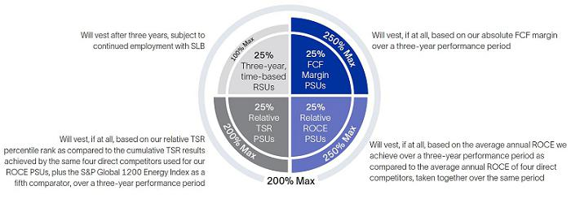

The maximum overall payout opportunity under the 2023 LTI program was 200% of target—consistent with 2022 and in line with market practice. The maximum payout opportunity for each type of LTI award is reflected by the outer bars in the chart above, with overall payout more heavily weighted in favor of Company financial performance metrics.

How We Determined the Target Value of 2023 LTI Equity Awards

The target value of an executive’s LTI grant increases with their level of responsibility at SLB. For our CEO and the other NEOs, it is the largest element of their compensation. In determining the value of LTI awards granted to our NEOs, our Compensation Committee (in recommending that the Board approve the CEO’s awards) and the CEO (in recommending awards for the other NEOs) first consider market data regarding the LTI value for the most comparable positions in our main executive compensation peer groups, as well as several other factors, such as:

- SLB’s financial and operating performance,

- the size and mix of the executive’s total compensation,

- internal pay equity,

- retention,

- the executive’s contribution to SLB’s success, and

- the level of competition for executives with comparable skills and experience.

Based on its review of comparator peer group data and internal equity factors, our Compensation Committee determined in January 2023 to maintain the 2023 grant date target LTI values at the same level awarded in 2022 for all of our NEOs.

2024 Proxy Statement |  | 41

Back to Contents

2023 Absolute FCF Margin PSUs — Performance Measures and Goals

In January 2023, our Compensation Committee set goals for the 2023 FCF Margin PSUs based on our absolute FCF margin over a three-year performance period (January 1, 2023 to December 31, 2025). At the end of the performance period, the Committee will certify our three-year cumulative absolute FCF margin and then determine the percentage of shares earned based on the graph below.

2023 FCF Margin PSU Payout Matrix
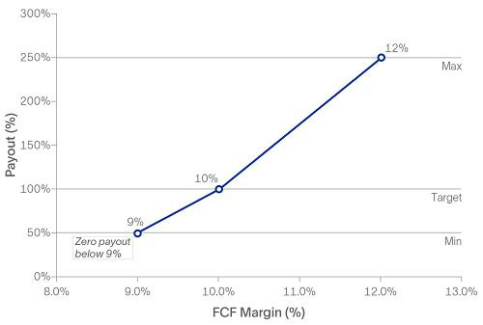

The number of 2023 FCF Margin PSUs that will vest and convert to shares as of the vesting date can range from 0% to 250% of target, depending on our absolute FCF margin performance over the three-year period. In setting FCF margin performance goals in January 2023, the Committee determined to keep the minimum, target and maximum goals consistent with 2022. As illustrated in the graph above, no SLB shares will be earned if our FCF margin over the three-year performance period is less than the minimum performance goal of 9.0%.

FCF margin is calculated as free cash flow divided by revenue. FCF margin measures how efficiently we convert revenue into free cash flow, and is an indicator of capital efficiency and the quality of revenue. In selecting absolute FCF margin as the performance metric for 25% of our NEOs’ 2023 target LTI grant date fair value, the Committee considered that this metric was aligned with our capital allocation strategy and publicly disclosed financial objective of achieving double-digit FCF margin. The Committee also believes that tying a portion of our NEOs’ LTI payout to FCF margin encourages our executives to:

- maintain capital discipline,

- generate high quality revenue to allow for increased returns to shareholders and net debt reduction,

- make key investments and capital expenditures in line with our stated growth strategy, including our energy transition strategy, and

- increase SLB’s liquidity.

The Committee also selected absolute FCF margin as the performance metric for a portion of our NEOs’ 2023 LTI awards because the Committee sought to maintain a mix of absolute (FCF margin) and relative (ROCE and TSR) metrics in the LTI plan, to effectively manage industry cycles.

Free cash flow represents cash flow from operations less capital expenditures, Asset Performance Solutions investments and exploration data costs capitalized.

42 2024 Proxy Statement

Back to Contents

2023 Relative ROCE PSUs — Performance Measures and Goals

In January 2023, our Compensation Committee set goals for the 2023 ROCE PSUs based on our average annual ROCE over a three-year performance period (January 1, 2023 to December 31, 2025), as compared to the average annual ROCE of the direct competitors identified below, taken together over the same period (together the ROCE comparator group). The ROCE comparator group was the same as the group used for ROCE PSU grants made to our NEOs in 2022. At the end of the performance period, the Committee will certify our average ROCE and that of the ROCE comparator group as a whole, and then determine the percentage of shares earned based on the graph below.

2023 Relative ROCE PSU Payout Matrix
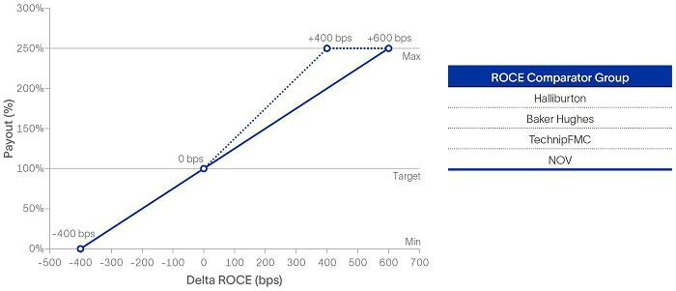

The number of 2023 ROCE PSUs that will vest and convert to shares on the vesting date can range from 0% to 250% of target, depending on our relative

ROCE performance over the three-year period. As illustrated in the graph above:

- If our average annual ROCE over the three-year performance period is four percentage points or more below the average of the ROCE comparator group, then no 2023 ROCE PSUs will vest and no shares will be earned. This is because our Compensation Committee believes our executives should not receive PSU payouts for significantly low relative ROCE performance.

- If our average annual ROCE over the three-year performance period is equal to that of the average of the ROCE comparator group as a whole, then the 2023 ROCE PSUs will vest at 100% of target. If our average annual ROCE over that period is higher than that of the average of the ROCE comparator group as a whole, then the 2023 ROCE PSUs will vest up to 250% of target, as shown by the solid line in the graph above.

- In addition, if both (x) our absolute, single-year ROCE is greater than 15% in 2025, and (y) our average annual ROCE over the three-year performance period exceeds that of the average of the ROCE comparator group as a whole, then the 2023 ROCE PSUs will vest at an increased rate (up to a maximum of 250%), as shown by the dotted line in the graph above. The Committee increased the trigger for potentially earning these shares from 10% in 2022 to 15% in 2023.

ROCE is a measure of the efficiency of our capital employed, and is a comprehensive indicator of long-term Company and management performance, measured in a way that is tracked and understood by many of our investors. Our Compensation Committee has based a portion of our NEOs’ LTI awards on a relative ROCE metric since 2016 because this metric allows us to directly compare how efficiently we deploy our capital against our direct competitors. The Committee also believes that tying a portion of our executives’ LTI payout to achieving our capital efficiency goals and comparing these results to our competitors will motivate our executives to focus on outperformance, and will result in increased revenue and improved margins. In selecting ROCE as the performance metric for 25% of our NEOs’ 2023 target LTI grant date fair value, the Committee also considered that ROCE performance goals align executives’ potential ROCE PSU payouts with SLB’s goal of achieving ROCE above its weighted average cost of capital.

We calculate ROCE as a ratio, the numerator of which is (a) net income excluding charges and credits, plus (b) after tax net interest expense, and the denominator of which is (x) stockholders’ equity, including non-controlling interests (average of beginning and end of each quarter in the year), plus (y) net debt (average of beginning and end of each quarter in the year). Our Compensation Committee has discretion to cap payouts on the 2023 ROCE PSUs at 100% of target in the event of material asset impairments.

2024 Proxy Statement |  | 43

Back to Contents

2023 Relative TSR PSUs — Performance Measures and Goals

In January 2023, our Compensation Committee set goals for the 2023 TSR PSUs based on our relative TSR percentile rank, as compared to the cumulative TSR results achieved by the four direct competitors used for the 2023 ROCE PSUs, plus the S&P Global 1200 Energy Index as a fifth comparator (each, a TSR comparator), over a three-year performance period (January 18, 2023 to December 31, 2025). At the end of the performance period, the Committee will certify the three-year, cumulative TSR results for us and for each TSR comparator, based on the average of the 20 trading days prior to the start and end of the performance period. The Committee will then determine our percentile rank relative to the five TSR comparators, as well as the percentage of shares earned based on the graph below.

2023 Relative TSR PSU Payout Matrix
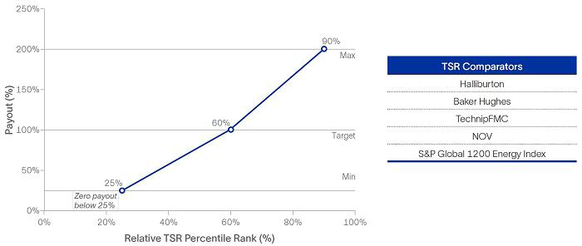

As in 2022, the number of 2023 TSR PSUs that will vest and convert to shares as of the vesting date can range from 0% to 200% of target, depending on our relative TSR performance over the three-year period. In maintaining the maximum payout opportunity for the 2023 TSR PSUs at 200%, which is below the maximum payout for the 2023 FCF Margin PSUs and 2023 ROCE PSUs, the Committee considered that management’s efforts would more directly affect FCF margin and ROCE, whereas management had less control over SLB’s TSR relative to that of the TSR comparator companies, due to external market and economic influences.

As illustrated by the graph above, our Compensation Committee set the target performance goal above median at the 60th percentile, consistent with
2022. No SLB shares will be earned if our three-year, cumulative TSR is in the bottom 25th percentile rank as compared to that of the individual TSR comparator companies. The Committee determined in 2023 to maintain the same TSR comparators as it had selected in 2022, to continue motivating our NEOs to outperform both our direct competitors and the broader global energy market.

44 2024 Proxy Statement

Back to Contents

Payouts Under Prior LTI Awards

PSUs Vesting in 2023

As previously disclosed in the proxy statement for our 2023 AGM, in January 2023 our Compensation Committee approved payout results for the PSUs issued in 2020 to our NEOs—other than our CEO—based on the Committee’s previously approved performance criteria. Our CEO, Mr. Le Peuch, did not receive an LTI award in 2020 because he had received a PSU award in 2019 in connection with his promotion to CEO, in lieu of a 2020 award. Because Mr. Le Peuch did not receive any LTI award in 2020, he did not vest in any stock awards in 2023.

Our NEOs (other than our CEO) earned 250% of target under the free cash flow conversion PSUs issued in 2020, based on our achievement of a cumulative free cash flow conversion rate of 192% for the two-year performance period applicable to those PSUs. They also earned 250% of target under the relative ROCE PSUs issued in 2020, based on (i) our absolute 2022 ROCE being 13%, and (ii) our average annual ROCE for the three-year performance period being 407 basis points above the average annual ROCE of five of our direct competitors, taken together over the same period. These competitors were Halliburton, Baker Hughes, TechnipFMC, Weatherford International, and NOV. For additional details, see the Option Exercises and Stock Vested in 2023 table on page 53 of this proxy statement.

PSUs and RSUs Vesting in 2024

In January 2021, our Compensation Committee approved PSU awards to our NEOs as follows:

- For 25% of our NEOs’ 2021 target LTI opportunity, PSU payouts were conditioned based on our absolute FCF margin achieved over a three-year performance period (the 2021 FCF Margin PSUs).

- For 25% of our NEOs’ 2021 target LTI opportunity, PSU payouts were conditioned based on our average annual ROCE achieved over a three-year performance period as compared to the average annual ROCE of the direct competitors in our ROCE comparator group, taken together over the same period (the 2021 ROCE PSUs).

- For 25% of our NEOs’ 2021 target LTI opportunity, PSU payouts were conditioned based on our relative TSR percentile rank, as compared to the cumulative TSR results achieved by eight comparator companies in our core industry, over a three-year performance period (the 2021 TSR PSUs). These comparator companies were Apache Corporation, Baker Hughes, ConocoPhillips, Halliburton, Hess Corporation, NOV, Occidental Petroleum, and TechnipFMC.

In addition, since 2021, 25% of our NEOs’ target LTI opportunity has been awarded in the form of three-year, time-based RSUs. The RSUs granted in January 2021 vested in January 2024.

In January 2024, the Committee approved the results for the 2021 FCF Margin PSUs, 2021 ROCE PSUs, and 2021 TSR PSUs using the Committee’s previously approved performance criteria.

- 2021 FCF Margin PSUs: The Committee determined that SLB had achieved the three-year, cumulative FCF margin performance target of 10.0% for our 2021 FCF Margin PSUs. As a result, and based on the Committee’s previously approved payout matrix, the Committee approved the issuance to our NEOs of 100% of the target shares under these PSUs.

- 2021 ROCE PSUs: The Committee determined that SLB’s average annual ROCE was 477 basis points above the average of the ROCE comparator group for the performance period through the third quarter of 2023, which was the then-most recent fiscal period end reported by all the companies in the ROCE comparator group. In addition, the Committee determined that SLB had achieved absolute 2023 ROCE of 16%. As a result, based on the Committee’s previously approved payout matrix, the Committee preliminarily determined that the 2021 ROCE PSUs had been earned at 250% of target. Because not all these companies had reported their 2023 audited results as of January 2024, the Committee approved a preliminary issuance of 80% of the shares earned under the 2021 ROCE PSUs. Any additional shares finally determined to have been earned by our NEOs will be issued after all the companies in the ROCE comparator group disclose their full-year 2023 audited results.

- 2021 TSR PSUs: The Committee determined that SLB’s relative TSR percentile rank for the 2021 TSR PSUs was 41%. As a result, and based on the Committee’s previously approved payout matrix, the Committee approved the issuance to our NEOs of 59% of the target shares under these PSUs.

Stock Options

Prior to 2017, SLB granted a significant portion of its LTI compensation to executives in the form of stock options. Beginning in 2017, SLB ended its practice of granting stock options to executive officers. As of December 31, 2023, all of our NEOs’ outstanding stock options were “underwater.”

Other Benefits

Officer Departure Guidelines

Our Compensation Committee has approved guidelines covering, among other things, LTI vesting, salary, benefits, and other compensation matters for officers departing SLB, either because they are eligible for retirement, early retirement, or special retirement, or because they are involuntarily terminated (if not eligible for retirement). These guidelines are a non-binding framework referenced by management in its executive succession planning, with flexibility as required by specific situations.

Under the guidelines, we may, at our discretion, enter into agreements with outgoing officers whereby they would remain employed by SLB during the agreement term and receive annual cash payments that would generally be less than their pre-termination annual base salary. In addition, outgoing officers would receive a prorated STI award payment with respect to the year of their departure. They would also receive benefits such as medical coverage and life and disability insurance during the agreement term, and would continue to vest in previously granted LTI awards—but would not receive any new LTI awards —during the agreement term. In exchange, the outgoing officers must agree to non-competition, non-solicitation, and non-disparagement covenants, and generally would agree to be available to SLB for a portion of their business time during the term.

2024 Proxy Statement |  | 45

Back to Contents

Broadly Available Benefit Plans

We seek to provide benefit plans, such as medical coverage and life and disability insurance, on a country-by-country basis in line with market conditions. Where the local practice is considered to be less than the SLB minimum standard, we generally enhance the local plans to meet the SLB standard plan. Our NEOs are eligible for the same benefit plans provided to other employees, including medical coverage and life and disability insurance, as well as supplemental plans chosen and paid for by employees who wish to obtain additional coverage. There are no special insurance plans for our NEOs.

In line with our aim to encourage long-term careers with SLB and to promote retention, retirement plans are provided, where possible and according to local market practice, for all employees, including NEOs. For details regarding our pension plans and nonqualified deferred compensation plans, see “Executive Compensation Tables—Pension Benefits,” “—Nonqualified Deferred Compensation,” “—Potential Payments Upon Termination or Change in Control—Retirement Plans,” and “—Retiree Medical” and the accompanying narratives beginning on page 54 of this proxy statement.

Limited Perquisites

We provide only limited perquisites to our NEOs, which are identified in the footnotes to the Summary Compensation Table.

Other Aspects of Our Executive Compensation Program

Competition for Our Executive Talent

A primary consideration of our Compensation Committee in overseeing our executive compensation program is the need to motivate and retain what it believes is the best executive talent in our industry. We are a global technology company, driving energy innovation for a balanced planet, and the Committee believes that delivering financial and operational outperformance and long-term shareholder returns depends on our ability to attract, develop, and retain the best talent globally. A highly competitive compensation package is critical to this objective.

As a result, the Committee generally seeks to target total compensation for our NEOs between the 50th and 75th percentiles of our two main executive
compensation peer groups. The Committee may also position an NEO who is new to a position at or below the 50th percentile for a period of time. An NEO’s target total compensation depends on a variety of factors, including tenure in a particular position, individual and Company performance, and internal pay equity.

Competition for executive talent in our industry is exceptionally fierce. The Committee believes that the 50th to 75th percentile range is appropriate for us to target in light of SLB’s leading position in our industry, and because our executives are very highly sought after, both by our direct competitors and by other leading oil and gas, advanced extractive, technology-driven manufacturing, and engineering-focused companies, including companies focused on the new energy economy.

In approving this target range and when setting compensation for 2023, the Committee considered that many current and former senior executives of leading companies in various industries have previously served in senior management at SLB. Former members of senior SLB management have either been, or are, senior executives at the competitors, customers, and other technology- and engineering-focused companies listed in the table below.

 | Engie | BAE Systems* |  |  | Bureau Veritas |  |  | TechnipFMC*
(current CEO) |  | (current CEO, CFO & CHRO) |  |  | (current CEO) |  | (current CEO and CTO)
Baker Hughes* |  | Patterson-UTI Energy |  |  | CGG |  | Amazon Web Services
(current CHRO, and past CLO) |  | (current CEO) |  |  | (current CEO and past CFO) |  | (current senior executive)
 | Nabors | NESR |  |  | Jacobs |  | Technip Energies
(current CFO) |  | (current CEO, CFO and COO) |  |  | (current CFO) |  |  | (current CLO)
Lufkin Industries |  | Borr Drilling |  |  | ADM |  |  | Air Liquide
(current CEO) |  | (current CEO) |  |  | (current CLO) |  | (current CHRO)
ConocoPhillips* |  | Expro |  |  | Flowserve |  |  | Archer
(past CTO) |  | (current CEO) |  |  | (current CEO) |  |  | (current CEO)
TotalEnergies |  | YPF |  |  | Weatherford |  | Kuwait Airways
(past CHRO) |  | (past CEO) |  |  | (past acting CEO and CFO) |  |  | (past CEO)
CEO = Chief Executive Officer |  | CTO = Chief Technology Officer |  |  |  | * Included in our main executive compensation peer
CFO = Chief Financial Officer |  | CLO = Chief Legal Officer / General Counsel
 |  |  |  |  |  |  | groups
COO = Chief Operating / Commercial Officer |  | CHRO = Chief Human Resources Officer
 |  |  | 46 |  |  |  |  | 2024 Proxy Statement

Back to Contents

Our Peer Group Companies

Our Compensation Committee considers formal executive compensation survey data prepared by Pay Governance when it reviews and determines executive compensation, and when considering changes to our executive compensation program. The Committee considers data for the companies comprising our two main executive compensation peer groups—our core industry peer group and our general industry peer group. The Committee believes these peer groups together provide the robust market data necessary to assess the current and future talent markets available to our executive officers, both in the oil and gas sector and in other advanced extractive, technology-driven manufacturing, and industrial engineering-focused sectors. General industry peer group comparisons are particularly relevant for non-operations positions, where skills and experience may be easily transferable to other industries. In addition, the evolving energy industry environment creates challenges in maintaining a robust peer group comprising solely oilfield services and upstream companies following consolidations and bankruptcies, as well as diversification into new energy investments.

The Committee annually reviews the specific selection criteria for our main executive compensation peer groups, such as competition for business or executive talent, revenue, market capitalization, and scope of international operations. Pay Governance annually recommends for the Committee’s review the addition or removal of companies from these peer groups, based on the Committee’s selection criteria. As a general matter, the Committee selects suitable comparator companies such that the companies in these peer groups, at the median, approximate SLB’s estimated revenue in the then-current year and its then-current market capitalization. The Committee modifies its peer group criteria as appropriate while seeking a satisfactory degree of stability, to provide a consistent basis for comparison.

In July 2022, our Compensation Committee reviewed and approved the companies listed below to comprise our two main executive compensation peer groups, effective for 2023 executive compensation decisions.

Core Industry Peer Group

This peer group comprises ten companies in the energy sector, primarily in the oilfield services and equipment and upstream oil and gas industries, with 2022 estimated revenues (as of July 2022) between $6.7 billion and $73.7 billion. The Committee identified the companies in this peer group as being broadly comparable to SLB in terms of revenue and market value, and also competing with us for business and executive talent. Several members of this peer group frequently seek to recruit SLB executives for their senior executive roles. See “—Competition for Our Executive Talent” on page 46.

In July 2022, applying the selection criteria above, our Compensation Committee removed Imperial Oil from this peer group and added Enbridge, after considering Enbridge’s growing renewable energy segment. As a result,
SLB was positioned at the 47th percentile of this peer group in terms of

estimated 2022 revenue as of July 2022, and at the 59th percentile of this peer group in terms of market capitalization as of April 2022.

Baker Hughes

BHP Group

ConocoPhillips

Enbridge

EOG Resources

Halliburton

NOV

Occidental Petroleum

Suncor Energy

TechnipFMC

General Industry Peer Group

This peer group comprises 27 mature, advanced extractive, technology-driven manufacturing, and industrial engineering-focused companies, including companies focused on the new energy economy, that have annual revenues, market valuations, and global scopes that are similar to SLB’s. The companies in this peer group had 2022 estimated revenues (as of July 2022) between $12.1 billion and $60.1 billion and average non-U.S. revenue of 61%. This peer group focuses on SLB’s current and future executive talent markets beyond the oil and gas sector, and ensures that competitors for technology and digital talent are represented for executive peer benchmarking purposes.

In July 2022, applying the selection criteria above, our Compensation Committee added Oracle and Siemens Energy to this peer group, in light of SLB’s digital and renewable energy strategies, respectively. As a result, SLB
was positioned at the 37th percentile of this peer group in terms of estimated

2022 revenue as of July 2022, and at the 58th percentile of this peer group in terms of market capitalization as of April 2022.

3M Company | Freeport-McMoRan
ABB | General Dynamics
Air Products and Chemicals | Honeywell International
Anglo American | Johnson Controls International
BAE Systems | Koninklijke Philips
Carrier Global | Linde
Caterpillar | LyondellBasell Industries
Compagnie de Saint-Gobain | Oracle
Corning | Rio Tinto
Deere & Company | Rolls-Royce Holdings
Dow | Schneider Electric
DuPont de Nemours | Siemens Energy
Eaton | Trane Technologies
Emerson Electric

2024 Proxy Statement |  | 47

Back to Contents

Executive Compensation Governance

No NEO Employment Agreements

Our NEOs do not have employment, severance or change-in-control agreements with SLB, and they serve at the will of the Board. This enables SLB to terminate their employment using judgment as to the necessity or terms of any severance arrangement and based on specific circumstances at the time they cease being executive officers.

Stock Ownership and Holding Requirements

Our Board and Compensation Committee strongly believe in linking executive long-term rewards to shareholder value. Our executive stock ownership guidelines require our executives to hold a minimum dollar value of SLB shares based on the table below.

Title | Stock Ownership Multiple
Chief Executive Officer | 6x base salary
Executive Vice Presidents | 3x base salary
Executive officers (non-EVP) | 2x base salary
Other EVP direct reports and Presidents | 1x base salary

Our executive officers must retain 50% of the net shares they acquire upon the exercise of stock options and after the vesting of PSUs and RSUs, after payment of applicable taxes, until they achieve the required ownership level.

Under the guidelines, our executives have five years to satisfy the ownership requirements. After the five-year period, executives who have not met their minimum stock ownership requirement must retain 100% of the net shares they acquire upon stock option exercises and any vesting of PSUs and RSUs until they achieve their required ownership level. Stock ownership for the purpose of these guidelines does not include shares underlying vested or unvested stock options, unvested RSUs, or unvested PSUs.

As of January 31, 2024, all of our NEOs were in compliance with our stock ownership guidelines.

Anti-Hedging and Anti-Pledging

Our executive officers and directors are prohibited from using any strategies or products (such as derivative securities or short-selling techniques) to hedge, directly or indirectly, against potential changes in the value of SLB shares. In addition, our executive officers and directors, as well as certain other key employees, are prohibited from holding SLB securities in a margin account or pledging SLB securities as collateral for a loan. Our insider trading policy strongly discourages, but does not prohibit, other employees from engaging in speculative transactions, including hedging or other financial mechanisms, holding SLB securities in a margin account or pledging SLB securities.

Process for Setting Executive Compensation

Compensation Committee Review

Our Compensation Committee reviews the elements of our NEOs’ total compensation throughout the year to evaluate whether each element remains competitive with the companies in our two main executive compensation peer groups. In making compensation decisions, the Committee relies on its own judgment after reviewing external market data, including analyses prepared by Pay Governance, and also considers the following factors:

- each executive’s scope of responsibilities, as well as leadership, management and technical expertise, growth potential, and position in our reporting structure,

- overall Company and individual performance,

- retention needs and risks,

- the recommendations of our CEO (except with respect to his own compensation), and

- internal pay equity.

Each January, the Committee evaluates all elements of executive officer compensation, after reviewing the prior year’s results and the achievement of Company financial objectives and each officer’s strategic personal objectives. The purpose of this annual evaluation is to determine whether any changes in an officer’s compensation may be appropriate. The CEO does not participate in the Committee’s deliberations regarding his own compensation. At the Committee’s request, the CEO reviews with the Committee the performance of the other executive officers, but no other NEO has any input in executive compensation decisions. Our Compensation Committee gives substantial weight to the CEO’s evaluations and recommendations because he is particularly able to assess the other executive officers’ performance and contributions to SLB. Our Chief People Officer assists the CEO in developing the other executives’ performance reviews and reviewing external market data to determine the CEO’s executive compensation recommendations. Our Chief People Officer also meets with the Compensation Committee on a quarterly basis.

48 2024 Proxy Statement

Back to Contents

The table below summarizes the approximate timing of significant annual executive compensation events.


Event

Establish Company financial objectives and CEO strategic personal objectives

Review and approve the peer group companies used for compensation benchmarking

Pay Governance provides market data and analysis that our Compensation Committee uses to evaluate year-to-date compensation decisions in light of year-to-date comparative data, and to prepare for the annual executive officer compensation review in January

Evaluate Company and executive performance (achievement of objectives established in previous year) and recommend STI payout based on those results

Review and recommend executive base salaries and determine equity-based grants

Timing

Early each year with respect to the current year

July of each year for compensation in the following year

October of each year for compensation in the following year

Results approved in January of each year for STI award with respect to the prior year. The STI award earned for the prior year is paid in February of the current year

January of each year for base salaries for that year and for equity-based grants

Equity Grant Practices

Our Compensation Committee is responsible for granting long-term equity-based compensation under our omnibus stock incentive plans. The Committee approves a preliminary budget for equity-based grants for the following year at each October meeting. Awards for the CEO are granted by the Committee following approval by the independent members of the Board. Awards for executive officers other than the CEO are granted by the Committee and discussed with the Board. Management determines the allocation of equity-based grants for other groups within the Company and individual recommendations are made by the heads of the groups and approved by the CEO. In addition to considering the value of each equity-based award, management and the Committee also consider, as an additional factor in approving long-term equity awards, the overall potential shareholder dilution impact and burn rate, which is the rate at which awards are granted as a percentage of SLB shares outstanding.

The regular Board and Compensation Committee meeting schedule is set at least a year in advance, with meetings held quarterly in mid-January, mid-April, mid-July, and mid-October. Annual grants of equity-based awards to our NEOs and other executives, as well as to other eligible employees, are made at the Committee’s January meeting. Additionally, specific grants may be made at other Committee meetings to recognize an employee’s promotion, change in responsibility or specific achievement, or to achieve other key compensation objectives, such as retention. Generally, the Committee sets the grant date for equity awards as the Committee meeting date, which is usually two days in advance of the Company’s announcement of earnings. The Company does not time the release of material non-public information for the purpose of affecting the values of equity grants. At the time equity grant decisions are made, our Compensation Committee is aware of the earnings results, but it does not adjust the size or the mix of grants to reflect possible market reaction.

In addition, PSUs and RSUs do not accrue or pay dividends or dividend equivalents prior to vesting.

Independent Compensation Consultant

Our Compensation Committee has retained Pay Governance as its independent consultant with respect to executive compensation matters, as well as non-employee director compensation matters. Pay Governance works with SLB’s Total Rewards team to compile annual compensation data for each executive officer, and to compare the compensation opportunities of our executive officers with those at comparable roles at companies in our main executive compensation peer groups. Pay Governance also annually prepares an analysis of competitive non-employee director compensation levels and market trends using the same two main peer groups as are used for the annual executive officer compensation review.

Pay Governance reports only to, and acts solely at the direction of, our Compensation Committee. The Committee has assessed the independence of Pay Governance pursuant to SEC rules and has concluded that its work did not raise any conflict of interest that would prevent Pay Governance from independently representing our Compensation Committee.

Clawback Policy

In 2023, our Board adopted a new clawback policy requiring the recovery of performance-based equity and cash incentive compensation from our executive officers under certain circumstances. A copy of this policy is filed as Exhibit 97 to our 2023 Annual Report and is incorporated into this CD&A by reference.

2024 Proxy Statement |  | 49

Back to Contents

Executive Compensation Tables

Summary Compensation Table

The following table sets forth information regarding the total compensation paid to our NEOs for fiscal years 2023, 2022 and 2021.

 |  |  |  |  | Change in
 |  |  |  |  | Pension Value
 |  |  |  |  | & Nonqualified
 |  |  |  | Non-Equity | Deferred
 |  |  | Stock | Incentive Plan | Compensation | All Other
 |  | Salary | Awards | Compensation | Earnings | Compensation | Total
Name | Year | ($) | ($)⁽¹⁾ | ($)⁽²⁾ | ($)⁽³⁾ | ($)⁽⁴⁾ | ($)
Olivier Le Peuch | 2023 | 1,550,000 | 12,000,045 | 3,502,150 | 1,022,545 | 174,845 | 18,249,585
Chief Executive Officer | 2022 | 1,550,000 | 11,999,949 | 1,929,750 | — | 234,058 | 15,713,757
 | 2021 | 1,400,000 | 10,499,803 | 3,916,100 | 802,703 | 176,896 | 16,795,502
Stephane Biguet | 2023 | 850,000 | 3,500,022 | 1,283,100 | 620,773 | 116,672 | 6,370,567
Executive Vice President and Chief Financial | 2022 | 850,000 | 3,499,993 | 690,650 | — | 139,327 | 5,179,970
Officer | 2021 | 770,000 | 3,199,750 | 1,458,400 | 462,189 | 127,749 | 6,018,088
Khaled Al Mogharbel | 2023 | 900,000 | 3,500,022 | 1,357,650 | 116,813 | 118,275 | 5,992,760
Executive Vice President, Geographies | 2022 | 900,000 | 3,499,993 | 731,250 | — | 169,951 | 5,301,194
 | 2021 | 900,000 | 3,499,787 | 1,715,850 | — | 244,569 | 6,360,206
Abdellah Merad | 2023 | 800,000 | 3,500,022 | 1,213,600 | 80,154 | 235,407 | 5,829,183
Executive Vice President, Core Services and | 2022 | 787,500 | 3,499,995 | 620,150 | — | 290,716 | 5,198,361
Equipment
Dianne Ralston | 2023 | 750,022 | 3,199,909 | 1,137,750 | 270,729 | 78,435 | 5,436,845
Chief Legal Officer and Secretary | 2022 | 750,022 | 3,199,948 | 581,250 | 361,028 | 94,160 | 4,986,408

- Includes the value of PSU and RSU awards. For 2023, each amount reflected in the “Stock Awards” column is the aggregate grant date fair value of (x) the 2023 FCF Margin PSUs, 2023 ROCE PSUs and 2023 TSR PSUs at target level performance, and (y) the 2023 RSUs that were granted to our NEOs. Each amount reflects an accounting expense and does not correspond to actual value that may be realized by an NEO in the future. The number of equity awards granted in 2023 to each NEO is provided in the Grants of Plan-Based Awards in 2023 table on page 51. PSUs and RSUs do not pay dividends or dividend equivalents or have voting rights prior to vesting. Accordingly, the fair value of the 2023 FCF Margin PSUs, 2023 ROCE PSUs and 2023 RSUs was the quoted market price of our common stock on the grant date less the present value of the expected dividends not received prior to vesting. The fair value of the 2023 TSR PSUs was determined based on a Monte Carlo simulation. Amounts may not add to the values shown in Grants of Plan-Based Awards in 2023 table due to rounding. Additional assumptions that we use in calculating these amounts are incorporated herein by reference to Note 12, “Stock-based Compensation Plans” to the Consolidated Financial Statements contained in our 2023 Annual Report.

The value of each NEO’s 2023 LTI grants at the grant date, assuming achievement of the maximum performance level for all PSUs, would be: Mr. Le Peuch — $24,000,091; Mr. Biguet — $7,000,044; Mr. Al Mogharbel — $7,000,044; Mr. Merad — $7,000,044; and Ms. Ralston — $6,399,819.

The NEOs may never realize any value from these LTI grants and, to the extent that they do, the amounts realized may have no correlation to the amounts reported above.

- STI awards to our NEOs are reflected in the “Non-Equity Incentive Plan Compensation” column; as a result, we have excluded the “Bonus” column.

- The changes in pension value reported in this column represent the increase in the actuarial present value of an NEO’s accumulated benefit under all benefit and actuarial pension plans in which the NEO participates. This change in present value is not a current cash payment. It represents the change in the value of the NEO’s pensions, which are only paid after retirement. There are no nonqualified deferred compensation earnings reflected in this column because no NEO received above-market or preferential earnings on such compensation during 2023, 2022 or 2021.

- Relocation assistance is provided to all employees on a company-wide basis. The amount disclosed for Mr. Le Peuch consists of unfunded credits to the Restoration Savings Plan ($94,493), employer contributions to the SLB 401(k) Plan ($16,500), financial planning services ($13,800), and housing allowance ($50,052). The amount disclosed for Mr. Biguet consists of unfunded credits to the Restoration Savings Plan ($36,320), employer contributions to the SLB 401(k) Plan ($16,500), financial planning services ($13,800), and housing allowance ($50,052). The amount disclosed for Mr. Al Mogharbel consists of unfunded credits to the Restoration Savings Plan ($78,075), employer contributions to the SLB 401(k) Plan ($26,400), and financial planning services ($13,800). The amount disclosed for Mr. Merad consists of unfunded credits to the Restoration Savings Plan ($65,409), employer contributions to the SLB 401(k) Plan ($26,400), financial planning services ($13,800), vacation travel allowance ($22,856), and children’s education ($106,942). The amount disclosed for Ms. Ralston consists of unfunded credits to the Restoration Savings Plan ($30,038), employer contributions to the SLB 401(k) Plan ($26,400), financial planning services ($13,800), and club membership ($8,197).

50 2024 Proxy Statement

Back to Contents

Grants of Plan-Based Awards in 2023

The following table provides additional information regarding cash incentive and PSU and RSU awards granted to our NEOs in 2023.

 |  |  | Estimated Possible Payouts |  |  |  | Estimated Possible Payouts |  |  |  |  |  | Grant Date
 |  |  | Under Non-Equity Incentive |  |  |  | Under Equity Incentive |  |  |  | All Other |  | Fair Value
 |  |  | Plan Awards⁽²⁾ |  |  |  | Plan Awards⁽³⁾ |  |  |  | Stock |  | of Stock
Name | Award₍₁₎ | Grant | Threshold | Target | Maximum |  | Threshold | Target | Maximum |  | Awards | (4) | Awards | (5)
Name | Type | Date | ($) | ($) | ($) |  | (#) | (#) | (#) |  | (#) |  | ($)
O. Le Peuch |  |  | 818,400 | 2,092,500 | 4,652,325
 | FCFM PSU | 1/18/23 |  |  |  |  | 27,052 | 54,103 | 135,258 |  |  |  | 3,000,011
 | ROCE PSU | 1/18/23 |  |  |  |  | 1 | 54,103 | 135,258 |  |  |  | 3,000,011
 | TSR PSU | 1/18/23 |  |  |  |  | 12,014 | 48,054 | 96,108 |  |  |  | 3,000,011
S. Biguet | 3-year RSU | 1/18/23 | 297,500 | 765,000 | 1,700,850 |  |  |  |  |  | 54,103 |  | 3,000,011
 | FCFM PSU | 1/18/23 |  |  |  |  | 7,890 | 15,780 | 39,450 |  |  |  | 875,001
 | ROCE PSU | 1/18/23 |  |  |  |  | 1 | 15,780 | 39,450 |  |  |  | 875,001
 | TSR PSU | 1/18/23 |  |  |  |  | 3,504 | 14,016 | 28,032 |  |  |  | 875,019
K. Al Mogharbel | 3-year RSU | 1/18/23 | 315,000 | 810,000 | 1,800,900 |  |  |  |  |  | 15,780 |  | 875,001
 | FCFM PSU | 1/18/23 |  |  |  |  | 7,890 | 15,780 | 39,450 |  |  |  | 875,001
 | ROCE PSU | 1/18/23 |  |  |  |  | 1 | 15,780 | 39,450 |  |  |  | 875,001
 | TSR PSU | 1/18/23 |  |  |  |  | 3,504 | 14,016 | 28,032 |  |  |  | 875,019
A. Merad | 3-year RSU | 1/18/23 | 280,000 | 720,000 | 1,600,800 |  |  |  |  |  | 15,780 |  | 875,001
 | FCFM PSU | 1/18/23 |  |  |  |  | 7,890 | 15,780 | 39,450 |  |  |  | 875,001
 | ROCE PSU | 1/18/23 |  |  |  |  | 1 | 15,780 | 39,450 |  |  |  | 875,001
 | TSR PSU | 1/18/23 |  |  |  |  | 3,504 | 14,016 | 28,032 |  |  |  | 875,019
D. Ralston | 3-year RSU | 1/18/23 | 262,508 | 675,020 | 1,500,794 |  |  |  |  |  | 15,780 |  | 875,001
 | FCFM PSU | 1/18/23 |  |  |  |  | 7,214 | 14,427 | 36,068 |  |  |  | 799,977
 | ROCE PSU | 1/18/23 |  |  |  |  | 1 | 14,427 | 36,068 |  |  |  | 799,977
 | TSR PSU | 1/18/23 |  |  |  |  | 3,204 | 12,814 | 25,628 |  |  |  | 799,978
 | 3-year RSU | 1/18/23 |  |  |  |  |  |  |  |  | 14,427 |  | 799,977

- All equity grants were awarded under the 2017 SLB Omnibus Stock Incentive Plan (as amended and restated, the 2017 Incentive Plan).

- These columns show the possible cash incentive payouts for each NEO for fiscal year 2023 based on performance goals set for the year. Threshold, target, and maximum possible payouts are based on the STI range established for each NEO, which is expressed as a percentage of base salary for the year. Actual cash incentive amounts earned for 2023 are reflected in the “Non-Equity Incentive Plan Compensation” column of the Summary Compensation Table. For information about the 2023 STI awards paid to our NEOs, see “Compensation Discussion and Analysis—Elements of 2023 Total Compensation—Short-Term Cash Incentive Awards” beginning on page 37.

- Relates to PSUs, all of which are subject to a three-year performance period. See “Compensation Discussion and Analysis—Elements of 2023 Total Compensation—Long-Term Equity Incentive Awards” beginning on page 41 for a detailed description of our PSUs, including the criteria to be applied in determining vesting of PSUs. “Threshold” represents the number of shares deliverable on achievement of the applicable threshold performance goal under each PSU grant. The PSU award agreements provide that no PSUs will vest unless a specified threshold level of performance is achieved. “Target” represents the number of shares deliverable on achievement of target performance under each PSU grant, and “Maximum” reflects the highest possible payout (250% of target for the 2023 FCF Margin PSUs and 2023 ROCE PSUs, and 200% of target for the 2023 TSR PSUs). PSUs do not accrue or pay dividends or dividend equivalents prior to vesting. Vested PSUs are paid in shares of our common stock.

- Relates to RSUs, all of which will vest on the third anniversary of the grant date, subject to continued employment with SLB. RSUs do not accrue or pay dividends or dividend equivalents prior to vesting. Vested RSUs are paid in shares of our common stock.

- With respect to PSU awards, this column reflects the grant date fair value for such PSUs at target. We calculated the grant date fair value of each PSU award by multiplying the number of PSUs at target by the applicable grant date fair values for the PSUs: (i) $55.45 for the 2023 FCF Margin PSUs and 2023 ROCE PSUs; and (ii) $62.43 for the 2023 TSR PSUs. With respect to RSU awards, we calculated the grant date fair value by multiplying the number of RSUs by the grant date fair value of $55.45.

2024 Proxy Statement |  | 51

Back to Contents

Outstanding Equity Awards at Year-End 2023

The following table provides additional information regarding outstanding and unexercised stock options and outstanding PSU and RSU awards for each of our NEOs as of December 31, 2023.

 |  |  | Option Awards |  |  |  |  |  |  |  |  | Stock Awards
 |  |  |  |  |  |  |  |  |  |  |  | Equity
 |  |  |  |  |  |  |  |  |  |  |  | Incentive |  | Equity
 |  |  |  |  |  |  |  |  |  |  | Market | Plan Awards: |  | Incentive
 |  |  | Number of | Number of |  |  |  |  |  | Number | Value of | Number of |  | Plan Awards:
 |  |  | Securities | Securities |  |  |  |  |  | of Shares | Shares or | Unearned |  | Market or Payout
 |  |  | Underlying | Underlying |  |  |  |  |  | or Units of | Units of | Shares, Units, |  | Value of Unearned
 |  |  | Unexercised | Unexercised | Option |  |  |  | Stock That |  | Stock That | or Other Rights |  | Shares, Units, or
 |  | Option/ | Options | Options Exercise |  | Option |  |  |  | Have Not | Have Not | That Have Not |  | Other Rights That
Name |  | PSU/RSU Exercisable |  | Unexercisable | Price Expiration |  |  |  |  | Vested | Vested₍₁₎ | Vested |  | Have Not Vested₍₁₎
 |  | Grant Date | (#) | (#) | ($) |  | Date |  | (#) |  | ($) | (#) |  | ($)
O. Le Peuch |  | 4/16/2014 | 30,000 | — | 100.555 | 4/16/2024
 |  | 4/16/2015 | 24,000 | — | 91.740 | 4/16/2025
 |  | 4/20/2016 | 30,000 | — | 80.525 | 4/20/2026
 |  | 1/19/2017 | 15,000 | — | 87.380 | 1/19/2027
 |  | 1/20/2021 |  |  |  |  |  |  | 110,290⁽³⁾ |  |  | 220,580⁽²⁾ |  | 11,478,983
 |  | 1/20/2021 |  |  |  |  |  |  |  |  | 5,739,492 | 96,440⁽⁴⁾
 |  | 2/3/2021 |  |  |  |  |  |  |  |  |  |  |  | 5,018,738
 |  | 1/19/2022 |  |  |  |  |  |  | 83,705⁽⁶⁾ |  |  | 242,204⁽⁵⁾ |  | 12,604,296
 |  | 1/19/2022 |  |  |  |  |  |  |  |  | 4,356,008 | 156,260⁽⁷⁾
 |  | 1/18/2023 |  |  |  |  |  |  | 54,103⁽⁸⁾ |  |  |  |  | 8,131,770
 |  | 1/18/2023 |  |  |  |  |  |  |  |  | 2,815,520
S. Biguet |  | 1/16/2014 | 13,000 | — | 88.765 | 1/16/2024
 |  | 1/15/2015 | 18,000 | — | 77.795 | 1/15/2025
 |  | 1/21/2016 | 28,000 | — | 61.920 | 1/21/2026 |  |  |  |  |  | 67,220⁽²⁾
 |  | 1/20/2021 |  |  |  |  |  |  | 33,610⁽³⁾ |  |  |  |  | 3,498,129
 |  | 1/20/2021 |  |  |  |  |  |  |  |  | 1,749,064 | 29,390⁽⁴⁾
 |  | 2/3/2021 |  |  |  |  |  |  |  |  |  |  |  | 1,529,456
 |  | 1/19/2022 |  |  |  |  |  |  | 24,414⁽⁶⁾ |  |  | 70,643⁽⁵⁾ |  | 3,676,262
 |  | 1/19/2022 |  |  |  |  |  |  |  |  | 1,270,505 | 45,576⁽⁷⁾
 |  | 1/18/2023 |  |  |  |  |  |  | 15,780⁽⁸⁾ |  |  |  |  | 2,371,775
K. Al |  | 1/18/2023 |  |  |  |  |  |  |  |  | 821,191
Mogharbel |  | 1/16/2014 | 53,000 | — | 88.765 | 1/16/2024
 |  | 1/15/2015 | 71,000 | — | 77.795 | 1/15/2025
 |  | 1/21/2016 | 114,000 | — | 61.920 | 1/21/2026 |  |  |  |  |  | 73,520⁽²⁾
 |  | 1/20/2021 |  |  |  |  |  |  | 36,760⁽³⁾ |  |  |  |  | 3,825,981
 |  | 1/20/2021 |  |  |  |  |  |  |  |  | 1,912,990 | 32,150⁽⁴⁾
 |  | 2/3/2021 |  |  |  |  |  |  |  |  |  |  |  | 1,673,086
 |  | 1/19/2022 |  |  |  |  |  |  | 24,414⁽⁶⁾ |  |  | 70,643⁽⁵⁾ |  | 3,676,262
 |  | 1/19/2022 |  |  |  |  |  |  |  |  | 1,270,505 | 45,576⁽⁷⁾
 |  | 1/18/2023 |  |  |  |  |  |  | 15,780⁽⁸⁾ |  |  |  |  | 2,371,775
 |  | 1/18/2023 |  |  |  |  |  |  |  |  | 821,191
A. Merad |  | 4/16/2014 | 20,000 | — | 100.555 | 4/16/2024
 |  | 4/16/2015 | 20,000 | — | 91.740 | 4/16/2025
 |  | 4/20/2016 | 20,000 | — | 80.525 | 4/20/2026 |  |  |  |  |  | 67,220⁽²⁾
 |  | 1/20/2021 |  |  |  |  |  |  | 33,610⁽³⁾ |  |  |  |  | 3,498,129
 |  | 1/20/2021 |  |  |  |  |  |  |  |  | 1,749,064 | 29,390⁽⁴⁾
 |  | 2/3/2021 |  |  |  |  |  |  |  |  |  |  |  | 1,529,456
 |  | 1/19/2022 |  |  |  |  |  |  | 22,321⁽⁶⁾ |  |  | 64,587⁽⁵⁾ |  | 3,361,107
 |  | 1/19/2022 |  |  |  |  |  |  |  |  | 1,161,585 | 5,604⁽⁵⁾
 |  | 4/19/2022 |  |  |  |  |  |  | 1,799⁽⁹⁾ |  |  |  |  | 291,632
 |  | 4/19/2022 |  |  |  |  |  |  |  |  | 93,620 | 45,576⁽⁷⁾
 |  | 1/18/2023 |  |  |  |  |  |  | 15,780⁽⁸⁾ |  |  |  |  | 2,371,775
 |  | 1/18/2023 |  |  |  |  |  |  |  |  | 821,191
 |  |  |  |  |  |  | 52 |  |  |  |  |  |  | 2024 Proxy Statement

Back to Contents
 |  |  | Option Awards |  |  |  |  |  |  | Stock Awards
 |  |  |  |  |  |  |  |  |  | Equity
 |  |  |  |  |  |  |  |  |  | Incentive | Equity
 |  |  |  |  |  |  |  |  | Market | Plan Awards: | Incentive
 |  |  | Number of | Number of |  |  |  | Number | Value of | Number of | Plan Awards:
 |  |  | Securities | Securities |  |  |  | of Shares | Shares or | Unearned | Market or Payout
 |  |  | Underlying | Underlying |  |  |  | or Units of | Units of | Shares, Units, | Value of Unearned
 |  |  | Unexercised | Unexercised | Option |  |  | Stock That | Stock That | or Other Rights | Shares, Units, or
 |  | Option/ | Options | Options Exercise |  | Option |  | Have Not | Have Not | That Have Not | Other Rights That
Name | PSU/RSU |  | Exercisable | Unexercisable | Price Expiration |  |  | Vested | Vested₍₁₎ | Vested | Have Not Vested₍₁₎
Name | Grant Date |  | (#) | (#) | ($) | Date |  | (#) | ($) | (#) | ($)
D. Ralston | 1/20/2021 |  |  |  |  |  |  | 33,610⁽³⁾ |  | 67,220⁽²⁾ | 3,498,129
 | 1/20/2021 |  |  |  |  |  |  | 33,610⁽³⁾ | 1,749,064 | 29,390⁽⁴⁾
 | 2/3/2021 |  |  |  |  |  |  |  |  | 29,390⁽⁴⁾ | 1,529,456
 | 1/19/2022 |  |  |  |  |  |  | 22,321⁽⁶⁾ |  | 64,587⁽⁵⁾ | 3,361,107
 | 1/19/2022 |  |  |  |  |  |  | 22,321⁽⁶⁾ | 1,161,585 | 41,668⁽⁷⁾
 | 1/18/2023 |  |  |  |  |  |  | 14,427⁽⁸⁾ |  | 41,668⁽⁷⁾ | 2,168,403
 | 1/18/2023 |  |  |  |  |  |  | 14,427⁽⁸⁾ | 750,781

- Market value is based on $52.04, the December 29, 2023 closing price of shares of our common stock, multiplied by the number of unvested PSUs or RSUs reflected in the previous column.

- Reflects the target number of FCF Margin PSUs and ROCE PSUs that were issued in January 2021 and that were scheduled to vest in January 2024, subject to the achievement of performance conditions. The combined number of FCF Margin PSUs and ROCE PSUs that actually vested in January 2024 for each NEO was as follows: Mr. Le Peuch — 330,870; Mr. Biguet — 100,830; Mr. Al Mogharbel — 110,280; Mr. Merad — 100,830; and Ms. Ralston — 100,830.

- Reflects the number of three-year RSUs that were issued in January 2021 and that vested on January 20, 2024.

- Reflects the target number of TSR PSUs that were issued in February 2021 and that were scheduled to vest in January 2024, subject to the achievement of performance conditions. The number of TSR PSUs that actually vested in January 2024 for each NEO was as follows: Mr. Le Peuch — 56,900; Mr. Biguet — 17,340; Mr. Al Mogharbel

— 18,969; Mr. Merad — 17,340; and Ms. Ralston — 17,340.

- Reflects the target number of FCF Margin PSUs, ROCE PSUs, and TSR PSUs that were issued in January 2022 and, solely to Mr. Merad, April 2022, and that will vest, if at all, in January 2025, subject to the achievement of performance conditions.

- Reflects the number of three-year RSUs that were issued in January 2022 and that will vest on January 19, 2025, subject to continued employment with SLB through that date.

- Reflects the target number of FCF Margin PSUs, ROCE PSUs, and TSR PSUs that were issued in January 2023 and that will vest, if at all, in January 2026, subject to the achievement of performance conditions.

- Reflects the number of three-year RSUs that were issued in January 2023 and that will vest on January 18, 2026, subject to continued employment with SLB through that date.

- Reflects the number of three-year RSUs that were issued to Mr. Merad in April 2022 and that will vest on April 19, 2025, subject to his continued employment with SLB through that date.

Option Exercises and Stock Vested in 2023

The following table provides additional information regarding stock options that were exercised and PSU and RSU awards that vested during 2023 for our NEOs.

 | Option Awards |  |  | Stock Awards
 | Number of Shares | Value Realized |  | Number of Shares | Value Realized
 | Acquired on Exercise | on Exercise |  | Acquired on Vesting | on Vesting
Name | (#) | ($) |  | (#) | ($)
O. Le Peuch | — | — |  | —(1) | —
S. Biguet | — | — |  | 189,950 | 10,896,672
K. Al Mogharbel | — | — |  | 282,650 | 16,214,500
A. Merad | — | — |  | 243,150 | 13,948,543
D. Ralston | — | — |  | 146,504 | 8,232,851

- Because Mr. Le Peuch did not receive any LTI award in 2020, he did not vest in any PSUs or RSUs in 2023.

2024 Proxy Statement |  | 53

Back to Contents

Pension Benefits

We maintain the following pension plans for our NEOs and other employees who began employment with SLB at times when new hires were eligible to participate. These plans provide for lifetime pensions upon retirement, based on years of service:

- Schlumberger Technology Corporation Pension Plan (STC Pension Plan),

- Schlumberger Technology Corporation Supplementary Benefit Plan (STC Supplementary Plan),

- Schlumberger Limited Supplementary Benefit Plan (SLB Supplementary Plan), and

- Schlumberger International Staff Pension Plan (International Staff Pension Plan).

The following table and the discussion below provide information regarding pension benefits payable to our NEOs.

 |  | Number of Years |  | Present Value of
 |  | of Credited |  | Accumulated | Payments
Name | Plan Name | Service | (1) | Benefits₍₂₎ | During Last
Name | Plan Name | (#) |  | ($) | Fiscal Year
O. Le Peuch | STC Pension Plan | 13.75 |  | 881,478 | —
 | STC Supplementary Plan | 7.25 |  | 1,079,455 | —
 | SLB Supplementary Plan | 5.00 |  | 4,328,150 | —
 | International Staff Pension Plan | 6.50 |  | 2,060,130 | —
S. Biguet | STC Pension Plan | 9.41 |  | 625,992 | —
 | SLB Supplementary Plan | 7.00 |  | 2,183,929 | —
 | International Staff Pension Plan | 3.70 |  | 197,307 | —
K. Al Mogharbel | International Staff Pension Plan | 16.20 |  | 1,390,336 | —
A. Merad | International Staff Pension Plan | 14.90 |  | 884,608 | —
D. Ralston | SLB Supplementary Plan | 8.50 |  | 766,141 | —

- The “Number of Years of Credited Service” column reflects each NEO’s actual years of service as a participant in each plan.

- The present value of accumulated benefits is calculated using the Pri-2012 healthy retiree amount-weighted table for participants and the contingent survivor amount-weighted table for spouses, both with generational projection using SSA-2023, and a discount rate of 5.25% at December 31, 2023. Retirement in each case is assumed to be the earlier of normal retirement age or December 31, 2023 if the NEO is employed after normal retirement age, or, as to our U.S. plans, the date that the sum of the NEO’s age plus years of service has reached, or is expected to reach, 85, but not before the NEO reaches age 55. Additional assumptions that we use in calculating the present value of accumulated benefits are incorporated herein by reference to Note 17, “Pension and Other Postretirement Benefit Plans” to the Consolidated Financial Statements contained in our 2023 Annual Report.

Tax-Qualified Pension Plan

The STC Pension Plan is a U.S. tax-qualified pension plan, funded through cash contributions made by SLB based on actuarial valuations and regulatory requirements. Benefits under the STC Pension Plan are based on an employee’s admissible compensation (generally base salary and cash incentive) for each year in which an employee participates in the plan, and the employee’s length of service with SLB.

Since 1989, the benefit earned under the STC Pension Plan has been 1.5% of admissible compensation for service prior to the employee’s completion of 15 years of active service and 2.0% of admissible compensation for service after completion of 15 years of active service. Normal retirement under the plan is at age 65—however, early retirement with a reduced benefit is possible at age 55 or as early as age 50 with 20 years of service. Mr. Biguet is eligible for early retirement with a reduced pension. Additionally, under the “rule of 85”, an employee or executive officer who terminates employment after age 55 and whose combined age and service is 85 or more, is eligible for retirement with an unreduced pension. Mr. Le Peuch is eligible for retirement with an unreduced pension under the rule of 85. The benefits are usually paid as a lifetime annuity.

In 2004, we amended the STC Pension Plan to generally provide that employees hired on or after October 1, 2004, would not be eligible to participate in the STC Pension Plan, and would instead receive an enhanced match in the SLB 401(k) Plan equal to 100% of up to 6% of admissible compensation. Participants actively accruing a benefit in the STC Pension Plan, including the pension-eligible NEOs, were able to participate in the SLB 401(k) Plan at a reduced match equal to 50% of up to 6% of admissible compensation. In 2023, the SLB 401(k) Plan was amended to provide to all participants, regardless of pension eligibility, with: (1) an additional enhanced match equal to 50% of deferrals between 6% and 10% of admissible compensation, and (2) a non-elective Company contribution of 2% of admissible compensation. The match is made each payroll period and the non-elective Company contribution is made on an annual basis.

Supplementary Benefit Plans

The SLB Supplementary Plan and STC Supplementary Plan (collectively, the Supplementary Plans) provide non-tax-qualified pension benefits. These plans, which have substantially identical terms, provide an eligible employee with benefits equal to the benefits that the employee is unable to receive under a qualified pension plan due to the Internal Revenue Code limits on (1) annual compensation that can be taken into account under qualified plans and (2) annual benefits that can be provided under qualified plans.

54 2024 Proxy Statement

Back to Contents

The retirement eligibility rules under SLB’s nonqualified pension plans are the same as those under the STC Pension Plan. These benefits are subject to forfeiture if the employee leaves SLB before the age of 50 with five years of service, engages in certain dishonest acts, or has violated a confidentiality arrangement with us. Reduced benefits are paid to an employee upon separation from service, provided the employee has attained the age of 55, or if earlier, age 50 with 20 years of service. Mr. Le Peuch is eligible for retirement with an unreduced pension under the rule of 85, described above. Mr. Biguet and Ms. Ralston are eligible for early retirement with a reduced pension. These nonqualified plan benefits are payable in cash from SLB’s general assets and are intended to qualify as “excess benefit plans” exempt from certain requirements of Title I of the Employee Retirement Income Security Act of 1974.

International Staff Pension Plan

We maintain the International Staff Pension Plan for certain employees who work in many different countries over the course of their careers, and who otherwise would be unable to accumulate any meaningful pension. Most of the NEOs have either been in the International Staff Pension Plan at some time during their career prior to becoming an executive officer or are in the plan because of their current assignment. This plan provides for a lifetime annuity upon retirement based on a specified number of years of service. The plan is funded through cash contributions made by SLB together with mandatory contributions by employees.

Prior to 2010, benefits under this plan were based on a participant’s admissible compensation (base salary, geographical or rotational coefficient, as applicable, and cash incentive) for each year in which the employee participated in the plan and the employee’s length of service. The benefit earned up to year-end 2009 is 2.4% of admissible compensation prior to completion of 15 years of service, and 3.2% of admissible compensation for each year of service after 15 years. Benefits are payable upon normal retirement age, at or after age 55, or upon early retirement with a reduction, at or after age 50 with 20 years of service.

With respect to pension rights accrued prior to 2010, Mr. Le Peuch and Mr. Biguet are eligible for normal retirement with no reduction, and Mr. Al Mogharbel and Mr. Merad are eligible for early retirement with a reduced pension. Since 2010, the benefit earned has been equal to 3.5% of admissible compensation regardless of an employee’s years of service. Benefits earned on or after this date are payable upon normal retirement age, at or after age 60, or upon early retirement at or after age 55 with a reduced pension. With respect to pension rights accrued in 2010 or later, Mr. Le Peuch is eligible for normal retirement with no reduction; Mr. Al Mogharbel, Mr. Biguet, and Mr. Merad will become eligible for normal retirement upon reaching age 60; Mr. Biguet is eligible for early retirement with a reduced pension, and Mr. Al Mogharbel and Mr. Merad will become eligible for early retirement upon reaching age 55.

Nonqualified Deferred Compensation

The following table and the discussion below provide information regarding nonqualified deferred compensation payable to our NEOs.

 |  | Executive | Company | Aggregate | Aggregate | Aggregate
 |  | Contributions | Contributions | Earnings | Withdrawals/ | Balance at
 |  | in Last FY | in Last FY | in Last FY | Distributions | Last FYE
Name | Plan Name | ($)⁽¹⁾ | ($)⁽²⁾ | ($) | ($) | ($)⁽³⁾
O. Le Peuch | SLB Supplementary Plan | — | — | 13,158 | — | 113,084
 | International Staff Profit Sharing Plan | — | — | 228,442 | — | 1,664,541
 | Restoration Savings Plan | 944,925 | 94,492 | 1,041,535 | — | 7,544,417
S. Biguet | SLB Supplementary Plan | — | — | 1,012 | — | 18,911
 | International Staff Profit Sharing Plan | — | — | 71,254 | — | 495,624
 | Restoration Savings Plan | 302,663 | 36,320 | 374,591 | — | 2,177,790
K. Al Mogharbel | SLB Supplementary Plan | — | — | 26,378 | — | 188,588
 | International Staff Profit Sharing Plan | — | — | 114,564 | — | 834,773
 | Restoration Savings Plan | 130,125 | 78,075 | 518,802 | — | 3,332,332
A. Merad | SLB Supplementary Plan | — | — | 482 | — | 3,447
 | International Staff Profit Sharing Plan | — | — | 84,621 | — | 616,593
 | Restoration Savings Plan | 65,409 | 65,409 | 180,738 | — | 889,724
D. Ralston | Restoration Savings Plan | 100,127 | 30,038 | 111,517 | — | 493,269

- Represents an NEO’s elective contributions to the Restoration Savings Plan of a portion of base salary and non-equity incentive plan compensation.

- Represents SLB’s contributions to each NEO’s SLB Supplementary Plan, International Staff Profit Sharing Plan, and Restoration Savings Plan accounts, as applicable, which amounts are also reported as 2023 “All Other Compensation” in the Summary Compensation Table.

- Represents each NEO’s account balances for the SLB Supplementary Plan, International Staff Profit Sharing Plan, and Restoration Savings Plan, as applicable.

2024 Proxy Statement |  | 55

Back to Contents

Supplementary Benefit Plans

The Supplementary Plans provide eligible employees, including our NEOs, with certain non-tax-qualified defined contribution benefits that are not permissible under a tax-qualified plan due to Internal Revenue Code limits on (1) annual compensation that can be taken into account under the qualified plan and (2) annual benefits that can be provided under the qualified plan. These nonqualified plan benefits are credited with earnings and losses based on employee investment elections. An employee forfeits rights under the nonqualified plans if the employee terminates employment before completing four years of service, engages in certain dishonest acts, or has violated a confidentiality arrangement with us. These nonqualified plan benefits are paid in a lump-sum payment following the end of the year in which the employee terminates active service, or the employee can elect to receive payment in installments of five or ten years following the termination of service.

International Staff Profit Sharing Plan

SLB maintains the International Staff Profit Sharing Plan which, through year-end 2023, provided for an annual employer contribution based on admissible compensation (base salary, geographical or rotational coefficient, as applicable, and cash incentive). Amounts allocated to the participants’ accounts share in investment gains and/or losses of the trust fund and are generally distributed in a lump sum upon the satisfaction of certain conditions on termination of employment or, upon the employee’s election, may be converted to additional pension rights under the International Staff Pension Plan. Effective January 1, 2024, SLB ceased to provide employer contributions to the International Staff Profit Sharing Plan. Benefits earned under the International Staff Profit Sharing Plan will be forfeited upon a determination by the International Staff Profit Sharing Plan’s administrator that the employee’s separation from service was due to circumstances of fraud or misconduct detrimental to us or any customer.

Restoration Savings Plans

The Restoration Savings Plan, a nonqualified deferred compensation plan, provides certain defined contribution benefits for our NEOs and other eligible employees. The Restoration Savings Plan allows an eligible employee to defer compensation (and receive an associated employer match) that the employee cannot otherwise defer under a tax-qualified plan because of Internal Revenue Code limits on the amount of compensation that can be taken into account. STC maintains the STC Restoration Savings Plan with substantially identical terms as the Restoration Savings Plan.

An eligible employee may elect in advance to defer a percentage (from 1% to 50%) of admissible compensation (generally base salary and cash incentive) over the Internal Revenue Code annual compensation limits. We make matching contributions with respect to each employee’s deferrals. For employees who participate in any SLB tax-qualified pension plan, the amount of the matching contribution equaled 50% of the first 6% deferred by the employee in 2023. For employees who do not participate in any SLB tax-qualified pension plan, the matching contribution was 100% of the first 6% deferred by the employee in 2023. Effective January 1, 2024, SLB added for all Restoration Savings Plan participants: (1) an additional matching contribution equal to 50% of deferrals exceeding 6% up to 10%, and (2) a non-elective Company contribution of 2% of admissible compensation over the IRS limit. The match is made each payroll period and the non-elective Company contribution is made on an annual basis. Neither the match nor the non-elective Company contribution is contingent on SLB’s profitability. Employees’ accounts are credited with earnings based on their investment elections. All NEOs are 100% vested in their Restoration Savings Plan matching contributions and related earnings.

An employee’s vested account balance is paid in a single lump sum (subject to tax withholding) following the participant’s death, qualifying disability, retirement, or other qualifying termination of employment or, subject to certain limitations, the employee can elect to receive payment in installments of five or ten years following the termination of employment. However, employees forfeit all benefits under the plan if a determination is made that they have engaged in certain dishonest acts or violated a confidentiality arrangement with us. Payment to key employees is delayed six months following separation from service.

56 2024 Proxy Statement

Back to Contents

Potential Payments Upon Termination or Change in Control

Our NEOs generally receive the same benefits as our other employees. As is the case with our other compensation arrangements, any differences are generally due to local (country-specific) requirements. In line with this practice, our NEOs do not have employment agreements, severance agreements, “golden parachutes,” or change in control agreements. Our NEOs serve at the will of the Board, which enables SLB to terminate their employment using judgment as to the necessity or terms of any severance arrangement and based on specific circumstances at the time they cease being executive officers.

All employees who receive equity awards, including our NEOs, are subject to the same terms and conditions in the event of a termination or change in control, except for certain stock options that were assumed in connection with our acquisition of Cameron International Corporation (Cameron), none of which are held by our NEOs.

Termination of Employment

PSUs and RSUs

If an NEO’s employment with SLB terminates prior to an applicable vesting date, that NEO’s PSUs and RSUs will be treated as follows:

Reason for Termination of Employment | Vesting
Death or Disability | Full, immediate vesting of target number of PSUs and all unvested RSUs
Retirement or, with Compensation Committee approval, Early Retirement | Continued vesting of PSUs and RSUs on the regularly scheduled vesting
 | dates, with the number of PSUs determined as if the holder’s employment
 | had not been terminated
With Compensation Committee approval, Special Retirement | Continued vesting of PSUs on the regularly scheduled vesting dates, with
 | the number of PSUs determined as if the holder’s employment had not
 | been terminated; and no additional vesting of RSUs
Any other reason | No additional vesting; all outstanding PSUs and RSUs forfeited

For these purposes, “retirement,” “early retirement,” “special retirement,” and “disability” have the meanings assigned to those terms in the applicable PSU and RSU award agreements. The applicable date of “retirement,” “early retirement,” or “special retirement” takes into consideration the completion of any active employment period, including employment pursuant to our officer departure guidelines described on page 45.

Stock Options

If an NEO’s employment with SLB terminates, that NEO’s outstanding options—all of which are vested—will be treated as follows:

Reason for Termination of Employment Post-Employment Exercise Period

Voluntary termination with SLB consent or termination by SLB other than for cause
Termination by SLB for cause

Retirement

Special Retirement

Exercisable (to the extent exercisable at termination) at any time within three months after termination
Vested and unvested options forfeited immediately Exercisable for 10 years from original grant date
Exercisable (to the extent exercisable at termination) at any time during the 60-month period after termination due to retirement or during the remainder of the option period, whichever is shorter

Death or Disability | Exercisable at any time during the 60-month period after termination due to
 | death or disability or during the remainder of the option period, whichever is
 | shorter

Notwithstanding the exercisability provisions described above, an option holder may forfeit the right to exercise stock options, and may have certain prior option exercises rescinded, if the option holder engages in “detrimental activity” within one year after termination of employment (or five years after termination of employment in the event of retirement or disability).

2024 Proxy Statement |  | 57

Back to Contents

Change in Control

Under our omnibus incentive plans, in the event of a merger, consolidation, acquisition of property or stock, separation, spinoff, reorganization, or liquidation (each a Corporate Transaction), our Board may, in its sole discretion, (i) provide for the substitution of a new award (or other arrangement) for or assumption of any award, (ii) provide for accelerated vesting of any awards, or (iii) decide to cancel any awards and deliver to the holders cash in an amount that our Board determines in its sole discretion is equal to the fair market value of such awards on the date of such event. However, no current agreement with respect to our outstanding RSUs, PSUs, and stock options currently provides for any definitive special treatment upon such a Corporate Transaction.

The following table sets forth the value of the unvested RSUs and PSUs (at target) and the intrinsic value of the unvested stock options held by each NEO as of December 31, 2023, that would become vested upon the occurrence of a Corporate Transaction, assuming that the Board elects to accelerate the vesting of RSUs, PSUs, and stock options as provided in the previous paragraph. Due to the various factors that could affect the nature and amount of any benefits provided upon these events, any amounts actually paid or distributed may be different. Factors that could affect these amounts include the time during the year of any such event, the price of SLB common stock, and SLB’s achievement of any relevant performance metric.

 | Upon Corporate Transaction
 | Value of Unvested RSUs and | Intrinsic Value
 | PSUs (at Target) | of Unvested Options
Name | ($)⁽¹⁾ | ($)⁽²⁾
O. Le Peuch | 50,144,807 | —
S. Biguet | 14,916,381 | —
K. Al Mogharbel | 15,551,790 | —
A. Merad | 14,877,559 | —
D. Ralston | 14,218,525 | —

- Calculated by multiplying the December 29, 2023 closing price of our common stock ($52.04) by the number of outstanding, unvested RSUs and PSUs (at target) held by the executive as of that date.

- Reflects that the December 29, 2023 closing price of our common stock ($52.04) was lower than the exercise price of all stock options held by our NEOs as of that date.

Retirement Plans

Our pension plans and nonqualified deferred compensation plans include the same terms and conditions for all participating employees in the event of a termination or change in control. The Restoration Savings Plan provides for accelerated payment of vested account balances within 30 days following a change in control as defined under Internal Revenue Code section 409A. Other than the Restoration Savings Plan, none of our nonqualified plans provide for the accelerated payment of benefits upon a change in control. For more information on these plans, see the Pension Benefits table and accompanying discussion beginning on page 54 above and the Nonqualified Deferred Compensation table and accompanying discussion beginning on page 55 above.

The following table sets forth the amounts as of December 31, 2023 of benefit payments that would be accelerated under the Restoration Savings Plan upon a change in control.

 | Amount
Name | ($)
O. Le Peuch | 7,544,417
S. Biguet | 2,177,790
K. Al Mogharbel | 3,332,332
A. Merad | 889,724
D. Ralston | 493,269

Retiree Medical

Subject to satisfying certain age, service, and contribution requirements, most U.S. employees, including NEOs in the United States, are eligible to participate in a retiree medical program. Generally, this program provides comprehensive medical, prescription drug, and vision benefits for retirees and their dependents until attaining age 65. The program also provides annual contributions to a health reimbursement arrangement that can be used to purchase medical coverage or Medicare supplemental coverage and other tax-deductible expenses.

58 2024 Proxy Statement

Back to Contents

Equity Compensation Plan Information

The following table sets forth information as of December 31, 2023 for all equity compensation plans approved and not approved by our shareholders.

 |  |  | (c)
 | (a) | (b) | Number of securities
 | Number of | Weighted- | remaining available
 | securities to | average | for future issuance
 | be issued upon | exercise price of | under equity
 | exercise of | such outstanding | compensation
 | outstanding | options, warrants | plans (excluding
 | options, warrants | and rights | securities reflected in
Plan category | and rights | ($)⁽¹⁾ | column (a))
Equity compensation plans approved by security holders | 26,994,176 | 72.55 | 32,190,471⁽²⁾
Equity compensation plans not approved by security holders⁽³⁾ | 1,056,419 | 66.91 | —
Total | 28,050,595 | 72.33 | 32,190,471⁽²⁾

- The weighted average price does not take into account shares issuable upon the vesting of outstanding PSUs or RSUs, which have no exercise price.

- Includes 526,050 shares of common stock issuable under the Directors Stock Plan at December 31, 2023.

- Consists solely of options that were assumed in connection with our 2016 acquisition of Cameron, none of which are held by our NEOs.

Equity compensation plans approved by our shareholders include the Directors Stock Plan, as amended and restated; the 2017 Incentive Plan; the 2013 SLB Omnibus Stock Incentive Plan, as amended and restated (the 2013 Incentive Plan); the 2010 SLB Omnibus Stock Incentive Plan, as amended and restated (the 2010 Incentive Plan); the French Sub Plan under the 2010, 2013 and 2017 SLB Omnibus Stock Incentive Plans, as amended and restated; the SLB Discounted Stock Purchase Plan, as amended and restated; the SLB 2008 Stock Incentive Plan, as amended and restated (the 2008 Incentive Plan); and the SLB 2005 Stock Incentive Plan, as amended and restated (the 2005 Incentive Plan). There are no securities issuable under the 2013 Incentive Plan, the 2010 Incentive Plan, the 2008 Incentive Plan or the 2005 Incentive Plan, other than shares of our common stock issuable upon the exercise of stock options currently outstanding.

CEO Pay Ratio

Based on the methodology described below, our CEO’s 2023 total compensation was 154 times that of our median employee.

Our pay ratio is affected by many factors, and may not be comparable to the pay ratios reported by other companies, even in the technology and energy services industries. For example, the following factors may affect the comparability of our pay ratio:

- our large global workforce, which may have significantly lower wages than a predominantly U.S.- or European-based workforce,

- varied methodologies for calculating total compensation for both the median employee and the CEO, which may include exclusions that SLB has elected not to make, and

- varied currency exchange rates.

To identify our median employee, we determined that, as of October 1, 2023, we had 97,051 employees working in 100 countries. This is the number of all employees on our different payroll systems as of that date, other than those employees of joint ventures whose salaries and compensation we do not set or control. In line with our global operations, we follow local market practices regarding pay levels and pay elements. In some cases, these local practices include paying relatively lower base salaries (upon conversion to U.S. dollars), plus additional compensation elements such as coefficients, housing, schooling, utilities, and other standard payments. We have excluded from our calculation of our median employee all employees located in the following countries, where either we have very few employees or where local pay practices diverge significantly from U.S. and European practices (all excluded employees collectively representing less than 5% of our total employees in 2023): Algeria, Bangladesh, Cameroon, Chile, Georgia, Indonesia, Libya, Myanmar, Pakistan, Philippines, South Sudan, Tanzania, Tunisia, Ukraine, Uruguay, Uzbekistan, Venezuela, and Yemen. After excluding these employees and for purposes of determining our median employee, we had 92,385 employees working in 82 countries. We did not make any cost-of-living adjustments when identifying our median employee.

A variety of pay elements comprise our employees’ total compensation, including base salary, field bonuses, annual performance-based cash incentives, commissions, and other benefits. The incentive awards an employee is eligible for are based on his or her pay grade and reporting level, and are consistently applied across the company. Cash incentives, rather than equity, are the primary vehicle of incentive compensation for most of our employees. While all employees earn an annual base salary, not all receive cash incentive payments. Furthermore, fewer than 3% of our employees receive equity awards. Consequently, for purposes of applying a consistent compensation metric for determining our median employee, we selected annual base salary as the sole, and most appropriate, compensation element. We used the annual base salary of our employees as reflected in our human resources systems on October 1, 2023, excluding that of our CEO, in preparing our data set.

Using this methodology, we determined that our median employee was a full-time, salaried employee working in Saudi Arabia as a field services specialist, whose 2023 total compensation was $118,141. Our CEO’s total compensation for 2023 was $18,249,585 (as reflected in the Summary Compensation Table).

2024 Proxy Statement |  | 59

Back to Contents

Pay vs. Performance Comparison

As discussed in the CD&A above, our Compensation Committee has implemented an executive compensation program designed to link a substantial portion of our NEOs’ realized compensation to the achievement of SLB’s financial, operational, and strategic objectives, and to align our executive pay with changes in the value of our shareholders’ investments. The following table sets forth additional compensation information for our NEOs, calculated in accordance with SEC regulations, for fiscal years 2023, 2022, 2021 and 2020.

 |  |  | Average | Average | Value of Initial Fixed $100
 | Summary |  | Summary | Compensation | Investment Based on: |  |  | (Stated in millions)
 | Compensation | Compensation | Compensation | Actually Paid |  | Peer Group
 | Table | Actually Paid | Table Total for | to Non-CEO | Total | Total |  | Net Income | Adjusted
 | Total for CEO | to CEO | Non-CEO NEOs | NEOs | Shareholder | Shareholder |  | (Loss) | EBITDA
Year | ($)⁽¹⁾ | ($)⁽²⁾ | ($)⁽³⁾ | _{($)}(2)(3) | Return | Return⁽⁴⁾ |  | ($) | ($)⁽⁵⁾
2023 | 18,249,585 | 26,165,195⁽⁶⁾ | 5,907,339 | 9,304,743⁽⁷⁾ | $140.98 | $134.09 |  | 4,275 | 8,107
2022 | 15,713,757 | 39,478,899 | 5,087,891 | 17,341,223 | $142.09 | $146.82 |  | 3,492 | 6,462
2021 | 16,795,502 | 32,392,156 | 6,353,971 | 13,116,171 | $78.43 | $82.83 |  | 1,928 | 4,925
2020 | 5,650,084 | (10,610,514) | 6,081,217 | 2,190,708 | $56.19 | $63.45 |  | (10,486) | 4,313

- The dollar amounts reported are the amounts of total compensation reported for our CEO, Mr. Le Peuch, in the Summary Compensation Table for fiscal years 2023, 2022, 2021, and 2020. Mr. Le Peuch served as CEO for each of the years presented.

- The dollar amounts reported represent the amount of “compensation actually paid”, as computed in accordance with SEC rules. The dollar amounts do not reflect the actual amounts of compensation paid to our CEO or other NEOs during the applicable year, but also include (i) the year-end value of equity awards granted during the reported year, (ii) the change in the value of equity awards that were unvested at the end of the prior year, measured through the date the awards vested or were forfeited, or through the end of the reported fiscal year, and (iii) certain pension-related costs. For reconciliations of the “compensation actually paid” in 2023 to the “Total” compensation amounts for 2023 reported in the Summary Compensation Table (SCT) on page 50 of this proxy statement, see footnotes (6) and (7) below.

- For 2023, reflects average compensation information for our NEOs, other than our CEO, as described in the CD&A of this proxy statement. For 2022, reflects average compensation information for Mr. Al Mogharbel, Mr. Biguet, Mr. Merad, and Ms. Ralston, as well as Ashok Belani, SLB’s former EVP, New Energy. For 2021, reflects average compensation information for Mr. Al Mogharbel and Mr. Biguet, as well as Mr. Belani and Hinda Gharbi, SLB’s former EVP, Services and Equipment. For 2020, reflects average compensation information for Mr. Al Mogharbel and Mr. Biguet, as well as Mr. Belani, Ms. Gharbi, and Simon Ayat, SLB’s former EVP and Chief Financial Officer.

- Reflects cumulative total shareholder return of the Philadelphia Oil Services Sector (OSX) index, as of December 31, 2023, weighted according to the constituent companies’ market capitalization at the beginning of each period for which a return is indicated. The OSX is the peer group used by SLB for purposes of Item 201(e) of Regulation S-K under the Exchange Act in our 2023 Annual Report.

- Adjusted EBITDA represents income before taxes, excluding charges and credits, depreciation and amortization, interest expense, and interest income. Adjusted EBITDA is a non-GAAP measure. See Appendix A for reconciliations of non-GAAP measures to their most comparable GAAP measures.

- To calculate the amount of “compensation actually paid” to our CEO for 2023, the following amounts were deducted from and added to (as applicable) our CEO’s “Total” compensation as reported in the SCT:

 |  |  |  | Reported
 |  | Reported |  | Change in the
 | Summary | Value of | Equity Award | Actuarial Present | Pension Benefit
 | Compensation | Equity Awards | Adjustments | Value of Pension | Adjustments | Compensation
 | Table Total for CEO | for CEO | for CEO | Benefits for CEO | for CEO | Actually Paid to CEO
Year | ($) | ($)^{(a)} | ($)^{(b)} | ($)^{(c)} | ($)^{(d)} | ($)
2023 | 18,249,585 | (12,000,045) | 20,767,832 | (1,022,545) | 170,368 | 26,165,195

- Represents the grant date fair value of the equity awards to our CEO in 2023, as reported in the “Stock Awards” column in the SCT.

- Represents the year-over-year change in the fair value of equity awards to our CEO, as itemized in the table below. No awards vested in the year they were granted.

 | Fair Value of Equity Awards for CEO | ($)
 | As of year-end for awards granted during 2023 | 18,520,456
 | Year-over-year increase of unvested awards granted in prior years | 2,247,375
 | Increase from prior fiscal year-end for awards that vested during 2023 | —
 | Total Equity Award Adjustments | 20,767,832

- Represents the change in 2023 in the actuarial present value of our CEO’s accumulated benefit under all benefit and actuarial pension plans in which he participates, as reported in the “Change in Pension Value & Nonqualified Deferred Compensation Earnings” column in the SCT.

- Represents the actuarially determined service cost for services rendered in 2023 under all benefit and actuarial pension plans in which our CEO participates.

60 2024 Proxy Statement

Back to Contents

- To calculate the amount of average “compensation actually paid” to our NEOs other than our CEO for 2023, the following amounts were deducted from and added to (as applicable) the average of the “Total” compensation of our non-CEO NEOs as reported in the SCT:

 | Average |  |  | Average Reported
 | Summary |  |  | Change in the
 | Compensation | Average |  | Actuarial Present | Average | Average
 | Table Total for | Reported Value of | Average Equity | Value of Pension | Pension Benefit | Compensation
 | Non- | Equity Awards for | Award Adjustments | Benefits for Non- | Adjustments for | Actually Paid to
 | CEO NEOs | Non-CEO NEOs | for Non-CEO NEOs | CEO NEOs | Non-CEO NEOs | Non-CEO NEOs
Year | ($) | ($)^{(w)} | ($)^{(x)} | ($)^{(y)} | ($)^{(z)} | ($)
2023 | 5,907,339 | (3,424,994) | 7,053,306 | (272,117) | 41,210 | 9,304,743

- Represents the average of the grant date fair value of the equity awards to our non-CEO NEOs in 2023, as reported in the “Stock Awards” column in the SCT.

- Represents the average of the year-over-year change in the fair value of equity awards to our non-CEO NEOs, as itemized in the table below. No awards vested in the year they were granted.

 | Fair Value of Equity Awards for Non-CEO NEOs | ($)
 | As of year-end for awards granted during 2023 | 5,286,005
 | Year-over-year increase of unvested awards granted in prior years | 831,292
 | Increase from prior fiscal year-end for awards that vested during 2023 | 936,009
 | Total Equity Award Adjustments | 7,053,306

- Represents the average change in 2023 in the actuarial present value of the accumulated benefits to our non-CEO NEOs under all benefit and actuarial pension plans in which they participate, as reported in the “Change in Pension Value & Nonqualified Deferred Compensation Earnings” column in the SCT.

- Represents the actuarially determined service cost for services rendered in 2023 under all benefit and actuarial pension plans in which our non-CEO NEOs participate.

Pay-for-Performance Alignment

The following table identifies the five most important financial performance measures used by our Compensation Committee to link the “compensation actually paid” (CAP) to our CEO and other NEOs in 2023, calculated in accordance with SEC regulations, to company performance. The role of each of these performance measures on our NEOs’ compensation is discussed in the CD&A above.

Financial Performance Measures

Adjusted EBITDA

Free Cash Flow
Free Cash Flow Margin
Return on Capital Employed
Total Shareholder Return

The charts on the following page reflect that the CAP over the four-year period ended December 31, 2023 generally aligns to trends in SLB’s TSR, net income, and adjusted EBITDA results over the same period. In addition, the chart titled “CAP vs. Total Shareholder Return (SLB and OSX)” reflects that SLB’s TSR over this four-year period aligns closely to OSX TSR over the same period. In 2020, the negative CAP for Mr. Le Peuch resulted primarily because he was not granted an LTI award in 2020, and was also impacted by stock price depreciation. In 2021, CAP for our CEO and other NEOs was primarily impacted by SLB’s share price appreciation of 43%. In 2022, CAP for our CEO and other NEOs was primarily impacted by SLB’s share price appreciation of 70%, partially offset by performance of unvested PSUs. For 2023, CAP for our CEO declined primarily because Mr. Le Peuch did not have any stock awards vest in 2023, and CAP for our other NEOs declined primarily as a result of SLB’s share price performance as compared to prior year.

2024 Proxy Statement |  | 61

Back to Contents

CAP vs. Total Shareholder Return

(SLB and OSX)
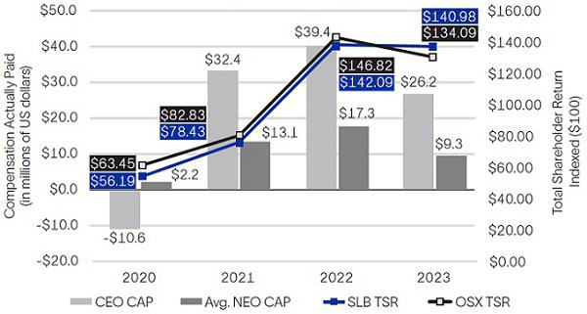

CAP vs. Net Income
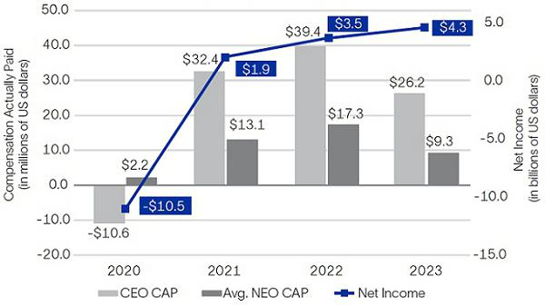

CAP vs. Adjusted EBITDA
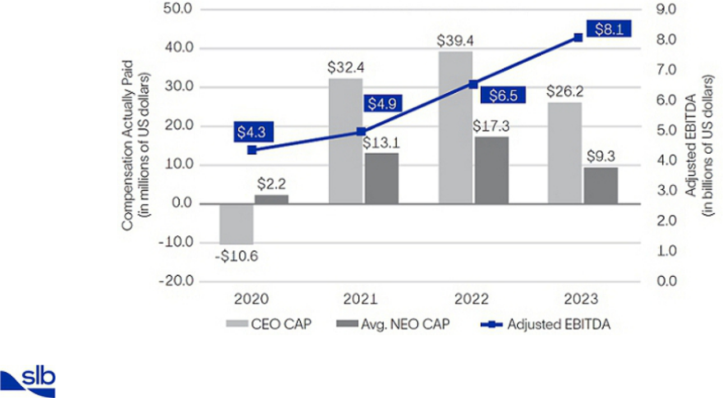

62 2024 Proxy Statement

Back to Contents

ITEM 3. Approval of Financial Statements and Dividends

Following completion of the audit procedures performed by PwC, we are asking you to approve the following financial statements that are included in our 2023 Annual Report:

- our consolidated balance sheet at December 31, 2023;

- our consolidated statement of income for the year ended December 31, 2023; and

- the declarations of dividends by our Board in 2023.

You should refer to our 2023 Annual Report in considering this agenda item.

The Board of Directors recommends a vote FOR this Item 3.

2024 Proxy Statement |  | 63

Back to Contents

ITEM 4. Ratification of Appointment of Independent Auditors for 2024

PwC has been selected by our Audit Committee as the independent registered public accounting firm to audit SLB’s annual financial statements for the year ending December 31, 2024. Although ratification is not required by our bylaws or otherwise, as a matter of good corporate governance, we are asking you to ratify, on an advisory basis, the appointment of PwC as our independent auditor for the year ending December 31, 2024. If the appointment is not ratified, the Audit Committee will consider whether it is appropriate to select another independent registered public accounting firm.

A representative of PwC is expected to attend our 2024 AGM, and will be available to respond to appropriate questions.

The Board of Directors recommends a vote FOR this Item 4.

Fees Paid to PwC

PwC has billed SLB the fees set forth in the table below for

- the audit of SLB’s 2023 and 2022 annual financial statements and reviews of SLB’s quarterly financial statements and other audit services, and

- the other services described below that were billed in 2023 and 2022.

(Stated in thousands) |  | Year Ended December 31,
(Stated in thousands) |  | 2023 |  | 2022
Audit Fees⁽¹⁾ | $ | 15,501 | $ | 13,909
Audit-Related Fees⁽²⁾ |  | 951 |  | 634
Tax Fees⁽³⁾ |  | 3,648 |  | 2,993
All Other Fees⁽⁴⁾ |  | — |  | 44
Total | $ | 20,099 | $ | 17,580

- Includes fees for integrated and statutory audits.

- Consists of fees for employee benefit plan audits and other audit-related items.

- Consists of fees for tax compliance, tax planning, and other permitted tax services.

- Consists of fees for permitted advisory services.

When evaluating PwC’s independence, the Audit Committee considers PwC’s provision of all services not related to the audit of our annual financial statements and reviews of our interim financial statements.

Audit Committee’s Pre-Approval Policy and Procedures

The Audit Committee has a policy to pre-approve all services provided to Schlumberger Limited and its subsidiaries by SLB’s independent registered public accounting firm. The Audit Committee has adopted a schedule for annual approval of the audit and related audit plan, as well as approval of other anticipated audit-related services; anticipated tax compliance, tax planning, and tax advisory services; and other anticipated services. In addition, the Audit Committee (or an authorized committee member acting under delegated authority of the Audit Committee) will consider any proposed services not approved as part of this annual process. For 2023 and 2022, all audit and non-audit services were pre-approved by the Audit Committee.

Shareholder Feedback

At our 2023 AGM, the proposal to ratify the appointment of PwC as our independent auditor for 2023 received the support of 93% of the votes cast. In selecting PwC as SLB’s independent auditor for 2024, the Audit Committee considered this substantial support of our shareholders, as well as PwC’s substantial experience auditing SLB’s complex global accounts and the regulatory requirement that the PwC lead engagement partner rotate every five years.

64 2024 Proxy Statement

Back to Contents

Audit Committee Report

During 2023, the Audit Committee periodically reviewed and discussed SLB’s consolidated financial statements with Company management and PwC, SLB’s independent registered public accounting firm, including matters raised by PwC pursuant to applicable Public Company Accounting Oversight Board (PCAOB) requirements. The Audit Committee also discussed with Company management and PwC the evaluation of SLB’s reporting and internal controls undertaken in connection with certifications made by SLB’s Chief Executive Officer and Chief Financial Officer in SLB’s periodic SEC filings pursuant to the Sarbanes-Oxley Act of 2002. The Audit Committee also reviewed and discussed such other matters as it deemed appropriate, including SLB’s compliance with Section 404 and other relevant provisions of the Sarbanes-Oxley Act of 2002 and rules adopted or proposed to be adopted by the SEC and the NYSE.

The Audit Committee also reviewed with PwC the matters required to be discussed by the independent registered public accounting firm with the Audit Committee under applicable requirements of the PCAOB and the SEC.

PwC provided the Audit Committee with the required PCAOB disclosures and letters concerning its independence with respect to the Company, and the Audit Committee discussed PwC’s independence with them.

Based on the foregoing reviews and discussions, the Audit Committee recommended that the Board include the audited consolidated financial statements in SLB’s Annual Report on Form 10-K for the year ended December 31, 2023, as filed with the SEC on January 24, 2024.

Submitted by the Audit Committee of the SLB Board of Directors
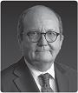




Patrick de La Chevardière, Chair |  | Samuel Leupold |  | Tatiana Mitrova | Jeff Sheets
2024 Proxy Statement |  |  | 65

Back to Contents

Information About the Meeting

Meeting Date: | Wednesday, April 3, 2024
Place: | Curaçao Marriott Beach Resort
 | John F Kennedy Boulevard, 3, Piscadera Bay
 | Willemstad, Curaçao
Time: | 9:00 a.m. Curaçao time
Record Date: | February 7, 2024

This proxy statement is first being made available to our shareholders on or about February 22, 2024. It is furnished in connection with the solicitation of proxies by the SLB Board of Directors to be voted during the 2024 AGM and at any postponement or adjournment of the 2024 AGM.

To be admitted to the meeting, shareholders of record and beneficial owners as of the close of business on February 7, 2024 must present a passport or other government-issued identification with a photograph and, for beneficial owners, proof of ownership as of February 7, 2024, such as the Notice of Internet Availability, and/or the top half of the proxy card or voting instruction card that was sent to you with this proxy statement.

The Chairperson of the meeting will determine the procedures for conducting the meeting and will limit the meeting to those matters properly brought by or at the direction of our Board or properly presented by a shareholder.

Proxy Materials are Available on the Internet

We are furnishing proxy materials to our shareholders primarily via the Internet instead of mailing printed copies of those materials to each shareholder. By doing so, we save costs and reduce the environmental impact of our 2024 AGM. On February 22, 2024, we mailed a Notice of Internet Availability to certain of our shareholders with instructions on how to access the proxy materials online and vote online or by telephone. If you would like to receive a paper copy of our proxy materials, please follow the instructions included in the Notice of Internet Availability. If you previously chose to receive our proxy materials electronically, you will continue to receive access to these materials via email unless you elect otherwise.

Proxies

Shares cannot be voted at the meeting unless the owner of record is present in person or is represented by proxy. SLB is incorporated in Curaçao and, in accordance with Curaçao law, meetings of shareholders are held in Curaçao. Because many shareholders cannot personally attend the meeting, it is necessary that a large number be represented by proxy.

Record Date

Each shareholder of record at the close of business on the record date, February 7, 2024, is entitled to one vote for each director nominee and one vote for each of the other proposals to be voted on, with respect to each share registered in that shareholder’s name. A shareholder of record is a person or entity who held shares on the record date registered in that shareholder’s name on the records of Computershare Trust Company, N.A. (Computershare), SLB’s stock transfer agent. On the record date, February 7, 2024, there were 1,432,365,447 shares of SLB common stock outstanding and entitled to vote. Persons who held shares on the record date through a broker, bank, or other nominee are referred to as beneficial owners.

Quorum

Holders of at least one-half of the outstanding shares entitled to vote at the 2024 AGM must be present in person or represented by proxy to constitute a quorum to take any action at the meeting. Abstentions and broker non-votes will be considered as present for quorum purposes, as discussed under “— Effect of Broker Non-Votes and Abstentions.” If a quorum is not present at the meeting, the Board may call a second general meeting of shareholders, at which the quorum requirement will not apply.

66 2024 Proxy Statement

Back to Contents

Votes Required to Adopt Proposals

To be elected, director nominees must receive a majority of the votes cast, which means the number of votes cast FOR a director nominee must exceed the number of votes cast AGAINST that nominee. Approval of each of the other matters on the agenda also requires the affirmative vote of the majority of the votes cast (excluding any abstentions).

Important Voting Information for Beneficial Owners

If your SLB shares are held for you in “street name”—which means you own your shares through a brokerage, bank, or other institutional account—then you are considered the beneficial owner of those shares, but not the record holder. This means that you vote by providing instructions to your broker rather than directly to SLB. If you do not provide voting instructions, your shares may not be represented or voted at the meeting, as discussed under “—Effect of Broker Non-Votes and Abstentions.”

Effect of Broker Non-Votes and Abstentions

Brokers holding shares must vote according to specific instructions they receive from the beneficial owners of those shares. If brokers do not receive specific instructions, brokers may in routine matters vote the shares in their discretion (such as Items 3 and 4 in this proxy statement), but they are not permitted to vote on the other, non-routine matters unless you provide voting instructions, resulting in a “broker non-vote” for the matters on which a broker does not vote. Abstentions occur when you abstain or instruct your broker to abstain from voting on a particular matter instead of voting for or against the matter. Abstentions and broker non-votes will be considered as present for quorum purposes, but they are not considered as votes cast and will not be counted in determining the outcome of the vote on the election of directors or on any of the other proposals on non-routine matters.

How to Cast Your Vote

Shareholders with shares registered in their names with Computershare may authorize a proxy:

By Internet
www.proxypush.com/SLB

By Telephone
(866) 240-5191

By Mail
Sign, date, and mail your proxy card

The internet and telephone voting facilities for shareholders of record will close at 11:59 p.m. Eastern time on Tuesday, April 2, 2024. The internet and telephone voting procedures have been designed to authenticate shareholders and to allow you to vote your SLB shares and to confirm that your instructions have been properly recorded.

Many banks, brokerage firms, and other nominees participate in programs that also permit beneficial owners to direct their vote by the internet or telephone. If you are a beneficial owner whose shares are held in an account at a bank, brokerage firm, or other nominee that participates in such a program, you may direct the vote of those shares by the internet or telephone by following the instructions on any voting instruction form or electronic voting instructions that you receive from your bank, brokerage firm or other nominee.

All shares entitled to vote at the 2024 AGM and represented at the meeting by properly executed, unrevoked proxies will be voted at the meeting in accordance with your instructions. If you are a shareholder with shares registered in your name with Computershare and you submit a properly executed proxy card or indicate your voting preference via phone or internet but do not direct how to vote on certain items, the persons named as proxies will vote as the Board recommends on each such proposal.

Changing Your Vote or Revoking Your Proxy

If you are a shareholder of record, you can change your vote or revoke your proxy at any time by timely delivering a properly executed, later-dated proxy (including an internet or telephone vote by April 2, 2024) or by voting by ballot at the 2024 AGM. If you hold shares through a bank, broker, or other nominee, you must follow the instructions of your bank, broker, or other nominee to change or revoke your voting instructions.

Soliciting Proxies

SLB will pay the cost of furnishing proxy materials to all shareholders and of soliciting proxies. We have retained D.F. King & Co., Inc. to assist in the solicitation of proxies for a fee estimated at $17,050 plus reasonable expenses. SLB directors, officers, and employees may also solicit proxies for no additional compensation. We will reimburse brokerage firms, fiduciaries, and custodians for their reasonable expenses in forwarding the solicitation material to beneficial owners.

2024 Proxy Statement |  | 67

Back to Contents

Duplicate Mailings

When a shareholder owns shares in more than one account, or when shareholders live at the same address, duplicate mailings may result. If you receive duplicate reports, you can help support SLB’s sustainability goals and eliminate added expense by requesting that only one copy be sent. To eliminate duplicate mailings, contact Computershare at the following address:

Computershare Trust Company, N.A.

P.O. Box 43006

Providence, RI 02940-3006

- 1 (877) 745-9341

- 1 (781) 575-2707

We will promptly deliver, upon written or oral request to the address or telephone number above by shareholders at a shared address to which a single copy of the documents was delivered, a separate copy of this proxy statement and the 2023 Annual Report.

Shareholder Proposals at 2025 AGM

In order for a shareholder proposal to be considered for inclusion in the proxy statement for our 2025 AGM pursuant to Rule 14a-8 of the Securities Exchange Act of 1934, as amended (the Exchange Act), or for director nominations to be included pursuant to SLB’s proxy access bylaw provisions, such proposals or notice of nominations must be received by the Secretary of the Company, 5599 San Felipe, Houston, Texas 77056, no later than October 25, 2024, and, in the case of a proxy access nomination, no earlier than September 25, 2024.

For shareholder proposals to be introduced for consideration at our 2025 AGM other than pursuant to Rule 14a-8 and for shareholder candidates to be nominated for election as directors other than pursuant to our proxy access bylaw provisions, notice must be delivered to the Secretary of the Company at our executive offices in Houston, Texas, not later than 90 days nor earlier than 120 days before the first anniversary of the date of the 2024 AGM. Accordingly, any such notice must be received no earlier than December 4, 2024, and no later than January 3, 2025, and must otherwise satisfy the requirements of our bylaws. Under the rules of the Exchange Act, we may use discretionary authority to vote with respect to any proposal not included in our proxy materials that is properly presented by a shareholder in person at the 2025 AGM if the shareholder making the proposal fails to meet these deadlines and fails to satisfy the requirements of Rule 14a-4 under the Exchange Act.

Further, to comply with the SEC’s universal proxy rules, if a shareholder intends to solicit proxies in support of director nominees submitted under these advance notice provisions, then we must receive proper written notice including all information required by Rule 14a-19 under the Exchange Act, delivered to the Secretary of the Company at our executive offices in Houston, Texas, by February 2, 2025 (or, if the 2025 AGM is called for a date that is more than 30
days before or more than 30 days after such anniversary date, then notice must be provided not later than the close of business on the later of the 60th day

prior to the 2025 AGM or the 10th day following the date on which public announcement of the 2025 AGM is made). The notice requirement under Rule 14a-19 is in addition to the applicable advance notice requirements under our bylaws.

Other Business

As of February 22, 2024, we know of no other business that will be presented at the 2024 AGM other than the matters described in this proxy statement. If any additional matters are properly presented at the meeting, we intend to vote the enclosed proxy in accordance with the discretion of the persons named in the proxy.

Please sign, date, and return the accompanying proxy in the enclosed envelope at your earliest convenience.

By order of the Board of Directors,
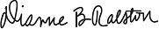

Dianne B. Ralston

Chief Legal Officer and Secretary

Houston, Texas

February 22, 2024

68 2024 Proxy Statement

Back to Contents

Appendix A

Non-GAAP Financial Measures

This proxy statement includes non-GAAP financial measures, including free cash flow, free cash flow margin, adjusted EBITDA, and net debt. Certain of these non-GAAP financial measures are used by SLB management as performance metrics when determining incentive compensation for our executive officers. Below are reconciliations of these non-GAAP financial measures to the comparable GAAP measures.

Adjusted EBITDA

Adjusted EBITDA represents income before taxes, excluding charges and credits, depreciation and amortization, interest expense, and interest income. Management believes that adjusted EBITDA is an important profitability measure for SLB and that it provides useful perspective on SLB’s underlying business results and operating trends, and a means to evaluate SLB’s operations period over period. Adjusted EBITDA is a non-GAAP financial measure that should be considered in addition to, not as a substitute for or superior to, other measures of financial performance prepared in accordance with GAAP.

Year Ended |  |  |  |  |  |  |  |  |  | (Stated in millions)
 |  |  | Dec. 31, 2023 |  |  |  | Dec. 31, 2022 |  | Dec. 31, 2021 |  | Dec. 31, 2020
Net income (loss) attributable to SLB |  | $ | 4,203 |  |  | $ | 3,441 | $ | 1,881 | $ | (10,518)
Net income attributable to noncontrolling interests |  |  | 72 |  |  |  | 51 |  | 47 |  | 32
Tax expense (benefit) |  |  | 1,007 |  |  |  | 779 |  | 446 |  | (812)
Income (loss) before taxes |  | $ | 5,282 |  |  | $ | 4,271 | $ | 2,374 | $ | (11,298)
Charges & credits (details below) |  |  | 110 |  |  |  | (347) |  | (65) |  | 12,515
Depreciation and amortization |  |  | 2,312 |  |  |  | 2,147 |  | 2,120 |  | 2,566
Interest expense |  |  | 503 |  |  |  | 490 |  | 529 |  | 563
Interest income |  |  | (100) |  |  |  | (99) |  | (33) |  | (33)
Adjusted EBITDA |  | $ | 8,107 |  |  | $ | 6,462 | $ | 4,925 | $ | 4,313
Charges & Credits
Year Ended |  |  |  |  |  |  |  |  |  | (Stated in millions)
 |  |  | Dec. 31, 2023 |  |  |  | Dec. 31, 2022 |  | Dec. 31, 2021 |  | Dec. 31, 2020
Merger & integration |  | $ | 56 |  |  | $ | — | $ | — | $ |  | —
Argentina devaluation |  |  | 90 |  |  |  | — |  | — |  |  | —
Gain on sale of Liberty shares |  |  | (36) |  |  |  | (325) |  | (28) |  |  | —
Gain on Arabian Drilling Company equity investment |  |  |  |  | — |  | (107) |  | — |  |  | —
Repurchase of bonds |  |  |  |  | — |  | (11) |  | — |  | 40
Loss on Blue Chip Swap transactions |  |  |  |  | — |  | 139 |  | — |  |  | —
Gain on sale of real estate |  |  |  |  | — |  | (43) |  | — |  |  | —
Early repayment of bonds |  |  |  |  | — |  | — |  | 10 |  |  | —
Unrealized gain on marketable securities |  |  |  |  | — |  | — |  | (47) |  | (39)
Goodwill |  |  |  |  | — |  | — |  | — |  | 3,070
Intangible assets |  |  |  |  | — |  | — |  | — |  | 3,321
APS investments |  |  |  |  | — |  | — |  | — |  | 1,994
North America pressure pumping |  |  |  |  | — |  | — |  | — |  | 587
Workforce reductions |  |  |  |  | — |  | — |  | — |  | 1,286
Fixed asset impairments |  |  |  |  | — |  | — |  | — |  | 666
Inventory write-downs |  |  |  |  | — |  | — |  | — |  | 603
Right-of-use asset impairments |  |  |  |  | — |  | — |  | — |  | 311
Costs associated with exiting certain activities |  |  |  |  | — |  | — |  | — |  | 205
Multiclient seismic data impairment |  |  |  |  | — |  | — |  | — |  | 156
Postretirement benefits curtailment gain |  |  |  |  | — |  | — |  | — |  | (69)
Facility exit charges |  |  |  |  | — |  | — |  | — |  | 254
Gain on sale of OneStim |  |  |  |  | — |  | — |  | — |  | (104)
Other |  |  |  |  | — |  | — |  | — |  | 234
Total Charges & (Credits) |  | $ | 110 |  |  | $ | (347) | $ | (65) | $ | 12,515
2024 Proxy Statement |  |  |  | A-1

Back to Contents

Free Cash Flow

Free cash flow represents cash flow from operations less capital expenditures, Asset Performance Solutions (APS) investments, and exploration data costs capitalized. Management believes that free cash flow is an important liquidity measure for the Company and that it is useful to investors and management as a measure of SLB’s ability to generate cash. Once business needs and obligations are met, this cash can be used to reinvest in the Company for future growth or to return to shareholders through dividend payments or share repurchases. Free cash flow does not represent the residual cash flow available for discretionary expenditures. Free cash flow is a non-GAAP financial measure that should be considered in addition to, not as a substitute for or superior to, cash flow from operations.

Year Ended |  |  | (Stated in millions)
Year Ended |  | Dec. 31, 2023 |  | Dec. 31, 2022 |  | Dec. 31, 2021
Cash flow from operations | $ | 6,637 | $ | 3,720 | $ | 4,651
Capital expenditures |  | (1,939) |  | (1,618) |  | (1,141)
APS investments |  | (507) |  | (587) |  | (474)
Exploration data capitalized |  | (153) |  | (97) |  | (39)
Free cash flow | $ | 4,038 | $ | 1,418 | $ | 2,997

Free Cash Flow Margin

Free cash flow margin is calculated as free cash flow divided by revenue. Free cash flow margin measures how efficiently SLB converts revenue into free cash flow, and is an indicator of capital efficiency. For the three-year period from January 1, 2021 through December 31, 2023, free cash flow margin of 10.0% was calculated based on SLB’s cumulative, three-year free cash flow of $8.453 billion (reflected in the table above), divided by SLB’s cumulative, three-year revenue of $84.155 billion (comprising $33.135 billion for 2023, $28.091 billion for 2022, and $22.929 billion for 2021).

Net Debt

Net debt represents gross debt less cash and short-term investments. Management believes that net debt provides useful information regarding the level of SLB’s indebtedness by reflecting cash and investments that could be used to repay debt. Net debt is a non-GAAP financial measure that should be considered in addition to, not as a substitute for or superior to, total debt.

 |  |  |  |  |  |  | (Stated in millions)
 |  |  |  |  | Dec. 31, 2023 |  |  | Dec. 31, 2022
Cash |  | $ |  |  | 2,900 |  | $ | 1,655
Short-term investments |  |  |  |  | 1,089 |  |  | 1,239
Short-term borrowings and current portion of long-term debt |  |  |  |  | (1,123) |  |  | (1,632)
Long-term debt |  |  |  |  | (10,842) |  |  | (10,594)
Net debt |  | $ |  |  | (7,976) |  | $ | (9,332)
 |  | A-2 |  |  |  |  | 2024 Proxy Statement

Back to Contents
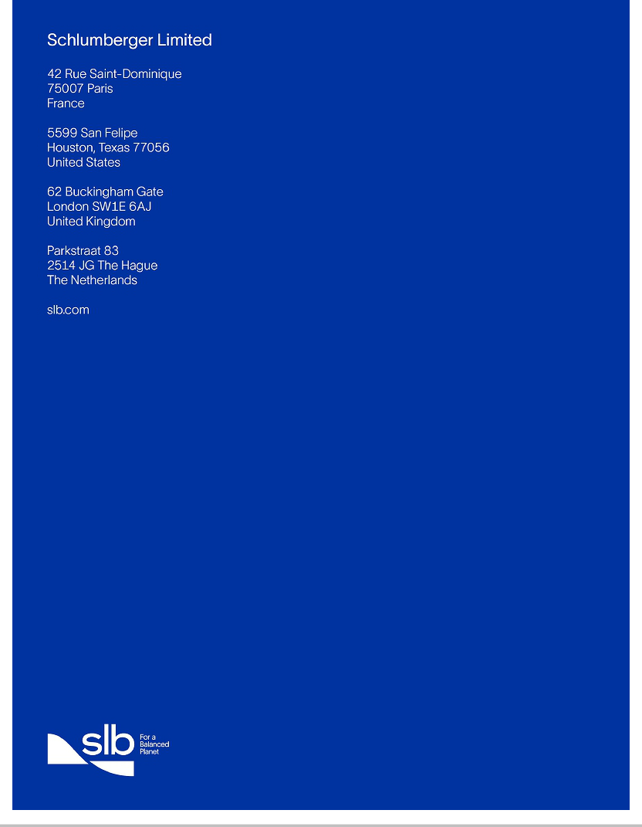

Back to Contents
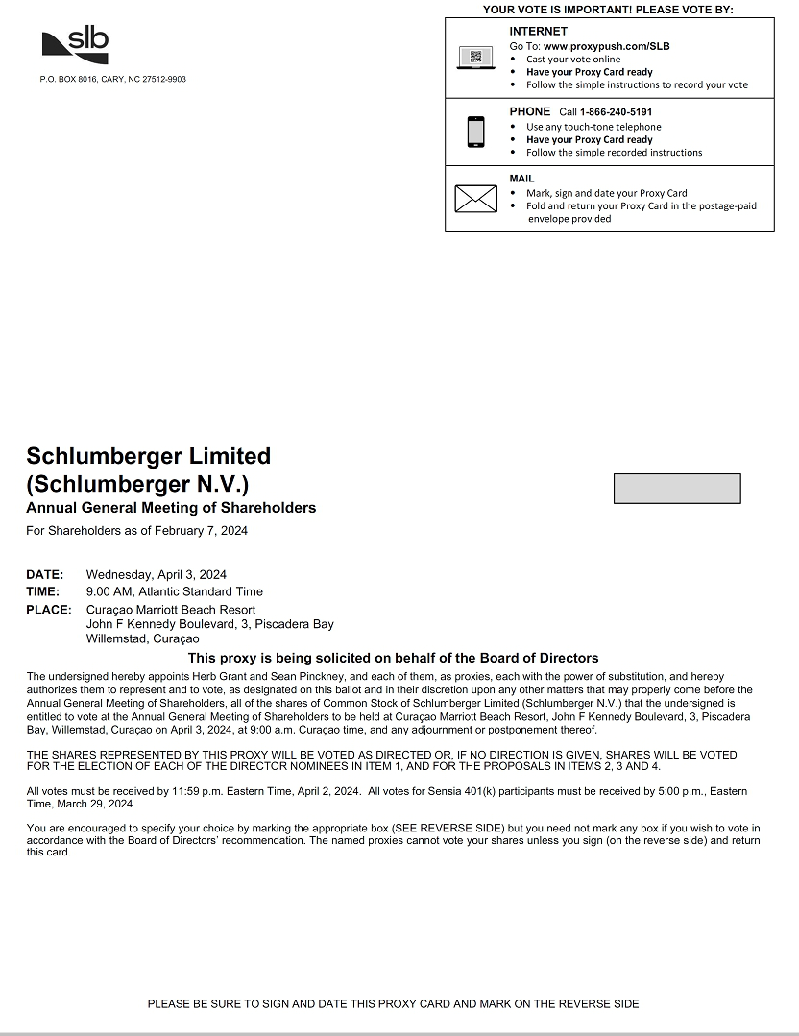

Back to Contents


