SECURITIES AND EXCHANGE COMMISSION

Washington, D.C. 20549

FORM 8-K

CURRENT REPORT

Pursuant to Section 13 or 15(d) of
the Securities Exchange Act of 1934

Date of Report (date of earliest event reported): March 29, 2004

SCHLUMBERGER N.V. (SCHLUMBERGER LIMITED)

(Exact name of registrant as specified in its charter)

Netherlands Antilles | 1-4601 | 52-0684746
(State or other | (Commission | (IRS Employer
jurisdiction of incorporation) | File Number) | Identification No.)
153 East 53rd Street, 57th Floor
New York, New York |  | 10022-4624
42, rue Saint-Dominique
Paris, France |  | 75007
Parkstraat 83,
The Hague,
The Netherlands |  | 2514 JG
(Addresses of principal executive offices) |  | (Zip or Postal Codes)

Registrant’s telephone number in the United States, including area code: (212) 350-9400

Item 7. Financial Statements and Exhibits.

(c) Exhibits

The following exhibit is furnished in response to Item 9:

99.1 Presentation at Howard Weil Energy Conference

Item 9.

Andrew Gould, Chairman and CEO of Schlumberger Limited (“Schlumberger”) is making a presentation on March 29, 2004 at the Howard Weil Energy Conference. A copy of the presentation and slides is attached as Exhibit 99.1. Schlumberger has also posted this information on its website at www.slb.com/ir.

SIGNATURE

Pursuant to the requirements of the Securities Exchange Act of 1934, the registrant has duly caused this report to be signed on its behalf by the undersigned hereunto duly authorized.

SCHLUMBERGER N.V.

(SCHLUMBERGER LIMITED)

By: /s/ Frank A. Sorgie

Frank A. Sorgie

Chief Accounting Officer

Date: March 29, 2004

Exhibit 99.1

HOWARD WEIL ENERGY CONFERENCE MARCH 29, 2004 PRESENTATION BY ANDREW GOULD
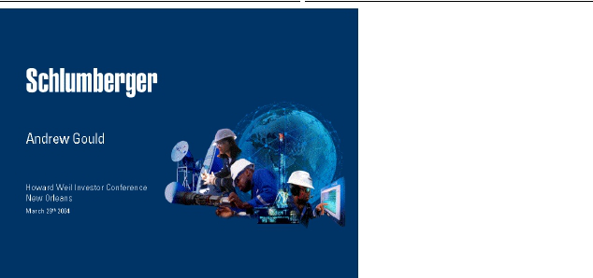

Ladies and Gentlemen Good Morning. Thank you very much for the invitation to be here today. I would like to share with you this morning three aspects of Schlumberger’s future. First, the macro environment for oil and gas, in both the long and short term. Second, some key technical directions that are emerging from our Oilfield portfolio and third, key developments within Oilfield Services including both our seismic joint venture WesternGeco and Schlumberger Information Solutions. However, I will begin by reviewing the progress we made on the financial goals that we shared with you last year, as well as on the remaining restructuring of the non-oilfield part of Schlumberger.
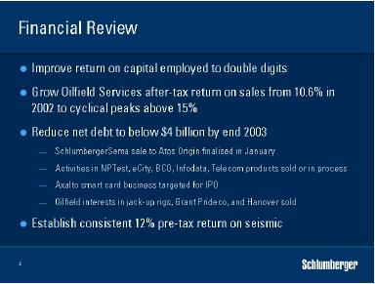

Early in 2003 we stated clear goals—and by year-end we had made solid progress. Return on capital employed had risen to 12.8% in the fourth quarter, double the corresponding figure in 2002 and well in line with our intention to reach the mid-teens longer term. After-tax return on sales for Oilfield Services reached 14.2% in the same quarter—a level much more consistent with our performance in

1

HOWARD WEIL ENERGY CONFERENCE MARCH 29, 2004 PRESENTATION BY ANDREW GOULD

previous cycles and consistent with the timing of the current cycle. Net debt fell to $4.2 billion, just shy of our $4 billion target as a result adverse currency movements.

In January 2004, we completed the sale of the major part of SchlumbergerSema to Atos Origin and reduced our holding in that company to 14.5%. Total proceeds from the cash and stock sale amounted to $1.1 billion. With probable conclusion of the sale of the North American electricity meter business and Business Continuity in the second quarter and the announced sales of Telecom software products, and Infodata businesses we expect to see net debt below the $3 billion dollar level by the middle of 2004. The next significant move below that level will come from the IPO of our smart card business, Axalto, as and when market conditions permit but we anticipate that a substantial portion will be placed in 2004. This means that apart from the remaining 14.5% shareholding in Atos Origin and a few minor activities by the end of 2004, Schlumberger will be a pure Oilfield services Company for the first time in almost 35 years.

The most difficult challenge that we set ourselves was to return WesternGeco to sustainable profitability. Continuing overcapacity in both the land, marine and multi-client data markets make this a daunting task. Our approach has been threefold, to bring capacity and cost down to appropriate levels, to reflect a proper carrying value for the data library, and to continue aggressive introduction of Q technology. The key to success is consistency, and while the fourth quarter results were encouraging, the industry as a whole remains in intensive care. I will return to this subject a little later this morning.
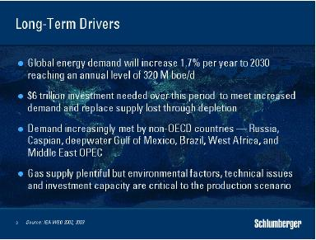

Last November the IEA published their 2003 World Energy Investment Outlook reiterating their view that world energy demand will increase at an average annual rate of about 1.7% until at least 2030, 90% of which will come from oil and gas. The key drivers of E&P activity remain the dual requirement to grow production at a long-term sustainable rate, while replacing production lost through decline.

For the first time, however, the IEA unveiled a look at the size of the capital investment needed in E&P to 2030—a total of $6 trillion split roughly equally between oil and gas development activities. This figure represents an acceleration in spending compared to the 1990’s and implies that the capital needs over the next thirty years will be much larger, in real terms, than over the past thirty years. I believe that these fundamentals confirm the attractiveness of the oilfield services sector as an investment.

2

HOWARD WEIL ENERGY CONFERENCE MARCH 29, 2004 PRESENTATION BY ANDREW GOULD

The IEA figure included detail on how this investment will need to be distributed. Only one quarter of the oil investment figure will be needed to grow capacity. The remaining three-quarters will be needed to replace existing capacity lost through production decline. New oil production will come from Russia, the Caspian, the deepwater Gulf of Mexico, Brazil, and West Africa, and as much as 70% of conventional new production will occur in non-OECD countries implying an increasing call on Middle-East OPEC producers.

Gas presents a different picture, with plentiful supply in almost all parts of the world with the possible exception of the continental US. The IEA predicts that gas consumption will double in the next 30 years and that almost half of the total investment figure will need to be spent on exploration and production. The ultimate production scenario will depend on environmental and technical factors as well as on the infrastructure investments necessary to bring the gas to market, but the same shift away from the OECD countries holds.

Activity so far this year is showing early signs of the picture that this investment scenario paints. The return of economic growth in the US, increasing demand, particularly in China, and continued political uncertainty in a number of major producing areas have combined to emphasize the tightness of supply and demand. Following demand growth of only 0.2% in 2002, growth in 2003 has been revised up to 2.1% following new data received by the IEA, and demand in 2004 is now also expected to grow by more than 2%.
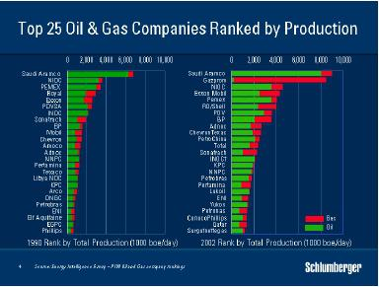

With this geographic scenario in mind, it is easy to see that the markets for oilfield services are changing, both in terms of the customer base, and in terms of customer needs. We see a shift towards the major resource holders and their national oil companies, and a shift towards more production decline management based activities as well as a ramp-up in the large infrastructure investments in gas that will lead to major development programs. Of the top 25 upstream companies ranked by production capacity, no less than 17 are owned by governments or are in Russia.

3

HOWARD WEIL ENERGY CONFERENCE MARCH 29, 2004 PRESENTATION BY ANDREW GOULD
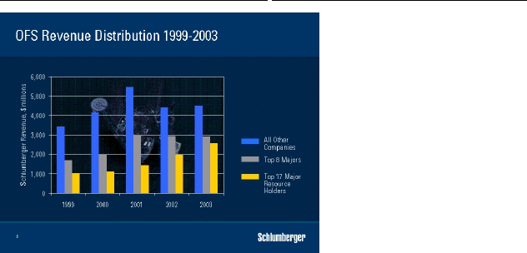

Our customer base continues to show a steady increase in revenue from the major resource holders. This provides new opportunities in the way we sell our services because of the way in which these customers manage their operating assets. International oil companies have the freedom to manage their portfolios by selling, acquiring or outsourcing while the major resource holders are focused on the management of their assets for the lifetime of those assets. Other new opportunities are presented by the growing markets of Russia, several of the former Soviet republics and more gradually, but equally China.
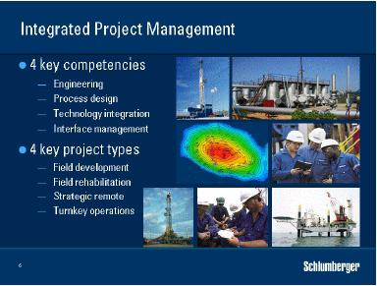

Within these markets, the approach of integrated project management, or IPM, has proved of particular value and is resulting in growing activity in the mature fields that make up much of the world’s producing base. This type of work is characterized by a combination of engineering, process design, technology integration and service interface management. IPM services can also include the provision of technical personnel and management expertise to supplement customers’ own efforts.

4

HOWARD WEIL ENERGY CONFERENCE MARCH 29, 2004 PRESENTATION BY ANDREW GOULD

Although there are many variations, integrated projects can be classed into four main groups. First field development—which includes services that range from reservoir characterization through well design and construction to production facilities and associated civil engineering. Second, field rehabilitation— designed to redevelop fields where value has been bypassed. Third, strategic projects that lie outside a resource holder’s envelope of operations. Finally, turnkey projects, for well construction or field construction, in which operators are able to achieve higher levels of efficiency by outsourcing.

Two overarching factors characterize IPM-type activity—the benefit of lower total cost, and the long-term relationship between the customer and Schlumberger. These factors are evident in our activity in Mexico. The Burgos gas well construction turnkey project, now in its seventh year, has lead to the award for work on the Chicontepec field. This reservoir is a complex series of tight sandstones that present economic challenges in exploitation. Schlumberger is not only tasked with lowering the cost of well construction, but also that of increasing production per well. Working in conjunction with PEMEX, who are drilling a number of the wells themselves, we bring the advantages of engineered solutions, technology integration and interface management.

Brownfields, where the focus is on maximizing post-plateau production and ultimate recovery, also offer considerable potential for IPM-type activity. These fields no longer benefit from the macro-engineering approach that first put them into production but rather respond to a much more detailed engineering. This is very resource intensive and is often the reason behind large companies divesting such properties to smaller specialized operators in areas such as the Gulf of Mexico and the North Sea. Major resource holders do not have this option and the integrated service approach of IPM within our unique GeoMarket structure is a natural fit.
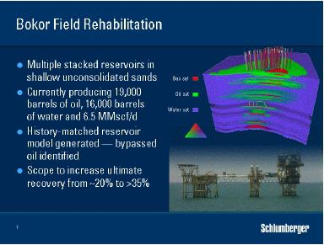

The Bokor field in Malaysia is an example of this. Schlumberger recently signed an alliance agreement with PETRONAS Carigali to redevelop the field, which had been on production for more than 20 years. New software has been used to model the field, and the goal is to increase production by at least 50% from the current level of 19,000 bopd. I would like to emphasize the collaborative aspect of this work and that it does not imply any change in the Schlumberger business profile. We remain an independent service company, we do not take equity, and we treat all customers equally.

5

HOWARD WEIL ENERGY CONFERENCE MARCH 29, 2004 PRESENTATION BY ANDREW GOULD
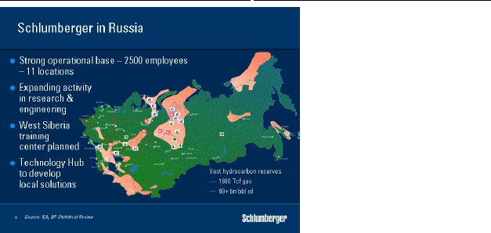

Specific geographic areas also present new opportunities for Schlumberger. Last year, we announced a phased agreement to acquire PetroAlliance, Russia’s largest independent oilfield service company. The size and scope of activity in Russia is huge, and this type of investment will benefit Schlumberger and the Russian oil and gas industry as that industry seeks to access the specific technologies it needs. More recently we signed an agreement with the Governor of Tyumen province, West Siberia, to increase our investment in the region. We will be developing a large-scale training facility for our own use as well as for that of our growing client base and we are also expanding our Research and Engineering capability. Today, Schlumberger employees number more than 2,500 in Russia, of whom more than 90% are Russian. We have recruited over 300 Russian engineers, many of whom have been, or are currently, on international assignment to gain exposure to worldwide operations.
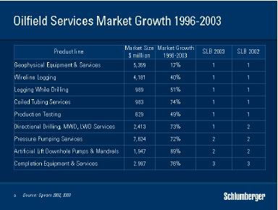

While the growing success of initiatives like IPM and Russia are due in no small part to the unique Schlumberger GeoMarket organisation they will only continue if we can provide customers with

6

HOWARD WEIL ENERGY CONFERENCE MARCH 29, 2004 PRESENTATION BY ANDREW GOULD

leading-edge technologies. Spears’ market research data show that the oilfield services’ markets with the highest growth rates over the last few years are those that help maintain production by managing decline. The growth rates of pressure pumping, coiled tubing, directional drilling, LWD, MWD, and completion services technologies all witness the need to sustain production.

We have always believed that you need to be number 1 or 2 to maintain technical leadership, or you need a plan to get there. You also need to have a clear idea of which technologies are going to most affect your customer’s business. As you can see, we have maintained leadership in our key segments while attaining leadership in others.
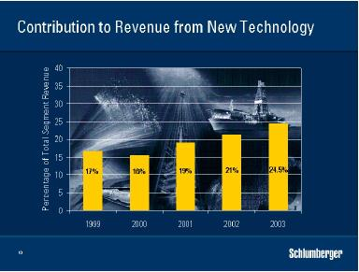

Schlumberger investment in R&D leads to the introduction of new technology on a regular basis. We track this contribution by monitoring the proportion of our revenue derived from these services, on a moving average, during their first years of commerciality. Over the past few years this percentage has been increasing, indicating the quickening pace of our technology development and deployment. To add some perspective, almost 60% of these new technology revenues in 2003 within the Wireline segment came from services that are targeted at the production phase of a field’s life. These include a heavy emphasis on formation evaluation quality measurements in cased hole. The Wireline segment is not unique in this respect with Drilling & Measurements, Well Services and Well Completions & Productivity all introducing production-focused technologies. The maturing of the world’s production provides clear opportunities for further technology-based growth in both traditional and new areas of oilfield services.

Let me take one example. Reentry drilling to tap bypassed oil in mature fields typically requires complex slimhole well trajectories that need to intersect several hydrocarbon accumulations to make economic sense. Such operations cannot typically use traditional methods of operation and new ways of working must be found. For example, the use of sliding technology with downhole motors to drill such sidetracks can lead to sticking that hinders weight transfer and limits horizontal reach. Rotary steerable technology offered the solution, but did not exist in small enough sizes although the necessary geosteering capability in slimhole already existed.

The Schlumberger response to the field need led to the first commercial slimhole rotary steerable system in the industry. The equipment was tested after only five months development and in less than a year, more than 30,000 feet of 6-in. diameter hole had been drilled on the UKCS.

7

HOWARD WEIL ENERGY CONFERENCE MARCH 29, 2004 PRESENTATION BY ANDREW GOULD
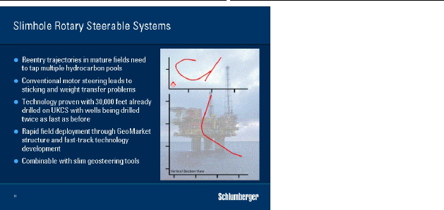

Rapid deployment of new technologies on a worldwide basis is enabled by the GeoMarket organisation and the community of technology experts within the GeoMarkets was able to share experience and contribute to development. As a result, use of rotary steerables has grown rapidly since their introduction in 2000 with slimhole systems representing the fastest growing market. The next step in the application of this technology for use in the exploitation of mature fields will be the deployment of still-slimmer tools capable of being run through tubing to drill side tracks without the need to pull the well completion. These new tools will be developed in collaboration with Shell and BP, and we expect to see their introduction in 2005.
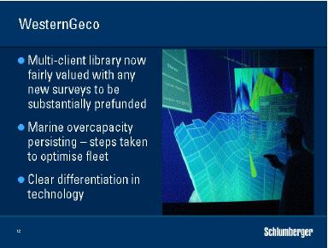

I would now like to turn to WesternGeco and the progress that has been made. You have followed with us the charges that we have taken in reducing the book value of our multiclient library over the past year. We now believe that the data are reasonably valued and we have no intention of returning to the past. Any further library data sets will need to be substantially prefunded and we do not exclude

8

HOWARD WEIL ENERGY CONFERENCE MARCH 29, 2004 PRESENTATION BY ANDREW GOULD

differentiating our library from other industry libraries in the future through the addition of new Q* technology data. While the last quarter’s library sales results were encouraging, it is my belief that data libraries will become a smaller and smaller part of seismic acquisition company operations in the future.

In marine seismic we have taken steps to control capacity, but this not something we can do alone and we have no intention of simply allowing other boats to replace our own. However we can optimize the financial performance of our own marine fleet and you have seen us take action in that regard. In land seismic, we have withdrawn from unprofitable operations.

The biggest story however is in technology differentiation. The language of geophysics, once spoken by only a very small group, is being adopted more and more by an entire E&P sector that has begun to realize the value of Seismic as a reservoir development as opposed to just being an exploration tool. 3D seismic has developed well beyond being a better exploration tool. For example, properly designed and executed high-resolution surveys are a major asset in optimizing topsides design. This has lead to smarter development plans, and less time to first production, both of which are critical to project NPV. Now 4D or time lapse Seismic is proving invaluable to improved recovery from producing fields, provided it can be done in a timely and cost effective manner. Let me show you one example.
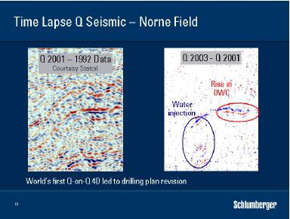

Last October, we acquired the first time-lapse Q survey in the North Sea for Statoil and I would like to express my gratitude to them, both for their enthusiastic adoption of new technology and also for permission to show this data set. These data were acquired with towed Q-Marine surveys just 21 months apart. The data shown here are pretty much final—however the initial 4D results were available from the vessel only 11 days after acquisition was completed. Quick data delivery is critical, but even more important is whether the results can impact drilling decisions. When differenced, these data show a striking 4D signal, with a clear signature from the water injection and movement of the oil-water contact. On the basis of the fast track results, Statoil revised their plans and gave a pre-designed well a shallower trajectory in order to avoid the encroaching oil-water contact. The value of this survey was delivered in less than 30 days. This is not the first 4D on the Norne field. The initial baseline survey was acquired in 1992 and has been reprocessed by Statoil together with the 2001 Q data to derive this 4D result. If you know where to look, you can find the genuine time-lapse signal, but there are high levels of noise due to the limitations of conventional towed marine.

9

HOWARD WEIL ENERGY CONFERENCE MARCH 29, 2004 PRESENTATION BY ANDREW GOULD

Towed streamer 4D seismic results of this quality are only possible because of Western-Geco’s unique steering and positioning technology. They can be combined with the production history to deliver a more accurate, calibrated, dynamic reservoir simulation model and an optimized field development plan— indicating infill drilling opportunities, predicting flood fronts and avoiding early water breakthrough.
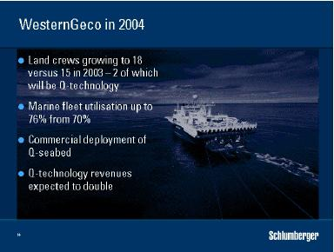

Signs are emerging that indicate a slightly more positive outlook for WesternGeco in 2004. Deployment of new land crews, of which 2 will be Q-technology based, will raise the average number of active crews to 18 or more, versus 15 in 2003. In marine, committed work implies almost full fleet utilization in the third quarter, raising the expected average figure for the year to 76% compared to 70% in 2003. Q-technology revenues are expected to double in 2004 over 2003 as acceptance accelerates and new systems, such as Q seabed are deployed.

My third objective today is to discuss progress at Schlumberger Information Solutions. In defining the businesses sold with SchlumbergerSema, we have maintained our commitment to growing activity in oil and gas information solutions. The combination of Schlumberger software and information management activities with the SchlumbergerSema oil and gas consulting and network infrastructure businesses was completed by last December. We have retained the Schlumberger Information Solutions name and the goal is to help customers extract more value from their core operational processes through leveraging the combination of our domain knowledge in both IT and in E&P. This offering responds to a clearly defined need and let me just take a few minutes to review that need.

Nobody disputes that the ability of the industry to continually lower finding and development cost over the last 20 years has been remarkable and much of this fall has been due to the investments made in new technology. Further gains however, are likely to come just as much from changes in the way the industry works, as they are from further technological silver bullets.

10

HOWARD WEIL ENERGY CONFERENCE MARCH 29, 2004 PRESENTATION BY ANDREW GOULD
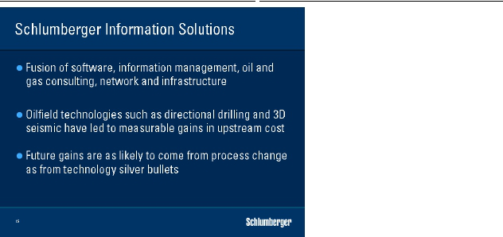

Adding more reserves, drilling better wells and maximizing production are clear industry goals. But the business is evolving, with changing operational issues and accelerating workforce dynamics. Many experienced people are preparing to retire with consequences for the communication of know-how within companies, between experts, and in frontier areas. There are clear gaps to be bridged between the operational and business sides of the industry and there is a growing need for information to move efficiently and effectively between the reservoir and the back-office with sufficient speed to enable decisions to be taken in a proactive manner.
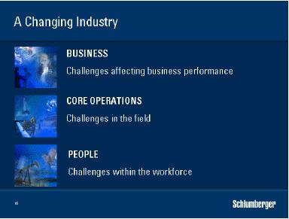

Schlumberger Information Solutions the response to these challenges through leveraging a number of IT enablers that enhance core E&P operations. First people and process. It is becoming apparent that increased productivity can be gained through proper workflow planning enabled by IT. Secondly, software and information technology are required to simplify, integrate and automate the process, while managing the information that enables decision-making. This dictates seamless

11

HOWARD WEIL ENERGY CONFERENCE MARCH 29, 2004 PRESENTATION BY ANDREW GOULD

interaction of the right people at the right time whether they are in the field or in the office. Thirdly, real time. This is the connection of the people, process and technology involved in any particular E&P operation, such as drilling, into an integrated seamless, secure loop so that information can be used in a way that increases value.
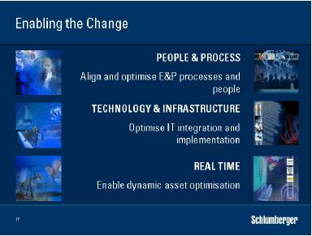

There are many criteria for successful real-time optimization of an oil and gas asset. I believe that SIS, with its combination of E&P and IT knowledge has unique and differentiated capabilities that can exploit this opportunity and I fully expect to see annual growth in double figures that would mean a one-billion dollar plus business for Schlumberger within four years.
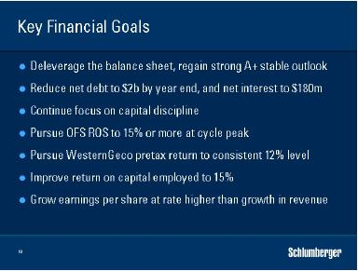

I would like now to update you on our financial goals for 2005. Further balance sheet improvement as net debt reduces should allow us to regain an A+ credit rating with stable outlook. Following the conclusion of the disposal of the non-oilfield activities of SLB reduces the annual run rate

12

HOWARD WEIL ENERGY CONFERENCE MARCH 29, 2004 PRESENTATION BY ANDREW GOULD

of corporate overhead by $35 million in 2005. The focus on capital discipline that we began a year ago will continue. Goals for profitability remain with our intention to pursue oilfield return on sales at the cycle peak in excess of 15%. We will also maintain our goal to earn a consistent 12% pretax return on seismic. We maintain our view that return on capital employed should approach and perhaps exceed 15%. Finally, I repeat our desire to grow earnings per share at a rate that exceeds our revenue growth. Ladies and Gentlemen, I began this talk with a description of the investment climate for oil and gas in the coming years. Renewed demand growth coupled with ageing reservoirs and a long period of underinvestment in new production capacity lead to a very favorable business climate for the service industry.


Schlumberger’s unique global coverage and cultural diversity coupled with our traditional leadership in technology development give us an ideal position to help our customers find and develop new capacity as well as to prolong production from their existing reservoirs.

Thank you for your attention.

13

